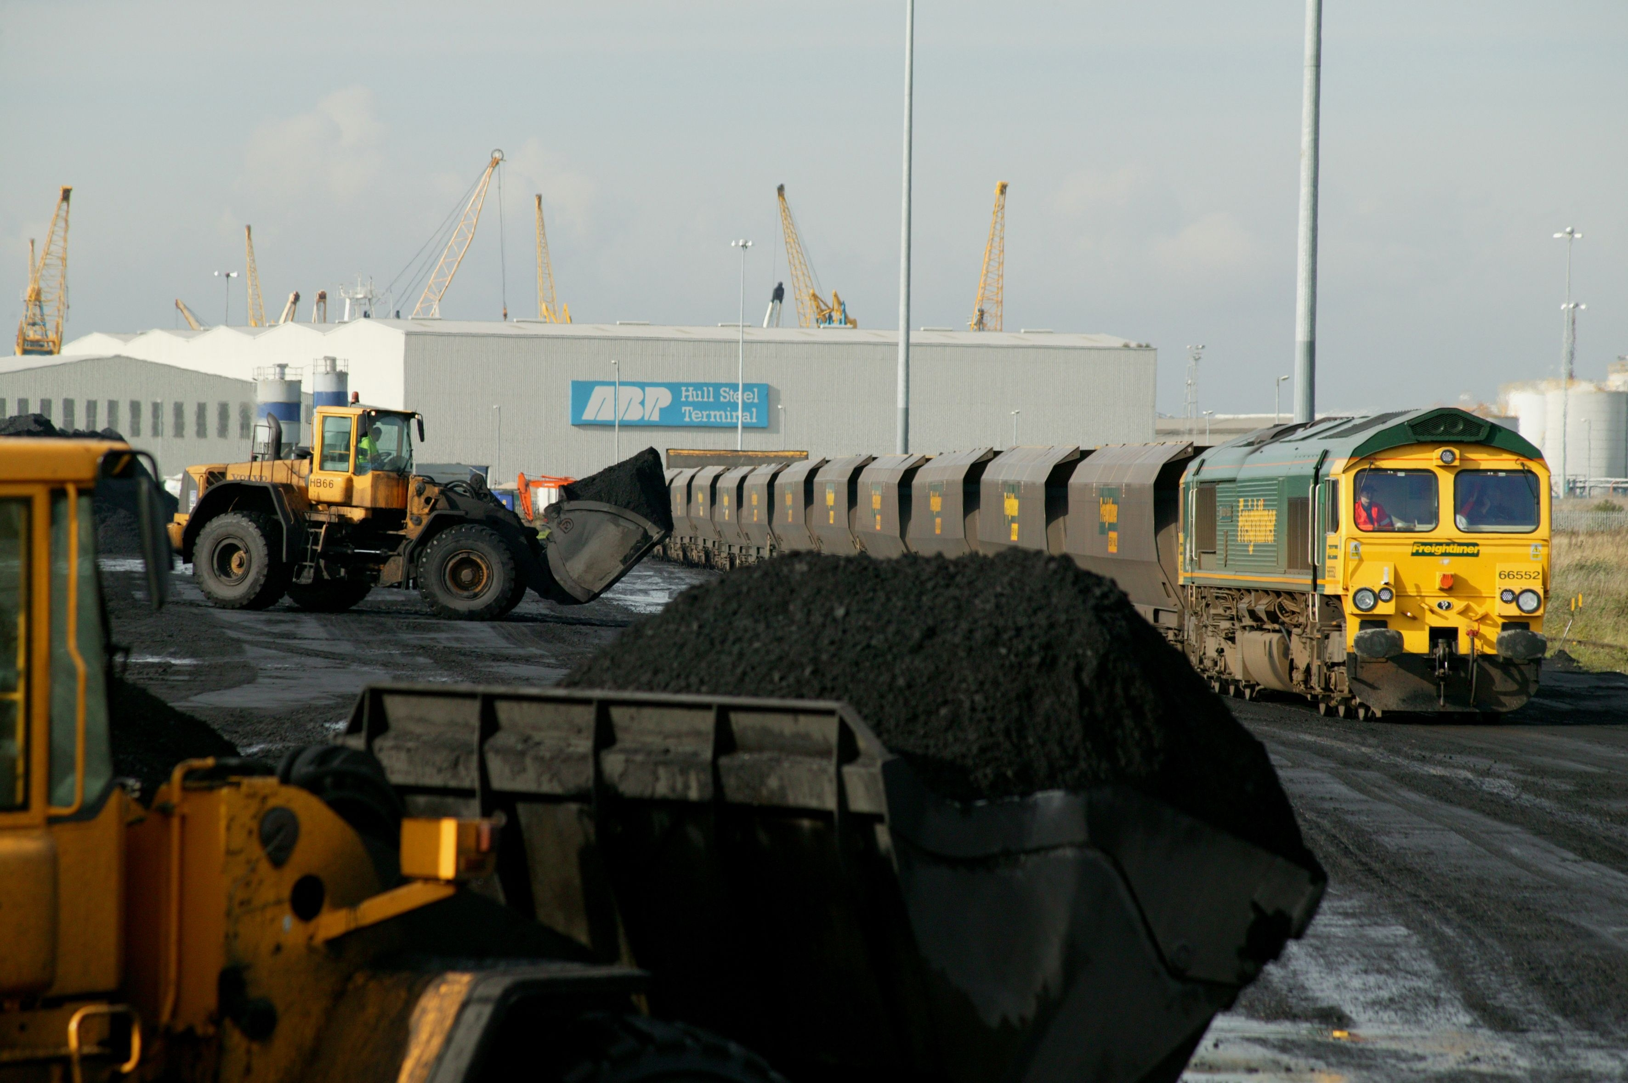

Briefing Pack - Rail freight improvements on the Humber.

 | 
 | 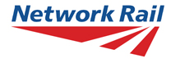

March 2007
Also available online at www.networkrailmediacentre.co.uk

Background

Plans to boost the movement of goods into and out of the Humber Ports without adding to road congestion were announced in March 2007

A partnership of national, regional and local organisations, including Network Rail, Yorkshire Forward, The Northern Way and Associated British Ports (ABP) has been working closely to develop a package of schemes which will improve rail freight access to the ports at Hull and Immingham; bringing substantial economic and environmental benefits to the region.

The Northern Ports enjoy some 34% of the market share of tonnes handled at all UK ports. This volume is already in excess of some entire countries (eg Sweden, Poland, Demark, Belgium). The Humber ports are already one of the UK’s busiest rail freight arteries and make a significant contribution to the region’s economy. Immingham is the largest port, by tonnage, in the UK and the sixth largest in Europe. Further traffic is projected and port growth continues. Enhancement of the rail routes is seen as bringing positive economic, environmental and social benefits.

Over the past five years rail freight in general has increased by 22%. Freight is expected to increase by a further 30% over the next decade. That’s the equivalent of an extra 120 trains per day.

The efficient movement of goods into and away from the ports at Hull and Immingham is vital for the region’s importers and exporters, and the supply chains associated with this activity are a key element in boosting the region’s economy.

The projects outlined in this briefing document are key elements of a wider scheme which is still being developed. Further funding and support for this wider scheme is being sought from a number of sources. Network Rail is currently working with the Department for Transport to develop a detailed case for funding through the productivity strand of the Transport Innovation Fund. A final announcement about this and the full scope of works will be made in due course.

Hull Docks branch line

£13.1million is being spent to improve the infrastructure on the Hull Docks branch line. Once complete this will increase capacity from ten to 22 trains per day in each direction with services operating a 16 hour day.

Work will start on site in Summer 2007 and is planned for completion in Spring 2008. This scheme is being funded by The Northern Way, Yorkshire Forward and Network Rail.

ABP are investing £2.6m in the stretch of the Hull Docks branch line that lies on their land, as well as on-dock rail infrastructure improvements.

The works comprise:
- Relaying Hessle Road junction as a double junction
- Double tracking the railway at either end of the branch line
- Repairs to various embankments and bridges to ensure that the infrastructure is robust enough to deal with the increased traffic
- Signalling improvements to allow traffic to move more quickly along the line (up to 30mph)

Brigg line

£10million is being invested in the Brigg Line to allow the scheduled movement of freight trains along the line.

This line currently operates one day a week for 3 passenger trains and as diversionary freight route. After the work it will be available 5 and a half days a week.

The freight traffic using the route will mostly be coal traffic bound for the Trent valley power stations at Cottam, West Burton Rugeley and Ratcliffe, as well as other freight traffic bound for the Midlands and South West.

Re-routing this traffic via the Brigg line will help to relieve demands on the busy south Humberside route - including relieving congestion within the Doncaster area.

The scheme will bring improved productivity for coal train movements to Cottam and West Burton as the route is both shorter and avoids the heavily congested rail network in the Doncaster area.

The works involve repairs to areas of key embankments and some bridges, track drainage works in Kirton tunnel and upgrading of certain level crossings to make them suitable for operation with regular freight services.

This work will be entirely funded by Network Rail.

Map

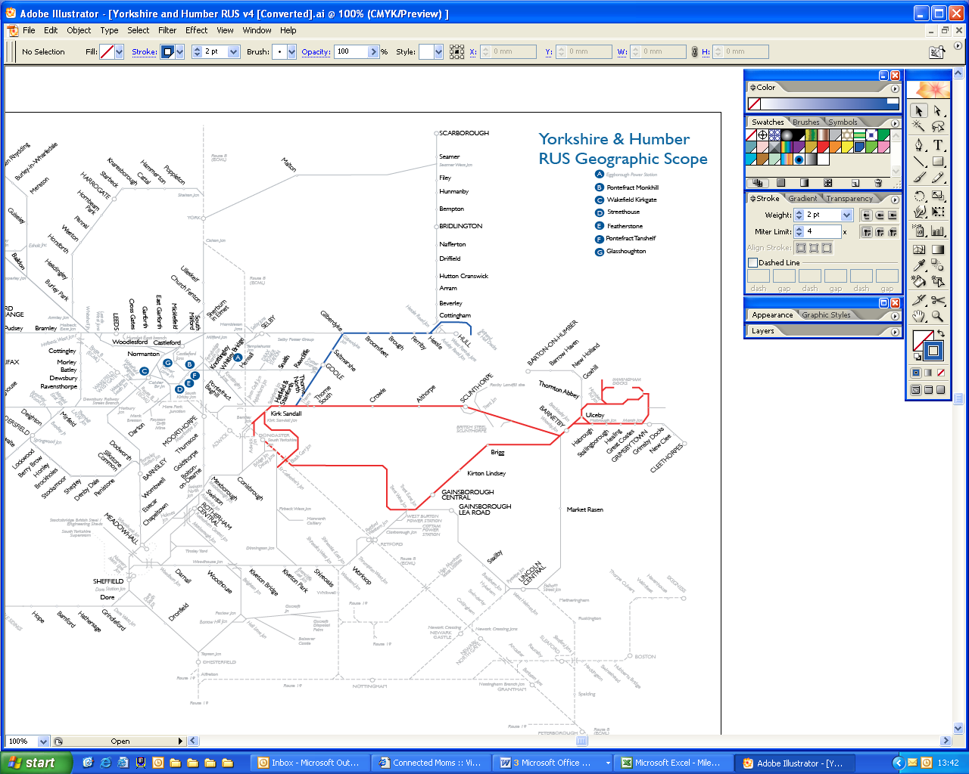
Hull Docks

Immingham / Brigg Line

The Ports
Brigg line and Hull Docks branch line and ABP’s Ports of Immingham and Hull
The development of the Brigg line and Hull Docks branch line will be necessary to accommodate the growing volumes of coal, dry bulks and containers moving in and out of ABP’s Ports of Immingham and Hull. The increased traffic is being generated by mounting customer demand and has been facilitated by ABP’s investment in new terminal infrastructure to expand handling capacity at its Port of Immingham, which is served by the Brigg line, and its Port of Hull, which is served by Hull Docks branch line.
ABP Immingham
In May 2006, the Port of Immingham’s £59.5 million dedicated coal-handling facility, Humber International Terminal 2, was officially opened. Situated close to six of Britain’s most important coal-fired power stations, including Drax, the country’s largest power station, Humber International Terminal 2 was developed to meet the power-generation industry’s escalating demand for coal. The terminal can handle an estimated 9.5 million tonnes of coal each year. The majority of imported coal is transported from the port to end-users by train. The development of Humber International Terminals 1 & 2 would not have been possible without having the means of moving vast quantities of imported coal out of the port on a daily basis.
The construction of Humber International Terminal 2 saw a further investment of £475,000 in a third rail siding and £750,000 in the installation of ‘bi-directional signalling’, facilitating faster and more flexible rail movement in and out of the port. The Humber International Terminal 2 project spend also made provision for the construction of two ‘rapid-loading rail bunkers’, which are able to load 23-wagon trains with approximately 1,600 tonnes of coal in just 20 minutes. The speed of the process means that, every week, the terminal now regularly handles 90 to 110 trains.
ABP Hull
Hull Riverside Container Terminal (‘Hull RCT’ – formerly Quay 2005) is the proposed two-berth riverside container terminal at the Port of Hull. Construction work on the terminal will commence once ABP secures customer contracts. The construction of Hull RCT will enable the existing Hull Container Terminal in the port’s Queen Elizabeth Dock to relocate to the new facility, which will immediately enable greater volumes of container imports and exports to be handled. The new terminal will also enable the growth of other trades at the port. Moving Hull Container Terminal from its current location will provide Finland Terminal, the port’s dedicated paper-handling facility, with clear room for further expansion.
ABP has also identified a need for additional bulk-handling capacity (particularly for coal imports) at the Port of Hull and plans to construct a new riverside bulk terminal at the eastern limit of the port, between Queen Elizabeth Dock and Saltend Chemical Works. The project – currently known as Hull Riverside Bulk Terminal (‘Hull RBT’) - will include a new jetty into the Humber Estuary, which will be linked to the bulk terminal on land by a conveyor.
The need for the development has been identified through consideration of the continued need to import coal to ensure a secure and cost-effective electricity supply in the UK, the need to transport coal efficiently, and the importance of ports to the economy. Hull RBT is currently in the early stages of planning. It is estimated that the development will cost in the region of £55-110 million to build (depending on final specification).

Freight developments
Network Rail published the Freight Route Utilisation Strategy (RUS) on Tuesday 6 March. This document outlines how Network Rail plans to meet demand for an anticipated 30% increase in demand for rail freight services in the next 10 years.
The Humber Ports scheme uses the information gathered in the RUS, including demand forecasts, to develop some of the recommendations of the RUS into committed schemes. The demand for this work is based upon sound information from the fright operating companies and the forecasts included in the RUS, and has been worked up in connection with Yorkshire Forward.
For more information about the freight RUS please see www.networkrail.co.uk under Route Utilisation Strategies.

Quick Q&A
Q. Why are you increasing the number of trains in and out of the Humber Ports?
A. To encourage the use of rail freight and reduce congestion on the roads, as well as to strengthen the regional economy. Demand is leading to rail expansion, particularly demand from the power stations in Yorkshire and the Midlands for coal but there are also increasing demands for non-coal goods to be moved from the ports across Yorkshire, the Midlands and the North West.
Q. How many extra trains will there be?
A. The plan is to run 12 extra freight trains per day in each direction on the Hull Docks Branch. These will run during the day over a 16 hour timescale. On the Immingham/Brigg line, the plan is to run 16 additional freight trains per day (eight each way) and these will operate over a 24 hour timescale. The Brigg line will also be used as a freight diversionary route as and when the need arises.
Q. Should lineside neighbours be concerned about this?
A. People who live alongside the railway are aware that train movements can increase as well as decrease. The speeds and weights of trains are carefully controlled. Data recorders (often referred to as the black box) are fitted to trains which enable speeds to be monitored. Weighbridges are used by freight trains prior to departure with the information fed to Network Rail. Tracks and other infrastructure are subjected to regular inspection and more maintenance gangs have been deployed to ensure these routes are fit for purpose.
Q. Will the extra freight trains have any impact on current passenger services?
A. No, the pathing of the freight trains will be designed so as not conflict with passenger services. The work will actually help to improve the reliability of services in the, currently, congested Doncaster area.
Q. What are the benefits for Hull City?
A. The additional trains will help to reduce road congestion through the city. The additional rail capacity is expected to support port growth with consequential growth in employment and new business opportunities.
Q. Are local taxpayers paying for this?
A. The projects are being funded with a mixture of public and private sector investment, but will not be funded through council tax
Q. When will this happen?
A. Work will commence in Summer 2007.
Q. Will these initiatives relieve congestion?
A. Yes, this is because one freight train can move the equivalent goods that would otherwise be transported by 50 lorries. As a result of these schemes, it is envisaged that 20 additional freight trains would serve the Humber Ports. This is the equivalent of 1, 000 lorries each day.

The partners

The funding partners so far are Network Rail; Yorkshire Forward; The Northern Way; and Associated British Ports (ABP).

The Humber Economic Partnership, Yorkshire and Humber Assembly and local authorities have also been involved in the early planning process.
Network Rail is the 'not for dividend' owner and operator of Britain's railway infrastructure, which includes the tracks, signals, tunnels, bridges, viaducts, level crossings and stations – the largest of which we also manage.
We aim to provide a safe, reliable and efficient rail infrastructure for freight and passenger trains to use.
Our website: http://www.networkrail.co.uk
Yorkshire Forward is the Regional Development Agency behind the economic regeneration of Yorkshire and Humber. It aims to make a positive difference by investing in jobs, improving towns and cities, and in supporting businesses throughout the region.
Over the past year, Yorkshire Forward has created and safeguarded more than 23,000 new jobs; helped create and attract more than 1,000 new businesses, provided nearly 59,000 learning opportunities and attracted more than £582 million private sector finance - achieving or exceeding all of the targets it was set.
Yorkshire Forward’s investment across the region is maximised by attracting European Regional Development Funding from the Objective One and Two programmes.

The Northern Way is a unique collaboration between the three Northern Regional Development Agencies: Yorkshire Forward, Northwest Regional Development Agency and One NorthEast.
This is a 20 year strategy to transform the economy of the North of England. Success will be determined by the bridging of a £30billion output gap between the North and the average for England.
The Northern Way focuses on tackling issues that are important for the whole of the North and which cannot be tackled by one region alone.

Associated British Ports (ABP) is the UK’s leading ports business which owns and operates 21 ports all around the UK and handles approximately a quarter of the country's seaborne trade. Its ports are: Ayr, Barrow, Barry, Cardiff, Fleetwood, Garston, Goole, Grimsby, Hull, Immingham, Ipswich, King's Lynn, Lowestoft, Newport, Plymouth, Port Talbot, Silloth, Southampton, Swansea, Teignmouth and Troon.

Contacts

Network Rail:
Rachel Lowe, Media Relations Manager. rachel.lowe@networkrail.co.uk
Tel 01904 383180
Phil Bustard, Public Affairs Manager. phil.bustard@networkrail.co.uk
Tel 01904 383181

Yorkshire Forward:
Janice Crich, Press Officer. Janice.crich@yorkshire-forward.com
Tel 0113 394 9715

The Northern Way:
Nicola Hughes, Communications Manager. Nicola.hughes@thenorthernway.co.uk
Tel 0191 229 6752

Associated British Ports:
Tristan Garrick, Corporate Communications Officer. tgarrick@abports.co.uk
Tel 020 7430 6860

