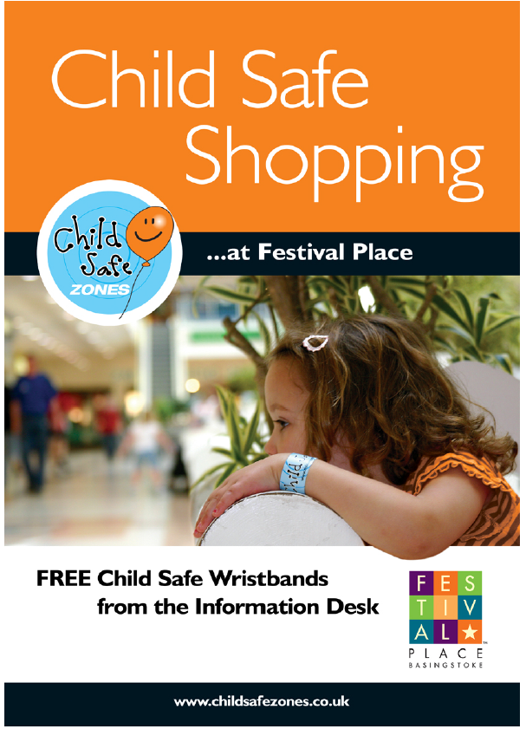
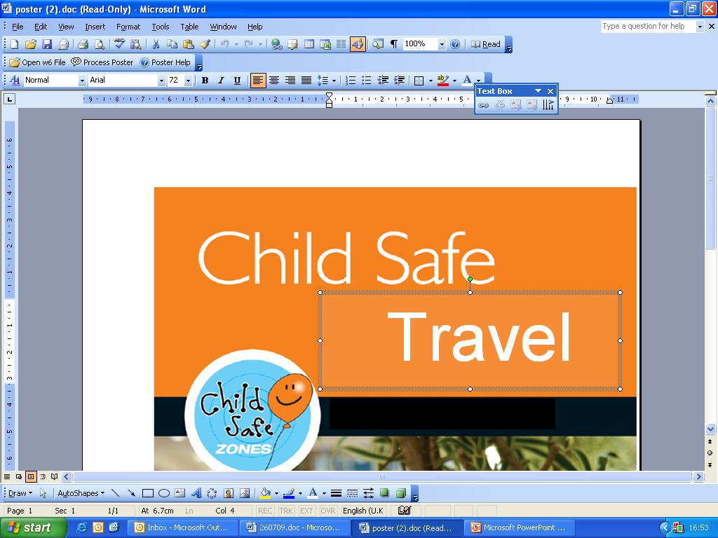
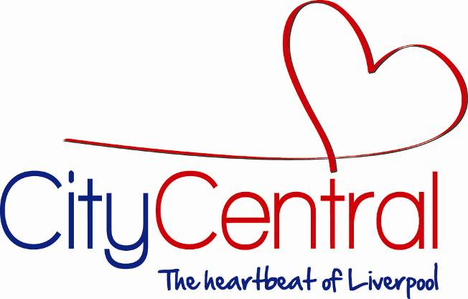
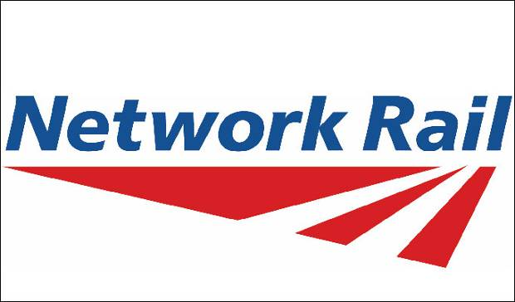
Travelling
….at Liverpool Lime Street
FREE Child Safe Wristbands
From the Network Rail Station Reception, Platform 1.
Liverpool Lime Street Station working in association with the Liverpool City Central Business Improvement District - The Retail and Leisure Heart of Liverpool City Centre.

