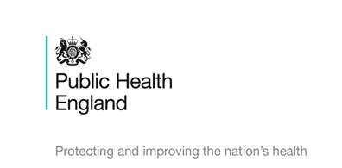

**Encouraging uptake of the MMR vaccine – toolkit for UK festivals**

Public Health England is asking for your help to encourage festival goers to make sure they’re up to date with their measles, mumps and rubella (MMR) jabs - so they can relax and enjoy their festival experience knowing they aren’t at risk of catching measles.

There has recently been an increase in measles cases across England, particularly in young people over the age of 15 years. There are also several large measles outbreaks across Europe.

Measles is a highly infectious viral illness that can sometimes lead to serious complications. It can be more severe in teenagers and adults than in children.

Mass gathering events like festivals can be hot spots for measles as they present the perfect opportunity for the infection to spread.

In 2016 there were 52 measles cases linked to music and arts festivals in England and Wales. Nearly half of these cases were in young people aged 15 to 19 years and several individuals who acquired measles at one festival subsequently attended another festival while infectious, resulting in multiple linked outbreaks.

Two doses of the MMR vaccine offer the best protection against measles. **We know that people aged 15-25 years may have missed out on the MMR vaccine when they were younger.** It is important that they check if they are up to date with their GP practice and make an appointment to get caught up before attending festivals.

To help protect young people attending festivals this summer, we need your help to spread the word about the MMR vaccine:

**How can you help?**

* Put information about measles and MMR on your website for people to read
* Include information in e-mails for people who have bought a ticket
* Use your social media channels to spread the word using PHE’s imagery and key messages
* Have posters and measles information available at the festivals

**Key messages**

* Measles is currently circulating in England and Europe, particularly among people over the age of 15
* Measles is very infectious, can cause serious complications and, in rare cases, can be fatal
* Measles can be more severe in young people and adults, and in some case can lead to hospital admissions
* The best way to protect yourself against measles is to get two doses of the MMR vaccine. It is never too late to get the vaccine
* Young people are strongly advised to check if they are up to date with their Measles, Mumps and Rubella (MMR) vaccine – you need two doses to be protected
* Although they’re great fun, festivals can be hotspots for measles – anyone who has not had two doses of the MMR vaccine is at risk
* Measles starts with cold-like symptoms and sore red eyes followed by a high temperature and a red-brown blotchy rash. If you experience these symptoms, call NHS 111
* It’s never too late to get your MMR vaccine – call your GP practice to catch-up
* If you haven’t had two doses of the MMR vaccine, book an appointment with your GP practice to catch up

**Social media activity**

Follow PHE social media accounts for updates:

* Twitter - @PHE_UK - Use #StopTheSpread and #MMR hashtags
* Facebook - <https://www.facebook.com/PublicHealthEngland/>
* Instagram - @publichealthengland

Template social media posts:

* #StopTheSpread of measles. Ensure you have two doses of #MMR vaccine from your GP practice to be protected <http://bit.ly/2GSBBH4>
* Serious about music? Get serious about measles. Make sure you have two doses of #MMR vaccine to stay healthy and #StopTheSpread <http://bit.ly/2HfSuyI>
* Measles is circulating in England, particularly among young adults. Stay healthy: make sure you have had two doses of #MMR vaccine, contact your GP practice if you’re not sure <http://bit.ly/2GSBBH4>
* It is never too late to have the #MMR vaccine to protect yourself against measles. If you haven't received two doses – or you’re not sure – talk to your GP practice <http://bit.ly/2HfSuyI> #StopTheSpread
* Make sure you’re festival ready and are up to date with #MMR vaccine– phone up your GP practice to check if you’ve had two doses #StopTheSpread
* Partying at a #festival this #summer? Don’t forget to get your #MMR jabs before you go. #StopTheSpread
* Pants, phone charger, sleeping bag, jabs… don’t forget to get the #MMR vaccine before hitting the main stage at #festivals this #summer. #StopTheSpread
* Check with your GP that you’ve had your #MMR vaccine before going to a #festival this #summer. #StopTheSpread
* Swap numbers not measles this #summer. Get the #MMR vaccine before you go to a #festival. #StopTheSpread
* Pass on good vibes not measles. If you’re feeling under the weather don’t travel to #festivals. Get your #MMR jabs before you go. #StopTheSpread

**Useful resources**

We have a range of free resources that you can use to get the message out to festival goers:

Leaflets and posters

* <https://www.gov.uk/government/publications/mmr-for-all-general-leaflet>
* <https://www.gov.uk/government/publications/think-measles-patient-leaflet-for-young-people>
* <https://www.gov.uk/government/publications/think-measles-poster-for-young-people>

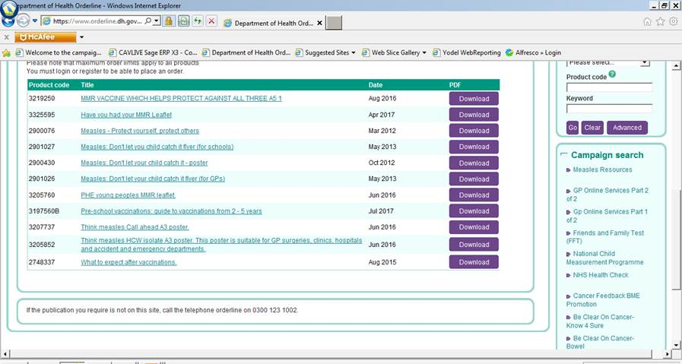To order these resources in hard copy register at the DH orderline (link overleaf)<https://www.orderline.dh.gov.uk/ecom_dh/public/saleproducts.jsf>

Registration only takes a few minutes , go to campaign search on the right of the screen (see arrow on screen shot above) and select Measles resources and then select the posters and leaflets you require and they will be dispatched free of charge to your location. or you can call 0300 123 1002

**MMR and measles social media banners**

* <https://publichealthengland-immunisati.box.com/s/rhrtl6io3fuimougtpe6zt2xj3ue8jdg>

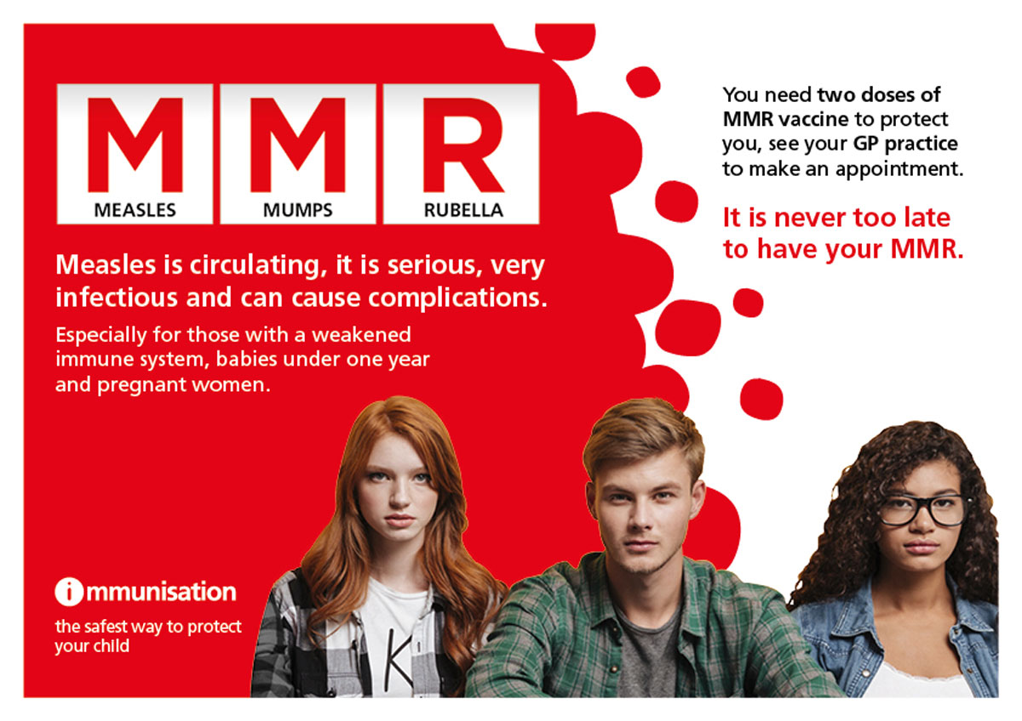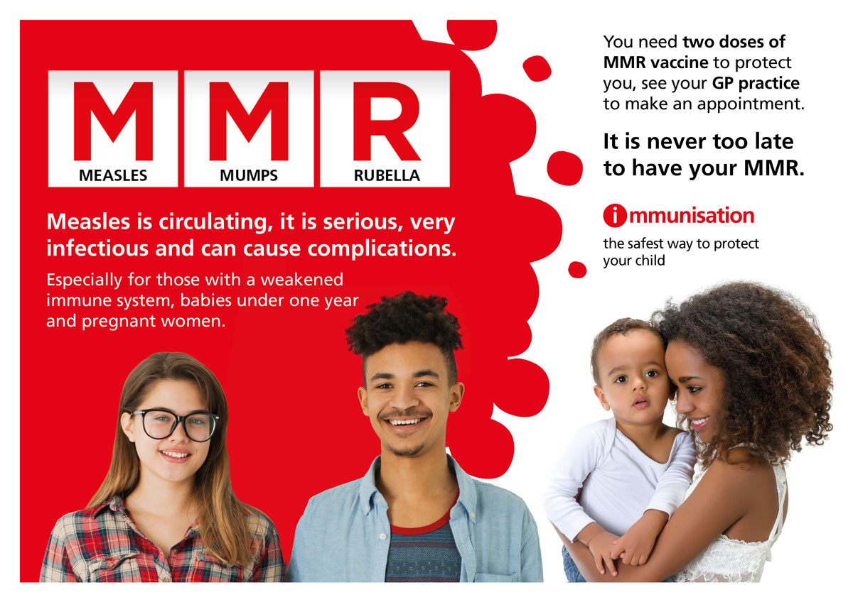`

**Measles adverts**

* <https://publichealthengland-immunisati.box.com/s/ryqnctn7vk7c5xqgsgkhlmrce0r4rtiy>

**World Health Organisation Measles gif**

* <https://publichealthengland-immunisati.box.com/s/mgppw733nelj3s4mtk8n13tsauznl691>

**Public Health England blog**

* You may find [PHE’s blog](https://publichealthmatters.blog.gov.uk/2016/04/27/5-avoidable-health-threats-every-student-should-know-about/) on ‘Why we still see measles outbreaks in the UK’ useful, please feel free to link to:

<https://publichealthmatters.blog.gov.uk/2018/01/22/measles-has-been-eliminated-in-the-uk-so-why-do-we-still-see-cases-and-outbreaks/>

**Useful links**

* MMR advice and information is available on the [NHS Choices website](https://www.nhs.uk/conditions/vaccinations/mmr-vaccine/) - <https://www.nhs.uk/conditions/vaccinations/mmr-vaccine/>

If you have further questions, please contact on [phe-pressoffice@phe.gov.uk](mailto:phe-pressoffice@phe.gov.uk) or 020 8327 7901