A Report on Consultations with Students, Teachers and Principals
on Free Period Products in Schools

Central Policy Unit
Department of Education and Youth

July 2026

Sandra Roe Research

Table of contents

Executive Summary……………………………………………………………………………………………………………………………3
Section 1: Introduction………………………………………………………………………………………………………………………4
Section 2: Provision of period products in schools consulted……………………………………………………………..8
Section 3: Consultation Key themes…………………………………………………………………………………………………12
Section 4: Key messages for policy makers……………………………………………………………………………………….24

Appendix A: Questions for teachers/school staff………………………………………………………………………………28
Appendix B: Methodology for Students……………………………………………………………………………………………29

Executive Summary
The Department of Education and Youth is planning the rollout of free period products in schools as part of the 2025 Programme for Government. This report details the findings of consultations with students, teachers and principals on the key issues related to free period products in schools.

A total of 47 students aged 12 – 19 years were consulted in five schools as well as four teachers and two principals. Schools consulted included one DEIS primary school, three DEIS Plus post-primary schools and a Gaelscoil. The key methodologies used were focus groups and Open Space method with students and qualitative interviews with teachers and principals.

All schools consulted were providing free period products on an informal basis. One teacher or SNA was usually in charge of the products. Period products were located in bathrooms, classrooms and communal areas. Products were financed by schools, period product companies, or in some cases, by individual teachers. The main barriers and challenges were embarrassment asking for products, students not knowing they were available and a small number of students messing with products.

The key themes identified in consultations included the importance of providing free period products due to the high cost of products, the necessity of period products for all girls, the unpredictability of periods and period poverty. Period poverty was highlighted as a particularly important issue for students in DEIS and DEIS Plus schools.

Students would like a variety of sanitary pads and tampons to be available in schools as well as other products such as period pants. The quality of products is very important as poorer quality products were perceived not to be as effective. Students would like period products to be located in bathrooms and suggested using dispensing machines with tokens. Information about free period products is also important to make sure students are aware they are available and where they are located in schools.

Students discussed the impact of periods on their education in terms of missing school and called for more supports in schools e.g., changes of clothes, heat pads and medication. They also called for more education for students and teachers on periods, period products and period related medical issues.
Section 1: Introduction
Background information
The Department of Education and Youth is tasked with planning the rollout of the Programme for Government commitment on free period products in schools. The 2025 Programme for Government makes the following commitment under ‘Ensuring our education system works for all’:

- “Provide free period products in schools to ensure no student is held back due to period poverty”.

To support this Government commitment, the Office of Government Procurement (OGP) has added period products to its framework for cleaning and bathroom supplies. These products consist of menstrual hygiene items such as sanitary pads, tampons, menstrual cups and period pants. Some schools already provide school-funded free products to their students.

Funding for free period products was sought but not received in Budget 2026, however it is planned to provide free products to a limited number of DEIS schools in the school year 2026/2027 under the DEIS strategy which was announced by the Minister for Education and Youth in March 2026

This free provision will be treated as a pilot to gather learning, strengthen the evidence base and contribute to the development of guidance for all schools thereafter. Any provision of free period products to all schools in subsequent years will be budget dependent. Engaging with stakeholders will ensure representation from schools that have experience of providing period products in a school setting already, as well as those that do not.

Consultation’s aim
The aim of these consultations was to capture the learning and issues that will need to be addressed in the future in relation to the provision of free period products in schools. The process also aimed to ensure that the student voice was included.

About the consultations
A total of five consultations with 47 children and young people aged 12 – 19 years were conducted in May and June 2026. Consultations took place in five schools based in Dublin, Carlow, Cork and Kildare. Four teachers and two principals in the schools were also consulted as part of the consultation process. The consultations were conducted by an independent researcher with experience in consulting with children and young people and were attended and supported by staff from the Central Policy Unit.

Demographic information
As can be seen from table 1 below, there were seven students consulted from a primary DEIS school, 29 students from post-primary DEIS Plus schools and 11 students from a Gaelscoil. Two students with Special Education Needs were consulted as part of one of the focus groups.

Table 1: Number of students and school type
School Type | Number of students
Primary DEIS | 7
Post-Primary DEIS Plus | 9
Post-Primary DEIS Plus | 10
Post-Primary DEIS Plus | 10
Gaelscoil | 11
Total | 47

Age
In terms of the age of the students consulted in the five schools, 14.9% were aged 12 years, 8.5% aged 13 years, 6.4% aged 14 years, 4.3% aged 15 years, 17% aged 16 years, 29.8% aged 17 years, 17% aged 18 years and 2.1% aged 19 years.
Table 2: Age of students by number and percentage
Age of students | No. | %
12 | 7 | 14.9%
13 | 4 | 8.5%
14 | 3 | 6.4%
15 | 2 | 4.3%
16 | 8 | 17%
17 | 14 | 29.8%
18 | 8 | 17%
19 | 1 | 2.1%
Total | 47 | 100%

Methodology
Qualitative interviews were conducted with teachers and principals (see Appendix A for questions). The key methodologies used with students were focus group discussions and Open Space methodology (see Appendix B for full methodology). Open Space method allows children and young people to identify and categorise their own topics or themes on an issue. In the consultations, children and young people were asked the following questions:
- Why is it important to have free period products in schools?
- What period products would you like to be available in schools?
- Where should period products be located in schools?

Children and young people were given a number of post-its. They were asked to write their ideas, one on each post-it, and stick them on the wall. A group of children/young people were asked to volunteer to gather the post-its together in themes and give each theme a name. These themes were then used as discussion points in the consultations. See example of post-it notes from consultations below.
Open Space Method
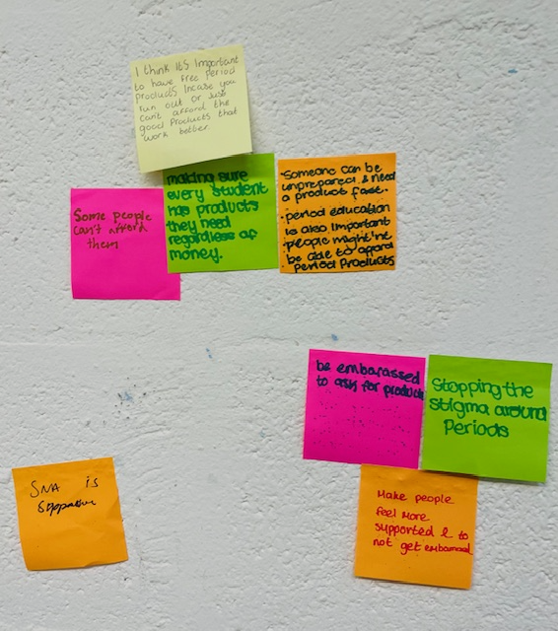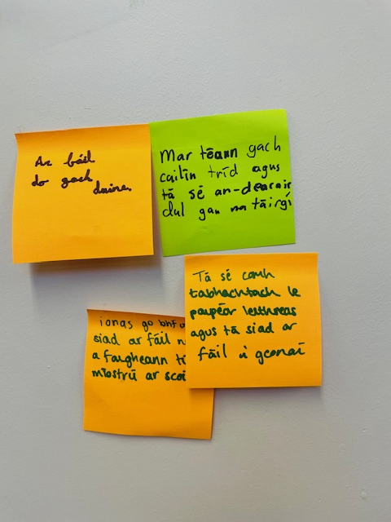
Data analysis
Notes were taken at all the consultations with students, teachers and principals. All notes and other materials from the consultations e.g., post-it notes from the Open Space method, were recorded and data was coded, categorised and analysed thematically. A fair representation of the data collected was assured through strategies such as content analysis to measure the frequency of emerging themes.

Consent/assent
Informed consent was sought from parents and guardians and assent from children and young people prior to participating in the consultations. Children and young people were also given information about the study verbally prior to the consultation e.g., in terms of assent, voluntary participation, anonymity and given the opportunity to ask questions.

Child safeguarding
The researcher was subject to Garda vetting by the Department of Education and Youth prior to the consultations. Information about child safeguarding and mandatory reporting of child safeguarding concerns was given to children and young people before taking part.

Study limitations
It should be noted that this is a small-scale study of five schools in relation to their experiences, learning and recommendations on providing free period products in schools.

Section 2: Provision of period products in schools consulted
Introduction
This section provides a brief overview of the provision of period products in the schools consulted, for example where they are located and stored, who is in charge of products, how they are financed and barriers and challenges. All the schools involved in the consultations were providing free period products on an informal basis.

Location and storage of period products in schools
Some schools had baskets or boxes with period products in bathrooms, base classrooms and communal areas such as ‘chill out rooms and libraries. Other schools had free period products available in the principal’s, secretary’s or Home School Liaison teacher’s offices. In many schools, there was a particular teacher or Special Needs Assistant (SNA) who had taken responsibility for period products e.g., storing them in their office, making sure there were enough supplies etc. In these cases, students felt this worked well as they knew where to access products and what teacher or SNA to approach. However, in some instances students felt the location of products in teachers’ or secretarys’ offices was a barrier to accessing the products due to embarrassment, particularly for younger students.

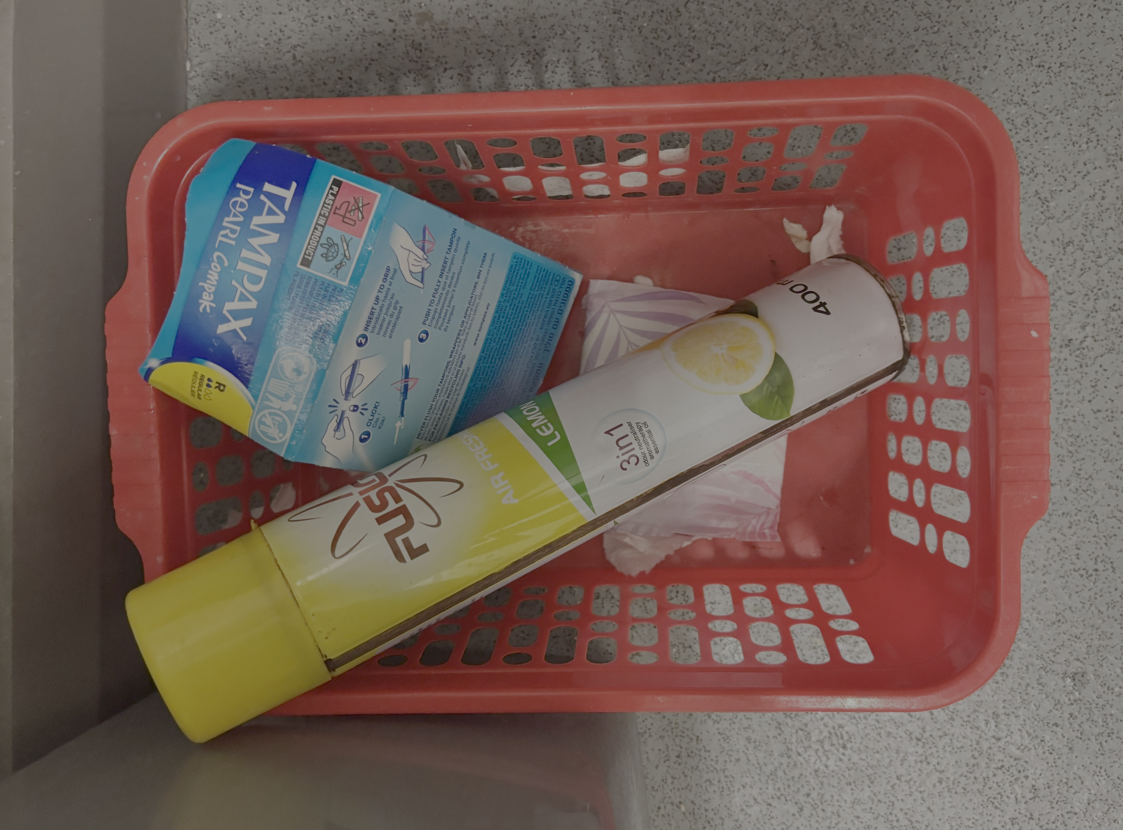

- “There are period products in a basket up on the windowsill in the bathrooms. There are leaflets about periods as well in the baskets.” [Student]
- “There are sanitary products in the teacher’s bathroom and we are allowed to use it if we need them.” [Student]
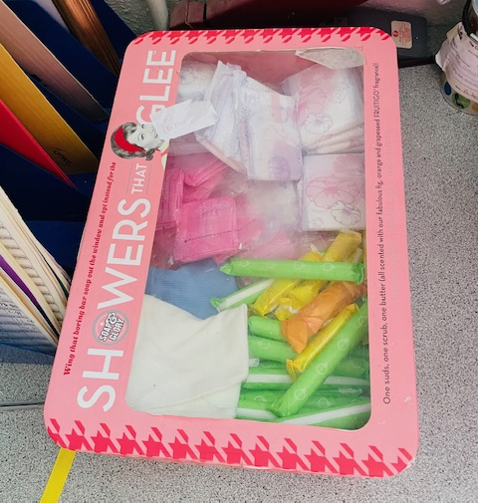

- “It’s important products are accessible especially for people in younger years who might be embarrassed to ask for products.” [Student]

- “There should be one female teacher in the school in charge of period products that you know you can go to if you need anything.” [Student]

- “We have an SNA that looks after the period products in our school. She leads on it and I’m very happy for her to do that.” [Principal]

How periods products are financed
The provision of period products was financed in different ways in different schools. In some schools, they were paying for period products out of their own or class budgets. In other schools, teachers accessed free period products from companies who manufacture them e.g., free period packs, or from charities/sponsorship. In some schools, teachers were buying period products for students out of their own money.

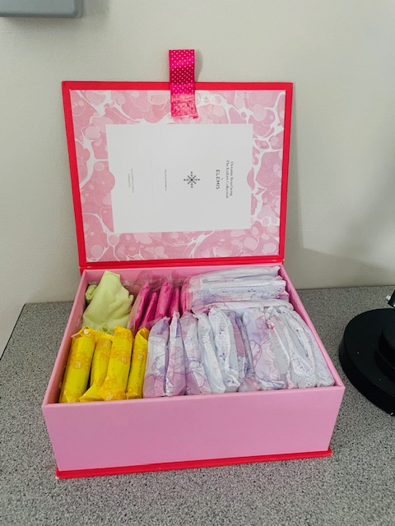
- “Class teachers have a budget and they buy period products out of that budget. So, there are period products in 4th class up to 6th class in the bathrooms and we have a bathroom upstairs that has period products too.” [Principal]

- “The teacher buys the sanitary products out of the class fund. So, it’s taking out of our class budget if they buy the products. Like sometimes we use the money for a surprise school trip. One year we didn’t have to get the sanitary products and we got two surprise school trips which was so much fun.” [Student]

- “I sign up to schemes with period product companies and get sent some period products every year. I get around 120 intro packs from a company each year. They have schemes to introduce first years to products but I use them to give out to all students who need them.” [Teacher]

- “We have had sponsorship before in the school to provide period products in the school.” [Teacher]

- “I would often put the pads in the trolley when I’m doing my own shopping.” [Teacher]

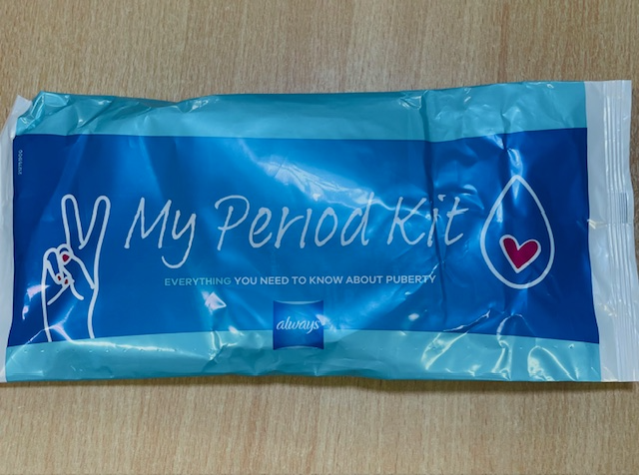

Challenges related to providing period products
One of the challenges identified by students and teachers was a small number of students messing with period products, particularly in bathrooms. In one post-primary school free period products had been removed from bathrooms due to students messing with them. In a primary school where there were gender neutral bathrooms, students described boys messing with sanitary pads, putting red paint on them and sticking them on the walls. Students suggested there should be better education for boys in schools on periods.

- “The boys were messing with the sanitary products on the bathrooms. They stuck them on the walls and they even put red paint on the pads. It was very annoying. The teacher took it very seriously though and talked to the boys about it and even spoke to their parents so it stopped then.” [Student]

Section 3: Consultation Key themes
Introduction
This section outlines the key themes to emerge from consultations with students, teachers and principals.

The importance of providing free period products in schools
Overall, students felt strongly that providing free period products in schools was very important. One student described having free period products in schools as “a basic human right”. Students felt period products should be provided for free, similar to toilet paper. The main reasons students gave for the importance of free period products in schools was the high cost of period products, period poverty, all girls having periods and needing products and having irregular and unpredictable periods.

- “It’s our basic human right to have free period products.” [Student]

- “Everyone needs sanitary products so they should be free.” [Student]

- “Sometimes your period starts at a random time and you don’t have period products with you in school.” [Student]

Teachers also thought the introduction of free period products in schools was a very good idea and was particularly important in terms of addressing period poverty in DEIS and DEIS Plus schools.

- “It’s important that period products are government funded because they are needed by some students.” [Teacher]

- “I think it’s a fantastic idea. I have a few girls that I know can’t afford periods products.” [Teacher]

- “I think it’s brilliant. There is so much we don’t know about because of period poverty. If a parent hasn’t sorted out period products for you it’s an issue.” [Teacher]

Cost of period products
All students consulted agreed that period products were very expensive, with the price increasing in recent years. Students also felt better quality periods products cost more.

- “They’re (period products) too expensive for young girls to afford.” [Student]

- “The price of period products has increased a lot recently, especially if you want good quality products. You won’t get good period products for less than €6 now.” [Student]

Period poverty
A number of students highlighted the issue of period poverty. As products are so expensive, students felt not all girls and their families would be able to afford them due to financial reasons. One student spoke about a friend who was currently experiencing homelessness not being able to afford period products. Another student said if there were free period products in her school she could give them to her family members and friends that can’t afford them.

- “Not everyone has enough money at home to buy period products.” [Student]

- “My friend is homeless at the moment and I’m not sure she would be able to afford period products.” [Student]

- “I think it’s important to have free period products in case you run out or just can’t afford the good products that work better.” [Student]

- “You could give them (period products) to your mum and friends.” [Student]
Teachers and principals also highlighted the issue of period poverty. Teachers and principals from DEIS and DEIS Plus schools discussed wider issues related to poverty, including homelessness and food poverty. One teacher described distributing weekly food hampers to families from their school and including period products and other hygiene products in the hampers. The teacher stated that some families experiencing poverty view period products “as a luxury” they cannot afford. Some teachers talked about the shame and stigma associated with period poverty for students. One teacher described how students experiencing period poverty had to use socks as an alternative to period products as they couldn’t afford them.

- “There is definitely period poverty in our school. We have a high level of need. We don’t have enough resources. Some students can’t access period products. I sometimes have to give money to parents to pay the gas metre and food hampers. Period products are the last thing looked for, it’s a luxury. There is such embarrassment about it.” [Teacher]

- “We are a DEIS Plus school and we give out ten weekly food hampers to families in the schools. I would often include period products and hygiene packs for girls and their parents.” [Teacher]

- “There can be a lot of shame attached to girls not being able to afford period products. Its linked to poverty and homelessness. It might be a choice between food and period products for some parents and it’s a difficult choice to make.” [Teacher]

- “In one family, the girls were using socks as sanitary pads because they couldn’t afford to buy period products. I know one girl whose parent told them they don’t need period products which is very difficult.” [Teacher]

Types of period products
All of the students consulted said they would like different types of period products to be available in schools. Students would primarily like sanitary pads and tampons (both with and without applicators) to be available. Some students also felt other period products such as period pants and menstrual cups should be available as alternatives to pads and tampons. It was suggested that there should be a variety of different types and sizes of period products available to suit students with different lighter or heavier periods. While tampons were not available in some schools consulted (due to concerns about Toxic Shock Syndrome), students felt strongly that tampons should be provided as part of any government funded scheme. The main reasons were that many students regularly use tampons, not all students use sanitary pads, some students find sanitary pads unhygienic and tampons are more convenient for students who play sport, swim etc. Some younger students felt it was important to have tampons available in schools are they might be too embarrassed to ask their parents to buy them. There appeared to be a lack of awareness of Toxic Shock Syndrome among some students.

- “I think there should be pads, tampons and period pants.” [Student]

- “It’s important to have a variety of types and sizes of products.” [Student]

- “I think there should be an option to have tampons available in the school. Our SNA has some if you need them like when you are going swimming. Some girls might be scared to ask their parents can they use tampons so it’s good they are available if you need them.”

Teachers also discussed the provision of tampons in schools. The majority of teachers said tampons were not provided in their school due to the risk of Toxic Shock Syndrome, however it was suggested that it could also be a “Catholic overhang”. Some teachers thought tampons should be made available in schools while other teachers thought they shouldn’t be available as they thought some students in very disadvantaged schools may not use or change tampons correctly due to period poverty.

- “I think tampons should be available in schools. It’s an old school white Catholic thing to not give girls tampons in schools. Some girls say they can’t use pads for different reasons.” [Teacher]

- “As the Home School Liaison teacher, girls come to you, as I have a stash of pads in my office. We don’t give out tampons, maybe it’s a Catholic overhang or to do with Toxic Shock Syndrome. I actually support not giving out tampons as out school is very disadvantaged and some students might not use them properly or change them as often as they should because they can’t afford period products.” [Teacher]
Quality of period products
Students consulted felt it was important to provide good quality period products in schools. Some students talked about finding cheaper products less effective and comfortable, for example sanitary pads leaking and not sticking properly. Other students also said they used a higher quantity of poorer quality products as they don’t work as well. A number of students highlighted the use of chemicals in some period products which they thought was harmful and suggested providing chemical free period products. Overall, students suggested providing branded and good quality period products in schools.

- “Some period products aren’t good quality and the cheaper brands; they can leak and don’t stick properly.” [Student]

- “Some period products are full of chemicals so it would be good if there were good quality organic products available in schools.” [Student]

Location of period products in schools
The majority of students felt period products should be located in bathrooms for ease of access. Some students spoke about being embarrassed about bringing period products from their classroom to the bathroom and felt locating them in the bathroom would help. Some students thought locating period products in base classrooms or communal areas was also a good idea but suggested they should be stored discreetly. They thought period products would be less likely to be disrespected if they were located in base classes.

- “Put them in the bathroom and in certain classrooms, not out in the open.” [Student]

- “Locate products in the bathroom and a classroom etc.” [Student]

Storage of period products
Students agreed that the storage of period products in schools was very important. Many students suggested having a dispenser in bathrooms for period products instead of baskets. Students though a dispenser would work better than having baskets which sometimes have been messed with by a small number of students. Having a token system for dispensers of period products was also suggested. However, the convenience of this was debated. Other suggestions included putting period products up on a high shelf or having a cupboard in bathrooms with period products.

- “I think there should be a press in the bathroom that you can open and get the products.” [Student]

- “I think a dispenser with a token system would work well. You could give the girls tokens and you get it back each time, but you can open it without the token so the boys won’t be messing with it.” [Student]

Supply of period products
Students highlighted the importance of ensuring there is constant supply of period products in schools. This includes during the school year as well as during summer programmes. Some students spoke about period products not being checked or changed often enough. This meant they got dusty and some students stopping using them as a result. It was suggested that cleaning staff might take on the role of checking and replenishing period products similar to toilet paper. Students also discussed the need to ensure there are enough sanitary bins in toilets and that they are emptied on a regular basis.

- “Our teacher doesn’t change the products that often and they get dusty, so people have stopped using them.” [Student]

Information about free period products
Students felt it was important to tell all students about the availability of free period products in schools. For example, making announcements, having talks and putting up posters in bathrooms and other parts of the school to inform students about the availability of free period products and where they are located. One school had posters in their bathrooms to let students know where period products were located. However, examples were given in a number of schools where students were unaware period products were available or where they were located.

- “We have a very open approach to periods and period products in the school. We talk to the girl and the boys about the products being available if they need them.” [Principal]

Impact of periods on education
The impact of periods on student’s education was highlighted in the consultations. Many students talked about missing time in school due to period pain, having to go home to change clothes and get medication. Some students also felt that having free period products available in schools would help reduce their discomfort and stress related to periods which would help them focus more on schoolwork and other activities like sport. Teachers agreed that that periods can have a negative impact on student’s education.

- “It would reduce stress and discomfort. If girls are worried about the cost or availability, they aren’t focused on school or sport.” [Student]

- “The bigger picture is that some girls need to go home when they have their periods due to pain and periods interrupt education.” [Teacher]

Female health issues
Female health issues related to periods were discussed in some of the focus groups. A number of students said they had heavy and painful periods, had been diagnosed with endometriosis and were on medication to address symptoms. Overall, students felt there wasn’t enough information provided in schools on periods, what a normal period looks like and awareness around conditions such as endometriosis.

- “I get very painful periods because I have endometritis. I’m on medication for it now.” [Student]
Education on periods
Students said they would like more education related to periods and female health issues on the education curriculum starting in primary school. For example, more factual information about what is a normal period, information on Toxic Shock Syndrome and awareness of related health issues such as endometriosis. It was hoped that more education on periods in schools would help to both educate and normalise conversations on periods. Students said they got most of their information about periods and period products online rather than in school or from their parents. The issue of misinformation online was also raised and it was suggested that better education in schools would help counteract this.

- “Period education is also important.” [Student]

Teachers agreed there should be more education on periods and related health issues in schools to increase awareness and reduce stigma and shame. An example of given of an SPHE teacher in one of the post-primary schools who provides extensive education on periods and period products.

- “There should be a bigger education piece about periods because there is stigma and shame among some students.” [Teacher]

- “There is a need for awareness talk and education on endometriosis for students.” [Teacher]

- “In our school we have a SPHE teacher who is very open about periods. She reviews period products like period pants and Mooncups for the students. She talks to the students about the history of menstruation and is very progressive. She talks to students about the different colour period blood etc.” [Teacher]

- “I encourage girls to try products like menstruation cups. I tell girls about all period products, like I stick sanitary pads on the whiteboard to show them. I am very open with the girls. It’s very important to talk about periods. It’s changed a lot in the last 20 years. You could barely use the word period but now it is more normalised. I do a little game with them about periods, like what is normal and what isn’t.” [Teacher]
Teacher’s understanding and support in relation to periods
Students felt teacher’s understanding and support in relation to periods varied. Overall, students thought female teachers were generally more understanding, supportive and empathetic than male teachers in relation to periods, however there were some exceptions.

- “It depends on the teacher how understanding they are. I feel the female teachers get it more and are more understanding.” [Student]

- “The teachers are quite understanding, but it depends on the teacher. Male teachers less likely to be sympathetic. Apart from the one male guidance counsellor.” [Student]

- “My SNA is supportive if I have my period.” [Student]

- “Our SNA has ‘emergency chocolate’ if you have your period!” [Student]

Teachers agreed that students usually feel more comfortable talking to female rather than male teachers. Teachers also mentioned that girls from the Traveller community might not feel comfortable talking to male teachers about certain issues including periods.

- “Their year head could be a male teacher and the girls might not feel confident asking for products. Traveller girls can feel uncomfortable too talking to male teachers about issues such as their period.” [Teacher]

Peer supports
One school consulted discussed having a peer support system called a ‘Period Pal’ system. This involves older students supporting younger students in relation to accessing period products e.g., an older student that younger students can approach to get period products.

- “We have a Period Pal system in our school, like a person you can go to get products and not feel uncomfortable. This works well particularly for younger students.” [Teacher]
Other period supports
Students discussed other period supports they would like to be available in schools. These included changes of clothes/spare uniforms, heat pads and medication. While a number of the schools had changes of clothes or uniforms available, none of the schools provided heat pads or medication. Students thought it was important for schools to be allowed to administer medication such as paracetamol to students who are experiencing pain due to period cramps. Some students suggested having a consent form signed by parents/guardians at the beginning of the year to allow schools to administer medication. The provision of a school nurse to support students experiencing period pain was also discussed in some focus groups.

- “I think there should be heat packs for girls in school if they have their period. The ones you crack and then they heat up.” [Student]

- “The SNA has spare pants and shorts if you need them. We can bring in spare clothes and leave them with her if you want as well. I just bring spare clothes in my bag.” [Student]

- “They aren’t allowed to give out medicine in school. I think at the start of the year there should be a slip your parents fill in and then the school can give you paracetamol if you need it for your period.” [Student]

Some teachers agreed schools should be allowed to give out medication for period pain in schools.

- “We should be able to give out paracetamol to girls. It breaks my heart to see them in pain with their period. Legally we can’t give them out.” [Teacher]

- “We should be able to provide students with medication to ensure girls grow up and aren’t embarrassed about periods.” [Teacher]

Other hygiene products
A number of students suggested the provision of other hygiene products in bathrooms in schools, for example deodorant, wipes and hand sanitiser. Some teachers also highlighted the need for hygiene products for some students with a Home School Liaison Teachers providing hygiene products in hampers on home visits.

- “I think the bathrooms should have other products like spray deodorant, wipes and hand sanitiser.” [Student]

Student’s attitudes towards periods
While most students were happy to discuss periods and period products in the focus groups, some students felt there is still embarrassment around the issue e.g., hiding period products up their sleeves when going to the bathroom or not wanting to tell teachers if they have an issue related to their period. Students also frequently suggested that period products should be placed in discreet locations in schools so they could access them without people knowing. It was suggested that having period products available in all schools would help to reduce stigma related to periods.

- “Having products readily available will take away stigma surrounding periods.” [Student]

Teachers consulted also felt there was an embarrassment around periods for some students, particularly younger students.

- “There is a lot of embarrassment among younger girls about periods.” [Teacher]

Gender issue
Some students felt girls not being provided with free period products was a gender issue and felt it was unfair that girls have to pay for period products. Some students argued that if boys had periods they wouldn’t have to pay for period products and they would be better supported in schools.
- “If boys had periods they’d (period products) be everywhere.” [Student]

- “Boys don’t have to pay for period products but girls do and that’s very unfair.” [Student]

- “If boys got periods there’d be a special hosptial to deal with them.” [Student]

Transgender students and period products
The issue of availability of period products for transgender students was raised in some consultations. It was suggested that period products should be located in bathrooms accessible to transgender students.

- “There should be period products available in toilets for transgender young people as well.” [Student]

- We have gender neutral bathrooms in the school. We had a transgender student a few years ago.” [Principal]

Administration of free period products in schools
Finally, one principal raised the issue of the administration of free period products in schools. He called for as little administration as possible to be linked to any scheme to roll out free period products in schools.

- “From a principal’s perspective, what would work best would be if there was a no tendering approach and there was little or no paperwork involved in purchasing the period products. Projects like the school meals programme have so much paperwork attached to them it’s a big burden on principal’s who are already overrun.” [Principal]

Section 4: Key messages for policy makers

Introduction
This section of the report identifies key messages for policy makers based on consultations with students, teachers and principals about free period products in schools.

Importance of free period products in schools
- The introduction of free period products in schools is very important due to the high cost of products, the necessity of period products for all girls, the unpredictability of periods and period poverty.
- The provision of free period products is particularly important in DEIS and DEIS Plus schools where many students experience period poverty.

Types of period products
- Sanitary pads and tampons (with and without applicators) are the main types of period products students would like to be available in schools.
- A wide variety of types of pads and tampons should be available to suit students with lighter and heavier periods.
- Other period products such as period pants and menstruation cups should also be available.

Quality of period products
- Students would like good quality period products to be available in schools as they are more effective than cheaper products.
- Students would like period products that are chemical free if possible.

Location of products
- Period products should be ideally located in bathrooms in schools.
- Period products could also be located in base classrooms or communal areas in schools where students can access them.

Storage of period products
- The storage of period products is important to ensure they are accessible to students and not easily messed with.
- Students suggested the use of a dispenser in bathrooms to store period products and a possible token system.

Supply of period products
- Ensuring students in schools have a constant supply of period products is important.
- Cleaning staff could take on the role of checking and replenishing period products in bathrooms similar to toilet paper.

Information about free period products
- It is important that students are provided with information about free period products in their school e.g., information talks, posters in bathrooms.

Teacher’s role
- One teacher/SNA in a school should have responsibility for overseeing the provision of free period products in schools.

Impact of periods on education
- Periods have an impact on student’s education in terms of missing school due to period pain, having to go home to change clothes, access medication etc.
- Providing free period products in schools would help reduce stress for students related to periods.
Other period supports
- Other period supports should be available in schools e.g., changes of clothes, heat pads and medication.
- Schools should consider changing medication policies in schools to support students experiencing period pain e.g., consent forms from parents/guardians.

Education on periods
- There should be more education in the school curriculum on periods, period products and period related health issues such as Toxic Shock Syndrome and endometriosis, starting in primary school.
- Teachers should be educated on periods, period products and period related health issues to support students.

Transgender students
- Period products should be accessible to transgender students who need them e.g., in gender neutral bathrooms.

Administration of free period products scheme
- The scheme to introduce free period products should have as little administration for schools as possible.

Appendix A: Questions for teachers/school staff

- What supports are currently available for students in your school in relation to periods/period products?
- What works well about having free period products in your school?
- What doesn’t work well about having free period products in your school?
- Are there any challenges related to having period products available in your school?
- How have these challenges been overcome?
- What types of period products are currently available in your school?
- Are there any other types of period products you would like to make available in your school?
- Where are period products located in your school?
- Does the location of period products work well?
- Is there anything you would change about the location of the period products?
- If your school supplies free period products, how much of a demand is there?
- How are period products currently funded in your school?
- Are there any other supports in relation to periods/period products that are/should be available in schools e.g., underwear, spare school uniforms, pain relief, heat packs, a place to lie down?
- How should information about period products/supports be shared with students in schools?
- Is there a particular teacher/school staff member that students can get support from in relation to periods/period products?
- How important is it to have free period products available in your school?
- Do you think period poverty is an issue for students in your school?
- Do you think period poverty is an issue for the families of students in your school?
- Do you have any other recommendations on period supports/period products in schools?

Appendix B: Methodology for Students

Introduction
Explain the aim of the consultation on period products in schools:
- The government are looking at providing free period products in schools. This is to make sure all students have access to period products. The Department of Education and Youth have been asked to help plan how this will happen. It is important to hear from students about what works well about having free period products, what are the challenges and why it is important.

Ice-breaker exercise:
- For example, students say their first name and what their favourite hobby is.

Introductory questions:
- Are free period products available in your school?
- If yes, can you tell me a bit about it?
- If no, do you think they should be available? Why?

Open space method
- Students are given a number of post-it notes and asked to write down their views in relation to a question (depending on whether period products are available in their school or not):

- ‘What works well about having free period products in your school? (If free period products are available in their school)
- ‘If your school made free periods products available, what should it look like?’ e.g. types of products, location of products, sharing information about products etc.? (If free period products are not available in their school)

- Students stick the post-its on the wall.
- Students are asked to group the post-its into common themes.
- Students come back together as a group and the key themes are discussed.
- Students are given a number of post-its and asked to write down ideas in relation to the question:
- ‘Why is it important to have free period products in schools?’
- Students stick the post-its on the wall.
- Students are asked to group the post-its into common themes.
- Students come back together as a group and the key themes are discussed.

Focus group discussion
A focus group discussion will take place with students with any questions which haven’t been already covered e.g.:
- If free period products are available in your school, is there anything that doesn’t work well about it?
- If free period products are available in your school, is there anything you would change about it e.g., types of products, number of products, location of products?
- Are there any other supports you would like in your school in terms of periods/period products e.g., underwear, spare uniforms, pain relief, heat packs, a place to lie down?
- How should information about free period products be shared with students?
- Is there a teacher in your school you can talk to if you need support around periods/period products?
- Is there anything else you would like the Department of Education and Youth to know about support for periods/period products in schools?

