

**PRgloo Handy Help Statement Guide**

Contents

New Statement Section 3

Adding a Statement 4

When adding a conversation can I still convert a note into statement? 5

When adding a conversation will I be able to see the Statement and background notes? 5

What if a statement in a topic has been update with a different statement? 6

## New Statement Section

We have now separated the Topics and Statements page. So you are now able to see a list view of all your statements. You will still be able to find your statements in the Topic section as before. In fact, the only thing we have changed in the Topic section is the name.

As before you can add a statement using the green button on the dashboard, in a Topic timeline, and now in the new statement section.

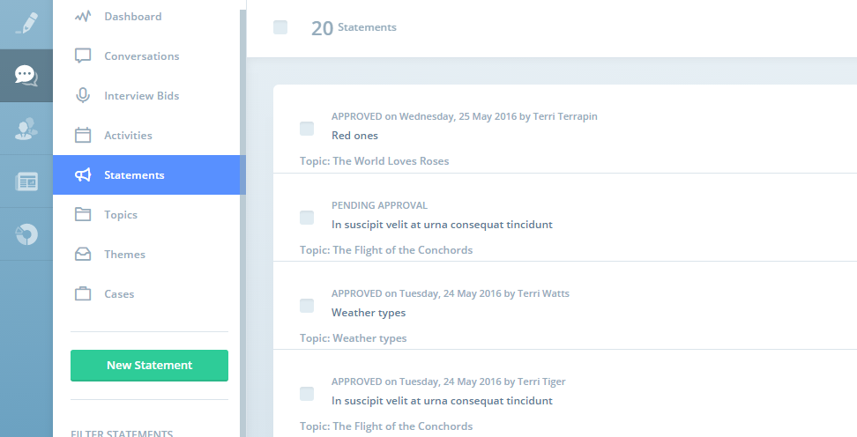

## Adding a Statement

The layout has changed slightly, but we hope it’s sticking to our intuitive feel of PRgloo.

* Fill out the date as before, it auto-fills to the date and time you are creating the Statement.
* Status can be mark as Approved, Pending Approval and Draft.
  + Only the Approved statements will show on the Dashboard and when adding a conversation to a topic.
  + When selecting Approved an ‘Approved by’ box will appear which you must fill in. A ‘Approved date and time’ will also appear, which you can edit if needed.
* Statement Title, if this is left blank the it will assume the Topic name it is associated to.
* Topic, simply start typing and select from the dropdown list that appears as you type OR create a new Topic by typing in the name you wish the Topic to have (when you hit save the new topic will be created).
* 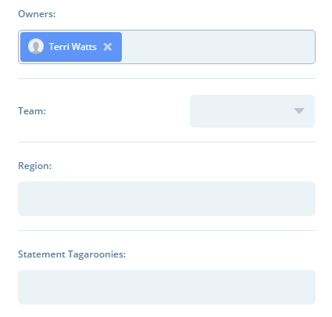The next is back ground notes, this is useful to help colleagues to understand why the statement was created or just information to go with the statement that should not be quoted.
* Owner defaults to the person adding the statement but this can be changed or another added by simply clicking on the box and selecting from the dropdown list.
* Team, again this defaults to your team but can be changed.
* Under the Team are the tag options (if you have already have tags group associated to statements). Just click on the tag box and select from the dropdown list. (If you wish to add a tag group to the statements then please refer to the main manual).
* Then on the right hand side you can add the statement. This can either be just typed in or copied and pasted in.
* Hit Save Statement!

## When adding a conversation can I still convert a note into statement?

**Yes!** However, you won’t get the statement template, so once you hit save, the system will auto fill some of the mandatory requirements:

* Only Approved statements can be added this way and your name will default as the person that authorised the statement.
* The name of the statement will default to the topic name that the conversation is associated to.
* Owner and Team are also defaulted to the person adding the statement.

This means you will be able to change/add any other details at a later date by going in to the Statement section.

## When adding a conversation will I be able to see the Statement and background notes?

Yes! The Statement will appear (as before) in the Note and Attachment area on the right and the background notes will display under the Topic name in red so you know NOT to quote from it!

## What if a statement in a topic has been update with a different statement?

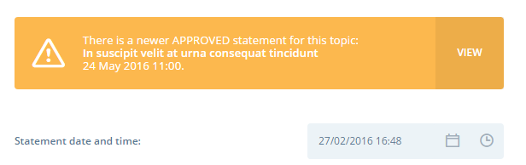We realise that a new statement may be issued for a Topic that supersedes the original. You will still be able to view all the statements in the timeline of the Topic and on the Statement view all list. The newest one added defaults to ‘Latest approved Statement’.

If you click on the any of the statements there will be a big notice at the top of the statement letting you know if this is the latest statement or if not, you can click on the ‘View’ button to take you to the latest statement.