New Train Service on the Falmouth Branch Line

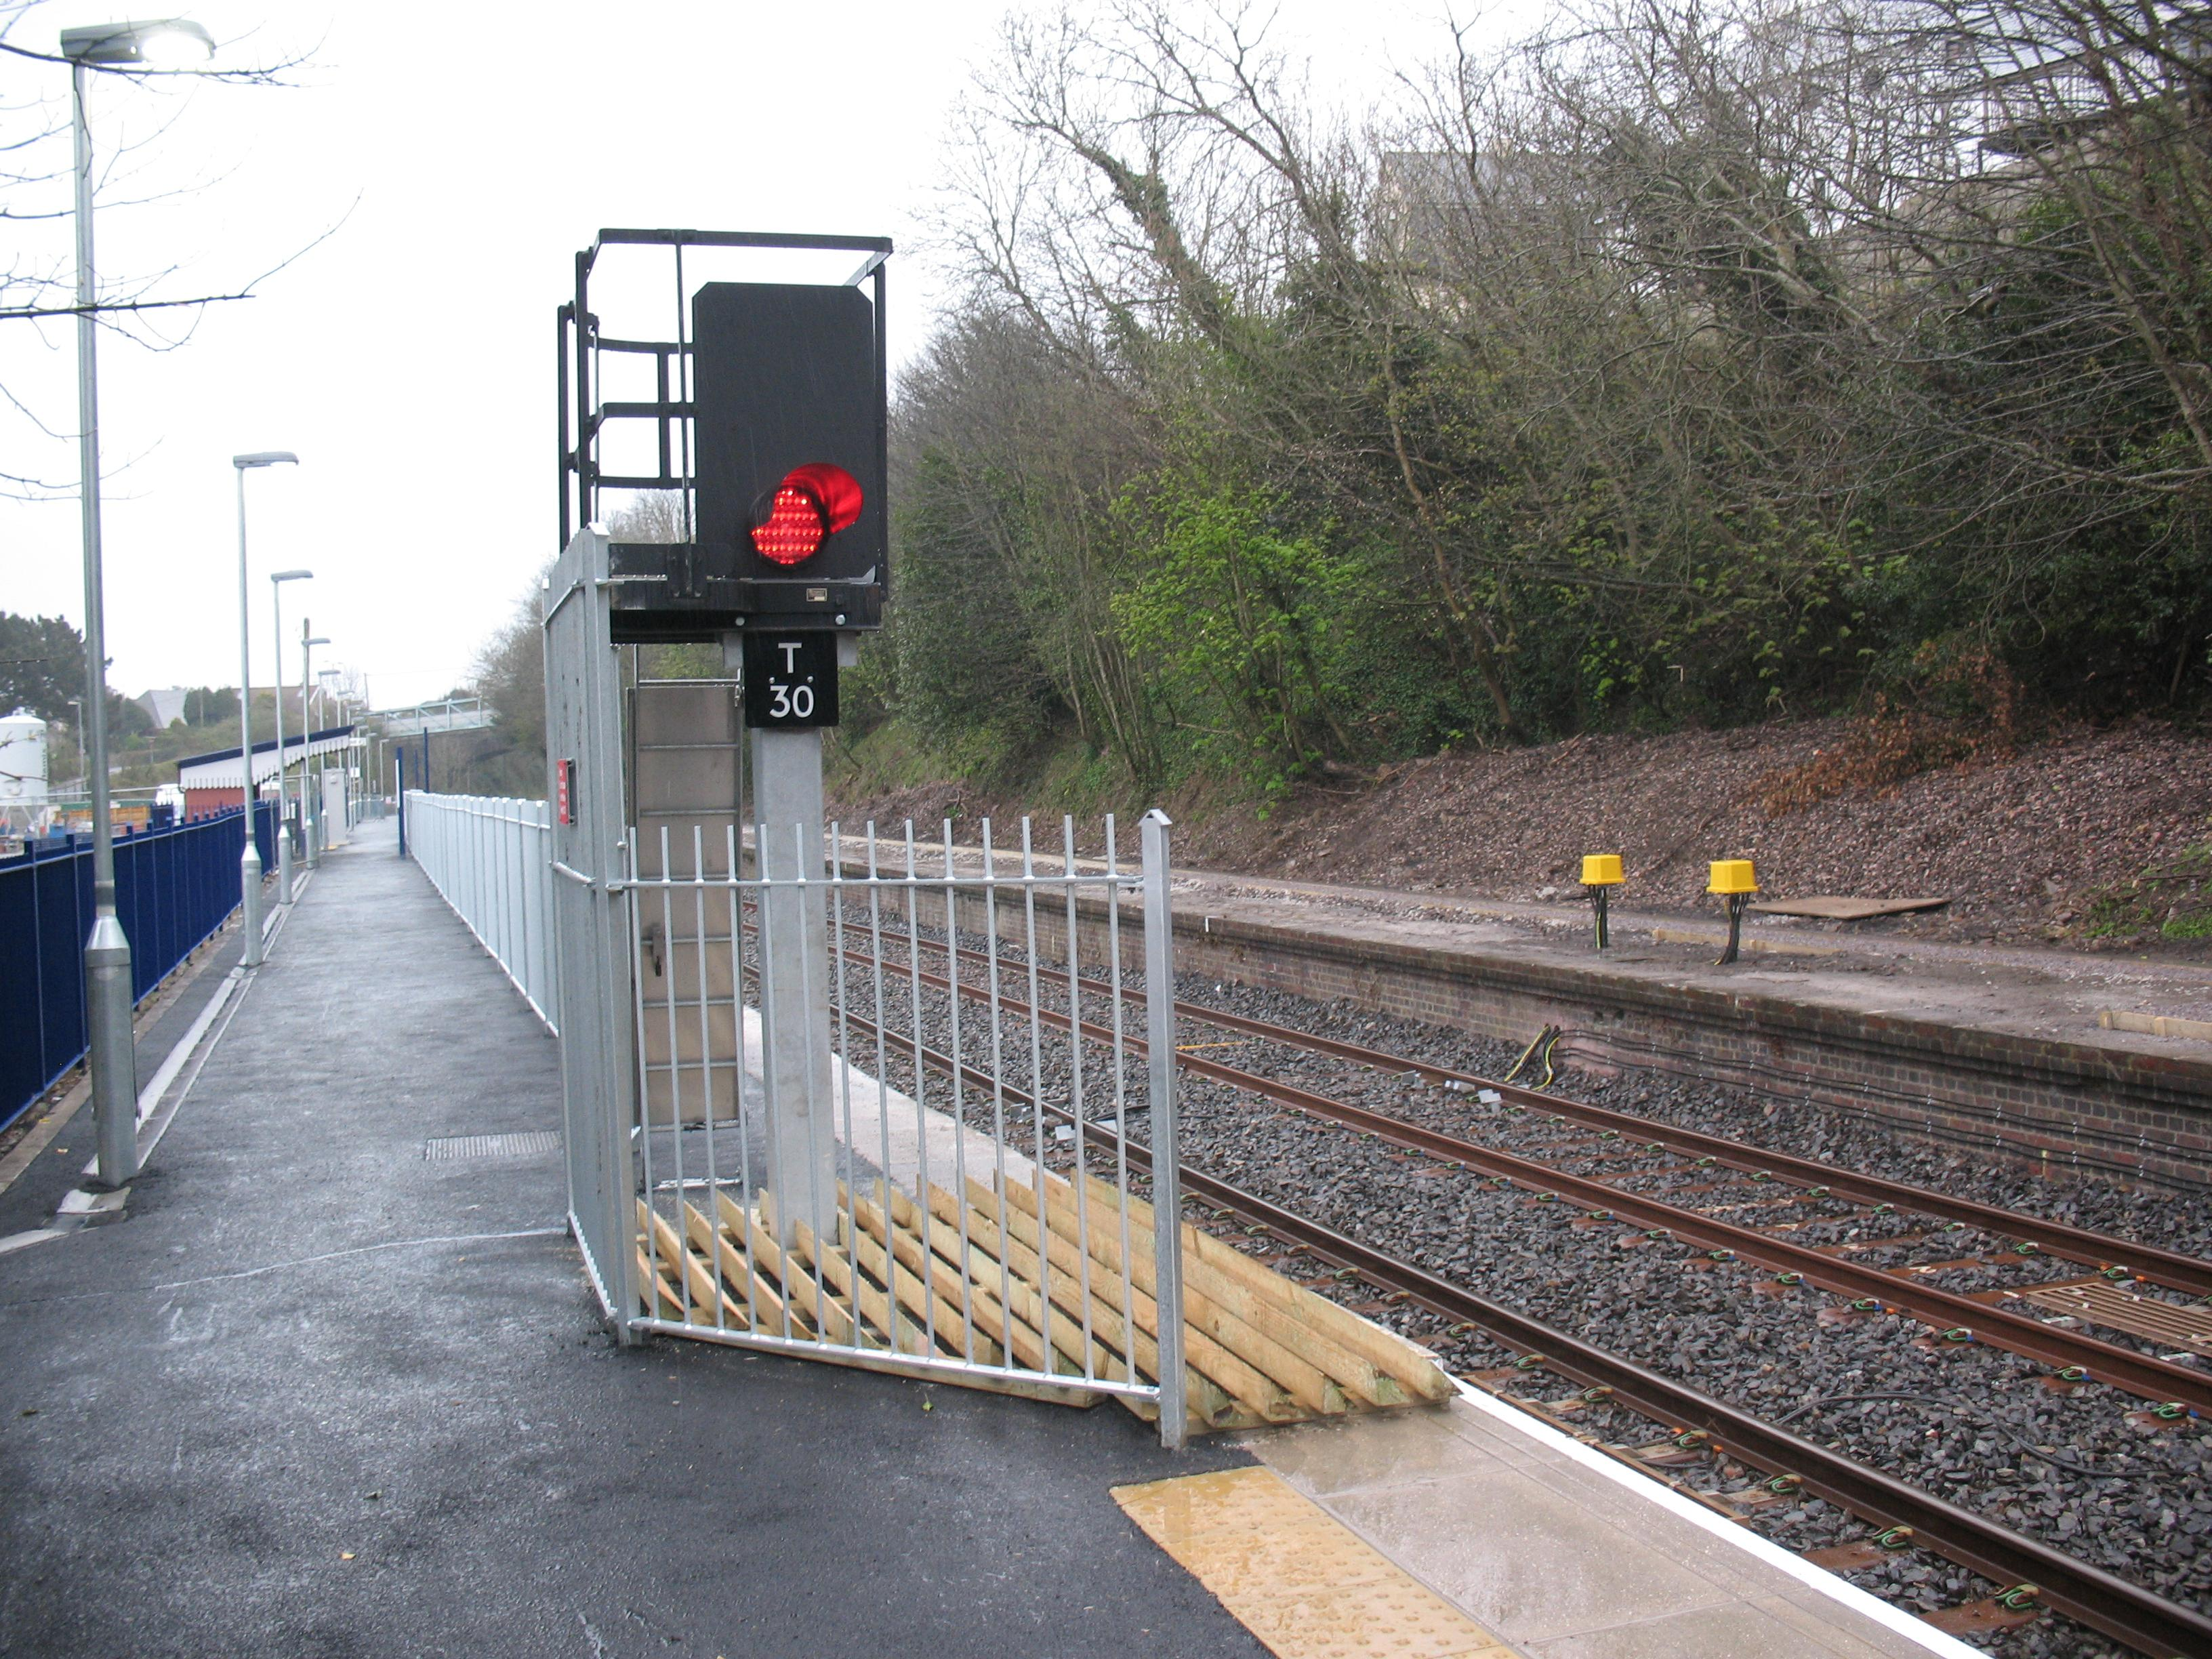

The train line from Truro to Falmouth Docks is being upgraded. The new service will provide trains every half hour on the route calling at Perranwell, Penryn, Penmere and Falmouth Town.

The new service starts on Sunday 17th May 09

The scheme is funded by Cornwall County Council with a grant from the EU and is promoted by the Department of Transport as a way forward on their Community Rail initiative.

A total of £7 million has been invested

The line is approximately 12 miles long and has scheduled running time of 25 minutes.

The work carried out on the line to upgrade the service includes:

- A new section of railway at Penryn
- An upgrade and extension of the existing platform at Penryn station to create a platform for Truro services and a platform for Falmouth services
- A new car park at Penryn station
- Renewal of the signalling and power supplies along the route to allow the enhanced train service

A grand opening for the new service will take place at Penryn station on the 18th May 09

