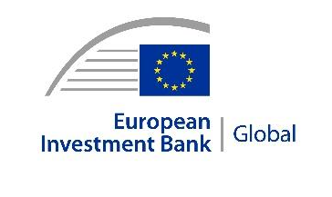 | 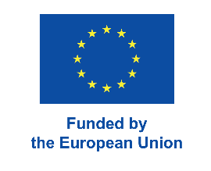 | 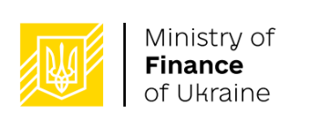 | 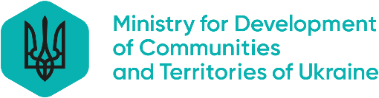 | 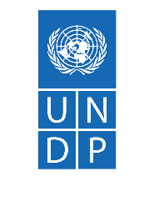
PRESS RELEASE
2025-154-EN
Hostomel, 26 April 2026
Ukrainian primary school in Hostomel reopens with EU support
- A primary school in Hostomel, Kyiv oblast, reopens after EU-financed renovation.
- Primary School No. 1, damaged during Russia’s full-scale invasion, almost doubles capacity to 120 pupils and gets energy-efficiency upgrades, backup power supply and new digital spaces in €613,000 revamp.
- Project financed through EIB’s €340 million “Ukraine Recovery Programme”
A primary school in Hostomel, Kyiv oblast, reopened today following a major European Union-financed renovation necessitated by damage inflicted during Russia’s full-scale invasion of Ukraine. Primary School No. 1 has almost double the capacity as well as energy and digital upgrades as a result of the €613,000 project.
The school is able to serve 120 pupils compared with 67 before the renovation, enabling more local children to avoid the need to study in neighbouring communities. It also has energy-efficiency upgrades, backup power supply and new spaces for digital learning, robotics and arts.
Primary School No. 1 is located in the Kyiv region in a community heavily affected in the early weeks of a war now in its fifth year. The works, which began in January 2025 and were completed this month, included replacing windows and doors, improving insulation and upgrading classrooms. The EU financing came through the European Investment Bank (EIB).
“Reopening this school in Hostomel, a community that experienced the war at its most intense, is a powerful sign of recovery,” said EIB Vice-President Karl Nehammer, who visited the town for the occasion. “It shows how investment in essential infrastructure can restore opportunities for children and support communities.”
The EIB provided €511,000 in financing for the renovation, which also received €102,000 in local funding.
“Restoring schools is a key priority for the Government of Ukraine,” said Deputy Prime Minister for Restoration of Ukraine and Minister for Development of Communities and Territories Oleksii Kuleba. “Our absolute priority is protecting people and the functioning of the communities – sequenced by season and by frontline geography.”
The support from the EIB was through its €340 million “Ukraine Recovery Programme”. The programme is one of three joint EU–EIB recovery initiatives delivered in partnership with the Ministry of Finance of Ukraine, the Ministry for Development of Communities and Territories of Ukraine and local authorities, with technical support from the United Nations Development Programme (UNDP).
Under EIB recovery programmes across the Kyiv region, or oblast, five projects have been completed and 61 are underway, helping to restore essential infrastructure.
“The reopening of the primary school in Hostomel is not just about reconstructing what was there before. It is about creating a safer place where children can learn and grow,” said Henrik Huitfeldt, Acting Head of Cooperation at the EU Delegation to Ukraine. “With EU support, communities across Ukraine are rebuilding essential services and ensuring schools are modern, well-equipped and ready to serve their pupils. This is recovery in action.”
For the local community, the reopening of Primary School No. 1 was a long-awaited moment.
“Since the beginning of the full-scale invasion, Hostomel has gone through immense challenges,” said Head of the Hostomel Settlement Military Administration Serhii Smal. “But today, thanks to the support of reliable partners, children can finally return to their classrooms in safe and dignified conditions.”
“We are rebuilding schools, hospitals and other critical facilities step by step,” said Head of the Kyiv Regional State Administration Mykola Kalashnyk. “It is especially important that schools like this one in Hostomel provide safe and reliable conditions for learning, even during ongoing challenges.”
“Through its partnership with the European Union and the EIB, UNDP is supporting communities in restoring essential infrastructure and improving living conditions,” said Auke Lootsma, UNDP Resident Representative in Ukraine.

Background information
The EIB in Ukraine
Present in Ukraine since 2007, the EIB has stepped up its financial support for the country’s resilience and modernisation since Russia’s full-scale invasion of Ukraine in 2022. Since then, the EIB has provided over €4 billion in financing. Through its EU for Ukraine (EU4U) Initiative, coupled with its key role in implementing a dedicated window under the Ukraine Facility, the EIB is strongly committed to stepping up and accelerating its activities in line with the mandate given by EU leaders and in close cooperation with the European Commission, the European Parliament, Member States and international partners.
EIB recovery programmes in Ukraine
The Hostomel school was renovated under the Ukraine Recovery Programme, one of three recovery initiatives supported by the EIB. As of April 2026, the EIB has provided €740 million through these programmes to support Ukraine’s recovery. The funding helps the government to restore essential services in communities across the country – including schools, kindergartens, hospitals, housing, heating and water systems. These EIB-backed programmes are further supported by €15 million in EU grants to facilitate implementation. The Ministry for Development of Communities and Territories of Ukraine, in cooperation with the Ministry of Finance, coordinates and oversees programme implementation, while local authorities and self-government entities are responsible for managing recovery sub-projects. The UNDP in Ukraine provides technical assistance to local communities, supporting project implementation and ensuring independent monitoring for transparency and accountability. More information about the programmes is available here.

Press contact

Olga Sushytska, o.sushytska@eib.org, tel.: +352437986063
Website: www.eib.org/press – Press Office: press@eib.org

Yuliia Samus, UNDP Ukraine Head of Communications; e-mail: yuliia.samus@undp.org

