Ansford Bridge

Diversionary Route:

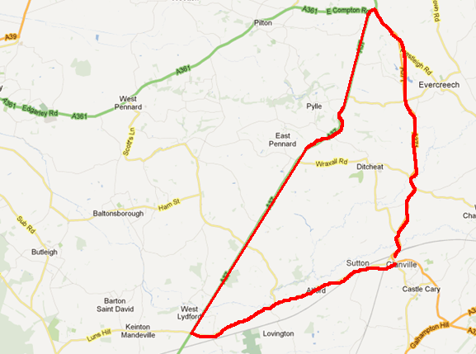

From the western end of the closure proceed in a south westerly direction along the B3153 to the junction with the A37. Turn right and proceed in a north easterly direction along the A37 to the junction with the A371. Turn right and proceed in a southerly direction along the A371 to the eastern end of the closure, and vice versa.

Advisory route for vehicles over 4.5Mts (14’ 9’’) will be signed via A371, A359, A303, A372, B3151 and B3153.

Alternative Route to Station from A371 South

