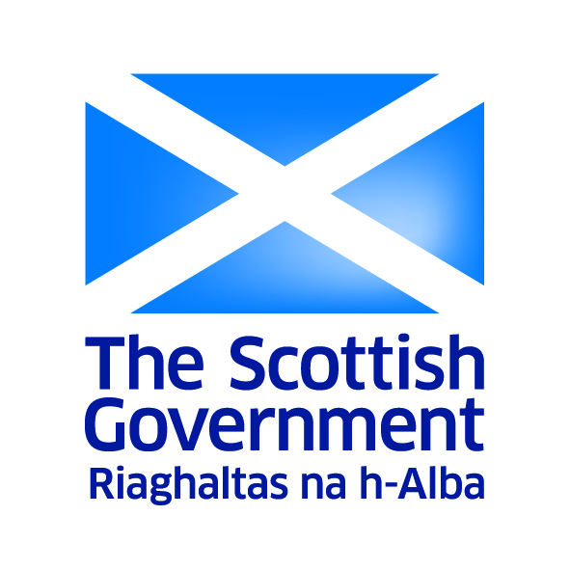
Scottish Income Tax from 2017/18
March 2016
This factsheet provides information on the Scottish Government’s proposals for setting the income tax rates and bands payable by Scottish taxpayers from 2017/18.

From 2017/18, the Scotland Bill will give the Scottish Parliament powers over all revenue raised from non-savings non-dividend income tax paid by Scottish taxpayers.

The Scottish Parliament will set the rates and band thresholds - excluding the personal allowance - for the first time.

The proposals at a glance

By limiting increases in the higher rate threshold to a maximum of inflation more than £1 billion of additional revenues will be generated up to the end of 2021/22 to be invested in public services such as the NHS.

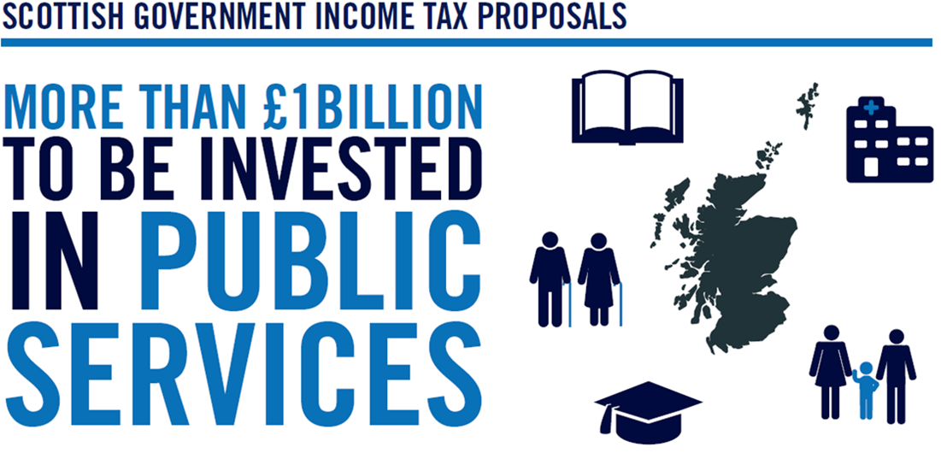

99 per cent of taxpayers in Scotland will pay no more than they do currently.

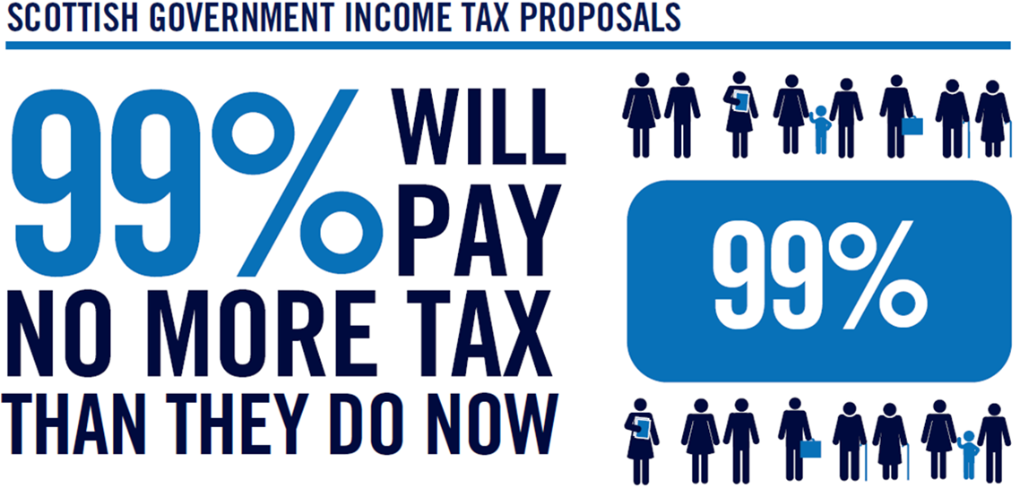

There will be no increase in the basic rate of tax, in a move that will protect 90 per cent of people in Scotland.

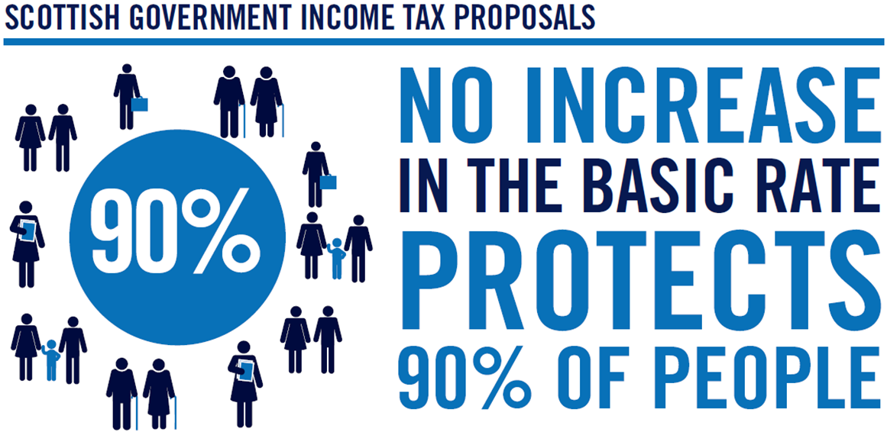

The lowest paid taxpayers will be better off by 2021/22, through a new zero rate band that will take the effective Personal Allowance for Scottish taxpayers from £12,500 to £12,750.

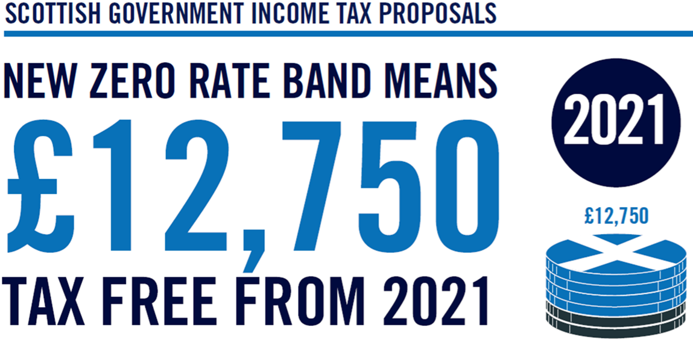
This is not the time to provide significant tax cuts to higher and additional rate taxpayers, so the higher rate threshold will increase by a maximum of inflation.

Proposed income tax band rates and thresholds in 2017/18 compared to 2016/17

 | Basic rate = 20%  Thresholds | Higher Rate = 40% Thresholds | Additional Rate = 45% Thresholds
2016/17 | £11,000 | £43,000 | >£150,000
2017/18 | £11,500 | £43,387 | >£150,000

