Cantwell ready for Flogas Irish Girls’ challenge at Corrstown
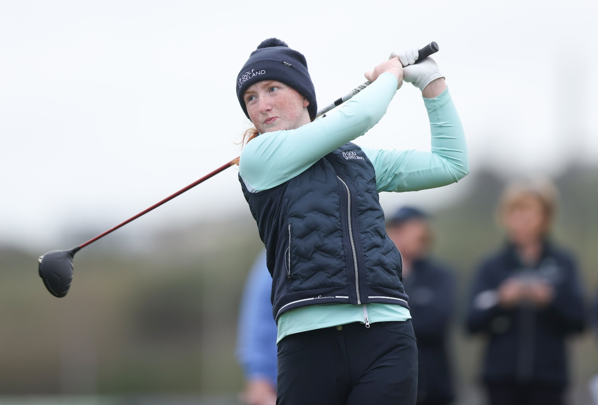
Caption: Ella Cantwell (Esker Hills) will compete at her third Flogas Irish Girls’ Amateur Open Championship this weekend
Photo: Inpho | Tom Maher

BY CAOMH BREEN ALLEN
A busy run of championship appearances culminates in one of the biggest weekends on the underage calendar for Ella Cantwell (Esker Hills), as she prepares to make a hat-trick of appearances at the Flogas Irish Girls’ Amateur Open Championship at Corrstown Golf Club this weekend.
Returning to Corrstown for the second consecutive year, the championship will see 67 of the best young amateur golfers from Ireland and across Europe tee it up over three rounds of stroke play, with players travelling from the UK, France and the Netherlands to compete for the coveted title.
Among the leading Irish contenders, Cantwell has been building a strong run of form over the past year. She has claimed, among her many honours, the Ulster U18 Girls’ Amateur Open Championship and the Ballybunion Scratch Cup while also being a part of a victorious U18 Leinster Interprovincial side. Her performances also saw her claim both the Golf Ireland U18 Order of Merit crown and Women’s Scratch Cup Order of Merit title.
That momentum has continued into 2026. In April alone, the 17-year-old secured a top 20 finish at the Scottish Girls’ Open Championship, followed by a top 10 at the South of Ireland Women’s Amateur Open Championship, before finishing third at the All-Ireland Irish Schools Championship earlier this week.
“At the schools I was definitely a bit tired, I won't lie. Fatigue was kind of hitting a little bit,” said Cantwell.
“I was delighted coming third and it's always a special thing to bring a medal home to your school and the school were pretty proud, so it was nice to see all the teachers saying well done. It's been a good start of the year.”
The Offaly native has seen steady improvement at this event over the past two years, finishing T26 in 2024 and T11 in 2025 and as she prepares for the 2026 edition, she has taken a few key lessons with her that could be vital in unlocking a higher finish this time around.
“Corrstown is a really good golf course, and it really does test every part of your game and that's what all of us want for an Irish girls’ event and it's a really strong field and that's all we want as amateurs, we want to play at the best level as we possibly can” said Cantwell.
“I’m probably more confident in my game now than I was. I know that I can hit the ball a bit further and I've gained a lot more strength over the winter so it's definitely going to play a bit shorter for me this week.”
“Putting in Corrstown is vital, if you make putts you are going to score well. It’s vital in Corrstown to get the pace of the greens quickly and get a few early putts.”
Despite a quick turnaround from her latest outing, Cantwell is keen to stick to the approach that has served her well lately, and she comes in with a clear gameplan in mind for the days ahead.
“I always have a goal going in and this week my goal is just to stick to the fundamentals, stick to the basics, and go back to striking the ball well,” said Cantwell.
“If I strike the ball well and putt well, hopefully I'll score well.”
Cantwell will be one of the early starters on Friday morning as she gets her opening round underway alongside Zara Bolton Scratch Cup winner Kayleigh Mulholland (Moyola Park) and Selina Bartarya (Royal Blackheath) at 8.41am.
Cantwell and Mulholland will also have plenty of familiar faces competing this weekend as fellow Golf Ireland U18 High Performance panellists Grace Dowdall (Forrest Little), Hannah Lee-McNamara (Royal Portrush), Gemma McMeekin (Royal Portrush), Claudia O'Donoghue (Douglas) and Jessica Reynolds (County Sligo) also tee up at the Dublin venue.
The Flogas Irish Girls’ Amateur Open Championship tees off on Friday morning with Lee-McNamara and Olivia Costello (Roscommon) getting proceedings underway at 8.30am.
View the first-round tee times here

ENDS

