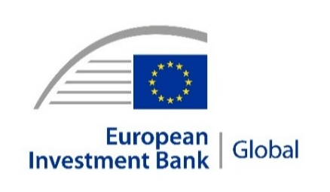 | 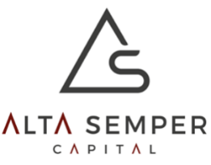 | 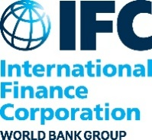 | 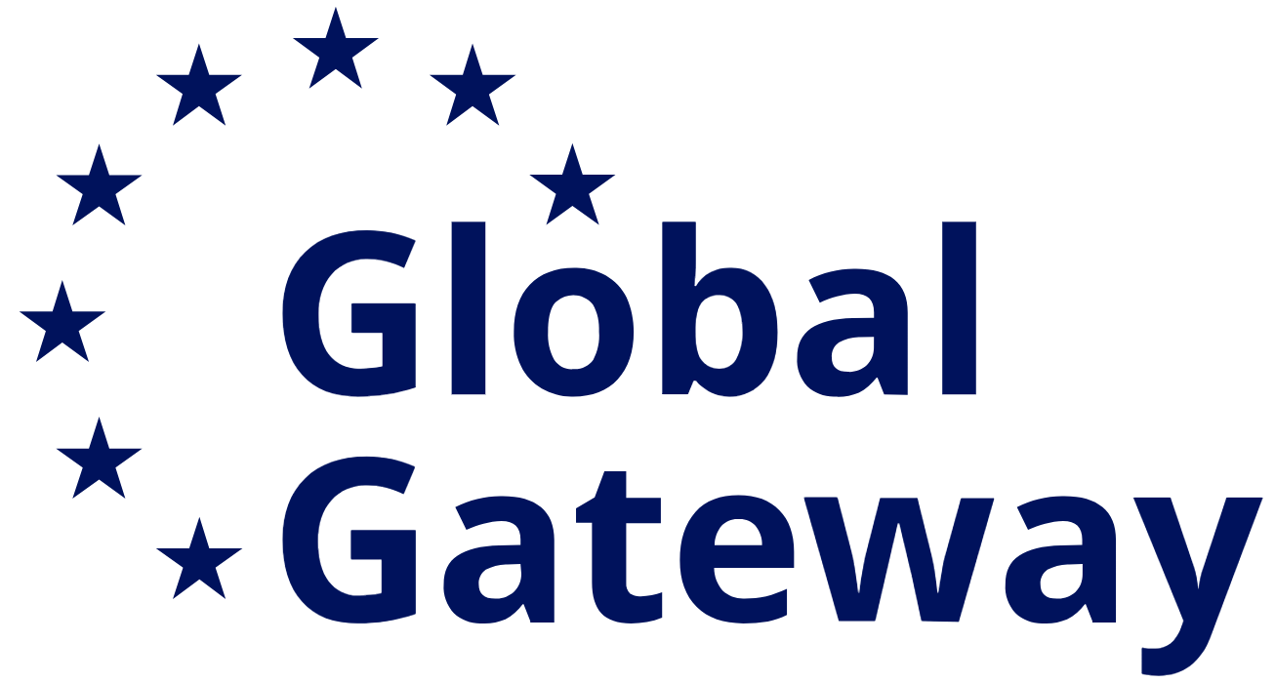
PRESS RELEASE
2026-007-EN
14 January 2026
EIB Global invests $37.5 million in Alta Semper Fund II to boost the growth of pharmaceutical and healthcare companies in Africa
- The EIB commits $37.5 million to Alta Semper Fund II, expected to catalyse up to $150 million for healthcare investments, particularly in North Africa.
- The fund promotes innovation, affordability, and regional cooperation between the European Union and its Southern Neighbourhood in the life sciences, pharmaceutical and MedTech sectors.
- It is expected that at least 30% of portfolio companies will advance gender equality.
The European Investment Bank (EIB), through its development arm – EIB Global, is investing $37.5 million in Alta Semper Fund II to support the growth of pharmaceutical and healthcare companies across Africa, including medical equipment and technologies. Targeting primarily North Africa (around 70%) and, to a lesser extent, sub-Saharan Africa (about 30%), the fund will strengthen innovation and sustainability in the life sciences sector while deepening EU-Africa trade relations.
The signature took place at an event in Cairo attended by Minister of Planning, Economic Development, and International Cooperation of Egypt H.E. Rania Al-Mashat, EIB Vice-President Gelsomina Vigliotti, CEO of Alta Semper Capital Afsane Jetha, and an IFC Division Director for North Africa and the Horn of Africa, Cheick-Oumar Sylla.
Managed by Alta Semper Capital, a female-led private equity firm with a proven track record in healthcare investments, the fund will support local companies in expanding access to affordable and quality products and services, driving inclusive economic growth and human capital development. Many portfolio companies are expected to partner with EU suppliers and MedTech firms to provide regional services, further linking African markets to the European Union’s life sciences value chain.
“With this investment, we reaffirm Europe’s commitment to building resilient healthcare systems and fostering equitable growth across Africa. The fund will empower innovative businesses led by talented entrepreneurs, many of them women, to deliver affordable solutions, strengthen local production, and create quality jobs,” said EIB Vice-President Gelsomina Vigliotti.
“Egypt represents a pivotal platform for international cooperation with development partners through the formulation and implementation of projects that directly benefit citizens, and the mobilization of funding and technical support for both the public sector and the local and foreign private sector. Through the partnership between the EIB and the Alta Semper Fund II work will be done to support the growth of pharmaceutical and healthcare companies in Africa, including medical equipment and technologies, especially in North Africa and sub-Saharan Africa, to promote innovation and sustainability and deepen trade relations between the European Union and Africa,” said Minister of Planning, Economic Development, and International Cooperation of Egypt H.E. Rania Al-Mashat.
"We are delighted to be partnering with the EIB, which marks a significant milestone in our long-term vision to build a resilient, equitable and future-proof healthcare ecosystem across our target markets. The commitment from the EIB will significantly enhance our capacity to deploy capital into new investments, accelerate the growth of our portfolio companies, and deepen our on-the-ground impact, ensuring we continue to meet the continent's rapidly growing demand for quality healthcare and democratise access to health and well-being. Our investment thesis bridges the gaps in healthcare services, facilities and products and we also selectively invest in proven disruptive technologies which accelerate business models and further access and health equity goals,” commented Alta Semper Capital CEO Afsane Jetha.
“Resilient economies start with local solutions,” said Cheick-Oumar Sylla, IFC’s Division Director for North Africa and the Horn of Africa. “By mobilizing private capital alongside development partners including EIB, this investment in Alta Semper Capital supports the growth of local healthcare and consumer businesses in Egypt and across Africa, including those led by women, expanding access to quality care.”
“The Egyptian Micro, Small and Medium Enterprises Development Agency (MSMEDA) is proud that international partners like the European Investment Bank (EIB) and the International Finance Corporation (IFC) are backing Alta Semper Capital Fund II. Their involvement validates the strength of Alta Semper’s strategic focus on Egypt’s healthcare and consumer sectors, which are vital to our national economic resilience.We believe that supporting funds like Alta Semper Fund II will accelerate the growth of medium-sized enterprises, particularly in vital sectors like healthcare and consumer goods, ultimately creating thousands of high-quality job opportunities for Egypt. We are currently finalizing our own investment commitment to the fund, which we expect to conclude within Q1 2026, further empowering high-impact enterprises to scale and innovate," said CEO of MSMEDA Basil Rahmy.
The operation reflects EIB Global’s strategy to mobilise private capital alongside experienced fund managers that can act as catalysts in local markets. The fund benefits from international investor cooperation, alongside the EIB and the International Finance Corporation (IFC) of the World Bank Group, which is already an investor in the fund. In addition, a significant number of private investors are in advanced discussions to join at final closing, underlining the fund’s strong market appeal.
The investment is aligned with the EU Global Health Strategy and the EU-Africa Global Gateway Investment Package, contributing to stronger regional manufacturing capacity, innovation and health security. By embedding gender considerations into its investment approach, the fund will ensure that at least 30% of its portfolio advances gender equality, supporting women-led enterprises and inclusive employment practices.
By crowding in additional European development finance institutions and private investors, the fund is expected to mobilise capital well beyond the EIB’s commitment, delivering a “win-win” partnership that improves health outcomes, boosts private sector growth and reinforces sustainable EU-Southern Neighbourhood cooperation.
Background information
About EIB Global
The European Investment Bank (ElB) is the long-term lending institution of the European Union, owned by its Member States. It finances investments that contribute to EU policy objectives.
EIB Global is the EIB Group’s specialised arm devoted to increasing the impact of international partnerships and development finance, and a key partner of the Global Gateway. It aims to support around €100 billion of investment by the end of 2027. EIB Global brings the EIB Group closer to people, companies and institutions through its offices across the world. Photos of EIB headquarters for media use are available here.
About the EIB Group
The EIB Group, consisting of the European Investment Bank and the European Investment Fund, is the biggest multilateral financial institution in the world and one of the largest providers of finance for climate action. As the bank of the European Union, its shareholders are the EU Member States, and it works in close collaboration with the European Commission. The EIB Group’s policy priorities are financing small and medium firms, innovation, digital and human capital, sustainable cities and regions, and sustainable energy and natural resources. Its work extends beyond Europe to over 160 countries.
About the Global Gateway Investment Agenda
EIB Global is a key partner in the implementation of the European Union’s Global Gateway Investment Agenda, supporting sound projects that improve global and regional connectivity in the digital, climate, transport, health, energy and education sectors. Investing in connectivity is at the very heart of what EIB Global does, building on the Bank’s 65 years of experience in this domain.
About Alta Semper Capital
Alta Semper Capital is a private equity firm focused on investing in healthcare, health-tech and consumer health opportunities across high-growth markets. Key investments include Macro Pharmaceuticals (Egypt’s leading cosmeceutical and generics pharma company), ODM (Morocco’s leading oncology, radiology and diagnostics platform), MYDAWA (Africa’s leading online pharmacy & telemedicine platform) and Allmed Medical (a leading innovator & manufacturer of renal care products, as well as the largest medical device manufacturer focussed on renal care across the Global South).
About IFC
IFC — a member of the World Bank Group — is the largest global development institution focused on the private sector in emerging markets. We work in more than 100 countries, using our capital, expertise, and influence to create markets and opportunities in developing countries. In fiscal year 2025, IFC committed a record $71.7 billion to private companies and financial institutions in developing countries, leveraging private sector solutions and mobilizing private capital to create a world free of poverty on a liveable planet. For more information, visit www.ifc.org.
Press contacts

EIB: Enrico Possenti, e.possenti@eib.org, tel.: +352 4379 82144, mobile: +352 691 28 55 32
Website: www.eib.org/press – Press Office: press@eib.org

Alta Semper Capital: Gulshan Batool info@altasemper.com Website: www.altasemper.com
IFC: Sarah Aly Moussa, Smoussa1@ifc.org tel.: +20 100 102 2872

