A new track material recycling facility would allow us to sort, clean, process and recycle replaced railway lines; allowing us to identify sleepers, rails and fastenings that can be reused in other parts of the network (slower branch lines, yards and sidings) or identify materials for further recycling or disposal. Last year approximately 40,000t of rail was sent to remote processing facilities to be sorted, graded or recycled. Carrying this activity out in the depot will greatly reduce the amount of lorries on the roads.
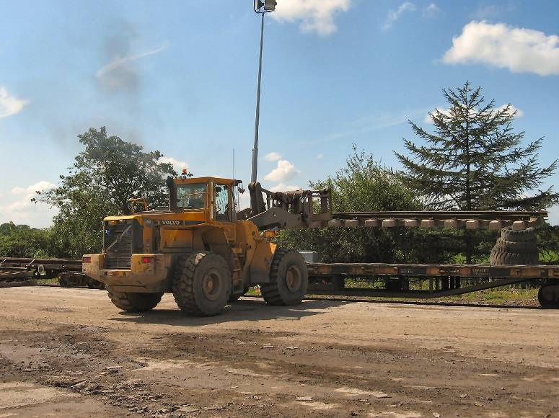
The process:
- Typically track panels arrive in 60 foot lengths and are offloaded from the train and stockpiled for later dismantling.

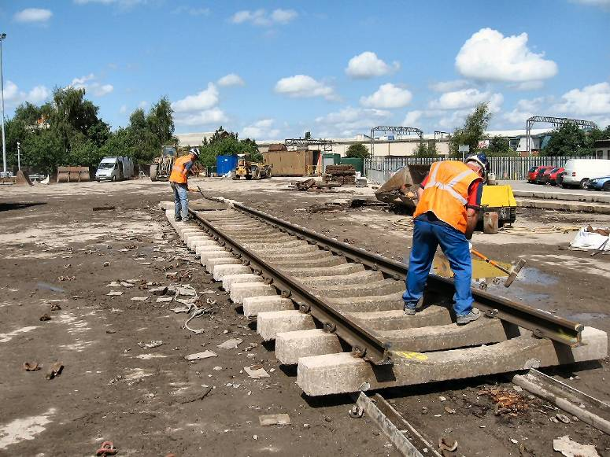
- The clips that hold the rails on are removed.

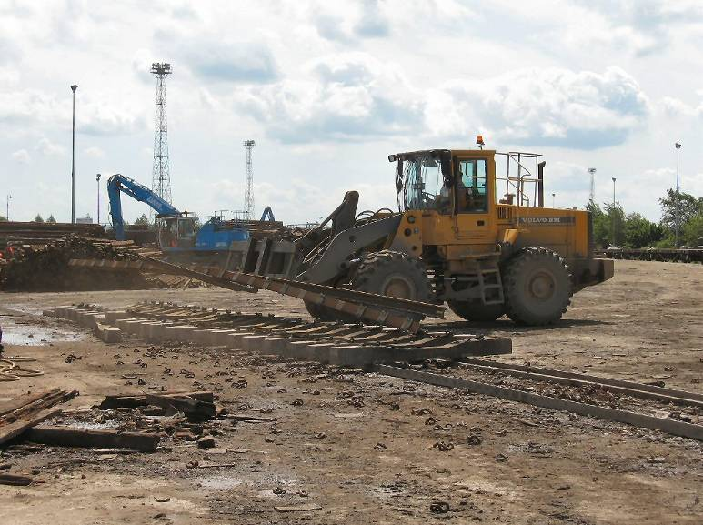

- The rails are then carefully removed.

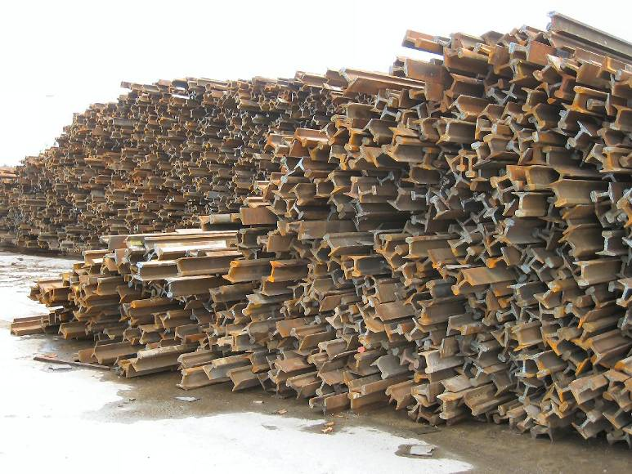
- And stockpiled for later processing.

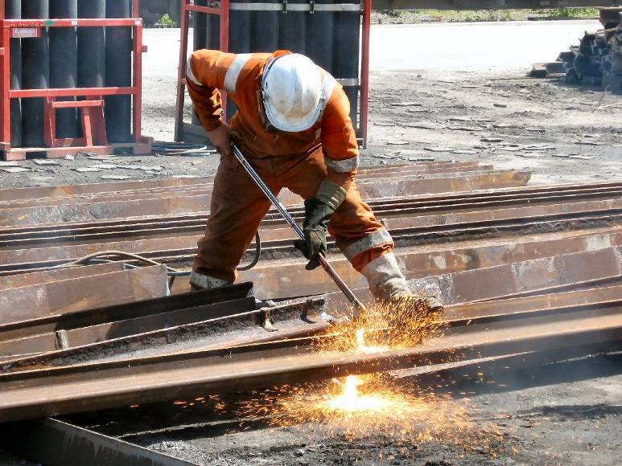
- Serviceable rail is placed to one-side for later re-use but ‘scrap’ rail is cut or burnt into smaller sections for disposal to the recycled steel market.
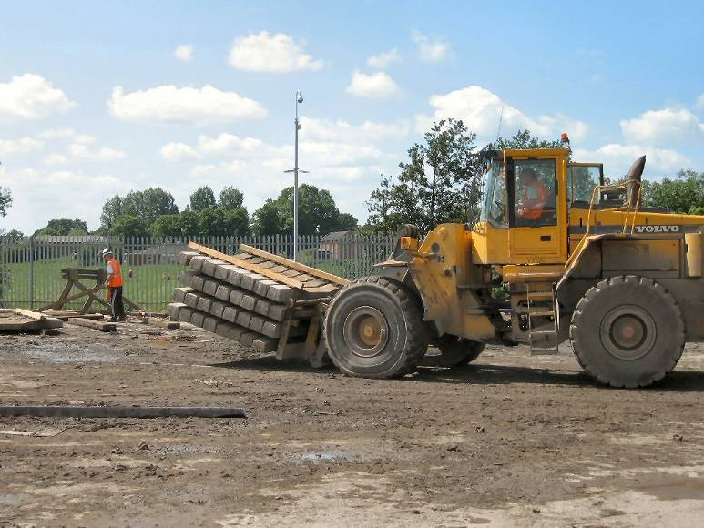

- The concrete sleepers are then lifted.

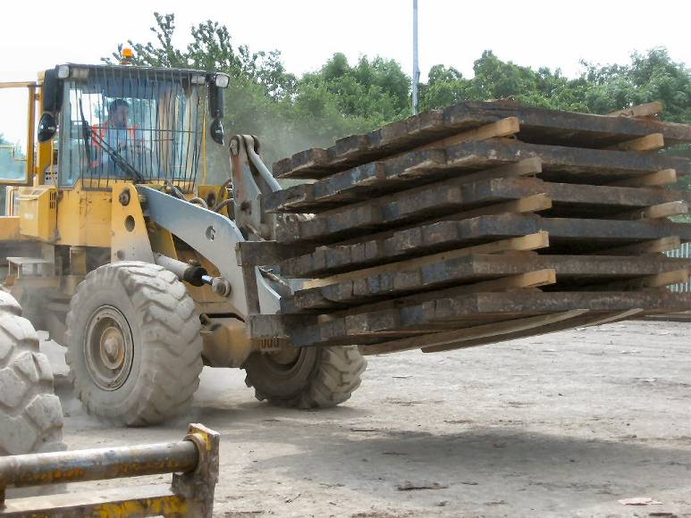
- And stockpiled for later processing.

- Wooden sleepers follow the same process.
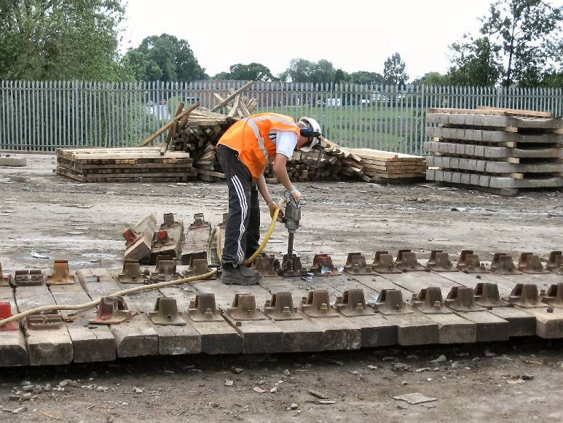
- Although various types of fittings and fixings exist. Some requiring special tools to remove.

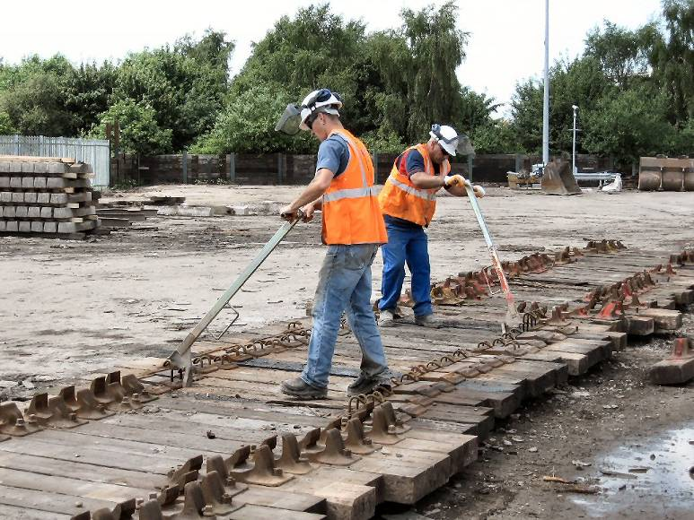
- Others need more traditional methods.

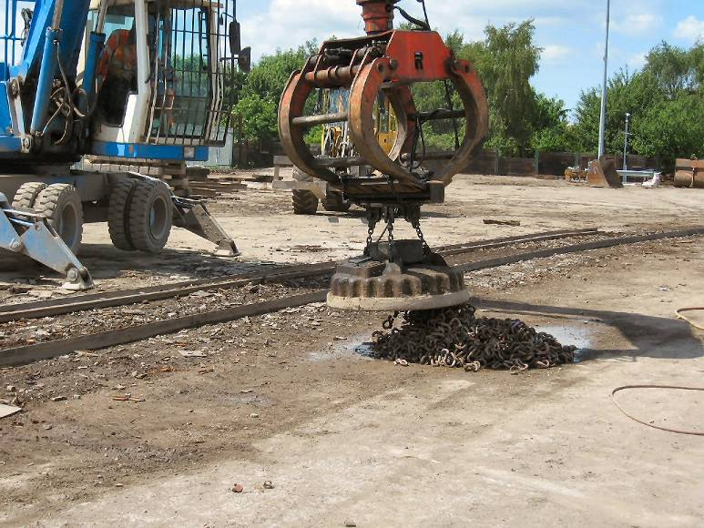
- Once the panel or sleeper dismantling is complete, a magnet comes in to remove the small clips and fastenings.

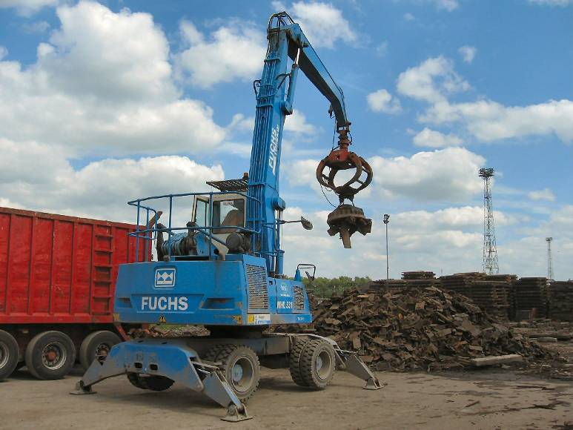
- Small non-serviceable steel products are loaded out using a similar style magnet.

