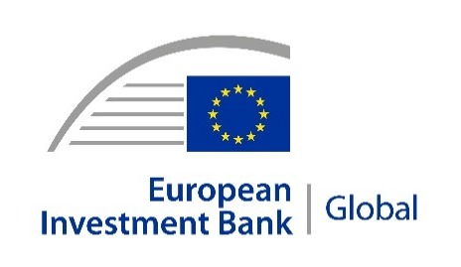 | 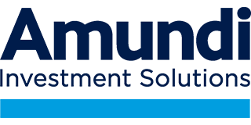 |  | 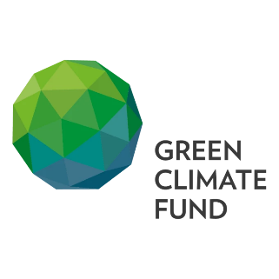
PRESS RELEASE
2026-192-EN
4 June 2026
Developing countries get more support for climate action as EIB reaches first agreement with UN Green Climate Fund
- EIB and UN Green Climate Fund sign first financing agreement.
- Accord backs EU Global Green Bond Initiative Fund.
- Partnership mobilises private finance for climate action.
Climate action in emerging markets will get a boost as a result of the first financing agreement between the United Nations Green Climate Fund (GCF) and the European Investment Bank (EIB). The accord enables the GCF to commit €200 million to a new flagship European Union programme known as the Global Green Bond Initiative (GGBI).
The GCF is investing the sum in the GGBI Fund, a public-private investment vehicle with a target size of €3 billion, which will be run by Amundi, Europe’s largest asset manager.
The GGBI Fund aims to mobilise as much as €20 billion in private capital for sustainable infrastructure projects in low- and middle-income countries.
“Our partnership with the Green Climate Fund shows how multilateral cooperation can scale up climate action where it is needed most,” said EIB Vice-President Ambroise Fayolle. “Together, we are supporting sustainable growth, resilience and better living standards in low- and middle-income countries.”
“GCF’s €200 million equity investment in the Global Green Bond Initiative will de-risk investments in 10 emerging economies. This equity will stimulate country-led green projects that deliver climate solutions in critical sectors such as energy and transport,” said the Green Climate Fund’s Chief Investment Officer (a.i.) Amer Baig. “The Global Green Bond Initiative is a landmark partnership with the European Commission and European Investment Bank that will enhance country ownership of national climate action and fill critical gaps in climate financing gaps. The partnership supports GCF’s ambition to be the climate partner of choice for developing countries.”
"The creation of the Global Green Bond Initiative Fund, and this first significant commitment from the Green Climate Fund demonstrates that we can build impactful blended finance investment solutions. The GGBI fund aims to mobilise public and private capital to finance climate transition in emerging markets - one of the defining challenges of our time," commented Valérie Baudson, Chief Executive Officer of Amundi. "Expertise, innovation and collaboration are essential levers to direct capital where it is needed most. We are very proud to be part of this collective initiative."
The EIB is an accredited entity of the GCF, which is the world’s largest dedicated multilateral climate fund. The financing agreement between the EIB and the GCF demonstrates both organisations’ commitment to multilateral climate action for low- and middle- income countries.
Global Green Bond Initiative (GGBI)
The GGBI is a flagship initiative of the EU’s Global Gateway strategy. It has three complementary pillars:
- The GGBI Fund which mobilises private capital at scale towards sustainable investments in developing countries through green bonds.
- A comprehensive Technical Assistance programme which will share EU expertise and support issuers in partner countries in designing and issuing both green bonds and projects.
- The Green Coupon Subsidy Facility (GCSF) which will help reduce borrowing costs for issuers facing particularly prohibitive interest rates, under specific circumstances.. This will allow partner countries to grow on the green bond market much faster and raise the money they need for their people and their economy.
Global Gateway
Global Gateway is the EU's strategy to boost smart, clean and secure links in digital, energy and transport, and to strengthen health, education and research systems worldwide. It delivers high quality investments that meet the highest environmental, social and governance standards, ensuring sustainability and transparency for partners, people and the planet.
Background information
EIB Group
The European Investment Bank (EIB) Group is the financing arm of the European Union, owned by the 27 Member States, and one of the largest multilateral development banks in the world. In 2025, the EIB Group signed €100 billion in new financing and advisory services for over 870 high-impact projects under eight core priorities that support EU policy objectives: climate action and the environment, digitalisation and technological innovation, security and defence, territorial cohesion, agriculture and the bioeconomy, social infrastructure, strong global partnerships and the savings and investments union. Beyond long-term loans for large infrastructure, the EIB Group crowds in private investment for high-risk innovative projects and businesses, with a growing role in Europe’s markets for venture debt, venture capital, guarantees and securitisations.
The European Investment Fund (EIF) is the subsidiary of the EIB Group specialised in providing guarantees and equity to improve access to finance for small and medium-sized businesses and startups across Europe. Acting as an anchor investor, through its extensive network of partnering banks and investment funds, the EIF mobilises private investment and nurtures the ecosystem of venture capital funds to support innovative European entrepreneurs.
Photos of the EIB Group's representatives and headquarters, logo files and video B-roll for media use are available here.
EIB Global
EIB Global is the EIB Group’s specialised arm devoted to increasing the impact of international win-win partnerships and development finance, and a key partner of Team Europe and the Global Gateway strategy. EIB Global brings the EIB Group closer to people, companies and institutions through its offices across the world.
About GCF
GCF is the world’s climate fund for developing countries, mobilising and delivering capital at scale, strengthening institutions and supporting transformative change, and bringing together our extensive partnership networks to deliver impact. GCF is mandated as the primary operating entity of the financial mechanism of the United Nations Framework Convention on Climate Change (UNFCCC) and serves the 2015 Paris Agreement. To fulfill its role in supporting global climate ambition, GCF is focused on delivering high-impact climate finance at scale, underpinned by a country-owned approach focused on system-wide change.The fund has over USD 19 billion committed across 134 developing countries through a wide range of adaptation and mitigation projects.
About Amundi
Amundi, the leading European asset manager, ranking among the top 10 global players, offers over 200 million investors a complete range of savings and investment solutions in active and passive management, in listed and private assets. Developed for a range of distributors (banks, wealth managers, financial advisors…) as well as for institutional investors and corporates, this offering is enhanced by services and technology tools covering the entire savings value chain. A subsidiary of the Crédit Agricole group and listed on the stock exchange, Amundi currently manages close to €2.4 trillion of assets. Its six international investment hubs, its financial and extra-financial research capabilities and its long-standing commitment to responsible investment make Amundi a leading player in the international asset management landscape. Thanks to a strong local presence, particularly in Europe and Asia, Amundi’s clients benefit from the expertise and advice of 5,400 professionals across 34 countries.
Press contacts

EIB:
Bruno Hoyer | b.hoyer@eib.org | +352 621 886 056
Website: www.eib.org/press - Press Office: press@eib.org

Corentin Henry, Amundi
Tel : +33 1 76 36 26 96
corentin.henry@amundi.com

Aude Humann, Amundi
Tel : +33 6 20 65 88 86
aude.humann@amundi.com

Source: IPE “Top 500 Asset Managers” published in June 2025, based on assets under management as at 31/12/2024
Amundi data as at 31/03/2026
Paris, London, Dublin, Milan, Tokyo and San Antonio (via our strategic partnership with Victory Capital)

