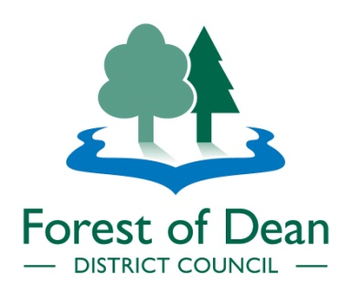
Destination Lydney Harbour Public Artwork Commission
Invitation to Tender:
https://in-tendhost.co.uk/publicagroup/aspx/Home

Lydney Coastal Communities Team (LCCT) and the Forest of Dean District Council (FoDDC) seek to procure an artist/company/organisation to create a landmark public artwork for the Destination Lydney Harbour project, funded by the government’s Coastal Community Fund.

The permanent artwork shall enhance the visitor experience of the harbour and encourage visitors to arrive by car, foot and cycle from Lydney Town, connecting the town with its industrial history. To achieve this, we wish to commission a two-part artwork, one on the roundabout on the A48 and the other at the harbour. The key purpose of the first is to signpost the harbour and the second part of the artwork.

We seek an artist who can make connections between the history and context of Lydney Harbour and the surrounding area, physically and conceptually, and evidence having worked on similar heritage projects in the public realm, or in non-traditional art space contexts.
We anticipate that the concept of the design will require further local research, to ensure it is place-specific and responds to Lydney Harbour in a pertinent and interesting way. The contract allows for a period of research and public engagement at the beginning, to ensure the concept is deeply grounded in Lydney Harbour as a place – both physically and historically.
The term ‘artworks’ can be interpreted in many ways – from sculptures to installations and things in between. The artworks can be created in any material, but it must be robust enough to withstand being installed in the open air. The contract is for a two-part permanent outdoor artwork and a ten-year maintenance schedule will be agreed with the selected artist.

Procurement timetable
Activity | Date
Invitation to Tender | 24th June 2020
Deadline for ITT Clarification questions | 10th July 2020
Clarification questions answered by | 17th July 2020
Deadline for return of Invitation to Tender ITT | 31st July 2020
Evaluation of ITT (incl. Post Tender Clarifications) | 1st -7th August 2020
Notify of invitation to interview | 7th August 2020
Interviews | 17th August 2020
Selection of successful Tenderer | 20th August 2020
Contract Award | 21st August 2020
Contract Commencement | 27th August 2020

