Creating content for Small Business Saturday

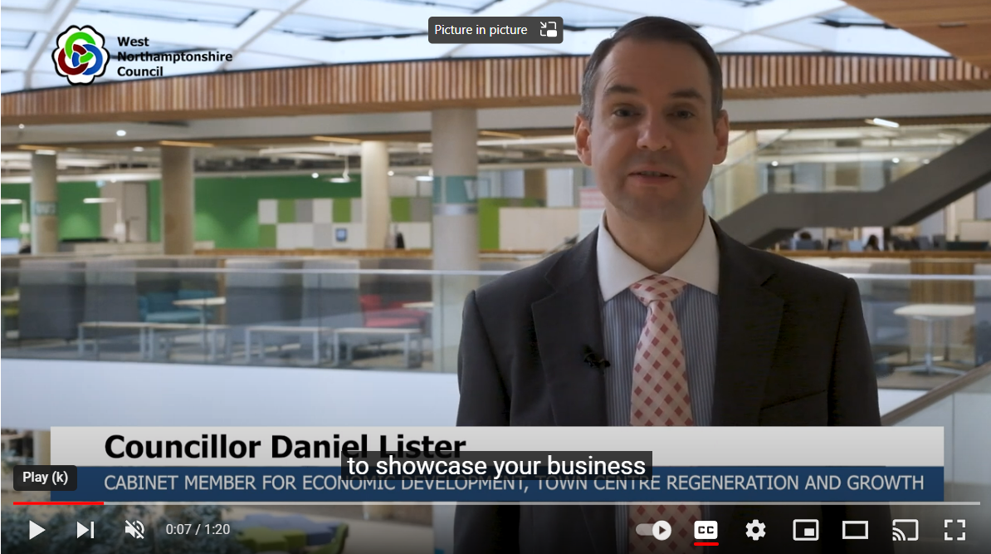
WATCH: Cllr Daniel Lister, WNC’s Cabinet Member for Economic Development, Town Centre Regeneration and Growth, talks more about Small Business Saturday in West Northants.

Small Business Saturday takes place on December 3, and we’re encouraging fantastic independent outlets like yours to share videos of your business on social media, to shine a light on all that West Northamptonshire has to offer.
It may seem daunting, but the filming can be done quickly and easily on your smartphone, helping you show off your business and engage with potential customers.
These great examples of videos that businesses have produced might give you some inspiration. But we’ve also put together some top tips to help you:

Planning your video
A good video is all in the planning and preparation. Decide whether you want to shoot your video selfie style, whether you want a colleague to film you, or whether you just want to show off your products on film while you provide a voiceover.
You may feel too shy to appear on film, but please remember that videos with people in them are more engaging on social media.If you’re not sure what to say, then why not use the following as a guide:
- Introduce your business
- Where in West Northants are you located?
- How long have you been here?
- What do you sell?
- What is a popular product?
- What’s unique about your shop?
- Why should a customer visit your shop?
- What are you most proud of?
- Can you describe the experience of visiting your shop?
- What is your favourite thing about being a business owner in West Northants?
You don’t need to answer all the questions – choose the most interesting ones for your business.

Shooting your video
Here are some things to think about when filming the video:
Light - Can you increase the light in the room? It might appear bright to the human eye but the camera on your phone may struggle. Move your subject so they’re facing the light source and their face is the brightest part of the picture.
Background – Look at the background of what you’re filming and think about how this portrays your business. What can you see? Is it uncluttered? Does the entire frame portray the message you want it to?
Noise – limit background noise and avoid filming outside if there is traffic or any wind.
Holding your phone – Hold your phone upright in portrait mode, as this style of video has a greater engagement rate on social media. If you’re getting a static shot then try to keep the phone straight and level and consider the use of a little tripod or something to rest the phone on.
Smile…and relax – if presenting to camera, try to be as relaxed as possible and project your smile through your entire face and eyes.

Sharing your video
If your video needs trimming you can usually do this using the camera app on your camera smartphone, though we have also provided a list of free editing apps overleaf.
Then please share it to your social media accounts. Be sure to tag us in @westnorthants on Facebook or Twitter and @West Northamptonshire Council on LinkedIn and use the #SmallBizSatUK hashtag. We can then share your videos on our channels to spread the word!

Free video editing software

Adobe Express
Web-based editor: https://express.adobe.com/sp/onboarding
Canva
Web-based editor: http://canva.com/video-editor/
Lightworks
Free software but installation required: https://lwks.com/lightworks-comparison/
iMovie
Free app for Apple devices: https://apps.apple.com/gb/app/imovie/id377298193

