Dependence and withdrawal associated with  
some prescribed medicines

An evidence review

About Public Health England

Public Health England exists to protect and improve the nation’s health and wellbeing, and reduce health inequalities. We do this through world-leading science, research, knowledge and intelligence, advocacy, partnerships and the delivery of specialist public health services. We are an executive agency of the Department of Health and Social Care, and a distinct delivery organisation with operational autonomy. We provide government, local government, the NHS, Parliament, industry and the public with evidence-based professional, scientific and delivery expertise and support.

Public Health England  
Wellington House

133-155 Waterloo Road  
London SE1 8UG  
Tel: 020 7654 8000  
[www.gov.uk/phe](http://www.gov.uk/phe)   
Twitter: [@PHE_uk](https://twitter.com/PHE_uk)

Facebook: [www.facebook.com/PublicHealthEngland](http://www.facebook.com/PublicHealthEngland)

Authors: Stephen Taylor, Fizz Annand, Peter Burkinshaw, Felix Greaves, Michael Kelleher, Jonathan Knight, Clare Perkins, Anh Tran, Martin White, John Marsden

Suggested citation: Taylor S, Annand F, Burkinshaw P, Greaves F, Kelleher M, Knight J, Perkins C, Tran A, White M, Marsden J. Dependence and withdrawal associated with some prescribed medicines: an evidence review. Public Health England, London. 2019.

For queries relating to this document, please contact: [pete.burkinshaw@phe.gov.uk](mailto:pete.burkinshaw@phe.gov.uk)



© Crown copyright 2019   
You may re-use this information (excluding logos) free of charge in any format or medium, under the terms of the Open Government Licence v3.0. To view this licence, visit [OGL](https://www.nationalarchives.gov.uk/doc/open-government-licence/version/3/). Where we have identified any third party copyright information you will need to obtain permission from the copyright holders concerned.

Published September 2019   
PHE publications PHE supports the UN

gateway number: GW- 675 Sustainable Development Goals

**[](https://www.gov.uk/government/collections/sustainability-and-public-health-a-guide-to-good-practice)**

Acknowledgements

Public Health England is very grateful to members of the review’s Expert Reference Group, who gave their time, expertise and experience to provide advice and support. Members of the ERG are listed in its [terms of reference](http://www.gov.uk/government/publications/prescribed-medicines-review-expert-group-terms-of-reference/terms-of-reference-expert-reference-group-for-the-prescribed-medicines-review#membership-and-representation). The chair of the ERG was PHE’s Emeritus Medical Director, Professor Paul Cosford, and vice chair was Rosanna O’Connor, Director, Alcohol, Drugs, Tobacco & Justice Division.

Public Health England would like to thank the following organisations and their staff that contributed to the review through commissioned research or data, data analysis and quality assurance, or advice or drafting:

* The National Institute for Health and Care Excellence (NICE): Paul Chrisp and Gareth Franklin
* NHS Business Services Authority: Nikki Dodds and Phil Godfrey
* The National Guideline Centre at the Royal College of Physicians: Serena Carville, Kate Ashmore, Agnes Cuyas, Nicole Downes, Lina Gulhane, Clare Jones, Eleanor Priestnall, Sharangini Rajesh, Eleanor Samarasekera and Maria Smyth, supported by the NGC document delivery team
* PHE’s National Cancer Registration and Analysis Service (NCRAS): Thomas Bacon, Gabrielle Emanuel, Katherine Henson, Alan MacDonald, Jem Rashbass and Brian Shand
* PHE North West Knowledge and Intelligence Team: Caryl Beynon
* PHE Health Intelligence Division: Georgina Anderson, Olivia Box Power and Sacha Wyke
* NatCen Social Research (for the Public Health Research Consortium): Sally McManus, Rukmen Sehmi and Neil Smith
* Dr Caroline Watson

PHE would also like to thank the peer reviewers of the rapid evidence assessment and the full report, who must remain anonymous for the purpose of impartiality, and Margaret Mauchline, who commissioned the peer reviews.

PHE steering group [S = secretariat]: Fizz Annand [S], Peter Burkinshaw [S], Rachel Clark (from February 2019), Felix Greaves, Michael Kelleher, John Marsden, Rosanna O’Connor, Lauren Oyinloye (from October 2018) [S], Clare Perkins, Garry Stillwell (to December 2018) [S], Steve Taylor [S], Anh Tran, Martin White

Contents

About Public Health England 2

Acknowledgements 3

List of figures 5

List of tables 7

Abbreviations and glossary of terms 8

What this report means for patients 9

More people are taking prescribed medicines for longer 9

Do not stop taking a prescribed medicine on your own 9

What your doctor should do 9

Executive summary 11

Introduction 11

Findings from the analysis of prescription data 12

Findings from the rapid evidence assessment 13

Recommendations 16

1. Introduction 17

The commission and where it came from 17

The scope of the PHE review 18

The context of the review 20

2. The methodology of the review 35

Mapping the medicines 35

Literature scoping search 35

Expert reference group 36

The review’s data analyses 36

Clinical Practice Research Datalink analysis 37

Rapid evidence assessment 37

Other research and reviews 40

3. Prescriptions and prescribing findings 41

Prescriptions data from NHS Business Services Authority 41

Earlier prescription data 87

Prescribing privately and in other settings 89

Clinical Practice Research Datalink 93

Other data and analyses 97

4. Rapid evidence assessment findings 98

Risk of harms of dependence and withdrawal 99

Harms associated with or caused by dependence and withdrawal 100

Prevention and treatment 102

Patients’ experiences of harms and of accessing support 103

Current practice examples 108

5. Conclusions and recommendations 115

Attention already being paid to these issues 115

The review’s conclusions 116

The review’s recommendations 120

References 127

Appendices 135

Appendix A. Medicines included in the scope of the review and in the data analyses 135

Appendix B. Issues not included but meriting further consideration 137

Appendix C. Search strategy for initial literature scoping search 140

Appendix D. Statistical analysis plan for the NHSBSA prescription data 141

Appendix E. Call for papers invitation 148

Appendix F. Papers describing relevant services – with no evaluation 150

List of figures

Figure 1: Proportion of adults resident in England receiving a prescription 2015 to 2018, by year and class of medicine 44

[Figure 2: Number of adults receiving a prescription 2015 to 2018, by first year observed,   
and class of medicine 45](#_Toc17201382)

Figure 3: Number of adults receiving a prescription 2015 to 2018, by number of years observed, and class of medicine 46

[Figure 4a: Proportion of adults resident in England receiving a prescription in 2017 to 2018,   
by sex and class of medicine 47](#_Toc17201384)

[Figure 4b: Proportion of adults resident in England receiving a prescription in 2017 to 2018,   
by age group and class of medicine 48](#_Toc17201385)

[Figure 4c: Proportion of population registered with GPs in England receiving a prescription   
in 2017 to 2018, by deprivation quintile and class of medicine 49](#_Toc17201386)

[Figure 5: Variation in standardised rates by CCG (195 CCGs) and class of medicine, 2017   
to 2018 51](#_Toc17201387)

Figure 6: Proportion with a retrospective duration of greater than or equal to 12 months by method for measuring continuous duration, at March 2018 54

[Figure 7: Number of adults reported as starting a prescription using monthly data   
(June 2015) compared to annual data (2015/16), by drug class 55](#_Toc17201389)

Figure 8a: Adults starting a prescription for antidepressants in June 2015, by prospective duration up to May 2018 56

[Figure 8b: Adults starting a prescription for opioid pain medicines in June 2015, by   
prospective duration up to May 2018 57](#_Toc17201391)

Figure 8c: Adults starting a prescription for gabapentinoids in June 2015, by prospective duration up to May 2018 58

Figure 8d: Adults starting a prescription for benzodiazepines in June 2015, by prospective duration up to May 2018 59

[Figure 8e: Adults starting a prescription for z-drugs in June 2015, by prospective duration   
up to May 2018 60](#_Toc17201394)

Figure 9: Adults starting a prescription in June 2015, by prospective duration exceeding thresholds and by medicine class 61

Figure 10: Trend in the proportion with a prospective duration of greater than or equal to 12 months by medicine class, June 2015 to June 2017 62

Figure 11a: Proportion of adults with a prospective duration of greater than or equal to 12 months from June 2015, by medicine class and sex 63

Figure 11b: Proportion of adults with a prospective duration of greater than or equal to 12 months from June 2015, by medicine class and age group 64

Figure 11c: Proportion of adults with a prospective duration of greater than or equal to 12 months from June 2015, by medicine class and deprivation 65

[Figure 12: Number of adults reported as receiving a prescription based on using monthly   
data (March 2018) compared to annual data (2017 to 2018) 68](#_Toc17201400)

[Figure 13a: Adults currently in receipt of a prescription for antidepressants at March 2018,   
by retrospective duration back to April 2015 68](#_Toc17201401)

Figure 13b: Adults currently in receipt of a prescription for opioid pain medicines at March 2018, by retrospective duration back to April 2015 69

[Figure 13c: Adults currently in receipt of a prescription for gabapentinoids at March 2018,   
by retrospective duration back to April 2015 70](#_Toc17201403)

[Figure 13d: Adults currently in receipt of a prescription for benzodiazepines at March 2018,   
by retrospective duration back to April 2015 71](#_Toc17201404)

Figure 13e: Adults currently in receipt of a prescription for z-drugs at March 2018, by retrospective duration back to April 2015 72

[Figure 14: Adults currently in receipt of a prescription at March 2018, by retrospective   
duration exceeding thresholds by medicine class 73](#_Toc17201406)

[Figure 15: Trend in the proportion with a retrospective duration of greater than or equal to   
12 months, April 2016 to March 2018 74](#_Toc17201407)

Figure 16a: Proportion of adults with a retrospective duration of greater than or equal to 12 months at March 2018, by sex 75

Figure 16b: Proportion of adults with a retrospective duration of greater than or equal to 12 months at March 2018, by age group 76

Figure 16c: Proportion of adults with a retrospective duration of greater than or equal to 12 months at March 2018, by deprivation 77

[Figure 17: Proportion of adults receiving a prescription in March 2018, by number of   
classes of drug 81](#_Toc17201411)

[Figure 18: Proportion of adults receiving a prescription in March 2018, by sex and number   
of classes of drug 82](#_Toc17201412)

Figure 19: Proportion of adults receiving a prescription in March 2018, by age group and number of classes of drug 83

Figure 20: Proportion of adults receiving a prescription in March 2018, by deprivation and number of medicine classes 84

[Figure 21: Number of adults receiving a prescription in March 2018, by combination of   
classes 86](#_Toc17201415)

[Figure 22: Proportion of adults receiving a prescription in March 2018, by number of   
medicine classes – based on sensitivity analysis method 87](#_Toc17201416)

Figure 23: Prescription items dispensed in the community in England, 2008 to 2018 88

Figure 24: Prescription items 2008 to 2018, antidepressants-only, by class 89

Figure 25: IQVIA - Drug group analysis - community (items dispensed) 91

Figure 26: IQVIA - Drug group analysis – hospitals (units) 91

Figure 27: IQVIA - Drug group analysis – care homes (units) 92

Figure 28: IQVIA - Drug group analysis – private prescriptions (units) 92

[Figure 29: Total counts of sales of individual codeine and dihydrocodeine-containing   
medicines 96](#_Toc17201423)

Figure 30: Study selection: Flow chart of study selection for the review 98

List of tables

Table 1: Overall level of confidence for a review finding in GRADE-CERQual explained 39

Table 2: Methodology per review theme 40

Table 3: Summary statistics for 195 CCGs in 2017 to 2018 49

[Table 4: Correlation matrix for the crude proportions receiving a prescription for each class   
of medicine in each CCG 50](#_Toc17201428)

Table 5: Example prescribing pattern for retrospective and prospective analysis 52

[Table 6: Variation at a CCG level in the proportion of individuals receiving a prescription for   
12 months or more, of those starting a prescription in June 2015, by medicine class 66](#_Toc17201430)

[Table 7: Correlation between proportions prescribed for 12 months or more at CCG level,   
by drug class, for those starting a prescription in June 2015 66](#_Toc17201431)

Table 8: Number and proportion of individuals in each medicine class in receipt of a prescription in April 2015 who received a prescription continuously up to March 2018 75

[Table 9: Variation at a CCG level in the proportion of individuals who have been in receipt   
a prescription for 12 months or more in March 2018, by drug class 78](#_Toc17201433)

Table 10: Correlation between proportions that have been in receipt of a prescription for 12 months or more at CCG level, by drug class, March 2018 78

Table 11: Correlation between proportions that have been in receipt of a prescription for 12 months or more and overall prescribing rates at CCG level, by drug class, March 2018 79

Table 12: Number of individuals receiving each combination of 2 or more classes of medicine in March 2018, grouped by the number of classes, and the proportion of the total (n=5.5 million) 85

Table 13: Summary statistics for those with 2 or more classes of medicine reported in the same month at CCG level 86

Abbreviations and glossary of terms

Abbreviations

**APPG PDD** All Party Parliamentary Group on Prescribed Drug Dependence

**BMA** British Medical Association

**CPRD / GPRD** Originally called the General Practice Research Database (GPRD), the Clinical Practice Research Datalink (CPRD) collates patient data from a large sample of primary care practices

**OPM** Opioid pain medicines

**PMR** Prescribed Medicines Review, shorthand for PHE’s review of the evidence for dependence on, and withdrawal from, some prescribed medicines

Glossary of terms

Terms used in definition text that are further defined themselves are shown in italics.

**Addiction** *Dependence* plus a compulsive preoccupation to seek and take a substance despite consequences

**Dependence** An adaptation to repeated exposure to some drugs and medicines usually characterised by *tolerance* and *withdrawal*, though *tolerance* may not occur with some. Dependence is an inevitable (and often acceptable) consequence of long-term use of some medicines and is distinguished here from *addiction*

**Discontinuation (syndrome)** This term was used in the early stages of the review as it was the only term recognised by some stakeholders in relation to the effects experienced by some patients when coming off antidepressants. However, it is a contentious term and has only been kept in the search terms and other processes of the review to ensure that a full range of appropriate evidence is captured. The term is no longer used in the review's outputs

**Tolerance** Neuroadaptation arising from repeatedly taking some drugs and medicines, in which higher doses are required to achieve a desired effect

**Withdrawal** Physiological reactions when a drug or medicine that has been taken repeatedly is removed

What this report means for patients

More people are taking prescribed medicines for longer

Some prescription medicines can be addictive and could cause problems for people taking them or coming off them, especially if someone has been taking them for a long time. These medicines include benzodiazepines and z-drugs, gabapentin and pregabalin, and opioid pain medicines. Antidepressants are not addictive but some people have problems coming off them.

The government asked Public Health England to look at the evidence about this problem. We found that, since at least 10 years ago, more people are being prescribed more of these medicines and often for longer.

The prescribing of some of these medicines (like benzodiazepines and opioids) has fallen recently but others (such as gabapentin, pregabalin and antidepressants) are being prescribed more and for longer. This means more people are at risk of becoming addicted to them or having problems when they stop using them. It also costs the NHS a lot of money, some of which is wasted because the medicines do not work for everyone all the time, especially if they are used for too long.

Do not stop taking a prescribed medicine on your own

The medicines we looked at help to make millions of people every year feel better and recover from their illness. Doctors can prescribe them because there is good evidence that they work, but they do have some risks. If you are a patient taking one of these medicines as prescribed by your doctor (or other prescriber), but you are worried by anything in this report, you should not stop taking them on your own. Instead, make an appointment to see your doctor and talk through your worries.

We do not want to put anyone off safely using medicines that could help them. Stopping or limiting the use of medicines could also cause harm, including increasing the risk of suicide or making people try to get medicines or illegal alternatives from less safe sources, such as illegal websites or drug dealers.

What your doctor should do

Because of this report – and work being done by lots of others – doctors and other healthcare professionals should:

* consider all the treatments that might work for you, including those that don’t involve (or are in addition to) medicines, like talking therapies or exercise
* tell you about the benefits and risks of medicines
* regularly review whether a medicine is helping you or not
* change the treatment if it’s not helping you

They might offer some patients the chance to gradually come off a medicine they have been taking for a long time.

If you need to start taking a medicine, or need to continue taking one, your doctor will always try to do what is in your best interests.

If you believe what your doctor is doing is not in your best interests you should talk to them first. You have the right to make a complaint and the right to ask for a second opinion. If you want support to make a complaint you can contact your local [NHS Complaints Advocacy Service](http://nhscomplaintsadvocacy.org/). Your local [Healthwatch](https://www.healthwatch.co.uk/your-local-healthwatch/list) can also give you more information.

We also recommend that there should be improvements in the information, advice and support available to patients from doctors and specialist services. If you have problems coming off a medicine, tell your doctor and they should offer you more support or put you in touch with another service that can help.

Executive summary

Introduction

In 2017, the minister for public health and primary care commissioned Public Health England (PHE) to identify the scale, distribution and causes of prescription drug dependence, and what might be done to address it.

The review covered adults (aged 18 and over) and 5 classes of medicines:

* benzodiazepines (mostly prescribed for anxiety)
* z-drugs (sleeping tablets with effects similar to benzodiazepines)
* gabapentin and pregabalin (together called gabapentinoids and used to treat epilepsy, neuropathic pain and, in the case of pregabalin, anxiety)
* opioids for chronic non-cancer pain
* antidepressants

The National Institute for Health and Care Excellence (NICE) first mapped out all the medicines prescribable in England in these classes so it was clear which were to be included.

This was a mixed-methods public health evidence review, including:

1. An analysis by PHE of all NHS community prescriptions in England reported to the NHS Business Services Authority during the period 2015 to 2018 (patient-linked data only available since 2015), supplemented by some longer-term prescription data that could better indicate trends, and data on medicines supplied in other settings.
2. An independently commissioned rapid evidence assessment (REA) of articles on prescription medicine-associated harms, dependence, withdrawal, risk factors and service models published between 2008 and 2018, and of documents submitted in an open public call-for-evidence which summarises patients’ experiences of taking these medicines and of treatment services.

An expert reference group advised on methods and discussed findings and recommendations.

Findings from the analysis of prescription data

Prevalence

PHE’s analysis shows that, in 2017 to 2018, 11.5 million adults in England (26% of the adult population) received, and had dispensed, one or more prescriptions for any of the medicines within the scope of the review.[1] The totals for each medicine were:

antidepressants 7.3 million people (17% of the adult population)

opioid pain medicines 5.6 million (13%)

gabapentinoids 1.5 million (3%)

benzodiazepines 1.4 million (3%)

z-drugs 1.0 million (2%)

There are large variations in the standardised rates of prescribing across clinical commissioning groups (CCGs).

Trends and demographics

Between 2015 to 2016 and 2017 to 2018 the rate of prescribing for antidepressants increased from 15.8% of the adult population to 16.6% and for gabapentinoids from 2.9% to 3.3%. There was a small decrease in prescribing rates for the other 3 medicine classes.

Rates of prescribing were higher for women (1.5 times those of men), and the rates generally increased with age.

After a long increasing trend, the annual number of prescriptions for opioid pain medicines has slightly decreased since 2016.

There is a continuing longer-term fall in prescription numbers for benzodiazepines. A longer-term increase in annual prescription numbers for z-drugs started to reverse in 2014.

Associations with deprivation

Prescribing rates for opioid pain medicines and gabapentinoids had a strong association with deprivation, being higher in areas of greater deprivation. Antidepressant prescribing had a weaker association with deprivation. For benzodiazepines and z-drugs, prescribing rates slightly decreased with higher deprivation. For all medicine classes the proportion of patients who had at least a year of prescriptions increased with higher deprivation.

Time receiving prescriptions

Most patients who started a prescription in June 2015 were estimated to have received a prescription for 3 months or less. This ranged from 51% for antidepressants to 82% for benzodiazepines.

The proportion estimated to have received a prescription continuously from June 2015 for at least 12 months varied from 5% (benzodiazepines) to almost 20% (gabapentinoids). These proportions were similar, at 4% and 19% respectively, for those starting a prescription in June 2017, the latest date at which 12-month duration could be estimated prospectively. This suggests that most people who start prescriptions receive them for a short time, but each month there is a group of patients who continue to receive a prescription for longer.

Looking retrospectively at people receiving a prescription in March 2018, around half of patients in each medicine class were estimated to have been receiving a prescription continuously for at least 12 months at that point. This proportion is much higher than for those starting a prescription in June 2015 as it reflects an accumulation of people who have long-term prescriptions, some of whom started prescriptions more recently, but many of whom were already receiving prescriptions by April 2015.

The number of patients who received a prescription continuously between April 2015 (and perhaps earlier) and March 2018 was as follows:

antidepressants 930,000 people

opioid pain medicines 540,000

gabapentinoids 160,000

benzodiazepines 120,000

z-drugs 100,000

Findings from the rapid evidence assessment

The REA identified 75 articles which included:

* 30 on harms
* 26 on interventions
* 17 on risk factors
* 2 on patients’ experiences

From the open call-for-evidence, the researchers included 10 more reports on patients’ experiences and 4 reports on current practice.

Dependence, withdrawal and interventions

Benzodiazepines, z-drugs, opioid pain medicines and gabapentinoids are associated with a risk of dependence and withdrawal.

Antidepressants are associated with withdrawal. Seventeen placebo-controlled trials (with 6,729 participants) show that withdrawal symptoms, such as insomnia, depression, suicidal ideation and physical symptoms, follow when patients stop taking medication. The evidence here was mostly very-low to moderate-quality. Only 1 trial was high quality.

Interventions for treating dependence and managing withdrawal varied widely, and meta-analysis, or combining data from the studies, was not feasible. The evidence here came from 26 trials and 2 non-randomised studies: 12 on opioids, 8 benzodiazepines, 3 antidepressants, 1 z-drugs and 4 on several drugs.

Patients’ experiences

Some patients reported harmful effects and withdrawal symptoms on stopping benzodiazepines, z-drugs, opioids and antidepressants which affected their well-being, personal, social and occupational functioning. These effects and symptoms could last many months.

Higher initial opioid doses and prior mental health problems were associated with long-term use of opioids and opioid dependence, respectively. Prescribing opioid pain medicines for longer than 90 days was associated with opioid overdose and dependence.

Low income and use of shorter-acting benzodiazepines are associated with long-term benzodiazepine use.

Patients experienced barriers to accessing and engaging in treatment services. They felt there was a lack of information on the risks of medication and that doctors did not acknowledge or recognise withdrawal symptoms.

Patients described not being offered any non-medicinal treatment options, their treatment not being reviewed sufficiently and a lack of access to effective management and NHS support services.

Service models

The evidence submitted was not enough for conclusions on the effectiveness and cost-effectiveness of service models.

Common features of service models submitted were:

the involvement of GPs and other primary care services

helpline and telephone support

counselling and support groups

Conclusions

In England in the year 2017 to 2018, one in 4 adults in England were prescribed benzodiazepines, z-drugs, gabapentinoids, opioids for chronic non-cancer pain, or antidepressants. Prescriptions for antidepressants and gabapentinoids are increasing, but prescriptions for opioid pain medicines are decreasing, after rising for many years. Prescriptions for benzodiazepines continue to fall, and those for z-drugs have more recently started to fall.

There is a higher rate of prescribing to women and older adults, and there are large variations in standardised rates of prescribing at the level of CCGs. The rate of prescribing and the time receiving a prescription increase with deprivation.

Longer-term prescribing is widespread. Aside from antidepressants, the medications reviewed are all licensed and indicated for (usually) short-term treatment of acute conditions. Clinical guidelines specify that benzodiazepines should not usually be prescribed for longer than 2 to 4 weeks. Long-term prescribing of opioids for chronic, non-cancer pain is not effective for most patients. And some patients need long-term prescribing of antidepressants to maintain benefit and prevent relapse.

Effective, personalised care should include shared decision making with patients and regular reviews of whether treatment is working. Patients who want to stop using a medicine must be able to access appropriate medical advice and treatment, and must never be stigmatised.

Inappropriate limiting of medicines may increase harm, including the risk of suicide, and lead some people to seek medicines from illicit or less-regulated sources, such as online pharmacies. There needs to be increased public and clinical awareness of other interventions, such as cognitive behavioural therapy.

There have been very few high-quality research studies on medicine dependence and withdrawal, and their prevention and treatment, in the past 10 years.

Recommendations

PHE’s recommendations fall into 5 broad categories which are:

1. Increasing the availability and use of data on the prescribing of medicines that can cause dependence or withdrawal to support greater transparency and accountability and help ensure practice is consistent and in line with guidance.
2. Enhancing clinical guidance and the likelihood it will be followed.
3. Improving information for patients and carers on prescribed medicines and other treatments, and increasing informed choice and shared decision making between clinicians and patients.
4. Improving the support available from the healthcare system for patients experiencing dependence on, or withdrawal from, prescribed medicines.
5. Further research on the prevention and treatment of dependence on, and withdrawal from, prescribed medicines.

The goal is to make sure that our healthcare system builds awareness and enhanced decision making for better patient treatment and support.

These recommendations are just the beginning. All parts of the healthcare system and the general population will need to engage with this complex problem and work together to find solutions. The local strategic leadership of CCGs, sustainability and transformation partnerships and integrated care systems will be vital.

1. Introduction

The commission and where it came from

In October 2017 the minister for public health and primary care commissioned Public Health England (PHE) to identify the scale and distribution, and causes, of prescription drug dependence, and what might be done to address it.

This commission followed representations by the All Party Parliamentary Group for Prescribed Drug Dependence (APPG PDD) and others, which came on the back of a long history of patient and other concerns, initially focused on benzodiazepines (and then also z-drugs), supported by the All Party Parliamentary Group on Involuntary Tranquilliser Addiction (APPGITA), but later extending to opioid pain medicines (and gabapentinoids) and antidepressants.

The National Treatment Agency for Substance Misuse, and its successor in Public Health England, worked with the Department of Health on the issue of addiction to medicines, as it was then known, from 2011. This work supported medicine labelling changes and provided advice to those commissioning and providing treatment services.

The minister’s 2017 commission also followed a report by the British Medical Association in 2015,1 and subsequent BMA-hosted roundtables, that expressed concerns about patients becoming dependent on, or suffering withdrawal symptoms from, some psychoactive medicines. The BMA reported that patients did not receive the support they needed, and the BMA promoted 3 recommendations:

* the creation of a national helpline for prescribed drug dependence
* an increase in provision of specialist support services
* revised guidance for doctors on safe prescribing, management and withdrawal of prescription drugs

In 2017, the Public Health Research Consortium (PHRC) reported on trends in what they termed “dependence-forming medicines”.2 These were benzodiazepines, z-drugs, gabapentin and pregabalin, and opioid pain medicines but not antidepressants. Although the PHRC study was able to use data in the Clinical Practice Research Datalink (CPRD) to report on the number and characteristics of a large sample of patients being prescribed dependence-forming medicines, including prescribing durations over 30 days, it did not come to conclusions about the prevalence of dependence.

The scope of the PHE review

The scope of the review was published online at [www.gov.uk/government/publications/prescribed-medicines-review-scope](http://www.gov.uk/government/publications/prescribed-medicines-review-scope).

Included in the scope were:

* adults (age 18 and over)
* dependence, withdrawal and, where the term was needed to ensure its inclusion in literature searches, discontinuation syndrome
* the prescribed medicines benzodiazepines, z-drugs, gabapentin and pregabalin (sometimes called GABA-ergic or gabapentinoid medicines), opioid pain medicines (including codeine, although this is often bought over the counter as well as prescribed) and antidepressants (listed in appendix A)
* prescribing in the community (medicines mainly prescribed in primary care and dispensed by community pharmacies, since this is how most patients obtain medicines); for completeness, the review also looked at prescribing in hospitals and care homes, and on private prescriptions

The focus of the review, the limitations of available data and the need to keep any analysis and reporting both manageable and timely, meant excluding several related and overlapping issues of importance and concern, including the following.

Under 18s

The licensed indications for many medicines do not extend to young people and, as a result, more prescribing to young people is ‘off-label’ (not covered by the product’s marketing authorisation). The prescribing of the medicines included in the review to patients under 18 years of age is contentious and can be complicated by developmental issues and treatment of mental health problems.

Over-the-counter medicines (except codeine as above)

Some problems of dependence are initiated or maintained by the use of over-the-counter medicines.3 Millions of patients find such medicines invaluable in self-treatment – and this frees up time that might otherwise be spent in GP surgeries – but some products are powerful and may lead to dependence.

Secure environments including prisons (and secure hospitals)

The policy and practice of prescribing medicines in these environments is complex and is described in appendix B.

The use of opioids for pain associated with cancer and at the end of life

For some patients, shorter-duration prescribing of opioids is indicated in the alleviation of cancer pain during end-of-life care. Patients in remission from cancer, and those who have longer survival with cancer, may suffer from pain that is more difficult to treat.4

The use of psychiatric medications in those with a learning disability, autism   
or both

NHS England has a [national project called STOMP](https://www.england.nhs.uk/learning-disabilities/improving-health/stomp/) (“stopping over medication of people with a learning disability, autism or both with psychotropic medicines”). These medicines are indicated for some people, but they may be associated with harm if used for too long, or at too high a dose, or for the wrong reason.

Drug misuse

Drug misuse has been excluded, except insofar as it involves prescribed medicines and is the result of prescribing. This is a complex and overlapping issue and is described in appendix B.

Harms other than dependence and withdrawal that may be caused by the   
long-term prescribing of some medicines

There is a very long list of possible harms arising from the long-term use of some medicines, including death. These are reported through the MHRA Yellow Card scheme and included in summaries of product characteristics (SmPCs) and patient information leaflets (PILs). These harms were excluded from the review unless evidence could be identified that pointed to dependence and withdrawal.

Some medicines with no marketing authorisation

The use of some medicines with no marketing authorisation (unlicensed), or use outside their marketing authorisation (off-label), in the UK has not been separately or specifically considered. It is not distinguished in the data, so is included, and it was not excluded from the rapid evidence assessment (REA). Some off-label or unlicensed medicine is appropriate, inevitable and helpful where good evidence exists on clinical benefit (and where there is no alternative). But it may also be riskier than using a licensed medicine as authorised, and could contribute to dependence and withdrawal. There is extensive guidance from the General Medical Council on these matters: [www.gmc-uk.org/ethical-guidance/ethical-guidance-for-doctors/prescribing-and-managing-medicines-and-devices/prescribing-unlicensed-medicines](http://www.gmc-uk.org/ethical-guidance/ethical-guidance-for-doctors/prescribing-and-managing-medicines-and-devices/prescribing-unlicensed-medicines)

Medicines prescribed or otherwise supplied by independent online doctors and pharmacies in this country and abroad

There is legitimate concern in relation to the safe supply of opioid medicines by websites based inside and outside the UK, and the unlawful online supply of prescription medicines. The focus of the PMR is on prescribing by GPs to their patients in the community in England. Concerns about online prescribing and supply are receiving attention from the Medicines and Healthcare products Regulatory Agency (MHRA), the Care Quality Commission (CQC) and the General Pharmaceutical Council (GPhC). Recent guidelines from the GPhC are designed to better regulate online prescribing and online pharmacies [www.pharmacyregulation.org/news/new-safeguards-people-seeking-medicines-online](http://www.pharmacyregulation.org/news/new-safeguards-people-seeking-medicines-online)

Co-proxamol and other medicines

Co-proxamol and other medicines that are no longer available to be prescribed in the UK other than off-label or unlicensed have also been excluded.

The context of the review

In the following section, a brief narrative is presented on each medicine class included in the review. This summarises the origins of each class and outlines research on identified harms, dependence or withdrawal. It should be noted that there will always be challenges for reliable measurement of incidence, severity and duration of adverse effects of medication due to the nature of the patient samples studied and the criteria used to assess symptoms.

Some medicines in the review share a common process when used longer-term, in which the patient becomes tolerant to the prescribed dose and requires more of the drug to achieve a desired effect. There may be cross-tolerance with other drugs and alcohol. Once tolerant, taking more of a medicine can increase the risk of dependence, and the patient may struggle to follow the prescriber’s instructions on frequency and dosing. Some patients in this situation may be motivated to buy medicines or drugs illegally from illicit markets and online sellers.

Benzodiazepines

**Overview**

During the 1950s, 1960s and 1970s benzodiazepines became the global, front-line medication treatments for anxiety and insomnia. There was an initial perception that they had a low toxicity profile and carried a negligible risk of dependence.5 Benzodiazepines rapidly replaced an older generation of barbiturate medicines, which had a high toxicity/overdose profile. Other uses of benzodiazepines include muscle relaxation and control, pre-surgical anaesthesia and the management of alcohol withdrawal.6-8

Relatively short-term randomised controlled trials established the anti-anxiety and sleep induction therapeutic action of benzodiazepines. Initially, there was limited data on long-term effects, but widespread concern grew rapidly, with warnings that a distinct pattern of withdrawal symptoms could arise when medication was stopped abruptly.9

**Adverse effects in the short term**

Benzodiazepines may achieve a therapeutic effect but in the presence of unwanted residual effects. The most common adverse effect is over-sedation (drowsiness, tiredness) and impaired of cognitive function. Some patients have reported feelings of increased aggression and problems with emotional and behavioural regulation. These adverse effects can diminish after a week or so and with a lower dose. Benzodiazepines enhance the sedative effects of opioids and antidepressants (and other drugs) and use of alcohol is not advised. Association studies have reported a link between benzodiazepines and road traffic accidents10 and accidents and cognitive problems in the elderly.11, 12

Some patients who take benzodiazepines in the medium term, and then discontinue, report ‘rebound symptoms’. These take the form of increased anxiety and sleep problems (compared to when the medication was started). These symptoms may last about 4 weeks (although since the 1980s there have been reports of patients who experience prolonged symptoms over several months13). Longer-acting benzodiazepines appear to carry a greater risk of these aversive rebound symptoms. These symptoms may make the patient fearful of discontinuing benzodiazepines.

**Risk of dependence**

In the 1970s case studies began to be reported of patients who experienced benzodiazepine dependence.14 Psychological symptoms were reported including frequent intrusive thoughts accompanied by strong urges to obtain medicine, with behavioural problems with controlling how often and how much medicine was taken.15

However, there are no accurate prevalence estimates of prescribed benzodiazepines being used not-as-directed (given the largely hidden nature of the sub-population affected) or estimates of illicit buying.

**Benzodiazepine withdrawal**

In the UK in the early 1980s there was intensive media attention on problems of withdrawal from benzodiazepines, especially from lorazepam. At that time, clinical evidence indicated that severe withdrawal complications on cessation could be experienced by patients who were – at that time – considered be receiving lower doses (such as about 30mg of diazepam equivalent).16

Case report evidence shows that, at higher doses of benzodiazepines taken for around 2 months or longer, most patients will experience characteristic withdrawal symptoms if the medication is stopped abruptly. These symptoms commonly include increased anxiety and insomnia (which may be hard for the doctor and patient to attribute to a return of the original anxiety disorder or as a symptom of withdrawal). Other symptoms may also be experienced including dizziness, loss of appetite, dry mouth, nausea and muscle weakness, and severe symptoms including vomiting, hyperthermia, headache, muscle pain, convulsions, confusion, and perceptual sensory disturbances. These reactions are usually pronounced during the few days after medication has been stopped. For some patients – if there is no resumption of benzodiazepine use – withdrawal symptoms will peak in severity after 2 weeks and return to pre-withdrawal levels by 4 weeks.17

It is reasonable to believe that a good clinical course and low relapse rate can be expected for most patients. However, some report symptoms, which they attribute to stopping benzodiazepines, for 1 to 2 years or more, although usually with diminishing intensity.18, 19 Others describe devastating and adverse reactions to benzodiazepine use with many years lost due to emotional numbing and amnesic effects.1

**Clinical guidelines**

Clinical guidelines have been developed to guide effective use of benzodiazepines and the medical management of benzodiazepine withdrawal.

The first formal statement was made in 1988 by the Committee on Safety of Medicines (CSM), recommending that benzodiazepines should only be used at the lowest dose possible and:

* for anxiety, for no more than 2 to 4 weeks, only for severe and disabling anxiety
* for insomnia, prescribed intermittently for no more than 4 weeks, only for severe and disabling insomnia20

The Royal College of Psychiatrists (RCPsych), in 1988 and 1997, and the Mental Health National Service Framework, in 1999, endorsed the CSM guidance. A joint statement from the RCPsych and the British Association for Psychopharmacology was issued in 2013.21

The general advice before prescribing benzodiazepines is to always consider the risk of harmful effects against the potential benefits from short-term or intermittent use, and to:

* judge alternatives including referral for psychological therapy, since the first-line intervention for generalised anxiety disorder, panic disorder and panic attacks is Cognitive Behavioural Therapy (CBT)
* where a benzodiazepine is indicated, inform the patient that treatment will be at the lowest effective dose for as short a time as possible (2 to 4 weeks)
* make the first prescription for no longer than 7 to 14 days, with no issue of a repeat prescription
* offer support for long-term patients in the form of a slow and gradual reduction in dosing (taper) to avoid withdrawal symptoms

Benzodiazepines should be avoided in patients with significant pulmonary disease, respiratory depression, obstructive sleep apnoea, and severe hepatic disease, and for those taking other hypnotics, (tricyclic) antidepressants, antihistamines, and opioids.

Medical management of benzodiazepine withdrawal should be individually tailored to the patient. It usually often involves switching to a longer-acting benzodiazepine, prescribed on a slow dose taper, maintaining the dose if symptoms become uncomfortable or increasing the dose if symptoms become intolerable, and sometimes with additional prescribing for symptomatic relief.

NICE’s Clinical Knowledge Summary for benzodiazepines and British National Formulary advice have been adapted from a protocol developed by Heather Ashton.22 They give detailed guidance on how to consult a patient who will need support to discontinue, and note that the taper for some long-term benzodiazepine patients usually involves a stepwise transfer to an equivalent daily dose of diazepam, then reducing the dose by 1 to 2mg every 2 to 4 weeks. The dose in patients taking high doses of benzodiazepines may need to be reduced by up to one-tenth every 1 to 2 weeks. If uncomfortable withdrawal symptoms occur, maintain this dose until symptoms lessen. Reduce diazepam dose further, if necessary in smaller steps – 500 microgram steps may be appropriate towards the end of withdrawal. For long-term patients, the period needed for complete withdrawal may vary from several months to a year or more.23

**Summary**

Benzodiazepines are effective in the short-term treatment of acute and severe anxiety. For patients with chronic anxiety or insomnia, chronic use of benzodiazepines risks tolerance to drug effects, dependence and withdrawal symptoms. Patients taking benzodiazepines longer-term need careful medical management and support.

Z-drugs

**Overview**

Introduced in the 1990s, 3 medicines (zopiclone, zaleplon and zolpidem), known as the ‘z-drugs’, and licensed only for insomnia, became commonly used (zaleplon no longer has a marketing authorisation in the UK). Insomnia is diagnosed as a chronic disturbance of normal sleep pattern and is associated with reduced quality of life and mental health problems.24 CBT has been shown to be an effective treatment for insomnia.25

Chemically different from the benzodiazepines, z-drugs are hypnotics and were developed with the aim of working faster and clearing quicker from the body, to prevent day-time sleepiness, and as a safer alternative to benzodiazepines with a low risk of dependence, especially in elderly patients.26 27

**Adverse effects in the short term**

In experimental laboratory studies zopiclone has the potential to induce residual sedation and impaired driving performance and accidents,28, 29 although driving after 4 hours following night-time dosing of zaleplon (a very short-acting medication with an elimination half-life of one hour) appears to not be affected.29 As would be expected, the risk to driver behaviour increases with dose and the use of longer half-life products, and during the first few weeks following medication initiation.30 Interpretation of epidemiological research on the driver safety profile of people taking z-drugs is hampered by variation in design and study quality. There is an association with female users of zolpidem who are 80 years or more,31 but the effect for zopiclone is mixed.10, 32 It should be borne in mind that there is a risk of confounding by indication: people who suffer from insomnia are more at risk of traffic accidents,33 and the detection of a drug metabolite in (say) a urine sample does not pinpoint the time of consumption.

As with the benzodiazepines, there is some evidence of a dose-response relationship between the z-drugs and balance.34, 35 Association studies of falls and fractures report an association with z-drugs and, as would be expected, is a more pronounced risk among older people and those with mobility problems. The research data is sparser here than for benzodiazepines. The 2 most recent reviews estimate that the use of zolpidem is associated with an increased risk of fracture (relative risk 1.92, 95 % CI 1.65-2.24)36 and injury (odds ratio 2.05, CI 95%: 1.95–2.15)37, so there is reliable evidence for caution in the use of this medicine with people at risk of fractures.

**Risk of dependence and withdrawal**

There have been many reports of adverse/paradoxical cognitive and psychomotor reactions associated with z-drug use, and it is now recognised that they have the risk profile as benzodiazepines. As with the benzodiazepines, there is some evidence that z-drugs may be prescribed for longer than guidelines recommend.38 Characteristic withdrawal symptoms are reported for zopiclone and zolpidem and include insomnia, headaches, confusion, anxiety and restlessness.39

There is also some evidence that GPs have more positive beliefs about the efficacy of the z-drugs, and their lower side-effect profile, compared to benzodiazepines.40 However, NICE does not judge that the z-drugs have any greater efficacy.27

**Clinical guidelines**

In 2014, the European Medicines Agency advised that the recommended dose for zolpidem should be a single dose before sleep, and driving should be avoided for the next 8 hours.41 Z-drugs have the potential to lose any therapeutic effect over time and cause tolerance and a risk of dependence, so the summary of product characteristics (SmPC) advises against long-term use: prescription should be for as short a time as possible and not exceed 2 weeks, including a taper, for zolpidem ([www.medicines.org.uk/emc/product/3976/smpc](http://www.medicines.org.uk/emc/product/3976/smpc)), not more than 2 to 5 days for transient insomnia, and 2 to 3 weeks for short-term insomnia using zopiclone ([www.medicines.org.uk/emc/product/2855/smpc](http://www.medicines.org.uk/emc/product/2855/smpc)).

Antidepressants

**Overview**

Depression is common and a leading global cause of social and occupational impairment (some £7.5 billion in social costs in England in 2007).42 In the UK, the prevalence of depression rose from 2.6% in 2007 (and 2.2% in 1993) to 3.8% in 2014.43

More severe forms of depression represent a sustained extreme exaggeration of normal negative human experience – with feelings of sadness, irritability and emptiness or loss of pleasure, accompanied by other symptoms that significantly affect the individual’s ability to function.44 Typically, a depressed person loses confidence, interest and pleasure in activities; experiences reduced sleep and weight loss, and develops a prominent and chronic negative thinking style. Very severe depression may be accompanied by psychotic symptoms (including hallucinations and delusions).

Depression is associated with episodes lasting several weeks or months and with a risk of recurrence (10.3% in one USA estimate45). Clinicians are advised to use a patient-centred assessment approach to guide medicine use and monitor patient response.46

**Antidepressant medicines**

The history of medical treatment for depression lies in the discovery that iproniazid and imipramine compounds increase mood. The first-generation antidepressants included tricyclic antidepressants and monoamine oxidase inhibitors, but these were often associated with side-effects and a risk of overdose toxicity. Contemporary antidepressants are based on selective serotonin, or serotonin and noradrenaline, reuptake inhibition (SSRI and SNRI, respectively). Antidepressant medicines may also be used to treat other conditions, such as mild depression, phobias, anxiety and neuropathic pain.

Overall, since the launch of the SSRI/SNRI products, the use of antidepressants to treat depression has been increasing in many Western countries. In the USA, the national prevalence of antidepressant use increased from 6.5% in 1999 to 2000 to 10.4% in 2009 to 2010.47 In the UK, Middleton and colleagues used GP data on antidepressant prescribing from the Medical Data Index published by Intercontinental Medical Statistics, reporting that there was a two-fold increase in the number of antidepressant prescriptions issued from 1975 to 1998 (and a three-fold increase between 1988 and 1998 mainly due to the SSRIs), and this appears to be associated with an increase in the proportion of patients enrolled in long-term treatment.48

For the period 1993 to 2005, a descriptive study using the GPRD reported that most antidepressant prescriptions were issued to patients receiving long-term treatment for depression or intermittent treatment (several episodes of recurring or relapsing depression).49 An observational cohort study of 78 urban GP practices in Scotland selected data on all patients in 2009 to 2010 and reported that 47.1% received an antidepressant (except amitriptyline given for neuropathic pain) for 2 years or more.50 More recent findings are reported in the later section on the review’s analysis of prescription data.

Antidepressants can be transformative in severe depression, but there have been claims and counter-claims for their efficacy.51-54

Unlike the other medication classes included in the review, there is little evidence that antidepressants carry any significant risk of dependence. A report by a Committee on the Safety of Medicines expert working group in 2004 concluded that all SSRIs may be associated with withdrawal reactions, some severe and disabling to the individual, but also that there was no clear evidence that they have any “significant dependence liability”, with no significant tolerance induction, and they do not appear “to lead to craving in comparison with other drugs of dependence [and that] there is no clear evidence of impaired control”.55

**Risk of withdrawal**

There have been many reports of withdrawal symptoms following cessation of antidepressants. These withdrawal symptoms appear to be highly variable in terms of onset, degree of severity and duration. Typically, they last a few weeks, but there is substantial patient variability. Berber56 coined the mnemonic ‘FINISH’ to capture the symptoms:

**F:** flu-like symptoms – lethargy, fatigue, headache, achiness, sweating  
**I:** insomnia – and including vivid dreams or nightmares  
**N:** nausea ­­– and sometimes vomiting  
**I:** imbalance – dizziness, vertigo, light-headedness  
**S:** sensory disturbances – ‘burning’, ‘tingling’, ‘electric-like’ or ‘shock-like’ sensations  
**H:** hyperarousal – anxiety, irritability, agitation, aggression, mania, jerkiness

One of the first reports of withdrawal was a study of patients who stopped taking the tricyclic imipramine.57, 58 Later it was estimated that, among patients who take all types of antidepressants continuously for one month or more and then stop, markedly reduce their dose or taper, up to approximately 20%59 would experience symptoms of what was originally termed a ‘withdrawal phenomena’ or ‘withdrawal reaction’60, 61 and has also been termed ‘antidepressant discontinuation syndrome’ (see glossary). A relapse of depressive symptoms can also follow antidepressant cessation, but the onset of mood disorder symptoms is usually longer than withdrawal. Among the SSRIs/SNRIs, paroxetine and venlafaxine may have a greater likelihood to cause withdrawal effects due to their short half-life.55

For the SSRIs, Fava and colleagues reported a systematic review of a mixed set of 61 investigations.62 No estimation was reported given differences in research design and patient populations and case identification. The authors concluded that withdrawal symptoms can follow any type of SSRI but appear to be much more frequent with paroxetine. A recent systematic review of 14 studies estimated that between 27% and 86% (weighted average 56%) of people who discontinue antidepressants experience withdrawal effects (46% reporting these to be ‘severe’).63 This review identified that 7 of 10 studies observe that a significant proportion of patients will experience withdrawal effects lasting more than 2 weeks.

**Patient perspectives**

A recent study reported on findings from an online survey by the mental health charity, Mind, of 752 people with experience of long-term antidepressant treatment.64 The majority were women (76.1%).

“Most participants had either come off antidepressants (34%) or had tried and failed (36%). Of those still taking them 76% had been doing so for at least a year and 36% for 5 years or more. 26% expected to take them forever. About half (48%) did not have their drugs reviewed at least every 3 months. Most (65%) had never had a discussion with the prescriber about coming off. Nearly half (45%) of those who had stopped the drugs had done so without consulting their doctor. However, of those who came off after consulting their doctor, the majority (65%) experienced the doctor to be supportive.”

A range of patient experiences has been amassed for a broad narrative review of observational and qualitative studies of antidepressants since 1990 by Gibson, Cartwright and Read.65 Qualitative studies can shed light on patient experiences and perspectives, but issues of representativeness cannot be addressed. The authors note research that indicates that people with more severe depression may have more positive attitudes towards antidepressants than those with less severe depression. For example, a prospective follow-up study in Finland found that patients reported mainly positive attitudes over 5 years.66

Themes reported in the Gibson et al review include:

* patients’ fears that antidepressants may be addictive
* that some will state a preference for psychotherapy over antidepressants
* that insufficient information is given about antidepressant effects
* a feeling that there may be limited support available during treatment65

**Clinical guidelines**

There are clinical guidelines on first and second line prescribing choices,67 but no recommended limits on duration. It may take several weeks for depressive symptoms to improve, and continued prescribing from 6 months after remission to 2 years or more is indicated.67

The National Institute for Health and Care Excellence (NICE) is reviewing the evidence for its planned guideline on ‘Depression in adults: treatment and management’ and is scheduled to publish in 2020.68

Recently, Horowitz and Taylor reviewed tapering procedures to mitigate withdrawal symptoms associated with SSRIs.69 They cite evidence from PET studies that may favour tapers conducted over a period of months that help the patient reduce to low dosage levels (well beneath the therapeutic dose). This report has stimulated debate on the need for better research, with consensus that the rate of tapering should be tailored to the individual.

**Summary**

Antidepressant medicines have been very extensively studied and many products are licensed. Prescriptions have been increasing, particularly for longer-term treatment. There is little evidence that antidepressants carry any significant risk of dependence, but there is now widespread recognition that antidepressants are associated with withdrawal symptoms in many patients. Patients who take antidepressants over the longer term and who wish to discontinue will likely require careful medical management and support.

Opioids for chronic, non-cancer pain

**Overview**

Chronic non-cancer pain (CNCP) is an aversive sensory experience (either continuous, intermittent or provoked) and a common presentation in primary care and specialist medical services. It is a major public health problem associated with significant patient distress, decreased quality of life, impaired personal and social functioning and high social costs. There has been no firm definition of chronic pain and researchers have operationalised it in different ways. However, the new version of ICD-11 (a widely-accepted, worldwide system of medical coding) defines it as pain that lasts or recurs for more than 3 months.44

Arguably, the origin of the current concerns about long-term opioid prescribing (and the epidemic of actual harm in North America) lies in the perception, promoted by some pharmaceutical manufacturers and clinical societies, that chronic pain in the general population was under-treated.70, 71 There was also an early controversy as to whether opioids represent an effective treatment for chronic pain or a significant risk for non-medical use,72 iatrogenic addiction73 and opioid-induced hyperalgesia.74

Pharmacotherapies for chronic pain associated with low back pain (probably the most commonly reported)75, along with injury-related and degenerative joint disease, include peripherally-acting non-steroidal anti-inflammatory medicines and centrally acting opioids. There is a view that a sub-population of chronic pain patients can be prescribed long-term opioids at relatively stable doses so that their analgesia and functioning can be maintained with good adherence and tolerable side-effects.

**Risk of dependence and withdrawal**

From the 1990s onwards, pain specialists debated the role of opioid therapy in chronic pain and the balance of initial benefit and cumulative risk. Assessing risk has been hampered by considerable variation in conceptual and measurement approaches, with contradictory reports of the scale of abuse and other harms associated with increased prescribing of opioids.

However, since the end of the 1990s, use of opioid medicines for chronic pain has become increasingly controversial, with concerns expressed about safety and efficacy and the potential for patient harm (risk of overdose, so-called aberrant drug-related behaviours, and addiction [opioid use disorder]), but rates of prescribing continued to rise in several countries worldwide.76

In the UK, concerns have been expressed about a steep rise in the number of prescriptions for many opioid pain medicines (Evening Standard, The Times, etc). Some have pointed out that only counting prescriptions (or tablets) misses an even steeper increase once medicine strength (and therefore dosing) is taken into account.77 This shows increasing use of strong opioids in the past 10 years such that the rate of increase in the total amount of morphine-equivalent opioids prescribed has been even greater than that of prescription numbers.

In the United States, after relatively low rates from the mid-1960s, from the mid-1990s to the end of the decade there was a four-fold increase in new users of opioids (from 628,000 to 2.4 million), and an increase of 135% (from 1995 to 2002) in emergency hospital admissions involving opioids.78, 79

Commentators at that time raised concerns that pharmaceutical opioid use (in particular OxyContin) could lead to heroin use.80 In their early report, Siegal and colleagues described a small convenience sample of patients who had experienced tolerance to the tablets’ effects and physical withdrawal symptoms and reported that they had to resort to using heroin when deprived of OxyContin and had found heroin to be readily available and less expensive.

Some patients in long-term opioid treatment report concerns associated with the medication. For example, the Prescribed Opioids Difficulties Scale (PODS)81 assesses perceived problems and concerns due to taking opioids, including: losing interest in activities, trouble with concentration or memory, over-sedation, low mood and anxiety symptoms, occupational, family and social problems, cognitive problems, risky behaviour (such as driving while feeling sleepy or less alert), and concerns about opioids (preoccupation, feeling could not control use, needing higher doses, worry might be dependent or addicted, and wanted to stop or cut down.

A hospital study of 414 patients in Sweden, reported that 13% were diagnosed with current opioid dependence and 2% with current opioid misuse.82 Ives and his colleagues conducted a prospective clinical study of patients enrolled in long-term opioid treatment for chronic pain. Using an operational definition of 12-month during-treatment opioid misuse, among 199 consecutive patients opioid misuse was recorded for 62 (32%) during 12 months of treatment.72

**Risk of long-term opioid treatment after surgery**

Using administrative data linkage in Ontario, Alam and colleagues identified older adults (aged 66 years and above) who had an opioid prescription dispensed within 7 days of a short-stay surgical procedure and then had a prescription dispensed for an opioid within 60 days of the 1-year anniversary of the surgery.83

In a recent Australian community sample study of long-term opioid treatment for chronic pain, people who rated themselves as having more prescription-related problems and concerns on the PODS tended to be younger and had poorer physical health and had greater pain severity.84

A range of drug-related behaviours that are not medically directed may reflect self-directed treatment. These behaviours may include:

* taking more of a prescribed opioid than prescribed or by a non-authorised route of administration
* request that a prescription be re-filled early
* seeking other treatment
* taking medication prescribed to another person
* taking over-the-counter medicines
* taking illicit drugs

**Clinical guidelines**

NICE has issued guidelines for the use of pharmacological treatments of central and peripheral neuropathic (nerve) pain.85 It is important to note that this can include neuropathic cancer pain. Other than trigeminal neuralgia, NICE recommends that the physician offer the patient a first-line choice of amitriptyline, duloxetine, gabapentin or pregabalin. If this initial treatment is not accepted or effective, one of the remaining 3 drugs should be considered, with further switching as required. Tramadol is recommended only if an acute rescue therapy is indicated.

The NICE guideline on low back pain and sciatica recommends that weak opioids (with or without paracetamol) are reserved for managing acute low back pain only when a non-steroidal anti-inflammatory drug (NSAID) is contraindicated, not tolerated or has been ineffective. The guideline recommends that opioids should not routinely be offered for managing acute low back pain and should not be offered for managing chronic low back pain.86

The PHE-supported Opioids Aware online resource ([www.rcoa.ac.uk/faculty-of-pain-medicine/opioids-aware](http://www.rcoa.ac.uk/faculty-of-pain-medicine/opioids-aware)) from the Faculty of Pain Medicine at the Royal College of Anaesthetists reflects NICE and other guidance, and expert clinical opinion, and is widely referenced and used.4

**Summary**

The process of tolerance-driven dependence has led opioids to become a major public health crisis in many countries. Opioids have a role in short-term prescribing for acute pain, but non-opioid medicines and other supports have often been overlooked. For most people with chronic non-cancer pain, opioids do not provide adequate clinical benefit when balanced against the risks of dependence and overdose poisoning, and harms to others in the community. As with the benzodiazepines and antidepressants, patients who have been prescribed to long-term and who wish to discontinue may need careful medical management and support to withdraw.

Gabapentinoids

**Overview**

The gabapentinoids (pregabalin and gabapentin) are analogues of the neurotransmitter γ-amino butyric acid (GABA) but they do not have direct action on GABA neurotransmitters. In the UK, gabapentin was first authorised in 1997 for seizure control and later for neuropathic (nerve damage) pain.85 Pregabalin has relatively higher potency and absorption rates and, as well as neuropathic pain, is also licensed for generalised and social anxiety disorder. They are also used, as are opioids, as second-line treatments for restless legs syndrome. In the USA, despite any evidence for efficacy, there has been off-label prescribing for other pain conditions, attributed in one study to industry marketing efforts.87 Shanthanna et al reported a systematic review of 8 randomised controlled trials and concluded a lack of efficacy and significant risk of drug-related adverse events.88

In terms of effectiveness, the latest update of the Cochrane review of 37 studies on 5,914 participants with a typical duration of treatment of 4 to 12 weeks has only moderate quality evidence (mainly due to small sample size).89 The review concludes that gabapentin is effective for shingles-related pain: 32% with substantial benefit (at least 50% pain intensity reduction or pain rated as very much improved) versus 17% for placebo. On the same outcome measure for diabetic neuropathy the findings were 38% versus 21%. Some patients with these problems may experience drug-related adverse events and some who tolerate the drug will not derive clinically meaningful benefit.

Onakpya et al reported a systematic review of the benefits and harms associated with pregabalin.90 Using data from 28 trials with 6,087 participants (evidence collectively rated as of low quality), patients receiving pregabalin achieved significant reductions in pain (standardised mean difference (SMD) − 0.49 on a subjective numerical rating scale compared with placebo). Pregabalin was associated with a risk of adverse events compared with placebo and this was associated with discontinuing treatment.

Gabapentinoids can cause reinforcing subjective effects, including euphoria, sedation and dissociation, and may be sought as a recreational drug.91 Smith et al highlighted the risk of medication diversion92 and Piskorska et al suggest that gabapentin is associated with the highest risk of non-medical use among all antiepileptic medicines (in Poland).93 This appears to be the case in Scotland but, in other parts of the UK, pregabalin is more commonly misused.

In a review of 59 studies, Evoy et al concluded that there is sufficient evidence to indicate that these drugs can be used for non-medical reasons.94 The authors concluded that there is a risk that patients will self-administer higher than recommended doses to achieve reinforcing effects (estimating a 1.6% prevalence of gabapentinoid abuse in the general population and a prevalence from 3% to 68% among populations with opioid use disorder (and additional risk factors including other mental health problems). There is also increasing evidence that, when used with opioids, a dangerous respiratory depression may be more likely.95

**Clinical guidelines**

PHE and NHS England issued advice for prescribers in 2014 on the risk of misuse of pregabalin and gabapentin, and advised caution in prescribing, especially co-prescribing, and dose tapering.96 Gabapentinoids have come to be used for a wider range of indications than is supported by the evidence or their licensing, and they have sometimes been prescribed in place of opioids or benzodiazepines in the likely-mistaken belief that they are less liable to misuse or dependence, and lack of awareness of the withdrawal problems that can arise when prescribing is stopped.

A repeating pattern?

What can be seen throughout many of these narratives is a story that occurs repeatedly: a new medicine arrives that offers benefits over existing medicines and is promoted as the hope for better treatment with fewer problems. Problems with the new medicine are quickly reported by some patients and doctors but are ignored or denied, or the evidence is just lacking for some years because the research is not done. Eventually enough reports and evidence accumulate that the problems are acknowledged and then the search is on for something better and safer… and the pattern repeats.

Clearly there are many highly effective medicines and many that have brought about transformative improvements in the lives of some patients. But it is remarkable how often the pattern above repeats. It happened when benzodiazepines replaced barbiturates, and when z-drugs replaced benzodiazepines for insomnia. And it may be happening now as gabapentinoids are used to replace opioids for some forms of pain.

2. The methodology of the review

Methods for the review are described in more detail in this section, and in greater detail in technical appendices or supplementary report, but in summary they included:

* mapping of medicine categories, conditions and guidance
* an initial literature scoping search
* an expert group to advise on methods and content of final report
* analysis of prescription and GP patient data
* a call for papers and evidence, including published research and reports in the grey literature (these are reports published by organisations outside of commercial or academic channels), including those that collate personal experiences
* a literature review to summarise the evidence on causes, harms and effective prevention and treatment, which was independently peer reviewed
* this report of the evidence review, which has been independently peer reviewed

Mapping the medicines

As a first step in scoping the review, and particularly the prescription data analysis, PHE commissioned the National Institute for Health and Care Excellence to map the medicines covered by the 5 broad classes to be included: benzodiazepines, z-drugs, opioid pain medicines, gabapentinoids and antidepressants.

NICE produced a detailed table showing the individual medicines to be included, their legal category, indications, usual dose, index events (when, in a patient’s condition or journey, they might be prescribed, or reviewed, or dose increased/decreased/ceased) and any recommended limits on duration of prescribing, with the latter 2 informed by the manufacturers' statement of product characteristics (SmPC), British National Formulary, NICE guidance and, in the case of opioids, the Opioids Aware online resource from the Faculty of Pain Medicine.

The full mapping is available separately as an Excel spreadsheet via the [project web page](https://www.gov.uk/government/collections/prescribed-medicines-an-evidence-review).

Literature scoping search

PHE’s knowledge and library service conducted a scoping search to gain insight into the range and depth of the research on prescribed medicines to inform the commissioning of the rapid evidence assessment. The databases Embase (1996 - 2018 week 12), Medline (1946 - March 19, 2018) and PsycINFO (2002 – March week 3) were searched for literature since 2007 on the prescribing patterns, risks of dependence and withdrawal, outcomes and interventions relating to antidepressant and pain medicines.

The search strategy for this scoping search is detailed in appendix C.

Expert reference group

An expert reference group (ERG) was recruited to support the project. Membership was by invitation to a broad range of people with relevant expertise from a range of professional backgrounds. In addition, 3 experts by experience were invited. All members completed a declaration of interest and this was made publicly available via the [project web page](https://www.gov.uk/government/collections/prescribed-medicines-an-evidence-review), along with ERG meeting notes and project documents. Secretariat to the ERG was provided by PHE. The role of the ERG was to contribute to the success of the project by:

* informing the approach and provide support for the project as a whole
* ensuring advice is available on the key issues
* commenting on draft versions of the written report
* advising on the quality, limitations and appropriate use of evidence
* highlighting relevant practice and implementation issues relevant to the PMR and signposting the PMR team to further information on such issues
* ensuring a focus throughout on how the findings will be used and presented
* assisting the development of PHE’s recommendations, ensuring they are realistic and based on the strongest interpretation of findings from the PMR

The full ERG met 3 times during the review, individual members responded to specific questions relevant to their areas of expertise, and smaller group meetings were held to discuss the data analysis and the published evidence.

The review’s data analyses

No single source of data, or analysis of it, can provide an accurate and comprehensive picture of the scale of dependence on and withdrawal from the medicines covered in the review. The report uses a mix of data and analyses to paint as complete a picture as possible. Each data source and analysis has strengths and weaknesses which are:

* NHSBSA data on all community-dispensed NHS prescriptions in England since April 2015, when patient identifiers were introduced, can identify numbers prescribed, and enable estimation of polypharmacy, duration, etc. - Appendix D describes the analysis plan for this data
* Longer-term Prescription Cost Analysis data from NHSBSA also has all community-dispensed NHS prescriptions in England but activity cannot be linked to patients so is useful for showing trends in prescribing over a longer time but not patient numbers or other patient factors. Data is analysed back to 2008
* IQVIA provided 3 data sets on prescriptions and dispensing not covered above:

care homes (2016 to 2018)

hospitals (2013 to 2018)

private prescriptions (2016 to 2018)

These only provide units and values prescribed or dispensed – and they are small compared to NHS prescriptions dispensed in the community – but they provide further evidence of volume of, and recent trends in, prescribing to compare with that for NHS community prescriptions.

Findings from these analyses are in chapter 3 and a detailed technical annexe accompanies the report.

Clinical Practice Research Datalink analysis

The Clinical Practice Research Datalink (CPRD) contains long-term prescribing data for patients in primary care but is only a sample. It has not been analysed as part of the review – it had already been [analysed for some of the medicines in the review](http://phrc.lshtm.ac.uk/project_2011-2019_014.html) by the Public Health Research Consortium (PHRC) in 2017 and this analysis was [updated and expanded](http://phrc.lshtm.ac.uk/project_2011-2019_014.html) in 2019 to:

* include additional analyses of prescribing duration
* add data on over-the-counter sales of some medicines
* append a critique of other estimates of prevalence
* additionally, and separately, report on antidepressants

PHRC’s analysis was commissioned by DHSC separately to the review, and formed no part of it, but draft findings were able to inform those of the review and are summarised in chapter 3.

Rapid evidence assessment

The REA of articles published between 2008 and 2018 was commissioned externally via an open tender process which started in June 2018. The specification for the literature review was drafted by the PHE project team and commented on by the expert reference group. The contract started in August 2018 and the work finished in February 2019.

The National Guideline Centre (NGC) was awarded the contract based on their skills, experience in undertaking this kind of review and understanding of the potentially contentious nature of the topic. The NGC is hosted by the Royal College of Physicians (RCP) and has governance partnerships with the Royal College of Surgeons of England, Royal College of General Practitioners, Royal College of Nursing and the RCP.

PHE worked closely with NGC formally in monitoring meetings, ensuring the work progressed, answering queries relating to the specification, or utilising PHE clinical advisers.

Frameworks guided the literature searching process, critical appraisal and synthesis of evidence. Review questions for harms, interventions and current practice were developed using a PICO framework (population, intervention, comparison and outcome). The risk factors review question was developed using a framework of population, presence or absence of factors under investigation (for example, prognostic factors) and outcomes. The patient's experience question was developed using a framework of population, setting and context for qualitative reviews.

NGC undertook a rapid evidence assessment (REA), carrying out literature searches of the Cochrane Library, Epistemonikos, Database of Promoting Health Effectiveness Reviews, Health Evidence, Medline, Epub Ahead of Print, In-Process & Other Non-Indexed Citations and Daily, Embase, PsycINFO, Health Technology appraisals, Trials Register of Promoting Health Interventions, and Applied Social Sciences Index & Abstracts looking for studies of dependence, short term discontinuation or longer term withdrawal symptoms from the following prescribed medicines: opioids for chronic pain (excluding end of life /palliative care/cancer pain), benzodiazepines, z-drugs, gabapentin and pregabalin (excluding epilepsy treatment), and antidepressants. Each study included was critically appraised for risk of bias, and the quality of evidence assessed for each review theme.

A level of confidence for the review findings was given, based on the GRADE-CERQual system which uses 4 levels of confidence: high, moderate, low and very low. Four components (methodological limitations, coherence, relevance and adequacy) are assessed for each paper in combination to form an overall judgement on the level of confidence in the review findings.

Table 1: Overall level of confidence for a review finding in GRADE-CERQual explained

|  |  |
| --- | --- |
| **Level** | **Description** |
| High confidence | It is **highly likely** that the review finding is a reasonable representation of the phenomenon of interest |
| Moderate confidence | It is **likely** that the review finding is a reasonable representation of the phenomenon of interest |
| Low confidence | It is **possible** that the review finding is a reasonable representation of the phenomenon of interest |
| Very low confidence | It is **not clear** whether the review finding is a reasonable representation of the phenomenon of interest |

The methods for each of the 5 questions included in the REA differ slightly and are detailed in table 2 below. Searches were limited to the last 10 years to capture the most recent literature in the area. Protocols for the REA were pre-registered at PROSPERO (CRD42018111310, CRD42018111319, CRD42018111349, CRD42018111356, CRD42018111357).

For the questions on patients’ experiences and current practice examples, searches of grey literature were undertaken in the King’s Fund library and the National Institute for Health Research Journals Library. In addition, a call for evidence was issued, asking stakeholders to submit evidence informing the responses to those 2 questions specifically. A month was allowed for information to be submitted. Details of the call for papers request letter can be found in appendix E.

Findings of the REA are summarised in chapter 4. Full reports of the REA are available from the NGC via the [project web page](https://www.gov.uk/government/collections/prescribed-medicines-an-evidence-review).

Table 2: Methodology per review theme

|  |  |  |  |  |  |  |
| --- | --- | --- | --- | --- | --- | --- |
| **Methods** | | **Harms** | **Risk factors** | **Treatment & prevention** | **Patients’ experience** | **Current practice** |
| **Search for SRs and peer reviewed publications** | | ✓ | ✓ | ✓ | ✓ | ✓ |
| **Search for grey literature** | | N/A | N/A | N/A | ✓ | ✓ |
| **Call for evidence** | | N/A | N/A | N/A | ✓ | ✓ |
| **Identifying and analysing the evidence** | **Sifting process** | ✓ | ✓ | ✓ | ✓ | ✓ |
| **Types of studies** | SRs, RCTs and non-randomised studies (NRS) | SRs & NRS | SRs, RCTs and NRS | SRs, Qualitative studies, grey literature | SRs, RCTs, NRS, Grey literature |
| **Appraising the quality of evidence** | **Risk of bias (checklist used)** | Cochrane RoB / ROBINS-I | QUIPS | Cochrane RoB / ROBINS-I | CASP | If RCTs / NRS had been identified – Cochrane would have been used. Instead, the Institute of Health Economics (IHE) Quality Appraisal of Case Series Studies Checklist was used as most relevant. |
| **Quality of evidence per outcome** | GRADE | Modified GRADE process | GRADE | GRADE CerQUAL | Not possible for evidence that was retrieved. |

**SR** – systematic review. **RCT** – Randomised control trials. **NRS** – Non-randomised studies. **RoB** – Risk of Bias. **ROBINS-I** - Risk of bias of non-randomized studies of interventions. **QUIPS** - Quality in Prognosis Studies. **CASP** - Critical Appraisal Skills Programme. **GRADE** - Grading of Recommendations Assessment, Development and Evaluation. **CerQUAL** - Confidence in the Evidence from Reviews of Qualitative Research.

Other research and reviews

Using databases of research and reviews other work that had been done in the past, or was on the horizon, was also mapped to inform recommendations for further investigation. Sources included PROSPERO (the international prospective register of systematic reviews), the ISRCTN registry of primary clinical trials, the National Institute for Health Research (NIHR), the Integrated Research Application System (IRAS) for health & social care and community care research in the UK, and the US National Institutes of Health’s ClinicalTrials.gov.

3. Prescriptions and prescribing findings

Prescriptions data from NHS Business Services Authority

The primary source for this chapter is PHE’s new analysis of dispensed prescriptions[2] data for adults collected by the NHS Business Services Authority (NHSBSA).

For the NHS payment system in England, NHSBSA requires that data is submitted on all prescriptions dispensed in the community. [Prescription Cost Analysis (PCA) reports](https://digital.nhs.uk/data-and-information/publications/statistical/prescription-cost-analysis) are available from the NHS Digital website back to 2004. These reports summarise the number of items dispensed and their associated costs.

Since April 2015, NHSBSA has included the patient’s NHS Number within the prescriptions dataset. The addition of the NHS Number enables an analysis of the number of individuals in receipt of a particular medicine for a particular period, rather than counting prescriptions. In addition, the ability to link 2 or more prescriptions for an individual means that the duration of continuous prescribing and the co-receipt of different types of medicine by the same individual can be estimated.

Aims of the analyses of NHSBSA data

For each of the 5 medicine classes in the review, the aims of the analysis of NHSBSA data are to estimate, for the medicines within the scope of the review:

* the overall prevalence of prescribing to individuals
* the duration of continuous prescribing to individuals
* the extent of co-prescribing of drugs between medicine class*
* the extent of variations in prevalence, duration and co-prescribing over time
* the extent of such variations by medicine class, gender, age, locality and social deprivation

*Co-prescribing of multiple medicines associated with dependence and withdrawal may be an issue generally (perhaps increasing the risk of dependence) and specifically (particular drug combinations that present risks). Examples include:

* coming off multiple medicines, which may be more difficult, with more complex and sequential withdrawal required
* the combination of gabapentinoids, opioids and benzodiazepines and z-drugs, which can all increase respiratory depression, leading to overdose and possible death95, 97
* increased risks to the elderly of falls and fractures98, 99
* the risk of serotonergic syndrome from combining SSRIs and some opioids (like tramadol) 100

Analyses have been carried out from national level down to clinical commissioning group (CCG) and GP practice level. Summaries of CCG level variation are included in this report and data on key indicators by CCG is published in a spreadsheet alongside the report. More detailed data at CCG and GP practice levels is not included with the report, but is expected to be published by PHE or the NHS.

Exclusions

The analysis covers all prescribing to patients registered in England, excluding prescriptions where:

* no NHS Number is shown (and therefore linkage is not possible)
* the medicine dispensed was an opioid for the treatment of cancer[3]
* the medicine dispensed was for treatment for addiction[4]
* the prescriber was a dentist using the FP10-D form

General caveats and limitations

Prescriptions are taken to have been dispensed in the month in which NHSBSA received the prescription. There may be a delay in submitting the data so this may not be equivalent to the month that the prescription was issued or dispensed. It is reasonable to assume that there is usually prompt submission of prescriptions so the impact on analyses and trends should be minimal, but there will be exceptions to this. This limitation has implications for the analysis of duration (see ‘Duration of prescribing’ section below).

There was no available method to identify and exclude the following categories of prescribing that are outside the scope of the review: (a) prescribing of gabapentin and pregabalin to patients with epilepsy[5], and (b) prescribing of opioids for pain in terminal illness not identified in the match to the cancer registration dataset.

In a small proportion of cases, there was missing information on a patient’s age or sex, so prevalence rates by age groupings or sex may be slightly underestimated.

Data on some prescribing, not intended to be out of scope, may appear in a category to which it does not belong. For example, amitriptyline (also used as an antidepressant) is recommended for the treatment of pain but is coded only as an antidepressant so appears in the data for antidepressants whatever indication it was prescribed for.

Annual data profile

**Overall numbers**

In 2017/18, approximately 11.5 million adults[6] in England received at least one prescription for a medicine in one of the 5 classes reviewed (26.3% of the 43.8 million resident adults in England). This is defined as the annual prescribing rate.

The number of individuals receiving at least one prescription relevant to the review increased slightly from 11.3 million in 2015/16. However, as the resident population also increased in this time, the annual prescribing rate was unchanged.

Figure 1 shows the proportion of adults who received a prescription for a medicine in each class during 2015 to 2018. The totals for 2017 to 2018 (ranking from largest to smallest and rounding to the nearest 100,000) were:

* antidepressants 7.3 million individuals (16.6% of the population)
* opioid pain medicines (excluding for treatment of cancer pain) 5.6 million (12.8%)
* gabapentinoids 1.5 million (3.3%)
* benzodiazepines 1.4 million (3.1%)
* z-drugs 1.0 million (2.3%)

For consistency, breakdowns by the class of medicine are presented in the above order for all cross tabulations.

Figure 1 shows that for antidepressants and gabapentinoids, the prescribing rate increased between 2015/2016 and 2017/18. For opioid pain medicines, benzodiazepines and z-drugs the prescribing rate decreased. The most marked increase was for gabapentinoids, from 2.9% in 2015/16 to 3.3% in 2017/18, or an increase of 19% in the number receiving a prescription (from 1.2 million to 1.5 million). This reflects the longer-term pattern of increasing prescription numbers described in the later section using prescriptions data.

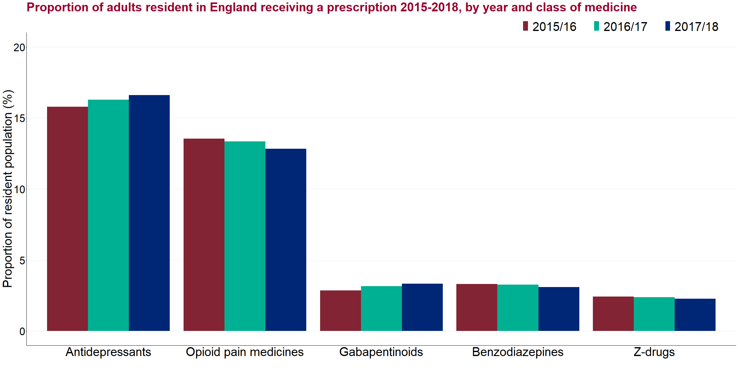

Figure 1: Proportion of adults resident in England receiving a prescription 2015 to 2018, by year and class of medicine

Figure 2 shows the breakdown of all individuals by the first year when they appeared in the 3-year reporting period. Between one-half (benzodiazepines) and two-thirds (antidepressants) of all those receiving a prescription in any of the 3 years had a prescription in the first year of the period (2015 to 2016).

This distribution would be expected given the limited timeframe of the available data. Many of those in receipt of a prescription during this period will have been prescribed that medicine before 2015 to 2016.

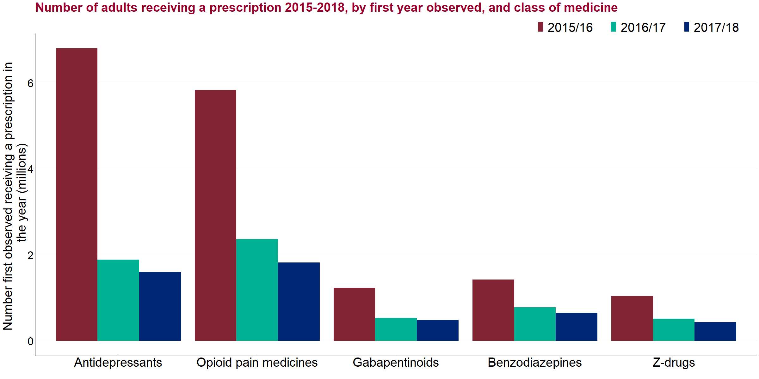

Figure 2: Number of adults receiving a prescription 2015 to 2018, by first year observed, and class of medicine

Figure 3 shows the breakdown by the number of years (1, 2 or 3) in which individuals were observed in the data. Among all adults who received an antidepressant prescription at any time in the 3-year periods, the largest group (43%, n=4.4 million) had at least one prescription in each of the 3 years. For the other classes of medicine, the proportion observed in all 3 years varied between 16% (benzodiazepines) and 31% (gabapentinoids).

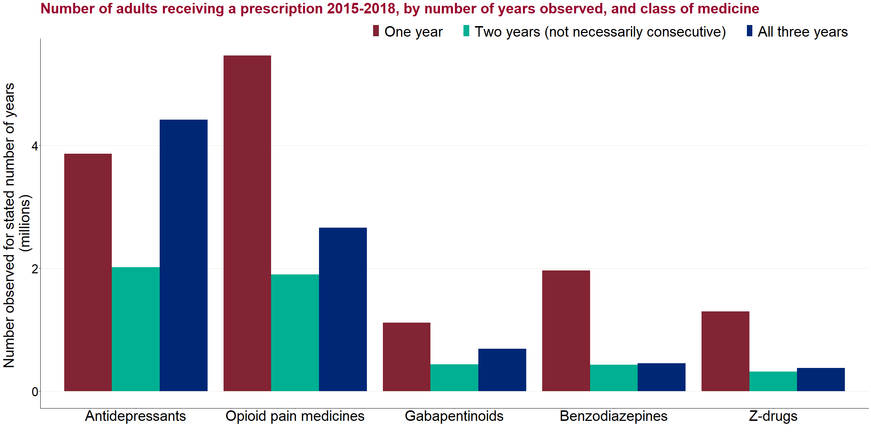

Figure 3: Number of adults receiving a prescription 2015 to 2018, by number of years observed, and class of medicine

The receipt of a prescription in each year does not necessarily imply continuous prescribing. Similarly, a short prescription around March and April could cross 2 financial years. Duration of prescribing is analysed in more detail in a later section.

**Sex and age group**

Figure 4a shows prescribing rates by medicine class and sex in 2017/18. Across all groups, the proportion of women receiving a prescription in the year was at least 1.5 times higher than the proportion of men. The greatest observed difference by sex was for antidepressants, where 21.3% of women received a prescription compared to 11.6% of men (1.8 times greater), and the smallest relative difference was for opioid pain medicines (15.3% of women, 10.1% of men).

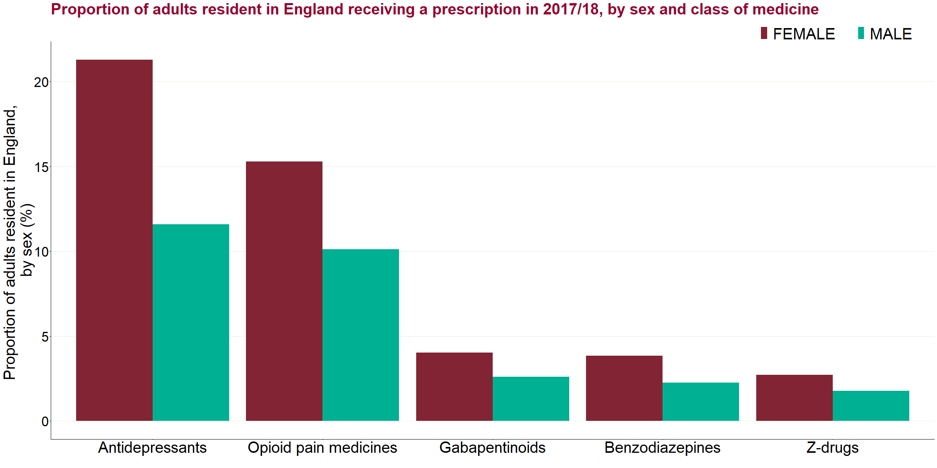

Figure 4a: Proportion of adults resident in England receiving a prescription in 2017 to 2018, by sex and class of medicine

For 2017/18, figure 4b shows for prescribing rates by class and by age group. The youngest band is 18 to 24 years. Then, 5-year bands are shown from 25 to 89 years, and the oldest group is 90 years and above.

Overall, prescribing rates increased with age, although this was not uniform and there were differences between the medicine class. For opioid pain medicines, there was an increase with every age group and the oldest age group had around 9 times the prescribing rate of the youngest age group. For gabapentinoids, the peak was in the 80-84 age group, at 12 times higher than the youngest age group, before reducing to around 9 times higher in the oldest age group. For antidepressants, the equivalent difference was just over 2 times the rate of the oldest to youngest group.

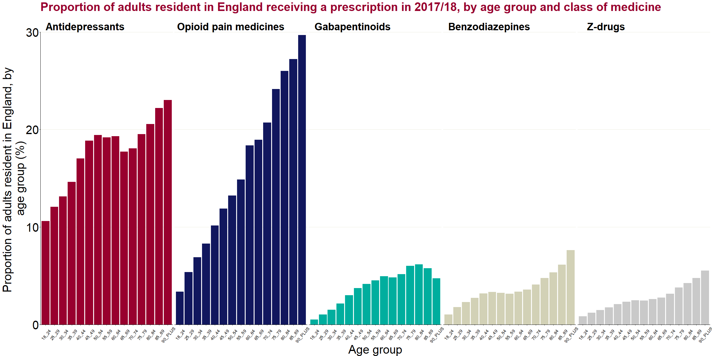

Figure 4b: Proportion of adults resident in England receiving a prescription in 2017 to 2018, by age group and class of medicine

An analysis of prescription rates by age group and sex (not shown here) indicated that across every age group, and for each medicine class, the prescribing rates were higher among women, while the broad patterns by age group shown in figure 7b were observed by sex.

**Deprivation**

For the analysis of deprivation, Indices of Multiple Deprivation (IMD) were used, grouping GP practices by quintile[7]. Each individual was assigned to the deprivation quintile associated with their GP practice. Totals by deprivation quintile were summed from GP practice totals.

Figure 4c shows the variation in the annual prescribing rate by deprivation. The positive (increasing) association between the annual prescribing rate and deprivation quintile was pronounced for opioid pain medicines and gabapentinoids. For these medicines, the prescribing rate for individuals in the most deprived quintile was approximately 1.6 times the rate for those in the least deprived quintile.

A less pronounced positive correlation was observed for antidepressants, although the most deprived quintile had a markedly increased rate compared to the least deprived quintile. For benzodiazepines and z-drugs there appeared to be evidence of similar or slightly decreasing rates with higher deprivation.

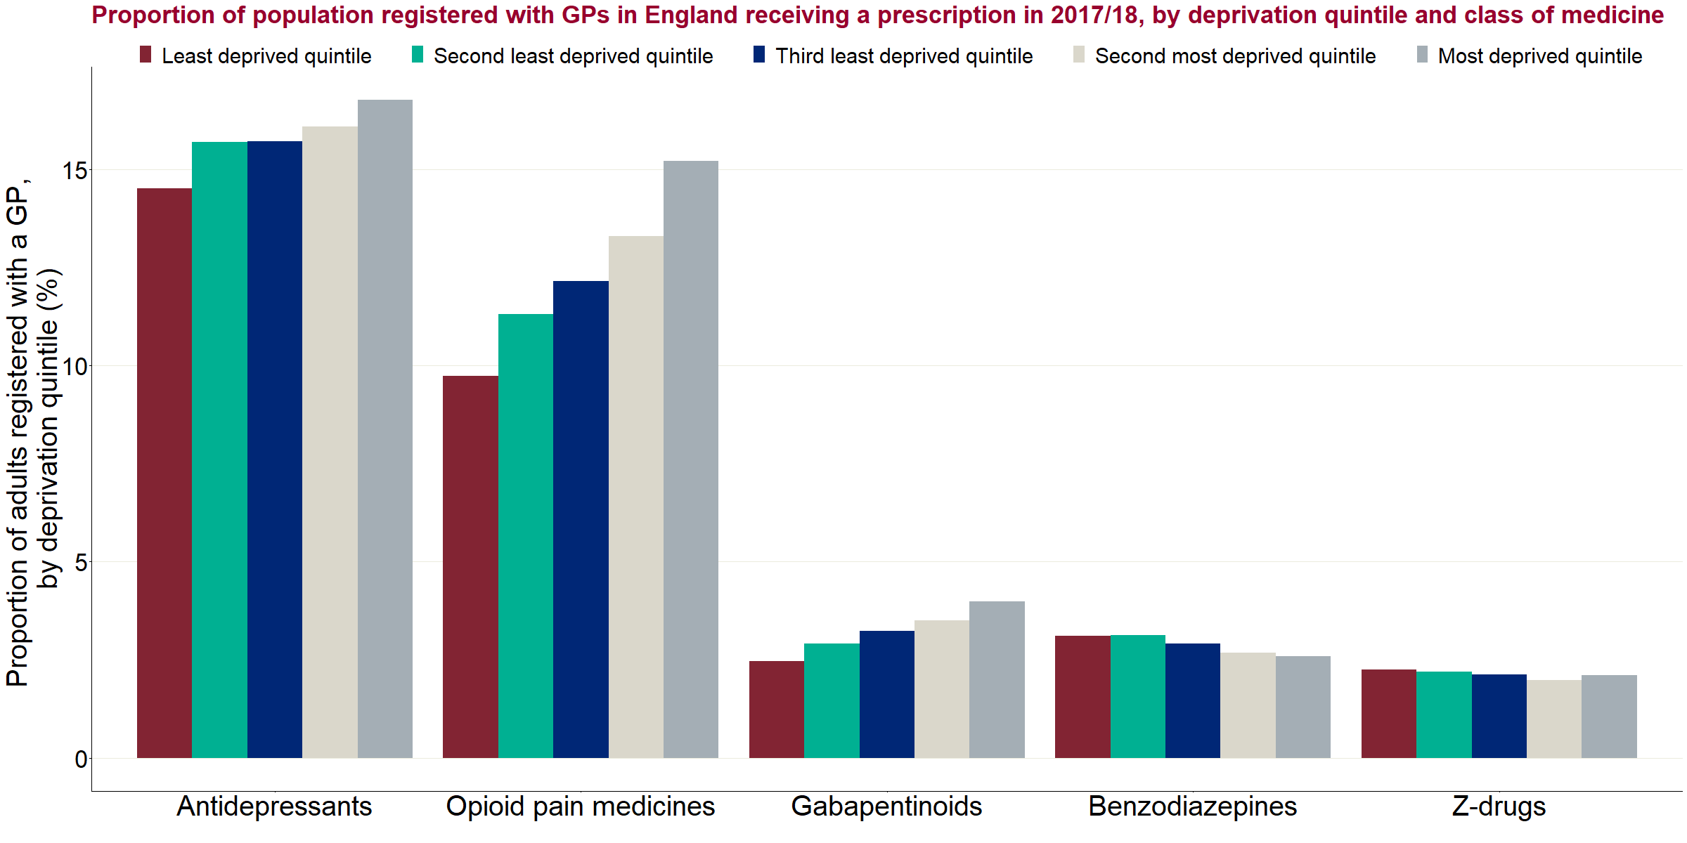

Figure 4c: Proportion of population registered with GPs in England receiving a prescription in 2017 to 2018, by deprivation quintile and class of medicine

**CCG variations**

For this analysis, rates of the registered population in each CCG were calculated for the 195 CCGs in England. Crude proportions were first calculated for each CCG to compare actual prescribing rates. Age-sex standardised rates were then calculated to estimate variations between CCGs having taken into account differences in age-sex distribution.

For 2017/18, table 3 shows summary statistics for the 195 CCGs, including the median crude proportion receiving a prescription in a CCG, the variation between the lowest and highest crude proportions observed in any CCG, and the interquartile range. A more detailed analysis of CCG-related data will be published later, after the review.

Table 3: Summary statistics for 195 CCGs in 2017 to 2018

|  |  |  |  |  |
| --- | --- | --- | --- | --- |
| **Medicine class** | **Median crude proportion with a prescription (%)** | **Lowest proportion in a CCG (%)** | **Highest proportion in a CCG (%)** | **Interquartile range of CCGs (%)** |
| Antidepressants | 16.9 | 7.3 | 22.5 | 14.2 - 18.5 |
| Opioid pain medicines | 12.5 | 5.7 | 20.6 | 10.6 - 14.6 |
| Gabapentinoids | 3.2 | 1.4 | 6.1 | 2.5 - 3.9 |
| Benzodiazepines | 2.9 | 1.2 | 5.1 | 2.5 - 3.4 |
| Z-drugs | 2.1 | 0.9 | 3.8 | 1.8 - 2.5 |

Table 4 shows a correlation matrix for the crude proportions receiving a prescription for each medicine class by CCG. A crude correlation score between -1 and 1 was assigned to compare the proportions in each class.

There were high positive scores between the antidepressant, opioid pain medicine and gabapentinoid categories, and between the benzodiazepines and z-drugs categories (highlighted in darker green). All other correlations were positive but the relationship for other combinations was weaker. This demonstrates that there is a relationship at the CCG level between prescribing rates for these classes but does not necessarily mean that the same individuals are receiving medicines from more than one of the classes. Direct co-prescribing to individuals is explored later in the analysis.

Table 4: Correlation matrix for the crude proportions receiving a prescription for each class of medicine in each CCG

|  |  |  |  |  |  |
| --- | --- | --- | --- | --- | --- |
| **Medicine classes being compared** | **Anti-depressants** | **Opioid pain medicines** | **Gaba-pentinoids** | **Benzo-diazepines** | **Z-drugs** |
| Antidepressants | - | 0.85 | 0.81 | 0.51 | 0.30 |
| Opioids | 0.85 | - | 0.89 | 0.32 | 0.15 |
| Gabapentinoids | 0.81 | 0.89 | - | 0.38 | 0.21 |
| Benzodiazepines | 0.51 | 0.32 | 0.38 | - | 0.80 |
| Z-drugs | 0.30 | 0.15 | 0.21 | 0.80 | - |

Figure 5 shows the variation in age-sex standardised prescribing rates between CCGs across the 5 medicine classes. After age and sex adjustment, there was considerable variation between CCGs. There are other factors, such as deprivation, that could influence the variation between CCGs and that have not been considered here.

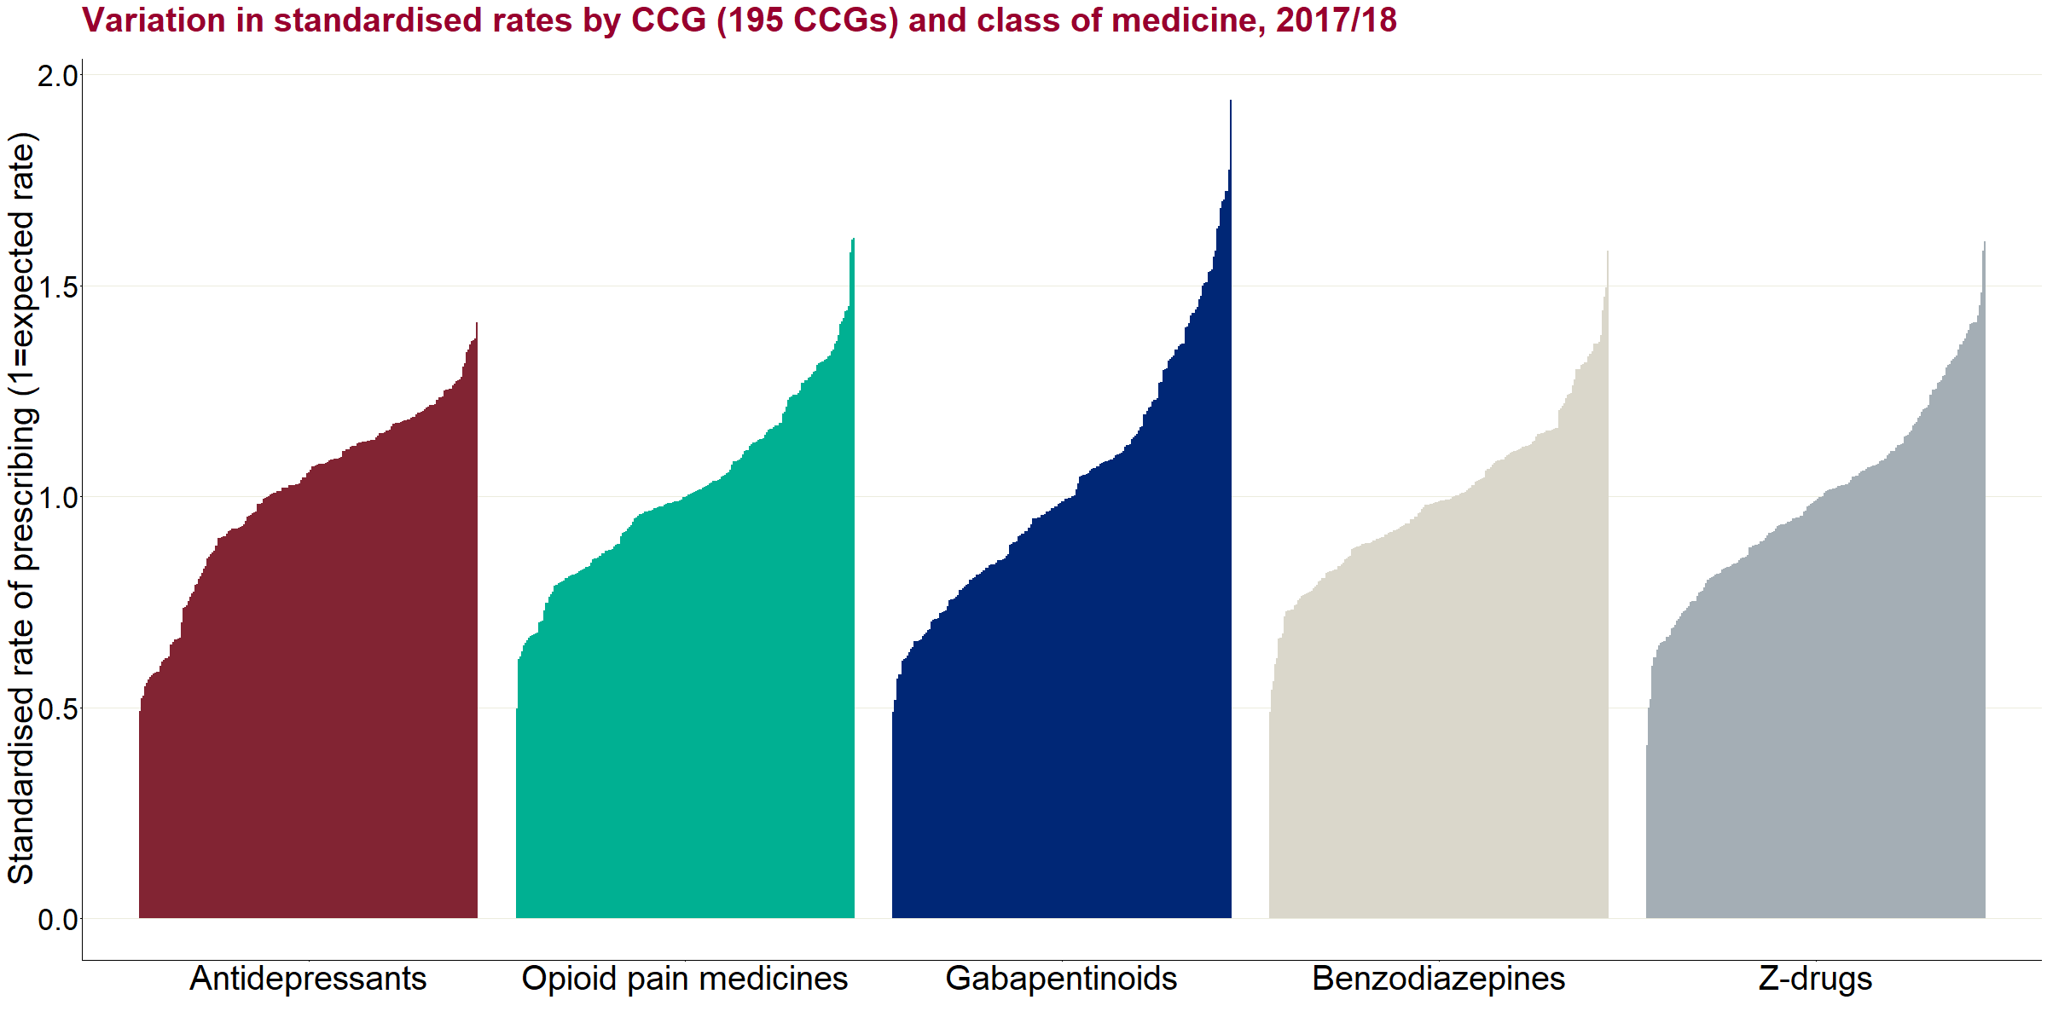

Figure 5: Variation in standardised rates by CCG (195 CCGs) and class of medicine, 2017 to 2018

CCGs are ordered from the lowest standardised rate to the highest for each medicine class. The order of CCGs therefore varies between the classes.

Duration of prescriptions

**Methodology**

Defining duration of prescriptions:

In this analysis, continuous prescribing was estimated by first judging whether an individual was in receipt of a prescription in each month[8]. The consecutive months in which an individual was judged to be in receipt of a prescription were taken to be periods of continuous prescribing.

Retrospective and prospective approaches:

In this analysis, 2 ways of assessing the distribution by duration of prescriptions were used. Both provide important information and need to be considered together, but they are distinct from one another. They are:

**Prospective** **approach** – estimates the total number of individuals who started a new period of prescribing for a given month and then ‘looks forward’ to the duration of continuous prescribing to the end of this period of prescribing, or to June 2018 if prescribing is on-going

**Retrospective approach** – estimates the total number of individuals who were in receipt of a prescription in a given month, and ‘looks back’ to the duration of continuous prescribing up to that point, back to April 2015[9]

In the example in table 5, an individual has had 2 prescribing periods (shaded sections), each continuously for 4 months. The individual started in month 1 and continued to month 4, so their total length of the continuous prescribing was counted as 4 months. If reported by the prospective approach at month 1 (highlighted in red), they would be reported with a duration of 4 months. For the second period, this began in month 9 and the duration of prescribing up until month 12 (the reporting month) was also 4 months up until that point, and may or may not continue into month 13 and beyond. If reported by the retrospective approach at month 12 (highlighted in blue), they would be reported with a duration of 4 months.

When analysing trends, information ‘as at’ the month of reporting is used. Therefore, in the example below the individual would be reported by the prospective approach in month 9 with a duration of 4 months. They would also appear in the retrospective approach in month 11, for example, with a duration of 3 months, as that is the duration of the period of prescribing up to that point.

Table 5: Example prescribing pattern for retrospective and prospective analysis



Since individuals in receipt of a prescription for a longer duration will go on to appear for more months, it would be expected that the retrospective approach will yield higher estimates for measures of long-term prescribing in contrast to prospective approach.

Defining current receipt of a prescription:

Three different methods were considered as a way of identifying if an individual is in receipt of a prescription at any month and how a period of continuous prescribing is defined. These were based on inferences from the observed pattern of prescriptions in the NHSBSA data. The inferences were:

* the defined duration if the individual had to have a new prescription reported in the month (so, any month in which no prescription was reported would break off a period of continuous prescribing)
* the defined duration if the individual had no more than one month at any time without a prescription reported (for example, if an individual had a prescription reported in February and another in April, they would then be judged to have a prescription in March) - this method allows for multiple one month breaks within a period of continuous prescribing and would include a scenario where prescriptions are reported every other month
* the defined duration if an individual had no more than 2 months at any time without a prescription reported - this is the same as the second method but is relaxed to allow 2 month breaks within a continuous prescribing period

To avoid concurrent reporting of all results by multiple methods, the second method (allowing for a one-month gap) was selected as the main approach for the analysis in the main body of the report. It was judged that this method had the right balance between allowing for genuine reasons for a gap in the data (such as due to prescriptions of up to 2 months or delays in reporting to NHSBSA), while reducing the risk of considering a prescription to be continuous over what was a real gap in prescribing.

However, all methods are compared at a high level in figure 6 (using the retrospective approach for March 2018 and measuring those with a continuous duration of 12 months or more) so that the difference each approach makes can be seen. Counting prescriptions as continuous over one-month breaks (labelled ‘using one month gap’) substantially increases the proportion of individuals who are counted as having been in receipt of a prescription for 12 months or more across all classes. Counting prescriptions as continuous over 2-month breaks (labelled ‘using 2 month gap’) also results in a further, smaller increase in this proportion.

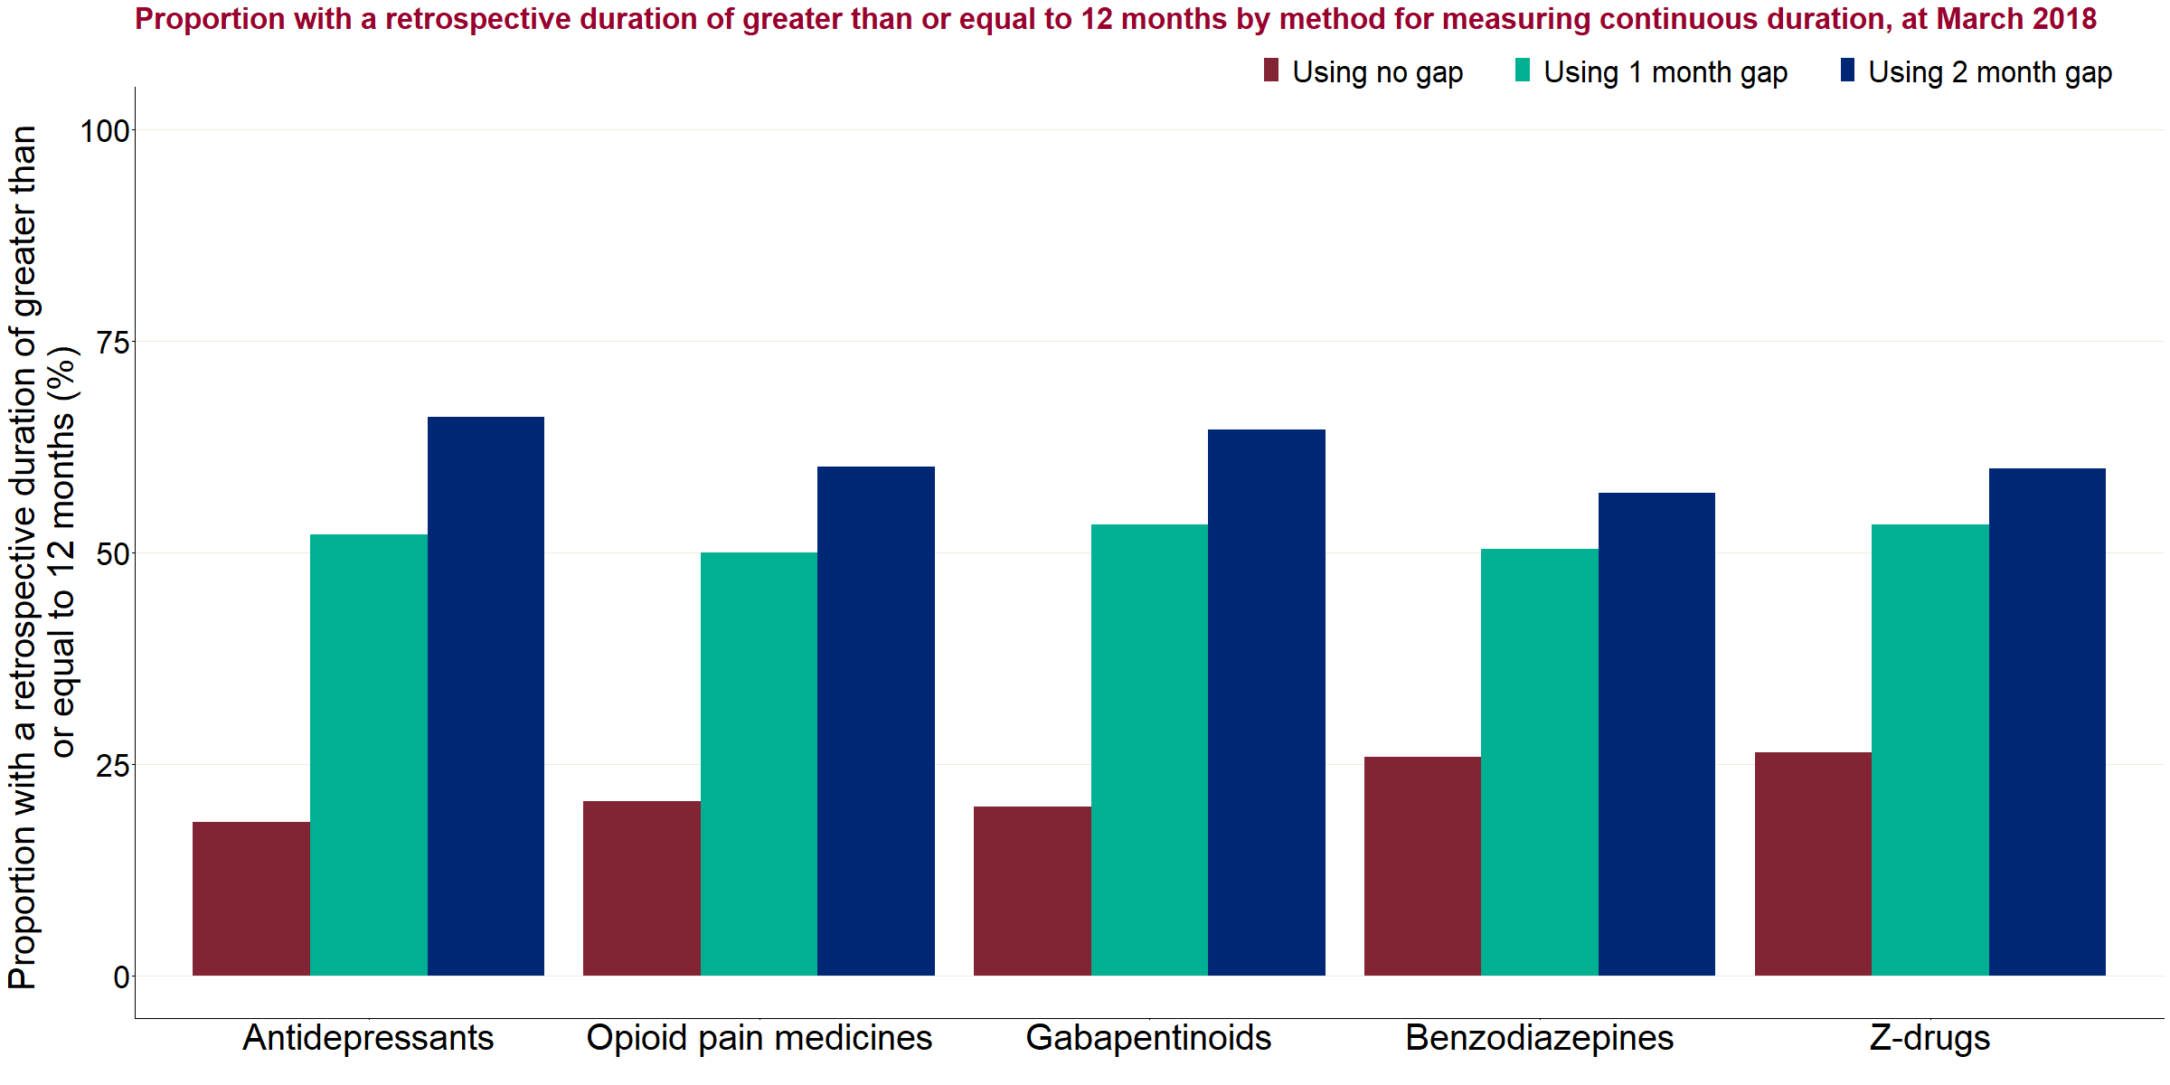

Figure 6: Proportion with a retrospective duration of greater than or equal to 12 months by method for measuring continuous duration, at March 2018

Limitations:

Any assessment of continuous prescribing from this data will be approximate due to the lack of specific information about prescribing dates, which has required inferences to be made from the month in which data was submitted to NHSBSA. In particular, it is inferred that if an individual is deemed to have a prescription for 2 adjacent months, these form part of a continuous prescribing period. Information was not available to show how closely together the prescriptions were dispensed, the volume that was dispensed or any other information that could help precisely define the length of each prescription, so prescriptions may be regarded as continuous where there was a gap in prescribing in practice. Conversely, if there is a month in which there was judged not to be a prescription, this would close a continuous prescribing period in all circumstances, even though it may be that the person did receive a prescription continuously in reality (such as an unusual delay in submitting data to NHSBSA). There may also be circumstances in which an individual takes the medicine at a different frequency to that prescribed, which could also create false gaps in this data.

**Results**

Prospective approach:

The data within this section initially reports on individuals who had their first prescription of a medicine class in the reporting period submitted during June 2015 and then how long they are then continuously prescribed to up to May 2018. A one-month gap has been permitted to allow for prescriptions that last longer than one month and/or to allow for delays in prescriptions being submitted to NHSBSA.

Figure 7 shows how many individuals had their first prescription submitted during June 2015 and how that compares to the total number of individuals who had a prescription submitted during 2015 to 2016. For antidepressants, there were around half a million people who had their initial prescription in June 2015, compared to 6.8 million people overall in the year having a prescription in that class.

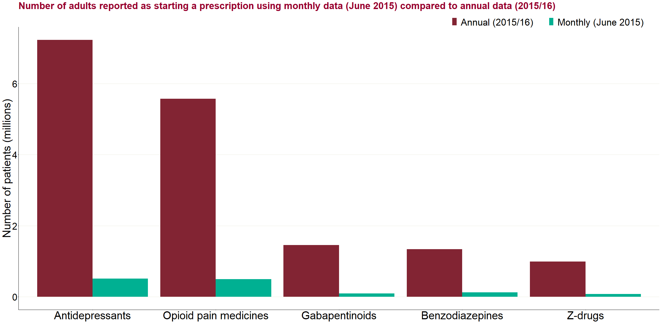

Figure 7: Number of adults reported as starting a prescription using monthly data (June 2015) compared to annual data (2015/16), by drug class

Prospective duration by class:

The following charts present the continuous prospective length of prescribing for each of the medicine classes within the analysis.

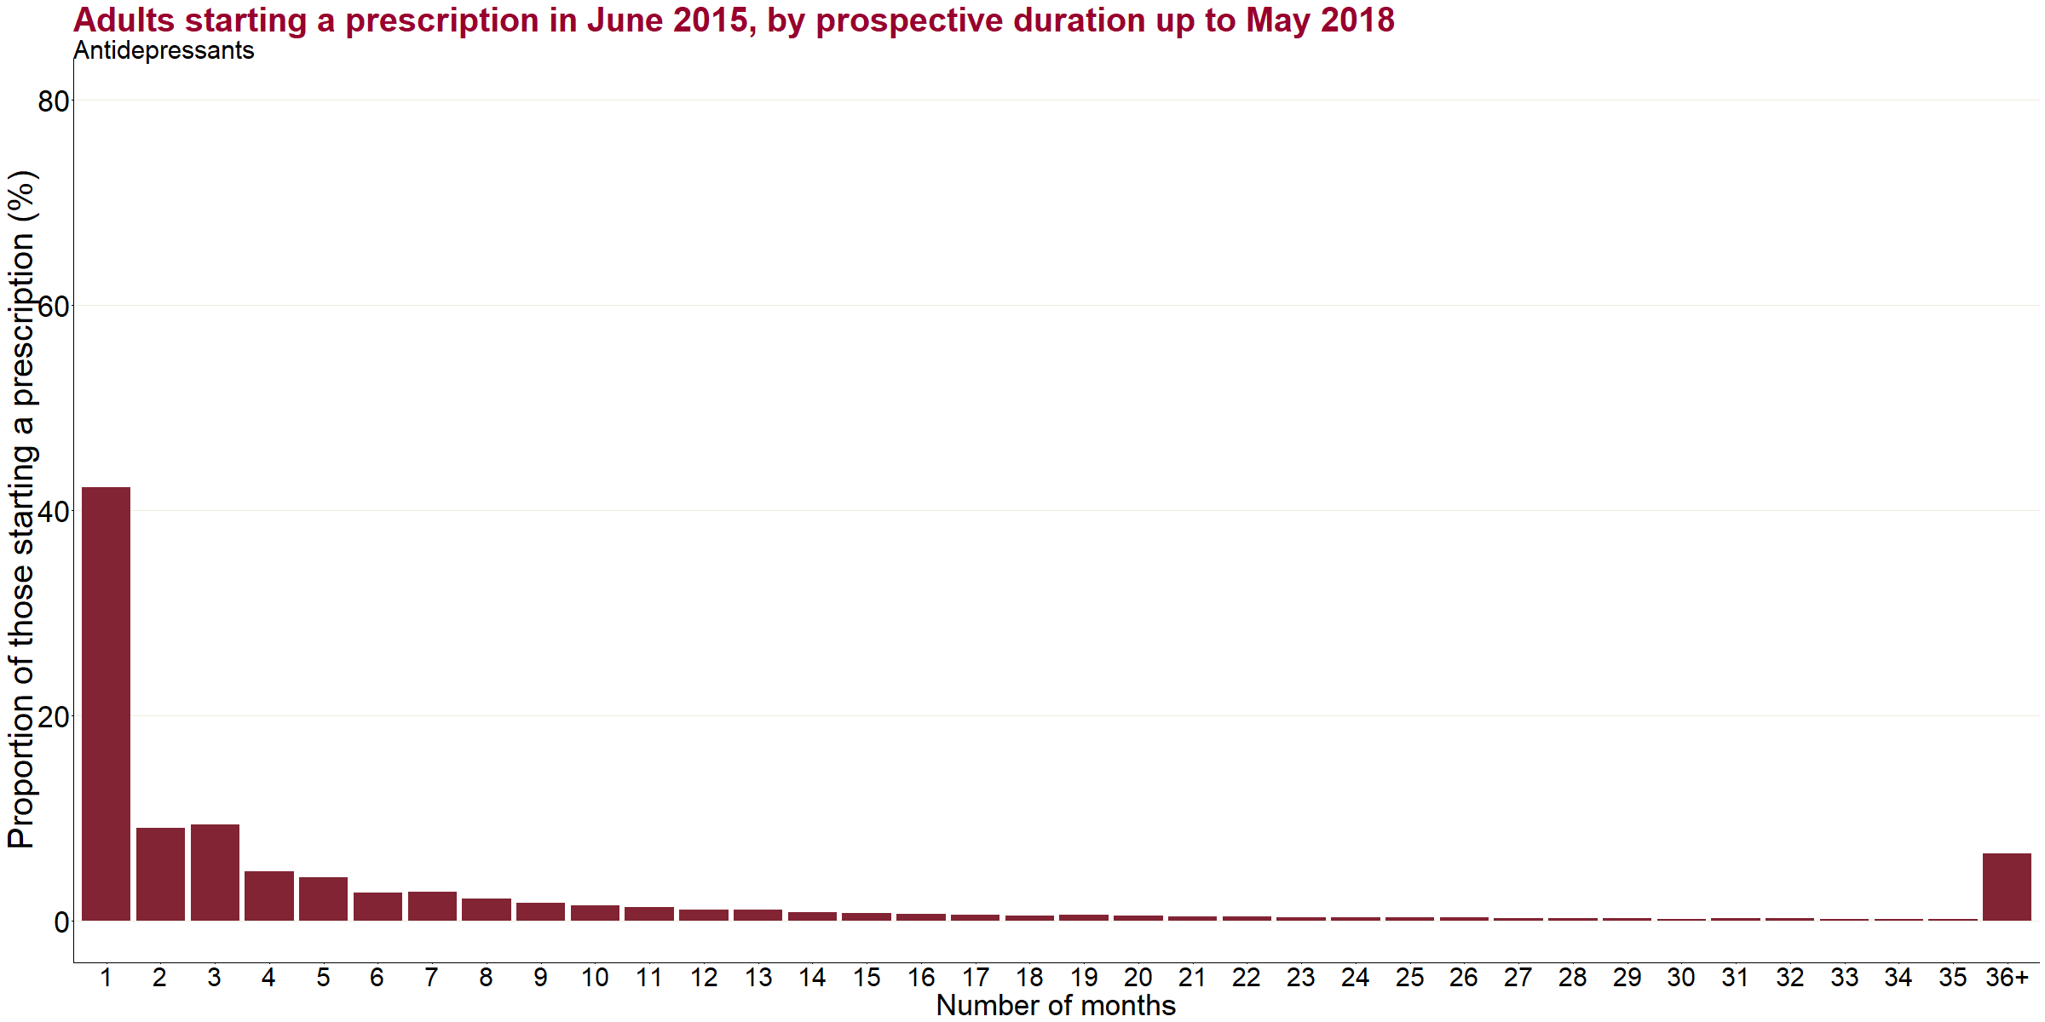

Figure 8a: Adults starting a prescription for antidepressants in June 2015, by prospective duration up to May 2018

Data for this chart is included in the technical annexe that accompanies this report

Figure 8a shows the prescribing duration of the approximately 512,000[10] individuals reported as starting a prescription for antidepressants in June 2015. Forty-two per cent were only in receipt of a prescription for an antidepressant for one month or less, with a further 18% with a duration of 2 or 3 months. The proportion of individuals with longer durations then generally decreases until a spike at 36 months, where 7% (around 33,000) had a continuous prescription for at least the full 36 months from June 2015 to May 2018.

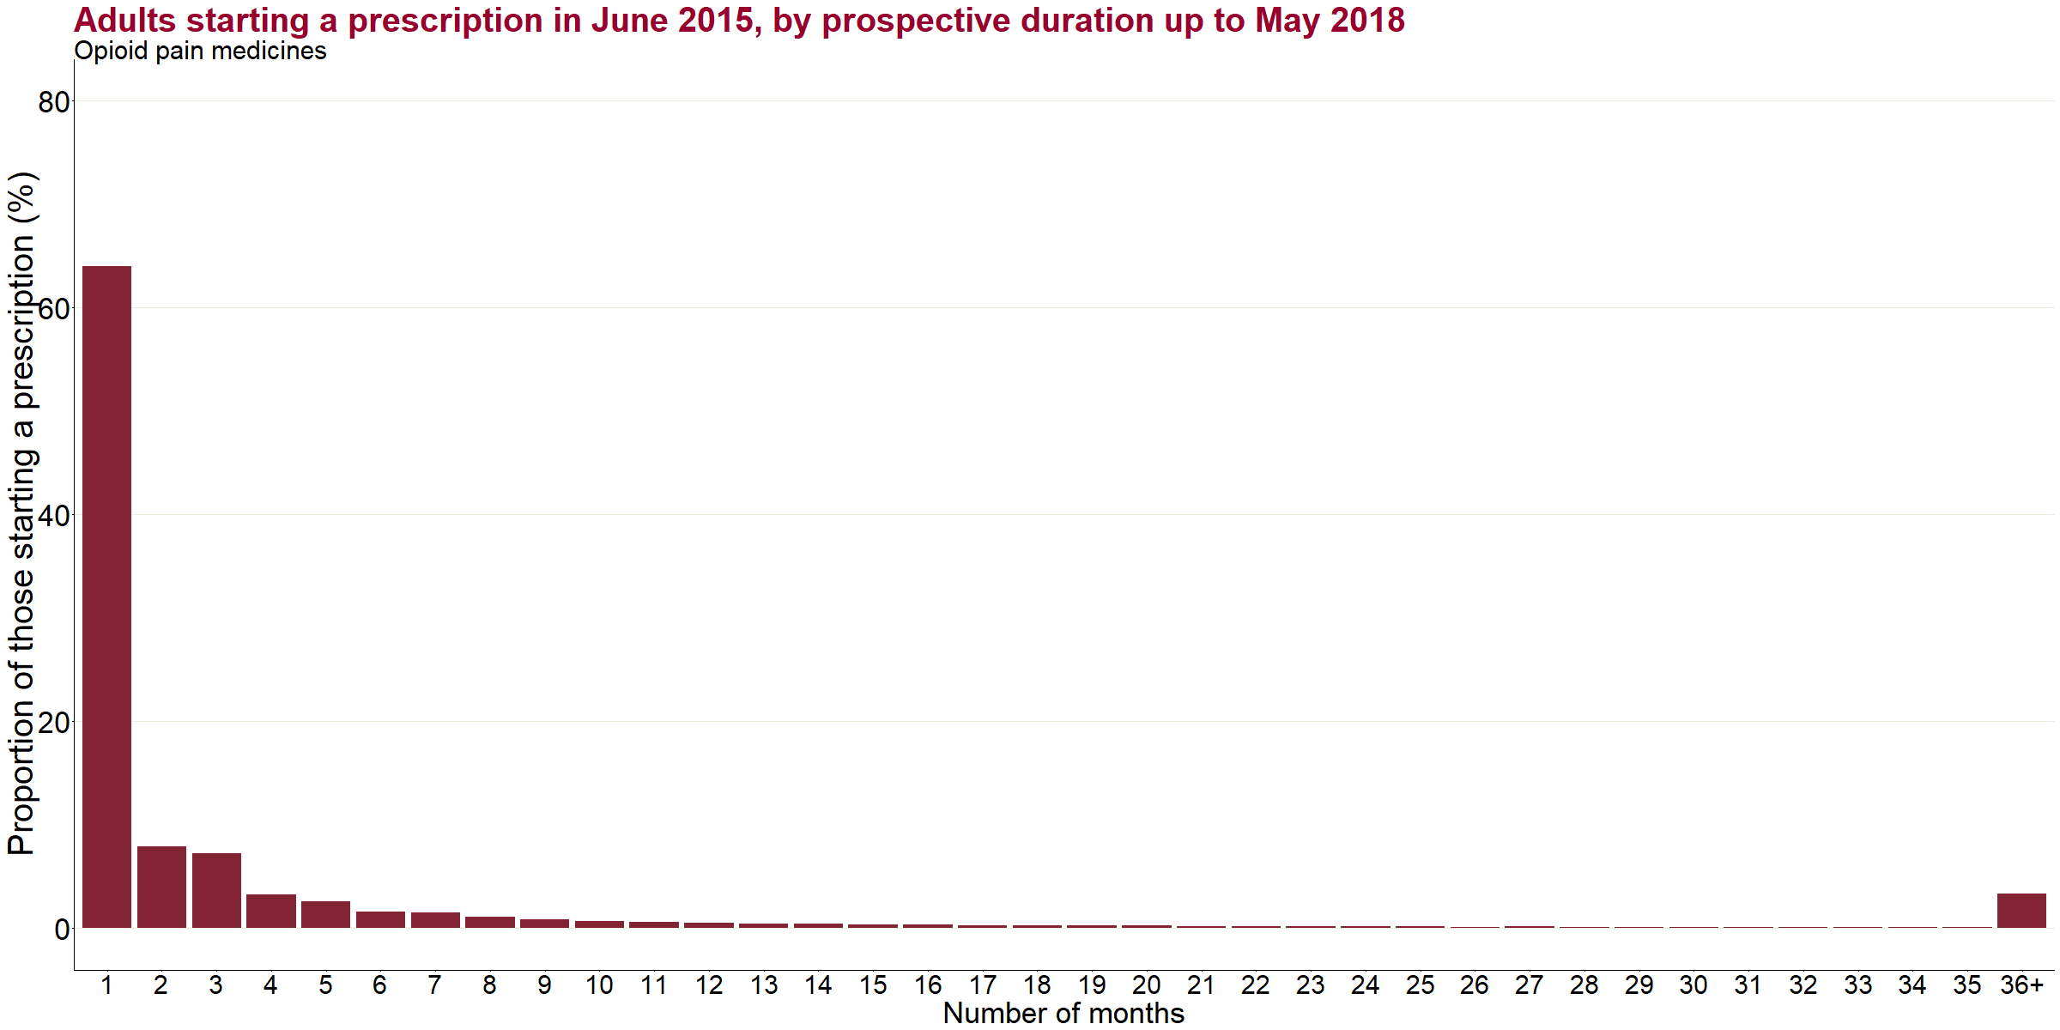

Figure 8b: Adults starting a prescription for opioid pain medicines in June 2015, by prospective duration up to May 2018

Data for this chart is included in the technical annexe that accompanies the report

In figure 8b, the distribution seen in the antidepressant duration analysis is replicated in those starting an opioid prescription in June 2015 (n=498,000) with the majority, 64% received a prescription for one month or less, followed by a large drop off to 15% receiving a prescription for 2 or 3 months. Proportionally there are then very few people receiving prescriptions for each number of months up until 36 months where 3% (approximately 16,500) individuals had a prescription lasting for at least the full June 2015 to May 2018 period.

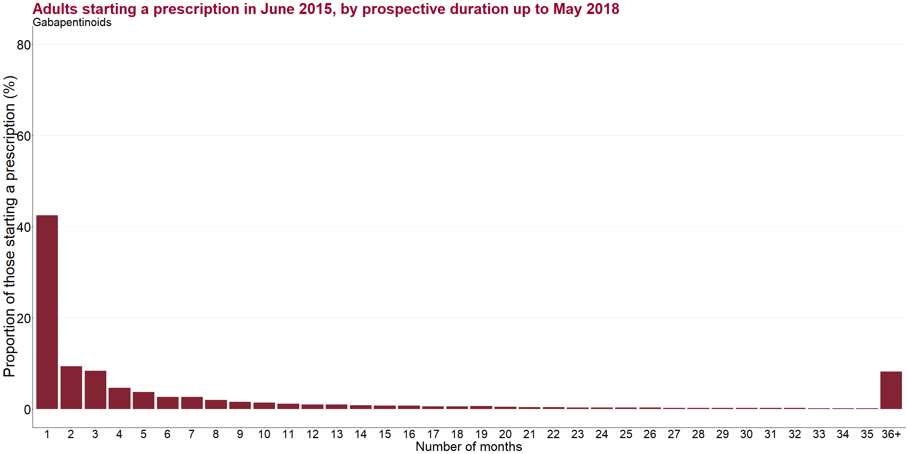

Figure 8c: Adults starting a prescription for gabapentinoids in June 2015, by prospective duration up to May 2018

Data for this chart is included in the technical annexe that accompanies the report

Figure 8c shows the prescribing duration of the 90,000 individuals starting a prescription for gabapentinoids in June 2015. Forty-three per cent were only in receipt of a prescription for gabapentinoids for one month or less, with a further 18% with a duration of 2 or 3 months. The proportion of individuals with longer durations is below 1% for each number of months from 13 months until a spike at 36 months, where 8% (approximately 7,400) had a continuous prescription for the full 36 months from June 2015 to May 2018. Note that gabapentinoids may necessarily be prescribed long-term to prevent epileptic seizures.

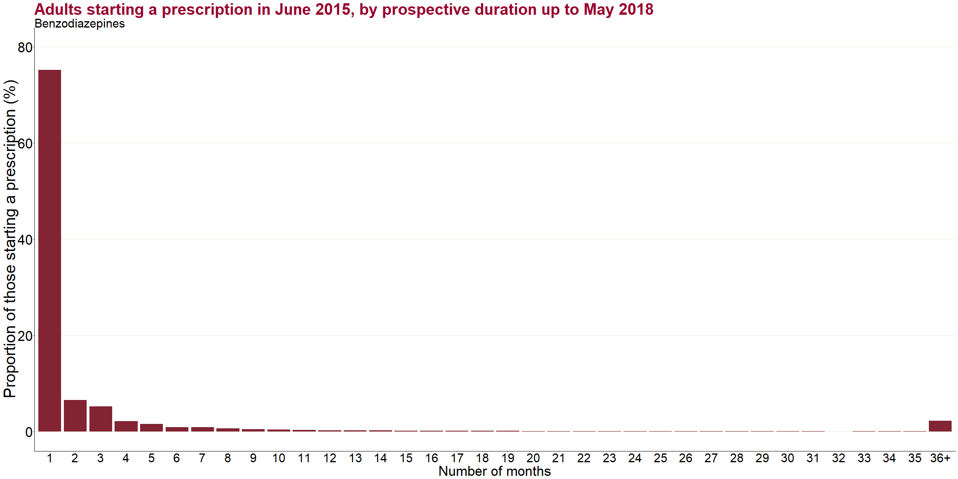

Figure 8d: Adults starting a prescription for benzodiazepines in June 2015, by prospective duration up to May 2018

Data for this chart is included in the technical annexe that accompanies this report

Figure 8d shows the prescribing duration of those starting a prescription for benzodiazepines in June 2015 (n=119,000). Seventy-five per cent of people in receipt of a prescription for benzodiazepines received it for one month or less, while a further 12% have a duration of 2 to 3 months. The proportion of individuals with longer durations is below 1% for each number of months from 6 months onwards until an increase at 36 months, where 2% (around 2,700) had a continuous prescription for the full 36 months from June 2015 to May 2018.

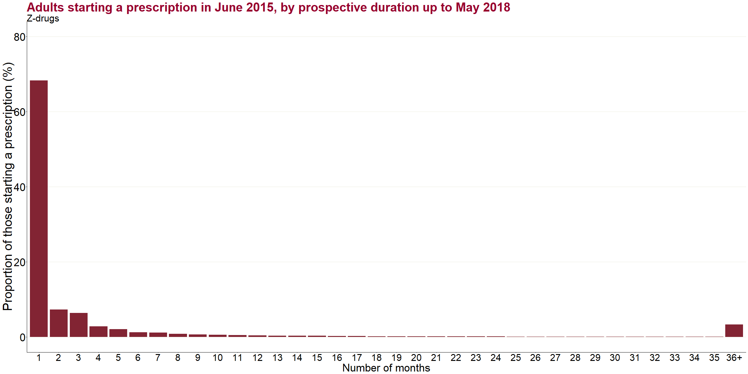

Figure 8e: Adults starting a prescription for z-drugs in June 2015, by prospective duration up to May 2018

Data for this chart is included in the technical annexe that accompanies this report

Figure 8e shows the prescribing duration of the 77,000 individuals starting a prescription for z-drugs in June 2015. Sixty-eight per cent were only in receipt of a prescription for z-drugs for one month or less, with a further 14% with a duration of 2 or 3 months. The proportion of individuals with longer durations is below 1% from 8 months until 36 months, where 3% (approximately 2,500) had a continuous prescription for the full 36 months from June 2015 to May 2018.

**Comparison of prospective prescribing durations by medicine class**

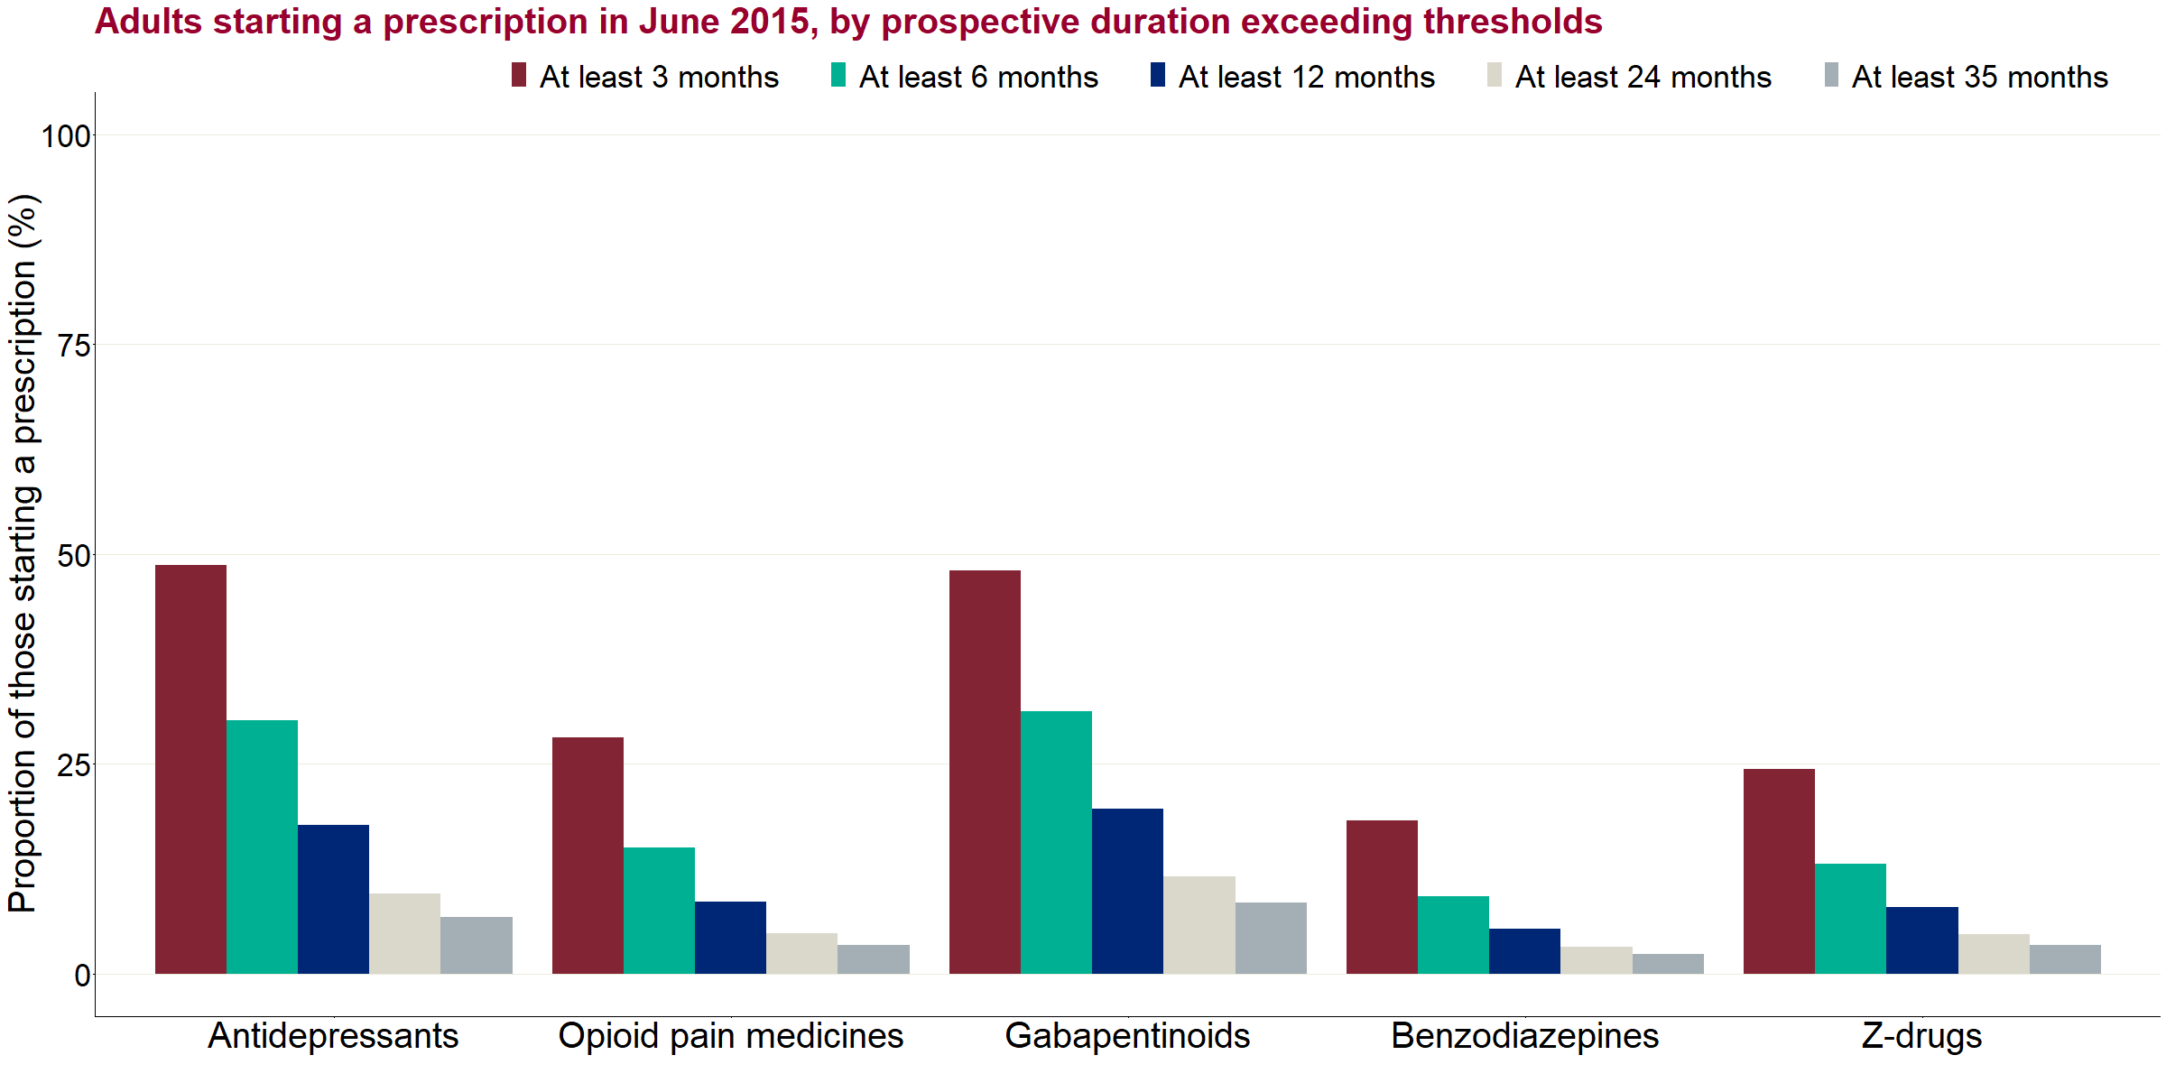

Figure 9: Adults starting a prescription in June 2015, by prospective duration exceeding thresholds and by medicine class

Figure 9 shows a comparison of different durations of prescribing by medicine class, showing the proportions who received a prescription for at least 3 months, at least 6 months, at least 12 months, at least 24 months or for all months (at least 35 months)[11].

In general, the distribution was very similar across all 5 classes, although the actual proportions exceeding the thresholds varied considerably by class. For example, nearly half of individuals starting a prescription for antidepressants (49%) and gabapentinoids (48%) in June 2015 had a prescription for at least 3 months or more compared 18% for benzodiazepines.

**Trend in prospective prescribing**

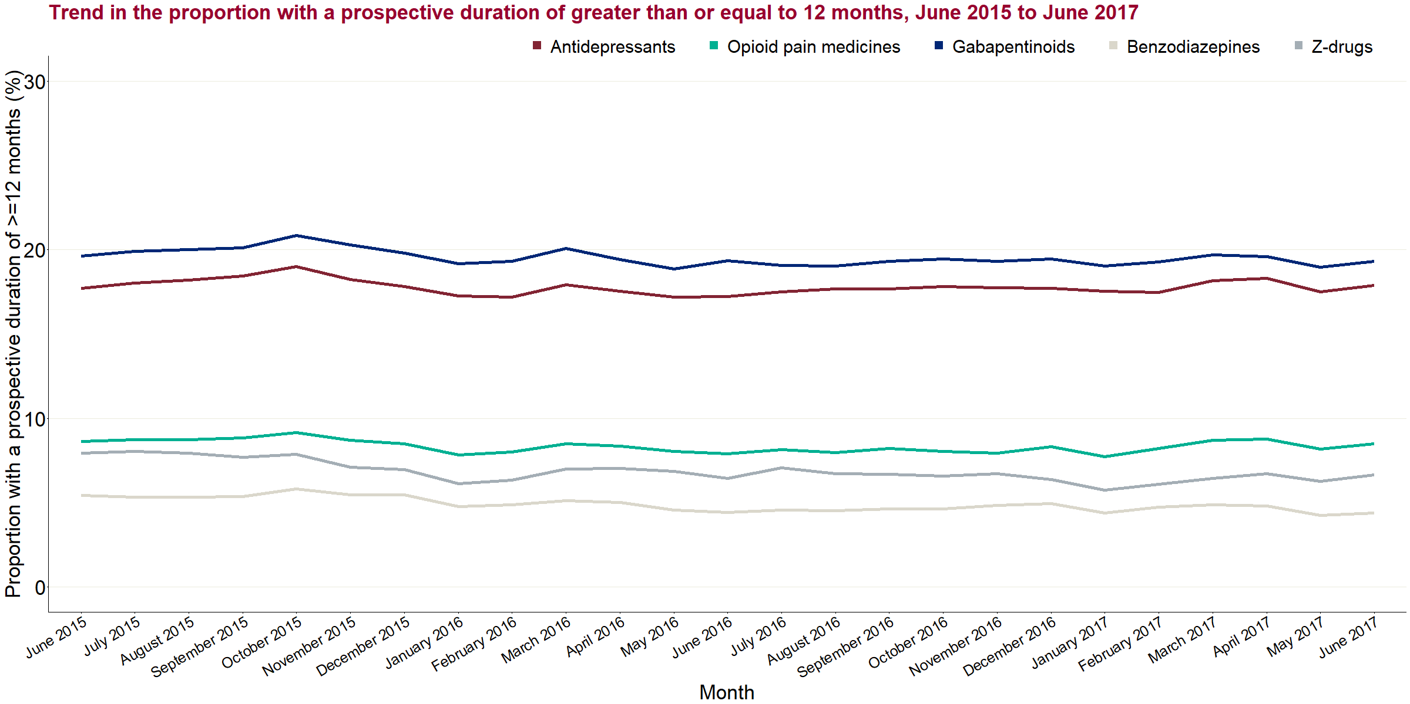

Figure 10: Trend in the proportion with a prospective duration of greater than or equal to 12 months by medicine class, June 2015 to June 2017

Figure 10 shows the proportion of individuals who were in receipt of a prescription in each of the 5 classes continuously for 12 months or more and how this varied over time. For all medicine classes this proportion remained relatively stable between June 2015 and April 2017, with the only percentage point increase in antidepressants at 0.2% and the biggest decrease in z-drugs at -1.3%.

**Prospective profile**

Sex:

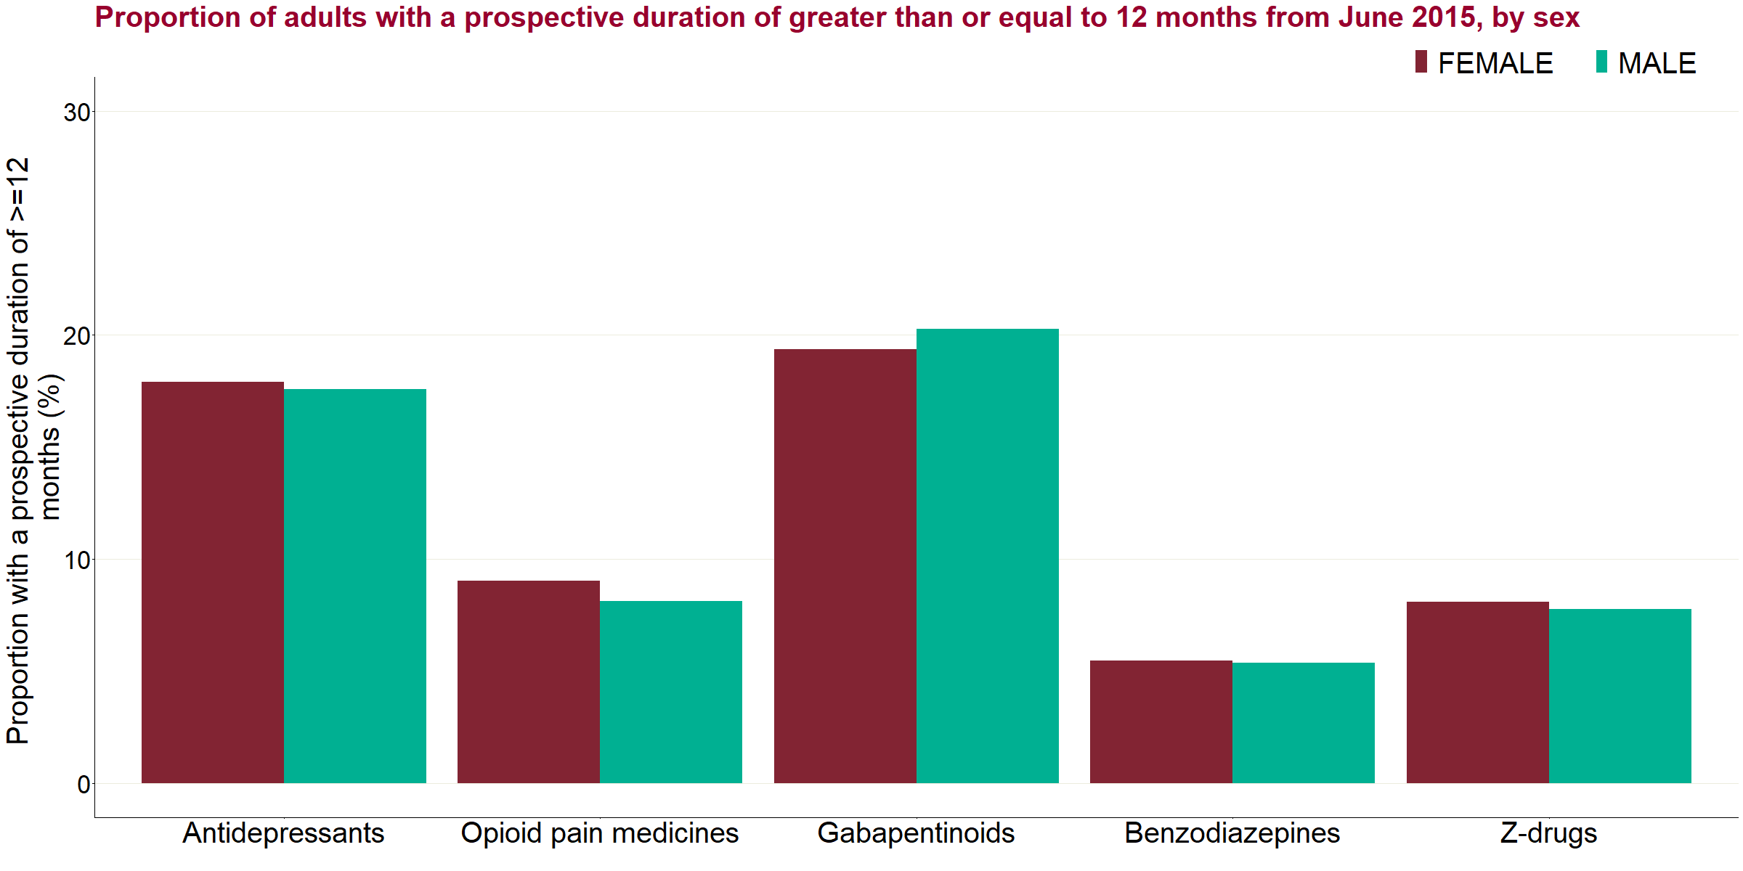

Figure 11a: Proportion of adults with a prospective duration of greater than or equal to 12 months from June 2015, by medicine class and sex

There was little variation in the proportions receiving a prescription for 12 months or between men and women, with the largest difference for those starting a prescription in June 2015 prescribed gabapentinoids though it was less than 1% (19.4% female vs. 20.3% male). However, as women have higher prescribing rates generally, the number of women receiving a prescription for 12 months or more was greater than the number of men in every medicine class.

Age:

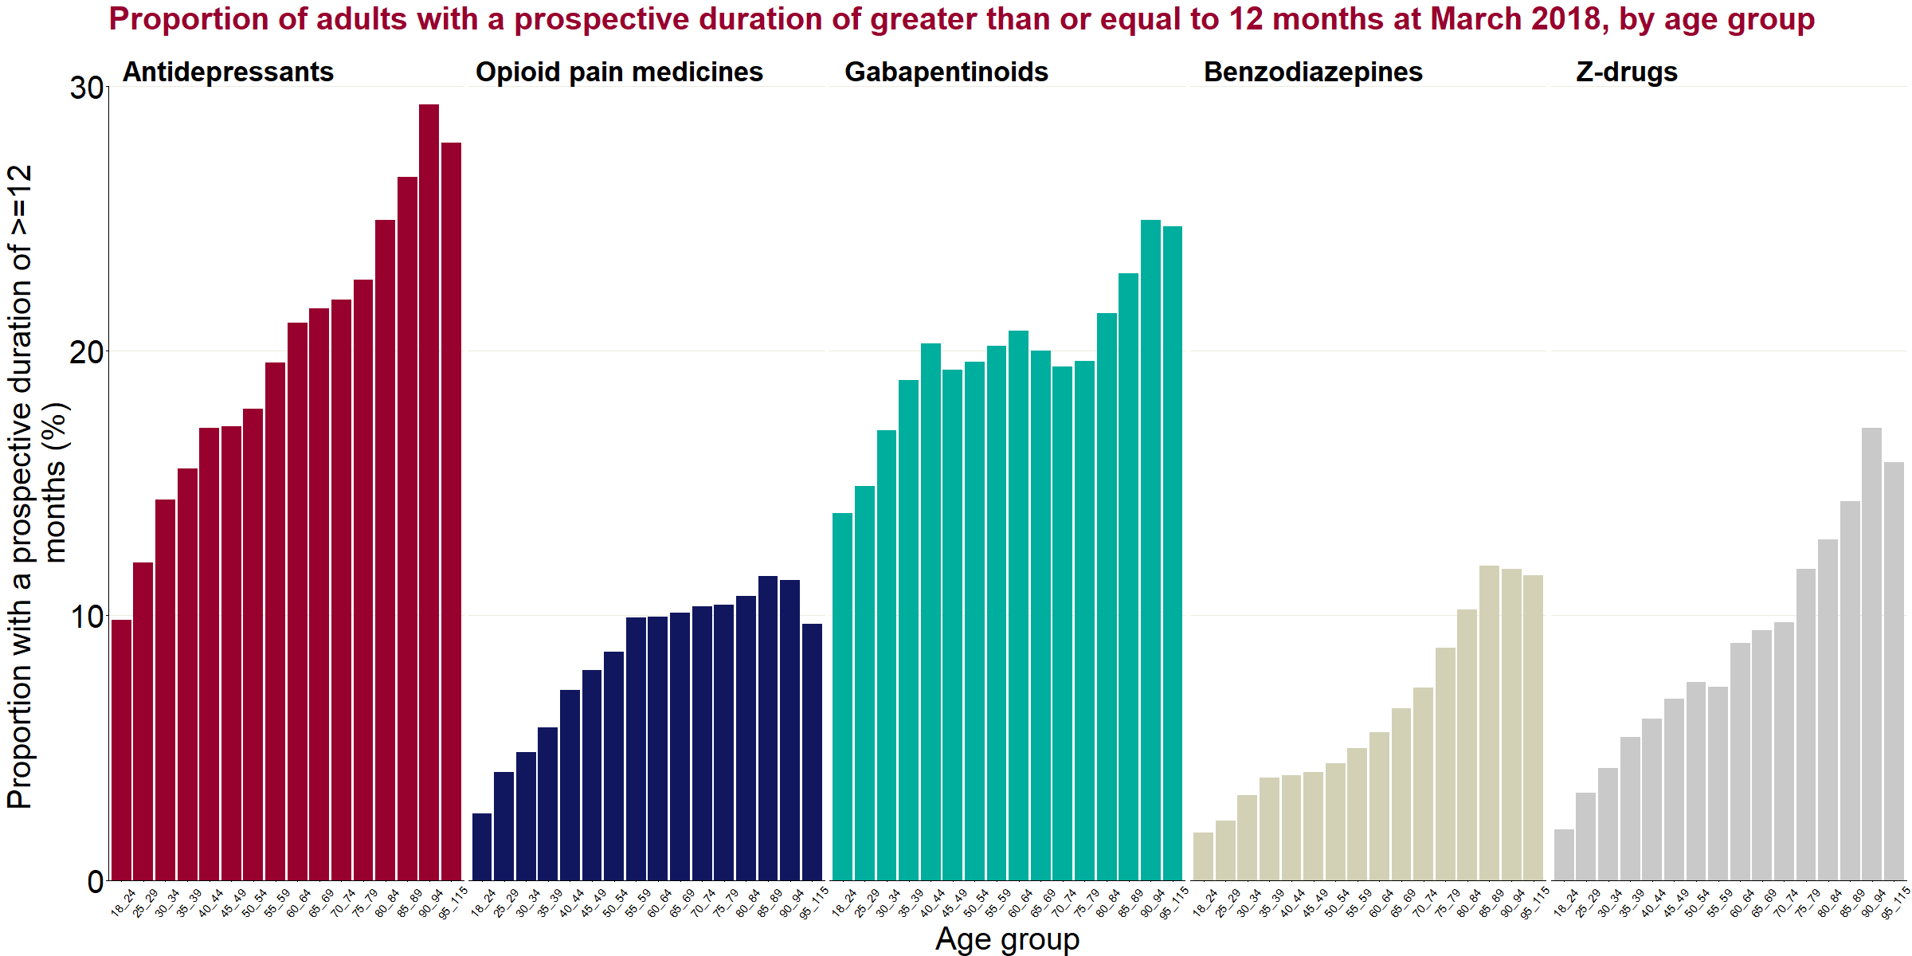

Figure 11b: Proportion of adults with a prospective duration of greater than or equal to 12 months from June 2015, by medicine class and age group

In this analysis, age groups are as in the analysis of overall rates, starting at 18 to 24, except that here the 90+ age group is split into 90 to 94 and 95+. Generally, the proportion of individuals receiving a prescription for 12 months or more increases with age, with those on a prescription for antidepressants, z-drugs or benzodiazepines showing a reasonably steady linear increase. This proportion for opioid medicines increased until around age 50 and then levelled off before increasing again in some older age groups, while for gabapentinoids this proportion increased until age 44 before stabilising for a period and then increasing notably after age 80.

Deprivation:

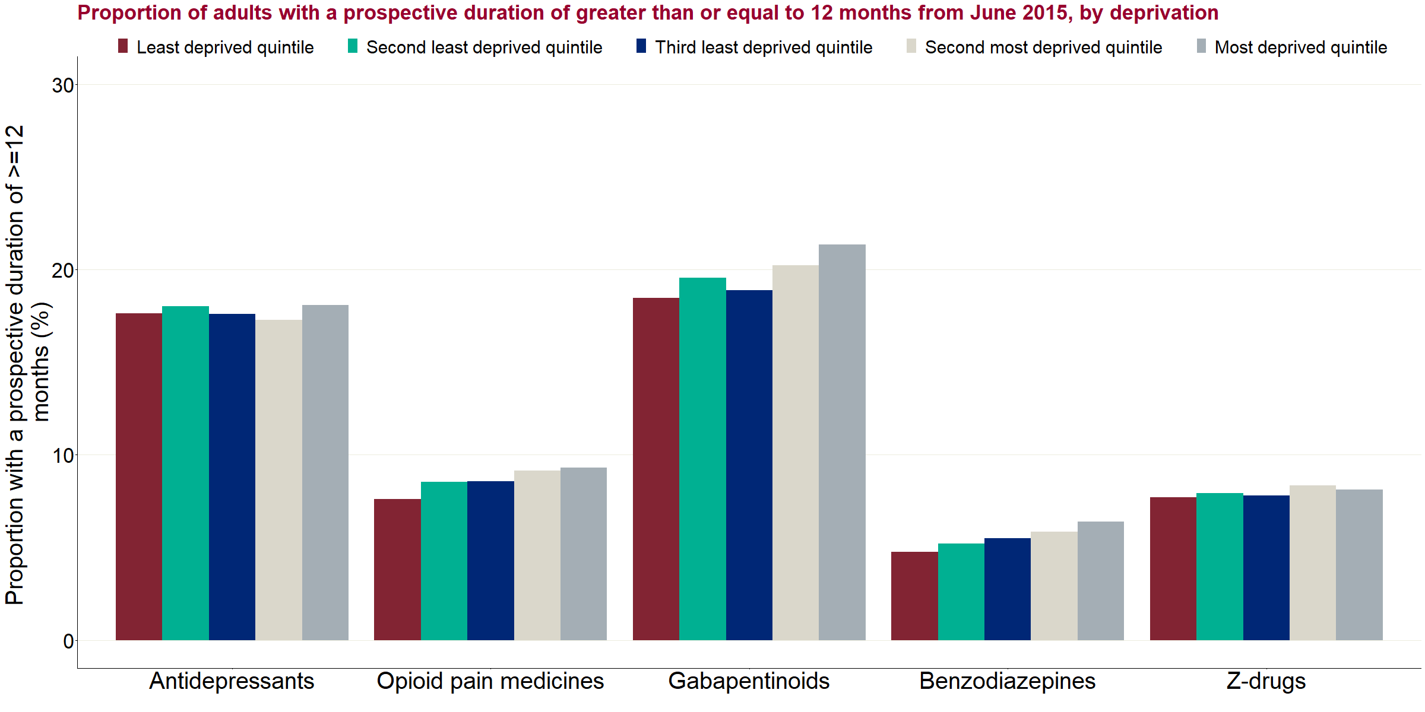

Figure 11c: Proportion of adults with a prospective duration of greater than or equal to 12 months from June 2015, by medicine class and deprivation

For opioids, gabapentinoids and benzodiazepines the proportion of individuals receiving a prescription for 12 months or more increased with deprivation – with those living in the most deprived areas being slightly more likely to be on a prescription for a year or more. The most notable difference in this proportion between the most and least deprived quintiles was seen in those prescribed gabapentinoids (18% vs 21%). The proportion of individuals in receipt of a prescription for 12 months or more by deprivation was stable for antidepressants and z-drugs.

Variation by CCG:

Table 6 presents the variation at a CCG level in the proportion of individuals receiving a prescription for 12 months or more by medicine class, having started at June 2015. There are substantial variations between the lowest and highest proportions in a CCG across all the medicine classes.

Table 6: Variation at a CCG level in the proportion of individuals receiving a prescription for 12 months or more, of those starting a prescription in June 2015, by medicine class

|  |  |  |  |  |
| --- | --- | --- | --- | --- |
| **Medicine class** | **Median proportion (%)** | **Lowest proportion in a CCG (%)** | **Highest proportion in a CCG (%)** | **Interquartile range of CCGs (%)** |
| Antidepressants | 18.0 | 7.8 | 30.6 | 15.1 - 20.4 |
| Opioid pain medicines | 8.7 | 4.3 | 13.8 | 7.5 - 9.9 |
| Gabapentinoids | 20.3 | 9.1 | 31.0 | 16.7 - 22.1 |
| Benzodiazepines | 5.2 | 1.6 | 10.0 | 4.3 - 6.4 |
| Z-drugs | 7.6 | 2.2 | 16.7 | 6.3 - 9.1 |

Table 7 shows the correlation in the combinations of medicine classes being prescribed for 12 months or more. A correlation score between -1 and 1 is assigned by comparing the proportions in each class at CCG level. A higher positive score indicates that CCGs that tend to prescribe for 12 months or more for one class of drug also tend to do the same for the second medicine class in the combination.

For all combinations there were positive correlations between the proportions prescribed to for 12 months or more of the different medicine classes. These correlations were much stronger between the antidepressant, opioid and gabapentinoid classes, so that CCGs where one of these classes was prescribed at a higher rate for 12 months or more also tended to have a high rate with another.

Table 7: Correlation between proportions prescribed for 12 months or more at CCG level, by drug class, for those starting a prescription in June 2015

|  |  |  |  |  |  |
| --- | --- | --- | --- | --- | --- |
| **Medicine classes being compared** | **Antidepressants** | **Opioid pain medicines** | **Gabapentinoids** | **Benzodiazepines** | **Z-drugs** |
| Antidepressants | - | 0.75 | 0.76 | 0.40 | 0.19 |
| Opioid pain medicines | 0.75 | - | 0.74 | 0.50 | 0.24 |
| Gabapentinoids | 0.76 | 0.74 | - | 0.38 | 0.17 |
| Benzodiazepines | 0.40 | 0.50 | 0.38 | - | 0.40 |
| Z-drugs | 0.19 | 0.24 | 0.17 | 0.40 | - |

**Retrospective approach**

Retrospective duration by class:

The data within this section reports on the individuals considered to be in receipt of a prescription in March 2018 and how long they had been continuously prescribed that class of medicine up until that point in time, back to April 2015. Again, a one-month gap was permitted to allow for prescriptions that last longer than one month and/or to allow for delays in prescriptions being submitted.

Where an individual is reported to have been in receipt of a prescription for the full 36 months it is highly likely that they will have already been receiving a prescription for that class at the start of the reporting period. It is not possible to determine how long they had already been in receipt of prescription at that point as it could range from one month to an indefinite period.

Due to the way the data is structured it is likely that a proportion of those in receipt for 35 months were also in receipt for the full 36 months and already receiving a prescription for that class at the start of the reporting period.

Figure 12 shows the number of individuals who have been included in this retrospective analysis by having a prescription submitted in March 2018 by class compared to the total number receiving a prescription in the year for the same class. Thirty-one per cent of those who had a prescription for benzodiazepines during 2017 to 2018 were estimated to be in receipt of a prescription in March 2018. This compares to 62% for antidepressants.

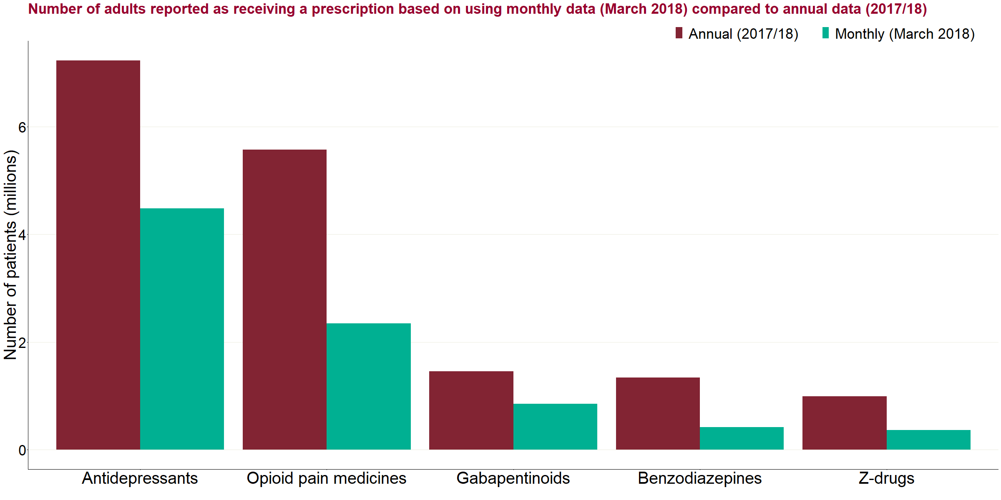

Figure 12: Number of adults reported as receiving a prescription based on using monthly data (March 2018) compared to annual data (2017 to 2018)

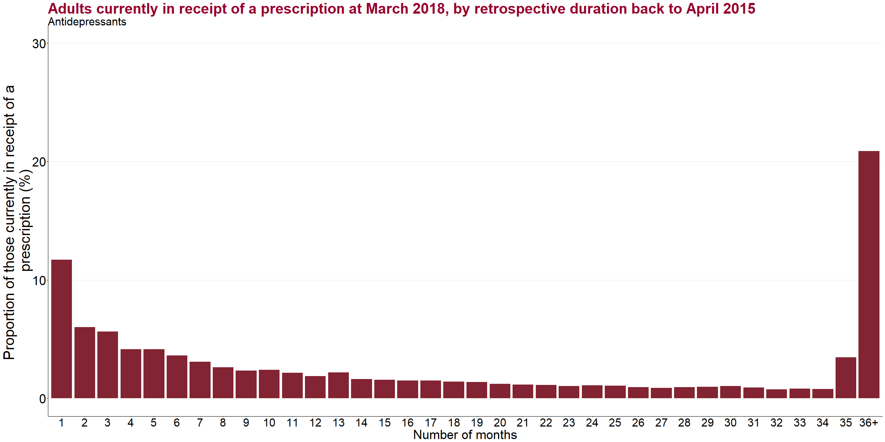

Figure 13a: Adults currently in receipt of a prescription for antidepressants at March 2018, by retrospective duration back to April 2015

Data for this chart is included in the technical annexe that accompanies this report

Figure 13a shows the retrospective duration for the 4.48 million individuals[12] considered to be in receipt of an antidepressant prescription in March 2018. Twenty-one per cent of them (approximately 940,000) had been in receipt of a prescription continuously for each of the preceding 36 months, with a further 3% (approximately 150,000) having had a prescription continuously for 35 months, indicating they were likely to have had a continuous prescription for the whole period.

Twelve per cent of individuals (approximately 520,000) had a duration of one month or less, denoting that their latest prescribing period began in March 2018. They could have had a prescription or prescriptions at other times during the reporting period.

The proportion of people continuously prescribed to for 2 to 34 months generally decreases.

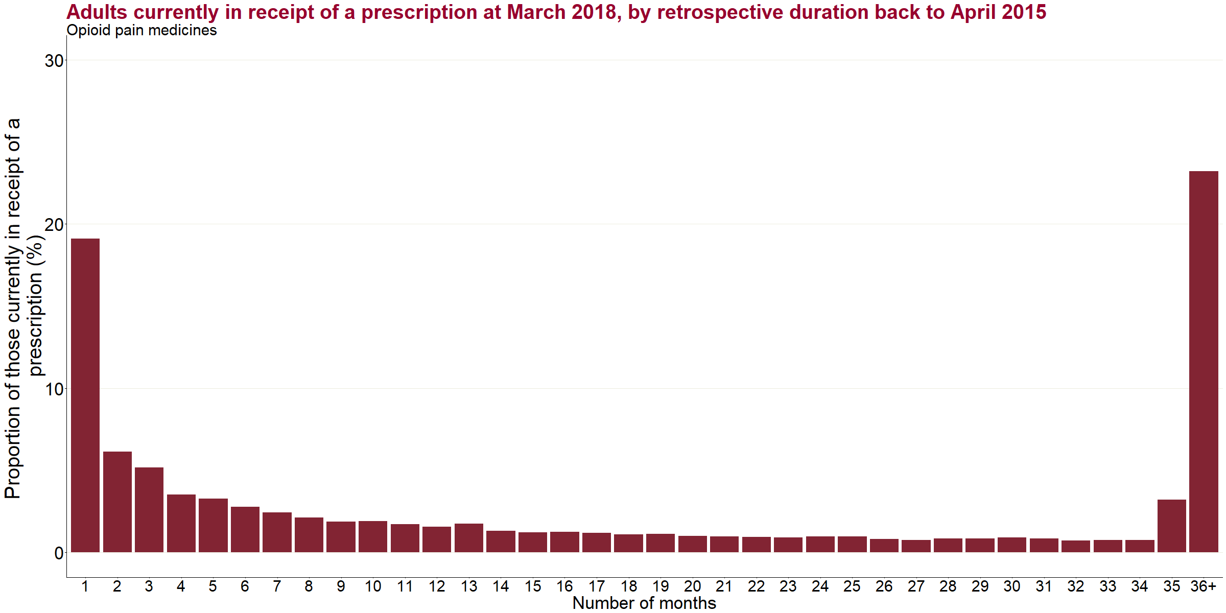

Figure 13b: Adults currently in receipt of a prescription for opioid pain medicines at March 2018, by retrospective duration back to April 2015

Data for this chart is included in the technical annexe that accompanies this report

Figure 13b shows the retrospective duration for individuals considered to be in receipt of a prescription for an opioid pain medicine in March 2018 (n=2.34 million). Of these, 23% (approximately 540,000) had been prescribed opioids continuously for 36 months or more, with a further 3% (approximately 80,000) who had a continuous prescription for 35 months. Nineteen per cent had received their first prescription in their latest (or only) spell that month.

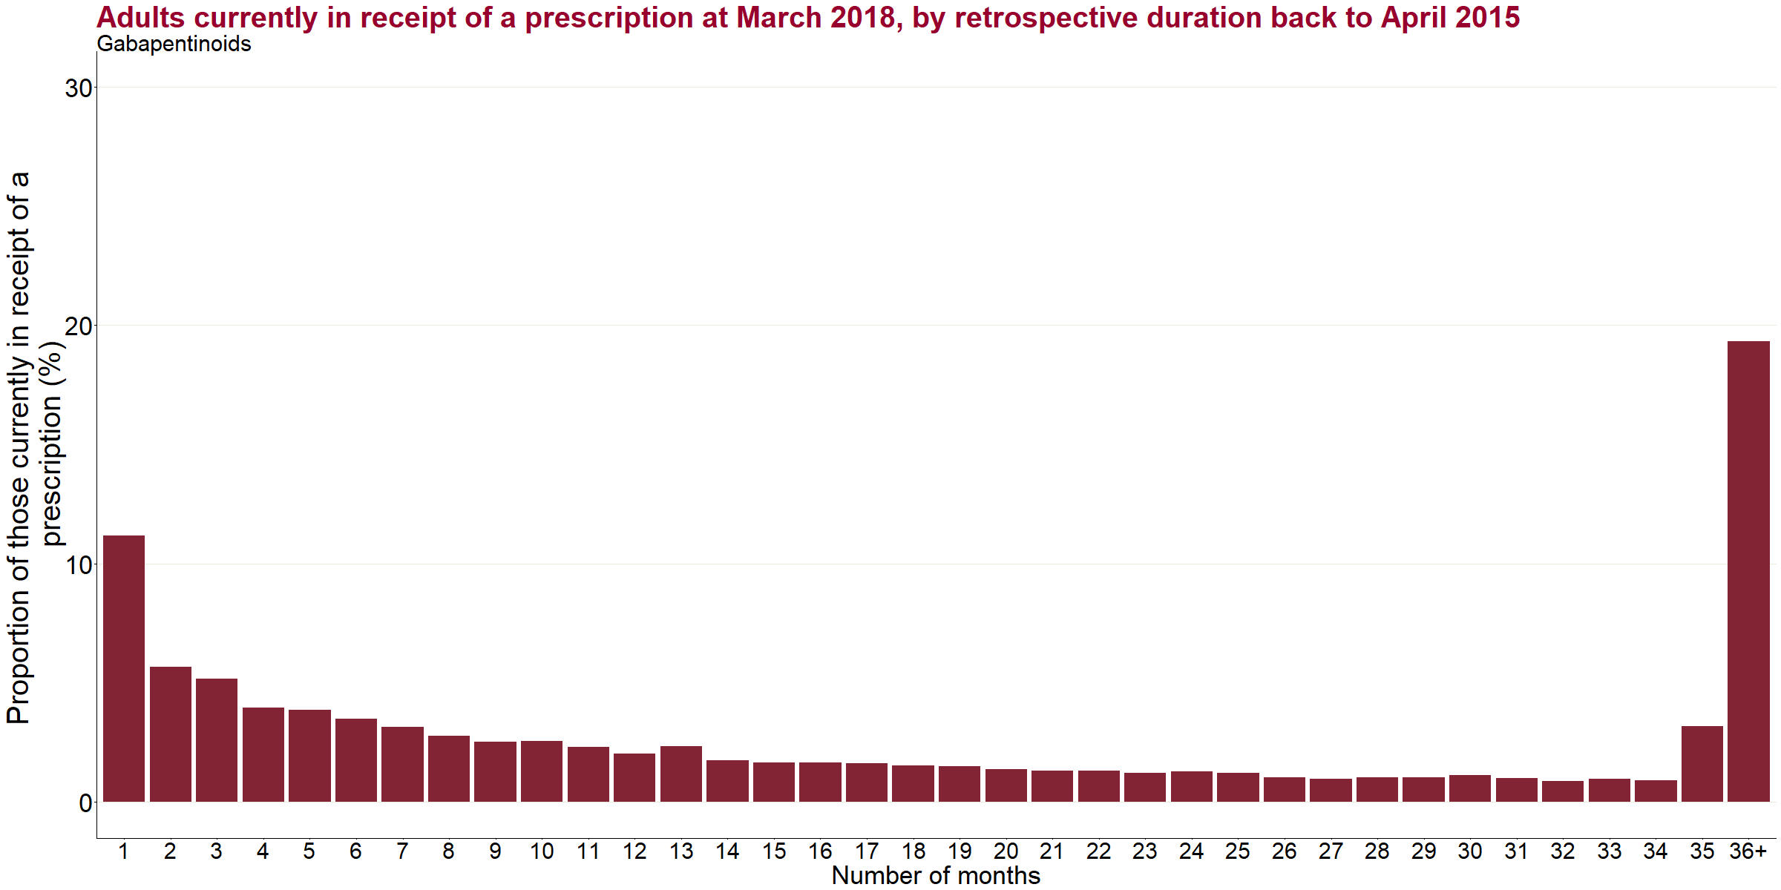

Figure 13c: Adults currently in receipt of a prescription for gabapentinoids at March 2018, by retrospective duration back to April 2015

Data for this chart is included in the technical annexe that accompanies this report

Figure 13c presents the retrospective duration for individuals considered to be in receipt of a prescription for gabapentinoids in March 2018 (n=850,000). Of these, 19% (around 160,000) had been prescribed gabapentinoids continuously for 36 months or more, with a further 3% (around 30,000) who had a continuous prescription for 35 months. Eleven per cent (around 100,000) had a prescription duration of one month or less. Note that gabapentinoids may necessarily be prescribed long-term to prevent epileptic seizures.

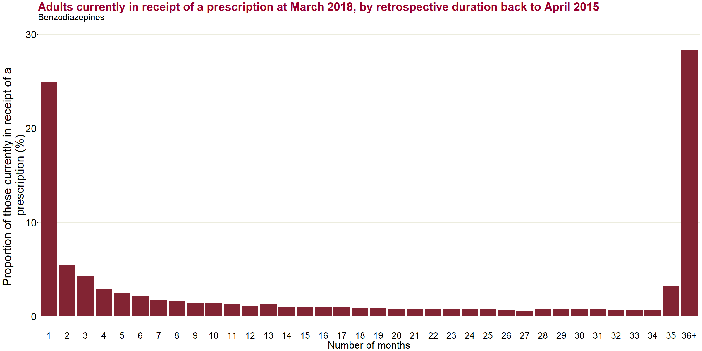

Figure 13d: Adults currently in receipt of a prescription for benzodiazepines at March 2018, by retrospective duration back to April 2015

Data for this chart is included in the technical annexe that accompanies this report

Figure 13d shows the retrospective duration for the individuals with a prescription for benzodiazepines reported for them in March 2018 (n=420,000). Of these, 28% (approximately 120,000) had been prescribed benzodiazepines continuously for 36 months or more, with a further 3% (approximately 13,000) who had a continuous prescription for 35 months. Twenty-five per cent (approximately 100,000) had a prescription duration of one month or less.

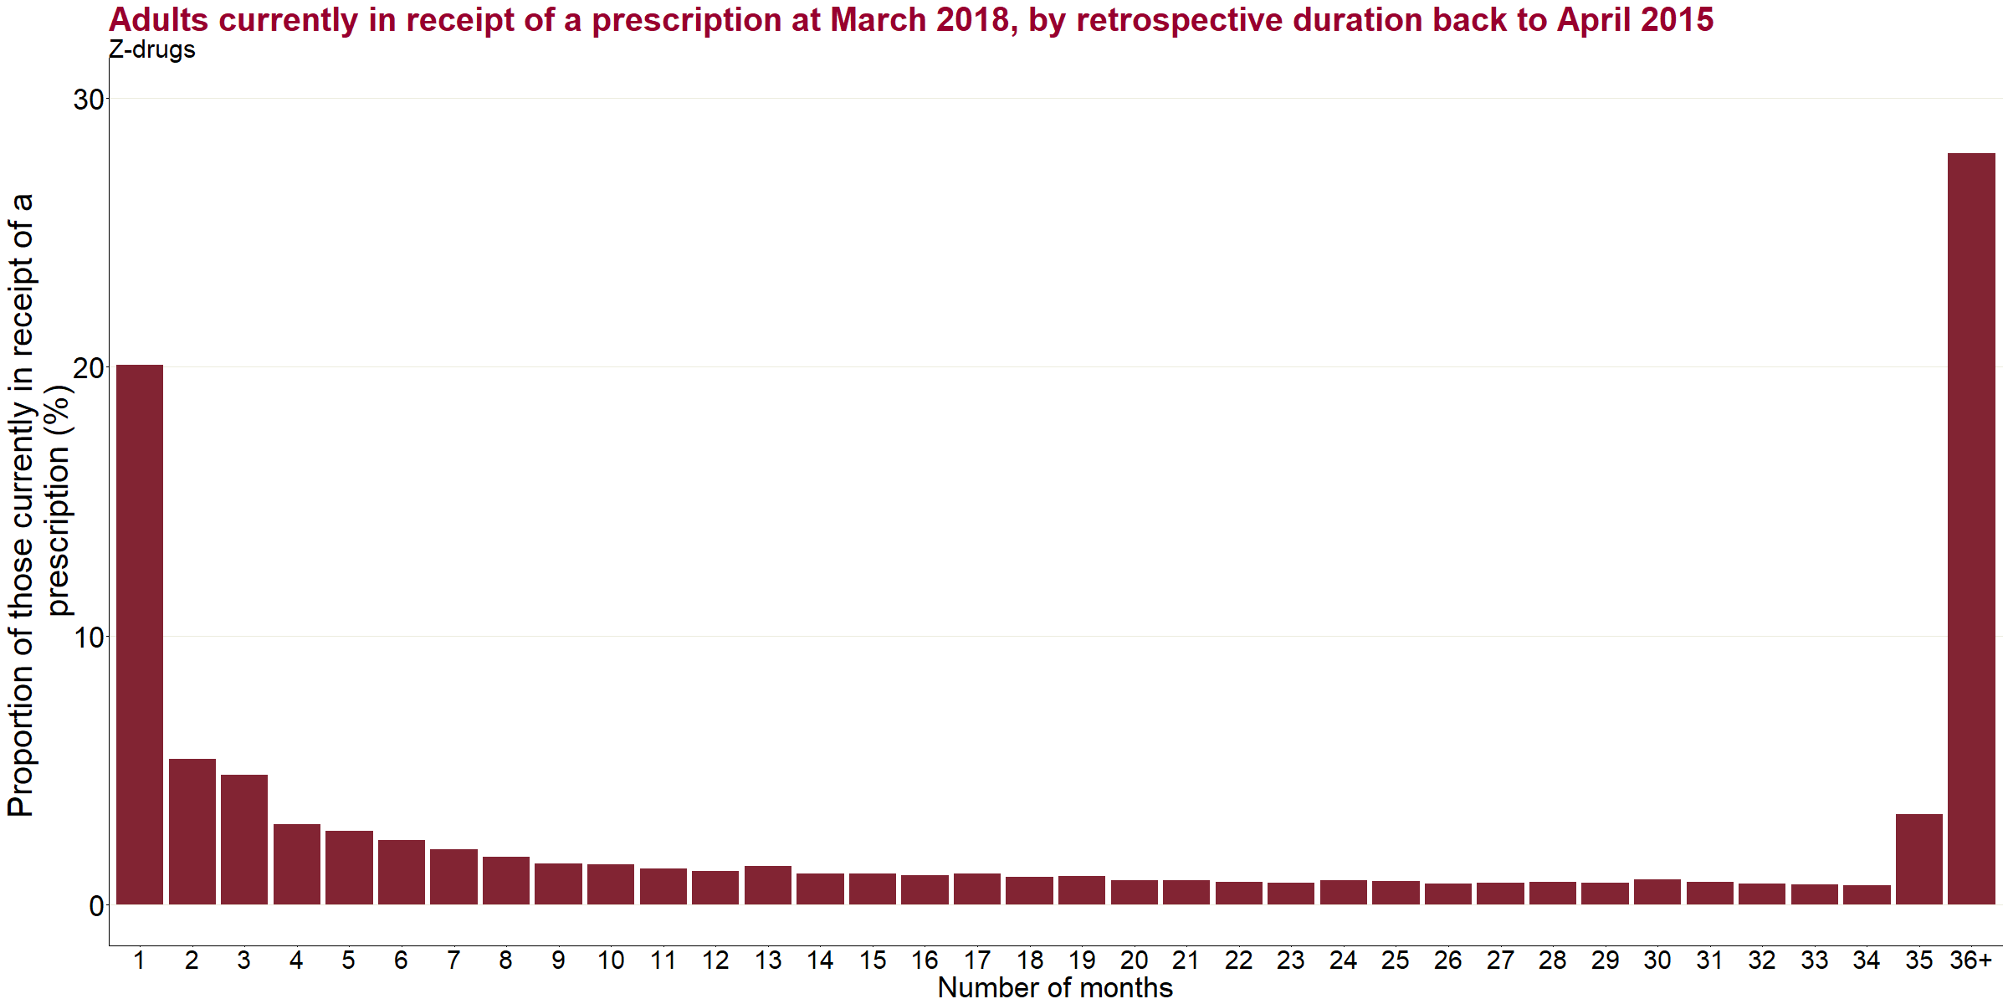

Figure 13e: Adults currently in receipt of a prescription for z-drugs at March 2018, by retrospective duration back to April 2015

Data for this chart is included in the technical annexe that accompanies this report

Figure 13e shows the retrospective duration for the individuals with a prescription for z-drugs reported for them in March 2018 (n=360,000). Of these, 28% (approximately 100,000) had been prescribed z-drugs continuously for 36 months or more, with a further 3% (approximately 10,000) who had a continuous prescription for 35 months. Twenty per cent (approximately 70,000) had a prescription duration of one month   
or less.

**Comparison of retrospective prescribing durations by medicine class**

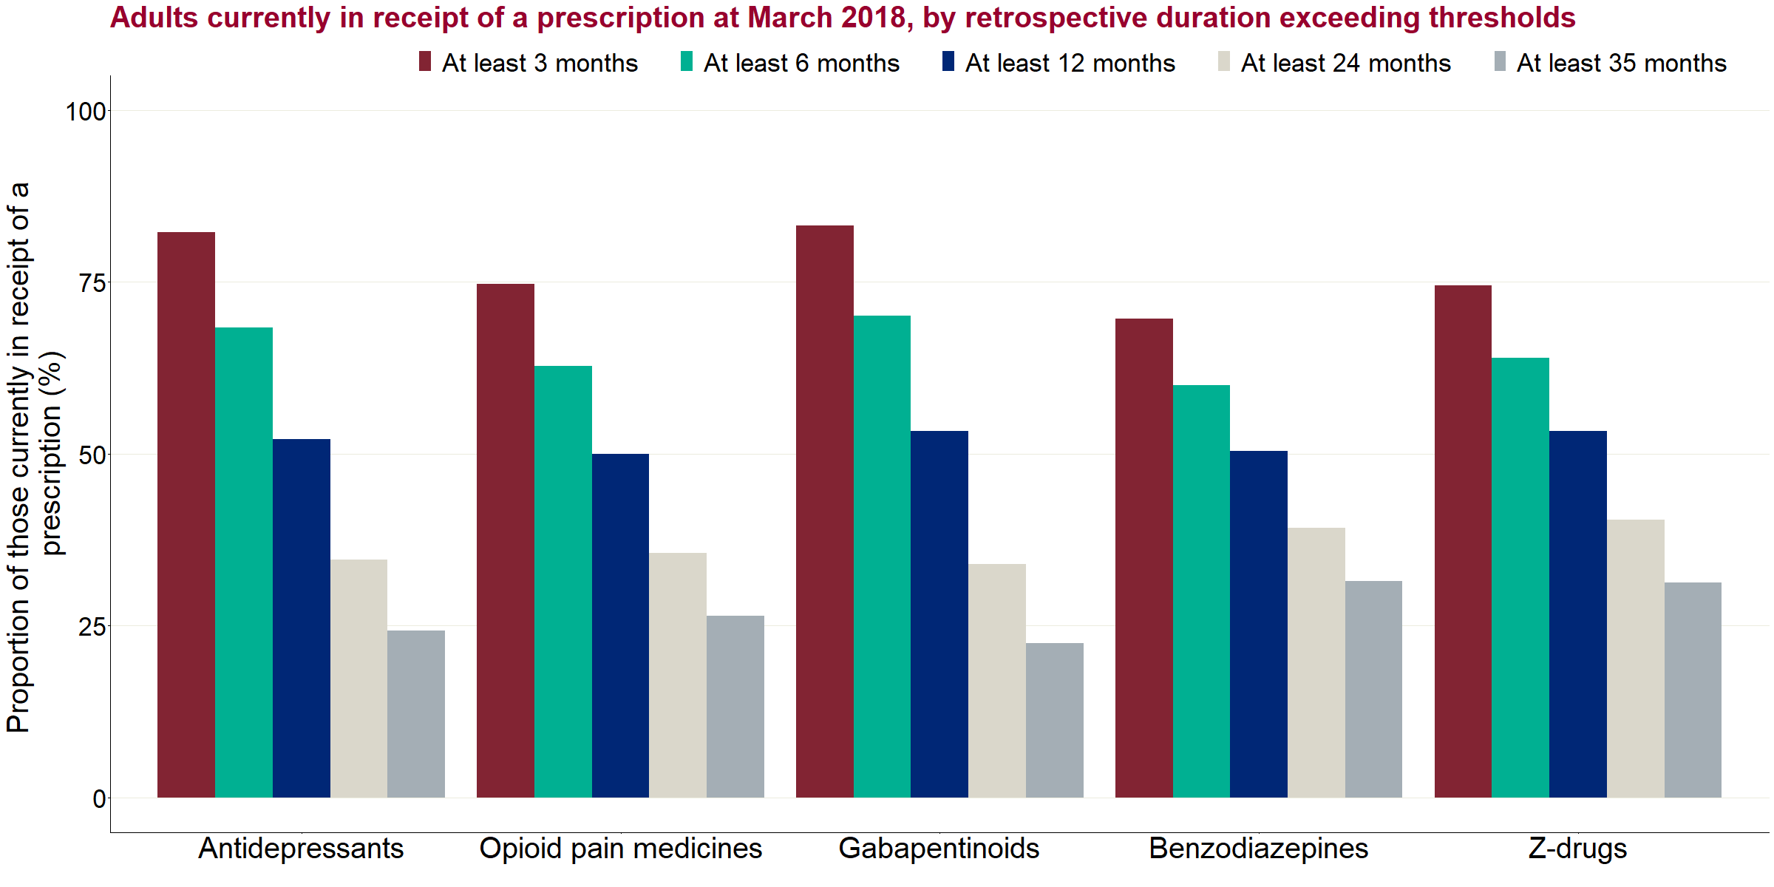

Figure 14: Adults currently in receipt of a prescription at March 2018, by retrospective duration exceeding thresholds by medicine class

The distribution of the duration of prescribing when compared between classes was similar, as shown in figure 14, with between 70% and 82% of individuals in all classes with a prescription in March 2018 having been in receipt of the prescription for 3 months or more. For those receiving a prescription for the full period (35 or 36 months), the proportion ranged from 22% (gabapentinoids) to 32% (benzodiazepines).

**Trend in retrospective prescribing**

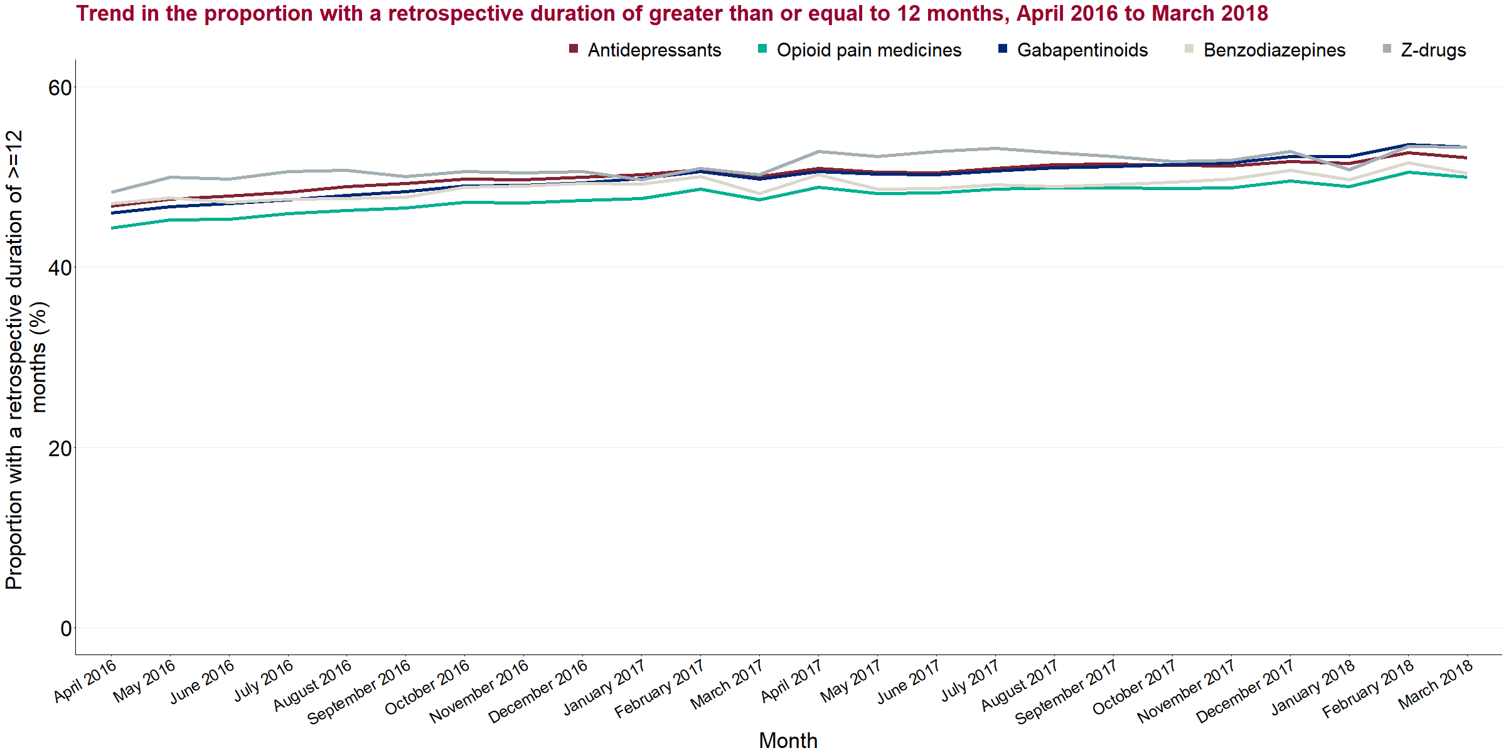

Figure 15: Trend in the proportion with a retrospective duration of greater than or equal to 12 months, April 2016 to March 2018

Figure 15 shows the proportion of individuals with a prescription in each of the 5 classes in each month that had been in receipt of that prescription continuously for 12 months or more and how this proportion varied over time. For all medicine classes this proportion has increased by about 5 percentage points between April 2016 and March 2018.

However, this will be in part due to the way the data is structured and that there is a ‘stock’ of individuals who have a duration of 12 months or more, which is being added to as the analysis moves forward month by month. It should therefore be contrasted with the prospective trend duration earlier in this report that shows that the proportion of people starting a new prescription period in the 3 years who have a duration of greater than 12 months has remained relatively stable.

To help understand this difference between the prospective and retrospective analyses, the duration was measured using the prospective approach for the cohort who first appear in the data in April 2015, following these up to the end of the period. Table 8 presents the number of individuals in each class who were in receipt of a prescription at April 2015 and then received the prescription for the full 36 months up to March 2018. For all classes the proportion was around 30%. These proportions were much higher than those observed for those commencing a new prescription in June 2015.

Table 8: Number and proportion of individuals in each medicine class in receipt of a prescription in April 2015 who received a prescription continuously up to March 2018

|  |  |  |  |
| --- | --- | --- | --- |
| **Medicine class** | **Number of individuals in receipt of prescription April 2015 (millions, rounded to 10,000)** | **Of which, those continuously receiving a prescription March 2018 (millions, rounded to 10,000)** | **Proportion still in receipt of prescription (%)** |
| Antidepressants | 3.14 | 0.93 | 30 |
| Opioid pain medicines | 1.98 | 0.54 | 27 |
| Gabapentinoids | 0.53 | 0.16 | 31 |
| Benzodiazepines | 0.40 | 0.12 | 29 |
| Z-drugs | 0.33 | 0.10 | 31 |

As these cohorts will include some who genuinely started a new prescribing period in April 2015, it is likely that the true proportions of the ‘stock’ already prescribed to at the start of the period who were retained for the full period were greater.

**Retrospective profile**

Sex:

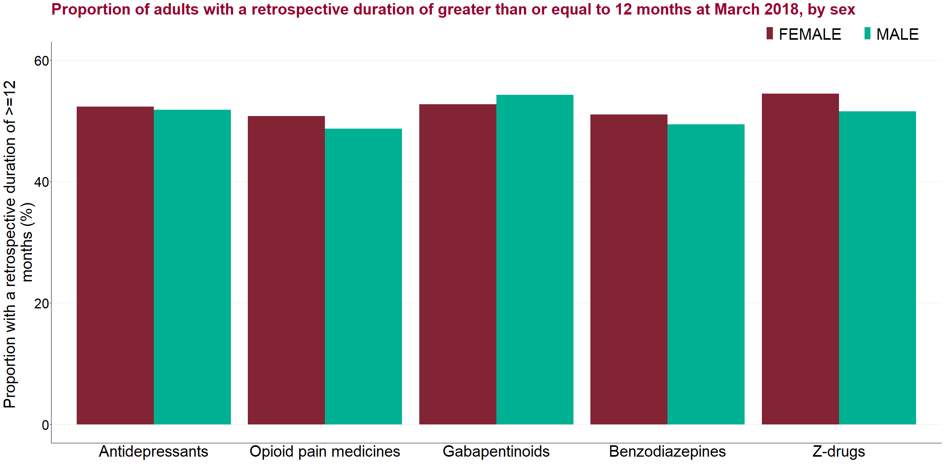

Figure 16a: Proportion of adults with a retrospective duration of greater than or equal to 12 months at March 2018, by sex

There was little variation in the levels of prescribing over 12 months between men and women, with the largest difference at March 2018 seen for those prescribed z-drugs though it is only 3% (54.4% female vs. 51.6% male). However, as in the prospective profile, more women were in receipt of prescriptions overall, so greater numbers of women had been in receipt of prescriptions for over 12 months.

Age:

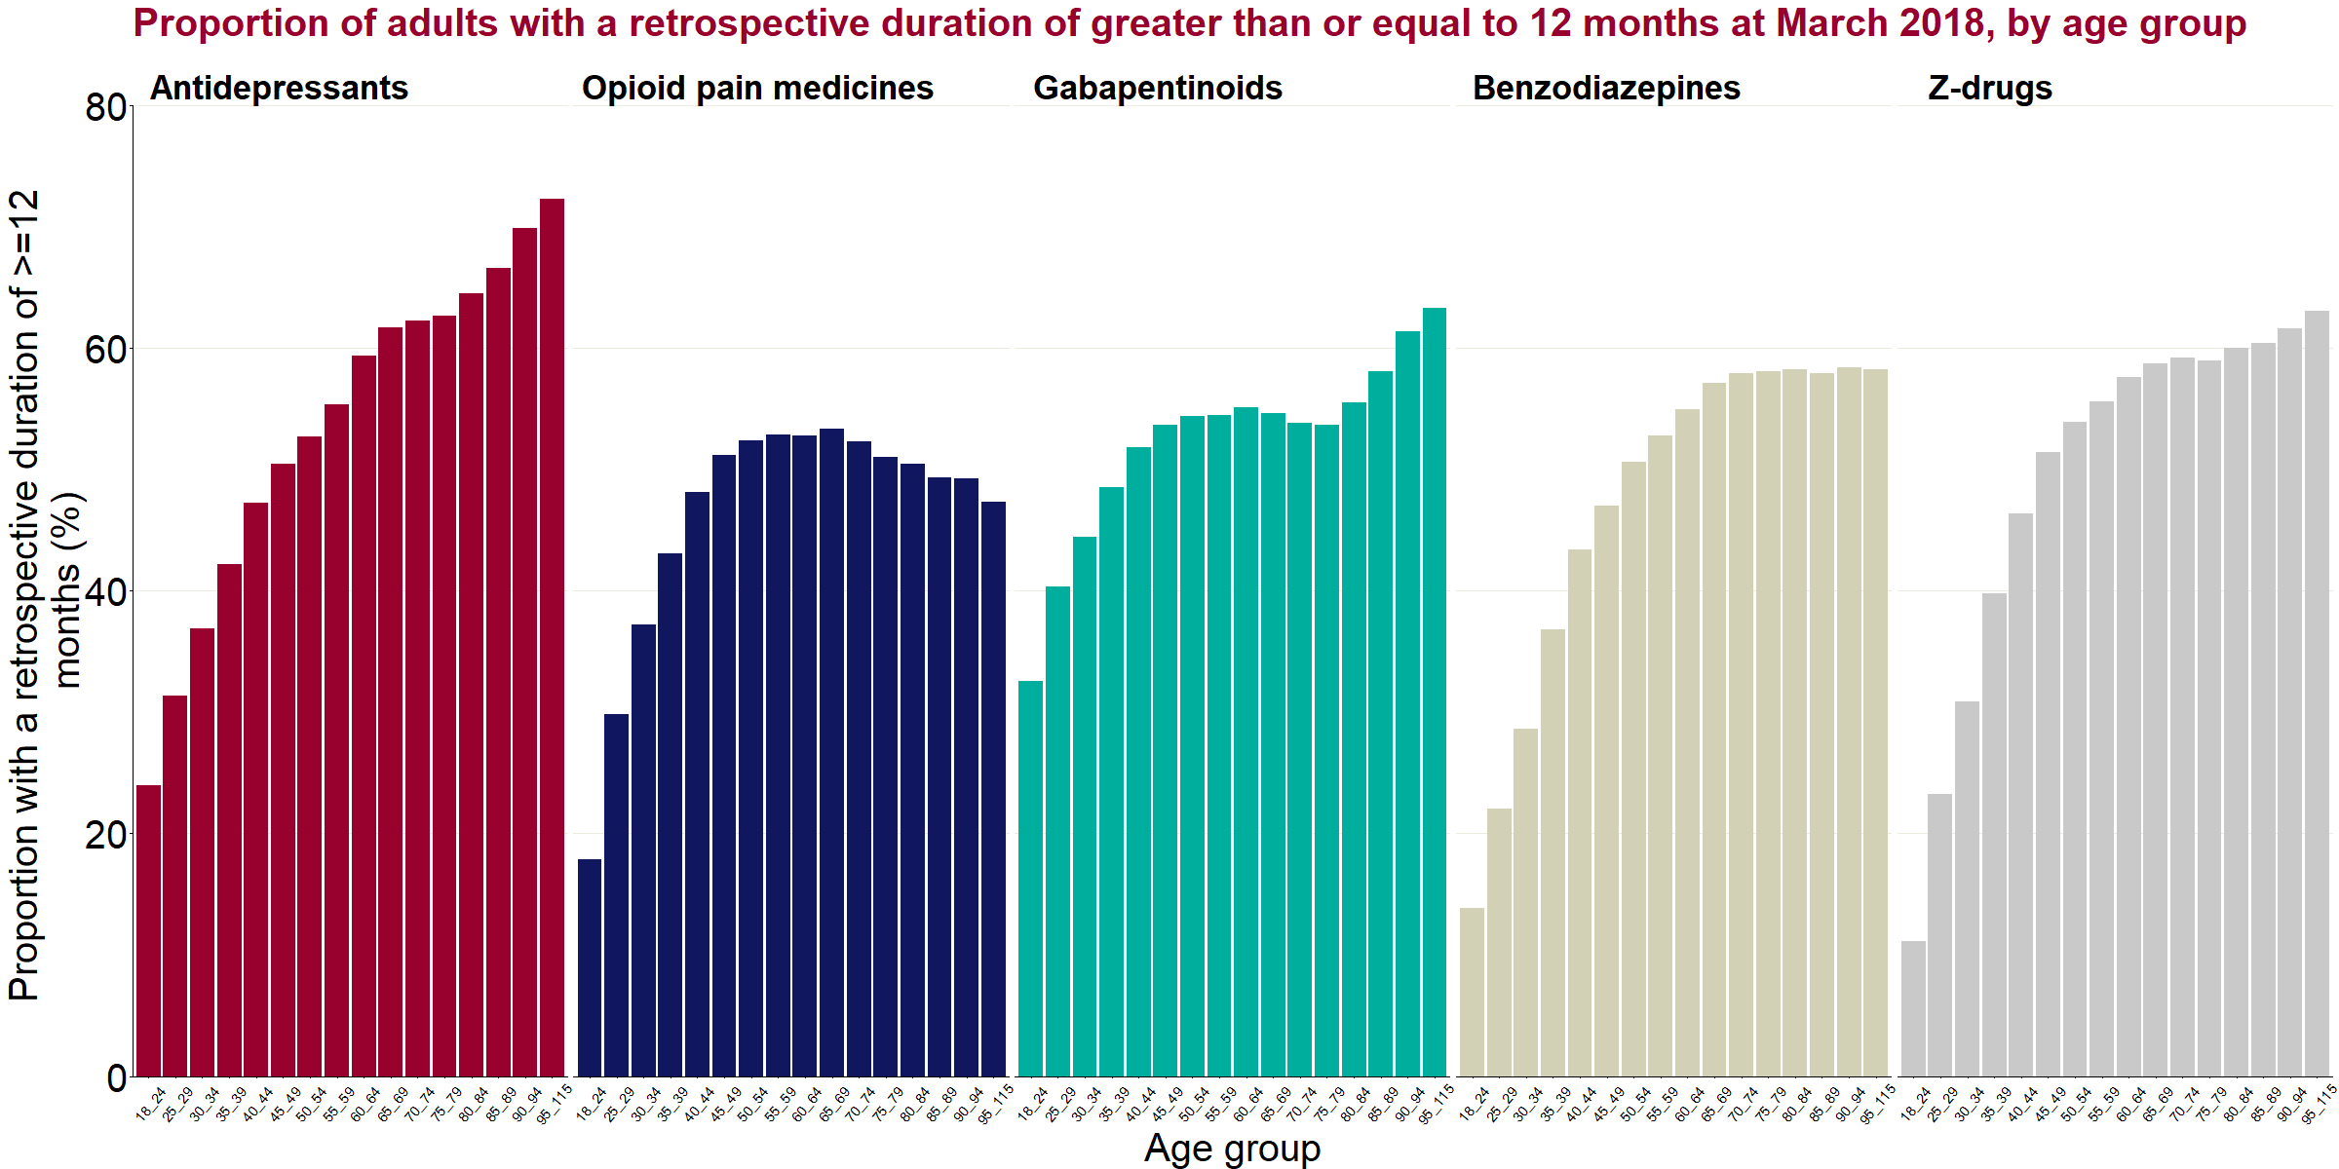

Figure 16b: Proportion of adults with a retrospective duration of greater than or equal to 12 months at March 2018, by age group

Generally, the proportion of individuals receiving a prescription for 12 months or more increases with age, with the most consistent increasing pattern seen within those on a prescription for antidepressants. The other classes tend to increase quite sharply up until about 50 and then level off, apart from gabapentinoids where there was a further spike in the oldest age groups.

Deprivation:

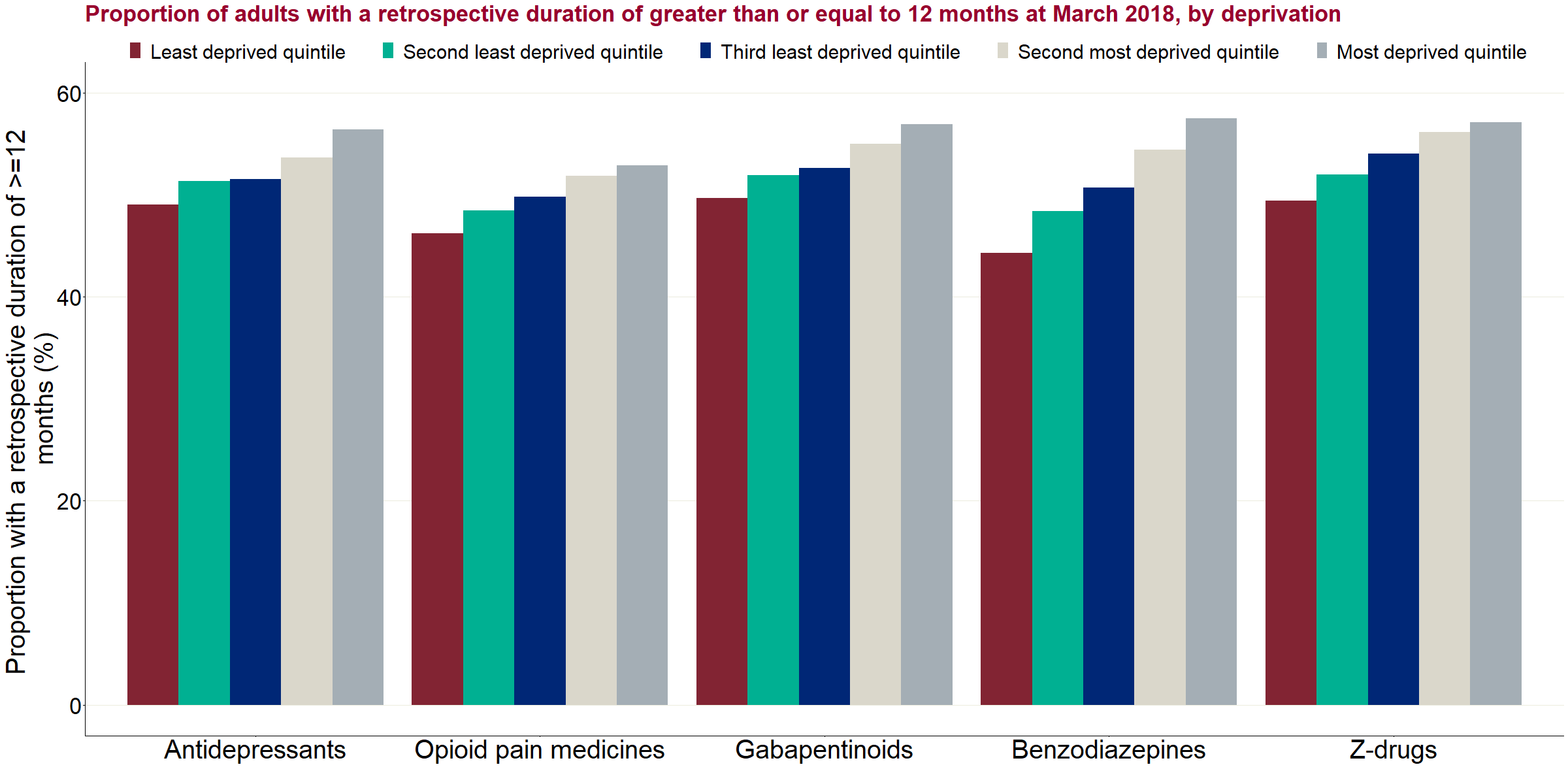

Figure 16c: Proportion of adults with a retrospective duration of greater than or equal to 12 months at March 2018, by deprivation

For all medicine classes the proportion of individuals who had been in receipt of a prescription for 12 months or more increases in line with deprivation, with those people living in the most deprived areas more likely to have been in receipt of a prescription for a year or more. The difference in prescribing rates between the most and least deprived quintiles was most markedly seen in those prescribed benzodiazepines (57% vs 44%).

Variation by CCG:

Table 9 shows the variation at CCG level in the proportion of individuals who had been in receipt of a prescription for 12 months or more by class at March 2018. As with the prospective analysis, there were substantial variations between the lowest and highest proportions reported in a CCG, such as from one-third to almost two-thirds for antidepressants.

Table 9: Variation at a CCG level in the proportion of individuals who have been in receipt a prescription for 12 months or more in March 2018, by drug class

|  |  |  |  |  |
| --- | --- | --- | --- | --- |
| **Medicine class** | **Median proportion (%)** | **Lowest proportion in a CCG (%)** | **Highest proportion in a CCG (%)** | **Interquartile range of CCGs (%)** |
| Antidepressants | 51.7 | 33.4 | 65.6 | 45.9 - 57 |
| Opioid pain medicines | 49.2 | 32.5 | 60.7 | 45.3 - 53.6 |
| Gabapentinoids | 52.9 | 37.7 | 63.6 | 47.7 - 57 |
| Benzodiazepines | 50.0 | 34.6 | 68.0 | 45.2 - 54.9 |
| Z-drugs | 53.6 | 38.8 | 68.6 | 49.1 - 58.2 |

Table 10 shows the correlations between combinations of classes being prescribed for 12 months or more. A correlation score between -1 and 1 is assigned by comparing the proportions in each class at CCG level. A higher positive score indicates that CCGs who tend to prescribe for 12 months or more of one class of drug also prescribe to do the same for the second medicine class in the combination.

There were strong correlations between prescribing for 12 months or more of different combinations of classes, with particularly strong correlations between the antidepressant, opioid and gabapentinoid classes. This means that, where larger proportions have been in receipt of prescriptions for 12 months or more in one of these classes, this also tends to be the case for the other classes.

Table 10: Correlation between proportions that have been in receipt of a prescription for 12 months or more at CCG level, by drug class, March 2018

|  |  |  |  |  |  |
| --- | --- | --- | --- | --- | --- |
| **Medicine classes being compared** | **Antidepressants** | **Opioid pain medicines** | **Gabapentinoids** | **Benzodiazepines** | **Z-drugs** |
| Antidepressants | - | 0.86 | 0.91 | 0.71 | 0.72 |
| Opioid pain medicines | 0.86 | - | 0.90 | 0.79 | 0.74 |
| Gabapentinoids | 0.91 | 0.90 | - | 0.76 | 0.71 |
| Benzodiazepines | 0.71 | 0.79 | 0.76 | - | 0.77 |
| Z-drugs | 0.72 | 0.74 | 0.71 | 0.77 | - |

In addition, table 11 shows correlation scores for overall prescribing rates at CCG level compared to the proportions who have been in receipt of a prescription for 12 months or more. This shows that, for antidepressants, opioids and gabapentinoids, there were strong relationships between CCGs that prescribed at higher rates and those that more commonly prescribed the same class of medicine for 12 months or more. For benzodiazepines and z-drugs, no such relationship was found.

Table 11: Correlation between proportions that have been in receipt of a prescription for 12 months or more and overall prescribing rates at CCG level, by drug class, March 2018

|  |  |  |  |  |  |
| --- | --- | --- | --- | --- | --- |
| **Comparison** | **Antidepressants** | **Opioid pain medicines** | **Gabapentinoids** | **Benzodiazepines** | **Z-drugs** |
| Proportion with a retrospective duration of 12 months or more compared to overall prescribing rate in CCG | 0.74 | 0.85 | 0.75 | 0.08 | 0.21 |

Co-prescribing between classes

**Defining co-prescribing**

In this analysis, co-prescribing refers to the reporting of 2 or more classes of medicine for the same person in the same month. As elsewhere in the analyses, this is based on the month in which prescriptions were submitted for payment. It is therefore assumed that any delays in submission of prescriptions to BSA are similar across the classes.

For most of this analysis, co-prescribing is reported based on the number of classes (up to 5) that were reported in the same month, with >=2 deemed to be co-prescribing. A high-level breakdown of the specific combinations is reported nationally.

**Limitations**

The main limitation is that it is not possible to distinguish whether multiple prescriptions have been reported for the same month are given consecutively or concurrently. As such, some activity will be flagged in this analysis as co-prescribing (implying concurrent receipt) when in fact the individual was prescribed one medicine and then separately the other, where both were reported in the same month.

To address this, a sensitivity analysis was produced which only counted an individual as receiving a co-prescription if the combination of classes of medicine was observed for consecutive months. The results of this analysis are presented beneath the main analysis.

**Results**

Overall:

In total, 5.5 million individuals received a prescription in March 2018 in at least one of the classes. Figure 20 shows the breakdown by the number of classes of medicine an individual received in that month. Three-quarters (75%) were receiving a prescription in one class only, while the remaining one-quarter (25%) were receiving prescriptions in 2 or more classes (so were considered to be co-prescribed to within these classes of medicine). This is taken to be the co-prescribing rate. Of these, the large majority (19% of all those with a prescription in March 2018) were receiving prescriptions in 2 different classes, with most of the rest (5%) receiving prescriptions in 3 classes.

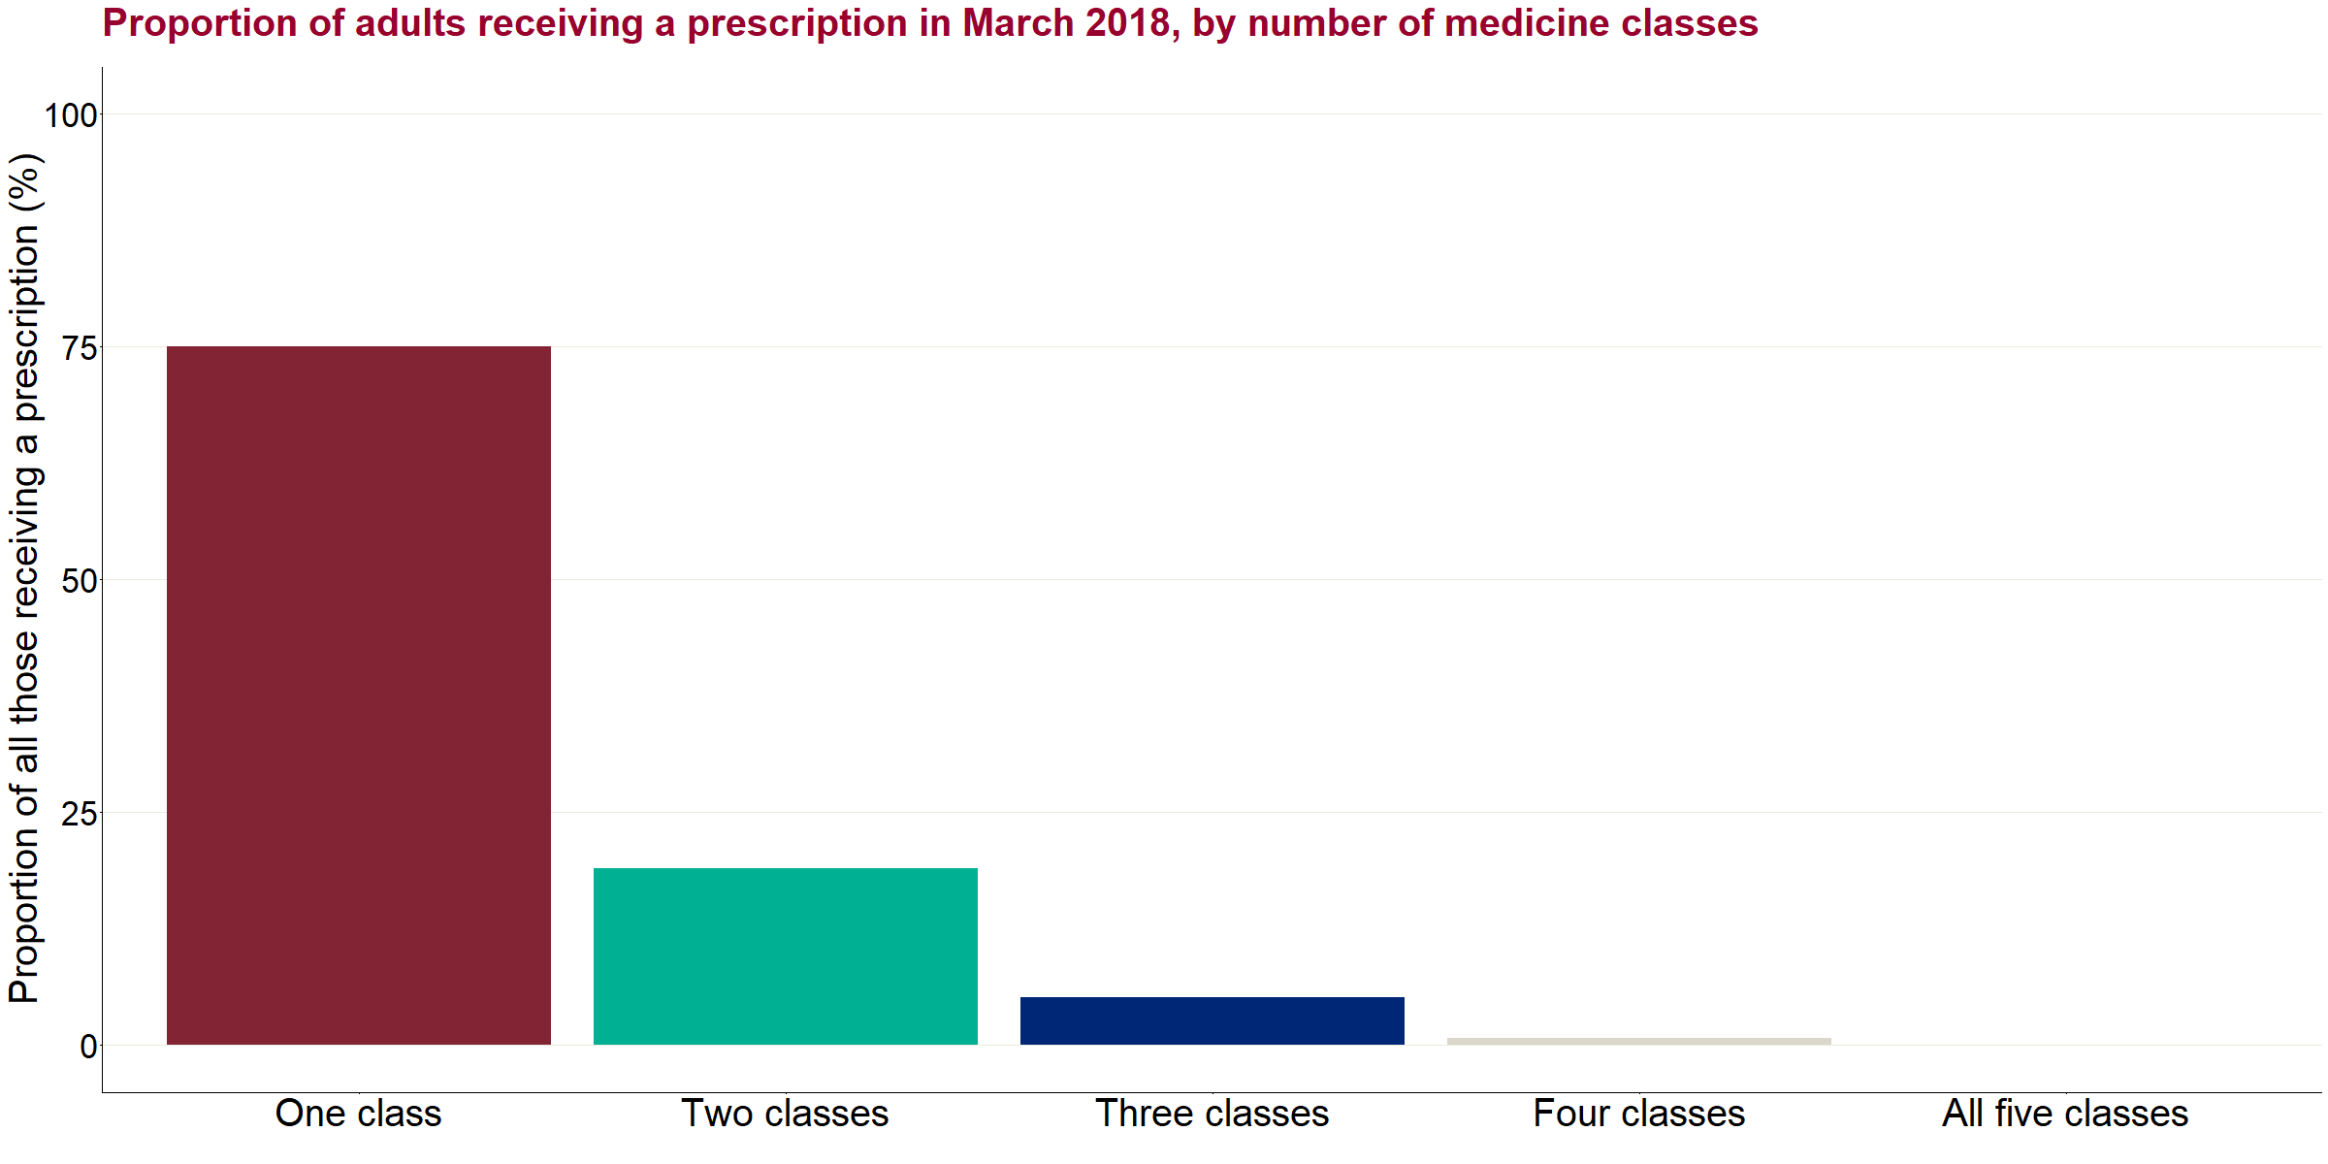

Figure 17: Proportion of adults receiving a prescription in March 2018, by number of classes of drug

Sex and age variation:

Figure 18 shows the difference in the distribution by the number of classes and by sex. Overall, women receiving a prescription in March 2018 had a slightly higher co-prescribing rate compared to men in the same month (26% vs. 24%).

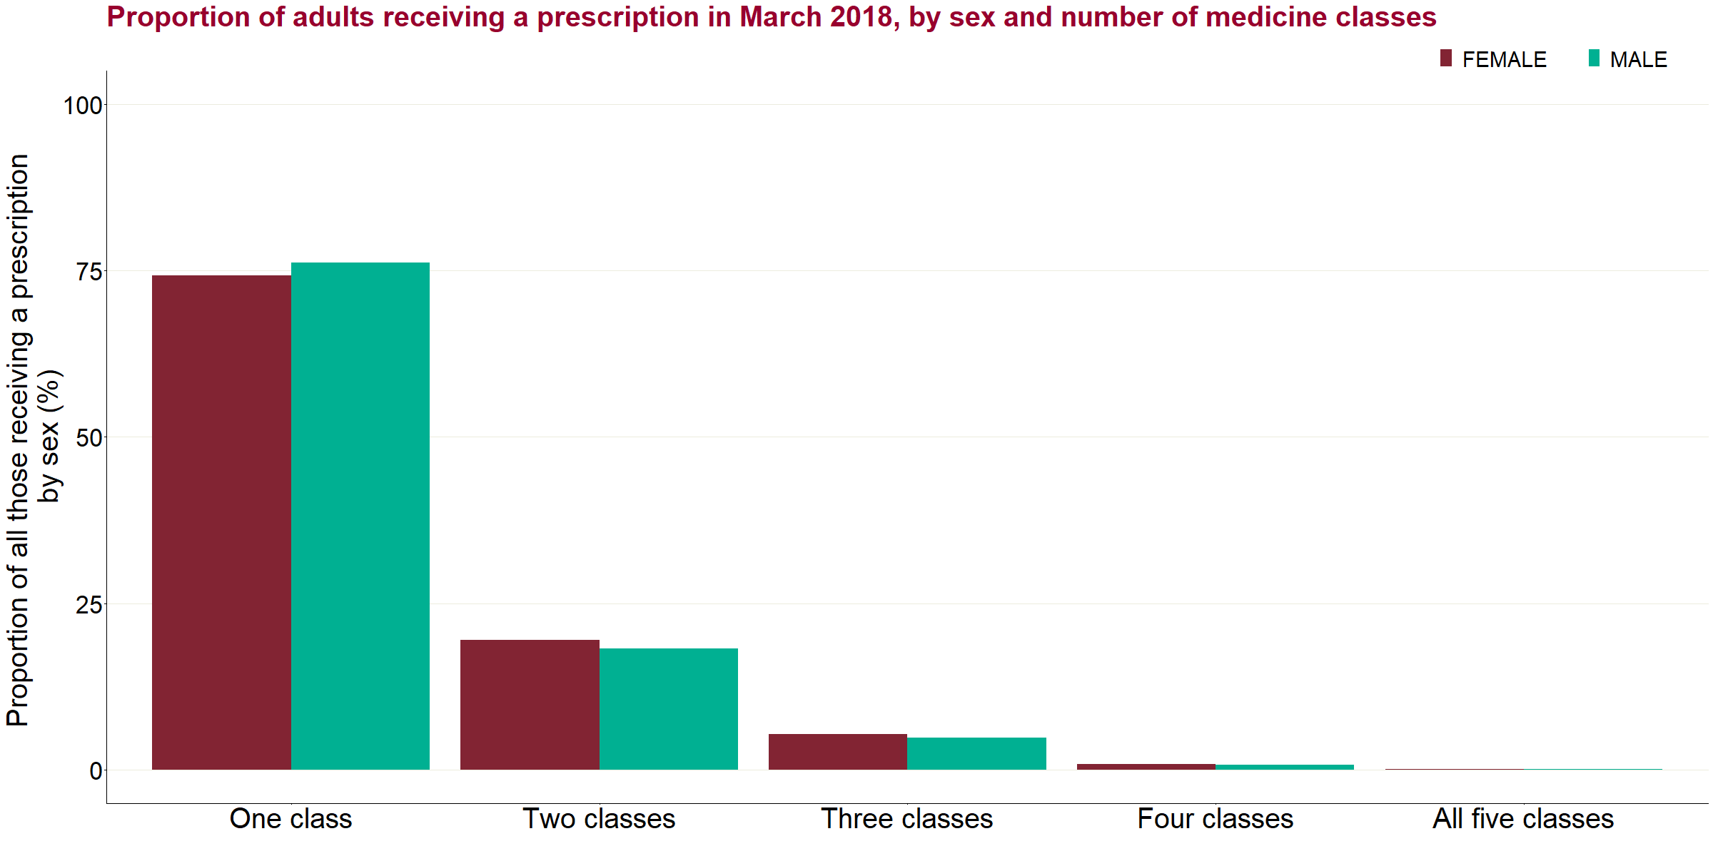

Figure 18: Proportion of adults receiving a prescription in March 2018, by sex and number of classes of drug

Age:

Figure 19 shows the breakdown by the number of classes according to age group. While overall prescribing and duration of prescribing tends to increase with age into the oldest age groups, the co-prescribing rate increased up to a peak in the 55-59 age group (30%), after which the proportions decreased with age up to the 95+ age group (23%).

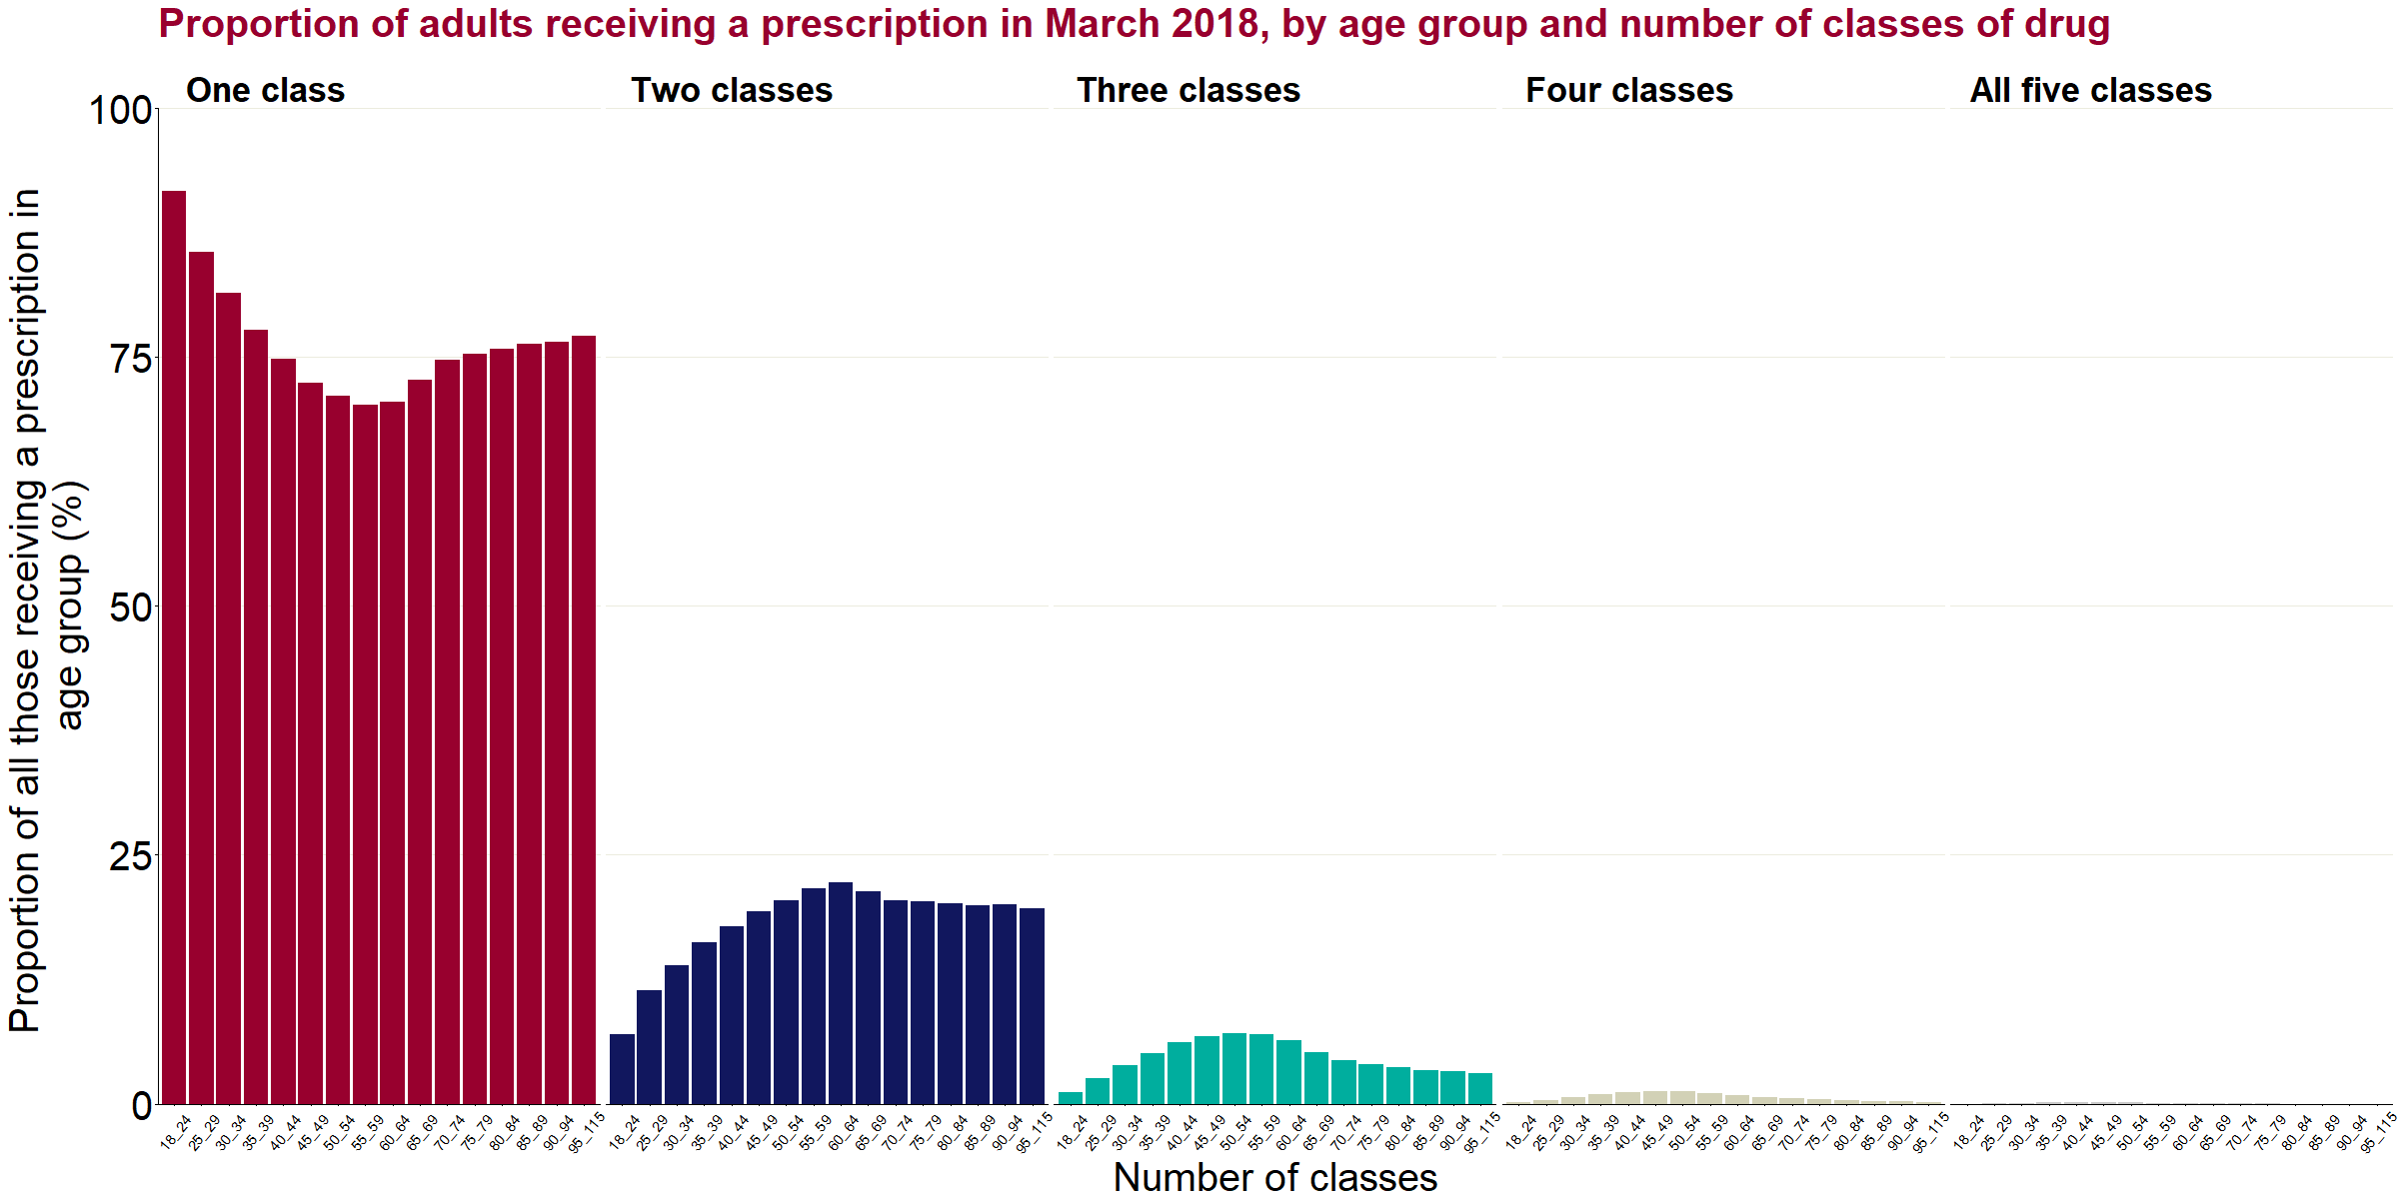

Figure 19: Proportion of adults receiving a prescription in March 2018, by age group and number of classes of drug

Deprivation:

Figure 20 shows the breakdown by the number of classes according by deprivation quintile. There is a clear relationship between increasing deprivation and increasing co-prescribing rates, with the co-prescribing rate in the most deprived quintile 1.4 times higher than in the least deprived quintile (30% compared to 21%).

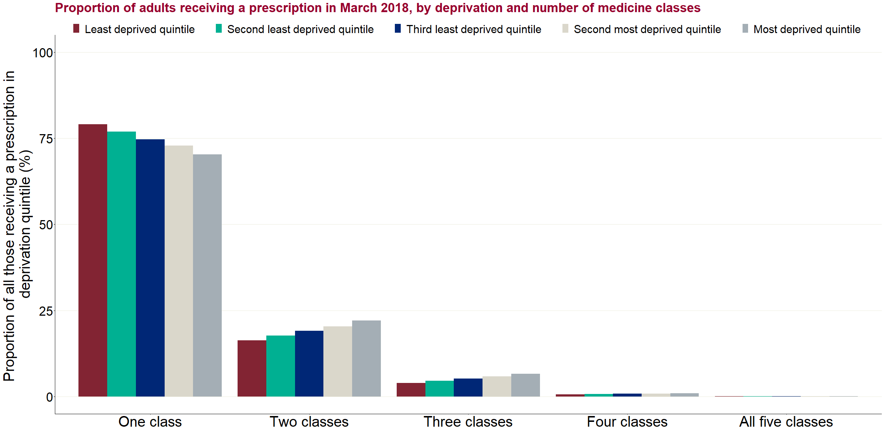

Figure 20: Proportion of adults receiving a prescription in March 2018, by deprivation and number of medicine classes

Combinations of co-prescription:

Table 12 shows the number of individuals who received each combination of 2 or more classes of medicine in March 2018, grouped by the number of classes, and the proportion of the total (n=5.5 million) that this represents. A combination refers to the classes that were prescribed in the individual month and, by implication, means other classes were not. For example, “antidepressants, opioids and gabapentinoids” means that the individual did not receive benzodiazepines or z-drugs at that point in time, though they might have done in another month during the 3 years.

The most common pairing was antidepressants and opioids, with 9% receiving these 2 classes alone and 14% receiving a combination which included both these classes and up to 3 other classes. The most common combination of 3 classes was antidepressants, opioids and gabapentinoids, with 3% receiving these 3 classes alone and 4% receiving a combination which included these drugs.

Table 12: Number of individuals receiving each combination of 2 or more classes of medicine in March 2018, grouped by the number of classes, and the proportion of the total (n=5.5 million)

|  |  |  |  |  |
| --- | --- | --- | --- | --- |
| **Number of classes** | **Overall proportion (%)** | **Combination of 2 or more medicine classes** | **Number of individuals (thousands)** | **Proportion of the total (%)** |
| Two classes | 19.1 | Antidepressants and opioids | 513 | 9.3 |
| Antidepressants and gabapentinoids | 162 | 2.9 |
| Gabapentinoids and opioids | 116.6 | 2.1 |
| Antidepressants and benzodiazepines | 90.1 | 1.6 |
| Antidepressants and z-drugs | 81.3 | 1.5 |
| Benzodiazepines and opioids | 39.8 | 0.7 |
| Opioids and z-drugs | 25.2 | 0.5 |
| Benzodiazepines and z-drugs | 8.1 | 0.1 |
| Benzodiazepines and gabapentinoids | 7 | 0.1 |
| Gabapentinoids and z-drugs | 5.8 | 0.1 |
| Three classes | 5.2 | Antidepressants, gabapentinoids and opioids | 156.7 | 2.8 |
| Antidepressants, benzodiazepines and opioids | 42.9 | 0.8 |
| Antidepressants, opioids and z-drugs | 32.9 | 0.6 |
| Antidepressants, benzodiazepines and z-drugs | 13.6 | 0.2 |
| Antidepressants, benzodiazepines and gabapentinoids | 12.7 | 0.2 |
| Antidepressants, gabapentinoids and z-drugs | 10.6 | 0.2 |
| Benzodiazepines, gabapentinoids and opioids | 6.7 | 0.1 |
| Gabapentinoids, opioids and z-drugs | 4.6 | 0.1 |
| Benzodiazepines, opioids and z-drugs | 3.1 | 0.1 |
| Benzodiazepines, gabapentinoids and z-drugs | 0.8 | 0.0 |
| Four classes | 0.8 | Antidepressants, benzodiazepines, gabapentinoids and opioids | 18.4 | 0.3 |
| Antidepressants, gabapentinoids, opioids and z-drugs | 13.4 | 0.2 |
| Antidepressants, benzodiazepines, opioids and z-drugs | 8.2 | 0.1 |
| Antidepressants, benzodiazepines, gabapentinoids and z-drugs | 3 | 0.1 |
| Benzodiazepines, gabapentinoids, opioids and z-drugs | 0.8 | 0.0 |
| All 5 classes | 0.1 | Antidepressants, benzodiazepines, gabapentinoids, opioids and z-drugs | 4.5 | 0.1 |

Figure 21 shows the numbers of individuals who received each co-prescribing combination from the table above, grouped by the number of classes. For brevity, the combinations are summarised in this graph with abbreviated codes where the first letter of each relevant medicine class is shown. For example, “AO” refers to “antidepressants and opioids”.

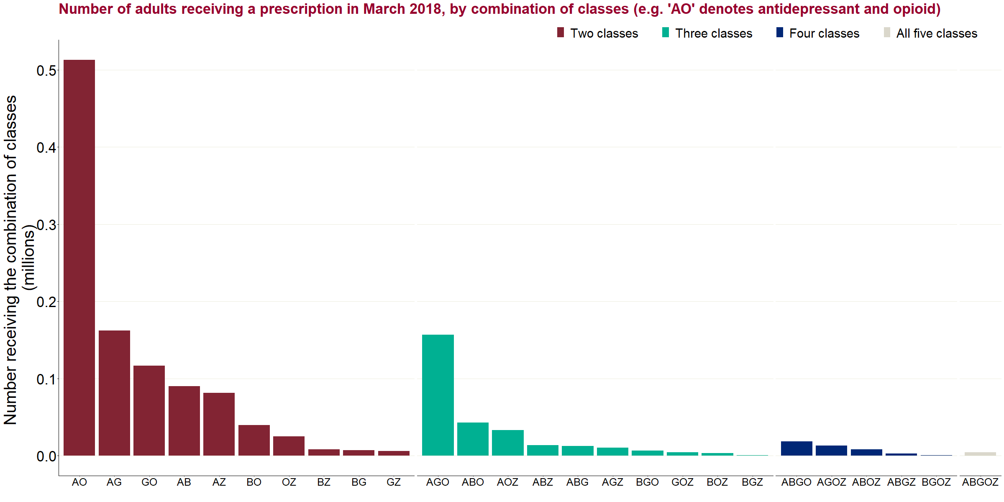

Figure 21: Number of adults receiving a prescription in March 2018, by combination of classes

For example, “AO” indicates antidepressant and opioid

Variation by CCG:

Table 13 shows the extent of variation between CCGs in the proportion of individuals where more than or equal to=2 classes were reported for an individual at March 2018. This shows that half of CCGs had a co-prescribing rate within the range of 23% to 26.5%, close to the median of 25%.

Table 13: Summary statistics for those with 2 or more classes of medicine reported in the same month at CCG level

|  |  |  |  |
| --- | --- | --- | --- |
| **Median proportion (%)** | **Lowest proportion in a CCG (%)** | **Highest proportion in a CCG (%)** | **Interquartile range of CCGs (%)** |
| 24.8 | 19.2 | 33.2 | 22.9 - 26.5 |

Sensitivity analysis:

As noted above in the Limitations section, the key limitation of this analysis of co-prescribing is that prescriptions from multiple classes reported against the same month may reflect a transition from one drug to another rather than a co-prescription. To test this, a sensitivity analysis was carried out introducing a further rule to only report co-prescribing where the combination of drugs was reported for consecutive months and would therefore very likely reflect concurrent prescriptions.

Figure 22 shows the high-level results of this analysis for March 2018. With the additional rule that combination of drugs must also be identified in February or April 2018, the co-prescribing rate at this time would be 19%, compared to the 25% shown in Figure 20. It should be noted that this method is quite conservative and may disregard cases of genuine co-prescribing, where that combination of classes was only observed in one month. It would be reasonable to suggest that the true rate of co-prescription at any time is probably between one-fifth and one-quarter.

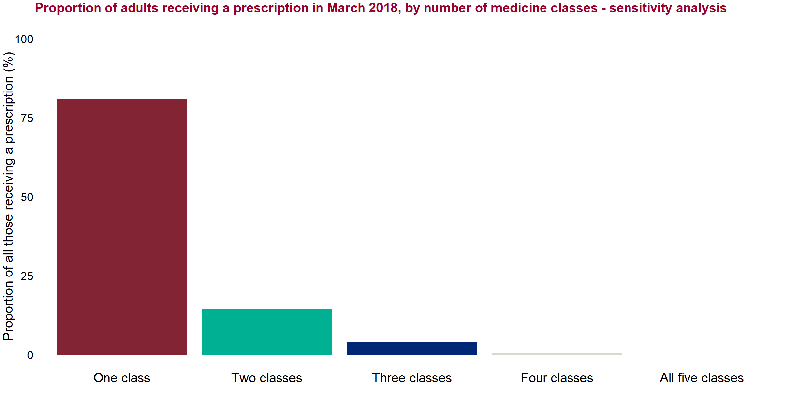

Figure 22: Proportion of adults receiving a prescription in March 2018, by number of medicine classes – based on sensitivity analysis method

Earlier prescription data

As the individual patient-level NHSBSA prescription data only covers 2015 to 2018, published prescription data going further back (to 2008) was also examined to provide a longer-term trend in prescription volumes. This is contained in the NHSBSA’s annual Prescription Cost Analysis (PCA) reports101 and in its latest trend report.102 What this data cannot do is cover duration of prescribing or numbers of individuals prescribed to. This prescription data is available going even further back than 2008 but data for the years 1991 to 2009 on prescriptions for some medicines liable to “addiction” was included in a 2011 report by the National Treatment Agency103 (although this did not include antidepressants or gabapentinoids) and can be attached to the data that follows to give even longer trends. But these trends largely reflect the patterns seen in the last 10 years, just starting from a lower base.

Longer-term prescription trend data echoes the more recent patterns shown in the BSA analysis:

* antidepressant prescriptions being by far the largest in number and doubling over 10 years
* opioid analgesic prescriptions (including opioid compound analgesics) having increased to 2016 before starting to fall
* benzodiazepines being the only class of medicines in the scope of the review whose prescriptions have consistently decreased
* z-drug prescription numbers having remained fairly flat over the period, increasing a little and then falling again
* gabapentinoid prescriptions being much smaller in number but having shown by far the greatest proportional increase, more than quadrupling in 10 years

Note: These figures in figure 23 below are raw prescription item numbers and have not been adjusted for the population, which has also been increasing and will mean any relative rates of increase have been less than shown.

Figure 23: Prescription items dispensed in the community in England, 2008 to 2018

Source: NHSBSA PCA. Opioids includes the opioid compound analgesics, co-codamol and co-dydramol

Breaking down the antidepressant prescriptions into the different types (figure 24) shows how the use of monoamine oxidase inhibitors (MAOIs) has remained very small, tricyclics have remained fairly stable, and the total increase is mostly explained by increases in prescriptions of SSRIs and others.

Figure 24: Prescription items 2008 to 2018, antidepressants-only, by class

Source: NHSBSA PCA

Prescribing privately and in other settings

To complement the NHSBSA prescription data, which only covers NHS prescriptions dispensed in the community, PHE obtained data from IQVIA that covered:

* hospitals – medicines dispensed from NHS hospital pharmacies for 5 years, November 2013 to October 2018
* care homes – prescriptions dispensed for residents in care homes in England for 2 years, November 2016 to October 2018 (unlike the prescribing data in the other 2 additional datasets, these prescriptions are reflected in NHSBSA prescription data – they are presented here because of interest in prescribing in care homes)
* private prescriptions – private prescriptions dispensed from retail pharmacists in England for 2 years, November 2016 to October 2018

This additional data further supplements the findings from the other analyses. Although it only provides counts of items or quantities, and cannot be analysed by patient, it provides further evidence of volume of, and recent trends in, prescribing. In terms of volume, antidepressants dominate prescribing in all settings except hospitals, which give out far more opioids than the other medicine classes. This might be as expected since a much higher proportion of people being prescribed for by hospitals will be in pain following an accident or surgical procedure or similar. However, hospitals are also where many long-term community prescriptions for opioids are started.

The volume of prescriptions varies considerably between the settings and the difference in these volumes should be borne in mind when interpreting the data. Data for private prescriptions in particular may be more variable due to the relatively very low volume compared to other settings. For example, in October 2018, the number of units of antidepressants dispensed in the community was almost 10,000 times greater than the number dispensed via private prescriptions.

In terms of trends in prescribing over the period covered by the data, these are largely consistent between all the settings. Apparently significant differences are:

* prescribing of z-drugs has fallen more in care homes than in other settings
* private prescriptions for opioids decreased from October 2017 to April 2018 but then increased at a higher rate than other settings to bring them back to their previous level

|  |
| --- |
| Chart notes:   * Community data from PCA (figure 25)) is essentially the same data as in figure 23 but divided into quarters, and only for November 2016 to October 2018, to allow comparison with the other IQVIA-supplied data * Monthly data has been aggregated to quarters to smooth out random fluctuations * Data is only presented for the 2 years covered by all IQVIA-supplied data * Opioid pain medicines include the compound analgesics co-codamol and co-dydramol |

Community

Figure 25: IQVIA - Drug group analysis - community (items dispensed)

Sources: IQVIA HPA & BPI National Audit, NHSBSA PCA, both November 2016 - October 2018

Hospitals

Figure 26: IQVIA - Drug group analysis – hospitals (units)

Sources: IQVIA HPA & BPI National Audit, NHSBSA PCA, both November 2016 - October 2018

Care homes

Figure 27: IQVIA - Drug group analysis – care homes (units)

Sources: IQVIA HPA & BPI National Audit, NHSBSA PCA, both November 2016 - October 2018

Private prescriptions

Figure 28: IQVIA - Drug group analysis – private prescriptions (units)

Sources: IQVIA HPA & BPI National Audit, NHSBSA PCA, both November 2016 - October 2018

Clinical Practice Research Datalink

A parallel study by the Public Health Research Consortium (PHRC), updating and expanding on research on dependence forming medicines[13] (DFM) published in 2017,2 has provided findings on prescription length and prescribing duration from the Clinical Practice Research Datalink (CPRD) that go further back than the NHSBSA prescription data.104 A separate analysis has been added to include antidepressants (ADM).105 These show that:

"A downward trend has been evident for benzodiazepines and - since 2004 - for GABAergic medicines in the proportion of individual prescriptions to exceed 30 days. The rate has been more stable for opioids and Z drugs."

"When the 2 main GABAergic medicines were examined separately, we can see that the overall fall in 2004 in the proportion of prescriptions exceeding 30 days was due to the introduction of pregabalin in that year. The proportion of pregabalin prescriptions to exceed 30 days has remained about half the rate for gabapentin. Trends for GABAergic medicines as a whole are likely to reflect changes in how much of the total prescribing was for pregabalin and how much was for gabapentin."

“A minority of individual ADM prescriptions exceed 60 days: this was consistently more likely for tricyclics (2% to 4%) than for SSRIs or other ADMs (both consistently below 2%). The proportion of tricyclic and other ADM individual prescriptions to exceed 60 days fluctuated, but with a general downward trend over time. For SSRIs, the proportion of individual prescriptions to exceed 60 days remained stable over time.”

In terms of continuous prescribing periods the CPRD analysis found:

Benzodiazepines

“While there has been a steep fall in the proportion of benzodiazepine prescribing periods to exceed 30 days (from about half of prescribing periods in 2000 to a third in 2014), reductions in the proportions of prescribing periods to exceed 6 and 12 months have been less clear.

In 2014, 12% of continuous benzodiazepine prescribing periods exceeded 6 months. Half of these (6% of prescribing periods that year) exceeded 12 months. There are indications of a slight downward trend over time. Around 13% of prescribing periods exceeded 6 months in 2001 to 2003, while since 2007 10% to 12% were prescribed at this level.”

Z-drugs

“In 2014, 37% of continuous Z drug prescribing periods exceeded 30 days. The rate has had a slight downward trend over time. Similar to benzodiazepines, in 2014 13% of Z drug continuous prescribing periods exceeded 6 months, and 6% exceeded a year. While the rate exceeding 30 days appears to have decreased, the rate exceeding these longer thresholds may be increasing.”

Opioids

“Similarly, while the proportion of continuous prescribing periods to exceed 30 days reduced (from 38% in 2001 to 34% in 2014) no reduction was evident at the longer thresholds. Rather, the data was indicative of a slight upward trend over time.”

Gabapentin

“Since 2010, the proportion of gabapentin prescribing periods to exceed 30 days fell from 76% to 60% in 2014. The rates exceeding 6 and 12 months fluctuate in the data but are not consistent with a pattern of long-time decline.”

Pregabalin

“While the proportion of pregabalin prescribing periods to exceed 30 days remained around 60% between 2004 and 2014, the proportion to exceed longer thresholds steadily grew over this period. In 2014, 16% of continuous pregabalin prescribing periods exceed 6 months and 8% exceeded a year.”

Antidepressants

“The mean average number of days of SSRI, tricyclic, and other ADM continuous prescribing periods increased year on year between 2005 and 2011.”

“For each type of ADM, the proportion of continuous prescribing periods to exceed one year increased between 2001 and 2011/2. Since 2012 there is evidence of a possible decline in the proportion of continuous prescribing periods to exceed this threshold.”

Similar patterns are seen for continuous prescribing exceeding 2, 3 and 5 years.

Characteristics of people prescribed DFM and antidepressants long-term

PHRC also examined the characteristics of people prescribed DFM medicines long-term and, like the analysis in this report, found:

* for most types of DFM (except opioids), older people prescribed the drug were more likely than younger people to be prescribed it for more than 6 months - for example, in 2014 18.7% of those aged 81 and over who were prescribed z-drugs were prescribed to for more than 6 months, compared with 5.1% of those prescribed the drug who were 18 to 40-year olds
* in 2014, for all types of DFM, continuous prescribing periods in excess of 12 months were slightly more likely among men prescribed the drug than among women - differences by sex, however, were not evident at other prescribing thresholds or in earlier years
* people prescribed DFM and living in the North of England were more likely than those living in other regions to be prescribed to for periods more than 6 and 12 months - this was the case for all classes of DFM
* among people prescribed DFM, those living in deprived areas were generally more likely to be prescribed to for longer - this association, for example, has remained evident and pronounced among those prescribed opioids in every year of the data extract

For antidepressants, PHRC found:

* men prescribed SSRIs were more likely than women to be prescribed them for longer than 3 years - there was little variation by gender of prescribing duration of tricyclics; for other ADM, after 2008 men were more likely to be prescribed to long-term
* older people prescribed SSRIs were more likely than younger people to be prescribed to for more than 3 years - among people prescribed tricyclics and other ADMs, associations with age were less clear
* SSRIs and tricyclics were also more likely to be prescribed long-term in the North of England

PHRC’s conclusions and implications

“Prescribing periods average about a year: Since 2000, individual prescriptions have been issued for short periods of time - overwhelmingly for less than 60 days.

Continuous prescribing periods, however, last much longer. In 2011, the average SSRI prescribing period was just under a year, and the average tricyclic or other ADM prescribing period lasted well over a year.

“Average prescribing periods have gradually increased over time: The rise in mean number of days was less pronounced for SSRI and more pronounced for other ADM.

“One in 12 tricyclic and other ADM prescribing periods exceed 3 years:

The proportion of SSRI prescribing periods to exceed 3 years remained around 4% between 2003 and 2014, while the proportion of ADM prescribing periods to exceed this length doubled between 2003 (4%) and 2014 (8%).

“There are indications that in recent years the proportion of prescribing periods to exceed long thresholds has fallen. This could result from changes such as greater switching between types of ADM.

“Variation among those prescribed to: Those more likely to be prescribed ADM beyond a 3-year threshold tended to be older, male, and living in the North of England – although this pattern varied by type of drug.”

Over-the-counter medicines

Finally, PHRC’s research looked at data from IRI on sales of codeine and dihydrocodeine-containing medicines bought over-the-counter (OTC) from February 2015 to February 2018. Total counts of individual tablets were derived for each 12-month period from week ending 28 February, 2015. Counts were calculated from the sales volume multiplied by the pack size.

Figure 29: Total counts of sales of individual codeine and dihydrocodeine-containing medicines

Source: IRI Group Ltd data on sales of OTC products (including own-label and generic) from all multiples and independent pharmacies and most supermarkets and grocery outlets in Great Britain. Independent grocers were generally not included in the sales data, which means that trends over time are likely to be reliable but the total volume is an underestimate

PHRC’s analysis says:

“There was a small decrease in total OTC sales of medicines containing codeine or dihydrocodeine between 2015/2016 and 2017/2018, broadly consistent across categories. Apart from a small increase over time in sales of ibuprofen and codeine combinations (1% increase), all types of medicine showed small decreases in sales volume between 2015/6 and 2017/18. The largest drop in sales was in aspirin and codeine products (15% reduction).

“These trends are broadly consistent with those reported for all analgesics in The Pharmaceutical Journal using sales data supplied by IRI Ltd (Connelly, 2017), as well as by Nielsen Scantrack (Connelly, 2018). The more recent article described sales of adult oral analgesics as ‘stagnated’.”

PHRC references:

“Connelly D. A breakdown of the over-the-counter medicines market in Britain in 2016. The Pharmaceutical Journal, April 2017, Vol 298, No 7900, online | DOI: 10.1211/PJ.2017.20202662.

“Connelly D. A breakdown of the over-the-counter medicines market in Britain in 2017. The Pharmaceutical Journal, May 2018, Vol 300, No 7913”

Other data and analyses

PHE will explore future opportunities to provide NHS cost estimates derived from the review data.

ONS publishes [annual data](https://www.ons.gov.uk/peoplepopulationandcommunity/birthsdeathsandmarriages/deaths/bulletins/deathsrelatedtodrugpoisoninginenglandandwales/previousReleases) on drug poisonings, including from medicines in the scope of this review. This data is not repeated here, but PHE plans to analyse death rates against prescribing rates.

4. Rapid evidence assessment findings

The findings in the following sections are based on the rapid evidence assessment (REA) described in chapter 2. As noted earlier, the REA was limited to 10 years   
(1 January 2008 to 3 October 2018).

The NGC identified 39,087 records through database searches and 249 records were identified through other sources. After screening and record exclusion, 1,067 text articles were assessed for eligibility. A total of 75 articles were included from the literature searches: 30 on harms, 26 on interventions, 17 on risk factors, and 2 on patients’ experiences. From the open call-for-evidence, 10 additional reports on patients’ experiences were included along with 4 reports on current practice.

Records screened, n=39336

Records excluded, n=38269

(113 requested but unobtainable)

Papers included in review:

* **Harms** **n=30**
* **Risk factors**  **n=17**
* **Interventions** **n=28**
* **Patients’ experience n=2**

(10 additional identified from call for evidence, leading to **12 total**)

* **Current practice** **n=0**

(3 included identified from call for evidence, 1 from grey literature, leading to **4 total**)

Papers excluded from full text sift, n=990

Reasons for exclusion are in an appendix in the full REA reports

Records identified through database searching, n=39087

Additional records identified through other sources, n=249

Full-text papers assessed for eligibility, n=1067

Figure 30: Study selection: Flow chart of study selection for the review

Risk of harms of dependence and withdrawal

The question addressed in the rapid evidence assessment in relation to risk of harms of dependence and withdrawal was:

“What are the factors that contribute to the risk of harms associated with dependence and the short term discontinuation or longer term withdrawal symptoms from the following prescribed medicines: opioids for chronic pain (excluding end of life/palliative care/cancer pain), benzodiazepines, z-drugs, gabapentin and pregabalin (excluding epilepsy treatment), and antidepressants?”

Conclusions drawn from the evidence identified were:

“A wide range of potential risk factors for harms of dependency were identified from the literature, however, all of the available evidence was relating to use of opioids or benzodiazepines. No evidence that was relevant to the review protocol was available for antidepressant withdrawals, z-drugs or gabapentinoids.

“There was considerable variation in methods to define the risk factors and a variety of methods to measure dependence, mean combining these data were not possible. Furthermore, the studies differed in terms of potential confounding factors that they had adjusted for, and in some cases the detail regarding the specific factors that were adjusted for wasn’t clearly reported. This taken alongside risk of bias in the studies and uncertainty in the effect resulted in all the evidence being graded as low or very low quality. Some results are conflicting between studies and firm conclusions can’t be made from this evidence alone. Nonetheless it does provide information on potential risk factors to be considered in relation to dependence or long term use.

“Factors identified from this literature that appear to demonstrate the strongest effect:

Opioids

* High initial dose – this was observed as a risk factor for long-term use of opioids from 2 studies, using different referents (<900mg and <250mg) and a dose-response gradient was suggested. It should be noted that the larger study was not adjusted for pain severity
* Pain intensity – one study reported that pain intensity at baseline rated at 5-6 or 8-10, on a 0-10 scale (where zero = ‘no pain’ to ‘pain as bad as could be’) was a risk factor for receiving a diagnosis of dependence. It should be noted that this was not adjusted for opioid dose
* Duration of treatment greater than 90 days – one study suggested this as a possible risk for opioid overdose and opioid dependence (but also for risk of dependence to other substances and depression)
* Prior or concurrent use of benzodiazepines, NSAIDs or pregabalin – effects varied in magnitude but one large, well-conducted study, suggested that this may be a risk factor long-term opioid use.
* The majority of the evidence (5 out of 6 studies), some of large sample size, suggested a mental health diagnosis as a possible risk factor for dependence (defined as official diagnosis, early opioid refills or persistent use). However, the size of this effect varied as did how the prognostic factor and outcome were defined.

Benzodiazepines

* Ethnicity – 2 studies identified non-white ethnicity (Black, Latino, or Asian; and Chinese or South Asian) being at lower risk of benzodiazepine dependence diagnosis or chronic sedative use compared to people of white ethnicity. The possible mechanisms underlying this effect, such as clinician perceptions and prescribing practices, should be considered
* Income – one study with a large sample size reported a modest effect size but clear gradient of increasing risk with decreasing income compared with the highest population income quintile
* Number and type of benzodiazepine prescribed – being prescribed 2 or 3 or more different benzodiazepines compared to one, and being prescribed a short-acting benzodiazepine compared with a long-acting one, were both reported as risk factors for long-term use in one study with a large sample size

“The other positive results were derived from studies with either modest effect sizes, single studies of small sample size or not consistent between studies and so it was difficult to draw conclusions from these data.

“As highlighted, all these conclusions should be interpreted with caution due to the low or very low quality of the evidence informing the conclusions, primarily due to risk of bias. Further research into the risk factors listed above that appear most likely to be associated from the evidence reviewed would be of value to strengthen this evidence base. Good quality research in this area is particularly lacking in other drugs of interest within this rapid evidence assessment. The variation in potential risk factors observed for opioids and benzodiazepines suggests that extrapolation of this preliminary findings should not be made to other medicine classes without further research in the area.”

Harms associated with or caused by dependence and withdrawal

The question addressed in the rapid evidence assessment in relation to harms was:

“What are the harms associated with dependence, and the short term discontinuation and longer term withdrawal symptoms from the following prescribed medicines: opioids for chronic pain (excluding end of life /palliative care/cancer pain), benzodiazepines,   
z-drugs, gabapentin and pregabalin (excluding epilepsy treatment), and antidepressants?”

Conclusions drawn from the evidence identified were:

“There is a lack of good quality quantitative evidence of the harms of dependency of the prescription medications included in this review. The only available evidence informing this area was comparing 2 different opioids and indicated that oxycodone may be more harmful than tapentadol in developing doctor shopping behaviour. Another study suggested that longer term use of opioids led to more incidences of depression, alcohol abuse, opioid abuse, other substance abuse, opioid overdose, other substance overdose, opioid dependence and other substance dependence. It is unclear whether these are due to dependence on the opioid however, as long term use was used as a proxy for dependence.

“Good quality recent evidence was lacking for benzodiazepines for all areas covered in the review. All this evidence was considered low to very low quality, meaning firm conclusions cannot be drawn from the effects observed and it is likely that more evidence would change the conclusions drawn from this. Similarly, there was only one study identified for z-drugs. This very limited recent evidence base for these drugs is insufficient for drawing conclusions.

“Whether or not a gradual tapering schedule minimised the adverse effects experiences was inconclusive from this evidence, although there did appear to be some advantage compared to abruptly stopping the medication.

“The majority of the available evidence was for harms from withdrawal or discontinuation of these medications. Most of these were from pharmaceutical funded trials designed to look at efficacy of medications rather than withdrawal from the drugs. However, from these trials there was a clear suggestion that when compared to placebo, withdrawal from antidepressants may lead to more people experiencing withdrawal syndrome, including taper/post-study emergent adverse events such as vertigo, dizziness and nausea.

“Further research would be beneficial to increase confidence in the findings from this review and to further clarify the harms experienced in withdrawing/discontinuing from long term opioid use and antidepressants, including longer term outcomes for all groups of drugs included.”

Prevention and treatment

The question addressed in the rapid evidence assessment in relation to prevention and treatment was:

“What are the most effective and cost effective approaches to the prevention and treatment of dependence and the short term discontinuation or longer term withdrawal symptoms from the following prescribed medicines: opioids for chronic pain (excluding end of life/palliative care/cancer pain), benzodiazepines, z-drugs, gabapentin and pregabalin (excluding epilepsy treatment), and antidepressants?”

Conclusions drawn from the evidence identified were:

"The majority of the evidence identified was for interventions for the prevention and treatment of dependence and the short term discontinuation or longer term withdrawal symptoms from opioids or benzodiazepines, with less evidence identified for antidepressants and Z-drugs and no evidence identified for gabapentinoids.

“All of the included studies compared interventions with usual care, different types of the same approach with each other or were non-comparative. There were no direct comparisons between different approaches.

“Variation between studies in the interventions and comparators meant that meta-analysis was not possible.

“Several outcomes were downgraded for indirectness because the studies included an indirect population. This was most often because the specific drugs used were not reported; therefore, it is uncertain whether the evidence is applicable to the review population.

“The quality of the evidence ranged from moderate to very low, with the majority of the outcomes being of very low quality. This was due to risk of bias, indirectness and imprecision.

“Considering the significant limitations of the evidence, no firm conclusions can be drawn regarding the most effective approach to the prevention and treatment of dependence and the short term discontinuation or longer term withdrawal symptoms from prescribed medicines, although there does appear to be some weak evidence of benefit for patient education or support programmes, although this is inconsistently observed.”

To gain a broader picture of the harms perceived by patients, the review was supplemented by a call for more experiential evidence, which was included in the questions that follow.

Patients’ experiences of harms and of accessing support

The question addressed in the rapid evidence assessment in relation to patients’ experiences was:

“What is the current evidence about patients’ own experiences of the harms caused by prescribed medicines specifically relating to dependence and the short term discontinuation or longer term withdrawal symptoms from the following prescribed medicines: opioids for chronic pain (excluding end of life /palliative care/cancer pain), benzodiazepines, z-drugs, gabapentin and pregabalin (excluding epilepsy treatment), and antidepressants, and experiences of accessing and engaging in treatment?”

To ensure findings were relevant to the experiences of patients using the NHS (being prescribed, treated and accessing support), only studies or reports conducted in the UK were included in this part of the literature review. The time frame used was 2008 to 2018, and papers did not have to appear in peer-reviewed journals but did have to be publicly available, for example on an organisational website or in a publicly available annual report.

As a result of the call for papers and database literature search 12 papers in total were included in the review looking at patients’ experiences. References are all in the REA report on patient experiences. Of these, 3 papers were qualitative studies, 3 were reports, one a Health Technology Appraisal (HTA), and the remaining 5 were based on online information on patient experiences. All papers covered prescribed antidepressants, with 2 papers also focusing on benzodiazepines, opioids and z-drugs. No papers were identified for patients’ experiences of the use of gabapentin and pregabalin.

The main findings are based on overarching themes across the 3 types of evidence: qualitative studies, reports and papers based on online information. All examples shown are from findings with a ‘high’ or ‘moderate’ confidence rating.

Finding 1. Patients experience physical, emotional, social and sexual side effects with benzodiazepines, z-drugs, opioids and antidepressants

Participants described physical and emotional side effects of antidepressant use in particular. Some participants felt that the treatment was often worse than the illness. They felt that, especially with antidepressants and benzodiazepines, there was an overall negative impact on their lives including impact on relationships and social life, and an occupational impact. Participants felt a sense of ‘not being normal’ related to difficulties and challenges inherent in taking medicines.

**Examples from the literature**

Side effects of medication:

Participants described side effects from prescribed drugs. One of the participants on antidepressants stated, “I was prescribed this medication for mild sleeplessness. I became addicted to it and after 18 months of severely debilitating symptoms, the principal symptom being persistent suicidal thoughts.”106

Participants expressed severe emotional/mental side effects with antidepressants. For example, one participant experienced numbing of both positive and negative emotions, and he stated, “There came a point where, alright, I've survived, but what's the point in surviving if you can't feel?”107

Feelings about course of drugs:

Participants often felt more ambivalent about medication, particularly when they had been on medication for a long time – there was a sense that they were caught in a drug loop. As one participant expressed it: “It's a part of my life really and I've just got to cope with it.”108

Other participants accepted antidepressants as a long-term intervention and paid little attention to the reasons why they continued taking them: “I don't really know. The doctors will keep an eye on things and if the time was appropriate then they would take me off it but … having kept me on it I assume they are happy for me to go on taking it so I take it but ... with all this medication I would come off it if I could. If I can't come off it then I accept it.”108

**Impact of the drugs on lives**

Some participants felt that treatment with prescribed drugs (specifically antidepressants and benzodiazepines) resulted in an overall negative impact on their lives including impact on relationships and social life, occupational impact and emotional impact. One of the participants noted, “I don’t believe I will ever again be the productive, happy, sociable person I used to be because of one 10 minute appointment where a GP decided it was appropriate to prescribe me SSRIs with no warning of possible side effects.”109 Another participant stated, “I was fully functioning working full time as accountant several staff under me, driving socialising dating - fully normal life. All taken away from me, driving included.”109

**Level of confidence in finding 1**

The GRADE-CERQual rating of confidence in the findings was moderate in qualitative studies, low in studies based on online information, and high in findings from reports submitted in the call for evidence.

Finding 2. Patients experience physical, emotional and social effects with withdrawal of benzodiazepines, z-drugs, opioids and antidepressants

Participants described physical and mental side effects that occur when discontinuing antidepressants in particular. Participants indicated that withdrawal impacts on work/finances and places great strain on essential relationships with close friends, children and (or) spouses/partners.

**Examples from the literature**

Withdrawal symptoms:

Participants described severe withdrawal symptoms such as sudden changes in emotion and mood, crying, insomnia, excessive anxiety and agitation, sweating and palpitations, bouts of stomach upsets, nausea, dizziness and headaches. They listed many diverse physical and mental/emotional symptoms, often describing how these impaired their ability to function normally, thus compounding existing and/or generating new feelings of depression and despair. One participant described antidepressant withdrawal: “Dizziness, nausea, alternate sweats and chills, unable to stand properly, balance affected. Dislike of bright lights, slurred speech, no appetite not even wanting liquids, pains in abdomen. Re-started medication, and symptoms increased in severity, vomited after 36 hours, once after taking first capsule and soup, saw out of hours doctor as blood pressure was raised, heart rate fast and blood in urine – on test strip. Continued to worsen. Family members called NHS direct helpline.”106 Another participant stated, “withdrawals are so severe I cannot function to do simple tasks like make a cup of tea let alone leave the house to go to work.”110

Impact of withdrawal:

Participants described negative impact of withdrawal on their lives, loss of job, loss of home, loss of friends. One of the participants noted, “I am unable to work and housebound. Withdrawal is the single most gruelling and challenging experience of my life and I know that I am far from alone. I understand what is happening to me, many don’t and are frightened by it.”109 Participants described working as too “challenging” given their symptoms, which often restricted the number of hours they could work, and/or the ability to function productively when at work. Participant responses indicated that withdrawal placed great strain on essential relationships with close friends, children and (or) spouses/partners. Many indicated the negative impact it exerted on others. Participants expressed “… accusations from family of being crazy.”110 One participant stated, “It affected my relationships with family members, as my thoughts/feelings seemed irrational and my behaviour uncharacteristic and unpredictable.”110

Negative outlook on life due to withdrawal:

Participants still suffering the adverse effects of withdrawal expressed a growing sense of hopelessness and pessimism about the future. Many participants widely feared that the suffering “would never end” that “there is no way out” and that they would never again be able to “function on any level that makes life worth living.”110 One of the participants expressed, “I know myself there have been times when I thought of ending it all. Lost all hope.”110 Another participant stated, “During withdrawals, I did not realise what was happening to me and thought I was dying. It was extremely scary.”110 Some participants noted that it sometimes took several attempts to withdraw and some others were unsuccessful and had to reinstate the drug as one participant who said, “after 6 months I reinstated the drug after suffering extensive and recurring withdrawals.”110

**Level of confidence in finding 2**

The GRADE-CERQual rating of confidence was low in qualitative studies, low in studies based on online information, and high in findings from reports submitted in the call for evidence.

Finding 3. Patients on benzodiazepines, z-drugs, opioids and antidepressants experience barriers to accessing and engaging in treatment and support

Participants felt there was insufficient, or a lack of, information offered on the side effects and withdrawal associated with the antidepressants, benzodiazepines, z-drugs, and opioids. They described prescribers not listening to their concerns. Participants expressed that there a lack of alternative interventions to drugs (specifically for antidepressants and benzodiazepines) and prescription was offered as an apparent first course of action. They felt that GPs do not recognise new symptoms as being symptoms of withdrawal, and discount patient experience of withdrawal as recurrence of the original issue. Participants felt there was a lack of dedicated NHS support.

**Examples from the literature**

Lack of warning about side effects and dependence:

Participants noted that no warning was given about side effects, and treatment was sometimes continued despite drugs not helping and/or severe side effects. One of the participants expressed, “GPs and psychiatrists have never warned me of the side effects [of venlafaxine] or difficulties I might face in withdrawal. They have all however been very keen to increase dosage and discharge me.”109

Participants expressed that there was a lack of alternative interventions to drugs (specifically for antidepressants and benzodiazepines) and prescription was offered as an apparent first course of action. One of the participants quoted, “If I had been offered a talking therapy 17 years ago instead of mind numbing, habit-forming drugs that my life, career and health would be in a much better place than it now is.”109

Lack of access to effective management and support:

Participants described prescribers not listening to their concerns, and that this could also be a factor influencing them to seek psychological therapy. One participant stated, “we'd all like to think that we're visiting Frasier Crane but we're not, you don't get to lay on the couch, you don't get to discuss your problems...you get to go in for 10 minutes if you're lucky once every 3 months - 'How are you feeling? Still taking medication? Sleeping alright? Well we'll leave you on that then' ... and I've had that for 10 years so I guarantee you ... that's what happens."107 Participants perceived an underlying cause that was not addressed by medication and one participant reportedly told the GP, "I'm on this medication and there's obviously some underlying cause and I'd like to try and sort that out.”107

Participants felt that there was lack of access to effective management and informed medical oversight of withdrawal process. Participants felt that they were either advised to continue with the antidepressant, had their withdrawal misdiagnosed as relapse or were recommended inappropriate support (for example, illegal drug use services not specific to prescribed drug withdrawal). Participants felt that GPs do not recognise new symptoms as withdrawal and discount patient experience of them as unrelated to the original issue. As one of the participants noted, “... my psychiatrist wouldn't entertain the idea of protracted withdrawal. My psychiatrist kept saying my symptoms were [psycho]somatic or medically unexplained.”109

Participants felt there was a lack of dedicated NHS support to access for help. As one participant noted, “I regularly saw my GP but they offered no guidance or support.”110

There was disillusionment with medical professionals due to the mismanagement, misdiagnosis and denial of withdrawal for example. One participant stated, “They dismissed any notion of withdrawal and prescribed a number of different medication.”110

Participants felt that poor monitoring systems in general practice was a cause of long-term prescribing for benzodiazepines. A submission from an individual affected by prescribed benzodiazepine dependence reported they were prescribed benzodiazepines regularly after being told by their psychiatrist that, “…like a diabetic needs insulin…”,1 they would always need to take benzodiazepines because of their anxiety.

Support provided by mental health crisis teams was similarly experienced as dismissive towards “any notion of withdrawal.” One individual referred to their local Youth Crisis Team as “frustrating and overwhelming” as withdrawal was not taken seriously. Wellbeing Teams were also referred to as “not at all helpful”, and of a social worker, one respondent said, “... this person who came over every week ... could only offer sympathy and had no idea about this.” NHS 111 was similarly experienced as unhelpful: “NHS 111. I asked them if it was OK to take vigorous exercise, spoke to an assessor and then a clinician for a total of 30 minutes and the clinician told me to talk to my doctor. I rang my surgery and they said if it's not urgent please ring NHS 111.”110

**Level of confidence in finding 3**

The GRADE-CERQual rating of confidence was moderate in qualitative studies, low in studies based on online information, and high in findings from reports submitted in the call for evidence.

Current practice examples

The question addressed in the rapid evidence assessment in relation to current practice examples was:

“What are the current existing examples of services providing withdrawal support and what is the effectiveness and cost-effectiveness of the health/social service delivery models that prevent or treat dependence and the short term discontinuation or longer term withdrawal symptoms from the following prescribed medicines: opioids for chronic pain (excluding end of life/palliative care/cancer pain), benzodiazepines, z-drugs, gabapentin and pregabalin (excluding epilepsy treatment), and antidepressants? (In England, as well as health service delivery models in other countries that might inform provision in England).”

The time frame used was 2008 to 2018, and papers did not have to appear in peer reviewed journals but would have to be publicly available, for example on an organisational website or in a publicly available annual report.

As a result of the call for papers and literature search a total of 4 articles describing a total of 7 services, were included within the review.111-114 Three of the included services were specific to opioid use. The remaining 4 covered a mixture of prescription drugs including benzodiazepines, z-drugs and antidepressants. In addition to the included studies, further submissions provided descriptions of programmes of interest which were in the public domain, but no evaluation or outcome measurements were available at present that could be analysed within the report to show effectiveness of the service. These are excluded from the analysis but are listed and briefly described in appendix F.

To ensure quality assessment was incorporated into this review, an assessment of risk of bias at the study level was performed using the Institute of Health Economics (IHE) Quality Appraisal of Case Series Studies checklist.

Main findings

The limitations in the evidence mean it is not possible to make any firm conclusions on the effectiveness of current practice examples within the UK, and the studies included gave only limited insight into the effectiveness of existing UK services for prescribed medication dependence in terms of patient outcomes and the cost of these services. Although all of the studies that reported on reduction in dose/cessation of prescribed drugs indicated that a certain proportion of service users did benefit from the services in terms of reducing dose/ceasing use completely,112-114 the proportion benefitting varied across individual services, the period over which data was collected was short, or data were collected from a small number of participants relative to the population served. There was also a very limited description of the service and components of the service in some cases. These factors mean that it was difficult to determine the effectiveness of the services over a longer time. For example, details of the proportion who may relapse later are not available, and limited descriptions of some of the services make it difficult to identify key components of services that may work well. These issues, among others specific to each individual study, resulted in all included studies being considered at high risk of bias, and the non-comparative nature of all the studies meant that differences between those using a service and those not using a service or using an alternative service could not be compared.

Despite the limitations of the evidence, some key themes within existing UK services were identified. These are described below and summarised at the end.

Summary of the literature

**Opioid reduction/withdrawal services within the UK**

Two conference posters were included in the review.112, 114 One112 described an existing opiate reduction service that had been developed within a primary care practice and the other114 described a pilot intervention performed across 2 GP practices that aimed to help patients understand their relationship with opioids and develop non-drug-based methods of managing pain. Information concerning the components of the services was very limited and reporting of the outcomes was brief however both reported that a proportion of service users were able to completely cease opioids or reduce their dose. One112 reported that 28% of participants were able to cease use of opioids and 70% significantly reduced their dose over 2 months, while the other114 indicated that 44% (15 out of 34) service users reduced their dose of opioids over an unreported period of time, including 3 (9%) who ceased use completely. The same study114 reported improvements in Current Opioid Misuse Measure (COMM) scale score, Brief Pain Inventory (BPI) severity and interference, Warwick-Edinburgh mental wellbeing scale and TOP quality of life scores (overall, physical and psychological), but a worsened percentage pain relief score, at follow-up compared with baseline although the length of follow-up was unclear.

One of the studies112 reported that becoming ‘opiate aware’ as a primary care practice had led to a reduction in the initiation of long-term opioid prescriptions, and the patients off opiates identified a higher quality of life (significant), lower anxiety (non-significant) and higher activity level (non-significant) in comparison with those on high-dose opiates.

Both studies were rated as being at a high risk of bias. The primary limitations were that very limited information was provided about the services, the period outcomes were measured over was short or was not reported and they are non-comparative reports.

**Mixed drug reduction/withdrawal services within the UK**

A document produced by the All Party Parliamentary Group for Prescribed Drug Dependence (APPG PDD)113 describes 4 existing UK services for prescription medication withdrawal:

Prescription Medication Support Service:

A service in Wales that covers benzodiazepines and z-drugs, antidepressants, pain killers (within prescribed limits) and other drugs (not specified). The key features of this service are that it involves medication therapists (nurses/counsellors) that are based within GP surgeries and collaborate with pharmacists and GPs to contact target client groups directly. Education and training are provided through workshops and talks, and personalised programmes for patients are developed following assessment. Support is available for patients in the form of monthly in-person follow-up, and telephone support available in between appointments. The key information reported for this service was:

* reduction/cessation in prescribed drug use – of 329 people using the service between April and September of 2018, 62% were reducing prescribed medications and 33% had ceased taking them
* cost outcomes – the service covers a population of 701,000 across 6 counties, at a cost per annum of £179,000, a cost per population head of £0.26 per year and a cost per person helped of £272 per year

The main limitations of the information reported for this service were that reduction/cessation outcomes were only available over a 6-month period and that the service covers over the counter pain killers, which were specified as an exclusion criterion for this project as well as other, unspecified drugs.

Bristol and District Tranquilliser Project (BTP):

A service in England that covers benzodiazepines and z-drugs, and antidepressants. Antipsychotics are addressed on GP request only. The service does not work with pain killers. The key features of this service are a helpline that supports the Bristol community and rest of the UK, with additional services available for Bristol residents only, where necessary, including weekly support groups and counselling. Non-Bristol residents can continue to use the helpline for support. The services are delivered by people with personal experience of prescribed drug dependence and prescriber permission is required before clients are given the opportunity to establish stabilising/tapering plans via the service. The key information reported for this service was:

* reduction/cessation in prescribed drug use – of 285 people helped in 2017/18, 83% commenced withdrawal, but there is no mention of the proportion that successfully completed withdrawal
* cost outcomes – the service covers a Bristol population of 450,000, with an annual expenditure of £91,200, a cost per head of £0.20 per year and a cost per person helped of £320 per year

The main limitations of the information reported for this service were that reduction/cessation outcomes were only available over one year, it was unclear whether the costs reported factor in those helped UK-wide via the helpline, and it covers antipsychotics (albeit only 1% of client group) which are excluded from this review.

The Bridge – Addiction to Medicines Programme:

A service delivered by a charity in Bradford, England, which is a sub-contractor to a larger substance misuse service. The service covers benzodiazepines and z-drugs, and opioid pain killers. It does not work with antidepressants. The service works with GPs to identify patients for proactive contact. 93% of referrals are from GPs. Meetings are arranged with Bridge contact workers, where assessments are performed and a support plan is designed. Support is provided for tapering, and prescription adjustments are provided by GPs, and follow-up meetings with Bridge workers with tailored individual support are arranged. Telephone support is also available. The key information reported for this service was:

* reduction/cessation in prescribed drug use – of 364 people who were helped in 2016/17, there were 43.3% successful completions for benzodiazepines and 47.4% successful completions for opioids (however, it is unclear what ‘successful completion’ refers to and whether this indicates successful reduction or cessation)
* cost outcomes – the service covers a population of 532,000, with an annual expenditure of £98,000, a cost per population head of £0.18 per year and a cost per person helped of £269 per year.

The main limitations of the information reported for this service were that reduction/cessation outcomes were only available over one year and it is unclear how ‘successful completion’ was defined.

Recovery Experience Sleeping Tablets and Tranquilisers (REST):

A service run by a charity called Mind, in Camden, England. The service covers benzodiazepines and z-drugs only. The key features of this service are that it is run by non-clinicians in a community setting, with an intention and ability to work with the NHS. The manager of the service and service users undertake networking and provide education in the area (no further details about this were provided in the report). The main aim of the service is to stabilise patients’ use of prescribed drugs before reducing or withdrawing. The support available includes advice via a helpline, one-to-one tapering advice, and counselling with tapering support (no description of what type of tapering support is provided in the report). It was noted that there is a 2-3 month wait for the counselling component of the service. In addition, weekly peer support groups and monthly family support groups are available, and other help can be provided such as accompanying service users to GP appointments or assisting with benefits and housing. The key information reported for this service was:

* reduction/cessation in prescribed drug use – of 194 people who received counselling support over the last 8 years (as of March 2018), 4% stabilised their dose, 51% lowered their dose, 29% withdrew completely, 6% had no change in dose, 1% were on a higher dose and the outcome of the service was unclear/not applicable for 21% of service users; the length of follow-up for each individual is also unclear from the report
* cost outcomes – the service covers a population of 215,667, with 130 people helped annually through the helpline and counselling services combined; the service cost per annum was reported to be £49,000, with a cost per head of population of £0.22 per year and a cost per person helped of £376 per year

The main limitations of the information reported for this service were that outcomes were only given for those who used the counselling service (outcomes for the helpline not included) and a relatively low number of people used the counselling support, 194 over an 8-year period.

Improving the use of prescription drug monitoring programmes:

One study111 reported information on a pilot intervention in the USA that assessed the use of an academic detailing intervention[14] to improve the use of a prescription drug monitoring programme by primary care physicians. This involved interactive sessions between academic detailers and primary care physicians on using and registering with the monitoring database. The study only reported preliminary findings regarding the feasibility and acceptability of the intervention by primary care physicians.

The key information reported for this pilot intervention was:

* delivery of the academic detailing sessions incurred problems, with 8% of primary care physicians not able to complete the real-time experience using the prescription drug monitoring database during the allocated time, which was a key component of the session – reasons for this included time constraints and issues logging into the database
* physicians also reported on potential barriers to using the database in practice – 43 of 75 reported at least one potential barrier, including time constraints, the database not being user friendly and it requiring practice to remember how to run the reports

The main limitations of this pilot intervention were that it was performed in the USA, it is unclear how relevant this type of intervention is to the UK setting and there are no outcomes concerning the effect on prescribing or patient use of prescription drugs. This study was considered to be at high risk of bias. Despite this, the outcomes that could be considered to reflect ‘staff satisfaction’ with this type of intervention designed to change prescribing practice. If a similar service/intervention was considered in the UK, it gives some insight into the potential barriers or issues that could arise in designing and delivering it.

**Key components of the services**

All the UK services/interventions described involvement of GP/primary care services. This involvement ranged from services being developed and based within primary care, to community-based services run by non-clinicians who had the ability to communicate and work with the NHS. In addition, many of the services identified offer helpline and telephone support as well as further services such as counselling/support groups, and individualised plans and programmes were a focus. Most services identified were small in terms of the number of staff involved and covered areas of variable sizes (population and area).

In conclusion, the evidence identified for this review is too limited to make firm conclusions in terms of UK best practice, though key features that were common to   
the existing UK services included in this review were a degree of GP or other primary care involvement and the combination of a helpline service with further support in the form of counselling sessions and/or support groups, and a focus on individualised support plans.

5. Conclusions and recommendations

Attention already being paid to these issues

A lot of work that might have been recommended by the review has already started or will do so shortly, prompted by some of the same concerns that drove the review or sometimes by knowledge of the review itself. There are many examples of this and just a few are:

* England’s Chief Pharmaceutical Officer, Dr Keith Ridge, was asked by the Secretary of State to review overprescribing in the NHS, addressing ‘problematic polypharmacy’ (where a patient is taking multiple medicines unnecessarily) and how to help patients come off repeat prescriptions they no longer need
* the National Institute for Health and Care Excellence (NICE) was asked by the Department of Health and Social Care to develop a quality standard covering safe prescribing of drugs associated with dependence and the careful management of withdrawing from these drugs – it is also already developing or updating guidance on chronic pain management, the treatment of depression and other topics relevant to medicines liable to dependence and withdrawal
* an expert group of the UK’s Commission on Human Medicines (CHM) has been reviewing the benefits and risks of opioid medicines, including dependence and addiction, and has made new warning label recommendations to the Medicines and Healthcare products Regulatory Agency (MHRA) that have been accepted. Packaging on opioid medications will have to carry a warning that informs patients about the risk of addiction
* the Royal College of Psychiatrists published a [position statement on antidepressants and depression](https://www.rcpsych.ac.uk/docs/default-source/improving-care/better-mh-policy/position-statements/ps04_19---antidepressants-and-depression.pdf?sfvrsn=ddea9473_5), setting out “the College’s view on promoting optimal use and management of antidepressants. It discusses the challenges with prescribing antidepressants, including considering the evidence around efficacy, benefits and harms, ensuring they are used when clinically indicated and managing withdrawal. The statement includes [a] range of recommendations aimed at the UK Health Departments, national bodies and commissioners”
* Keele University has been awarded an NIHR programme grant to investigate ways to reduce inappropriate opioid prescribing in primary care by working with clinical pharmacists who will be trained to offer alternative pain management strategies
* the University of Warwick has a randomised controlled trial of a self-management intervention to improve the wellbeing of people with opioid-treated chronic pain and a Health Foundation-funded project testing an electronic intervention with prescribers to improve medication selection and dispensing, to reduce costs and polypharmacy – the latter project is not targeted at specific medicines but opioids are expected to be a cost-priority for some organisations
* the University of Sheffield has been studying the extent and nature of opioid analgesic dependence in primary care
* the Centre for Epidemiology Versus Arthritis at Manchester University is assessing patterns of opioid use and comparative opioid safety for non-cancer pain, seeking to identify subgroups of patients at an increased risk of chronic opioid use
* Public Health England (PHE), with NHS England and Versus Arthritis, has published a [5-year framework for preventing musculoskeletal conditions](https://www.gov.uk/government/publications/musculoskeletal-health-5-year-prevention-strategic-framework) –opioids, gabapentinoids and benzodiazepines are all used to treat these conditions
* [PrescQIPP audit tools](https://www.prescqipp.info/our-resources/webkits/pain/high-dose-opioids-audits/) are available to support primary care practices and community pharmacists to review and tackle high dose opioid prescribing

The review’s conclusions

The analysis of NHSBSA data for this review showed that, in England in 2017 to 2018, around one in 4 adults had a prescription dispensed in the community for one of the medicines in scope. For antidepressants alone, this figure was around one in 6 adults.

The number of patients prescribed medicines liable to dependence or withdrawal, and the prescriptions for them, have varied by class over the last 3 years and prior to that:

* antidepressants and gabapentinoids have seen a rise that continues the trends seen in previous years, but with antidepressants at much larger numbers (71 million prescriptions in 2018, and 7.3 million people in 2017 to 2018) and gabapentinoids a greater rate of increase
* opioid pain medicines have continued to fall, a trend started recently after years of increases
* a fall in benzodiazepines has continued
* a longer-term increase in z-drugs started to reverse in 2014

The longer-term trends referred to above show:

* dispensed prescriptions for benzodiazepines falling since 2008 and earlier to under 8 million in 2018
* z-drugs peaking in 2014 at more than 6 million prescriptions a year and then starting to fall, after an earlier rise as they replaced benzodiazepines for insomnia
* opioid pain medicine prescriptions rising from the mid-1990s to 24 million in 2016, before starting to fall
* gabapentinoids increasing sharply (from under a million prescriptions in 2008 to 7 million in 2018)
* antidepressants rising in a straight line from 2008 and earlier (prescription numbers doubling in the 10 years 2008 to 2018 from 36 million to 71 million)

Age and sex impact on the rates of prescribing, with women and older adults being prescribed to at higher rates (though this would be expected for older adults who will develop more long-term conditions needing treatment). There is also substantial variation in the rates of prescribing at CCG level, even after adjusting for age and sex. The overall rate of prescribing, prescribing duration and the rate of prescribing more than one class of medication to an individual all increase with higher rates of deprivation.

It is difficult to determine the prevalence of dependence on, or withdrawal from, the medicines covered in the review from any available data sets, but the data on the duration of prescribing suggests that dependence and withdrawal are likely to be significant issues, particularly when seen together with the significant concerns raised by some patients, campaigners and others.

The data on the duration of receipt of a prescription is particularly significant in relation to opioid pain medicines and benzodiazepines. Long-term prescribing of opioids for chronic, non-cancer pain is not effective for most patients and guidelines specify that benzodiazepines should not usually be used for longer than 2 to 4 weeks.

It is important to recognise that long-term prescribing – in some circumstances and for some patients – may be clinically appropriate. For example, antidepressants are recommended for longer-term treatment for some people, including to prevent relapse to depression.

Personalised care, shared decision making with patients, informed choice, and regular and purposeful review are all central tenets of effective clinical practice. Such practice is an important safeguard against people being left for too long on any medicine, and developing dependence or experiencing withdrawal, which may outweigh any benefits they derive.

The data analysis shows there is a significant population who were already in receipt of a prescribed medicine at the point when the data starts in April 2015. A significant proportion of them were still in receipt of the same class of medicine 3 years later. Of those who started new prescriptions in the period, much smaller proportions are going on to receive prescribing long term, but those who do add to a growing cohort in long-term prescribing. At least half of those with a prescription at March 2018 had been in receipt of a prescription for at least 12 months, a proportion that has gradually increased since 2016 and should be expected to continue to increase if this trend persists.

In the CCG level data, if longer-term prescribing of one class of drug is evident, it is also likely to be seen in other classes. This is particularly apparent with antidepressants, opioid pain medicines and gabapentinoids, where higher rates and higher proportions with longer prescribing durations in one of these classes in a CCG tend to mean the same in the other classes.

Any focus on longer-term prescribing must not be allowed to generate unintended negative consequences. Stigmatising the appropriate and safe use of potentially helpful medicines may stop people from benefiting from them. And inappropriately curtailing or limiting the use of medicines may increase harm, including the risk of suicide. There is also a very real and significant risk that poorly managed or blanket ‘deprescribing’, with people receiving inadequate support, could lead to people seeking medicines from illicit or less-regulated sources, including online, or even resorting to illicit drugs to treat their symptoms or prevent withdrawal.

Patients may come to medical appointments with a clear expectation that medicines will meet their needs, and some will assertively make a case to receive a prescription. Increased awareness among the public and clinicians of treatments that are alternative, or supplementary, to medicines, and of the risks and benefits of medicines, is vital.

Recurring patterns are evident in the history of medicines that may cause dependence or withdrawal. New medicines are seen as an important part of the solution to a condition, resulting in widespread use. Their dependence or withdrawal potential are either unknown at this point, due to a lack of research, or perhaps downplayed. As evidence of harm from dependence or withdrawal emerges, efforts are made to curtail prescribing. The repetition of this pattern is striking and clearly illustrated in the context section of this review.

A key conclusion from the rapid evidence assessment (REA) was that, in the last decade, there is only a small amount of high-quality research from which firm conclusions related to dependence can be drawn – more high-quality research is therefore needed on issues related to dependence and withdrawal. Any high-quality relevant evidence was usually taken from trials, often industry-funded or commissioned, where the primary aim of the study was to establish the efficacy of the medicine. Such trials are also often not designed to detect harms that may occur relatively infrequently. Limited high-quality evidence on risk factors and harms of dependence or withdrawal was identified.

The call for evidence provided detailed descriptions of patients’ experiences around the harms caused by dependence or withdrawal and the support, or lack of it, they received. Some patients experience physical, emotional and social effects with withdrawal of benzodiazepines, z-drugs, opioids and antidepressants. Patients listed many diverse physical and mental or emotional symptoms, often describing how these impaired their ability to function normally, thus compounding existing, or generating new, feelings of depression and despair that affected relationships, mental health and work. In some cases, withdrawal symptoms were reported in the longer term, for many months or years.

Patients on benzodiazepines, z-drugs, opioids and antidepressants experience barriers to accessing and engaging in treatment and support for dependence or withdrawal. Patients described a lack of information on side effects and withdrawal as well as feeling doctors and other prescribers did not acknowledge withdrawal or did not recognise it as such, sometime diagnosing a return of the original condition. They described not being offered any non-medicinal treatment options, a lack of review, and a lack of access to effective management and NHS support services.

Evidence on patients’ experiences of gabapentinoids was lacking and therefore more research is needed. However, the recommendations of this review will also be relevant to this class of medicines, based on the evidence outlined in the context section of the review. In the context of the significant limitations of the evidence identified in the REA, no firm conclusions can be drawn regarding the most effective approach to the prevention and treatment of dependence and withdrawal symptoms from prescribed medicines from the published evidence base, although there is some weak evidence of benefit for patient education or support programmes.

The call for evidence provided a description of small-scale services in the UK that are available but no robust comparable evidence on the effectiveness and cost effectiveness of different approaches is available, leading again to the conclusion that more research is needed. However, some common features were identified, including the involvement of primary care services in support services, the offer of helpline telephone support, tapering support, counselling and support groups, and individualised plans and programmes. As these services seem to be well used and received, it is reasonable to conclude that these components should be considered in the development of support for these patients.

From the patients’ experiences papers submitted in the call for evidence it can be concluded that it is very important to patients that they are consistently informed about non-medicinal treatments and the benefits, harms and risks of taking medicines that may cause dependence or withdrawal. Furthermore, patients said that withdrawal was not always recognised by clinicians, which indicates a need for further research and training.

Finally, it is important that treatment pathways are available to patients who experience problems with dependence or withdrawal, which meet their support needs in relation to withdrawal and related conditions, and reduce the risk of relapse and harm. Clinicians need the time and resources to explore these options with patients. These pathways might include referrals to mental health teams, IAPT (Improving Access to Psychological Therapies) services, support groups, pain clinics, social prescribing navigators and, in some local arrangements, where more complex cases are identified that cannot be treated in primary care or specialist services where they exist, to addiction services. Many of the actions outlined in the NHS Long Term Plan, published in January 2019, will address some of these issues.

The review’s recommendations

The recommendations of this report are just the beginning of the way forward – all parts of the healthcare system and the general population will need to engage with this complex issue, developing solutions and responses over time. The strategic leadership of CCGs, integrated care systems (ICS) and sustainability and transformation partnerships (STPs) at local level will be vital. The recommendations therefore focus on ensuring that different elements of the healthcare system pay greater attention to the issue, building awareness and enhancing decision making, and supporting people currently experiencing problems.

Recommendations from the review fall into 5 broad areas:

1. Increasing the availability and use of data on the prescribing of medicines that can cause dependence or withdrawal to support greater transparency and accountability and help ensure practice is consistent and in line with guidance.
2. Enhancing clinical guidance and the likelihood it will be followed.
3. Improving information for patients and carers on prescribed medicines and other treatments, and increasing informed choice and shared decision making between clinicians and patients.
4. Improving the support available from the healthcare system for patients experiencing dependence on, or withdrawal from, prescribed medicines.
5. Further research on the prevention and treatment of dependence on, and withdrawal from, prescribed medicines.

1. Increasing the availability and use of data

It is recommended that:

* 1. In addition to the CCG indicators published in the spreadsheet accompanying this report, PHE or the NHS Business Services Authority (NHSBSA) publish this review’s data on the prevalence and duration of the prescribing of medicines that can cause dependence or withdrawal, at clinical commissioning group (CCG) and practice levels.
  2. PHE and the NHSBSA work together to establish the feasibility of publishing regularly updated data on the prevalence and duration of the prescribing of medicines that can cause dependence or withdrawal at CCG and practice levels, establishing which measures would most effectively supplement the data the NHSBSA currently publishes. As part of this process, consideration should be given to allowing third parties with relevant expertise to analyse and present existing and new prescribing data to enhance transparency and support improvements in practice.
  3. Commissioners, primary care staff and clinicians, including clinical pharmacists, use available data on prescribing patterns to identify need in relation to dependence on or with withdrawal from prescribed medicines, with training made available to allow them to do this effectively.
  4. The Care Quality Commission (CQC) uses data on the prescribing of medicines that can cause dependence or withdrawal to inform their inspections of primary care.
  5. Regional Medicines Optimisation Committees look at variations in prescribing practice to inform the medicines optimisation support they provide to local areas and work with ICS and STPs to support changes in practice, where appropriate.
  6. NHS England & NHS Improvement (NHSE&I), NHSBSA and the Department of Health and Social Care (DHSC), with input from PHE, review the data collected nationally on prescribing to establish whether it can be enhanced to provide better intelligence on prescribing practice to support improving, and monitoring variations in, that practice.

|  |
| --- |
| NHSBSA dispensing data is primarily collected to support the reimbursement of pharmacists and as such its utility for other purposes is limited. However, the data has been used for a number of other purposes, including to support transparent audit, and to review and benchmark GP prescribing practice. It has also informed guidelines and supported academic studies. |

* 1. NHSE&I ensure that the work of their Medicines Safety Programme is aligned with, and responds to, the findings of this review.

1. Enhancing clinical guidance and the likelihood it will be followed

It is recommended that:

* 1. NICE enhances its focus, in the context of the findings of this review, on medicines that can cause dependence or withdrawal when developing or reviewing relevant prescribing recommendations, including withdrawal management and reviewing prescriptions. It may be appropriate that, when reviewing or developing recommendations, NICE places a greater emphasis on withdrawal management and support, to better balance the important emphasis to date on ensuring people have access to medicines they may benefit from. NICE should also undertake a targeted review of all output including commissioned products, guidelines and technology appraisals that recommend the prescribing of opioid pain medicines.
  2. Following the development of its planned guideline and quality standard on ‘safe prescribing and withdrawal management of prescribed drugs associated with dependence and withdrawal’, NICE and NHSE&I work together to support its implementation and consider the implications of this guidance on the relevant condition-specific guidance it publishes.
  3. NICE considers including information to help shared decision making, including the development of decision aids, during development of its guidance on safe prescribing and withdrawal management of prescribed drugs associated with dependence and withdrawal.
  4. Regional Medicines Optimisation Committees continue to develop prescribing and medicines safety protocols for local implementation, and include a focus on the safe prescribing of medicines that can cause dependence or withdrawal, including review and withdrawal management or, where appropriate, ending prescribing.
  5. NHSE&I look at the potential for the new service specification on structured medication review, which forms part of the new primary care network arrangements through the GP contract, to address medicines that can cause dependence or withdrawal.
  6. As new clinical pharmacists are deployed across primary care, NHSE&I continue to ensure that their role in medication reviews has sufficient focus on medicines that can cause dependence or withdrawal.
  7. NHSE&I evaluate the impact of the medicines safety quality improvement module of the Quality Outcomes Framework (QOF) and explore the feasibility of enhancing safer prescribing practice for medicines that may that cause dependence.
  8. The relevant medical colleges and other professional bodies continue to provide leadership, and publish briefings and resources, including information on withdrawal and dependence, to support effective and safe prescribing.

|  |
| --- |
| The Faculty of Pain Medicine, Royal College of Anaesthetists, Royal College of General Practitioners, Royal College of Surgeons and partners are “establishing an evidence-based clinical framework to facilitate local decision-making and policy regarding opioid management perioperatively [at or around the time of an operation] and, most importantly, opioid prescribing following discharge” from hospital.  [www.rcoa.ac.uk/news-and-bulletin/rcoa-news-and-statements/fpmrcoa-call-action-perioperative-opioid-management](http://www.rcoa.ac.uk/news-and-bulletin/rcoa-news-and-statements/fpmrcoa-call-action-perioperative-opioid-management) |

* 1. The General Medical Council, Academy of Medical Royal Colleges and Medical Schools Council provide advice or support to help ensure that curricula for medical education and training to adequately address issues related to dependence on and withdrawal from prescribed medicines, at undergraduate, foundation and postgraduate levels.
  2. Health Education England reviews the training and educational resources available to health practitioners on prescribing medicines that can cause dependence or withdrawal, and on supporting people who are experiencing problems.
  3. Pharmaceutical industry influence on, and involvement in, training and activities is transparent and monitored to help ensure objectivity and independence.
  4. NHS trusts, third sector drug treatment service providers, local authority drug treatment commissioners and Health Education England local offices work together to provide training places for addiction psychiatrists, who have a role in supporting local areas with their expertise and, dependent on local arrangements, can work with people with the most complex needs in relation to dependence on, and withdrawal from, prescribed medicines.
  5. As part of its opioids review the Commission on Human Medicines (CHM) examines the evidence and related guidance on over-the-counter opioid medicines (principally those containing low-dose codeine, usually in combination with another, non-opioid, painkiller), and considers options for reducing easy access to them.
  6. The Medicines and Healthcare products Regulatory Agency (MHRA) and CHM consider how risks of dependence on, and withdrawal effects from, medicines might be further assessed as part of requirements for marketing authorisation applications and in post-authorisation pharmacovigilance.

1. Improving information for patients and increasing informed choice

It is recommended that:

* 1. As part of their commitment to universal personalised care, NHSE&I ensure there is a significant focus on medicines that may cause dependence and withdrawal in medicines reviews and in work to improve shared decision making between patients and clinicians.

|  |
| --- |
| NHSE&I are already working to raise public awareness about the need to be involved in shared decision making and to train the workforce to deliver it. This programme of work will begin by training clinical pharmacists in primary care networks to host medication reviews with an emphasis on medicines safety and on medicines that cause dependence or withdrawal. Shared decision-making supports patients to understand the options available to them, alongside what is known of the benefits, harms and consequences of those options. Options may include psychological treatment including IAPT, self-management education, health coaching or less structured interventions such as peer support or other social prescribing options. Over the next 5 years, NHSE will train over 75,000 professionals in shared decision making and is working with HEE and RCGP to deliver this. |

* 1. Building on its review of opioids, the Commission on Human Medicines considers evidence and guidance on the labelling of other medicines that may cause dependence or withdrawal to ensure patients are clearly alerted to the dependence and withdrawal potential.
  2. NHSE&I, MHRA, CCGs and primary care services ensure that accurate and accessible information is available to patients on the benefits and potential harms of medicines that may cause dependence and withdrawal, and, as part of its inspections of primary care, CQC assesses the availability and quality of this information.
  3. As part of its regulatory processes, CQC takes into account the availability of accessible information for patients, appropriate to their needs and the care delivered. Where relevant this would include information about the potential harms of medicines that may cause dependence and withdrawal.
  4. The Government, through its relevant organisations, including NHSE&I, investigates and researches marketing routes that deliver personalised interventions, messages and tools to engender and support behaviour change, including in the expectations and use of prescribed medicines that may cause dependence or withdrawal, to support the public to make informed decisions about risks, benefits and treatment options.
  5. Local health and social care commissioners ensure that treatment pathways are available to patients who experience problems with dependence or withdrawal, which meet their support needs in relation to the underlying or related conditions. Clinicians must have the time and resources to explore these options with patients. These pathways should include pain clinics, mental health teams, IAPT services, support groups, and social prescribing link workers.
  6. PHE continues to support the development of evidence and approaches that underpin a broad focus on psychosocial responses to mental distress, problems and illness, including understanding the relationship between social determinants, psychosocial factors and health outcomes, while recognising that pharmacological treatment can play an important role: [www.gov.uk/government/publications/psychosocial-pathways-and-health-outcomes](http://www.gov.uk/government/publications/psychosocial-pathways-and-health-outcomes)
  7. PHE and the healthcare system continue and enhance efforts to promote effective self-care in relation to good mental health, through campaigns and support such as PHE’s Every Mind Matters campaign.

|  |
| --- |
| Every Mind Matters is a new national mental health campaign, due to launch in October 2019 following a pilot programme, which seeks to improve understanding of mental health among the general population, help people recognise that their mental health is as important as their physical health, and build people’s knowledge and confidence to take positive steps to look after their mental health and support others. |

1. Improving the support available from the healthcare system

It is recommended that:

* 1. The NHS locally works with local authorities to commission the tiered support previously recommended by PHE.115 Depending on local needs and circumstances, the response should be developed by local primary care services, involving pain and addiction specialists, and peer support groups.
  2. Primary care services, clinical and community pharmacists, and GPs develop their knowledge of, and competence to identify, assess and respond to, dependence or withdrawal associated with some medicines and the support needs of people experiencing problems with withdrawal or dependence.
  3. DHSC considers supporting the development of a time-limited national helpline and associated website to provide expert advice and support to patients while changes in practice, prevention activities and support services scale up to meet support needs. Any helpline and website services should be developed in consultation with key stakeholders (including experts by experience) and in line with guidance and relevant standards, and with appropriate clinical oversight. A helpline service would provide patients with a combination of support and guidance, to include:

drug information, including common side effects, information on dosages and typical duration of treatment

advice on withdrawal, including tapering, with medical support and what to expect

information on withdrawal symptoms especially regarding symptoms and suggestions for coping strategies

patient rights and advocacy information

details of local specialist in-person support services

discussion of options for non-drug alternatives to help patients cope with the underlying issues, as well as coping with withdrawal symptoms

information and advice for carers and family members

* 1. The associated website is developed to act as a prescribed medicine dependence and withdrawal resource, including evidence-based information – for patients, doctors and other prescribers, and other healthcare professionals – on the medicines, effects and side effects, and advice on shared decision making with patients working alongside medical practitioners to withdraw safely if appropriate.

1. Further research
   1. Isolating withdrawal effects (especially of antidepressants) from the original disorder and its return.
   2. Better understanding the incidence, duration, nature and severity of withdrawal from antidepressants, including long-term and enduring side effects.
   3. Optimal recommended withdrawal regimes for each of the classes of medicines covered in the review, while recognising the importance of individualised care.
   4. Determinants that result in higher risk of dependence or of experiencing withdrawal: systemic factors, prescriber behaviour and individual (patient) factors.
   5. Harms of dependence or withdrawal from prescription medicines, including impact of dose and duration of treatment, particularly for people who are already dependent.
   6. Prevention or treatment of dependence or withdrawal caused by prescription medicines
   7. Patients’ experiences (from qualitative studies) of harms of dependence or withdrawal associated with prescription gabapentinoid use.
   8. Published service evaluations of existing services including service level outcomes, patient outcomes and cost effectiveness. Following on from this, practice standards and model service specifications could potentially be developed to support local areas.

References

1. British Medical Association. Prescribed drugs associated with dependence and withdrawal—building a consensus for action. BMA; 2015.

2. Cartagena-Farias J, Porter L, McManus S, Strang J, Hickman M, Reed K, et al. Prescribing patterns in dependence forming medicines. PHRC/NatCen; 2017.

3. Fingleton N, Duncan E, Watson M, Matheson C. Specialist Clinicians’ Management of Dependence on Non-Prescription Medicines and Barriers to Treatment Provision: An Exploratory Mixed Methods Study Using Behavioural Theory. J Pharmacy. 2019;7(1):25.

4. Faculty of Pain Medicine. Opioids Aware 2019 [Available from: www.rcoa.ac.uk/faculty-of-pain-medicine/opioids-aware]

5. Ashton H. The diagnosis and management of benzodiazepine dependence. Curr Opin Psychiatry. 2005;18(3):249-55.

6. Rickels K, Downing RW, Winokur A. Antianxiety drugs: Clinical use in psychiatry. Handbook of psychopharmacology: Springer; 1978. p. 395-430.

7. Tyrer P. Dependence on benzodiazepines. Br J Psychiatry. 1980;137(6):576-7.

8. Lader M. The present status of the benzodiazepines in psychiatry and medicine. Arzneimittelforschung. 1980;30(5a):910-3.

9. Pevnick JS, Jasinski DR, Haertzen CA. Abrupt withdrawal from therapeutically administered diazepam. Report of a case. Arch Gen Psychiatry. 1978;35(8):995-8.

10. Orriols L, Philip P, Moore N, Castot A, Gadegbeku B, Delorme B, et al. Benzodiazepine-like hypnotics and the associated risk of road traffic accidents. Clin Pharmacol Ther. 2011;89(4):595-601.

11. Pariente A, Dartigues JF, Benichou J, Letenneur L, Moore N, Fourrier-Reglat A. Benzodiazepines and injurious falls in community dwelling elders. Drugs & Aging. 2008;25(1):61-70.

12. Hanlon JT, Horner RD, Schmader KE, Fillenbaum GG, Lewis IK, Wall WE, et al. Benzodiazepine use and cognitive function among community‐dwelling elderly. Clin Pharmacol Ther. 1998;64(6):684-92.

13. Ashton H. Benzodiazepine withdrawal: an unfinished story. Br Med J (Clin Res Ed). 1984;288(6424):1135-40.

14. Marks J. The benzodiazepines: Use, overuse, misuse, abuse. Lancaster: MTP; 1978.

15. Miller NS, Mahler JC. Addiction to and dependence on benzodiazepines. Diagnostic confusion in clinical practice and research studies. J Subst Abuse Treat. 1991;8(1-2):61-7.

16. Pétursson H, Lader MH. Dependence on tranquillizers: Oxford University Press, USA; 1984.

17. Ashton H. Protracted withdrawal syndromes from benzodiazepines. J Subst Abuse Treat. 1991;8(1-2):19-28.

18. Ashton H. Benzodiazepine withdrawal: outcome in 50 patients. Br J Addict. 1987;82(6):665-71.

19. Ashton CH, Rawlins MD, Tyrer SP. A double-blind placebo-controlled study of buspirone in diazepam withdrawal in chronic benzodiazepine users. Br J Psychiatry. 1990;157(2):232-8.

20. Committee on Safety of Medicines. Benzodiazepines, dependence and withdrawal symptoms. Current Problems. 1988;21:1-2.

21. Baldwin DS, Aitchison K, Bateson A, Curran HV, Davies S, Leonard B, et al. Benzodiazepines: risks and benefits. A reconsideration. J Psychopharmacol. 2013;27(11):967-71.

22. Ashton H. The Ashton Manual: Benzodiazepines: How They Work And How to Withdraw, Chapter II Slow Withdrawal Schedules 2002 [Available from: <https://benzo.org.uk/manual/bzsched.htm>]

23. British National Formulary: British Medical Association and the Royal Pharmaceutical Society; 2019 [

24. Wilson S, Nutt D. Management of insomnia: treatments and mechanisms. Br J Psychiatry. 2007;191(3):195-7.

25. Belanger L, Savard J, Morin CM. Clinical management of insomnia using cognitive therapy. Behavioral sleep medicine. 2006;4(3):179-202.

26. Nutt D. NICE: The National Institute of Clinical Excellence - or Eccentricity? Reflections on the Z-drugs as hypnotics. J Psychopharmacol. 2005;19(2):125-7.

27. National Institute for Clinical Excellence. Guidance on the use of zaleplon, zolpidem and zopiclone for the short-term management of insomnia. National Institute for Clinical Excellence; 2004.

28. Leufkens TR, Vermeeren A. Zopiclone’s residual effects on actual driving performance in a standardized test: a pooled analysis of age and sex effects in 4 placebo-controlled studies. Clinical therapeutics. 2014;36(1):141-50.

29. Verster JC, van de Loo AJ, Moline ML, Roth T. Middle-of-the-night administration of sleep medication: a critical review of the effects on next morning driving ability. Curr Drug Saf. 2014;9(3):205-11.

30. Smink BE, Egberts AC, Lusthof KJ, Uges DR, De Gier JJ. The relationship between benzodiazepine use and traffic accidents. CNS drugs. 2010;24(8):639-53.

31. Booth III JN, Behring M, Cantor RS, Colantonio LD, Davidson S, Donnelly JP, et al. Zolpidem use and motor vehicle collisions in older drivers. Sleep medicine. 2016;20:98-102.

32. Barbone F, McMahon AD, Davey PG, Morris AD, Reid IC, McDevitt DG, et al. Association of road-traffic accidents with benzodiazepine use. The Lancet Psychiatry. 1998;352(9137):1331-6.

33. Greenblatt DJ. Sleep‐promoting medications: Weighing the hazards of use versus non‐use. Clinical pharmacology in drug development. 2014;3(3):167-9.

34. Allain H, Bentué-Ferrer D, Polard E, Akwa Y, Patat A. Postural instability and consequent falls and hip fractures associated with use of hypnotics in the elderly. Drugs & Aging. 2005;22(9):749-65.

35. Mets MA, Volkerts ER, Olivier B, Verster JC. Effect of hypnotic drugs on body balance and standing steadiness. Sleep Med Rev. 2010;14(4):259-67.

36. Park SM, Ryu J, Lee DR, Shin D, Yun JM, Lee J. Zolpidem use and risk of fractures: a systematic review and meta-analysis. Osteoporosis International. 2016;27(10):2935-44.

37. Treves N, Perlman A, Kolenberg Geron L, Asaly A, Matok I. Z-drugs and risk for falls and fractures in older adults—a systematic review and meta-analysis. Age and Ageing. 2017;47(2):201-8.

38. Davies J, Rae TC, Montagu L. Long-term benzodiazepine and Z-drugs use in the UK: a survey of general practice. Br J Gen Pract. 2017:bjgp17X691865.

39. Olson L. Hypnotic hazards: adverse effects of zolpidem and other z-drugs. Aust Prescr. 2008;31(6):146-9.

40. Siriwardena AN, Qureshi Z, Gibson S, Collier S, Latham M. GPs' attitudes to benzodiazepine and ‘Z-drug’prescribing: a barrier to implementation of evidence and guidance on hypnotics. Br J Gen Pract. 2006;56(533):964-7.

41. European Medicines Agency. New advice to minimise risk of next-morning impaired driving ability and mental alertness with zolpidem: EMA; 2014 [Available from: www.ema.europa.eu/en/medicines/human/referrals/zolpidem-containing-medicines]

42. McCrone PR, Dhanasiri S, Patel A, Knapp M, Lawton-Smith S. Paying the price: the cost of mental health care in England to 2026: King's Fund; 2008.

43. McManus S, Bebbington P, Jenkins R, Brugha T. Mental Health and Wellbeing in England: Adult Psychiatric Morbidity Survey 2014. NatCen Social Research and the Department of Health Sciences, University of Leicester; 2016. Report No.: 1783868252.

44. World Health Organization. International statistical classification of diseases and related health problems (11th Revision) Geneva: World Health Organization; 2019 [Available from: <https://icd.who.int/browse11/l-m/en>]

45. Kessler RC, Petukhova M, Sampson NA, Zaslavsky AM, Wittchen HU. Twelve-month and lifetime prevalence and lifetime morbid risk of anxiety and mood disorders in the United States. Int J Methods Psychiatr Res. 2012;21(3):169-84.

46. Rush AJ, Thase ME. Improving Depression Outcome by Patient-Centered Medical Management. Am J Psychiatry. 2018;175(12):1187-98.

47. Mojtabai R, Olfson M. National trends in long-term use of antidepressant medications: results from the US National Health and Nutrition Examination Survey. J Clin Psychiatry. 2014;75(2):169-77.

48. Middleton N, Gunnell D, Whitley E, Dorling D, Frankel S. Secular trends in antidepressant prescribing in the UK, 1975–1998. J Journal of Public Health. 2001;23(4):262-7.

49. Moore M, Yuen HM, Dunn N, Mullee MA, Maskell J, Kendrick T. Explaining the rise in antidepressant prescribing: a descriptive study using the general practice research database. BMJ. 2009;339:b3999.

50. Johnson CF, Macdonald HJ, Atkinson P, Buchanan AI, Downes N, Dougall N. Reviewing long-term antidepressants can reduce drug burden: a prospective observational cohort study. Br J Gen Pract. 2012;62(604):e773-e9.

51. Geddes JR, Carney SM, Davies C, Furukawa TA, Kupfer DJ, Frank E, et al. Relapse prevention with antidepressant drug treatment in depressive disorders: a systematic review. Lancet. 2003;361(9358):653-61.

52. Cipriani A, Furukawa TA, Salanti G, Chaimani A, Atkinson LZ, Ogawa Y, et al. Comparative efficacy and acceptability of 21 antidepressant drugs for the acute treatment of adults with major depressive disorder: a systematic review and network meta-analysis. Lancet. 2018;391(10128):1357-66.

53. Timimi S, Moncrieff J, Gotzche P, Davies J, Kinderman P, Byng R, et al. Network meta-analysis of antidepressants. Lancet. 2018;392(10152):1011-2.

54. Hengartner MP, Plöderl M. Statistically significant antidepressant-placebo differences on subjective symptom-rating scales do not prove that antidepressants work: Effect size and method bias matter! Frontiers in psychiatry. 2018;9:517.

55. Committee on Safety of Medicines. Report of the CSM Expert Working Group on the safety of selective serotonin reuptake inhibitor antidepressants. London: Medicines and Healthcare products Regulatory Agency; 2004.

56. Berber MJ. FINISH: remembering the discontinuation syndrome. Flu-like symptoms, Insomnia, Nausea, Imbalance, Sensory disturbances, and Hyperarousal (anxiety/agitation). J Clin Psychiatry. 1998;59(5):255.

57. Andersen H, Kristiansen ES. Tofranil-treatment of endogenous depressions. Acta Psychiatr Scand. 1959;34(4):387-97.

58. Mann AM, MacPherson AS. Clinical experience with imipramine (G 22355) in the treatment of depression. Canadian Psychiatric Association Journal. 1959;4(1):38-47.

59. Oehrberg S, Christiansen PE, Behnke K, Borup AL, Severin B, Soegaard J, et al. Paroxetine in the treatment of panic disorder. A randomised, double-blind, placebo-controlled study. Br J Psychiatry. 1995;167(3):374-9.

60. Dilsaver SC, Greden JF. Antidepressant withdrawal phenomena. Biol Psychiatry. 1984;19(2):237-56.

61. Rothschild AJ. Selective serotonin reuptake inhibitor-induced sexual dysfunction: efficacy of a drug holiday. Am J Psychiatry. 1995;152(10):1514-6.

62. Fava GA, Gatti A, Belaise C, Guidi J, Offidani E. Withdrawal Symptoms after Selective Serotonin Reuptake Inhibitor Discontinuation: A Systematic Review. Psychother Psychosom. 2015;84(2):72-81.

63. Davies J, Read J. A systematic review into the incidence, severity and duration of antidepressant withdrawal effects: Are guidelines evidence-based? J Addictive Behaviors. 2018.

64. Read J, Gee A, Diggle J, Butler H. Staying on, and coming off, antidepressants: The experiences of 752 UK adults. Addict Behav. 2019;88:82-5.

65. Gibson K, Cartwright C, Read J. Patient-centered perspectives on antidepressant use: A narrative review. International Journal of Mental Health. 2014;43(1):81-99.

66. Holma IA, Holma KM, Melartin TK, Isometsa ET. Treatment attitudes and adherence of psychiatric patients with major depressive disorder: a five-year prospective study. J Affect Disord. 2010;127(1-3):102-12.

67. National Institute for Clinical Excellence. Depression in adults: Recognition and management. Clinical guideline [CG90]. London: NICE; 2009.

68. National Institute for Health and Care Excellence. Depression in adults: treatment and management: National Institute for Health and Care Excellence; 2019 [Available from: www.nice.org.uk/guidance/indevelopment/gid-cgwave0725]

69. Horowitz MA, Taylor D. Tapering of SSRI treatment to mitigate withdrawal symptoms. The Lancet Psychiatry. 2019;6(6):538-46.

70. Marks RM, Sachar EJ. Undertreatment of medical inpatients with narcotic analgesics. Ann Intern Med. 1973;78(2):173-81.

71. Ghodse H. Pain, anxiety and insomnia–a global perspective on the relief of suffering: comparative review. Br J Psychiatry. 2003;183(1):15-21.

72. Ives TJ, Chelminski PR, Hammett-Stabler CA, Malone RM, Perhac JS, Potisek NM, et al. Predictors of opioid misuse in patients with chronic pain: a prospective cohort study. BMC Health Serv Res. 2006;6(1):46.

73. Zacny J, Bigelow G, Compton P, Foley K, Iguchi M, Sannerud C. College on Problems of Drug Dependence taskforce on prescription opioid non-medical use and abuse: position statement. Drug and alcohol dependence. 2003;69(3):215-32.

74. Angst MS, Clark JD. Opioid-induced HyperalgesiaA Qualitative Systematic Review. Anesthesiology: The Journal of the American Society of Anesthesiologists. 2006;104(3):570-87.

75. Reid MC, Engles‐Horton LL, Weber MB, Kerns RD, Rogers EL, O'Connor PG. Use of opioid medications for chronic noncancer pain syndromes in primary care. J Journal of general internal medicine. 2002;17(3):173-9.

76. Giraudon I, Lowitz K, Dargan PI, Wood DM, Dart RC. Prescription opioid abuse in the UK. Br J Clin Pharmacol. 2013;76(5):823-4.

77. Curtis HJ, Croker R, Walker AJ, Richards GC, Quinlan J, Goldacre B. Opioid prescribing trends and geographical variation in England, 1998–2018: a retrospective database study. The Lancet Psychiatry. 2019;6(2):140-50.

78. Substance Abuse and Mental Health Services Administration. Emergency department trends from the Drug Abuse Warning Network, final estimates 1995–2002. US Department of Health and Human Services Rockville, MD; 2003.

79. Stockmann T, Odegbaro D, Timimi S, Moncrieff J. SSRI and SNRI withdrawal symptoms reported on an internet forum. Int J Risk Saf Med. 2018;29(3-4):175-80.

80. Siegal HA, Carlson RG, Kenne DR, Swora MG. Probable relationship between opioid abuse and heroin use. Am Fam Physician. 2003;67(5):942-5.

81. Banta-Green CJ, Von Korff M, Sullivan MD, Merrill JO, Doyle SR, Saunders K. The prescribed opioids difficulties scale: a patient-centered assessment of problems and concerns. Clin J Pain. 2010;26(6):489-97.

82. Hoffmann NG, Olofsson O, Salen B, Wickstrom L. Prevalence of abuse and dependency in chronic pain patients. Int J Addict. 1995;30(8):919-27.

83. Alam A, Gomes T, Zheng H, Mamdani MM, Juurlink DN, Bell CM. Long-term analgesic use after low-risk surgery: a retrospective cohort study. Archives of internal medicine. 2012;172(5):425-30.

84. Larance B, Campbell G, Moore T, Nielsen S, Bruno R, Lintzeris N, et al. Concerns and help-seeking among patients using opioids for management of chronic noncancer pain. Pain medicine. 2018.

85. National Institute for Health and Care Excellence. Neuropathic pain in adults: pharmacological management in non-specialist settings. London, UK: NICE; 2013.

86. National Institute for Health and Care Excellence. Low back pain and sciatica in over 16s: assessment and management NICE Guideline [NG59]. London: National Institute for Health and Care Excellence; 2016.

87. Steinman MA, Bero LA, Chren MM, Landefeld CS. Narrative review: the promotion of gabapentin: an analysis of internal industry documents. Ann Intern Med. 2006;145(4):284-93.

88. Shanthanna H, Gilron I, Rajarathinam M, AlAmri R, Kamath S, Thabane L, et al. Benefits and safety of gabapentinoids in chronic low back pain: A systematic review and meta-analysis of randomized controlled trials. PLoS Med. 2017;14(8):e1002369.

89. Wiffen PJ, Derry S, Bell RF, Rice AS, Tolle TR, Phillips T, et al. Gabapentin for chronic neuropathic pain in adults. Cochrane Database Syst Rev. 2017;6(6):CD007938.

90. Onakpoya IJ, Thomas ET, Lee JJ, Goldacre B, Heneghan CJ. Benefits and harms of pregabalin in the management of neuropathic pain: a rapid review and meta-analysis of randomised clinical trials. BMJ Open. 2019;9(1):e023600.

91. Schifano F, D’offizi S, Piccione M, Corazza O, Deluca P, Davey Z, et al. Is there a recreational misuse potential for pregabalin? Analysis of anecdotal online reports in comparison with related gabapentin and clonazepam data. Psychotherapy and psychosomatics. 2011;80(2):118-22.

92. Smith RV, Havens JR, Walsh SL. Gabapentin misuse, abuse and diversion: a systematic review. Addiction. 2016;111(7):1160-74.

93. Piskorska B, Miziak B, Czuczwar SJ, Borowicz KK. Safety issues around misuse of antiepileptics. Expert Opin Drug Saf. 2013;12(5):647-57.

94. Evoy KE, Morrison MD, Saklad SR. Abuse and Misuse of Pregabalin and Gabapentin. Drugs. 2017;77(4):403-26.

95. Lyndon A, Audrey S, Wells C, Burnell ES, Ingle S, Hill R, et al. Risk to heroin users of polydrug use of pregabalin or gabapentin. Addiction. 2017;112(9):1580-9.

96. Stannard C, Brew I, Browne E, Brinksman S, Collett B, Gilvarry E. Advice for prescribers on the risk of the misuse of pregabalin and gabapentin. In: Public Health England and NHS England, editor. London2014. p. 1-9.

97. Nahar LK, Murphy KG, Paterson S. Misuse and Mortality Related to Gabapentin and Pregabalin are Being Under-Estimated: A Two-Year Post-Mortem Population Study. J Anal Toxicol. 2019.

98. Gerlach LB, Olfson M, Kales HC, Maust DT. Opioids and other central nervous system–active polypharmacy in older adults in the United States. Journal of the American Geriatrics Society. 2017;65(9):2052-6.

99. Richardson K, Bennett K, Kenny RA. Polypharmacy including falls risk-increasing medications and subsequent falls in community-dwelling middle-aged and older adults. Age & Ageing. 2015;44(1):90-6.

100. Baldo BA. Opioid analgesic drugs and serotonin toxicity (syndrome): mechanisms, animal models, and links to clinical effects. Arch Toxicol. 2018;92(8):2457-73.

101. NHS Digital. Prescription Cost Analysis Data: NHS Digital; 2019 [Available from: <https://digital.nhs.uk/data-and-information/publications/statistical/prescription-cost-analysis/2018>]

102. NHS Digital. Prescription Cost Analysis: England 2018 - Trends - Items. In: NHS Digital, editor. 2019.

103. National Treatment Agency for Substance Misuse. Addiction to medicine: an investigation into the configuration and commissioning of treatment services to support those who develop problems with prescription-only or over-the-counter medicine. London: National Treatment Agency for Substance Misuse; 2011.

104. Sehmi R, Nguyen A, McManus S, Smith N. Trends in long-term prescribing of dependence forming medicines. London: PHRC/NatCen; 2019.

105. Sehmi R, Nguyen A, McManus S, Smith N. Trends in long-term prescribing of antidepressant medicines. London: PHRC/NatCen; 2019.

106. Avery AJ, Anderson C, Bond C, Fortnum H, Gifford A, Hannaford PC, et al. Evaluation of patient reporting of adverse drug reactions to the UK ‘Yellow Card Scheme’: literature review, descriptive and qualitative analyses, and questionnaire surveys. Health Technology Assessment. 2011.

107. Bayliss P, Holttum S. Experiences of antidepressant medication and cognitive–behavioural therapy for depression: A grounded theory study. Psychology and Psychotherapy: Theory, Research and Practice. 2015;88(3):317-34.

108. Dickinson R, Knapp P, House AO, Dimri V, Zermansky A, Petty D, et al. Long-term prescribing of antidepressants in the older population: a qualitative study. Br J Gen Pract. 2010;60(573):e144-55.

109. Guy A, Brown M, Lewis S, Reid S, Epsley K, Cope D, et al. The Patient Voice: an analysis of personal accounts of prescribed drug dependence and withdrawal submitted to petitions in Scotland and Wales. : All Party Parliamentary Group for Prescribed Drug Dependence; 2018 [Available from: <http://prescribeddrug.org/wp-content/uploads/2018/10/Voice-of-the-Patient-Petition-Analysis-Report.pdf>]

110. Davies J, Pauli R, Montagu L. Antidepressant Withdrawal: A Survey of Patients’ Experience by the All-Party Parliamentary Group for Prescribed Drug Dependence. All-Party Parliamentary Group for Prescribed Drug Dependence; 2018.

111. Barth KS, Ball S, Adams RS, Nikitin R, Wooten NR, Qureshi ZP, et al. Development and Feasibility of an Academic Detailing Intervention to Improve Prescription Drug Monitoring Program Use Among Physicians. J Contin Educ Health Prof. 2017;37(2):98-105.

112. Dann A. A novel approach to the identification, reduction and rationalisation of opiate prescribing: Royal College of Practitioners; 2018 [Available from: www.rcgpac.org.uk/programme-overview/2018-app/]

113. Guy A, Davies J. An Analysis of Four Current UK Service Models for Prescribed Medication Withdrawal Support: APPG for Prescribed Drug Dependence; 2018 [Available from: <http://prescribeddrug.org/wp-content/uploads/2018/11/APPG-Service-Model-Report.pdf>]

114. Kesten JM, Scott LJ, Bache K, Collins R, Redwood S, Thomas K. South Gloucestershire Opioid Pain Review Pilot study: a mixed methods evaluation. Lancet. 2018;392:S47.

115. Public Health England. Commissioning treatment for dependence on prescription and over-the-counter medicines: a guide for NHS and local authority commissioners. London: Public Health England; 2013.

Appendices

Appendix A. Medicines included in the scope of the review and in the data analyses

This list refers to codes from BNF version 68.

| **Medicine class (for this analysis)** | **BNF chapter** | **Drugs included** |
| --- | --- | --- |
| Opioids | 4.7.2 | Buprenorphine |
| Codeine* |
| Dextromoramide |
| Diamorphine |
| Dihydrocodeine* |
| Dipipanone (including with cyclizine) |
| Fentanyl |
| Hydromorphone |
| Meptazinol |
| Methadone |
| Morphine (including with cyclizine) |
| Oxycodone (including with naloxone) |
| Papaveretum |
| Pentazocine |
| Pethidine |
| Tapentadol |
| Tramadol (including with paracetamol) |
| 4.7.1 | Codeine with paracetamol = co-codamol* |
| Dihydrocodeine with paracetamol = co-dydramol* |
| Z-drugs | 4.1.1 | Zaleplon |
| Zopiclone |
| Zolpidem |
| Benzodiazepines | 4.1.1 (insomnia) | Flurazepam |
| Loprazolam |
| Lormetazepam |
| Nitrazepam |
| Temazepam |
| 4.1.2 (anxiety) | Diazepam |
| Chlordiazepoxide |
| Lorazepam |
| Oxazepam |
| Gabapentinoids | 4.7.3 | Gabapentin |
| 4.8.1 | Pregabalin |
| Antidepressants  Antidepressants (continued) | 4.3.1 (Tricyclics) | Amitriptyline (including with perphenazine) |
| Amoxapine |
| Clomipramine |
| Dosulepin |
| Doxepin |
| Imipramine |
| Lofepramine |
| Maprotiline |
| Mianserin |
| Nortriptyline |
| Protriptyline |
| Trazodone |
| Trimipramine |
| 4.3.2 (MAOIs) | Isocarboxazid |
| Moclobemide |
| Phenelzine |
| Tranylcypromine |
| 4.3.3 (SSRIs) | Citalopram |
| Escitalopram |
| Fluoxetine |
| Fluvoxamine |
| Paroxetine |
| Sertraline |
| 4.3.4 (Other antidepressants) | Agomelatine |
| Duloxetine |
| Flupentixol |
| Mirtazapine |
| Nefazodone |
| Oxitriptan |
| Reboxetine |
| Tryptophan |
| Venlafaxine |
| Vortioxetine |

* Although they are captured within different BNF chapters, codeine and co-codamol, and dihydrocodeine and co-dydramol, were regarded as single drugs when considering co-prescribing within the opioid class.

Appendix B. Issues not included but meriting further consideration

Secure environments (drafted by Dr Caroline Watson)

The number of people prescribed medicines in secure environments that may cause dependence or withdrawal has increased, reflecting the trend in community prescribing of DFMs. These medicines are most commonly prescribed for persistent pain but may also be prescribed for anxiety or epilepsy. A recent audit of gabapentinoid prescribing in secure environments in the East of England (April 2019) has shown that prescribing has doubled since a similar audit in 2012.

First-night reception screening includes questions to detect dependence on over-the-counter and prescribed medication as well as use of illicit substances. However, in reality, dependence on prescribed medicines is rarely acknowledged on entry into the secure environment and urine drug tests detect only illicit drugs and opioids. While there is a clear pathway for referral to substance misuse teams for support of people using and misusing illicit substances, it can be challenging to provide a holistic multidisciplinary approach to reduction or cessation of inappropriate prescribed medication.

The medicines reconciliation process, which should be carried out within 72 hours of arrival, is an important initial step in optimising prescribing on entry into a secure environment and it can be viewed as an opportunity to review all prescribed medicines for ongoing clinical need. If, on review of medicines prescribed in the community, there is no clear ongoing clinical indication for a dependence forming medicine, or there are medicines of equivalent effect that are safer for use in the secure setting, a plan will be agreed to provide assisted withdrawal from a particular medicine, with a multidisciplinary approach to supporting those patients with complex problems or with concurrent substance misuse issues. There is no place for abrupt cessation of medicines due to the risk of withdrawals and attendant distress.

RCGP Safer Prescribing in Prisons 2nd edition (RCGP 2019) recommends judicious prescribing in secure environments that take account of the risk of a particular prescribed medicine to the patient and to the wider population. The use of a formulary that reflects guidance such as the Prison Pain Formulary, Opioids Aware and Safer Prescribing in Prisons is recommended. There are clear directives on the storage and handling of prescribed Controlled Drugs in Secure Environments and most medicines liable to dependence and withdrawal will be administered under supervision to minimise the risk caused by diversion and misuse. In lower security environments, some medicines may be given in possession, with compliance checks being carried out to confirm that they are being taken correctly.

**References and further reading**

This content was adapted from RCGP 2019 Safer Prescribing in Prisons: Guidance for clinicians, from which more detailed guidance is available: [www.rcgp.org.uk/-/media/Files/Policy/2019/RCGP-safer-prescribing-in-prisons-guidance-jan-2019.ashx?la=en](http://www.rcgp.org.uk/-/media/Files/Policy/2019/RCGP-safer-prescribing-in-prisons-guidance-jan-2019.ashx?la=en)

Drug misuse

The Prescribed Medicines Review does not cover drug misuse, except insofar as it involves prescribed medicines and is the result of prescribing. However, issues of prescribing, dependence and misuse are complex, overlapping and important. Some people may become dependent on prescribed medicines and then, when they are no longer prescribed, seek them from other sources, including online. Others may misuse the medicines they are prescribed: taking too much, seeking early repeat prescriptions, etc. Other people may misuse, and become dependent on, illicit drugs and then seek to replace them with prescribed medicines. Some may persuade a doctor to prescribe them. Others may obtain prescription medicines through routes other than prescription: stolen or diverted from pharmacies or warehouses, sold or given by those to whom they were prescribed, bought off the internet, etc.

This is a complex spectrum onto which different people’s histories fall, and may then move. The focus of the Prescribed Medicines Review is on one end of the spectrum, where patients are prescribed a medicine and then inadvertently become dependent or suffer withdrawal. But attention and care are needed across the spectrum.

In particular, people with a current or past history of substance misuse or in recovery from dependence on drugs need clinical understanding and expertise to treat their legitimate need for medicines that can cause dependence and withdrawal, especially opioids when they are in acute pain or at the end of life. This issue is covered in more detail in the 2017 Clinical Guidelines, British Pain Society guidance, and the online Opioids Aware resource.

Dependence on and misuse of opioids, benzodiazepines, pregabalin and others can be driven by the availability of medicines excessively prescribed and consequently diverted. These are issues receiving attention from the Medicines and Healthcare products Regulatory Agency (MHRA), Care Quality Commission (CQC) and General Pharmaceutical Council (GPhC), among others.

ATOMIC (Addiction TO Medication: Improving Care) is a Health Foundation-funded project being run by Central and North West London NHS Foundation Trust to improve patient care by increasing clinicians’ knowledge and competence in identifying, assessing and managing the misuse of medication by young people <https://clubdrugclinic.cnwl.nhs.uk/need-help/addiction-online-medicine-service/>

**References and further reading**

Our invisible addicts (college report CR211), RCPsych 2018 [www.rcpsych.ac.uk/docs/default-source/improving-care/better-mh-policy/college-reports/college-report-cr211.pdf?sfvrsn=820fe4bc_2](http://www.rcpsych.ac.uk/docs/default-source/improving-care/better-mh-policy/college-reports/college-report-cr211.pdf?sfvrsn=820fe4bc_2)

Drug misuse and dependence: UK guidelines on clinical management, DH 2017 [www.gov.uk/government/publications/drug-misuse-and-dependence-uk-guidelines-on-clinical-management](http://www.gov.uk/government/publications/drug-misuse-and-dependence-uk-guidelines-on-clinical-management)

Pain and substance misuse: improving the patient experience, BPS 2007 [www.britishpainsociety.org/static/uploads/resources/misuse_0307_v13_FINAL.pdf](http://www.britishpainsociety.org/static/uploads/resources/misuse_0307_v13_FINAL.pdf)

Opioids Aware [www.rcoa.ac.uk/faculty-of-pain-medicine/opioids-aware](http://www.rcoa.ac.uk/faculty-of-pain-medicine/opioids-aware)

Appendix C. Search strategy for initial literature scoping search

(Search strategies for the rapid evidence assessment are in the separate REA reports)

Database(s): Embase 1996 to 2018 Week 12

1 exp *inappropriate prescribing/

2 (prescri* adj1 (drug* or medic*)).tw.

3 1 or 2

4 (Opioid* or Buprenorphine or Codeine or Dextromoramide or Diamorphine or Dihydrocodeine or Dipipanone or Fentanyl or Hydromorphone or Meptazinol or Methadone or Morphine or Oxycodone or Pentazocine or Pethidine or Tapentadol or Tramadol).tw.

5 (Benzodiazepine* or Z-drug* or Zaleplon or Zopiclone or Zolpidem or Flurazepam or Loprazolam or Nitrazepam or Temazepam or Diazepam or Chlordiazepoxide or Lorazepam or Oxazepam).tw.

6 (Gabapentinoid* or Pregabalin or Gabapentin).tw.

7 (Antidepressant* or Tricyclics or Amitriptyline or Amoxapine or Clomipramine or Dosulepin or Doxepin or Imipramine or Lofepramine or Maprotiline or Mianserin or Nortriptyline or Protriptyline or Trazodone or Trimipramine).tw.

8 (MAOI* or Isocarboxazid or Moclobemide or Phenelzine or Tranylcypromine).tw.

9 (SSRI* or Citalopram or Escitalopram or Fluoxetine or Fluvoxamine or Paroxetine or Sertraline).tw.

10 (Agomelatine or Duloxetine or Flupentixol or Mirtazapine or Nefazodone or Oxitriptan or Reboxetine or Tryptophan or Venlafaxine or Vortioxetine).tw.

11 ((non-cancer or "non cancer") adj (drug* or medic*)).tw.

12 or/4-11

13 exp *addiction/

14 (abus* or addict* or dependen* or withdrawal or "discontinuation syndrome").tw.

15 13 or 14

16 (risk* or prone or suseptib* or vulnerab* or reason).tw.

17 ((community or social) adj (intervention* or prescribing or referral* or support or program* or treatment)).tw.

18 (behavio?r* adj (cognitive or change)).tw.

19 (psychosocial or biopsychosocial or bio-psychosocial).tw.

20 17 or 18 or 19

21 3 and 15 and 16

22 3 and 15 and 20

23 12 and 15 and 16

24 12 and 15 and 20

25 limit 21 to (human and yr="2007 -Current")

26 limit 22 to (human and yr="2007 -Current")

27 limit 23 to (human and yr="2007 -Current")

28 limit 24 to (human and yr="2007 -Current")

Appendix D. Statistical analysis plan for the NHSBSA prescription data

Here, the aims, administrative information, definitions and methods used for the analysis of data gathered for PHE’s prescribed medicines review (PMR) are described. The goal of the review’s statistical analysis plan (SAP) is to ensure that the approach to answering a primary research question: “What is the overall volume and duration of prescribing over time and among sub-populations and by socio-demographic factors?”, is approached and implemented in a pre-specified, transparent way to enable scrutiny, interpretation and reproducibility.

The analysis of any data set will always rest on assumptions and often pragmatic decisions. This SAP is intended to give the reader a non-technical – but sufficient – description to facilitate interpretation of the analyses, and their strengths and limitations. Further descriptions of quality assurance processes and results and technical aspects of data-linkage and analysis will be attached to future publications.

This document was prepared by Martin White, John Marsden, Jon Knight and Steve Taylor from PHE’s Alcohol, Drugs, Tobacco & Justice Division and was informed by discussion with members of the project team and the ERG. Following independent review, and further interval quality assurance, the SAP may be revised.

The SAP has 6 sections:

1. Overview on data sources and exclusions

2. Definitions

3. Social-demographic and local administrative data

4. Analysis

5. Limitations

6. Planned sensitivity analyses

An additional section describes other data or analysis included, and a separate appendix (A) shows the list of medicines included.

1. Overview on data sources and exclusions

The primary data source will be electronic and paper prescriptions data on all NHS prescriptions dispensed by medical practitioners (not dentists) to patients registered in the community in England by NHSBSA (April 2015 to March 2018). These data are collected to facilitate reimbursement to retail pharmacies and have obvious limitations for epidemiological research given the short-term nature of the data and the specific information collected within this dataset.

Since April 2015 NHSBSA have collected NHS Number - which is necessary to link prescriptions for the same person. Electronic prescriptions account for the majority of the data; for paper forms, only the month of submission to NHSBSA is known (herein, ‘reimbursement month’) and this is the base unit of time at which the data will be analysed.

All prescriptions data otherwise relevant will be discounted if the NHS Number is not recorded (a small percentage of cases). Given the goal of the review, we will remove data on opioid medications prescribed to patients with cancer. This will be achieved through data linkage with the National Cancer Registration Dataset (held by the National Cancer Registration and Analysis Service in PHE) so that all persons with cancer on that register are not included in the analysis. It is acknowledged that some opioid prescribing for terminal pain and also prescribing of gabapentin and pregabalin for epilepsy cannot be identified and removed.

Data on opioid prescribing to patients with opioid use disorder will also be removed via either the use of BNF codes specifying prescription for opioid substitution treatment or identification of smaller quantities (instalments) at specified intervals on the FP-10 MDA form.

All exclusions apply to specific prescriptions and do not exclude other prescriptions in scope (for example, data concerning a methadone prescription for opioid use disorder is not included, but if the same patient is also prescribed a non-opioid medication within scope, this data is included).

2. Definitions

**Reimbursement month:** This is not necessarily the month the prescription was issued to the patient and it is not a valid indicator of whether the medication was actually taken by the patient. It is judged reasonable to assume that retail pharmacies implement procedures to submit data for payment close to the date ofprescription in most instances.

**Duration of prescribing:** For the analysis, ‘duration of prescribing’ will be defined as the number of consecutive months that at least one prescription is identified relating to the same patient for medication within the same medicine class. For the main indicator, a person could have a gap (or multiple gaps) of one month within a period of continuous prescribing, without this ending the period of prescribing. This allows, for example, a person with a prescription reported every other month to be counted as receiving prescriptions continuously throughout. Analyses will also be done out using 2 other rules: (1) allowing no gap (i.e. a prescription in each month); (2) allowing gaps of up to 2 months.

Duration will be reported either prospectively or retrospectively. The prospective method considers all those starting a new period of continuous prescribing in a specific month and reports the breakdown of how long they ultimately receive the prescription. The retrospective method considers all those currently in receipt of a prescription at any time and reports how long they have been in receipt of continuous prescribing up to that point.

Our methodology for defining duration does not identify occasions where there are prescriptions reported in the same month for multiple drugs for the same individual, either within the same or different medicine classes. Our aim is to relate the data to the recommended maximum duration for each medicine class, where this is available. NICE have produced a mapping to support this. However, because reimbursement month is available but not the exact prescribing date, there will be instances of uncertainty as to whether a person has been prescribed to for longer or shorter than the recommended maximum duration.

The definition of duration used cannot identify exactly how long the patient has been treated by a medication. There are 2 consequences here: (1) there will be cases in which a person appears in consecutive months and will, therefore, be taken as being prescribed to continuously – but there may have been time when there was no prescription; and (2) there will be cases where an individual has been prescribed to continuously, but a gap appears in the reported data because (among several possible reasons) the prescription data is submitted late for payment. The assumption however is that in usual circumstances the pattern of prescriptions observed within the dataset reflects the frequency with which the patient received prescriptions and accordingly inferences can be made to estimate the duration of continuous prescribing.

**Co-prescribing:** Co-prescribing is defined as the report to NHSBSA for payment of from 2 or more different medicine classes within the same month (i.e. multiple prescriptions within the same class are not considered to be co-prescribing). Specific co-prescribing combinations are reported.

3. Social-demographic and local administrative data

Counts of prescribing activity will be compared to published English general population data broken down by age (<18 years, 18-24 years, then in 5-year bands to 95+, as used in tabulations of each GP practice population) and sex, in order to estimate differences in prescribing patterns. These data will be used to calculate standardised rates by Clinical Commissioning Group (CCG) and crude rates at GP practice level (but not identifying any CCG or practice by name within the report).

For national rates, including by age group and sex, English resident populations will be used for prescribing rates to address known double-counting across GP registers. For this analysis, the oldest age group is grouped at 90+ in accordance with the cut-off used in mid-year population estimates.

A methodology used within PHE’s GP practice profiles will be used to map GP practice localities to a deprivation score using the Indices of Multiple Deprivation (IMD for the April 2016 population). Practices will then be grouped by the quintile of their deprivation score and breakdowns by deprivation are reported for each quintile, aggregated from practice data.

Confidence intervals will be applied using the Wilson Score method in accordance with the methods advised by the Association of Public Health Observatories.

4. Analysis

For each class and for the 3-year period, the **overall volume**, **prescribing duration** and **co-prescribing** will be reported over the 3 years by age, sex and deprivation quintile. Denominators for overall proportions at GP practice and CCG level will be calculated by summing published monthly data on the number of patients registered at each GP practice and then each CCG.

Reporting at national level will be based on the English resident mid-year population estimates as described above. The nature of change in prescribing rates and prescription duration over time will be shown. Co-prescribing of 2 or more different medicine classes will be summarised by age group, sex, CCG and deprivation, and all the combinations of co-prescription observed (totals only).

5. Limitations

**Prescribing duration:** The retrospective and prospective approaches of addressing the question of duration will need to be interpreted very carefully and have inherent limitations, given the left and right truncation of this data and its relatively short period.

The **retrospective analysis** is anchored on the population in receipt of prescriptions at any given time and their distribution by duration as at that time. As such, while the analysis will show ‘X% of people in receipt of a prescription at [a given month] have been receiving the prescription continuously for Y months’, it will not be possible to infer that there is a general X% likelihood of a person receiving a prescription continuously for at least that time. Statements referring to the extent of people prescribed a drug for at least X months will therefore only refer to the trend from at least X months into this period. For example, it will not be possible to estimate proportion of people who were in receipt of a prescription for at least 12 months consecutively until the twelfth month (March 2016).

For many patients who have a retrospective continuous prescribing period identified back to the beginning of the period of study (April 2015) the prescribing will have been longstanding by this point. As such, the estimate for this group can only ever reflect the minimum duration for that group. For those prescribed to since March 2018 it will be stated they have been prescribed to for at least 36 months. Furthermore, there may be examples where a person is tracked back by our method to May 2015, but it will not be possible to view March 2015 data to establish if the gap in April 2015 was for a single month only. A pragmatic view will therefore be taken that a person who is identified from May 2015 to March 2018 will be considered to have had a continuous prescription through April 2015 (if this data was available), and that they received a prescription for the whole period.

The **prospective analysis** will include people who are receiving a prescription before April 2015, so it will not be possible to use the earliest months (particularly April 2015) as many patients will not truly be starting a prescription in that month. June 2015 is used as the baseline month to address this issue. Statements referring to the extent of people prescribed a drug for at least X months will therefore only refer to the trend from at least X months from the end of time series. For example, it will not be possible to estimate what proportion of people at the reimbursement month were in receipt of a prescription for at least 12 months consecutively after April 2017.

For the **co-prescribing analysis** there will be occasions within the data where prescriptions from different medicine classes are submitted to NHSBSA for an individual within the same month but in fact the prescriptions were consecutive within that month, potentially without overlap. Options for defining co-prescribing in a more restricted way (such as prescriptions on the same form or the same date) were considered but an exact prescription date will not be available in all cases and, although prescriptions listed on the same form can be identified, drugs being co-prescribed may not appear on one form (perhaps because there was limited space to record multiple prescriptions on the same form). It is anticipated that adopting this definition of co-prescribing will lead to overstatement of true rates of co-prescribing. It is also possible that a person may have had a relevant combination of medicines prescribed in the same month but the prescriptions were, for unknown reasons, submitted in different months of prescriptions data. Conversely, they may not have had the relevant combination of medicines prescribed within the same month, but they happened to be submitted to NHSBSA for payment within the same month.

6. Planned sensitivity analyses

The SAP includes the following planned sensitivity analyses, and there may be other analyses specified following report review and internal quality assurance.

**Missing NHS Numbers:** An analysis will be done of the extent of missing NHS Numbers nationally on prescription forms in a one-year period, by the medicine class, age and sex. This will determine potential bias created by excluding those without NHS Numbers.

**FP-10 MDA forms:** An analysis will be done of FP10-MDA forms over a one-year period, by drug name (other than those identified by the BNF code as being for opioid substitution treatment). This will identify which substances are being prescribed in instalments and have been excluded.

**Co-prescribing in consecutive months:** A variation of the analysis of co-prescribing will be carried out, which only counts co-prescribing combinations which are repeated in either the preceding or following month. This will provide an estimate of the co-prescribing rate by seeking to remove co-prescribing combinations which appear in a single month in isolation and which therefore may reflect a transition between medicine classes.

Complementary data sources used

Several other data sources are used to complement the main analysis, either covering prescribing other than in the community, or to give longer term trends than the main analysis allows:

Routinely published [Prescription Cost Analysis](https://digital.nhs.uk/data-and-information/publications/statistical/prescription-cost-analysis/2018) (PCA) data from NHSBSA is used to show trends in community prescribing back to 2008, counting numbers of prescriptions. This is the same data as used in the main analysis, but data at individual level is not available.

Data collected from other settings (hospitals, care homes and private prescriptions) will be provided by the private company IQVIA. This covers a slightly different period to our main analysis (November 2016 to October 2018) and contains counts of prescriptions or rather than data at individual level. It should be noted that there are considerable differences in the volume of prescriptions in each setting, with community data by far the largest and private prescribing the smallest, and numbers reported from smaller settings will have greater volatility. To reduce the impact of noise in the data, the data will be grouped into 3-month periods.

Analyses carried out by the Public Health Research Consortium in tandem with our review will also be reported. These analyses use the Clinical Practice Research Datalink (a representative sample of GP practices) and explore patterns of prescribing for the same medicines for the period 2000-2015. This includes examination of continuous prescribing using a different method to that used in the review’s report. Their work will update and expand earlier work reported in [Prescribing Patterns in Dependence Forming Medicines](http://phrc.lshtm.ac.uk/papers/PHRC_014_Final_Report.pdf) (2017).

Appendix E. Call for papers invitation

Review of the evidence on dependence, short-term discontinuation and longer-term withdrawal symptoms associated with prescribed medicines

**Call for evidence**

Please forward this letter to any relevant organisations or individuals with expertise or experience in this field.

September 2018

Dear Stakeholder,

Public Health England has commissioned the National Guideline Centre (NGC) to produce an evidence review of the literature on dependence, discontinuation and withdrawal from prescribed medicines, and their prevention and treatment.

We are inviting stakeholders to submit research data or reports (see details below for the formats that will be accepted) on 2 key areas to inform the review:

* collations of patients’ experiences of the harms caused by prescribed medicines and ability to access and engage in treatment specifically relating to dependence, short term discontinuation or longer term withdrawal symptoms from the following prescribed medicines: opioids for chronic pain (excluding end of life /palliative care/cancer pain), benzodiazepines, z-drugs, gabapentin and pregabalin (excluding epilepsy treatment), and antidepressants. (In England only)
* effectiveness and cost effectiveness of current examples of health/social service delivery models that prevent or treat dependence and the short term discontinuation or longer term withdrawal symptoms (opioids for chronic pain (excluding end of life /palliative care/cancer pain), benzodiazepines, z-drugs, gabapentin and pregabalin (excluding epilepsy treatment), and antidepressants). (In England, as well as health service delivery models in other countries that might inform provision in England)

We would like:

* information published between 2008 and 2018
* unpublished information related to research carried out between 2008 and 2018, including any ongoing research
* reports which summarise/collate patient experiences e.g. organisational reports or internal evaluations of projects or services (the views, experiences and opinions of individual professionals, researchers, commentators or patients will not be able to be included, however)

We are especially interested in the following outcomes for part b:

* reduction/cessation in prescribed drug use
* successful withdrawal
* cost effectiveness
* use of healthcare resources
* health-related quality of life
* patient/staff satisfaction
* social outcomes e.g. employment, relationships, parenting
* reduction in disability

**Sending information**

For published information, send only the details (to include author/s, title, date, journal or publication details, including volume and issue number, and page numbers). Do not send a pdf/Word document or paper copy.

For unpublished information, send:

* a link to any relevant trials registered with the Cochrane Central Register of Controlled Trials, or with the US National Institutes of Health trials registry
* paper or electronic copies of other relevant unpublished information

Highlight any confidential sections (unpublished research or commercially sensitive information) in unpublished information.

Email [prescribedmed@rcplondon.ac.uk](mailto:prescribedmed@rcplondon.ac.uk) these forms with any relevant information by midnight on Tuesday 23 October 2018.

We look forward to receiving information and thank you in advance for your help.

Appendix F. Papers describing relevant services – with no evaluation

In addition to the included studies, further submissions provided descriptions of programmes of interest which were in the public domain, but no evaluation or outcomes were available at time of submission that could be analysed within the report of effectiveness of the service. These are excluded from the analysis but are listed and briefly described below as examples of programmes, services or research available and in progress:

British Medical Association (2017) Chronic pain: supporting safer prescribing of analgesics. London: British Medical Association

A briefing paper highlighting some of the key issues surrounding the use of analgesics in the management of patients with chronic pain, setting out a range of recommendations for governments, policy makers and healthcare professionals, with the aim of supporting the safer prescribing of these medicines. While it provides an introduction to the current state of the evidence in this area, it is not intended to provide a systematic review of the evidence or act as a clinical guide. A comprehensive resource to support the clinical use of opioids – Opioids Aware – has also recently been developed and is discussed within this report.

The Faculty of Pain Medicine’s resource ‘Opioids aware’

[www.rcoa.ac.uk/faculty-of-pain-medicine/opioids-aware](http://www.rcoa.ac.uk/faculty-of-pain-medicine/opioids-aware)

A resource written and collated by healthcare professionals with the support of stakeholder policy groups to provide information to support a safe and effective prescribing decision for opioids. This is an online resource which covers aspects including:

* best professional practice
* understanding pain and medicines for pain
* clinical use of opioids
* a structured approach to opioid prescribing
* opioids and addiction
* information for patients

Centre for Effective Practice Opioid Tapering Template

<https://thewellhealth.ca/opioidtaperingtool>

A tool developed in Ontario, Canada designed to assist family physicians and primary care nurse practitioners on developing tapering plans with their patients and adjusting those plans as their patients’ needs change due to pain, function and withdrawal symptoms. It is a template that can be freely downloaded from the website. The tool is divided into 5 sections to guide providers through the opioid tapering process which are:

* important considerations for opioid tapering
* how to taper, reduce or discontinue
* withdrawal symptoms & management
* tapering plan
* follow-up tapering visits

I-WOTCH: Improving the Wellbeing of People with Opioid Treated Chronic Pain

<https://warwick.ac.uk/fac/sci/med/research/ctu/trials/iwotch/health/>

An ongoing randomised controlled trial with the Warwick Clinical Trials Unit to test the effectiveness and cost effectiveness of a multicomponent self-management intervention targeting withdrawal of strong opioids in comparison to best usual care (that is, the control intervention) for people living with persistent pain.

NHS Gloucestershire Living Well with Pain Programme

[www.gloucestershireccg.nhs.uk/your-health/health-topic/pain/](http://www.gloucestershireccg.nhs.uk/your-health/health-topic/pain/)

The aim of the programme is "Making Gloucestershire the best place to live with persistent pain and to protect patients from the harms of pain treatments." The programme addresses challenges in managing pain generally and prescribing specifically. ‘Upstream’ and ‘downstream’ approaches are used. Upstream interventions promote a shared understanding of the complexity of persistent pain. Downstream initiatives focus on support and management for patients who remain on high dose opioids, often in combination with other psychoactive drugs, many of whom have failed to make progress with specialist support. Other elements include development of a joint formulary and promotion of the key concept of “first do no harm:” Offering multidisciplinary assessment for complex patients and follow-up of these patients with their GP. Running training sessions for primary care staff in the community and masterclasses for healthcare professionals, exploring conversations in pain management and using themes from transactional analysis to recognise prescribers’ own behaviours and feelings in consultations that often lead to poor prescribing decisions. Implementing a risk mitigation programme to ensure that all patients taking high dose opioids and those taking multiple opioids or opioids in combination with other medicines, particularly gabapentinoids, antidepressants and benzodiazepines are identified and reviewed in primary care to optimise their prescriptions and reduce exposure to harm.

South Gloucestershire opioid analgesics dependency pilot project

[www.southglos.gov.uk/health-and-social-care/staying-healthy/drugs-and-alcohol/drug-information-and-treatment/opioid-analgesics-dependency-oad-pilot-project/](http://www.southglos.gov.uk/health-and-social-care/staying-healthy/drugs-and-alcohol/drug-information-and-treatment/opioid-analgesics-dependency-oad-pilot-project/)

The pilot project aims to address the misuse of prescribed medications. It is seeking to establish how to work more effectively alongside GPs in primary care settings. The pilot has been commissioned to be delivered by Developing Health & Independence (DHI), in conjunction with Battle Against Tranquillisers (BAT) between July 2016 and June 2018. The effectiveness of the Pilot Project will be evaluated by NIHR CLAHRC West. (Evaluation not available at time of development of this rapid evidence assessment).

REDUCE Programme Work Stream 4: REviewing long term anti-Depressant Use by Careful monitoring in Everyday practice. Randomised controlled trial

[www.isrctn.com/ISRCTN15036829](http://www.isrctn.com/ISRCTN15036829)

The REDUCE (REviewing long term antiDepressant Use by Careful monitoring in Everyday practice) study aims to identify safe, effective, and cost-effective ways of helping patients taking long-term antidepressants taper off and stop treatment, when appropriate. This study aims to determine the feasibility of a randomised controlled trial of online (Internet) interventions to support practitioners and guide patients on coming off antidepressants. The aim is to assess the acceptability of the Internet interventions, recruitment of practitioners and patients, and acceptability of planned outcome measures.

1. Other than opioid prescriptions for cancer pain, which were excluded as far as possible through a match to the National Cancer Registration Dataset, it was not possible to identify the conditions for which these medicines were prescribed, as conditions are not recorded in prescription data.
2. Throughout this section, references to “prescriptions” and to prescribing are to prescriptions dispensed since only these are submitted to NHSBSA for payment and are recorded in the dataset. Some prescriptions are written and given to patients but never taken to a pharmacy for dispensing.
3. These opioid prescriptions were identified by matching NHSBSA data to the National Cancer Registration Dataset and excluding all opioid prescriptions that were: (a) within 5 years after a diagnosis of cancer; (b) within 6 months prior to a diagnosis of cancer; and (c) within one year prior to the date of death, where the cause of death was cancer, and the person had a cancer diagnosis at any time.
4. These medicines were identified either by the use of a specific medicine code that indicates use in treatment for addiction (via the British National Formulary) and/or use of FP10-MDA (instalment prescribing) form. Principally this refers to opioids used in opioid substitution treatment but use of the FP10-MDA can extend to other classes.
5. The vast majority of prescribed gabapentin is coded in prescription data under 'control of epilepsy' (4.8.1) and this is what has been used in our analyses. Gabapentin is also coded under 'neuropathic pain' (4.7.3) and this code is ostensibly more relevant to the terms of the review. However, so little gabapentin prescribed and dispensed is coded as 4.7.3 that it makes almost no difference numerically and it has not been included in the analyses.
6. This figure excludes those under 18 but includes those where age information was not available (0.6% of cases). Only a very small proportion of prescriptions were reported to under 18s, and therefore it is assumed that those with missing age information are adults.
7. For this analysis, the registered population was therefore used as the denominator – the registered population exceeds the resident population nationally (46.7 million adults), leading to slightly lower proportions overall.
8. Depending on the approach taken, it was not always necessary for the individual to have a new prescription reported in the month to be judged to be in receipt of a prescription.
9. It is important to appreciate that this includes individuals who started a prescription recently and also those who may have been in receipt of one for many years in advance of the reporting period covered by this analysis but can only be observed as far back as April 2015.
10. Figures in this section are rounded to the nearest 500
11. This includes those who have a prescription for 35 or 36 months, the assumption being that those who only have a gap in prescribing in the first month may have been counted in all months if data were available for March 2015.
12. Figures in this section are rounded to the nearest 10,000
13. Benzodiazepines, z-drugs, opioids and GABAergic medicines
14. Academic detailing is interactive educational outreach to physicians to provide unbiased, non-commercial, evidence-based information about medications and other therapeutic decisions, with the goal of improving patient care. It is usually provided to clinicians one-on-one in their own offices. The approach is based on the effective communication/behaviour change/marketing approach. (Introductory guide to academic detailing, NARCAD)