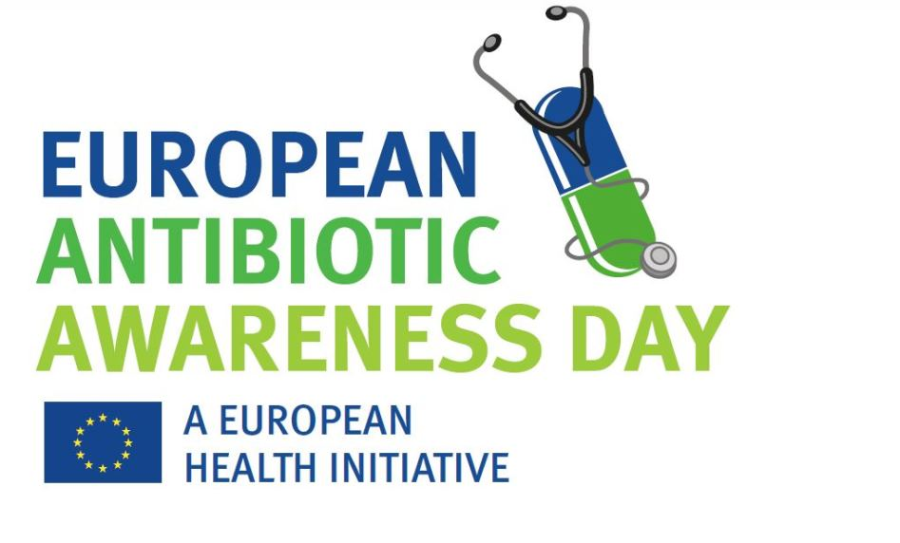

European Antibiotics Awareness Day Communications Information Pack
18 November 2020

www.hse.ie/infectioncontrol
#KeepAntibioticsWorking

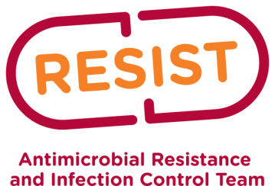
Background
Every day antibiotic resistance is making people suffer more and die younger than they need to. We know that every year many people in Europe die earlier from antibiotic resistance infection (there is no exact number for this for any country in Europe including Ireland.)
Antibiotics were the wonder drugs of the last century; the magic bullets. We got better at making antibiotics in bulk and doing it cheaply. For more than 50 years most countries in the world have been using vast amounts of antibiotics in people, in animals and in forestry. Nearly every time we kill bacteria with antibiotics most of them die but a tiny few survive and multiply. This is because they happen to have a genetic trick up their sleeve that blocks the antibiotic. Years of using lots of antibiotics around the world have left us with a world where those antibiotic resistant superbug numbers are increasing in people, in animals and the environment (water and soil).
Over all those years of overusing antibiotics people have started to live longer because of better living conditions. We have also got much better at helping people with diseases that were rapidly fatal to live some good quality extra years. The price of that progress is more people vulnerable to infection and more people who need high tech healthcare. A lot of the progress in treatment depends on protecting vulnerable people from infection during their treatment using antibiotics. We now risk losing a lot of the progress because our antibiotics do not work so well. There are superbugs in existence (e.g. MRSA, VRE, ESBL and CPE) that are resistant to many of the antibiotics we have. There is also very little progress in the development of new antibiotics.
It is an important part of this year’s campaign that we continue to highlight that antibiotics do not work to treat viruses including COVID-19.
Target audiences
- Patients/service users
- HSE prescribing staff in community and hospital settings
- GPs, dentists and pharmacists (relevant GMS contractors)
- Department of Health
- Key agencies e.g. IPU, ICGP, Royal Colleges etc.
- Relevant stakeholders
How can you help?
We are launching a social media campaign to highlight awareness of European Antibiotic Awareness Day with a focus on:
- Taking antibiotics properly
- Hand hygiene
- Superbugs
- HSE Chief Clinical Officer welcomes EAAD
You can access the videos on the HSE YouTube account by clicking the links above. We are asking for your continued support share the videos, talk about antibiotic resistance, promote proper use of antibiotics and highlight prescribing guidelines www.antibioticprescribing,ie to prescribers. We would be grateful if you could point patients and service users to www.undertheweather.ie as it provides information on managing simple illnesses without antibiotics. We would like if you could share and comment on our videos and social media posts, and to challenge day-to-day misinformation about antimicrobial resistance.
There are three ways you can support us:
- Messaging
It is valuable to share consistent messages, and our communications team has created some, images and social media posts that encapsulate some key points:
- Take care of yourself and learn to treat common illnesses that do not require antibiotics www.undertheweather.ie
- Antibiotics can cause more harm than good if taken unnecessarily
- COVID-19, influenza, colds are viral infections – antibiotics don't work for virus infection
- If you do need antibiotics take them as prescribed
- For prescribers; prescribe antibiotics as set out on www.antibioticprescribing.ie or on hospital/community guidelines and be aware of the red/green antibiotic prescribing programme.

2 Media
Contained in this pack are the HSE press release and examples of content which can be tweeted or posted on EAAD and the days before/after.
3 Sharing
Please let your members, colleagues or staff know about the videos, www.antibioticprescribing.ie , www.undertheweather.ie and the communications materials that are available.
Media Relations
If you do not have access to a clinical spokesperson, the HSE can provide clinical spokespeople from the health services to support the media campaign.
Social Media
We welcome your support in promoting the key messages of the campaign by tweeting or retweeting, posting or sharing and engaging with the content listed below on your social media platforms. The tweets will commence on 15th November with an average of 1/2 tweets per day until 25th November. Please show your support by liking/sharing on twitter.
Hashtag: #KeepAntibioticsWorking
Twitter handle: @HSELive
Date | Tweet | Image/video | Web link
15th | European Antibiotics Awareness Day 18th November. Your body can fight most infections, antibiotics are only needed for bacterial infections.  #KeepAntibioticsWorking | EAAD image | https://bit.ly/3wCGzlL
16th | #KeepAntibioticsWorking: hand washing is the single most effective way to stop the spread of infection in homes, workplaces and hospitals, limiting the need to use antibiotics if someone gets very sick. | Handwashing video (https://youtu.be/YZMkyQCarXk) | NA
17th | Antibiotics can do more harm than good if they are not required. To prevent antibiotic resistance, it’s important to only use antibiotics when prescribed by your doctor.  #KeepAntibioticsWorking |  | https://bit.ly/3n6IhZI
18th | Many antibiotics are no longer effective against some bacteria. Using antibiotics only when needed can help stop this happening #KeepAntibioticsWorking | https://youtu.be/Zskk7npqC7w | na
18th | Using antibiotics when they’re not needed helps superbugs grow, some superbugs can make you very sick – skip the antibiotics unless prescribed, and get better by yourself. #KeepAntibioticsWorking | https://youtu.be/hOVQNhG8tOQ
19th | Using antibiotics when they’re not needed helps superbugs grow and some superbugs can make you very sick – skip the antibiotics unless prescribed, and get better by yourself. #KeepAntibioticsWorking | Superbugs video | NA
21st | Antibiotics have transformed medicine. Keep them working. Only prescribe when absolutely needed. #KeepAntibioticsWorking  #PrescribeWisely |  | https://bit.ly/30eB1Sd
22nd | Remember that antibiotics don’t work on viruses, like COVID19, colds and flu. Taking them when you don’t need them may make you even sicker with no benefit for you. #KeepAntibioticsWorking  #AntibioticResistance | Antibiotics video | www.undertheweather.ie

Suggested social media images
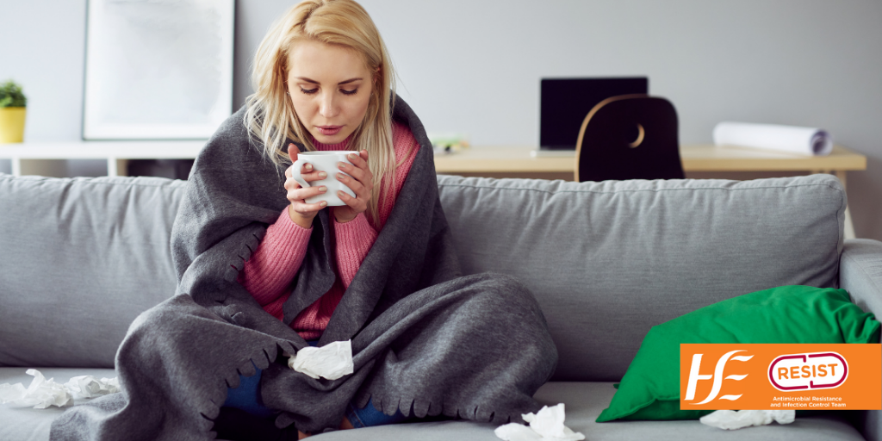
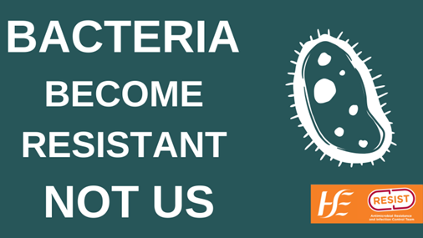 | 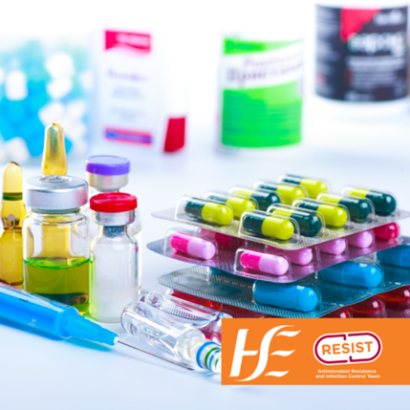
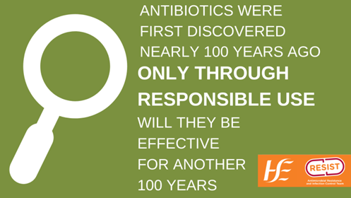 | 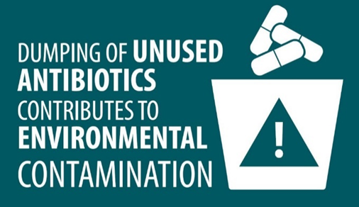
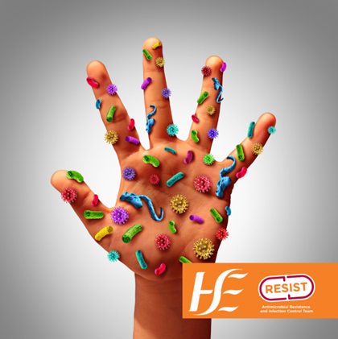 | 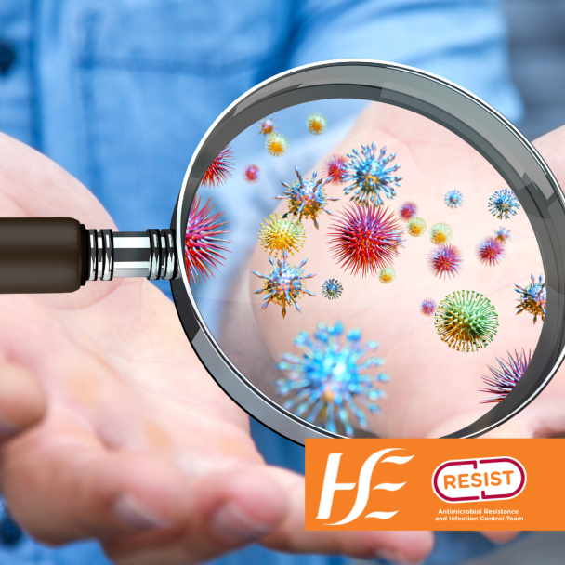

Keeping well content
How to cope with winter illnesses and why it’s a good thing if your doctor says you don’t need an antibiotic

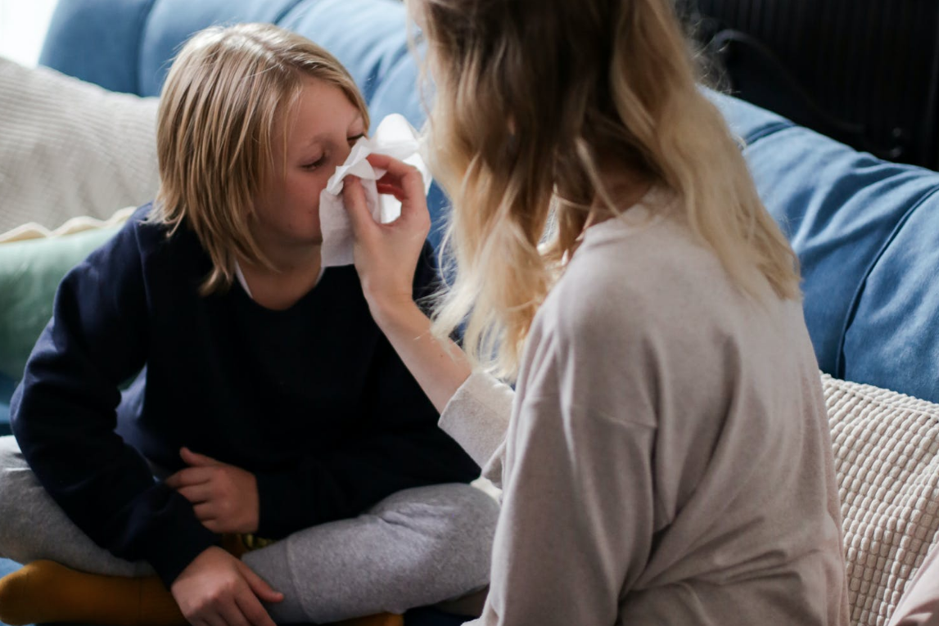
We are all worrying a little bit more this year about the kids getting sick. As well as COVID-19, viruses like croup RSV, tend to be commonplace around autumn and winter. It can be hard to know how to mind everybody. We asked Dr Nuala O’Connor for her advice about managing illnesses this winter.

The most important thing to do if your child is unwell is to keep them home from school or crèche to stop infections including COVID-19 spreading in our communities.

Most common illnesses are caused by viral infections and do not require an antibiotic. Our bodies can fight off these infections without antibiotics. Young children may get 6-7 viral infections each year mainly in the autumn and winter months. The good news is that there is lots of information available to help you cope with common illnesses this winter.
For information on how to protect your child from COVID-19, including when they should stay home from school, click here. For other common winter illnesses, check out the HSE website and MyChild.ie where you’ll find lots of helpful information about everyday illnesses like colds, coughs, croup ,flu, earache and sore throats and how your own immune system is enough to help you get better.

Vaccination is a great way to protect your child from certain infections. This is the time of year when flu starts to circulate and children are twice as likely as adults to catch the flu, which can sometimes cause serious illness. The good news is that all children aged 2 to 17 can now get their free, nasal spray flu vaccine. It’s a safe and effective way to protect them, and the rest of your family too. You can make an appointment with your GP or a local participating Pharmacist. You can find out more at www.hse.ie/flu

Everyone aged 12 and over can get a free COVID-19 vaccine too. 65% of 12-15 year olds and 77% of 15-17 year olds are now fully vaccinated against COVID-19. You can register your child for this and find more information here.

Antibiotics do not treat common viruses including the flu, COVID-19 or colds. Taking antibiotics when you do not need them can cause you unnecessary harm. About one in five people who take antibiotics develop side effects, such as a rash, upset stomach or diarrhoea.

If we have an infection caused by bacteria like pneumonia or a kidney infection we need antibiotics so we can accept the minor side effects that go with them. However if we have an infection caused by a virus, like coughs, colds, flus and sore throats, we might get side effects but for zero benefit because antibiotics don’t treat viral illness.

Antibiotics will not relieve pain or a fever – for this, you will need to take paracetamol or ibuprofen.

Antibiotics will not ease a cough unless the cough is from pneumonia, which thankfully is uncommon. If you are unsure, you can talk to your pharmacist for cough medicines or try warm honey and lemon drinks. Remember that honey is not suitable for child under 1 year of age. You can cough for up to 3 weeks after a viral infection.

Taking antibiotics when you don’t need them means that they might not work for you when you do need them. Antibiotics have been overused in recent years and bacteria are becoming resistant to the antibiotics used to treat them. This means that some common antibiotics no longer work as well as they used to and that some of them don't work for certain infections anymore. Also, some bacteria have changed. This means some antibiotics that were used to treat them no longer work very well.

We need to use antibiotics in the right way to slow down antibiotic resistance. This will help them remain effective for us and our children.

You can help prevent antibiotic resistance by:

- not asking for antibiotics to treat viral infections, including COVID-19, colds and flu
- taking antibiotic doses as prescribed and only when you need them
- cleaning your hands regularly before and after preparing or eating food
- knowing how to treat and recover from common viral illnesses

You can find more information about everyday illnesses like colds, coughs, flu, earaches and sore throats don’t need an antibiotic on the HSE website and MyChild.ie.

PRESS RELEASE – EMBARGOED UNTIL 18TH NOVEMBER
Shooting apples on European Antibiotic Awareness Day
The story goes that on the 18th of November 1307 William Tell shot an apple of his son’s head with a crossbow. Exactly 701 years later in 2008 we first marked European Antibiotic Awareness Day (EAAD).
European Antibiotic Awareness Day (EAAD) is an annual event to remind everyone how valuable antibiotics are, how important it is that we only use them when we need them and that these amazing drugs are under threat from the growing problem of antibiotic resistance.
Professor Martin Cormican, HSE National Clinical Lead for Antimicrobial Resistance and Infection Control sys, “Antibiotics are like magic arrows that hit the bacteria where it hurts but are usually very safe for us. However over the last 100 years or so people have used a lot of antibiotics in people and in animals. In some countries antibiotics have even been sprayed on fruit trees, and yes it was apple trees. Because of all the antibiotics many bacteria have changed so that these arrows do not work as well as they used to work 20 years ago. This is the problem of antibiotic resistance. Antibiotics can cause more harm than good if taken unnecessarily. COVID-19, influenza and colds are viral infections – antibiotics don't work for virus infection, if you do need to take antibiotics always take them as prescribed by your doctor.”

Dr. Nuala O’Connor, GP and ICGP lead for Antimicrobial Resistance says, “A key message of EAAD is to only use antibiotics when they are likely to help someone who is sick get better. Antibiotics don’t help you to get better faster if the infection is caused by a virus such as COVID-19, colds or flu. As a GP I still get some requests for antibiotics from people who have viral infections such as colds and flus or for their children. This is a bit less common now because more people know that antibiotics are not always necessary, but it does still happen. Antibiotics will not help them get better and in fact can cause side effects like upset tummies, nausea or skin rash. It is safer for you not to take an antibiotic you don’t need because antibiotics like all medicines can have side effects.”
The HSE, in partnership with general practitioners and pharmacists has a website which gives practical, common sense advice and information on dealing with many common illnesses like colds, flu, earaches, sore throats, tummy bugs and rashes.
www.undertheweather.ie provides sound advice to give us the confidence and skill we need to take care of ourselves and our families without resorting to antibiotics. Antibiotics can cause more harm than good; they should be used only as prescribed and when needed.”
- Antibiotics don’t work for viral illnesses including COVID-19, colds or flu. If you have a cold or flu, visit www.undertheweather.ie for advice on how to help yourself get better and ask your doctor for advice if you are concerned.
- If you have symptoms of COVID-19 please stay at home, book an online test. If you are particularly concerned ring your GP.
- Antibiotics should be taken exactly as prescribed - at the right time for the right duration.
- Never share antibiotics or take them without a prescription.
The best treatments for most common viral infections are rest, plenty of fluids and paracetamol or ibuprofen to treat fever and pain symptoms. Both doctors and patients in the community and the hospital need to keep in mind that antibiotics are a valuable resource and should only be used when the benefit is greater than the risk.
It is still important to get checked by your GP if you are worried especially for very young children, older people and those with long-term medical conditions or whose immune system is suppressed. Your GP will be able to judge if are likely to have and infection that needs treatment with an antibiotic. If your GP says you do not need an antibiotic this is good news because antibiotics are only for when you need them.
Ends

Communications contact details
HSE Press Office: press@hse.ie
Audrey Lambourn AMRIC Communications Lead
audrey.lambourn@hse.ie 087 988 9264 (12/11/21)

