**BIOGRAPHIES**

Members of the Scottish Women and Girls in Sport Advisory Board

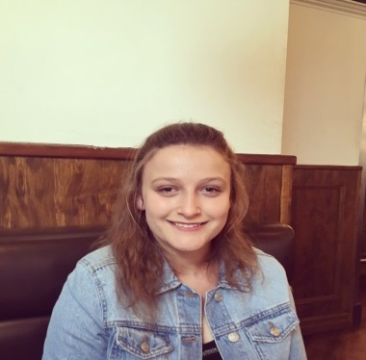**Gemma Lumsdaine:**

Gemma is a 20 year old athlete who plays Wheelchair Basketball and Wheelchair Rugby. As a member of the U23 Scotland squad Gemma has won gold at the Celtic Cup 2016 and Co-Captained Scotland U19s at both the School Games and National Junior Championships. Gemma coaches wheelchair basketball for Dundee Dragons Wheelchair Sports Club and is Scotland U19 Assistant Coach. She plays wheelchair rugby at a high level and currently represents Caledonian Crushers in the BT Super Series. Gemma has won a number of awards both nationally and locally including GBWR Best in class 2016, the Angus Sports personality of the Year for people with a disability 2017, BWB Young Volunteer of the year 2016 and Tayside & Fife Disability Coach/Player of the Year (2015). Gemma sits on both the Scottish Disability Sport and Basketball Scotland Young Peoples’ Panels. She has spoken at the House of Lords about the benefits of disability sports and has been recognised as one of the most inspirational young women in Scotland by the YWCA. Gemma has recently been asked to trial for GB at Wheelchair Rugby and hopes to combine her sporting career with her studies at Abertay University.



**Amanda Jones:**

Amanda Jones is a partner at leading firm MMS which is soon to merge with the world’s largest law firm, Dentons. She has been practising Employment law for more than 20 years and has a particular interest in discrimination and sports law. She is also a non-executive Director of Hibernian Football Club Limited, Hibernian Community Foundation, and Lothian Racing Syndicate Limited. She lives in East Lothian with her husband, sons, Great Dane and cat.

**Claire Nelson**:

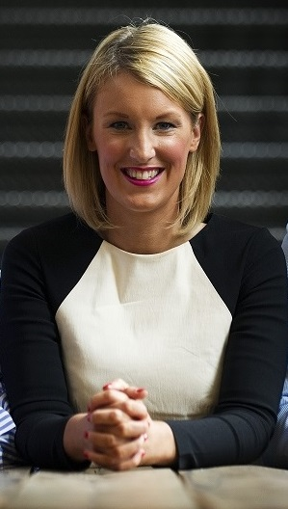Claire Nelson is the CEO of Netball Scotland and since taking up the role less than two years ago she has managed to position the organisation as a leading Governing Body in Scottish sport, introducing new and innovative strategies to growing and developing the sport and it’s people. Netball Scotland are a finalist in the SGB of the Year category at this month’s Team Scotland Awards for the second year running. With a background in business and marketing, and having operated across multiple global markets in the technology field, Claire brings a fresh approach to sport leadership and isn’t afraid of a challenge. Last year her team successfully tendered for one of ten places in the UK-wide Sky Sports televised Netball Superleague, and in February the new semi-professional national Franchise - the Sirens - launched in Scotland in front of a sell-out crowd and live tv cameras to an impressive reception and huge off court impact. A passionate advocate for equality and winner of a prestigious ‘Leaders Under 40’ global sports industry award this year, Claire is on a mission to change the landscape of women’s sport, recently launching the #ChangingTheGame campaign to challenge the many disparities that currently face women and girls in Scotland.

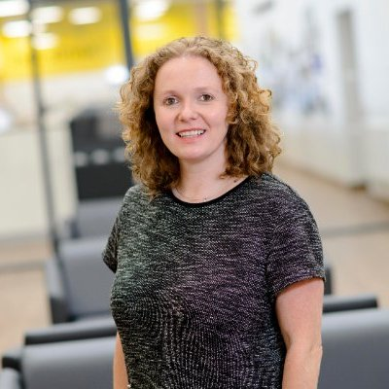**Viv McLaren:**

Vivienne joined the SWF board in June 2014 as media and communications director and led the re-brand and re-launch of SWF competitions as well as growth of awareness of SWF in order to attract the organisation’s first commercial partners.

She was appointed Chair in October 2016. An avid supporter of women’s football for over 20 years Vivienne is honoured to be part of the SWF board and is determined to play her part in raising the profile of the game further, as well as playing a key role in growing player numbers.

In her day job, Vivienne is an award-winning marketing and communications strategist with a propensity for digital marketing. With 21 years’ industry experience, she has cultivated significant perspective working across both client and agency sides in Scotland and London.

Having held senior positions in leading UK communications and digital agencies, in 2007 Vivienne founded one of Scotland’s first dedicated digital marketing agencies.

Well known for her passion for sport she is often seen at sporting events and still plays hockey for her local club, Giffnock Tennis Squash and Hockey Club, in Glasgow’s South Side where she has been a committee member for 6 years.

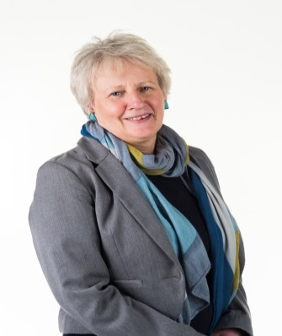

**Maggie Cunningham**

Maggie Cunningham has been chair of MG ALBA since July 2012. Maggie worked in a number of senior positions in the BBC for almost 20 years until 2009. Her roles included Joint Head of Programmes and Services and Head of Radio in BBC Scotland. She is a founder member and vice chair of Sistema Scotland, the charity which aims to transform children’s lives through music.  She is also vice chair of Columba 1400, where she was chief executive until August 2015.   Maggie is an executive and leadership coach and is an associate tutor with The Social Enterprise Academy.

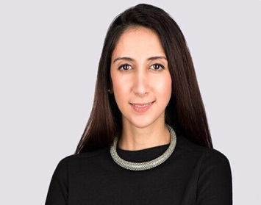**Hala Ousta**

As Diversity and Inclusion Manager for the Scottish Football Association, Hala is an established campaigner for equality, diversity and inclusion within sports at several levels.

Having a Masters in Public Policy & Post graduate Diploma in Equality & Discrimination, her experience covers a wide range of roles and responsibilities related to Equality and Sports development.

She currently sits on the Board of ‘Women in Football’, ‘sportscotland’, ‘ICON Awards’, with advisory roles on the ‘Scottish committee of the British Council’ and is involved within the ‘UEFA’s Captains of Change’ programme. In addition, she has founded and chairs ‘Inspiring Women Scotland’, an organisation promoting empowerment and leadership for multicultural young women.

In addition, she has recently been chosen as one of the UK’s 30 under 30 Sports Industry Group Next Gen Leaders 2017 which recognises and rewards the rising industry individuals.

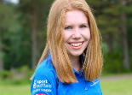**Emma Mahon**

I’m all about athletics and I run as part of the my local athletics club. At school, I am a Young Ambassador and I also act as Active Schools vice captain. I also run a netball club in my community.

I really am passionate about sport. It’s been a massive part of my life and I definitely think it has given me the confidence to try new things. I really want more people to get involved in sport. When I finish a run, I get such a sense of achievement and I want other people to experience this feeling too

**Kirsty Ewen**

I currently volunteer for Scottish Swimming as the Domestic Open Water Events Co-ordinator. I have a particular interest in swimming having competed at a variety of levels including regional and national over the years. I was also lucky enough to go and compete at the Youth Friendship Games in Holland! Since stopping competitive swimming I have had roles as both a swim teacher and swim coach and volunteered at the IPC World Championships in Glasgow in 2015.

I have also been involved in volunteering both at London 2012 and Glasgow 2014 and was lucky enough to travel around Scotland as part of the Queen’s Baton Relay, where I got to meet loads of inspiring people!

I have a particular interest in Leadership within sport and would like to encourage young people of all shapes, sizes and abilities to get involved in sport in some way, whether through participating, competing or volunteering.

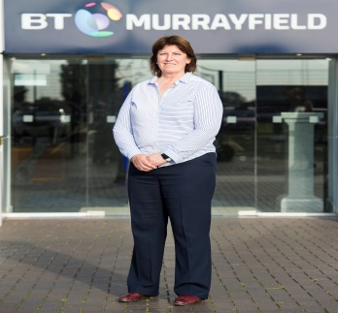**Sheila Begbie:**

Sheila is the former Captain of the Scotland Women's Football Team.

Initially starting her career as a Physical Education teacher she moved into Sports Development working for The Scottish Sports Council as their Teamsport Scotland Girls'/Women's Development Officer.

Sheila was previously the Head of Women & Girls Football at the Scottish FA where she worked for a number of years leading the strategic development of the girls and women's game. She was the catalyst for the Scottish FA's inaugural Women into Leadership programme which supported key professional and volunteers in the game to support them for future roles in football.

The former Vice Chair of the Women's UEFA Committee Sheila was key to the creation of a strategy for girls and women's football at UEFA which attracted a €22 million budget.  Passionate about supporting Women into Leadership she was again instrumental in the establishment of UEFA's Women into Leadership programme which is highly successful in supporting and developing women involved in football for key roles in the game.

She was awarded an MBE in 2001 for her work in Girls' & Women's Football.

Sheila is a graduate of the Women in Sport Leadership Academy which is supported by the Anita White Foundation which is delivered annually with the support of Chichester University.

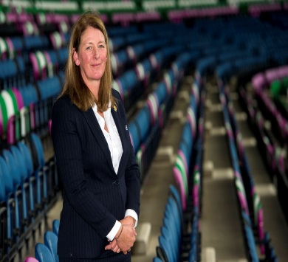**Dee Bradbury**

Dee is currently the Vice President of the Scottish Rugby Union and Scottish Rugby’s representative to Rugby Europe. She will automatically take over as President of Scottish Rugby in August 2018 for a term of two years. On a professional level, she was a Police Officer for 30 years and retired in 2014.

Having been involved in sport from an early age, she has represented Scotland and Great Britain in athletics at both junior and master’s levels. Dee has also played and coached netball for many years. After deciding to take up rugby at the age of 38, she became closely involved with her local club as a player, coach and latterly became one of very few female club Presidents in Scotland at the time.

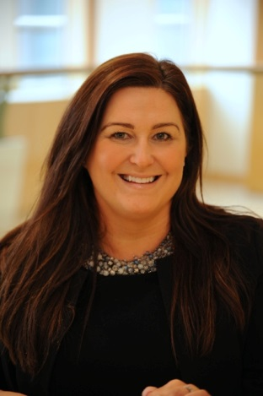**Yvonne Greeves**

As National Women in Business Manager for NatWest, The Royal Bank of Scotland and Ulster Bank, Yvonne is responsible for designing and implementing the Women in Business Strategy both internally and externally across the UK. With over 400 WIB specialists across the country she is also responsible for supporting this network to collaborate, build relationships and influence senior stakeholders, strategic partners and external organisations across the UK to drive the WIB proposition for the bank.

Yvonne is a keen mentor to several female entrepreneurs and is Chair of MsMissMrs a social enterprise seeking to support women and girls from disadvantaged backgrounds and is a trustee of Changing the Chemistry.

**Maureen McGonigle**

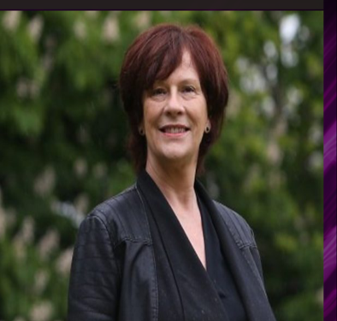Maureen McGonigle is the Founder and CEO of Scottish Women in Sport which is a national equity charity launched in November 2013 to increase the profile and raise awareness of all areas of women in sport in Scotland. Its vision is for a Scotland where females of all ages, abilities, ethnicities and walks of life are participating in sport or physical activity; within a positive, equitable culture where their achievements are promoted and celebrate.

Chair of Scottish Sports Futures an organisation that uses the power of sport to empowers young people to make positive lifestyle choices. A member of the Board for The School of Social Entrepreneurs, which is a charity that supports people using entrepreneurial approaches to tackle complex social problems.

Maureen has been involved in sports administration for over 25 years. Executive Administrator of Scottish Women’s Football till December 2013, Maureen was the first female Scottish FA Council Member and Non-Professional Game Board member in football in Scotland. She is now the only Scottish FA female life member and is currently a member of the Scottish FA Judical Panel

Maureen currently writes a weekly column for The National on women and girls in sport.