23 June 2020
News Release
An investor’s perspective on the post COVID-19 market recovery

- UBS Asset Management predicts a return to end-2019 economic levels in mid-2022 in its base case scenario
- The most powerful contributors to a full economic recovery will likely be the development of a vaccine followed by a government pivot from support to stimulus
- Markets’ reaction to the virus reinforced the resilience and diversification benefits of Chinese assets and validated the ability of sustainable investments to outperform during volatile periods

Investors should prepare for a gradual, uneven economic recovery that could take until 2022 to re-establish levels reached at the end of 2019. In this environment, relative value opportunities are ample across asset classes. Financial markets reflect China’s status as among the first economies to move toward a recovery. In addition, the outperformance of sustainable investing through the recent volatility is likely to foster increased investor demand. These are some of the views of UBS Asset Management’s (UBS AM) latest Panorama market outlook published today.

The COVID-19 pandemic led to a shutdown of global economic activity and an unprecedented policy response from governments and central banks around the world. This has been followed by mass doubt about the long-term future of work and social interactions. Capital spending is likely to stay in the doldrums in this highly uncertain backdrop, and the scope for households to reduce saving rates is also limited. As a result, UBS AM’s base case is for the nascent recovery to be gradual and uneven, with a wide degree of dispersion among different countries and sectors.
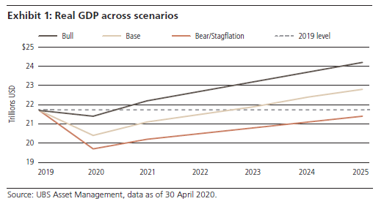
Evan Brown, Head of Multi-Asset Allocation Strategy at UBS AM, said: “Risk assets around the world have enjoyed substantial rallies since late March, as initial policy enthusiasm was followed by incremental progress on both public health outcomes and economic activity across the developed world. Nonetheless, in our base case scenario, lingering safety concerns will keep demand and capacity below pre-COVID-19 levels in 2020 and beyond.”

There is an upside scenario in which a faster than expected arrival of an effective vaccine allows for a comprehensive economic reopening, with governments nimbly turning to stimulus spending.

“We believe the most powerful determinant of economic recovery will be the development of a still-elusive vaccine or proven treatment protocol, followed by a government pivot from providing a cushion to stimulus. In addition to breakthroughs in the medical field, public policy decisions will be instrumental in deciding the character – whether it be a V, a U, or most likely in our view, a ‘swoosh’ – that defines the shape of differing recoveries,” continued Evan Brown.

“Rarely have investors been bombarded with so much change to so many drivers of investment decisions in such a short period of time. For those that can process the implications of all this change and invest in the most dispassionate manner, the opportunities are potentially boundless. Our long-held bullish stance on Chinese securities still holds water and integrating sustainability into investment decisions has shown its worth throughout the recent volatility,” added Barry Gill, Head of Investments at UBS AM.

The correlation between domestic China and other equity markets remains low and this was again proven during this crisis. With the country showing signs of being one of the first economies to move toward a recovery and its equity market remaining under-represented in global equity indices, there are opportunities for investors.

Market data shows that ESG indices, such as the MSCI SRI global and ACWI indices, have outperformed their traditional counterparts by 10% over three and five years. Based on initial indicators over the past few months, this trend has continued and the companies held by sustainable investors have seen a surge in demand.

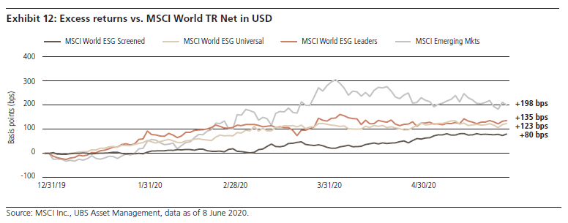
- Ends -

About UBS Asset Management

Asset Management is a large-scale asset manager with a presence in 22 markets. It offers investment capabilities and investment styles across all major traditional and alternative asset classes to institutions, wholesale intermediaries and wealth management clients around the world. It is a leading fund house in Europe, the largest mutual fund manager in Switzerland, the second largest fund of hedge funds manager and one of the largest real assets investment managers in the world.

