Benefits of Improved Economic Performance
Scottish Government
Introduction
Scotland’s Economic Strategy sets out an over-arching framework for how we aim to achieve a more productive, cohesive and fairer Scotland.
This paper provides illustrative estimates of the potential impact that improving Scotland’s productivity, investment and export performance can have on employment, GDP and tax revenue.
The analysis demonstrates that relatively small changes in these areas of economic performance can have a potentially significant impact on Scotland’s wider long-term economic performance. The results summarised below show the potential scale of the impacts after 10 years:
- Increasing Scotland’s total factor productivity by an additional 0.1% a year over a 10 year period could boost GDP by 1.3%, employment by 11,000 and tax revenue by £400 million;
- Narrowing the gap in investment between Scotland and its international peers could increase GDP by 1.6%, employment by 39,000 and tax revenue by £800 million;
- Achieving the Scottish Government’s target to boost exports by 50% could boost GDP by 2.7%, employment by 67,000 and tax revenue by £1.6 billion.
Impact of an increase in Total Factor Productivity
Total Factor Productivity (TFP) is determined by how efficiently and intensely production inputs are utilised. It is often seen as a measure of technological progress and is a key driver of economic growth.
Improving Scotland’s TFP could have a significant impact on the country’s economic performance, employment and the tax revenue generated.
Over the decade prior to the recession, 1997-2007, the ONS estimate that TFP growth in the UK averaged 1.0% a year. The analysis below models the impact of an additional 0.1% increase in Scotland’s TFP per year to assess the impact that this improvement could have on Scotland’s economic performance.
The results demonstrate that by year 10, this scenario could add 1.3% to the level of GDP. Employment could rise by 11,000 and tax revenues by £400 million as a result of the expansion in the economy.

Impact of a 0.1% increase in TFP per annum over 10 years
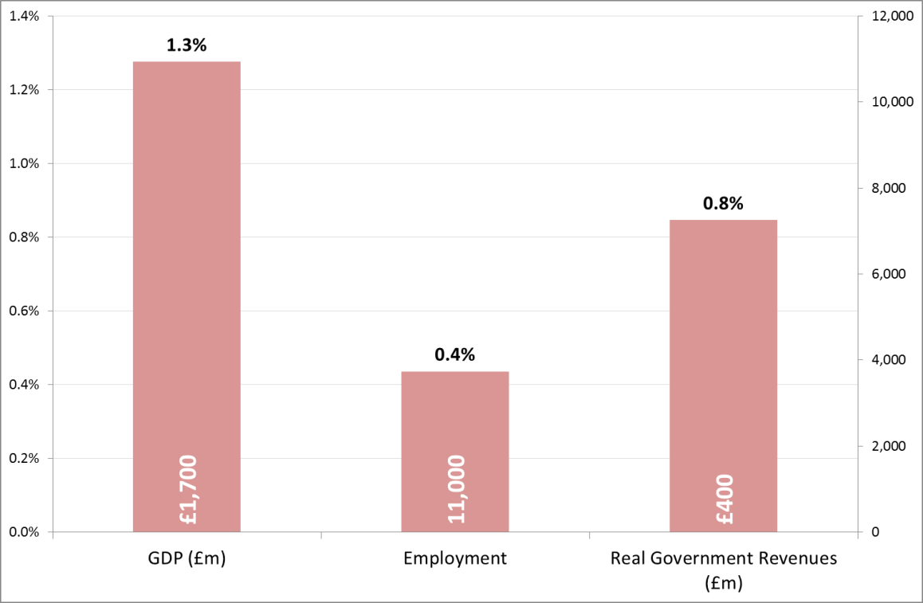
Impact of a rise in business investment
Business investment and innovation is also a key driver of economic performance. As firms invest in new technology, the improvement in productivity increases their competitiveness and supports increased output and employment.
International comparisons show that investment in the UK remains at a low level as a percentage of GDP. In 2013, Gross Fixed Capital Formation (GFCF), a measure of investment, was 16% of GDP in the UK compared to an average G7 of over 20%. A similar trend is evident in Scotland.
Increasing the level of GFCF by an additional 0.5% a year would bring the investment spending in the UK closer to that observed in other G7 economies such as France and the US in the decade prior to 2007.
The analysis suggests show that such an improvement in Scotland could drive a 1.6% increase in GDP at the end of a 10 year period. This could potentially boost employment by 39,000 and increase tax revenues by £800 million.

Impact of a 0.5% increase per annum in business investment over 10 years
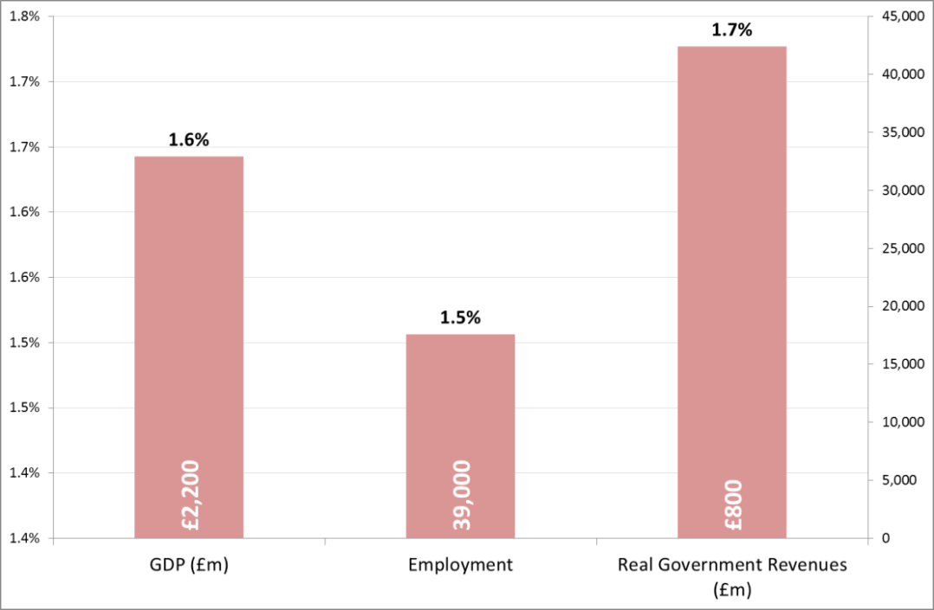
Impact of boosting exports
With increasing globalisation, exports will make an increasingly vital contribution to Scotland’s future economic performance. The Scottish Government has a target of boosting exports by 50% in cash terms over the period 2010 to 2017. Over the first three years of this period, exports have increased by 20%.
Achieving this target could have a potentially significant impact on the wider economy.
As an illustration, over a ten year period, achieving this 50% target could increase GDP by 2.7%, increase employment by 67,000 and boost tax revenue by £1.6 billion.
Impact of a 50% increase in the value of exports
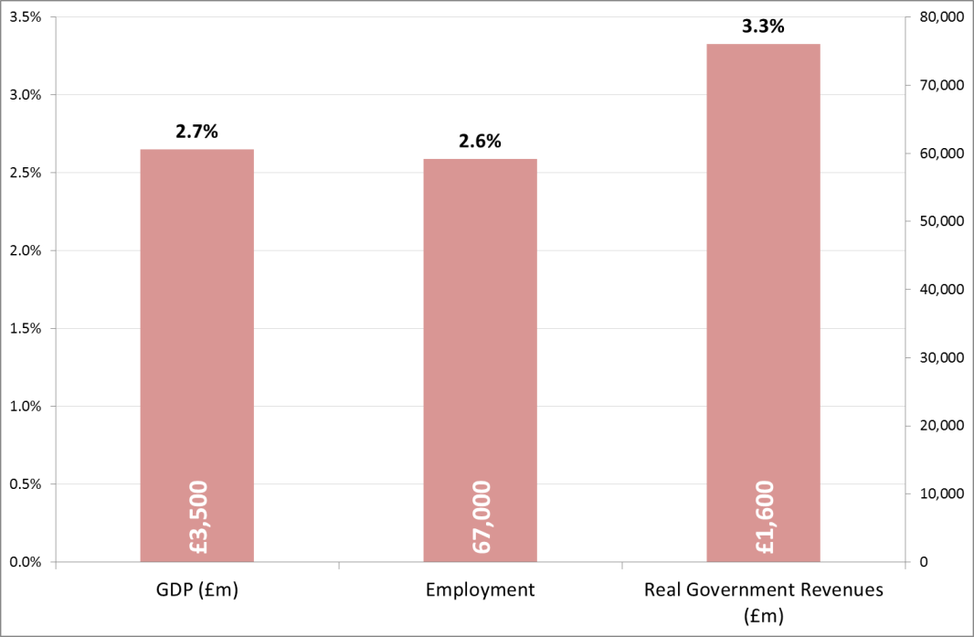
Conclusion
This paper has shown how three drivers of economic growth – productivity, business investment and exports – can act to increase economic growth, employment and tax revenues.

Multi-factor Productivity, Indicative Estimates to 2012, http://www.ons.gov.uk/ons/dcp171766_349616.pdf
World Bank World Development Indicators
Building Security and Creating Opportunity, p182 http://www.gov.scot/resource/0043/00438277.pdf,

