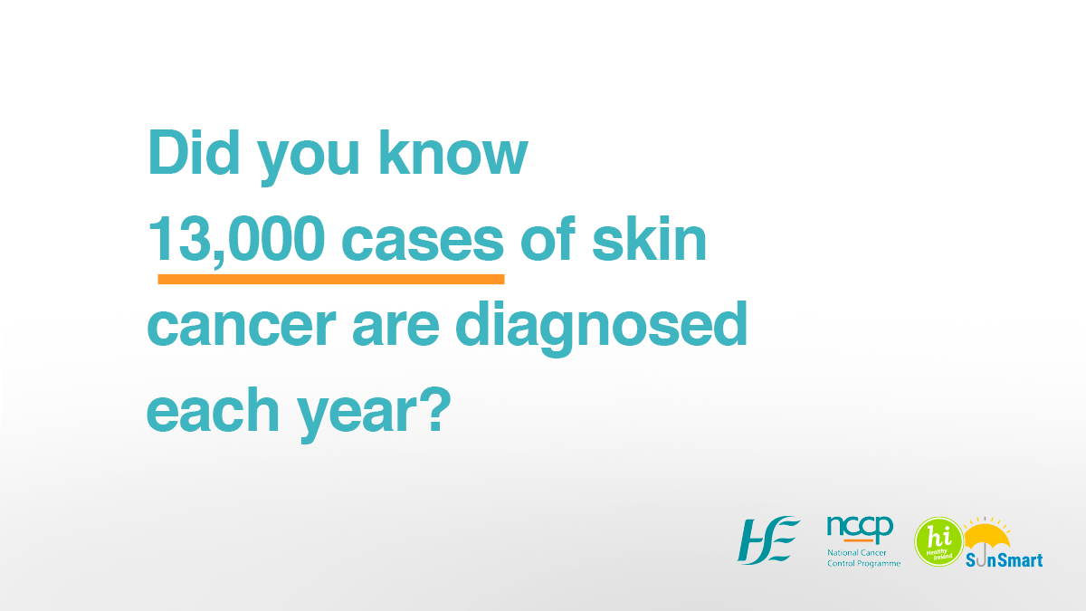
SunSmart Campaign 2023
SunSmart Campaign Partner Pack
1st April to 30th September 2023
#SunSmart

Contents
Background 2
Campaign key messages 2
How you can support the campaign 3
Re-sharing 3
Sample social media messages for your use 3
Images for your use 4
Videos for your use 4
Information materials 4

Background
The annual SunSmart campaign is run by the HSE’s National Cancer Control Programme (NCCP), in collaboration with Healthy Ireland and cross-sectoral partners. We are working together to support people to reduce their risk of skin cancer by protecting their skin from the sun. This is the fourth year of the campaign and each year it continues to grow.

The aim of the campaign is to increase awareness of the steps you, your family, friends and colleagues can take to protect your skin from the sun and reduce your risk of skin cancer.

The campaign will communicate and engage with people living in Ireland through multiple communications channels including: radio and digital audio, press activity and social media.

This partner pack contains information, video links and image links for your use and to share with your own networks to support the SunSmart campaign 2023.

Campaign key messages
- Skin cancer is the most common form of cancer in Ireland with almost 13,000 cases diagnosed annually.
- The number of people being diagnosed with skin cancer in Ireland is rising rapidly. Yet skin cancer is largely preventable by protecting skin from UV rays.
- Protecting your skin from the sun whether at home or abroad can reduce your risk of skin cancer.
- Be prepared. Follow the Healthy Ireland SunSmart 5 S’s: Slip on clothing, Slop on sunscreen, Slap on a wide-brimmed hat, Seek shade, Slide on sunglasses.
- Make sun protection part of your daily routine, especially from April to September, even when it is cloudy.
- No sunscreen can provide 100% protection, it should be used alongside other protective measures such as clothing and shade.

How to be SunSmart:
Follow the Healthy Ireland SunSmart 5 S’s to protect your skin:
- Slip on clothing that covers your skin such as long sleeves, collared t-shirts;
- Slop on broad spectrum (UVA/UVB) sunscreen on exposed skin, using factor 30+ for adults and 50+ for children. Reapply regularly;
- Slap on a wide-brimmed hat;
- Seek shade - especially if outdoors between 11am and 3pm - and always use a sunshade on a child’s buggy;
- Slide on sunglasses to protect your eyes.
As well as the 5 S’s it is important to remember
- Do not deliberately try to get a suntan.
- Avoid getting a sunburn.
- Never use a sunbed.

How you can support the campaign
We welcome you supporting the SunSmart campaign by posting content to your social media channels using #SunSmart in newsletters or publications and sharing this partner pack. Resources for your use are listed below:

Re-sharing
We will post content on our social media channels listed below for you to re-share.
- Twitter handles: @HSELive @hseNCCP @HealthyIreland
- Facebook Page: https://www.facebook.com/HSElive/
- Instagram: https://www.instagram.com/irishhealthservice

Sample social media messages for your use
Skin cancer is the most common type of skin cancer in Ireland, and most cases are preventable by protecting skin from the sun’s UV rays and not using sunbeds. Protect your skin from the sun whether at home or abroad. Follow the SunSmart 5 S’s: Slip, Slop, Slap, Seek and Slide. #SunSmart
Protecting your skin from the sun, no matter where you are or why you are outdoors, can reduce your risk of skin cancer. The best way to protect your skin is to follow the #SunSmart 5 S’s: Slip-on clothing that covers your skin, Slop on sunscreen, Slap on a wide-brimmed hat, Seek shade, and Slide on sunglasses. #SunSmart
Did you know that UV rays can damage your skin even on cloudy days? UV rays cannot be seen or felt and can pass through cloud cover. Follow the #SunSmart 5 S’s to protect your skin. #SunSmart
Sunscreen is an important sun protection measure, but cannot provide 100% protection. It should be used alongside other protective measures such as covering up with clothing, wearing a wide-brimmed hat, sunglasses and limit time in the mid-day sun when UV rays are at their strongest. #SunSmart
Make sun protection part of your daily routine, especially from April to September even when it is cloudy. Slip on clothing, Slop on sunscreen, Slap on a wide-brimmed hat, Seek shade and Slide on sunglasses. #SunSmart
Being SunSmart is important as most skin cancers are preventable. For the best protection follow the SunSmart 5 S’s of sun protection – Slip on clothing, Slop on sunscreen, Slap on a broad-brim hat, Seek shade and Slide on sunglasses. #SunSmart

Images for your use
Please find images for your use on social media channels and publications attached to partner pack. Images/video are also linked below:
HSE SunSmart 5 S's
Did you know 13,000 cases of skin cancer are diagnosed each year?
Protect your skin by wearing clothing that covers skin or long sleeve clothes
Protect skin, even when it's cloudy

Videos for your use
You can view and share SunSmart videos, you can find these at the following links:
SunSmart 5 S’s
Irish Skin Foundation - SunSmart for Everyone
SunSmart Patient Skin Cancer Story, Martin’s Story

Information materials
Downloadable information materials on the SunSmart campaign and fact sheets are available on www.hse.ie/sunsmart or you can email prevention@cancercontrol.ie with your request.

Thank you for your support

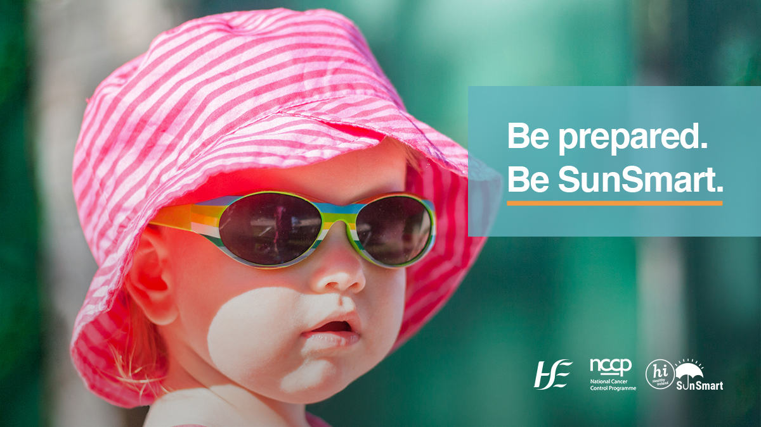
SunSmart Campaign 2023

SunSmart Campaign Partner Pack Children
1st April to 30th September 2023

#SunSmart
Contents
Background 2
Campaign key messages: Children……………………………………………………………1
How you can support the campaign 3
Re-sharing 3
Sample social media messages for your use 4
Images for your use 4
Videos for your use 4

Background
The SunSmart campaign is run by the HSE’s National Cancer Control Programme (NCCP), in collaboration with Healthy Ireland and cross-sectoral partners. We are working together to support people to reduce their risk of skin cancer by protecting their skin from the sun. This is the fourth year of the campaign and each year it continues to grow.

The aim of the campaign is to increase awareness of the steps you, your family, friends and colleagues can take to protect your skin from the sun to reduce your risk of skin cancer.

The campaign will communicate and engage with the population living in Ireland through multiple communications channels including: radio and digital audio, press and social media.

This partner pack contains information, video links and image links specifically related to parents and guardians of children for your use and to share with your own networks to support the SunSmart campaign.

Campaign key messages: Children
- Playing and spending time outdoors is good for children. But it is important to protect their skin when outside in the sun.
- Children’s skin is very sensitive to UV from the sun. Sunburn during childhood increases the risk of getting skin cancer as an adult. If your child is badly sunburned more than 3 times before the age of 20, they more than double their risk of skin cancer as an adult.
- Protect yourself and your children by being SunSmart as part of your daily routine from April – September in Ireland, even when it’s cloudy.
- Always protect children and babies skin from the sun. For babies under 1 year old, keep them in the shade and dress them in loose clothing that covers the skin.
- It is better to protect babies up to 6 months old from sunlight by using shade and clothing rather than sunscreen. You may choose to use sunscreen sometimes on small parts of your baby’s skin. If you do, choose a sunscreen that is for babies such as sensitive or toddler sunscreen.
- There are simple things you can do to reduce the risk of sunburn and keep children safe in the sun. Find shade to play under, wear wide-brimmed hats and long-sleeved shirts and apply sunscreen on exposed skin.
How to be SunSmart:
Follow the Healthy Ireland SunSmart 5 S’s to protect your child’s skin
- Slip on clothing that covers your child’s skin such as long sleeves, collared t-shirts;
- Slop on sunscreen on exposed areas, using factor 30+ for adults and 50+ for children with high UVA protection, and water resistant. Reapply regularly;
- Slap on a wide-brimmed hat;
- Seek shade - especially if outdoors between 11am and 3pm. Sit in cover of trees to avoid direct sunlight and use a sunshade on your buggy or pram. Keep babies and children out of direct sunlight;
- Slide on sunglasses to protect your child’s eyes.

As well as the 5 S’s it is important to remember
- Do not deliberately try to get a suntan.
- Avoid getting a sunburn.
- Never use a sunbed.

How you can support the campaign
We welcome your being part of the campaign by posting SunSmart content to your social media channels using #SunSmart in newsletters or publications and sharing this partner pack. Resources for your use are listed below

Re-sharing
We will post content on our social media channels listed below for you to re-share.
Twitter handles: @HSELive @hseNCCP @HealthyIreland
Facebook Page: https://www.facebook.com/HSElive/
Instagram: https://www.instagram.com/irishhealthservice

Sample social media messages for your use
Don’t just wait for hot or sunny days to use sun protection. UV can damage your skin on cool and cloudy days too. Be prepared and protect yourself and your children’s skin from the sun especially from April to September when UV from the sun is strongest. Be SunSmart: Slip, Slop, Slap, Seek, Slide. 🔆 #SunSmart
Playing and spending time outdoors is good for your child. It is important to protect their skin when outside to reduce risk of sunburn. #SunSmart
Whether your family is playing a game of football in the garden or a day at the beach, don’t forget the SunSmart 5 S’s to help keep your family safe from the sun’s UV rays. #SunSmart
Protect yourself and children by being SunSmart as part your daily routine from April – September, even on cloudy days! In Ireland, UV from the sun is strongest between 11am-3pm. #SunSmart
Being SunSmart is important, as nearly all skin cancers are preventable. Spending extended time in the sun and getting sunburnt, especially in the first 15 years of life, increases the risk of developing skin cancer. To reduce the risk of sunburn and skin cancer, follow the SunSmart 5 S’s. #SunSmart

Images for your use
Please find images for your use on social media channels and publications attached to partner pack. Images/video are also linked below
Seek shade - especially between 11am-3pm, mother and child
Protect your skin from the sun, mother and child
Always use a sunshade on a buggy
HSE SunSmart 5 S's

Videos for your use
You can view and share SunSmart videos you can find these at the following link:
SunSmart 5 S’s How to protect your child's skin
ISF SunSmart for Children and Young People
SunSmart 5 S’s

Information materials
You can down load information materials and resources for children and young people at the links below:
SunSmart Kit Instruction Sheet
SunSmart Colouring in Sheet
SunSmart Playing Outdoors: Skin protection for children factsheet
SunSmart Education Slides for staff working with children
Protecting Children’s Skin from the Sun: Your Questions Answered

Further information materials on the SunSmart campaign and fact sheets are available on www.hse.ie/sunsmart or email prevention@cancercontrol.ie with your request.

Thank you for your support

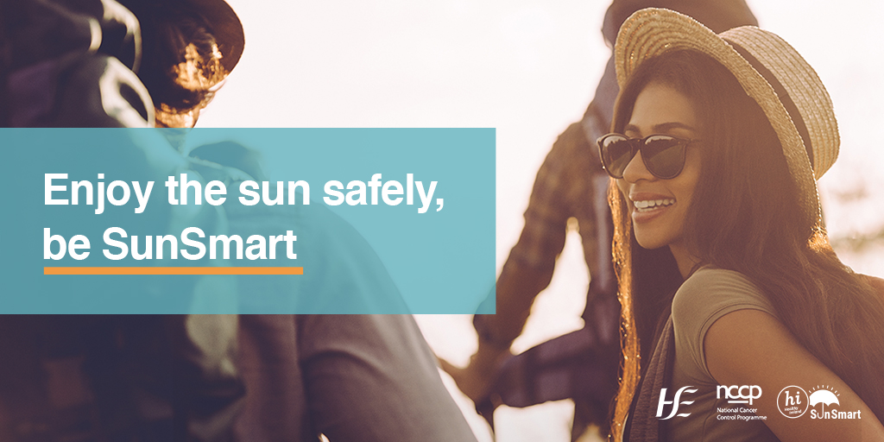
SunSmart Campaign 2023

SunSmart Campaign Partner Pack - Adolescents and Young People
1st April to 30th September 2023

#SunSmart
Contents
Background 2
How you can support the campaign 3
Re-sharing 3
Sample social media messages for your use 3
Images for your use 4
Videos for your use 4

Background
The SunSmart campaign is run by the HSE’s National Cancer Control Programme (NCCP), in collaboration with Healthy Ireland and cross-sectoral partners. We are working together to support people to reduce their risk of skin cancer by protecting their skin from the sun. This is the fourth year of the campaign and each year it continues to grow.

The aim of the campaign is to increase awareness of the steps you, your family, friends and colleagues can take to protect your skin from the sun to reduce your risk of skin cancer.

The campaign will communicate and engage with the population living in Ireland through multiple communications channels including: radio and digital audio, press and social media.

This partner pack contains information, video links and image links specifically related to adolescents and young adults for your use and to share with your own networks to support the SunSmart campaign.

Campaign key messages: Adolescents and young adults
- Getting sunburnt in childhood or adolescence can particularly increase the risk of skin cancer, including melanoma – the most serious form of skin cancer.
- Overexposure to UV rays from the sun or sunbeds increases the risk of developing skin cancer. Tanned or red skin is damaged skin. There is no such thing as a healthy suntan.
- Getting too much sun can be harmful whatever your age. It exposes your skin to UV rays that can damage your skin and lead to skin cancer. Enjoy time out in the sun while also protecting your skin and being SunSmart.
- Research has shown that nearly 90% of 10- to 17-year-olds said they have experienced sunburn in their lifetime. Sunburn can be avoided with good skin protection by following the SunSmart 5 S’s.

How to be SunSmart:
Follow the Healthy Ireland SunSmart 5 S’s to protect your skin
- Slip on clothing that covers your skin such as long sleeves, collared t-shirts;
- Slop on sunscreen on exposed areas, using factor 30+ for adults and 50+ for children. Reapply regularly;
- Slap on a wide-brimmed or bucket style hat to protect your face, neck and ears;
- Seek shade - especially if outdoors between 11am and 3pm when the sun’s UV rays are strongest;
- Slide on sunglasses to protect your eyes.
As well as the 5 S’s it is important to remember
- Do not deliberately try to get a suntan.
- Avoid getting a sunburn.
- Never use a sunbed.

How you can support the campaign
We welcome your being part of the campaign by posting SunSmart content to your social media channels using #SunSmart in newsletters or publications and sharing this partner pack. Resources for your use are listed below

Re-sharing
We will post content on our social media channels listed below for you to re-share.
Twitter handles: @HSELive @hseNCCP @HealthyIreland
Facebook Page: https://www.facebook.com/HSElive/
Instagram: https://www.instagram.com/irishhealthservice

Sample social media messages for your use
When it comes to taking care of our skin most of us are familiar with the importance of using sunscreen. However, no sunscreen can provide 100% protection. It should be used alongside other protective measures such as clothing and shade #SunSmart
Exposure to ultraviolet (UV) rays from the sun can cause sunburn, skin damage, eye damage and an increased risk of developing skin cancer. Protect you skin by following the SunSmart 5 S’s – Slip, Slop, Slap, Seek and Slide. #SunSmart
Getting too much sun can be harmful whatever your age. It exposes your skin to UV rays that can damage your skin and lead to skin cancer. Enjoy time out in the sun while also protecting your skin and being SunSmart.
Severe sunburn during childhood and adolescence (3 or more instances before the age of 20) is associated with a 2-4 times higher risk of developing melanoma skin cancer in later life. To reduce the risk of skin damage and skin cancer, follow the SunSmart 5 S’s. #SunSmart
Being SunSmart is important as nearly all skin cancers are preventable. Spending extended time in the sun and getting sunburnt, especially in the first 15 years of life, increases the risk of developing skin cancer. To reduce the risk of skin damage and skin cancer, follow the SunSmart 5 S’s. #SunSmart

Images for your use
Please find images for your use on social media channels and publications attached to partner pack. Images/video are also linked below:
The 5S’s for protection against sun damage
Some effects of unprotected sun exposure
Severe sunburns, especially during childhood and adolescence
Protect your skin from the sun, Be SunSmart

Videos for your use
You can view and share SunSmart videos at the following link:
SunSmart 5 S’s
SunSmart Patient Skin Cancer Story, Kate's Story (Short Version) 2022
ISF SunSmart for Children and Young People

Information materials
You can download information materials and resources for children and young people at the links below:
Youth friendly summary report: Consultation with young people
Youth friendly summary report: Consultation with young people from Traveller community
ICS SunSmart teens poster

Further information materials on the SunSmart campaign and fact sheets are available on www.hse.ie/sunsmart or email prevention@cancercontrol.ie with your request.
Thank you for your support
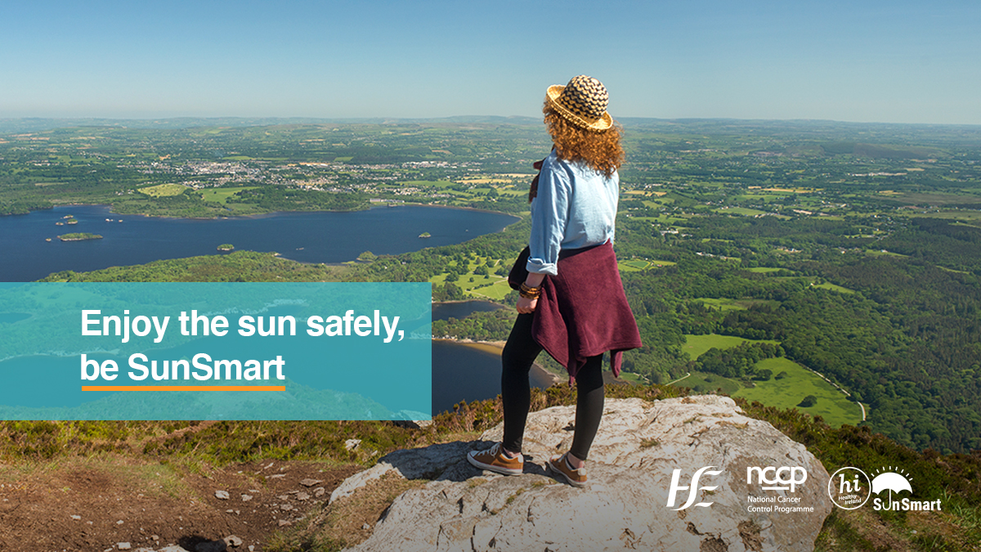
SunSmart Campaign 2023

SunSmart Campaign Partner Pack: Sport, Recreation and Tourism
1st April to 30th September 2023
#SunSmart
Contents
Background 2
Campaign key messages 2
How you can support the campaign 3
Re-sharing 3
Sample social media messages for your use 3
Images for your use 4
Videos for your use 4

Background
The SunSmart campaign is run by the HSE’s National Cancer Control Programme (NCCP), in collaboration with Healthy Ireland and cross-sectoral partners. We are working together to support people to reduce their risk of skin cancer by protecting their skin from the sun. This is the fourth year of the campaign and each year it continues to grow.

The aim of the campaign is to increase awareness of the steps you, your family, friends and colleagues can take to protect your skin from the sun reduce your risk of skin cancer.

The campaign will communicate and engage with the population living in Ireland through multiple communications channels including: radio and digital audio, press and social media.

This partner pack contains information, video links and image links specifically related to outdoor leisure activities for your use and to share with your own networks to support the SunSmart campaign.

Campaign key messages: Sport, recreation and tourism
- Skin cancer is the most common form of cancer in Ireland with almost 13,000 cases diagnosed annually.
- Protecting your skin from the sun whether at home or abroad can reduce your risk of skin cancer.
- Make sure to protect your skin from the sun while getting the health benefits of being active outdoors. Think about how you will protect your skin when outside. Be prepared, be SunSmart.
- In Ireland, take extra care to protect your skin especially from April to September when the sun’s UV rays are at their strongest. Be SunSmart.
- We can all spend time outside safely by following the SunSmart 5 S’s, to make sure we are protected from too much of the sun's UV rays.
- Exposure causing sunburn is the most damaging but frequent non burning exposures also significantly increase the risk of skin cancer.
- When you participate in outdoor sport activities, you are exposed to the sun’s UV rays. Too much UV exposure leads to sun damage and skin cancer. Make sure you’re well protected by following the SunSmart 5 S’s of skin protection.
How to be SunSmart:
Follow the Healthy Ireland SunSmart 5 S’s to protect your skin
- Slip on clothing that covers as much skin as possible while still being comfortable. Wear clothes with long sleeves, breathable sports tops and high collars to protect your neck.
- Slop on broad spectrum (UVA/UVB) sunscreen on exposed skin, using factor 30+ for adults and 50+ for children. Reapply regularly, more frequently if you are sweating.
- Slap on a wide-brimmed hat or bucket hat to protect your face, neck and ears. Typical baseball-style caps provide no sun protection for the ears and neck, which are particularly vulnerable and often overlooked.
- Seek shade. The sun’s UV is strongest between the hours of 11am to 3pm. If possible, plan outdoor activities early in the morning or late in the afternoon.
- Slide on sunglasses to protect your eyes.
As well as the 5 S’s it is important to remember
- Do not deliberately try to get a suntan.
- Avoid getting a sunburn.
- Never use a sunbed.

How you can support the campaign
We welcome your being part of the campaign by posting SunSmart content to your social media channels using #SunSmart in newsletters or publications and sharing this partner pack. Resources for your use are listed below.

Re-sharing
We will post content on our social media channels listed below for you to re-share.

Twitter handles: @HSELive @hseNCCP @HealthyIreland
Facebook Page: https://www.facebook.com/HSElive/
Instagram: https://www.instagram.com/irishhealthservice

Sample social media messages for your use
Being active outdoors is good for you but it is also important to protect your skin from UV rays from the sun when outside. Be prepared, be SunSmart. #SunSmart
Unprotected exposure to the sun’s UV rays can lead to skin damage, sunburn and skin cancer. You can protect your skin. When outside from April – September, remember to be SunSmart. #SunSmart
Are you playing sports or plan on being active outdoors today? Make SunSmart part of a daily routine, especially from April to September when the intensity of UV rays from the sun is greatest, even when it is cloudy. #SunSmart
We sometimes think Irish sun isn’t real sun, but skin cancer is actually the most common cancer in Ireland. Protect yourself by being SunSmart – Slip on clothing, Slop on sunscreen, Slap on a wide-brimmed hat, Seek shade and Slide on sunglasses. Even on cloudy days. #SunSmart
If you’re out watching or participating in sport today, don’t forget to protect your skin. Follow the SunSmart 5 S’s - Slip on clothing, Slop on sunscreen, Slap on a wide-brimmed hat, Seek shade and Slide on sunglasses. #SunSmart
If you’re holidaying in Ireland or abroad, remember to pack long sleeve clothing, a wide brimmed hat, sunscreen and sunglasses. #SunSmart

Images for your use:

Please find images for your use on social media channels and publications attached to partner pack. Images/video are also linked below:
Enjoy the sun safely, outdoor leisure
Protect your skin from the sun, Be SunSmart
Be SunSmart, wear a wide brimmed hat, dog walker
Be SunSmart, wear a wide brimmed hat, sea swimmers
Protect your skin from the sun, gardening female

Videos for your use:

You can view and share SunSmart videos you can find these at the following link.
SunSmart 5 S’s
ISF SunSmart for Outdoor Leisure
SunSmart Patient Skin Cancer Story, Martin’s Story

Information materials you can download information materials and resources for outdoor leisure at the links below.
General Sport – SunSmart for your sport key messages
Sample UV protection policy for outdoor organisations
Skin cancer prevention framework for outdoor leisure organisations
ISF – Holidaying at home or abroad?

Further information materials on the SunSmart campaign and fact sheets are available on www.hse.ie/sunsmart or email prevention@cancercontrol.ie with your request.

Thank you for your support!

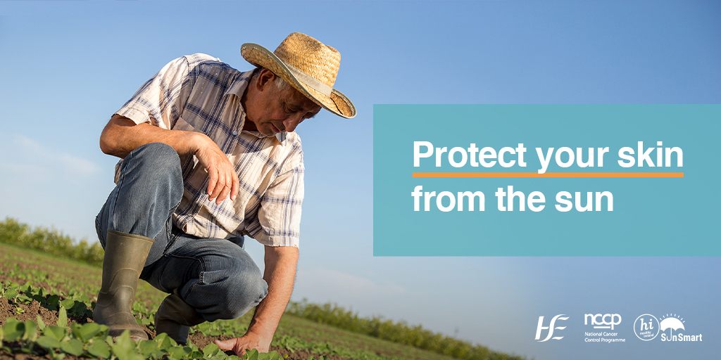
SunSmart Campaign 2023

SunSmart Campaign Partner Pack: Outdoor Worker
1st April to 30th September 2023
#SunSmart

Contents
Background 2
Campaign key messages: Outdoor workers 2
How you can support the campaign 3
Re-sharing 3
Sample social media messages for your use 4
Images for your use 4
Videos for your use 4
Information materials 4

Background
The annual SunSmart campaign is run by the HSE’s National Cancer Control Programme (NCCP), in collaboration with Healthy Ireland and cross-sectoral partners. We are working together to support people to reduce their risk of skin cancer by protecting their skin from the sun. This is the fourth year of the campaign and each year it continues to grow.

The aim of the campaign is to increase awareness of the steps you, your family, friends and colleagues can take to protect your skin from the sun and reduce your risk of skin cancer.

The campaign will communicate and engage with the population living in Ireland through multiple communications channels including: radio and digital audio, press activity and social media.

This partner pack contains information, video links and image links for your use and to share with your own networks to support the SunSmart campaign.

Campaign key messages: Outdoor workers
- If you work outdoors, you are exposed to 2-3 times more UV radiation from the sun than people who work indoors, putting you at a higher risk of skin cancer.
- If you spend all or part of the day regularly working outdoors you can reduce your risk of skin cancer by protecting your skin and eyes from the sun’s UV rays.
- Unprotected exposure to the sun’s UV rays can cause skin damage. Sunburn is the most damaging, but long term exposure, like working outdoors most days, even without burning also significantly increase the risk of skin cancer.
- Outdoor workers are at increased risk of UV exposure and therefore skin cancer. That is why employers need to commit to protecting workers and adhere to skin cancer prevention best practice in the workplace.
- It's the sun's UV rays, not heat, that causes sunburn and skin damage. UV rays can't be seen or felt so you don't know when your skin is being damaged until it’s too late. Because UV damage builds up over time, outdoor workers should consider using sun protection all year-round.
How to be SunSmart:
Follow the Healthy Ireland SunSmart 5 S’s to protect your skin
- Slip on clothing that covers your skin such as long sleeves, collared t-shirts;
- Slop on sunscreen on exposed areas, using factor 30+ for adults and apply 20 minutes before going outside. Reapply regularly– more often if sweating.
- Slap on a wide-brimmed hat, hard hats and helmets can have attachable brims and neck flaps;
- Seek shade - especially if outdoors between 11am and 3pm. Plan your work outdoors early in the morning or late afternoon to avoid the peak UV rays from the sun. Use trees or portable shade for break times and lunch if possible.
- Slide on sunglasses to protect your eyes.

As well as the 5 S’s it is important to remember
- Do not deliberately try to get a suntan.
- Avoid getting a sunburn
- Never use a sunbed.

How you can support the campaign
We welcome you supporting the campaign by posting SunSmart content to your social media channels using #SunSmart in newsletters or publications and sharing this partner pack. Resources for your use are listed below.

Re-sharing
We will post content on our social media channels listed below for you to re-share.

Twitter handles: @HSELive @hseNCCP @HealthyIreland
Facebook Page: https://www.facebook.com/HSElive/
Instagram: https://www.instagram.com/irishhealthservice

Sample social media messages for your use
People who spend most of their day working outdoors are exposed to more UV rays from the sun than indoor workers and therefore have a high risk of skin cancer. Be SunSmart. #SunSmart
The more UV you are exposed to, the greater your risk of skin cancer. Don't just wait for summer to be SunSmart, sun protection should be used all year round when working outdoors #SunSmart
Working outdoors is an everyday part of life for many people. It is important to take steps to protect skin from the sun to reduce skin cancer risk. Be prepared, be SunSmart. #SunSmart
If you work outdoors, you are exposed to 2-3 times more UV rays from the sun than people who work indoors. Damage from UV rays adds up over time so the more you're exposed, the greater your risk of skin cancer. #SunSmart
Are you an outdoor worker who spends most of your time outdoors? Farmers, construction workers, gardeners and other outdoor workers have a higher than average risk of skin cancer. Be prepared and be SunSmart. #SunSmart

Images for your use
Please find images for your use on social media channels and publications attached to partner pack. Images/video are also linked below:
Be SunSmart, wear a wide brimmed hat, working outdoors
Protect your skin from the sun, gardening
Be SunSmart, protect your skin from the sun, outdoor worker
Avoid sunburns and be SunSmart, outdoor worker

Videos for your use
You can view and share SunSmart videos, you can find these at the following links:
SunSmart Patient Skin Cancer Story, Martin’s Story
SunSmart 5 S’s Outdoor workers
Outdoor Workers and UV risks – Animation Video
ISF SunSmart for Outdoor Workers

Information materials
You can down load information materials and resources for outdoor workers at the links below
- SunSmart Outdoor Worker Infographic
- SunSmart framework for skin cancer prevention in outdoor workers
- SunSmart UV Exposure Risk Assessment for Outdoor Workers
- SunSmart audit tool for skin cancer prevention in outdoor workers
- SunSmart sample solar UV protection policy for outdoor workers
- SunSmart solar UV protection policy for outdoor workers checklist
- Summary report of literature review to identify the outdoor occupations with the greatest exposure to solar UV radiation
- ICS SunSmart Outdoor Workers leaflet

Further information materials on the SunSmart campaign and fact sheets are available on www.hse.ie/sunsmart or email prevention@cancercontrol.ie with your request.

Thank you for your support

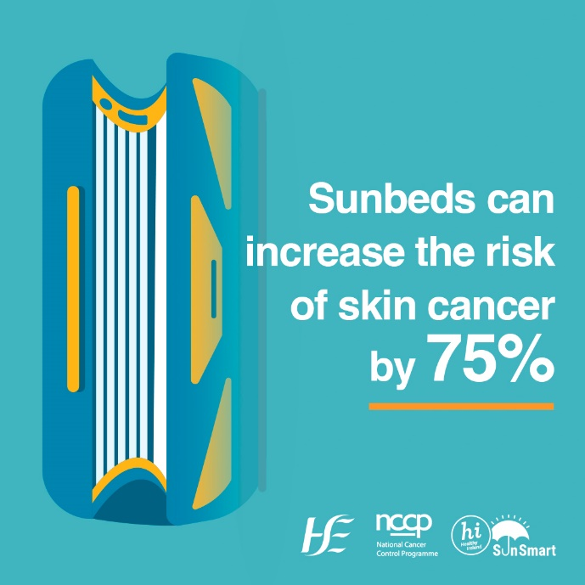
SunSmart Campaign 2023

SunSmart Campaign Partner Pack 2023: Sunbeds
#SunSmart
Contents
Background 2
Campaign key messages: Sunbed users 2
How you can support the campaign 3
Re-sharing 3
Sample social media messages for your use 4
Images for your use: 4
Videos for your use: 4

Background
The SunSmart campaign is run by the HSE’s National Cancer Control Programme (NCCP), in collaboration with Healthy Ireland and cross-sectoral partners. We are working together to support people to reduce their risk of skin cancer by protecting their skin from Ultraviolet (UV) radiation from the sun and artificial sources such as sunbeds. This is the fourth year of the campaign and each year it continues to grow.

The aim of the campaign is to increase awareness of the steps you, your family, friends and colleagues can take to protect your skin from UV radiation from the sun and to never use a sunbed.

The campaign will communicate and engage with the population living in Ireland through multiple communications channels including: radio and digital audio, press and social media.

This partner pack contains information, links and images specifically related to sunbeds, for your use and to share with your own networks to support the SunSmart campaign.

Campaign key messages: Sunbed users
- Sunbeds give out ultraviolet (UV) rays that increase the risk of developing skin cancer.
- People who use sunbeds for the first time before the age of 35 increase their risk of developing melanoma, the most serious form of skin cancer, by 75 per cent.
- The International Agency for Research on Cancer (IARC) classifies sunbeds as cancer causing to humans.
- Sunbeds work by exposing the user to ultraviolet (UV) radiation. Exposure to sunbeds increases the risk of developing skin cancer, a risk which can be avoided by not using sunbeds.
- There is no such thing as a healthy suntan. A suntan is a sign of skin damage and your body’s defence response to harmful UV radiation. Tanning exposes your skin to greater amounts of UV radiation and increases your risk of developing skin cancer.
- Providing a sunbed service, or the hire or sale of a sunbed to anyone under the age of 18 is a breach of the Public Health (Sunbeds) Act 2014.

How to be SunSmart:
Follow the Healthy Ireland SunSmart 5 S’s to protect your skin
- Slip on clothing that covers your skin such as long sleeves, collared t-shirts;
- Slop on sunscreen on exposed areas, using factor 30+ for adults and 50+ for children;
- Slap on a wide-brimmed hat;
- Seek shade - especially if outdoors between 11am and 3pm when UV rays are at their strongest;
- Slide on sunglasses to protect your eyes.
As well as the 5 S’s it is important to remember
- Do not deliberately try to get a suntan.
- Avoid getting a sunburn
- Never use a sunbed.

How you can support the campaign
We welcome your being part of the campaign by posting SunSmart content to your social media channels using #SunSmart in newsletters or publications and sharing this partner pack. Resources for your use are listed below.

Re-sharing
We will post content on our social media channels listed below for you to re-share.

Twitter handles: @HSELive @hseNCCP @HealthyIreland
Facebook Page: https://www.facebook.com/HSElive/
Instagram: https://www.instagram.com/irishhealthservice

Sample social media messages for your use
Each time skin is exposed to UV rays from a sunbed, the risk of developing skin cancer is increased. By not using sunbeds and following the SunSmart 5 S’s you can help to protect your skin and reduce your risk of Ireland’s most common cancer. #SunSmart
Sunbeds give out UV rays which can damage skin, eyes, accelerate skin ageing, and increase the risk of skin cancer. #SunSmart
Using sunbeds before the age of 35 increases the risk of melanoma, the most serious form of skin cancer by 75%. #SunSmart
Using sunbeds before you go on a sun holiday does not protect against further damage from the sun. It can increase your risk of developing skin cancer. #SunSmart
Sunbeds give out very high levels of UV rays. There is no safe level of exposure to UV from sunbeds. Never use a sunbed. #SunSmart
There is no such thing as a healthy suntan. A suntan is the body’s attempt to protect itself from the damaging effects of UV rays. Tanning exposes your skin to greater amounts of UV radiation and increases your risk of developing skin cancer. #SunSmart
Like the sun, sunbeds gives off UV rays and there is no safe limit for exposure to UV rays from sunbeds. Everyone who uses sunbeds increases their risk of UV damage and skin cancer. #SunSmart

Images for your use:

Please find images for your use on social media channels and publications attached to partner pack. Images/video are also linked below:
Sunbeds can increase the risk of skin cancer
Sunbeds and premature skin ageing
Tanning on sunbeds speeds up visible signs of ageing

Videos for your use:

You can view and share SunSmart videos. You can find these at the following link.
SunSmart Patient Skin Cancer Story, Shirley's Story
ISF SunSmart for Sunbeds

Further information materials on the SunSmart campaign and fact sheets are available on www.hse.ie/sunsmart or email prevention@cancercontrol.ie with your request.

Thank you for your support!

International Agency for Research on Cancer Working Group. The association of use of sunbeds with cutaneous malignant melanoma and other skin cancers: a systematic review. Int J Cancer 2006; 120: 1116–22
International Agency for Research on Cancer. Radiation Volume 100D A review of human carcinogens. Lyon: International Agency for Research on Cancer: 2009
World Health Organisation. Artificial tanning devices: public health interventions to manage sunbeds. 2017. Geneva.

