Operation Destabilise Case Studies

Case study 1

Two people have been jailed for a combined 13 years for laundering more than £6 million, after an investigation by the Metropolitan Police’s economic crime team.

The group used criminal money to purchase vans and lorries in the UK and sold them to Ukraine. The earnings were then converted into cryptocurrency. They exploited the legitimate demand in Ukraine for vehicles as part of their war effort, and the lack of cryptocurrency regulation, to maximise their profit and made millions in just over a year.

Valeriy Popovych, 52, (08.09.1972) of The Avenue, Sudbury‐on‐Thames, and Vitaliy Lutsak, 43, (07.08.1981) of Shortmead Drive, Cheshunt, Hertfordshire, were sentenced at Wood Green Crown Court on Monday, 7 April, following a five-week trial.
Oksana Popovych, 42, (19.03.1983) of The Avenue, Sudbury‐on‐Thames was sentenced to 2 years imprisonment suspended for 2 years.
Confiscation for all three is currently ongoing.

They were all found guilty of transferring criminal property and running an unregistered money service business, following an investigation by the Met.

The criminal enterprise enabled Valeriy and Oksana Popovych and to purchase a second house in South West London for just under £1 million.

Detective Constable Harry Davies, from the Metropolitan Police, who led the investigation, said: “This was a thorough and complex investigation into an organised crime gang operating internationally, I’d like to thank the dedicated officers and our partners for their work in bringing this group to justice.

“Mr Popovych presented himself as a hardworking, legitimate tradesman and used his reputation within the second-hand lorry market to clean criminal cash. He also callously saw the conflict in Ukraine as a lucrative business opportunity.

“The sentences given to the group today show how committed we are in tackling organised crime groups and the serious risk they pose to our communities.”

Valeriy Popovych ran an export business, Sprint Commercial Ltd, purchasing vehicles in the UK from legitimate traders and selling them in Ukraine. His wife, Valeriy Popovych, was also employed by the business.

He would purchase the goods with criminal cash, the money was deposited in Ukraine and converted to cryptocurrency.

Lutsak acted as the money co-ordinator and would send the Popovychs to collect criminal cash from customers in the UK. During the investigation officers found more than $14million in cryptocurrency had passed through his “cyrptowallets” stored on his computer.

A part of the laundered cash was controlled by a Russian National called Semen Kuksov, who was convicted on Friday, 27 October 2023 at Southwark Crown Court, under the National Crime Agency’s (NCA) Operation Destabilise.

Acting on intelligence, on Wednesday, 28 June 2023, police stopped a vehicle in Twickenham in which Valeiry Popovych was the passenger. Following a search of the vehicle Met officers found more than £60,000 in cash and arrested him at the scene.

During a further search at his address on Gloucester Road, Feltham, officers recovered £130,000 in cash. This was seized, alongside a laptop and mobile devices.
Following Popovych’s arrest, extensive investigations by the Economic Crime Unit discovered the link with Oksana and Lutsak, who were arrested at their homes on Wednesday, 15 May 2024. Lutsak was charged on the same day.

Valeriy and Oksana Popvych were charged on Tuesday, 14 June 2024.
They were all found guilty by the jury on Wednesday, 5 March 2025 at Wood Green Crown Court.

A variety of complex evidence was obtained by officers, including chats, money transactions, CCTV, cryptocurrency wallets and call logs.

The Met’s economic crime unit worked with partner agencies including the NCA, HM Revenue and Customs and the Financial Conduct Authority to conduct a robust investigation.

Messages outlined key times in which Valeriy and Popovych visited addresses to collect cash.

The most crucial element was an Excel spreadsheet, named ‘V Enf Acc’. This document proved the group laundered over £6 million between August 2022 and June 2023.
Valeriy Popovych and Vitaliy Lutsak were both sentenced to six years and six months' imprisonment.

They were all found guilty of transferring criminal property over the value of £6million under Section 327 of the Proceeds of Crime Act 2002 and running an unregistered money service business under the Money Laundering, Terrorist Financing and Transfer of Funds Regulations 2017.

Negeen Momtahen, Specialist Prosecutor for the Crown Prosecution Service, said:
"Together, these defendants used an export business as a front to launder millions of pounds of criminal cash across borders. They attempted to conceal the source of this illicit money by using secret token exchanges and cryptocurrency.
"Money laundering is not a victimless crime – it is the financial lifeline which enables criminals to profit from their illegal activities.
"Last year we convicted other key members of this same money laundering network. I hope this latest prosecution demonstrates our ongoing determination to dismantling these criminal operations and bringing all involved to justice.
"We will be pursuing confiscation proceedings against the defendants to remove any available criminal benefits gained from this enterprise.”

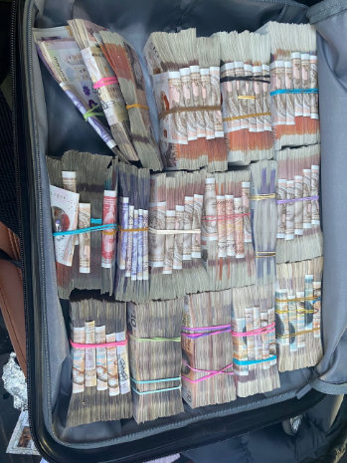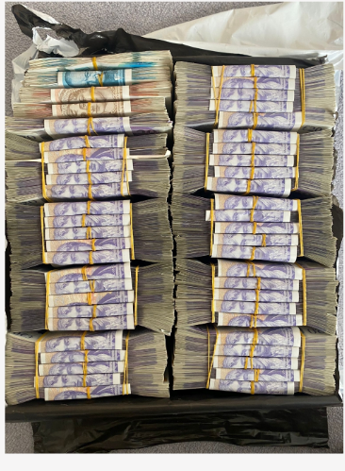

Case study 2

On 10th April 2024 Giorgi Tabatadze was stopped by NCA Officers whilst driving a vehicle. During a search of the vehicle, a holdall was discovered containing £357,550. Tabatadze was arrested on suspicion of money laundering. During a search of Tabatadze’s home address, a further £392,565 was discovered at his premises. A cash counting machine and cash bundling paraphernalia (namely elastic bands) were also seized. The total amount seized from Tabatadze’s possession / control on 10th April 2024 was £750,115.

The Crown amended Tabatadze’s indictment to cover a three month period from February – April 2024. Tabatadze pleaded guilty to three counts: possessing criminal property in the sum of £750,115 (counts 1 and 2); and entering into or becoming concerned in a money laundering arrangement in the sum of circa £2.2m (count 3). Tabatadze was sentenced on 19th March 2025 to a 3-year custodial sentence.

Forensic examination was undertaken of the holdall seized from Tabatadze’s vehicle. A DNA profile was found on the external zip tags and the external padlock matching Mark James Manning. Fingerprint marks on the cash also matched Manning’s.

Manning was arrested on 24th September 2024 on suspicion of money laundering. A search of his home address resulted in the seizure of a further £210,130. Manning pleaded guilty on 24th July 2025 to transferring criminal property (count 1) and possessing criminal property (count 2). The Crown assessed that the total value of criminal property possessed / transferred by Manning was £567,680. He was sentenced on 22nd September 2025 and received 40 months imprisonment.

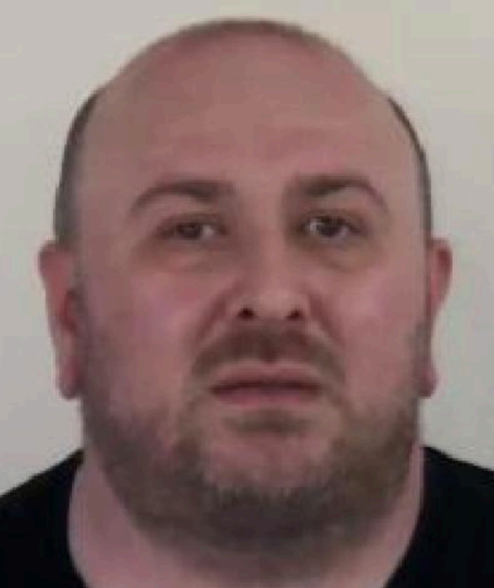 Giorgi Tabatadze HMPS

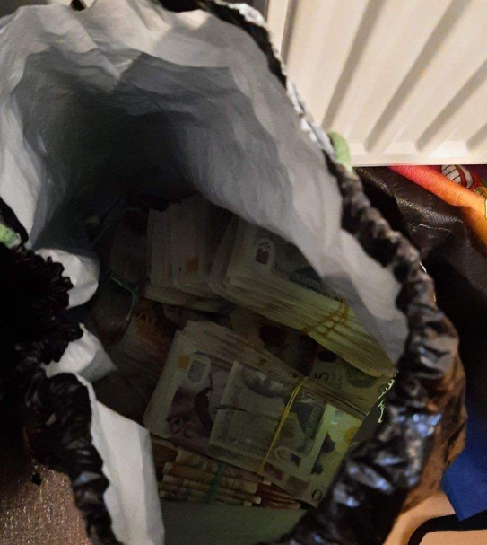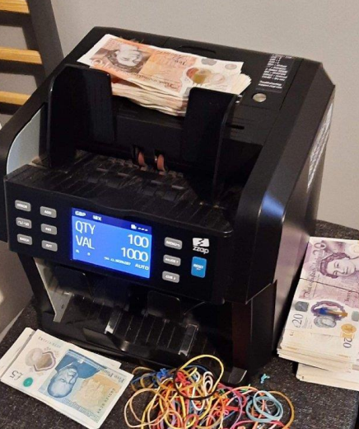
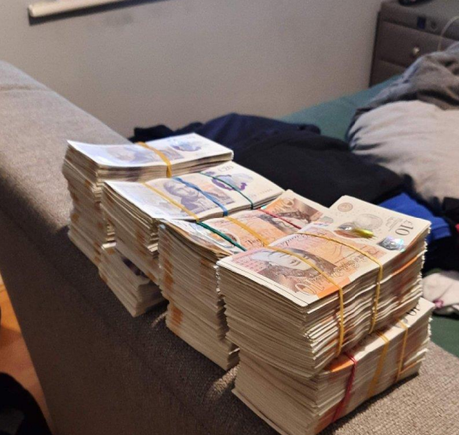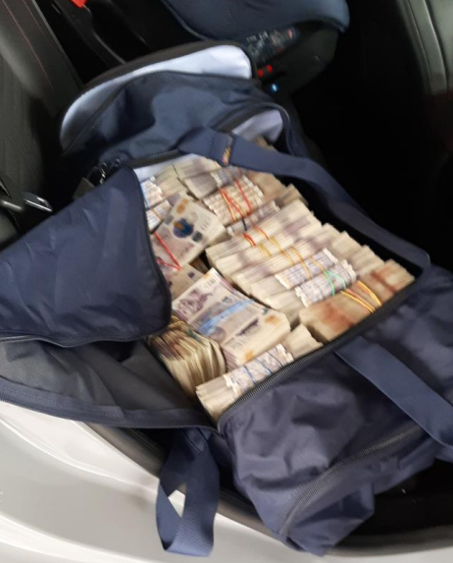

Case study 3:

Footballer sentenced for cash handover following NCA and Police Scotland investigation

A footballer who attempted to launder almost £400,000 in criminal cash has been sentenced to 13 and a half months.

Investigators from the Organised Crime Partnership, a joint unit made up of National Crime Agency and Police Scotland officers, started an investigation after watching James Keatings, 33, from Ryde Road in Wishaw remove two boxes from the back of his white transit van and place them in the back of a second van before driving away at around 2.30pm on 28 June last year.

The second van was stopped and searched by officers and two boxes were discovered in its rear containing 78 bundles of notes up to a total of £390,040.

A forensic examination of the money and the boxes found that Keatings’ fingerprints were on a number of areas including the money, the boxes and the elastic bands keeping the notes together.

He appeared at Falkirk Sheriff Court on 20 August 2025 where he pleaded guilty to possessing and transferring criminal property. He was sentenced to 13 and a half months at the same court on 19th September 2025.

Ian Thomas, from the NCA, said: “James Keatings moved hundreds of thousands of pounds in suspected criminal funds but what he didn’t know was OCP officers were watching his every move.

“The NCA will continue to work closely with our law enforcement partners to bring offenders like Keatings to justice and disrupt offenders and their criminality, wherever there is an opportunity to do so.”

https://www.nationalcrimeagency.gov.uk/news/former-footballer-sentenced-for-cash-handover-following-nca-and-police-scotland-investigation

