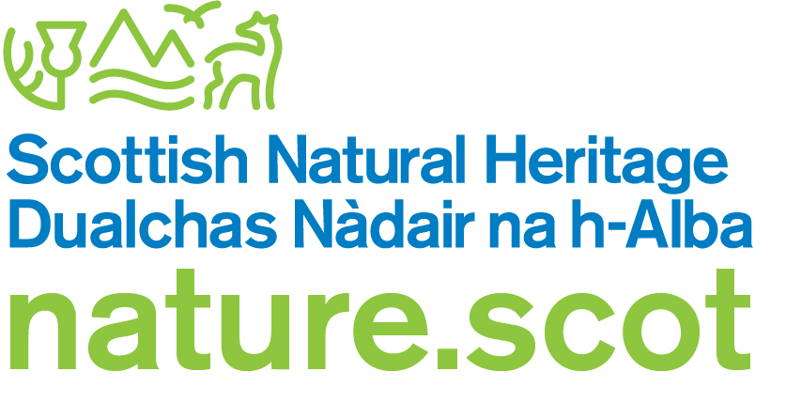

Reasons for the proposed partial denotification of Foveran Links SSSI

- Foveran Links SSSI is 203 ha in area and comprises approximately 154 ha of dune habitat and 49 ha of intertidal sand.

- The construction of Menie Links Golf Course within the SSSI has adversely affected the Coastal Geomorphology of Scotland and Sand Dune habitat notified natural features as well as interrupting natural dune processes. Together, the combined loss and damage represents 11% of the total SSSI and 15% of the sand dune habitat.

- The negative impacts on the Sand dune habitat feature include:

  - permanent direct loss of habitat, i.e. conversion of semi-natural habitats to golf course infra-structure (including tracks, tees, fairways, greens, water features)
  - potential indirect impacts from the use of irrigation, fertilisers and herbicides which in time may affect plant communities
  - stabilisation of mobile sand which has destroyed the dynamic nature of the site and the cycle of habitat creation which is necessary for periodic renewal of sensitive habitats such as dune slacks and mobile dune.
  - control of grazing (rabbits, deer) which will in time result in scrub and coarse vegetation development in sensitive habitats such as dune slacks and wetlands

- 34% (23 ha) of the semi-natural habitats in the Menie Links section of the SSSI has been destroyed or severely modified. Of particular importance was the movement of free sand across the links which drove a process of dune succession and habitat renewal. This has been prevented by the golf course construction. Of particular note are the losses of 99% and 90% of the Menie and Sandend sand sheets respectively– both key geomorphological features in the SSSI illustrating the unusual dynamic nature of the Menie Links sand dune system – as well as the loss of 64% of the dune slacks/open water habitats in the estate, rare features in the UK which require episodes of renewal through sand movement.

- The remaining 66% (44 ha) of the semi-natural habitats in this section of the SSSI has become fragmented and will likely suffer further adverse effects as a result of the severe restriction of natural dynamic geomorphological processes necessary to sustain the natural interest. These fragments will no longer be affected by and in some cases periodically rejuvenated by sand movements. They are vulnerable to adverse effects such as changes in ground water quality and flow rates, lack of grazing management and accumulation of organic materials, all of which are very likely over time to significantly alter the composition and structure of these areas and in most cases lead to reduced nature conservation value.

- Whilst some of the remaining fragmented habitats are of nature conservation value, they are not of SSSI quality. Some management intervention is proposed but is very unlikely to be sufficient to replace the natural cycle of dune succession and renewal.

- Drums Links is a narrow band of sand dune immediately to the north of Menie Links. It is backed by grazed agricultural land and is not known to support features of conservation importance within the SSSI. It is a separate geomorphological unit from Menie Links to the south and the links to the north. In the context of the current SSSI it is mainly an area of linking habitat between Menie and Foveran Links.

- Taking all of this in combination, we propose the removal of Menie Links along with the adjoining Drums Links from the SSSI as we consider that retention of that land cannot be otherwise justified.

- The case for a remnant Foveran Links SSSI on biological grounds once the Menie and Drums Links sections have been removed is not strong. It is proposed that after the boundary has been amended the remaining SSSI would be merged with the immediately adjacent Sands of Forvie and Ythan Estuary SSSI. The two sites complement each other, and a single SSSI would place the geomorphological site interest (known as the Forvie Geological Conservation Review site) within a single SSSI.

Scottish Natural Heritage
June 2019

Annex 1. Foveran Links SSSI citation

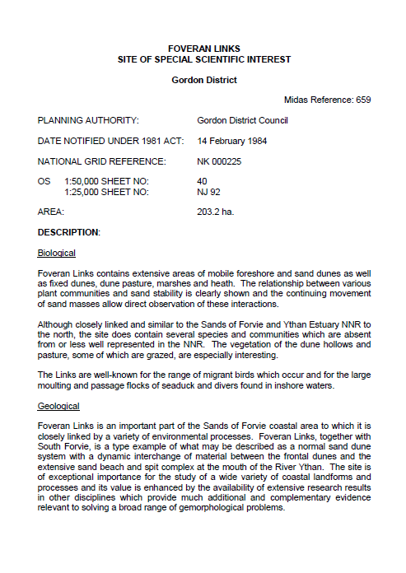
Annex 2 – Foveran Links SSSI – boundary in red

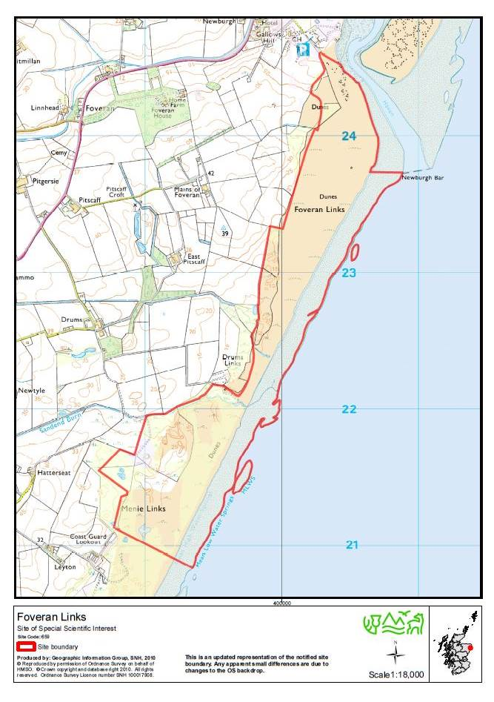

Annex 3 - Map of Forvie Geological Conservation Review site

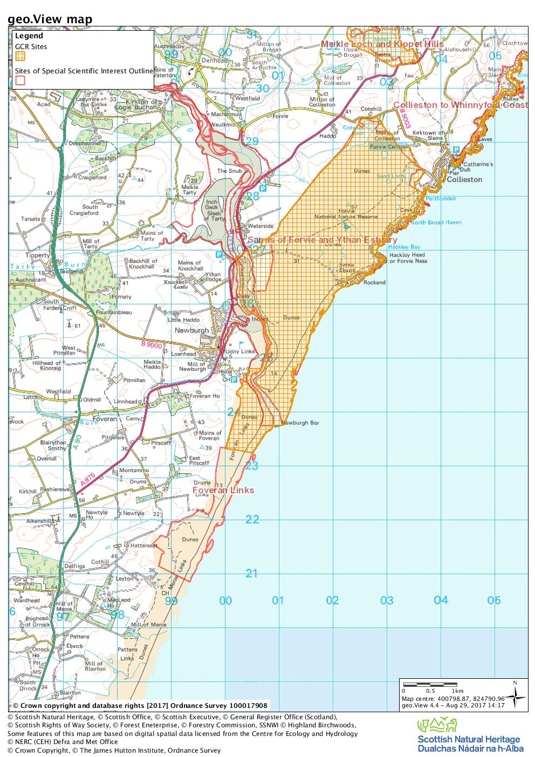
Forvie GCR site within Sands of Forvie and Ythan Estuary SSSI
Forvie GCR site within Foveran Links SSSI

