**Greater Manchester’s Integrated Settlement – Frequently Asked Questions**

**When is Greater Manchester receiving its Integrated Settlement?**

The Greater Manchester Integrated Settlement takes effect from 1 April 2025, as part of our trailblazing devolution deal signed with the government.

**What does the Integrated Settlement provide?**

The settlement is a massive change in how central government gives us money.

It provides a single funding pot allowing greater flexibility with what Greater Manchester can do with its budget.

In the past, funding would be provided for specific areas or projects. Now Greater Manchester will be able to move funding between policy areas with more flexibility, allowing joined up funding and delivery across similar policy areas.

In return, Greater Manchester will deliver a number of outcomes, agreed with the Government.

**How does this affect how Greater Manchester sets local budgets in the future?**

As the settlement is implemented, the GMCA budget-setting process will involve much greater local decision making on how the funding is spent.

**What are some of the main advantages of this?**

The flexibility will give us greater ability to join up delivery, improving outcomes for residents and businesses. Previously, funding supplied by government could only be siloed into specific projects, even if there were similar or complementary areas that could have benefited.

An example would be greater join-up between our local adult skills and employment support system. By targeting support so that Greater Manchester residents can develop the skills they need to find fulfilling employment that is linked to local demand, we can deliver much better outcomes.

For instance, as Greater Manchester will no longer receive funding on the condition it is used for one specific purpose, we could use our Employment Support and Skills funding to target the local skills gaps, regional employment opportunities and wider Greater Manchester strategies we choose when allocating funding.

The Integrated Settlement also allows us to be more innovative and address the needs of our residents with local expertise. The Greater Manchester system has already shown that we can be trailblazers and pioneer innovative solutions to achieve our ambitions, including by taking buses back under public control. The Integrated Settlement will make it easier for Greater Manchester to drive this innovation, by giving us more autonomy over how funds related to key thematic areas such as transport and adult skills are allocated.

It also takes us away from short-term decision-making due to restricted funding pots. The Integrated Settlement will give Greater Manchester funding which is aligned to Governmental Spending Reviews, meaning that from April 2026 onwards, Greater Manchester will have a multi-year settlement with the ability to move funding between financial years within the same Spending Review period. The settlement also opens up the possibility of moving funding into future years beyond Spending Review periods, with Treasury approval, and will give us the following flexibilities:

* The ability to move 10% of funding between thematic areas, or pillars. This could include moving money from education to transport if the lack of a bus route or other transport infrastructure in an area is seen as a barrier to people gaining skills.
* The ability to move money flexibly within pillars between different types of spending, such as investment or resource for day-to-day services
* The flexibility to allocate funding based on our regional ambitions, in line with joint outcomes agreed with Government through our outcomes framework.

**What is the breakdown of funding?**

The £630m confirmed so far for Greater Manchester for 2025/26 includes:

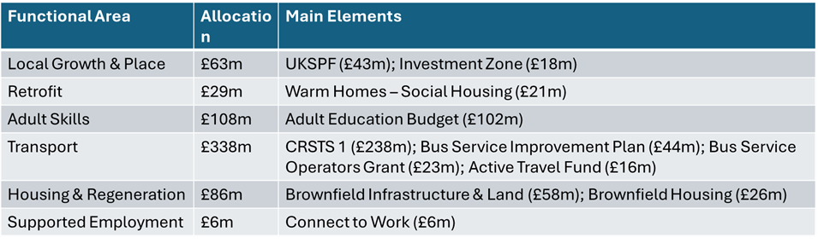

The full details are here: [Integrated Settlements for 2025 to 2026 - GOV.UK](https://www.gov.uk/government/publications/integrated-settlements-for-2025-to-2026)

**Is Greater Manchester getting any more money under this new system?**

This is not new money. Most of the money already flowed into the GMCA through dozens of separate funding streams from different Government departments, and the difference is that it will now all come in a single funding settlement. The Government is working with us to agree the broad delivery outcomes of the funding, and the GMCA will spend the money to meet those outcomes. Previously, the Government dictated how GMCA spent its budget, whereas now we will have much more flexibility on spending.

**Are there any new funding streams that Greater Manchester is getting?**

Greater Manchester is not getting new funding streams in the sense of Government creating new funding commitments. Instead, existing funds - while not 'new' - will now be subject to much greater local, Greater Manchester control.

National funds which are in scope of the settlement have had formulae applied to them to work out the share which should go to GMCA and West Midlands Combined Authority (WMCA) under the terms of the devolution deal. Further detailed information can be found in the [paper published by the Treasury on the Integrated Settlements](https://assets.publishing.service.gov.uk/media/65e71b503f69457ff10360e2/Annex_to_the_Memorandum_of_Understanding_for_the__Trailblazer__Single_Settlements_with_Greater_Manchester_and_West_Midlands_Combined_Authorities.pdf).

In other parts of the country, the decisions on how these national funds are spent are still made in Whitehall. What we have gained is the ability to decide how to spend this money.

**Has the Integrated Settlement had any impact on budget setting this year? If so, what?**

The timing of the General Election and Spending Review has meant that the Integrated Settlement for 2025/26 was negotiated very close to the start of the financial year, when budgets and delivery plans in many areas had already had to be set. However, the Integrated Settlement will have an impact in 2025/26 in terms of flexibility around delivery, for example in not having to meet national funding requirements or being able to make changes between programmes during the year.

**Can capital funding be used as revenue?**

Up to 10% of capital funding in each pillar of the Integrated Settlement can be converted to revenue funding.

**The trailblazer agreement included scrutiny of the Mayor by MPs. Will that still happen?**

Local MP scrutiny sessions were a proposal put forward by the previous Government. The current Government has replaced this with new proposals outlined in the [English Devolution White Paper](https://www.gov.uk/government/publications/english-devolution-white-paper-power-and-partnership-foundations-for-growth/english-devolution-white-paper).

**Are there any other measures planned to increase scrutiny and accountability?**

The English Devolution White Paper sets out the Government’s commitment to improving accountability and scrutiny of local spending. The Government is engaging with Mayoral Combined Authorities on how best to deliver that improved accountability and scrutiny through the mechanisms indicated in the White Paper, including reviewing the existing Scrutiny Protocol and a Local Public Accounts Committee model.

**Will any more funding be added to the Integrated Settlement in future?**

We are working with the Government on how further devolution could drive growth in Greater Manchester through a Task & Finish process announced by the Deputy Prime Minister and Chancellor in December. That will include considering how the Settlement could be expanded to cover new areas of funding.