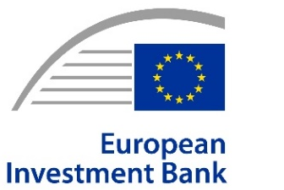 |  |  | 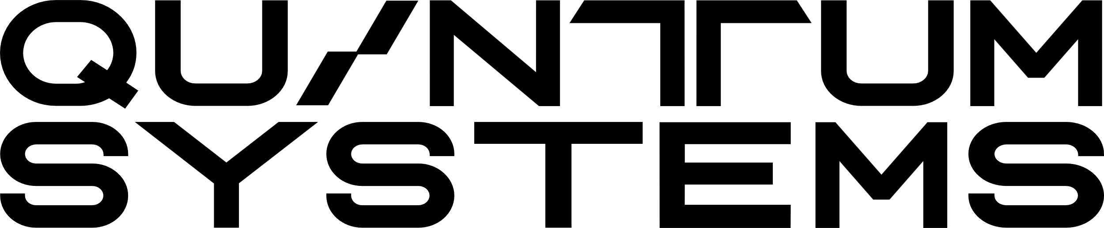
PRESS RELEASE
2026-057-EN

Gilching, 12. February 2026

Quantum Systems Secures New European Financing Package to Scale the Future of Unmanned Technologies
Quantum Systems has secured €150M financing backed by the European Investment Bank, Commerzbank, KfW and Deutsche Bank. The agreement highlights a growing commitment to ensuring that security-related innovation can be developed and scaled with European capital.
Quantum Systems, the global powerhouse of unmanned systems, today announced a new financing package supported by the European Investment Bank (EIB) and leading European commercial banks, including Commerzbank, Deutsche Bank and KfW. The package is designed to support the company’s continued growth and industrial scaling in Europe and was presented at a joint press conference at Quantum Systems’ headquarters in Gilching, ahead of the Munich Security Conference.
The financing reflects recent, targeted adjustments to ESG frameworks, enabling European banking to support security-relevant technologies more effectively. It sends a clear signal that technological resilience, security, and European sovereignty require not only innovation but also access to appropriate capital. The agreement underscores the growing recognition that critical security infrastructure must be financed within Europe to ensure long-term independence and stability.
Today’s €70 million loan marks the EIB’s second investment in Quantum Systems, following its €10 million investment in June 2021, underscoring the bank’s sustained commitment to the company. Together with Commerzbank, Deutsche Bank and KfW, the long-term debt financing totals €150 million.
“This financing is a strong vote of confidence in our company, technology, and our vision,” said Jonas Jarosch. “It enables us to scale responsibly while remaining firmly anchored in Europe. Security and technological sovereignty start with the ability to invest long-term in critical capabilities.”
“Drones and aerial intelligence are essential to Europe’s security. With this financing, we further reinforce Europe’s defence capabilities and technological sovereignty to ensure the protection of our citizens.” said Nadia Calviño, President of the European Investment Bank.
“As a banking partner, we are delighted with the successful development of Quantum Systems, which we have been supporting since its early growth phase as its principal bank and also as its first lender,” said Michael Kotzbauer, Deputy Chairman of the Board of Managing Directors of Commerzbank AG.
“This financing package sends a strong signal about Europe’s ability to develop and scale security relevant technologies with its own capital. At Deutsche Bank, we are committed to supporting companies like Quantum Systems as they expand critical capabilities responsibly – strengthening Europe’s industrial base and technological sovereignty for the long term,” said Michael Diederich, Global Co-Head of Corporate Banking at Deutsche Bank.
“Through its Venture Tech Growth Financing program, KfW is backing Quantum Systems’ continued growth in Europe. By providing targeted growth capital - including equity via KfW Capital and debt - we are strengthening Europe’s technological resilience and contributing to security-relevant capabilities that are developed, financed, and anchored in Europe. This commitment is an essential building block for Europe’s sovereignty and its ability to act independently in a changing security environment,” said Melanie Kehr, Member of the Executive Board of KfW.
The financing package will support Quantum Systems’ ongoing investments in technology, industrial capacity, and organizational growth, while reinforcing its commitment to European security, resilience, and long-term value creation.

Background information
About EIB
The EIB Group
The European Investment Bank (ElB) Group is the financing arm of the European Union, owned by the 27 Member States, and one of the largest multilateral development banks in the world. In 2025, the EIB Group signed €100 billion of new financing and advisory services for over 870 high-impact projects in eight core priorities that support EU policy objectives: climate action and the environment, digitalisation and technological innovation, security and defence, territorial cohesion, agriculture and the bioeconomy, social infrastructure, strong global partnerships and the savings and investment union. Beyond long-term loans for large infrastructures, the EIB Group crowds-in private investment for high-risk innovative projects and businesses, with a growing role in Europe’s markets for venture debt, venture capital, guarantees and securitisations.

The European Investment Fund (EIF) is the subsidiary of the EIB Group specialised in providing guarantees and equity to improve access to finance for small and medium size businesses and startups across Europe. Acting as an anchor investor, through its extensive network of partnering banks and investment funds, the EIF mobilizes private investment and nurtures the ecosystem of venture capital funds to support innovative European entrepreneurs.

In 2023, the EIF together with six member states (France, Germany, Italy, Spain, Belgium and the Netherlands) launched the European Tech Champions Initiative, a fund of funds to scale-up innovative startups. This initiative has already enabled the creation of 12 European venture capital mega-funds and scaled up 38 companies, including 11 unicorns (with more than €1 billion in capital).
Photos of the EIB Group's spokespeople and headquarters, logo files and video B-roll for media use are available here.

About Quantum Systems

Quantum Systems is a global high-tech company specializing in unmanned systems. The company develops integrated hardware, software, and AI systems that deliver operational data in real time and enable informed decision-making across multiple domains.
All core technologies are developed in-house and stand for technological excellence, scalability, and sovereignty in the global dual-use market.

Press contacts:
EIB: Richard Willis, r.willis@eib.org, tel.: +352 43 79 82155 / Mobile: +352 621 55 57 58
Website: www.eib.org/press - Press Office: press@eib.org

Quantum Systems: Paul C. Strobel
Spokesperson
press@quantum-systems.com
+49 160 962 463 79

