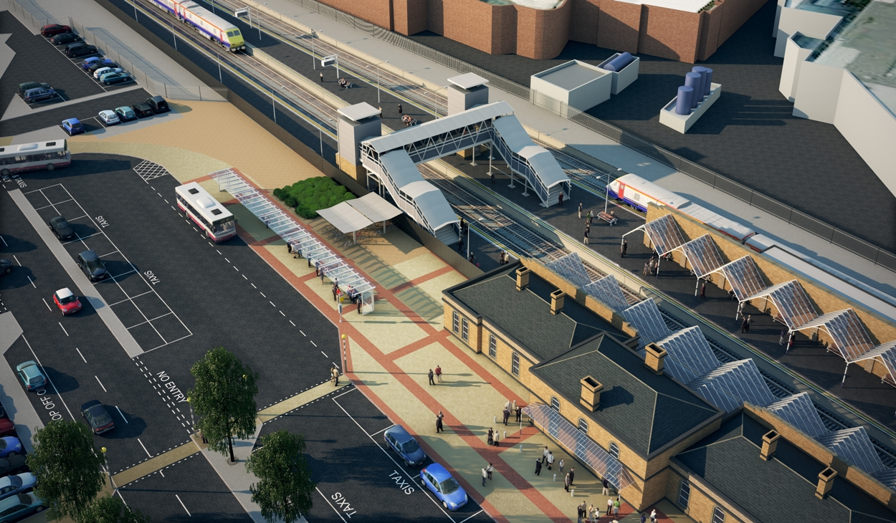 LOUGHBOROUGH UPGRADES

Following major investment from Network Rail, Department for Transport, East Midlands Trains and Charnwood Borough Council, Loughborough railway station has been revamped into a brighter, spacious and more accessible travel hub, ready for the Olympics and Paralympics Games 2012 and beyond:

Access for All - delivered by Network Rail
New Footbridge and Lifts providing step free access to all platforms
Amount spent : £1.6m
Contractor: Spencers
Work Started: June 2011

Platform Extensions - delivered by Network Rail
Platforms 1 & 2 extended to accommodate 10 car trains and Platform 3 extended to accommodate 6 car trains
Amount spent : £3.2m
Contractor: Spencers
Work Started: June 2011

Loughborough Eastern Gateway (station works) - delivered by Charnwood Borough Council
New Car Park and Station Forecourt
Amount spent: £1.2m
Contractor: Ringway
Work Started: April 2011

National Stations Improvement Programme - delivered by Network Rail
New cycle parking, re-furbished toilets and waiting rooms, decoration of booking hall and new computer information screens
Amount spent: £0.280m
Contractor: May Gurney
Work Started: May 2010

Canopy Renewal - delivered by Network Rail
Refurbishment of platform canopies
Amount spent: £1.5m
Contractor: May Gurney
Work Started: May 2010

Station Enhancements - delivered by East Midlands Trains
New ticket vending machines, new signage, new seating, ticket on departure machines and booking hall improvements
Amount Spent: £100k
Contractor: Various EMT contractors
Work Started: 2009

