Social media example posts
2021/22 academic year

Below are some draft social media posts for you to use on your accounts. Please amend to fit the style and tone of your accounts as necessary.

General messages
- Twitter: Have you started a pre-reg healthcare course? Take a look @NHSBSA_LSF and see if you’re eligible for additional funding support during your studies https://bit.ly/3hTqZu6 #NHSLSF
- Facebook: Have you started a pre-reg healthcare course? Take a look @LearningSupportFund and see if you’re eligible for additional funding support during your studies https://bit.ly/3hTqZu6 #NHSLSF
- Twitter: Give @NHSBSA_LSF a follow for all the latest information and useful tips for the NHS Learning Support Fund!
- Facebook: Give @LearningSupportFund a follow for all the latest information and useful tips about the NHS Learning Support Fund!
- USE FROM 1 JUNE Twitter: Are you a new healthcare student? You can now apply for funding support from @NHSBSA_LSF https://bit.ly/3hTqZu6
- USE FROM 1 JUNE Facebook: Are you a healthcare student? You can apply now for funding support from @LearningSupportFund https://bit.ly/3hTqZu6
- USE BEFORE 1 JUNE Twitter: Are you a new healthcare student starting in September 2021? You’ll be able to apply for funding support from @NHSBSA_LSF from 1 June https://bit.ly/3hTqZu6
- USE BEFORE 1 JUNE Facebook: Are you a new healthcare student starting in September 2021? You’ll be able to apply for funding support, including the £5,000 Training Grant, from @LearningSupportFund from 1 June https://bit.ly/3hTqZu6
- USE FROM 29 MARCH Twitter: Are you continuing your healthcare studies in September 2021? You will receive an email from @NHSBSA_LSF inviting you to apply for next year’s funding.
- USE FROM 29 MARCH Facebook: Are you continuing your healthcare studies in September 2021? You’ll receive an email from @LearningSupportFund inviting you to apply. Don’t worry if you don’t get yours straight away, this is being done in stages to allow them to process all your applications in time for the new academic year.
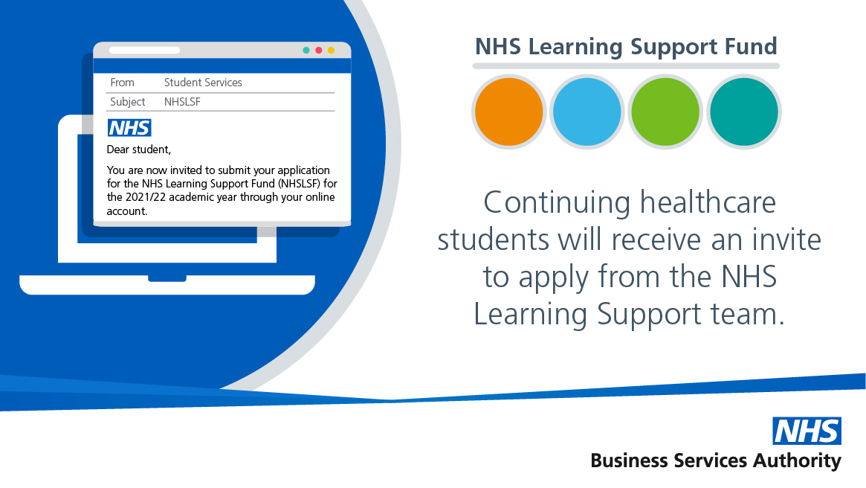
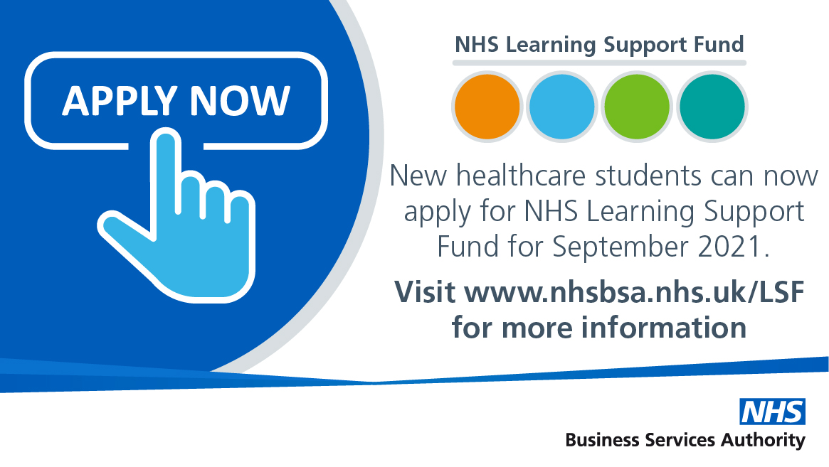
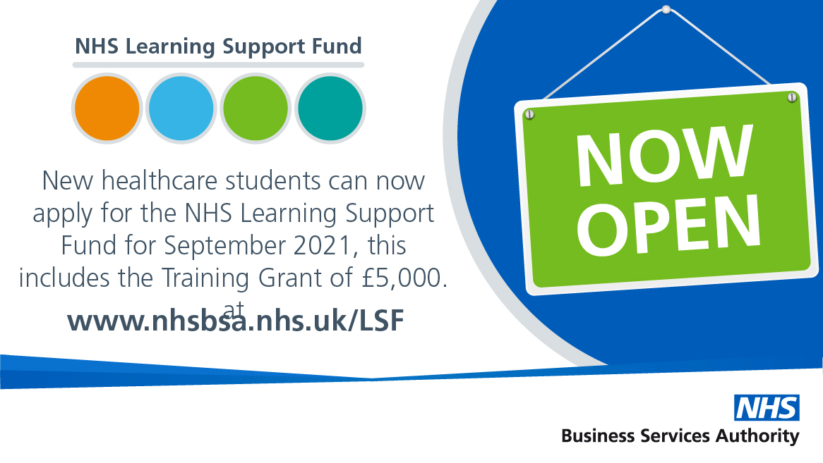

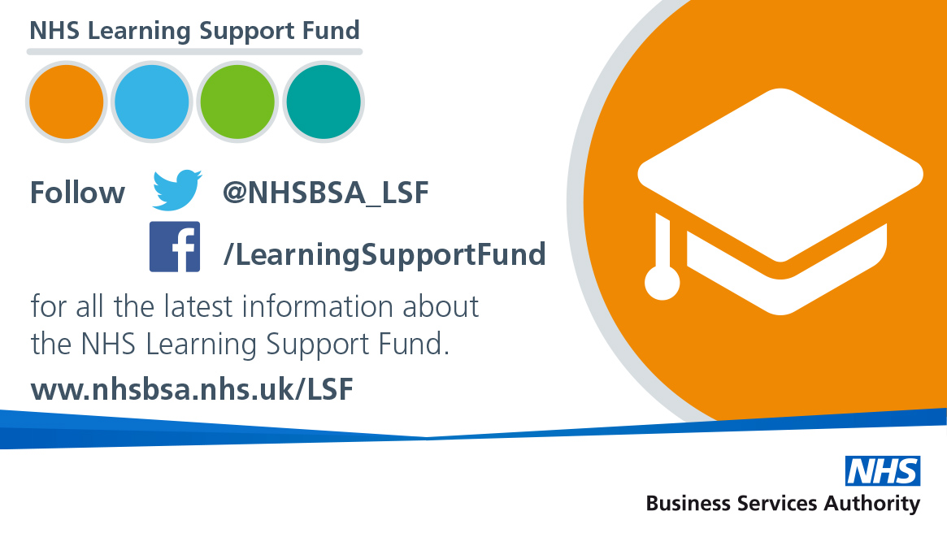
Training Grant
- Twitter: Looking for information about the £5,000 Training Grant for healthcare students from @NHSBSA_LSF? Take a look at their website for more info https://bit.ly/3drH9aK #NHSLSF
- Facebook: Have you heard about the £5,000 Training Grant for healthcare students? Take a look at the @LearningSupportFund website for more information including how to apply https://bit.ly/3drH9aK
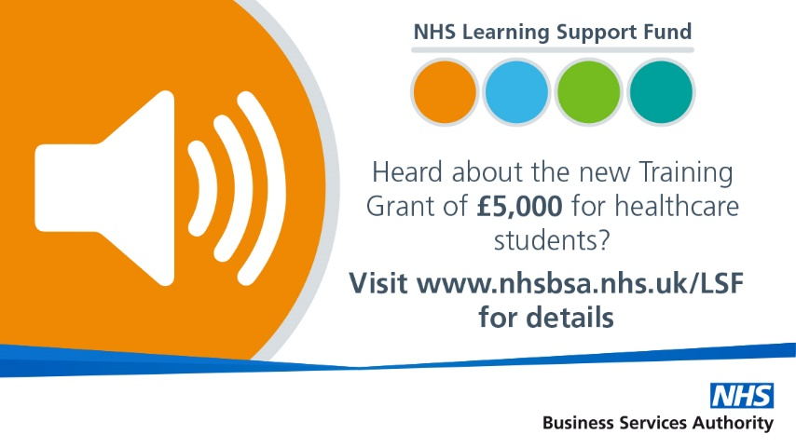
Parental Support
- Twitter: Are you a healthcare student? Do you have parental responsibility for one or more children? You could receive £2,000 from @NHSBSA_LSF, find out more here https://bit.ly/2V9E8We #NHSLSF
- Facebook: Are you a healthcare student with parental responsibility for a child? Did you know you could get £2,000 Parental Support from the @LearningSupportFund? Take a look at their website for more information https://bit.ly/2V9E8We
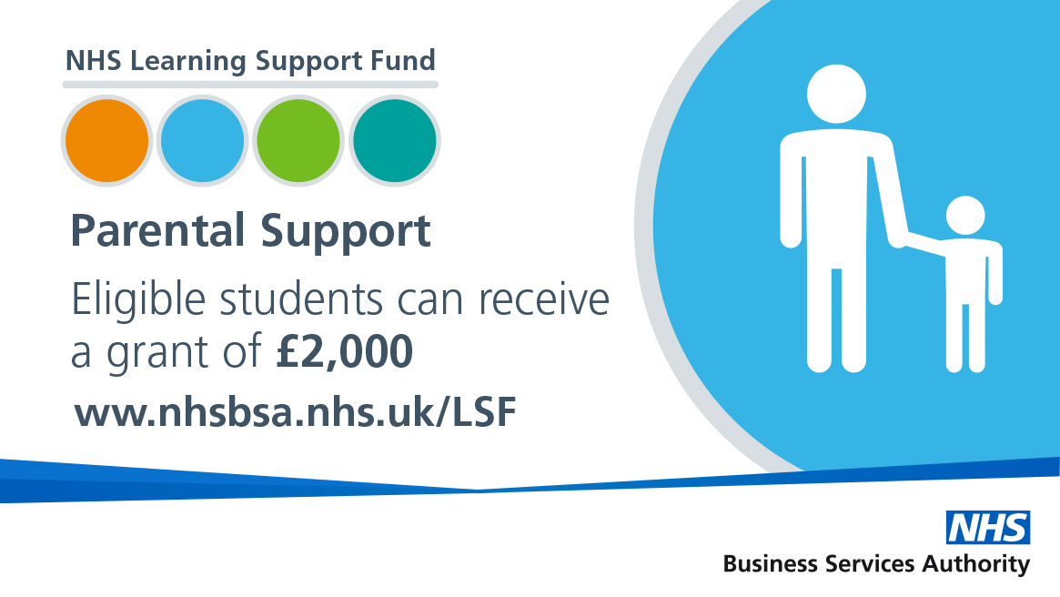
Travel and Dual Accommodation Expenses
- Twitter: Healthcare students can claim their travel and temporary accommodation expenses through @NHSBSA_LSF TDAE. For more info take a
look at their website https://bit.ly/2YnBnmp #NHSLSF
- Facebook: Once you’ve been on placements you can claim back the cost of some travel and accommodation – make sure you keep hold of your invoices, receipts and travel tickets. For more information about claiming travel and accommodation please visit @LearningSupportFund https://bit.ly/2YnBnmp
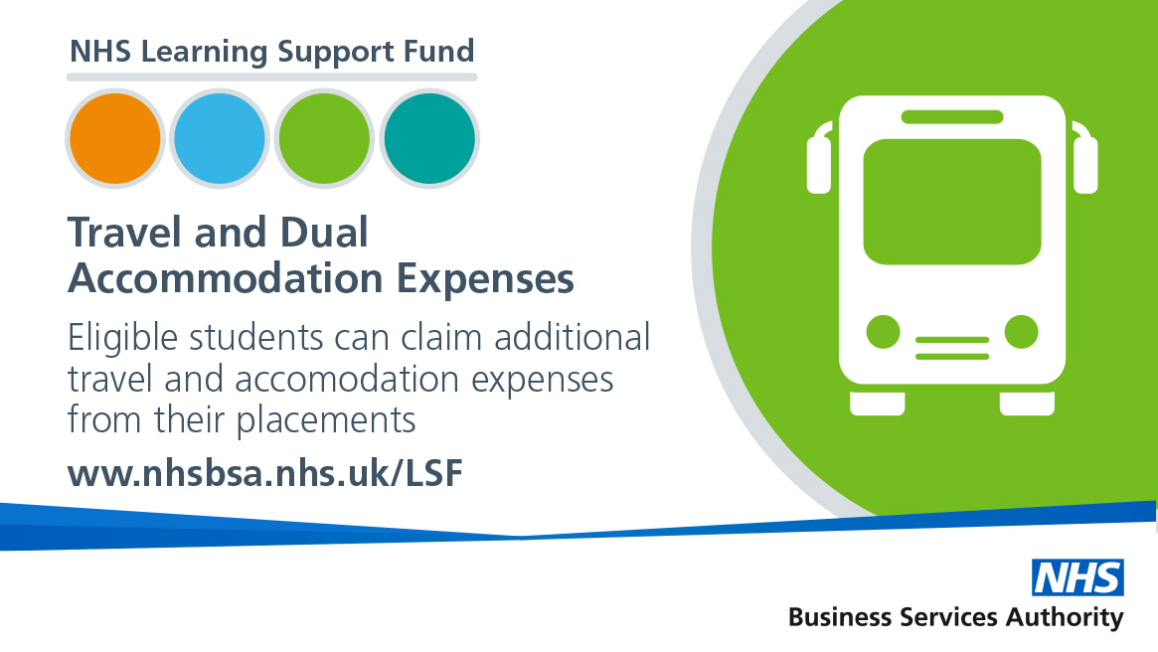
Exceptional Support Fund
- Twitter: If you’re a healthcare student and find yourself in genuine and unforeseen financial difficulty you could get help from @NHSBSA_LSF ESF, find out more here https://bit.ly/3hKS3vP #NHSLSF
- Facebook: Did you know that ESF is available to help healthcare students who are experiencing genuine and unforeseen financial difficulty? Find out more, including how to apply @LearningSupportFund https://bit.ly/3hKS3vP
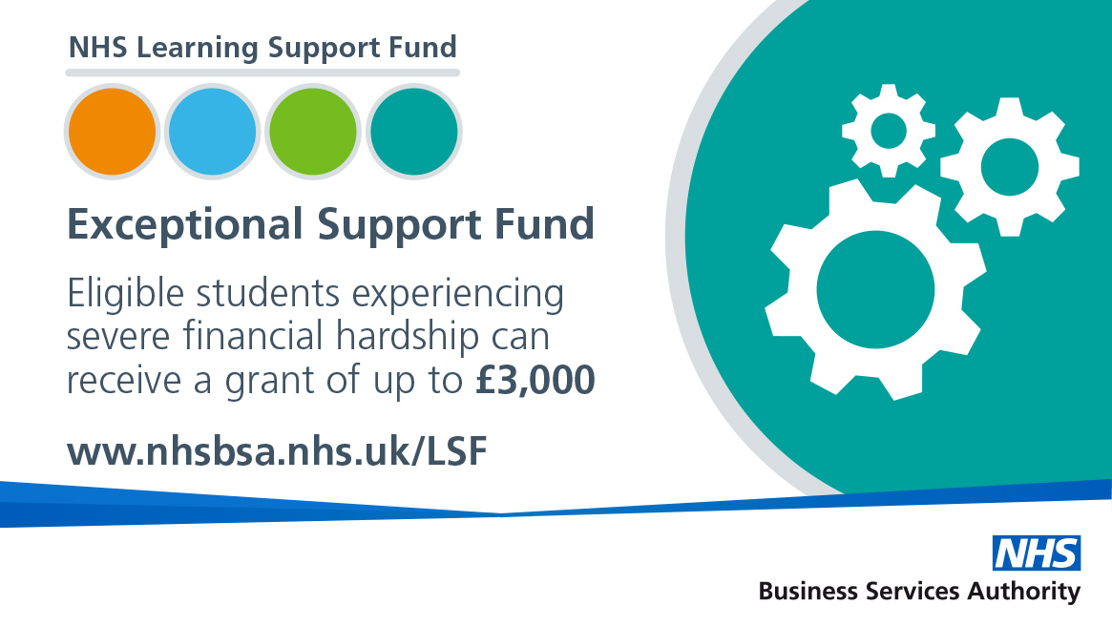
Images and other resources
If you require any of the images below in a different format please contact nhsbsa.studentservices@nhs.net and we will arrange for this to be done for you.

