

climate ready

INFRASTRUCTURE

Memorandum of understanding

scotland: forum


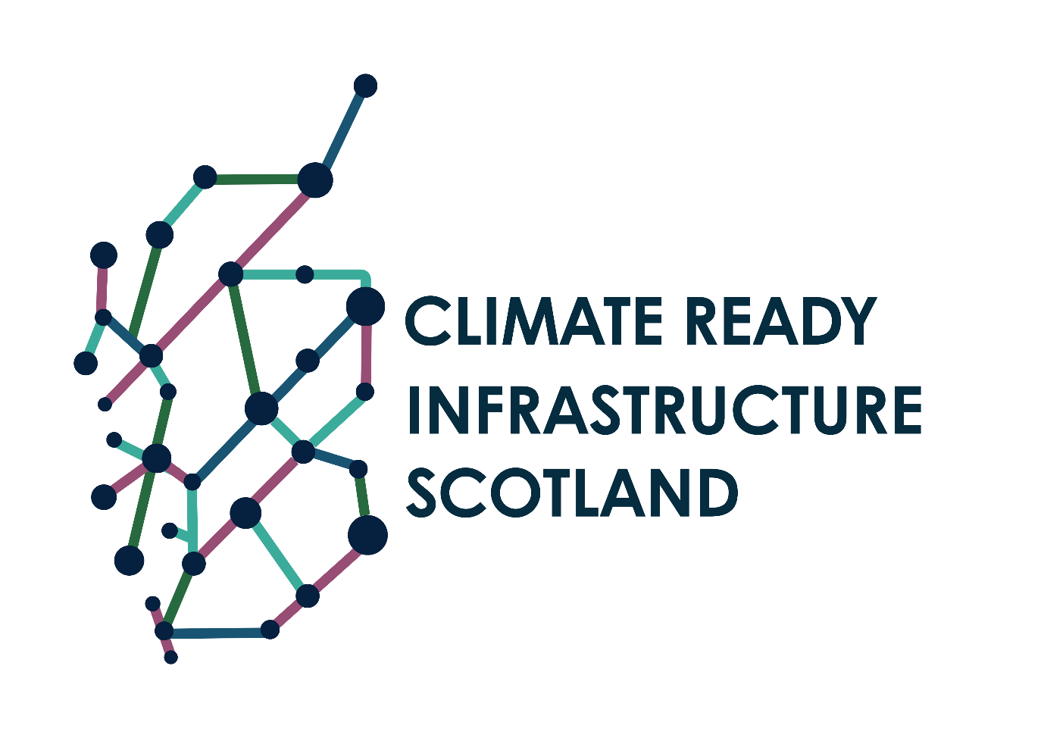

BACKGROUND

Infrastructure across Scotland operates as a system of systems and not in isolation. It means that when weather and climate-related risks materialise, they can cascade from one sector or operator to another and result in far-reaching societal impacts. To effectively respond to and manage these shared climate-related risks, infrastructure owners and operators across Scotland are going to have to work together to pool knowledge and resources, and to work increasingly in collaboration on climate adaptation initiatives.

The Climate Ready Infrastructure Scotland Forum (The Forum) has been established to foster closer collaboration between owners and operators of infrastructure in Scotland and to support shared ambitions of adapting to the impacts of climate change.

This Memorandum of Understanding serves as a non-binding statement of intent for member organisations of The Forum, outlining the terms and details of our collaboration.

case for change

There has been a sustained and notable change in Scotland’s climate. It is warmer than it once was, rainfall patterns have changed, and certain weather extremes are occurring more frequently, and are often more severe. Historic weather and sea-level observations confirm that:

- Scotland's 10 warmest years on record have all occurred since 1997.

- The average temperature for the last decade (2014-2023) was 1.02°C warmer than the 1961-1990 average, and the warmest year on record was 2022.

- There has been an increase in rainfall over Scotland in the past few decades. The annual average rainfall in the last decade (2014-2023) was 10% wetter than the 1961-1990 average, with winters 29% wetter.

- Mean sea level around the UK has risen by approximately 18.5cm from the start of the 20th century and the rate of sea level rise has increased over the last 30 years.

These changes in climate will continue and intensify in the years ahead. We know Scotland’s summers will become hotter and drier, and with more intense, convective type rainfall events. And we know Scotland’s winters will become warmer and wetter.

In response to this change in climate, and a growing understanding of the risks associated with a changing climate, owners and operators of infrastructure must work at pace to adapt infrastructure assets, so that they are able to better cope with these changes in climate. Doing so has benefits:

- Avoided losses: Targeted investment at locations vulnerable to changes in our climate – guided by a robust understanding of Scotland’s changing climate – will help avoid losses associated with climate change. This could include loss of performance, assets, services and economic impacts etc.

- Economic gains: A growing body of research and evidence suggests that ‘many early adaptation investments deliver high value for money. The benefit-cost ratios typically range from 2:1 to 10:1 – i.e., every £1 invested in adaptation could result in £2 to £10 in net economic benefits’.

- Social and environmental benefits: Resilient infrastructure will deliver wide-sweeping social and environmental benefits to the people of Scotland and is an integral component to Scotland achieving its other climate action goals, such as achieving net-zero emissions by 2045. For example, a resilient rail service can support modal shift from higher emitting forms of transport to a less carbon-intensive mode of transport.

memorandum of UNDERSTANDING

OBJECTIVE

The Climate Ready Infrastructure Scotland Forum is to be established to advance the climate adaptation and resilience efforts of infrastructure owners and operators in Scotland, and to foster closer collaboration.

The Forum will work collaboratively to co-develop, co-fund, and co-deliver tactical climate adaptation and resilience initiatives that advance the ability of infrastructure operators and owners in preparing for Scotland’s changing climate.

MEMBERSHIP

Membership of The Forum is open to any infrastructure operator or owner (public and private) either based or with a presence in Scotland. Wider participation in The Forum is actively encouraged, particularly from non-infrastructure focussed organisations, regional partnerships and academic and research participants where there is a relevant contribution to make to objectives of The Forum.

AREAS OF COOPERATION

Participants of The Forum intend to cooperate initially on the following priority areas:

Climate-related risk interdependencies.

This would involve Forum members working collaboratively to enhance our understanding of shared climate-related risks, and the interdependencies that exist between owners and operators of infrastructure / service providers.

Climate-related risk approaches and data requirements.

This would involve Forum members working collaboratively to set-out common principles in undertaking climate change risk assessments, sharing of best practice, and development of papers outlining our climate-related data requirements as a collective.

Co-delivering adaptation interventions.

This would involve Forum members working collaboratively to set-out guidance, common principles and additional requirements that would support stronger on-the-ground collaboration of adaptation interventions (e.g., co-funding flood resilience works in an area of shared risk).

forms OF COOPERATION

Forms of cooperation under this Memorandum of Understanding are built around the sharing of best practice, exchanging relevant knowledge, acting as a peer review community for Forum members and providing linkages and representation of infrastructure requirements in key regional and national adaptation communities. In practice, this may include, but is not limited to, the following:

- Member representation and active contribution at three hybrid meetings of The Forum annually.

- Member representation and active contribution at one in-person full-day meeting annually.

- Joint organisation and/or participation in conferences, workshops and other external facing events where collaboration is beneficial, for example, co-delivering a workshop or panel discussion at the annual Scottish Flood Resilience Conference.

- Exchange of relevant data and information between Forum members - pending any necessary data sharing / non-disclosure agreements for sensitive data – for example, sharing results of climate risk assessments and locations of planned adaptation interventions.

- Providing linkages for Forum members into national adaptation initiatives, for example, the forthcoming 4th UK Climate Change Risk Assessment and the Maximising UK Adaptation Hub.

- Forum members voluntarily providing climate adaptation and resilience progress updates as part of The Forum drumbeat of meetings and events, for example, raising awareness of their periodic DEFRA-led Adaptation Reporting Power submission (where relevant).

- Organising collective action across infrastructure operators and owners in support of delivery of Scottish National Adaptation Plan (SNAP3) objectives.

legal and financial considerations

No element of this Memorandum of Understanding binds Forum members to financial or legal commitments, rather it forms a statement of intent endorsed by Forum members. Members may choose at their discretion to co-commission and co-fund tactical projects / research commissions, and these will be developed on a case-by-case basis.

duration

The initial term of The Forum will be aligned to the Scotland’s National Adaptation Plan (SNAP3) timeline (2024 – 2029). In practice, no binding time commitment is set or required by Forum members who can choose when engagement is and isn’t beneficial to them.

MOU signatories
Organisation |  | Name | Role | Date | Signature
 | CalMac Ferries Limited | Duncan Mackison | Chief Executive Officer | 06.05.2025 | 
 | Caledonian Maritime Assets (Ltd) | Kevin Hobbs | Chief Executive Officer | 03.04.2025 | 
 | Forestry and Land Scotland | Kevin Quinlan | Chief Executive Officer | 28.04.2025 | 
 | Met Office | John Harrison | Associate Director | 30.04.2025 | J. Harrison
 | NatureScot | Clive Mitchell | Head of Terrestrial Science | 30.04.2025 | 
 | NEStrans | Paul Finch | Interim Director | 01.05.2025 | 
 | Network Rail (Scotland) | Alan Ross | Director of Engineering and Asset Management | 16.04.2025 | 
 | NHS National Services Scotland | Julie Critchley | Director | 10.04.2025 | 
 | OpenReach | Robert Thorburn | Partnership Director - Scotland and the North of England | 06.05.2025 | 
 | Scotland Beyond Net Zero | Kate Symons | Research Partnership Manager | 01.05.2025 | 
 | ScotRail | Scott Prentice | Strategy and Planning Director | 29.04.2025
 | Scottish Canals | John Paterson | Chief Executive Officer | 10.04.2025 | 
 | Scottish and Southern Electricity Networks (Distribution) | Shirley Robertson | Head of Strategic Planning and Sustainability | 02.04.2025 | 
 | Scottish Gas Networks | Louis Quinn | Head of Asset Engineering | 10.04.2025 | 
 | Scottish Rail Holdings | Hannah Ross | Chief Executive | 28.04.2025
 | Scottish Water | Mark Williams | Head of Sustainability | 30.04.2025 | 
 | South East Scotland Transport Partnership | Rebecca Smith | Project Officer | 02.05.2025 | R. Smith
 | Scottish Power Energy Networks | Eddie Mulholland | Director Process & Technology | 02.05.2025 | 
 | Sustrans | Jon Rowe | Head of Design, Engineering, Assurance & Mobility – Sustrans Scotland | 08.04.2025 | 
 | University of Edinburgh | Ian Hatch | Head of Business Development for the College of Science & Engineering | 05.05.2025 | 
 | University of Strathclyde | Andrew MacKenzie | Head of Grants and Contracts | 10.03.2025 | 
 | Transport Scotland | Morna Cannon | Director of Environment, Climate and Sustainability | 30.04.2025 | 
 | Verture | Jonny Casey | Head of Climate Ready Leadership | 23.04.2025 | 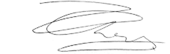

Adaptation Scotland, Climate Trends and Projections (2024)
Paul Watkiss, The Costs of Adaptation, and the Economic Costs and Benefits of Adaptation in the UK (2023)

