27th July 2020

Fixed penalty notices issued under COVID-19 emergency health regulations by police forces in England and Wales

Introduction

This release presents the latest data on the police use of COVID-19 enforcement notices and includes revisions to previously published figures. The figures reported here do not include any Fixed Penalty Notices (FPNs) issued under the Health Protection International Travel Regulations, nor the Health Protection (Coronavirus, Wearing of Face Coverings on Public Transport, England) Regulations, or the Health Protection (Coronavirus Restrictions) Regulations in Leicester.

Data FPNs issued in England and Wales is collated centrally by the ACRO Criminal Records Office and cover the 43 territorial forces, the British Transport Police and Ministry of Defence Police.

The figures below relate to enforcement activity by police forces and these data should be seen in the context of wider police activity to engage with the public to explain and encourage compliance with the new regulations. As outlined in previous releases, the police have recorded hundreds of thousands of Covid-19 related incidents since the 27th March. This will include incidents where officers have proactively offered advice to people, responded to reports from the members of the public about breaches of the regulation by others and offences where criminals have sought to take advantage of the pandemic to commit a crime.

Headline figures for England and Wales

In total, 18,669 notices have been recorded as having been issued in England (16,029) and Wales (2,640) between Friday 27th March and Monday 20th July.

Chart 1 shows previously published figures for earlier reporting periods together with the latest revisions as more FPNs have been processed. In previous releases this was reported on a daily basis but, given the length of time these regulations have been in place, this is now summarised on a weekly basis.

The weekly count for England and Wales shows that there was a general upward trend in the first period of the restrictions which continued through early April and peaked in the week ending 16th April which included the Easter Bank holiday. There was then generally a flatter trend through the rest of April and early May. From mid-May onwards there has been a considerable reduction in enforcement activity as the restrictions have been progressively eased, particularly in England. While figures for the most recent weeks are subject to revision, the levels of FPNs now being issued are at the lowest levels since the restrictions started, with one FPN issued between 17th and 20th July (partial week), no FPNs issued in the last full week (10-16 July), and only 12 issued the week previous (2-9 July).

Chart 1: FPNs issued under COVID-19 regulations between 27th March and 20th July
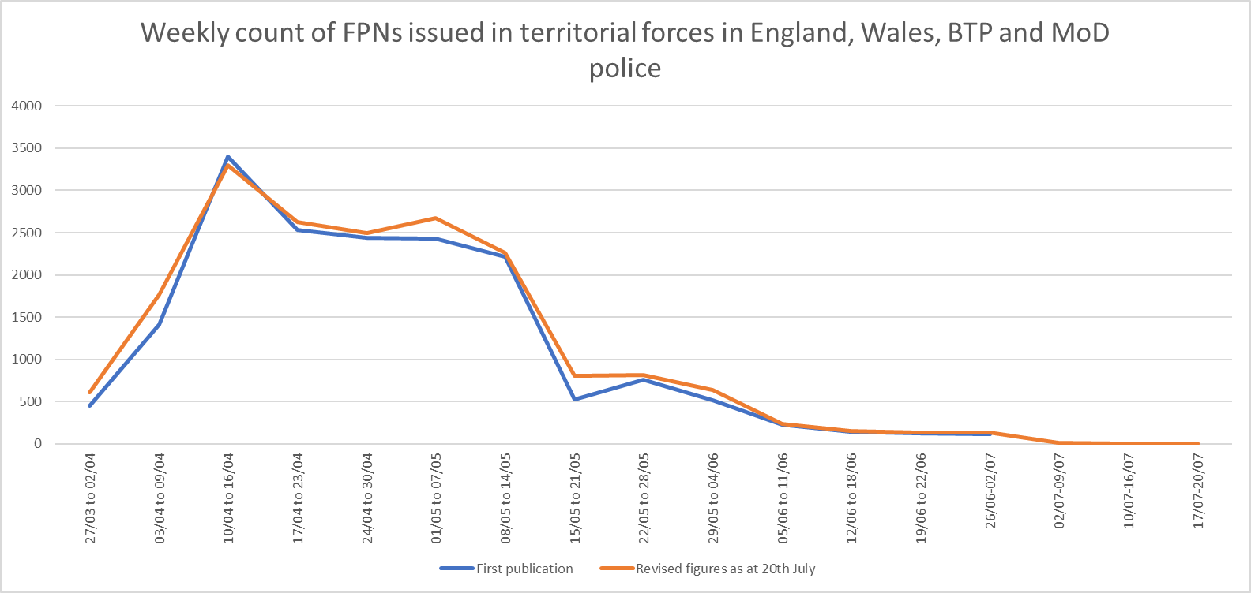

Note: excludes 3. FPNs with incorrect date of issue.
Of all enforcement notices issued in England and Wales:

- The vast majority (14,015) were issued for ‘Contravene requirement as to restriction of movement during emergency period’ (Table 1).

- The large majority (around 8 in 10) were issued to males (Table 2).

- Around 7 in 10 were issued to the under 35s; with 36% issued to 18-24 year olds, 18% to those aged 25-29 and 14% to those aged 30-34 (Table 3).

- Of those FPNs where the individual issued with the notice had a self-identified ethnicity recorded, 80% were issued to people who self-identified as White. Around one in eight (12%) went to Asians and 4% to those identifying as Black (Table 4).

- To date, 787 FPNs have been identified as having been issued to repeat offenders, that is the individuals who have been fined two or more times. The vast majority of these (81%) being for those who had been fined twice (Table 5).

Table 1: Reasons for which FPNs has been issued under emergency COVID-19 regulations, between 27th March and 20th July in England and Wales

Reason for issue | England | Wales | Total
Contravene requirement as to restriction of movement during emergency period | 11,842 | 2,173 | 14,015
Contravene a direction or fail to comply with instruction | 2,260 | 345 | 2,605
Contravene requirement to not participate in a gathering in public of more than two people | 4,169 | 261 | 4,430
Contravene requirement from a relevant person | 424 | 52 | 476
Obstruct person carrying out a function under the regulations | 276 | 9 | 285
Contravene requirement to not participate in an indoor gathering of two or more people | 9 | - | 9
Contravene requirement to not participate in an outdoor gathering of more than six people | 35 | 2 | 37
Stay overnight other than at place of living / linked household, in England, without reasonable excuse | 7 | - | 7
Total to date | 19,022 | 2,842 | 21,864

Note: The total in this table exceeds the headline measure of total FPNs issued as an FPN can be issued for more than one reason.

Table 2: FPNs issued under emergency COVID-19 regulations, by gender, between 27th March and 20th July in England and Wales

 | England | Wales | Total
Male | 80% | 76% | 79%
Female | 18% | 23% | 19%
Unknown | 2% | 1% | 2%

Table 3: FPNs issued under emergency COVID-19 regulations, by age group, between 27th March and 20th July in England and Wales

 | England | Wales | Total
18-24 | 37% | 30% | 36%
25-29 | 18% | 17% | 18%
30-34 | 14% | 15% | 14%
35-39 | 10% | 12% | 11%
40-44 | 7% | 8% | 7%
45-49 | 6% | 6% | 6%
50-54 | 4% | 4% | 4%
55-59 | 2% | 3% | 2%
60-64 | 1% | 2% | 1%
65+ | 1% | 2% | 1%
Unknown | 0.2% | 0.1% | 0.2%

Table 4: FPNs issued under emergency COVID-19 regulations, by self-defined ethnicity, between 27th March and 20th July in England and Wales

 | England | Wales | Total
White | 79% | 85% | 80%
Asian and Chinese | 12% | 10% | 12%
Black | 5% | 2% | 4%
Mixed | 2% | 2% | 2%
Other | 1% | 1% | 1%

Notes: Excludes 15% of FPNs where the ethnicity of the individual issued with the notice was unknown (17% for England and 7% for Wales).

Table 5: Number of FPNs issued to repeat offenders under emergency COVID-19 regulations, between 27th March and 20th July in England and Wales

Number of FPNs | England | Wales | Total
2 | 559 | 78 | 637
3 | 95 | 4 | 99
4 | 33 | 2 | 35
5 | 7 | 2 | 9
6 | 2 | 0 | 2
7 | 2 | 1 | 3
8 | 2 | 0 | 2
Total | 700 | 87 | 787

Understanding the data

These data cover the number of FPNs issued under COVID-19 regulations which came into effect from 27th March.

Data presented in this release represent the number of FPNs issued. While the vast majority of FPNs relate to a single individual, some people have been issued with an FPN more than once. An FPN can be issued for more than one reason.

Figures on the number of FPNs issued should not be seen as a measure of the amount of police activity involved in policing the new measures, or the level of public non-compliance, since fines are issued as a last resort after initial attempts to engage with the public to explain and encourage compliance with the new regulations have not been successful.

Owing to the time taken to process FPNs, figures presented here are likely to underestimate the volume of FPNs issued each day and will be updated with each release as new data are received, although the rate of increase in revised data appears to be slowing.

The nature of the administrative process involved in issuing an FPN is such that there is sometimes missing data or discrepancies when data are returned. For example, as ethnicity is self-defining this is not always completed, and the level of missing data needs to be considered when interpreting such figures.

Force level figures can be found here. However, caution should be taken to make comparisons between forces as variation in is likely to reflect a range of factors including how the force has decided to police non-compliance as well as differences in local context (e.g. composition and density of the local population).

Includes three notices issued prior to 27th March.
15% of FPNs issued did not have the self-defined ethnicity of the individual identified.

