Lucy Ruck
10 Somerville Close
High Legh
Cheshire
WA16 6TR
22 March 2018
To whom it may concern
RE: Farnborough North Station planning application to build a bridge
25 years ago, I was using the crossing at Farnborough North station when I was hit by a train travelling at 65mph. This amputated my right leg - I had become disabled. The 21st October 1993 was the day that changed my life.
I was a normal 17-year-old attending Farnborough Tech College and just starting the second year of my course. I had regularly been travelling from Crowthorne station to Farnborough North and was, by now, quite familiar with the unusual set up of the Farnborough station. I had always found it quite uncomfortable crossing the tracks, but as there was no other option open to me, this was my only choice.
On this particular day, I was one of the first at the pedestrian gate, and waited as our train left the station. Once it had, the business travellers and students came past me and started to cross the track, so I followed them.
What I wasn’t aware of was the fast train was just about to come through the station, travelling at 65mph. I only just had time to react and threw myself back onto the track behind me. I wasn’t quick enough. The train amputated my right leg and they found it half a mile up the track.
I was incredibly lucky to have no other serious injuries. This was not the case 10 years earlier, where someone had lost their life in the same spot under similar circumstances.
So this is my public plea to allow Network Rail to build a bridge at this dangerous crossing. It saddens me, that at a time Network Rail are willing to invest more than £2million to improve safety at the crossing, that they are being met with resistance from the council and local residents. Are you waiting for another fatality, or for someone else to be permanently disabled before you are prepared to support them?
I am struggling to understand why anyone would resist a bridge being put up at Farnborough North Station, especially as they have a strong focus on making this accessible to everyone, including those with buggies and wheelchairs.
Network Rail have made improvements at the crossing to improve safety, such as providing attendants, but this is not sustainable- the crossing simply must be replaced to remove this risk once and for all.
Please allow Network Rail to ensure the safety of everyone by removing this dangerous crossing and installing a new footbridge.
Kindest regards
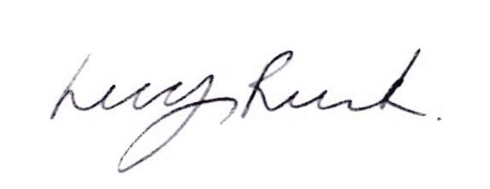
Lucy Ruck (nee Ottaway)

