Impact of COVID-19 vaccines on mortality in England

December 2020 to March 2021

Contents

Impact of COVID-19 vaccines on mortality in England 1

December 2020 to March 2021 1

Contents 2

1. Background 3

2. Methods 4

3. Results 4

4. Conclusions 6

References 7

1. Background

Vaccination against COVID-19 commenced in England on 8 December 2020, initially using the Pfizer-BioNTech mRNA vaccine. The Oxford-AstraZeneca vaccine was then added to the programme from 4 January 2021.

The target groups for vaccination followed the Joint Committee on Vaccination and Immunisation (JCVI) prioritisation (1) and so residents and staff of care homes for the elderly, individuals over the age of 80 years and health and social care workers were the first to receive vaccination. The programme was subsequently extended to those aged over 70 years, plus individuals in the Clinically Extremely Vulnerable group in mid-January, those aged 60 years and older in February and those aged 50 years and older in March.

Over the course of the vaccine rollout (from 6 January 2021) a national lockdown was introduced which included 'stay at home' measures and closure of non-essential retail, hospitality and personal care services and school closures for most children.

Both the lockdown and the vaccination programme are likely to have impacted on incidence of COVID-19 cases, hospitalisations and deaths, therefore there are challenges in estimating the impact of either intervention alone.

Taking into account observed deaths with COVID-19 and emerging real world evidence of the effectiveness of COVID-19 vaccines Public Health England and the University of Warwick have estimated the number of deaths prevented by vaccination in England between the start of the vaccination programme and the end of March 2021.

2. Methods

COVID-19 deaths were defined as any death within 28 days of a positive SARS-CoV-2 test (2).

The daily impact of vaccination on deaths was estimated based on vaccine effectiveness against mortality multiplied by vaccine coverage. Observed deaths were then divided by the impact to estimate the expected deaths in the absence of vaccination.

Vaccine effectiveness against mortality was based on PHE estimates of effectiveness of vaccination against symptomatic infection (58%) and of death given infection (54%) which combined gives 81% protection against death (3). In order to allow for the time taken to develop an immune response to vaccination and for a mortality endpoint, we assumed it would take 31 days before the effect of vaccination on deaths is observed (3, 4). For example, the coverage of 64.9% in age 80+ on 19 January applies to deaths on 19 February.

The calculation was done in the 60 to 69, 70 to 79, and 80+ year olds separately. The overall total is cumulated across all days until 31st March 2021 and across the three years age groups.

3. Results

Vaccine coverage, observed deaths and expected deaths using approach 1 are shown in Figure 1. By the end of March 2021, it is estimated that 9,100 deaths were averted in individuals aged 80 years and older, 1,200 in individuals aged 70 to 79

and 100 in individuals aged 60 to 69 years giving a total of 10,400 deaths averted in individuals aged 60 years or older.

Figure 1: Daily Observed COVID-19 deaths aged 60+ and expected numbers in the absence of vaccination using the back calculation method

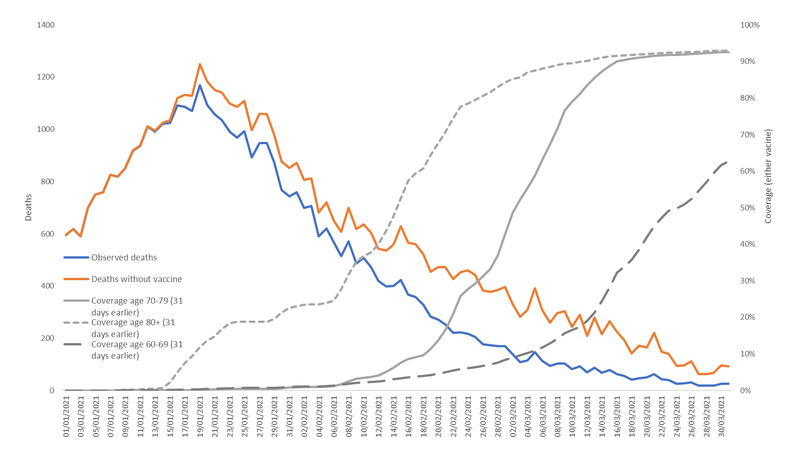

4. Conclusions

An estimated 10,400 deaths have been averted as a result of the COVID-19 vaccination programme up to the end of March 2021.

This analysis is based on the direct effects of the vaccination on mortality. There is increasing evidence that both vaccines in use in England prevent infection and transmission (8,9). The indirect effects of the vaccination programme will not be incorporated in this analysis, therefore the figure of 10,400 deaths averted is likely to be an underestimate.

These findings provide further evidence that the COVID-19 vaccination programme is already having a significant impact on severe COVID-19 disease in England beyond the effect of the national lockdown. Furthermore, the true value of these vaccines may be in terms of future deaths we might now avoid if there is a resurgence of covid-19 in the UK in the future.

References

1. JCVI. [Priority groups for coronavirus (COVID-19) vaccination: advice from the JCVI, 30 December 2020](https://www.gov.uk/government/publications/priority-groups-for-coronavirus-covid-19-vaccination-advice-from-the-jcvi-30-december-2020). 30 December 2020. [Cited: 19 March 2021].
2. [Technical summary: Public Health England data series on deaths in people with COVID-19](https://assets.publishing.service.gov.uk/government/uploads/system/uploads/attachment_data/file/916035/RA_Technical_Summary_-_PHE_Data_Series_COVID_19_Deaths_20200812.pdf). 12 August 2020. [Cited: 19 March 2021.]
3. England, Public Health. [PHE monitoring of the early impact and effectiveness of COVID-19 vaccination in England, March 2021](https://www.gov.uk/government/publications/phe-monitoring-of-the-effectiveness-of-covid-19-vaccination). 17 March 2021.

1. [The impact of social and physical distancing measures on COVID-19 activity in England: findings from a multi-tiered surveillance system](https://doi.org/10.2807/1560-7917.ES.2021.26.11.2001062). Bernal Jamie Lopez, Sinnathamby Mary A, Elgohari Suzanne, Zhao Hongxin, Obi Chinelo, Coughlan Laura, Lampos Vasileios, Simmons Ruth, Tessier Elise, Campbell Helen, McDonald Suzanna, Ellis Joanna, Hughes Helen, Smith Gillian, Joy Mark, Tripathy Manasa, Byf. 11, s.l. : Eurosurveillance, 2021, Vol. 26.

1. [Predictions of COVID-19 dynamics in the UK: Short-term forecasting and analysis of potential exit strategies](https://doi.org/10.1371/journal.pcbi.1008619). Keeling MJ, Hill EM, Gorsich EE, Penman B, Guyver-Fletcher G, et al. 1, s.l. : PLOS Computational Biology, 2021, Vol. 17.

1. [Vaccination and non-pharmaceutical interventions for COVID-19: a mathematical modelling study](https://doi.org/10.1016/S1473-3099(21)00143-2). Sam Moore, Edward M Hill, Mike J Tildesley, Louise Dyson, Matt J Keeling. s.l. : The Lancet ID

1. [Early effectiveness of COVID-19 vaccination with BNT162b2 mRNA vaccine and ChAdOx1 adenovirus vector vaccine on symptomatic disease, hospitalisations and mortality in older adults in England](https://doi.org/10.1101/2021.03.01.21252652). Jamie Lopez Bernal, Nick Andrews, Charlotte Gower, Julia Stowe, Chris Robertson, Elise Tessier, Ruth Simmons, Simon Cottrell, Richard Roberts, Mark O’Doherty, Kevin Brown, Claire Cameron, Diane Stockton, Jim McMenamin, Mary Ramsay
2. [Effectiveness of BNT162b2 mRNA vaccine against infection and COVID-19 vaccine coverage in healthcare workers in England, multicentre prospective cohort study (the SIREN Study).](https://science.sciencemag.org/content/early/2021/03/08/science.abg8663) V. J. Hall, S. Foulkes, A. Saei, N. Andrews, B. Oguti, A. Charlett, E. Wellington, J. Stowe, N. Gillson, A. Atti, J. Islam, I. Karagiannis, K. Munro, J. Khawam, The SIREN Study Group, M. A. Chand, C. Brown, M. E. Ramsay, J. Lopez Bernal, S. Hopkins. SSRN 3790399 [Preprint]. 22 February 2021
3. [Vaccine effectiveness of the first dose of ChAdOx1 nCoV-19 and BNT162b2 against SARS-CoV-2 infection in residents of Long-Term Care Facilities (VIVALDI study)](https://www.medrxiv.org/content/10.1101/2021.03.26.21254391v1) Madhumita Shrotri, Maria Krutikov, Tom Palmer, Rebecca Giddings, Borscha Azmi, Sathyavani Subbarao, Christopher Fuller, Aidan Irwin-Singer, Daniel Davies, Gokhan Tut, Jamie Lopez Bernal, Paul Moss, Andrew Hayward, Andrew Copas, Laura Shallcross

Published: March 2021

PHE gateway number: GOV-7803

Prepared by: Nick Andrews, Julia Stowe, Sharif Ismael, Laura Coughlan, Hester Allen, Mary Ramsay, Jamie Lopez Bernal

Website: [www.gov.uk/phe](http://www.gov.uk/phe)

Twitter: [@PHE_uk](https://twitter.com/PHE_uk)

Facebook: [www.facebook.com/PublicHealthEngland](http://www.facebook.com/PublicHealthEngland)

© Crown copyright 2021