**Christmas Stars for Festive Style**

**With Halloween and All Saints under our belt, retailers now have a clear run up to Christmas and are creating fabulous merchandise and window display to entice shoppers. Whilst the seasonal shift is a big deal for all gift-oriented shops and grocers, for garden centres it represents a full metamorphosis, from outdoor living and gardening to Christmas decs and winter houseplants.**

One of the most popular – if not THE most popular – festive plants is the poinsettia, also known as the Christmas Star. Famed for their centuries-old association with traditions that range from the Mayan culture of their native Mexico to the season of Advent on both sides of the Atlantic, these winter beauties are being put front and centre in garden centres nationwide.

**Affordable and Versatile**

With price points that start at a couple of pounds and bract colours that range from creamy white and mood enhancing yellow to Barbie pink, St Nicholas red and stunning variegation, poinsettias are the gift that keeps on giving at Christmas. Not only do they make the perfect gift for houseguests to give to their hosts, they also serve as beautiful table and Christmas tree decorations and make stylish cut flowers.

Poinsettias can be used to realise countless festive DIY ideas. With cut and mini poinsettias in particular being perfect for creative craft projects. Decorations and fabrics with a vintage feel are on-trend and work beautifully with poinsettias, the classic Christmas plant!

Here the specialists at [**Stars for Europe**](https://starsforeurope.com/en/) – an agency which promotes poinsettia sales in all retail outlets across Britain and the wider continent – look at some of the many ways you can bring Christmas Stars into your home this season.

**Heralding Advent**

In this homemade Advent calendar, the surprises are contained in 24 beautifully wrapped cardboard boxes, arranged in the shape of a Christmas tree on a shelf. A variety of wrapping paper, colourful ribbons, pine branches and cut poinsettias in flower tubes attached to the bows of some presents, create a decorative effect. To ensure the poinsettias stay fresher for longer, immediately after cutting, first dip the cut ends in hot water (around 60°C) for a few seconds and then straight into cold water. Tip: If necessary, use hot glue and/or adhesive pads at some points to ensure the structure doesn't collapse.

**Tablescaping**

Whether it’s a cool Scandi-chic vibe you’re looking for, or full-on traditional British opulence, poinsettias can do a lot to help you achieve your tablescaping goals this season.

This colourful vintage winter table with a Scandi feel is guaranteed to brighten your mood. The relaxed combination of poinsettias (in pots and as cut flowers) and pine greenery, teamed with playful accessories, classic tableware and candles creates a cheerful mix of colours and styles as well as an inviting, feel-good atmosphere.

For a subtle and elegant look, Cream poinsettias and dried flowers look beautiful in DIY vases made from Christmas baubles. For this elegant upcycling idea, you will need white lustre baubles, log slices (for example, birch wood), a hot glue gun and glue sticks, cut poinsettias and dried flowers. They are so easy to make. Simply remove the little caps from the baubles and, with the opening at the top, attach them to the log slices using hot glue. Fill each bauble vase with dried flowers and cut poinsettias. Place several vases together on your Christmas table for a striking centrepiece.

*Tip: Cut poinsettias will stay fresh in clean water for up to two weeks if, immediately after cutting, you first dip the cut ends in hot water (approx. 60°C) for a few seconds, then straight into cold water.*

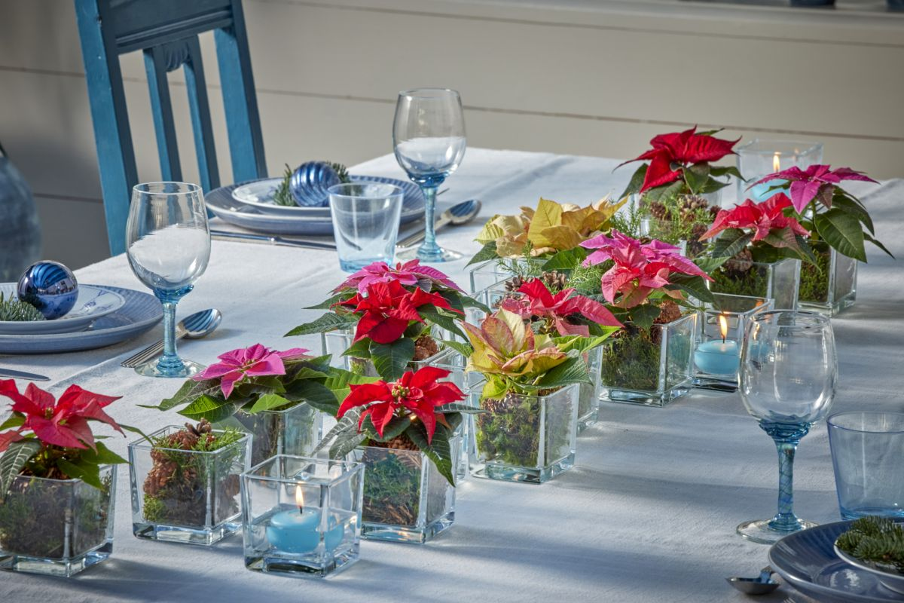

This contemporary table centrepiece in a modern, country house style is both simple and stunning. In the centre of the table, square glass vases filled with colourful mini poinsettias and blue floating candles draw the eye. The warm colours of the bracts form an attractive contrast to the blue tones dominating the table.

*Tip: Wrap the root balls of the mini poinsettias in moss before placing them in the vases.*

What would a Christmas table be without candlelight and floral decorations? These DIY flower arrangements offer both at the same time. You can create these magical table arrangements yourself in just a few steps. You'll need small bowls, double-sided transparent tape, stemmed glasses, a hot glue gun and glue sticks, wool string and tealights. You will also need the following florals for the arrangements: poinsettias, silver dollar eucalyptus (Eucalyptus polyanthemos), crab apple (Malus floribunda), dwarf mountain pine (Pinus mugo), Austrian pine (Pinus nigra) rosehips (Rosa multiflora).

**Tree Decoration**

What would Christmas be without a lovingly decorated tree? Colourful poinsettias are perfect as living tree decorations. Whether as cut flowers or, as here, in the form of Kokedamas, their bright bracts, together with fairy lights, stars and colourful baubles, make every Christmas tree sparkle. For the Kokedamas, take mini poinsettias out of their plant pots and water them thoroughly. Wrap the root balls with moss and secure it in place with fine wire. Hang up the finished Kokedamas. Tip: Later, carefully water the mini poinsettias from above or briefly place the moss balls in a container with a little lukewarm water so that they can soak it up.

Whether as living Christmas tree decorations or a colourful sea of plants in a vintage box serving as a tree stand, poinsettias are the focus of this festive Christmas Eve decoration. With their beautiful, colourful bracts, they conjure up an unforgettable atmosphere and make any other decoration redundant. Tip: The tree decorations are Kokedamas made with mini poinsettias. To make these, first water the poinsettias thoroughly. Then remove the root balls from their pots and wrap them with moss. Secure it with fine craft wire, before hanging the kokedama balls on the tree. Tip: Later, you can water the plants carefully from above or by regularly placing the moss balls briefly in a container of lukewarm water so they can soak it up.

This rustic DIY Christmas tree is perfect for anyone who cares about a sustainable lifestyle. It's a recycling project because the tree is created from an old trunk (for example, last year's Christmas tree), wire, clay and evergreen branches. Here's how to make it: Form a conical tree shape out of a piece of chicken wire and attach it to the tree trunk with florists' stub wire. Next, attach the evergreen branches to the chicken wire frame with more stub wire. Make mini poinsettia Kokedamas and hang them on the tree with parcel string. Finally, attach a beautiful cut poinsettia in a test tube filled with water to the top of the tree. Done! Add a layer of clay at the bottom of the basket to ensure the tree stands securely. For the Kokedamas, first water the mini poinsettias thoroughly. Next, take them out of their pots and wrap the root balls with moss, securing it with fine craft wire. Tip: After hanging, you can either water your mini plants gently from above or regularly place the moss balls in a container of lukewarm water to absorb it.

**Centrepieces and Focal Points**

For Christmas spirit in rustic Scandi style: The branches in this oversized container, decorated with poinsettia Kokedamas and colourful baubles, make a beautiful Advent decoration and a needle-free alternative to the classic Christmas tree. The vibrant bracts of the poinsettias add attractive accents to the room, dominated by shades of blue. For the Kokedamas, first water the mini poinsettias thoroughly. Next, take them out of their pots and wrap the root balls with moss and secure it in place with fine wire. Hang up the finished Kokedamas. Tip: Later, carefully water the mini poinsettias from above or briefly place the moss balls in a container with a little lukewarm water so that they can soak it up.

This unusual Advent wreath in warm terracotta, salmon and red tones looks sophisticated and rustic at the same time. To create this natural centrepiece yourself, add four candle holders to a straw wreath frame and attach small terracotta pots around it with hot glue. Stick dried rose heads and pine cones between the pots. Finally, place mini poinsettias and matching dried banksias and proteas in the terracotta pots and add taper candles to the holders. Tip: Place your wreath in a bright, warm spot away from draughts. Water the mini poinsettias regularly from above with a small amount of water. Make sure they don't get waterlogged.

Making this artistic poinsettia arrangement yourself is easier than it looks. To frame the poinsettia, place it in its planter on a slice of wood. Then cut a metal ring and insert the ends into pre-drilled holes on either side of the piece of wood. Next, cover the top of the ring with wild clematis (Clematis vitalba) tendrils. Loosely wrap chicken wire around the bottom half of the metal ring, then wrap it in the moss and decorate it with natural materials, if you want. A decorative star gives this homemade project the finishing touch. Your perfect poinsettia gift for anyone who loves natural things is ready.

Poinsettias need a bright position. A spot near a window is ideal, as long as the plants aren't exposed to cold draughts and their sensitive leaves don't touch the cold window panes. Poinsettias also shouldn't be placed too close to a radiator that is turned up, as temperatures above 22°C are not good for them.

**Find out more**

To find out more about Stars for Europe, and to access its incredible library of advice, aspirational imagery and content please visit <https://www.starsuniteeurope.eu/en/>

**NOTES TO EDITORS**

**Stars for Europe**

Stars for Europe (SfE) is a marketing initiative founded by European poinsettia breeders Dümmen Orange, Selecta One, Beekenkamp and Syngenta Flowers. The initiative began in 2000 with the aim to promote and secure long-term poinsettia sales in Europe. SfE activities are currently taking place in 22 European nations.

**Press contact**

Charlotte Cowell: [charlotte@hornbygeorgepr.com](mailto:charlotte@hornbygeorgepr.com) / 01442 863646

