
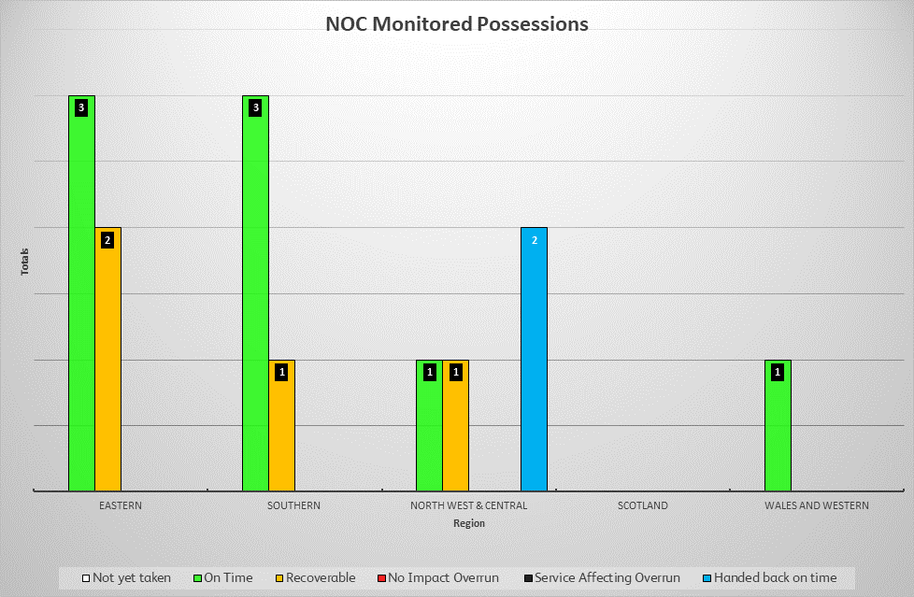
Engineering status

Region/Route | Item | Owner | Date/Time to/from | Location | Update | Status
Eastern/  Anglia | 143 | Southern - Anglia | Fri 01:05 – Tue 03:50 | Watlington – King’s Lynn  King’s Lynn Enhancement | On time.  NKM: Change of train describers at King’s Lynn
Eastern/  Anglia | 220 | Southern - Anglia | Sat 00:50 – Tue 02:30 | Blackhorse Road – Woodgrange Park Jn  Sebert Road & Balmoral Road Bridges | Time lost owing to design issue with bearer installation.  Expected to have been back to time for next key milestone, confirmation awaited.
Eastern/  Anglia | 260 | Signalling - Southern | Sat 02:00 – Tue 00:01 | Barking Tilbury Line Jn East – Dagenham Dock  Barking Riverside | On time.  NKM: commence tamping 23:00
Eastern/  EM | 15 | Track RS Alliance Central East | Sat 02:05 – Tue 03:45 | Dock Jn North – West Hampstead Thameslink  Carlton Road | Reported as 4 hours behind at 20:00, but approx.one hour has since been recovered with tamping now complete.  Time lost due to panel installation slowing up for cable protection mitigations, followed by having to reposition tamper  13 hours welding (due complete 07:05 Mon), 6 hours of stressing and 4 hours float in the possession which can all be used to recover time. No concerns.
Eastern/  EM | 16 | Central - EM | Sat 02:20 – Tue 03:45 | West Hampstead Thameslink – Silkstream Jn  Cricklewood Siding / Brent Cross | On time.  NKM: complete removal of OLE structures 23:59
NW&C/  NW | 33 | Signalling | Sat 00:45 -Tue 04:45 | Weaver Jn – Wavertree Jn  Ditton Re-Control | Slightly behind.  71% of planned work completed, against planned 76%  NKM: Fiddlers Ferry train describers change over and test until 06:00
NW&C/  NW | 72 | Works Delivery | Sun 00:01 – Sun 09:20 | Preston (Ribble Jn) – Cove LC  Catterall Feeder Station | POSSESSION HANDED BACK
NW&C/  NW | 212 | Track RS Central Alliance Central West | Sat 20:45 – Sun 18:30 | Chinley North Jn – Buxton  Peak Forest | POSSESSION HANDED BACK
NW&C/  Central | 85 | Renewals/ Track RS Alliance Central West | Sat 01:40 – Tue 05:20 | Long Lawford – Birmingham International  Albany Road/Pinley | On time.  NKM: complete tamping 00:01
Southern/  Kent | 49 | Maintenance | Sat 00:20 – Tue 04:00 | Nunhead Jn – Bellingham  Catford Structure Works | 90 minutes behind.  Additional time lost due to additional movements of bridge machine. No concerns for handback and lost time is expected to be recovered with concurrent activities.  NKM: remove ‘LCH’ track protection, excavators and ballast ramps 20:30
Southern/  Kent | 63 | Track RS Alliance Southern | Sat 01:50 – Tue 03:50 | Slade Green – Dartford Jn  Crayford Spur A’ Jn S&C renewal | On time.  NKM: install conductor rail 23:15
Southern/  Sussex | 140 | Southern - Sussex | Sat 01:05 – Tue 04:00 | Lingfield – Dormans  Oxted Viaduct | On time.  NKM: commence bridge jacking 09:00 Monday.
Southern/  Wessex | 132 | Track RS Alliance Southern | Sat 00:45 – Tue 04:50 | Twickenham – Ashford (Middlesex)  Whitton Jn | On time.  NKM: complete installation of panels 28 to 32 by 21:50
W&W/Western | 129 | Track RS Alliance W&W | Sat 01:30 – Tue 05:00 | Alderton Tunnel West – Westerleigh Jn  Chipping Sodbury Tunnel | On time.  Bottom ballast installed.  NKM: install G4 sleepers and rail, top stoning starts from 22:00
Any concerns regarding ‘Green sites’ listed on the agenda will be detailed above.
Significant event(s) update:

Protests: The planned marches around the London area today saw low turnouts. Co-location and camera monitoring with BT Police continued.

