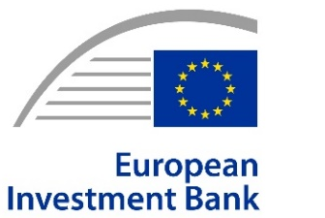
Joint PRESS RELEASE
2026-248-EN
Vienna, 13 July 2026
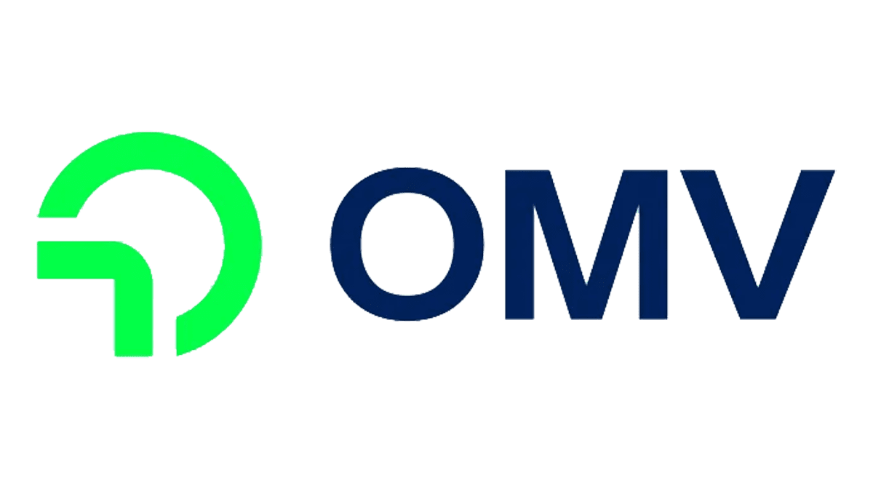
EIB provides €450 million financing for OMV’s flagship green hydrogen project
- Austrian integrated energy, fuels and chemicals company OMV gets €450 million EIB loan to build major green hydrogen plant in northeastern town of Bruck an der Leitha.
- Green hydrogen will replace fossil-based hydrogen at OMV’s Schwechat refinery, cutting CO₂ emissions by up to 150,000 tonnes per year.
- Largest-ever EIB financing in Austria’s energy sector, supporting Europe’s clean industrial transition through the EIB’s TechEU initiative.

The European Investment Bank (EIB) is providing €450 million to Austrian integrated energy, fuels and chemicals company OMV to build a large-scale green hydrogen production facility in Bruck an der Leitha in Lower Austria, supporting industrial decarbonisation, Europe’s clean technology leadership and a more secure energy system. The loan represents the EIB’s largest-ever investment in Austria’s energy sector and covers nearly three-quarters of the projected €600 million investment cost. The green hydrogen plant is already under construction and is expected to commence operations by the end of 2027.
The plant will feature a 140 MW electrolyser powered by renewable electricity. Once operational, it will produce up to 23,000 tonnes of renewable hydrogen annually, making it the largest facility of its kind in Austria and among the five largest in Europe.
Renewable hydrogen will be transported through a 22-kilometre pipeline to OMV’s Schwechat refinery, where it will progressively replace fossil-based hydrogen used in refining processes. The investment is expected to reduce the refinery’s direct CO₂ emissions by up to 150,000 tonnes annually—around 10% of current direct emissions—and create the basis for future production of sustainable aviation fuels and other low-carbon products.
“Green hydrogen is a cornerstone of Europe’s transition to a competitive, climate-neutral and secure energy system,” said EIB Vice-President Karl Nehammer during the site visit. “By supporting green hydrogen production at industrial scale, we are strengthening Europe’s competitiveness, reinforcing our energy security and helping decarbonise refining by replacing fossil-based hydrogen with renewable hydrogen. This investment also lays the foundation for the future production of sustainable aviation fuels, supporting the EU’s climate and energy security objectives.”

The operation reinforces the EIB’s role as the EU Climate Bank by financing strategic infrastructure that accelerates the deployment of renewable hydrogen at industrial scale. It also advances the EIB’s TechEU initiative by strengthening Europe’s electrolysis value chain and contributes to the objectives of the European Green Deal and REPowerEU.

“The European Investment Bank’s loan commitment is a strong signal of confidence in OMV’s transformation strategy and our ability to deliver large-scale projects that drive industrial decarbonisation,” said Deputy Chairman of the Executive Board of OMV Aktiengesellschaft and Chief Financial Officer Reinhard Florey. “This investment is of strategic importance for both Austria and Europe. By producing green hydrogen in Austria, we are strengthening Europe’s energy value chain, enhancing energy security, and contributing to a more sustainable energy system. The construction of one of Europe’s largest green hydrogen plants marks a major milestone in the decarbonisation of our industrial processes. Once operational, the facility will make a significant contribution to reducing CO₂ emissions at our Schwechat refinery and underscores our ambition to actively shape the energy transition in Austria and across Europe.”

Under its Strategy 2030, OMV is expanding renewable hydrogen and renewable fuels production as part of its pathway towards net-zero emissions by 2050. The EIB-financed project in Bruck an der Leitha is expected to become a cornerstone of this transition by replacing fossil-based hydrogen with renewable hydrogen in refinery operations.
Background information
EIB Group
The European Investment Bank (ElB) Group is the financing arm of the European Union, owned by the 27 Member States, and one of the largest multilateral development banks in the world. In 2025, the EIB Group signed €100 billion of new financing and advisory services for over 870 high-impact projects in eight core priorities that support EU policy objectives: climate action and the environment, digitalisation and technological innovation, security and defence, territorial cohesion, agriculture and the bioeconomy, social infrastructure, strong global partnerships and the savings and investment union. Beyond long-term loans for large infrastructures, the EIB Group crowds-in private investment for high-risk innovative projects and businesses, with a growing role in Europe’s markets for venture debt, venture capital, guarantees and securitisations.
The European Investment Fund (EIF) is the subsidiary of the EIB Group specialised in providing guarantees and equity to improve access to finance for small and medium size businesses and startups across Europe. Acting as an anchor investor, through its extensive network of partnering banks and investment funds, the EIF mobilizes private investment and nurtures the ecosystem of venture capital funds to support innovative European entrepreneurs.
In 2023, the EIF together with six member states (France, Germany, Italy, Spain, Belgium and the Netherlands) launched the European Tech Champions Initiative, a fund of funds to scale-up innovative startups. This initiative has already enabled the creation of 12 European venture capital mega-funds and scaled up 38 companies, including 11 unicorns (with more than €1 billion in capital).
Photos of the EIB Group's spokespeople and headquarters, logo files and video B-roll for media use are available here.

Press contacts

Clara Wanjek-Bauer | c.wanjek-bauer@ext.eib.org | mob.: +43 664 5608656
Website: www.eib.org/press | Press Office: press@eib.org
OMV Aktiengesellschaft
It is our purpose to re-invent essentials for sustainable living. OMV is transitioning to become an integrated sustainable energy, fuels and chemicals company. OMV is striving to achieve net zero by 2050 at the latest. In 2025, the company generated revenues of €24 billion and employed around 22,300 people worldwide. OMV’s key strategic shareholdings include a 51.2% stake in OMV Petrom and 50% in Borouge International. OMV shares are traded on the Vienna Stock Exchange (OMV) and in the United States on OTCQX (OMVKY, OMVJF). For more information, please visit www.omv.com.

