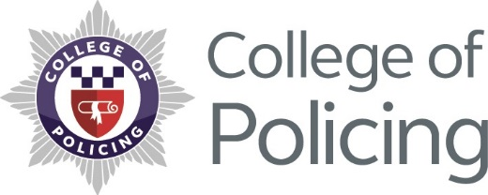

INTRANET COPY

Launch of National Police Wellbeing Service

A ground-breaking National Police Wellbeing Service aimed at improving mental and physical health support for officers and staff has now been launched.
We hear loud and clear that some of the biggest issues that affect the wellbeing of officers and staff are the fact that you are under increasing pressure, not just with fewer staff but with the types of demands that are placed on you while you’re at work.
This is why wellbeing, and everything that means, needs to become part of daily business. How well your organisation looks after you has a direct impact on not just your own individual resilience but the operational resilience of your force, and therefore, how well we can protect the public - which is what we are all here to do.
How many people are in work, whether they well when they are at work, whether they have the right kit to do their jobs, whether they genuinely feel supported by the organisation is the stuff we are aiming at.
We are facing unprecedented demand and what we aim to do as the national wellbeing service is to help your force by providing evidence based resources, toolkits and training so they can continue to build on the support they offer you at work.
We want to:
- Make sure that every member of the police service to feel confident that their wellbeing is taken seriously and is properly supported by their organisation

- Make sure that every force has access to the best guidance and support to provide top class wellbeing support

- Be part of reducing stigma around seeking support or help

- Improve knowledge and understanding of help and support available

- Encourage people to support themselves and realise their own potential

- Improve personal resilience and self-help skills

- Improve how people feel at work

As a national service, we are going to do that by providing support to your force in the form of training, workshops, toolkits amongst other things so that:
- line managers are properly trained and supported to support you

- there are effective and safe peer support networks in place

- psychological screening tools are in place and being used effectively to keep those in high risk roles safe

- signposting and support – so you know where to seek help if you need it and if you don’t want to seek help from within your organisation, where to go externally

- senior leaders understand their impact on wellbeing and what they need to do to get this right

- your force has access to evidence based best practice to make sure that any support offered is safe

- your wellbeing services can be brought out to you at your stations where you work every day
You are a whole person when you come to work, you are not just the officer or member of staff who switches off to another person when you sign off for the day and ‘wellbeing’ means different things to different people.
Some people want help, some people don’t, some people will come to the organisation for that, others won’t.
That is why are encouraging forces to offer a range of services and signpost out to others to make sure that no matter who you are, how you deal with things, or what you need - you know what is available and how to access it.
You’ll be hearing a lot more form us as we continue to develop this service because it is for everyone and we want feedback from you so visit www.oscarkilo.org.uk to find out more about the service and what it means to you and how you can get involved to help us shape the service and the support we provide to your force.

​
Further information about Oscar Kilo:
Since its launch in 2017, Oscar Kilo has grown at a rapid rate. Every police force in England, Wales and Northern Ireland including a further six non HO forces and organisations now subscribe to the site and have adopted the Blue Light Wellbeing Framework. We continued to grow and just one year from our launch date, every Fire Service in the UK signed up via the National Fire Chief’s Council.
As we continued to build Oscar Kilo, we worked with the Home Office, the College of Policing and the NPCC following the announcement of investment of £7.5 million (over three years) from the Police Transformation Fund to help provide enhanced welfare support for policing.
This programme, overseen by the College of Policing with support from the NPCC and Oscar Kilo, established the basis for a National Police Wellbeing Service which is due to launch in April 2019, and we are very excited to say that Oscar Kilo will become the home of this new service.
Oscar Kilo will continue to offer its services across all emergency services and will host the National Police Wellbeing Service under a brand new area of the website, which is accessible to any member of the police service.

