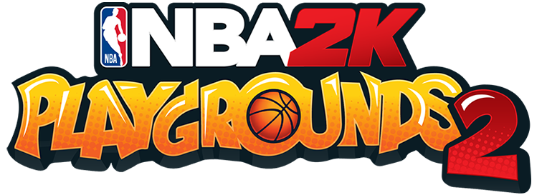

**FACT SHEET**

**Title**:NBA 2K Playgrounds 2

**Genre**: Arcade-action sports

**Publisher**: 2K

**Developer**: Saber Interactive

**Platforms**: PlayStation®4, Xbox One, Nintendo Switch™, Windows PC  
**Release Window**: Fall 2018

**Pricing**: TBA

**Rating**: E

**GAME OVERVIEW**

NBA arcade action is back with ***NBA 2K Playgrounds 2***! The sequel to the original smash hit takes street balling to the next level with a massive roster of current and retired NBA players, improved online matchmaking with dedicated servers, four-player online matches, three-point contests, new playgrounds, custom matches, and more! Pick your team, get ready to jam, and Ball Without Limits!

**Features:**

* **Totally new modes**, including the single-player Season mode, which recreates the in-depth experience of leading a team in the regular season and playoffs, and Playgrounds Championship mode, a worldwide ranked league with multiple competitive solo and co-op ladders.
* **Dozens more playable characters from past and present** including all-stars like Michael Jordan, Kobe Bryant, Kareem Abdul-Jabbar and Carlos Boozer, with nearly 200 more pros arriving in updates after release.
* **All-new, incredible playgrounds from around the world**, including brand-new courts in Washington, D.C., St. Louis, Seoul and Australia.
* **Play with friends** in local multiplayer or online in matches for up to four players on dedicated servers with enhanced matchmaking.
* **More than 100 signature move animations** like Lebron James’ self alley-oop, and George Gervin’s finger roll.
* **Customize your players** with over 450 items like jackets, shirts, pants and sneakers.
* **Electric soundtrack** featuring tracks from hit artists like Run The Jewels, DJ Premier, and Oddisee.