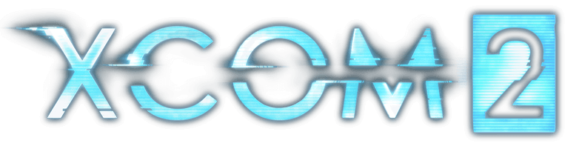

# Overview

Game: *XCOM 2*

Website: [www.xcom.com](http://www.xcom.com)

|  |  |  |  |  |
| --- | --- | --- | --- | --- |
| **Platform** | **Publisher** | **Developer** | **Release Date** | **Rating** |
| PC, OS X | 2K Games | Firaxis Games | February 5, 2016 | Teen / 16 |
| PlayStation 4, Xbox One | 2K Games | Firaxis Games | September 6, 2016 | Teen / 16 |
| Nintendo Switch | 2K Games | Firaxis Games  Virtuos Games | March 29, 2020 | Teen / 16 |

# Game Description

Ignite a global resistance to eliminate the alien threat and save the human race from extinction with the XCOM 2 Collection on Nintendo Switch. Voted ‘Best Strategy Game of 2016’ by PC Gamer and IGN, XCOM 2 is a turn-based strategy game sequel to XCOM: Enemy Unknown. The XCOM® 2 Collection includes the award-winning strategy game XCOM 2, four DLC packs (Resistance Warrior Pack, Anarchy’s Children, Alien Hunters, Shen’s Last Gift) and the War of the Chosen expansion.

Game Stats & Accolades

**Notable Stats:**

* XCOM 2 has an average Metacritic review score of 88

**Notable Accolades:**

* **XCOM® 2** 
  + IGN
    - [“Strategy Game of the Year” (2016)](https://uk.ign.com/wikis/best-of-2016-awards/Best_Strategy_Game)
  + PC Gamer
    - [“Best Strategy Game” (2016)](https://www.pcgamer.com/best-strategy-game-2016-xcom-2/)
* **XCOM® 2: War of the Chosen**
  + Game Informer
    - [“Best Strategy Game" (2017](https://www.gameinformer.com/b/features/archive/2018/01/04/game-informers-best-of-2017-awards.aspx?PostPageIndex=4))
  + PC Gamer
    - [“Best Expansion” (2017](https://www.pcgamer.com/best-expansion-2017-xcom-2-war-of-the-chosen/))
  + NAVGTR Awards
    - [“Best Strategy Game” (2018](https://www.imdb.com/event/ev0003381/2018/1?ref_=ttawd_ev_1))

# Key Features

In **XCOM® 2** aliens rule Earth, promising a brilliant future for mankind while secretly hiding a sinister agenda. As the leader of a guerrilla force facing impossible odds, you must ignite a global resistance to eliminate the alien threat and save the human race from extinction.

Experience XCOM’s game changing expansion **XCOM® 2: War of the Chosen,** which makes significant changes and additions to the XCOM campaign. Fight alongside new resistance factions and hero characters as you attempt to eliminate the alien threat on Earth and stop new enemies, known as the Chosen, from recapturing the Commander

XCOM 2 Collection also includes four DLC packs;

* **(DLC) Resistance Warrior Pack:** Customize your squad of resistance fighters with a set of bonus outfits and head gear, as well as custom armor and face camo. Instantly unlock a survivor of the old war as a new recruit in your barracks.
* **(DLC) Anarchy’s Children:** This rebellion-themed content pack introduces more than 100 new exotic customizations for the entire arsenal of armors available to your XCOM soldiers. These options are purely cosmetic and do not alter the stats of a soldier.
* **(DLC) Alien Hunters:** Transform the soldiers of XCOM into an elite alien hunting squad with impressive new weapons and armor to face off against new alien Rulers that will pursue your squad across an entire campaign. Additional cosmetic upgrades to soldiers and the Avenger are included, as well as a new epic mission where Central Officer Bradford leads a squad with the guidance of an old friend.
* **(DLC) Shen’s Last Gift:** Investigate ADVENT’s “Lost Towers” facility where Chief Engineer Lily Shen accompanies your squad in search of her late father’s secretive final project. Discover a unique new soldier class complete with powerful new combat abilities, strategy mechanics, and customization options.

# System Requirements:

* Cartridge: 8GB Cartridge included with physical purchase
* Includes 2 base game missions
* Download: up to 24GB download required for the rest of content

# Release Information

* **Release Date/Window for ALL TERRITORIES:** May 29, 2020
* **Number of Players:** 1
* **Internet Compatibility:** No
* **NSO Required?** No
* **Fully Compatible with TV Mode/Tabletop Mode/Handheld Mode?:** Yes
* **Languages supported:** EN, FR, IT, DE, SP (text only: RU, JP, KO, SC, TC)

# Legal Line

©1994-2020 Take-Two Interactive Software, Inc. Take-Two Interactive Software, 2K, Firaxis Games, XCOM, XCOM 2, and their respective logos are trademarks of Take-Two Interactive Software, Inc. All rights reserved.