

**PRgloo Handy Help Guide**

Contents

PRgloo – The Basics 4

Getting Started 4

Help and Support 4

The Response Desk: Logging conversations, interview bids, statements etc 5

The Response Desk Dashboard 5

Conversations 5

Adding / Editing Conversations 5

Closing a Conversation 6

Interview Bids 7

Approving, Rejecting or Aborting Interview Bids 7

Activities 7

Topics & Statements 8

The Topic Summary 8

Adding or Editing a Topic 8

Adding or Editing a Statement 9

Case Manager 9

Creating or Editing a Case Type 12

Add / Edit and Tag group 12

Editing or Creating a New Case Type 12

Searching, Exporting & Bulk Editing Response Desk Items 13

Searching 13

Exporting & Bulk Editing 13

Classification Tags 13

The PR Planner 14

Influencers 15

Influencer Groups 16

Content Hub 17

Creating Press Releases 17

Distributing a Press Release 19

Who’s Read My Release? 20

Resource Library 21

Coverage 22

# PRgloo – The Basics

Hello and welcome to PRgloo. This guide will teach you some basic tips and tricks to help you get the most out of the system. In summary with PRgloo you can:

* Record interaction with journalists, stakeholders and the world including keeping track of statements and interview bids.
* Push out proactive communications such as press releases and news items
* Manage your contacts and contact lists
* Manage your newsroom
* Manage your coverage

PRgloo is a young company and we make changes and roll out new features on a monthly basis so if you’re reading this, please make sure you have this month’s version. If you don’t, please email [support@prgloo.com](mailto:support@prgloo.com) for an updated copy.

# Getting Started

To access PRgloo please visit our website [www.prgloo.com](http://www.prgloo.com) and click on Customer Login or simply bookmark the following page: <https://admin.prgloo.com/login/>. Your username is your email address and if you have any problems with your password simply click the ‘reset password’ button or email us at [support@prgloo.com](mailto:support@prgloo.com)

# Help and Support

As well as the [support@prgloo.com](mailto:support@prgloo.com) email address you can also request help by clicking on the PRgloo Logo in the top left hand corner of your screen. This will allow you to send a request to our entire support team and the system logs lots of useful information automatically (such as browser and the page you are requesting help from) to ensure we can deal with your request as quickly as possible.

# The Response Desk: Logging conversations, interview bids, statements etc

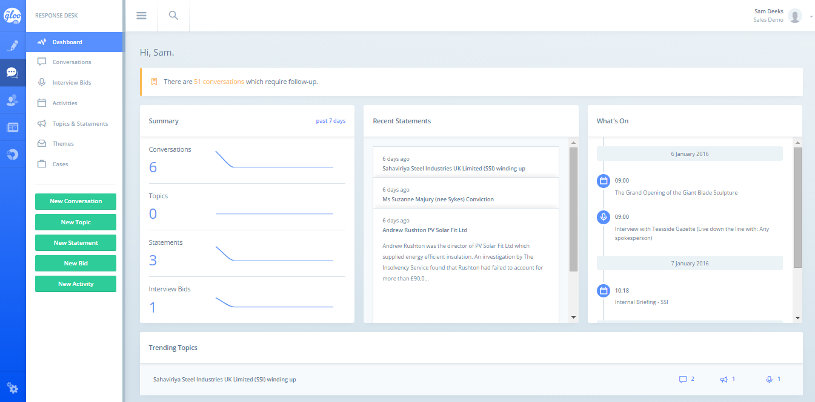The Response Desk is where you keep track of the ebb and flow of communication with the media and stakeholders.

## The Response Desk Dashboard

When you first log into PRgloo you will be presented with a dashboard. This dashboard will show you what the team has been up to in the past week, what important statements you should know about, what activities are coming up and (if you scroll down the page) what topics are currently trending within the team. From this page you can also add a new conversation, bid etc by using the big green buttons.

## Conversations

Click on the Conversation navigation item and you’ll see a list of all the conversations which your team has logged. You can search through this using the keyword search or by using the filters beneath the navigation on the right hand side. Click on any of the conversations to expand a little summary of the last thing which was said, or click on the title of the conversation to open the conversation up in full.

## Adding / Editing Conversations

From within the Conversations area, simply click ‘New Conversation’ and fill in the form you are presented with.

1. **Who did you speak to?** Simply start typing in the name of the person you spoke to. If they come up in the list, then select them. Note: you can select multiple people in this way and on save, the system will create multiple conversations (very handy if you have had loads of enquiries about the same issue) If the person does not pop up then click the NEW button by their name and fill in as much information as you have time to fill in. This will then create the person and they will be there for you to select another time.

TIP! You can edit the details of anyone you select or add by simply clicking on their names

1. **What topic did you discuss?** Start typing in the basics of the conversation such as ‘Budget Cuts impact on social care projects” and the system will automatically bring up all the latest topics which your team members have been having conversations about. If the topics presented back to you are appropriate, then select one. If not, then keep typing to create a new one

**TIP!** If the topic selected has a megaphone beside it, this means that there is an approved statement associated with this topic. To save you time, the system will automatically load this statement into the notes field but you can edit or delete this at any time if you don’t want to use it in the form it has been presented in. This will have no impact on the approved statement itself.

1. **What was the overall feeling of this conversation?** Or in other words do you think this conversation may result in some positive or negative feedback. We default this to neutral so you don’t have to do anything here
2. **Who owns this conversation?** This will default to you but you can add team mates to this list. They will the get an email telling them all the details of the enquiry.
3. **Which Team?** If your PRgloo platform is split into teams, this will default to your default team but (like with the owners) you can change this
4. **When did it take place?** This defaults to now, but you can change this
5. **What’s the Deadline?** Set an optional deadline and the system will flag this conversation as needing ‘follow up’
6. **Add Note or Attachment.** This will enable you to add notes about the conversation. When you click this you can start typing the details of the conversation or copy and paste in the email you received. You can add as many notes as you like and even upload attachments to the conversation. If your response has been particularly good, you can even turn this into a ‘Public Statement’ which your colleagues can then view should they get any calls on this issue.
7. **Save.** Once you are done, hit save

## Closing a Conversation

Closing a conversation is very simple. Find the conversation, open it by clicking on the title and then click the yellow flag at the bottom. The system will ask you if you’d like to put a ‘close date / time’ of now and you can either say yes, or edit the close date and time before saying yes.

# Interview Bids

Interview bids and conversations work in pretty much the same way. The only differences are as follows:

1. Status: This will either be Pending, Approved or Declined. We default this to Pending
2. When? If the interview is still Pending then you don’t need to enter a time (just select ASAP or one of the other options). If the Interview is approved then you will need to specify an exact date and time
3. Format and Location: enter these details here (EG Live – Down the line)
4. Who do they want to interview? Enter the name of the person who needs to be interviewed
5. Notes and Attachments. You can put all the background information into the notes and attachments in the exact same way as on conversations

**TIP**: if you get lots of bids on the same topic, then you can do this easily. Just keep typing in all the people who want the interview and then on save, the system will create multiple pending interview requests.

**TIP**: You can also view your interview bids on the PR Planner

**TIP**: approved bids will appear on the ‘What’s On’ section of the Response Desk Dashboard

## Approving, Rejecting or Aborting Interview Bids

Once a bid has been added into the system you can edit it at anytime to either change the status (IE from Pending to Approved or from Approved to Aborted etc) or to add notes, change the date and time etc. Simply locate the interview bid and click on the title to edit any aspect you like. Note: when you change a bid from pending to approved you will need to enter an exact date and time.

# Activities

Activities are any events which the team should know about such as internal or external briefings, the launch of a campaign etc. To add an activity navigate to the activities section and click ‘New Activity’. Simply fill in the details as requested, enter a from and to date and optionally colour code the activity. Colour coding helps when looking at the PR Planner as you can identify activities of different types straight away.

# Topics & Statements

Within this section you can create topics in advance (for campaigns and issues), create statements, edit existing topics and statements and run some nice exportable reports. Topics can be anything, for example “sunbed awareness campaign” or “Manufacturing Subsidy Levels 2015” or “Fred Jones Murder Inquiry”. Within the system you can associate coverage, conversations, statements, activities, press releases, documents and interview bids with topics and all of this activity is presented to you when you visit this section and click on a topic.

## The Topic Summary

A nice way to view all the activity associated with a particular topic is to go to the Topics & Statements section, click on a topic (these are ordered by most recent activity first) and take a look at the topic timeline. This will show you a chronology of all the activity surrounding this topic. At the top you can see a summary of the activity and if you roll over the numbers you’ll see that from here you can add more statements, bids, activities etc.

The latest statement is presented on the right hand side (click on the title to edit it) and you can even filter your timeline using the tick boxes on the left.

If you’d like to export this report, simply click on the 3 dots to the right of the topic name and click ‘export report’. This will download an editable word document with all the activity itemised for you. These three dots also contain an EDIT topic function where you can add an ‘overview’ which acts as a useful guide to the background of the topic and also attach files.

## Adding or Editing a Topic

You can create topics in 2 ways:

* By logging a conversation and typing in a new entry in the ‘what topic did you discuss’ field.
* By going to the Topics & Statements section and clicking ‘New Topic’. TIP this is mostly used when you know or think an issue is going to break OR when you know a campaign is going to kick off soon

We are going to have a look at the second method. After you’ve navigated to the Topic & Statements section and clicked ‘New Topic’ you will be presented with a simple form which will ask you for:

1. Topic Title. Enter in the title of the issue or campaign here
2. Add Attachment. If you want you can upload attachments to your topic and turn this into a bit of a ‘Knowledge hub’ around this issue or campaign
3. Overview. Add some background notes to the topic to enable people to understand the context of the issue or the aims of the campaign
4. Date and time: defaults to now but this can be changed to a date in the past or the future
5. Owners: will default to you but this can be changed and owners added
6. Which Team? If your account is set up with multiple teams then this will default to your default team but this can be changed
7. Which Theme does this sit under? Themes often align with your business areas and you can associate your Topic to one or more Theme
8. Add Statement. Clicking this button will enable you to create a ‘for release’ or ‘not for release’ statement

## Adding or Editing a Statement

To add a statement you can either:

* Click the green button that says ‘New Statement’, select the topic the statement relates to and then copy and paste in the details of the statement
* Go into a topic and click ‘New Statement’ from the top of the topic timeline and simply copy and paste in the details of the statement here

# Case Manager

Cases are all held within the Response Desk in the navigation area called ‘Cases’. Cases allow customers to record interactions (such as FOI requests) which require a higher level of auditing than a conversation. Adding a case is a simple matter of filling in a form and can be done in a few easy steps.

1. Within the Cases section, click on the big green ‘New Case’ button
2. 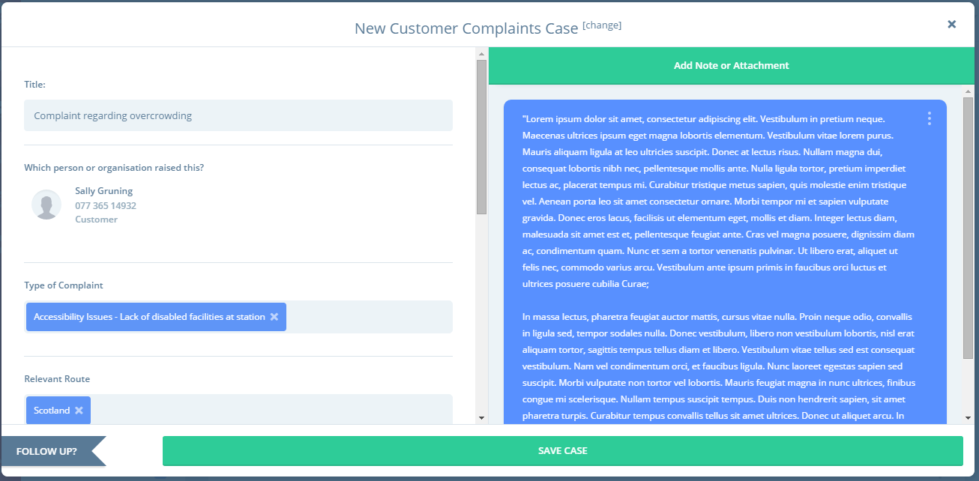If you have multiple case types (for example Customer Complaints and FOI cases, then you’ll be asked to select what kind of case you wish to record. Select the correct one, and a new page will load which will allow you to log your case.
3. **Title:** call your case anything, just be aware that this is what everyone will be able to see in the view all screen, so it’s best practice to keep it concise and to the point
4. **Which Person or Organisation Raised this?** Start typing the name of the person who raised the enquiry and the system will search for them. If they can’t be found, click the ‘NEW’ button to add the person into the system. Fill in as much information as you have to hand – note all we need is for you to say what category this person fits into (EG customer, media, stakeholder etc). Note when searching for a contact check for possible shortened names (e.g. Nick vs Nicholas).
5. **Tags:** Next you will be asked to ‘tag’ or classify your case. Again, simply start typing and the system will suggest the tags for you to select. If the list of tags is fairly short, you can also use the scrolling bars.
6. **Does this relate to a Topic?** If your case relates to a bigger department wide issue or campaign, you can link this case to a topic. Or if you think the enquiry you are dealing with will lead to further enquiries from the media or stakeholders then you can create your own topic. Simply start typing and either link to an existing topic OR carry on typing to create a new topic.
7. 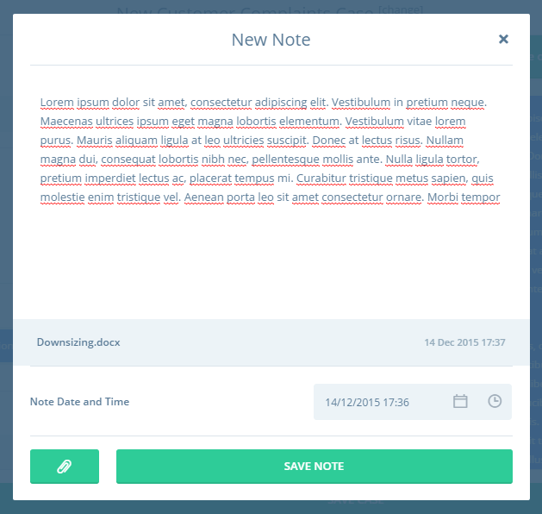**Who Owns this Case?** This will default to you but you can change this to someone else, or add someone else in as an owner alongside you. Anyone who you add as an owner will automatically get an email detailing the case and associated deadline.
8. **Team:** This will default to your default team but you can also change this
9. **Raised:** Use this field to specify when the enquiry was raised. You can add in a date in the past if you are filling this in at a later date. NOTE if the system has been set to auto populate the deadline, then if you change the raised date, the deadline date will update also.
10. **What’s the deadline?** This will either be auto populated by the system or it will be blank. Either way you are free to change this.
11. **Add Note or Attachment:** Now let’s add the meat and potatoes of the enquiry! Click this button to copy and paste in the details of the email / type in the details of any phone call or face to face interaction. You can edit the date / time here too and if you click on the attachment button you can also attach files from your desktop. Once you are done, click Add Note. If you want to edit the note, simply click on the three dots to the right of your note. If you want to add another note, simply repeat this process.
12. **Save Case:** when you are ready you can save the case

# Creating or Editing a Case Type

Now you may find that you want to tweak the options available to you when logging a case. For example you may want to add more tags, a whole new tag group, or modify the default deadline. Alternatively you may want to add a new kind of case altogether. That’s fine and that’s why we built the Case Type manager and Tag Groups. You can find Tag Groups under the settings/cog icon at the bottom left of the screen

## Add / Edit and Tag group

1. Go to Tag Group page and either click on the Tag Group you need to edit or click ‘Add New Tag Group’
2. Type in / edit the name
3. To ensure these tags appear in your cases, select Case Type from the selection of modules
4. Then use the buttons to Add / Delete or Edit any of the tags within the group

## Editing or Creating a New Case Type

In the same settings area, select Case Types

1. Either select the case whose details you want to edit OR click ‘New Case Type’
2. **Case Name:** Edit or Enter in the Case Name (EG Customer Enquiry)
3. **Case Number Prefix:** Use can use any prefix you wish; however it is best to use the initials of the Case Type name for better identification. Each time a new Case is generated it will go in number sequence with this prefix
4. **Default Deadline** can be changed by using the drop down list and typing in the number units required
5. **Classification / Tag Group**
   1. Select the tag group which you would like people to choose a tag from.
   2. You can add a minimum and maximum number of tags to be chosen when creating the case. Leave them blank if you want the tags to be optional. Choose a minimum of 1 tag if you want the tag to be mandatory. Choose a maximum number only if you want to restrict the number of tags a person can select.
   3. You can add a description and notes for this Tag group in Field title and Guidance notes, this will help explain the use for these tags.
6. If you need more than one Tag group click on ‘Add Classification’ at the top of the Case Type and repeat the Tag group process

# Searching, Exporting & Bulk Editing Response Desk Items

## Searching

In any section on the site, you can use any of the following to search over your cases, bids, conversations etc

* The Global search (search icon in the header)
* The keyword search (top right of the screen)
* The date range search (to the right of the keyword search)
* Filter (to the bottom left of the screen) where you can filter by:
  + My items (items owned by you)
  + Follow up (items which have a deadline)
  + Or any combination of the above!

## Exporting & Bulk Editing

At any point you can select your items by ticking the box at the top of the screen which tells you how many results are shown or by clicking all the items you want individually. Once you tick this little box, you’ll see 3 icons appear at top right. Use the arrow to export your results to Excel. Use the pencil icon to add a note to ALL of the items selected. You can also use this to close any items which are open.

# Classification Tags

Classification tags are used on cases, content items such as press releases, resources and activities. To create a tag group with tags in them, go to the settings section (bottom left of your screen) and click Tags.

To add a new Tag Group click New Tag Group, add a title and specify where you’d like these tags to appear. Once you’ve done that you can simply start adding Tags by clicking the ‘add tag’ button. You can add as many as you like and edit them at any time. If a Tag Group is no longer relevant, you can set the status to archived and the tags will simply disappear from view.

# The PR Planner

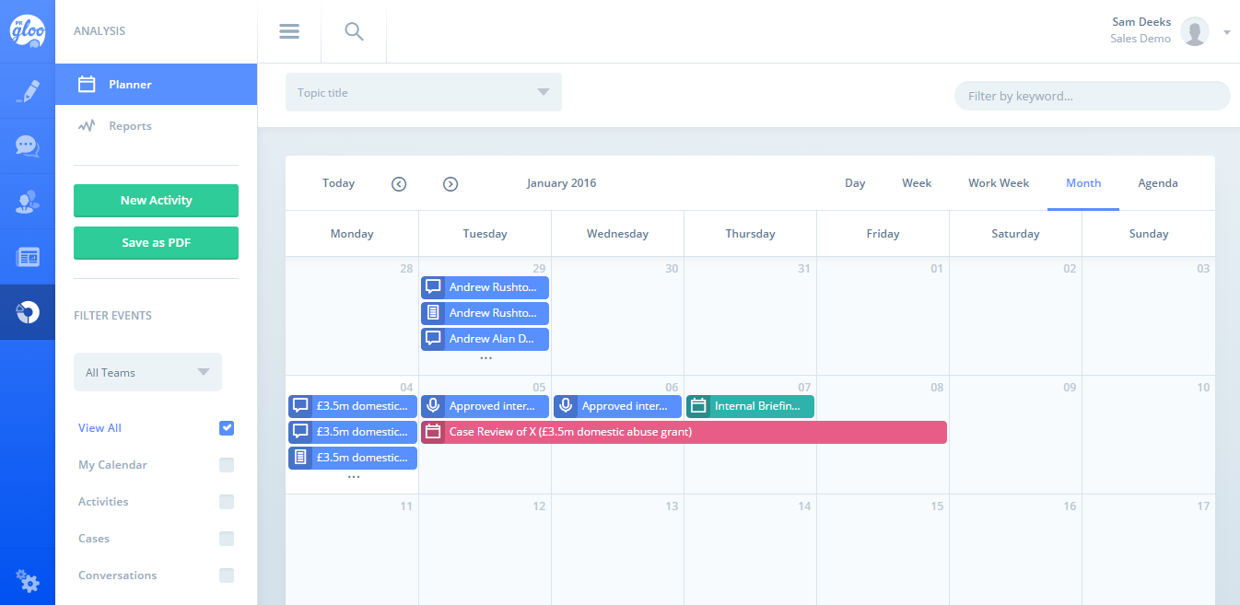The PR Planner is available from the last navigation item on the left. This displays all the media activity added in from the rest of the site. You can filter the PR Planner by activity type (conversations, bids etc), Topic, Keyword and activities which you own. You can also add in new activities from this screen and export the whole lot to a PDF file. Please also note that you can choose to view the planner by month, week, day and a handy agenda view.

# Influencers

The influencers section displays all your contacts and organisations.

It is broken down in to two Influencer navigation areas called “My contacts” and “Gloo Influencers”.

Use the filters to narrow your search to

* Your contacts
* Organisations only
* People only
* Influencers of a certain type (Stakeholder, Media, Internal etc)

Use the Keyword search to search for influencers. This searches over names, notes, email addresses, job titles and twitter biographies. The search is very comprehensive so you can make use of:

* Phrase searches “Business Editor”
* If you simply type in Business Editor into the search it will bring back anyone with Business AND editor in their profile
* Wildcard searches such as David D* when you can’t remember how to spell someone’s last name

Gloo Influencer are media contacts and organisations that our research team has found on twitter. We take their name, organisation and twitter details and make them available to you.

You can add your own contact details to these influencers and these details become part of 'My contacts’ - your personal address book.

Each Gloo Influencer has a '2 side' record one side contains their picture, organisation and Twitter handle, the other, extra details they have supplied on twitter, giving you useful information at the click of a button.

## Influencer Groups

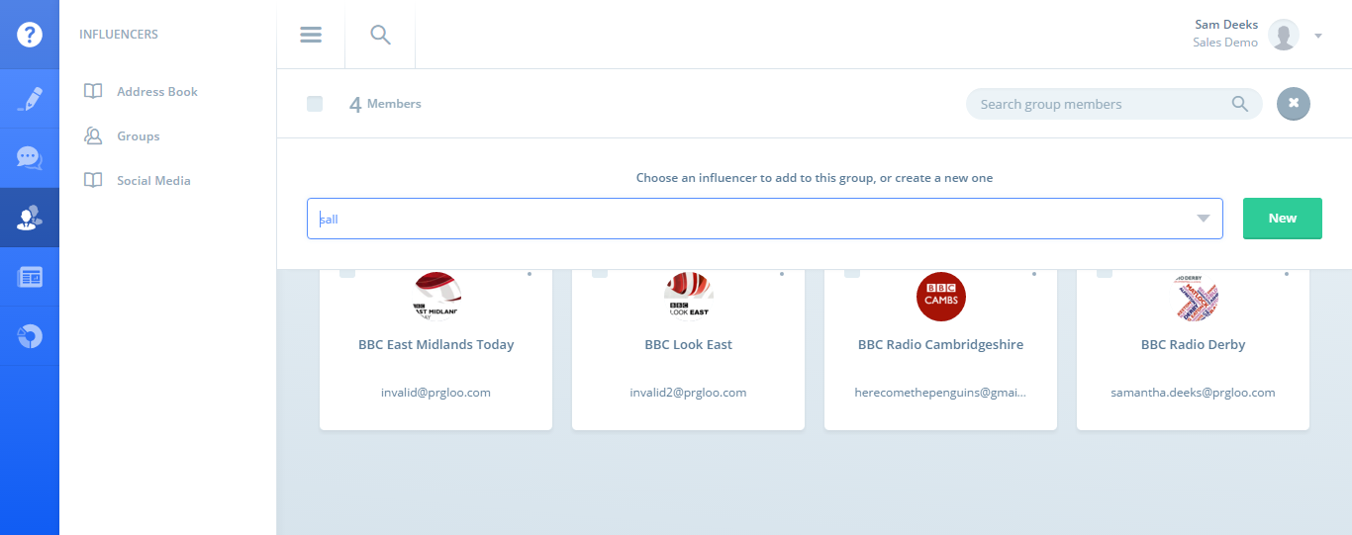You can also put your influencers into groups by clicking on the Groups section. To add a new group click ‘New Group’ and enter in the name.

To add people to a group, select the group and click on the green plus button. This will then allow you to search for influencers to add to this group. Enter in the name of the people you wish to add to the group and then select them. If the person does not yet exist, simply click the NEW button to the right to add their details into the system.

To find a person in an influencer group, simply use the search in the top right of the screen.

# Content Hub

The content Hub is where you can create content which can then be published and distributed via email to interested contacts (media, stakeholders and even internal team members).

## Creating Press Releases

To create a Press Release, go to the Content Hub (pencil icon) and click ‘New Press Release’.

* Title. Copy and paste the title of the release into this field
* Summary. Copy and paste the summary of the release into this field. Note that this is optional if you don’t have a newsroom but very important if you do have a newsroom as this text will appear beneath the title on all lists of press releases
* 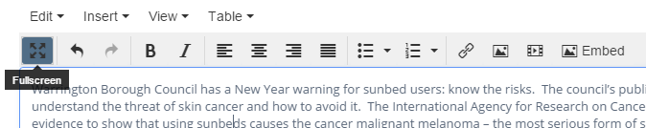Body. Copy and paste the body of your release into the body. TIP if you want more space to edit the text of your release, then simply click the ‘Fullscreen’ option. To close this view click this button again. You can also add in links, embed images, and insert video using the tools available.
* Automatically generate friendly URL? The system will automatically set a friendly URL for you but you can change this if you want
* Keywords. You can add keywords to this release to help with search engine optimisation
* Set as featured? If you have a Newsroom with PRgloo then setting a release as featured will enable you to mark this release as being of importance and it will then be included in certain widgets (such as the home page carousel)
* 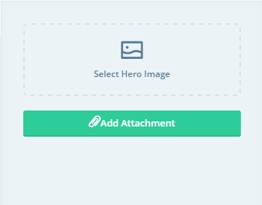Tags. If you have a newsroom, then selecting tags will ensure that people can find this release easily
* Region. If you operate regionally then select the region this release relates to
* Is this related to a topic? If the release is related to a topic then select this here. The press release will then appear in the topic reports
* Which team? If your PRgloo platform is split into teams then this will default to your default team
* Hero Image. Click here to select an image for your release from your resource library or from your desktop. Use the search to find the image you want or use the ‘Upload new resource’ to grab a resource from your computer.
* Add attachment. Click here to select secondary files to include in your release. These could include documents (such as PDFs, word etc) rather than pictures
* To check your release, click the Preview option to see what your release will look like. NOTE if you do not have a website with PRgloo we will automatically create a landing page for each and every release which you create. This will enable you to send releases via email with large image or document attachments as the attachments will never be sent – they will simply appear on the email and the journalist can click on the image to be taken to the landing page where they can then be downloaded. You can also send yourself a test email.
* Distribute to. Within this field you can then select the groups of journalists and stakeholders to send this release to.
* Sender. This defaults to you, but can be changed to anyone on the list. If you need someone added to this list, please contact [support@prgloo.com](mailto:support@prgloo.com)
* Once you are happy with the release you can do the following:
  + Save as draft. This will let you come back to your release later
  + Publish Now. This will let you send the release immediately
  + Publish Later. This will enable you to set a publish date in the future

# Distributing a Press Release

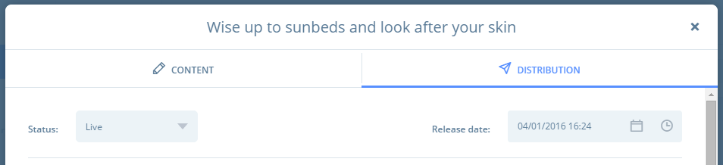Once you are happy with your release, you can choose to send this to the world. If you’ve saved the release as draft, then to send the release, simply click into the release and click on the Distribution Tab. Make sure you have selected the correct distribution groups and the correct sender. Then change the status from Draft to Live. Once you do this, you will see a date and time picker appear. Select the correct date and time and then click Save.

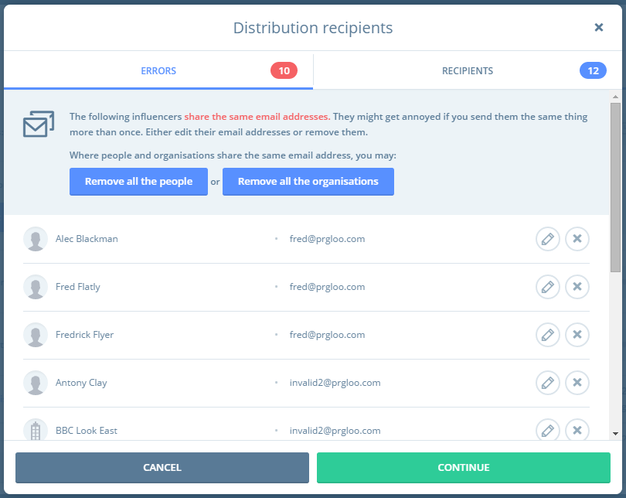The system will then give you a chance to review your email distribution and point out to you any errors. The system will automatically remove duplicates (so if a person is on multiple lists then it will only be sent to the person once) but will require you to take action if two separate influencers share the same email address or if the influencer on the group does not have an email address. These will appear in the tab marked ERRORS.

* To deal with duplicates, simply remove the one you don’t want by clicking the X or edit the email address to be unique by clicking on the pencil icon. If you take no action the system **will not send** to anyone listed here.
* To deal with influencers who don’t have email addresses, click the pencil icon to add an email address. Note you’ll only ever have to do this once as the system will update the influencer permanently. If you don’t have time to add the email addresses, that’s fine as the system will simply not send to these people.

On the Tab marked Recipients, you will see all the people who the release WILL be sent to. You can remove people from this distribution by clicking the X or edit their details by clicking the pencil icon. Once you are happy, click Continue.

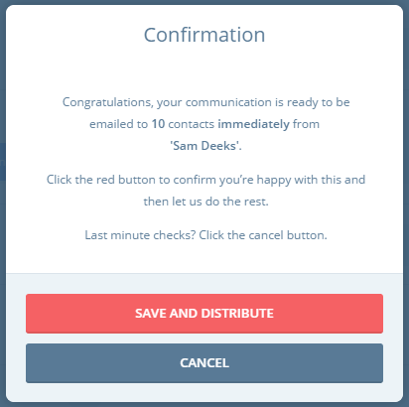Once you click Continue your final confirmation screen will pop up. This will confirm what you are about to do and give you the chance to cancel (click cancel) or continue (click Save and Distribute). If you are happy go ahead and click the red button and the system will send your release at the date and time specified.

# Who’s Read My Release?

Once your release has been sent, go back into the distribution tab and click on the latest distribution. You will then be shown a few things:

* What groups the release was sent to
* Who opened the release (green tick). Please note the only way any system can tell if an email has been opened is if the person has chosen to ‘view images’ or if this setting is there by default.
* Who’s had trouble getting your release (warning triangle). Note this is normally due to the email being incorrect

From this page you can also choose to send the release to more groups of influencers if you like. Simply add in the groups to the distribution field and click save. The system will then take you through the distribution validation process again.

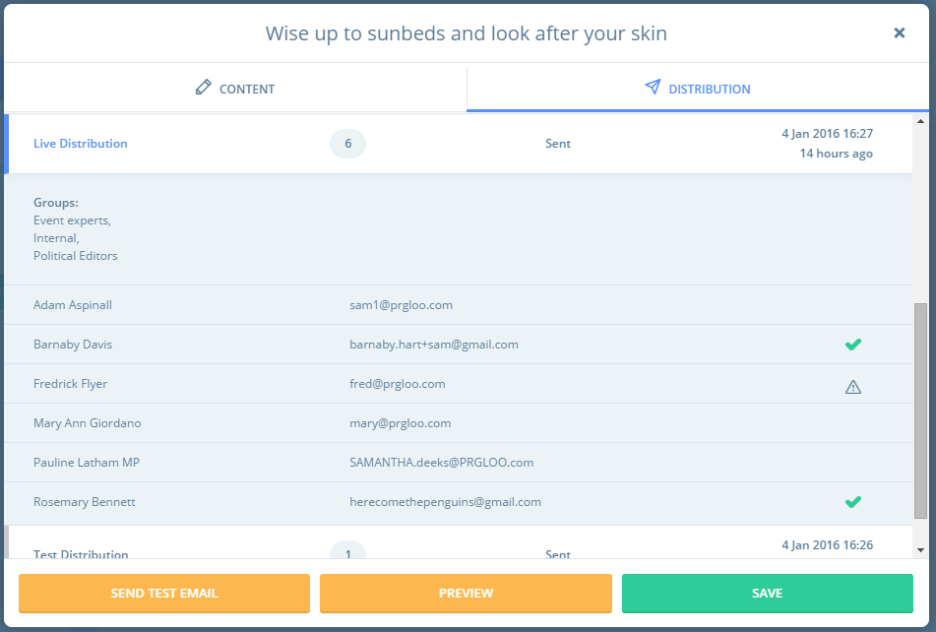

# Resource Library

The Resource Library houses all your public and internal resources. You can create folders to store your assets in or simply upload them into the main library. Within the Resource Library you can:

* 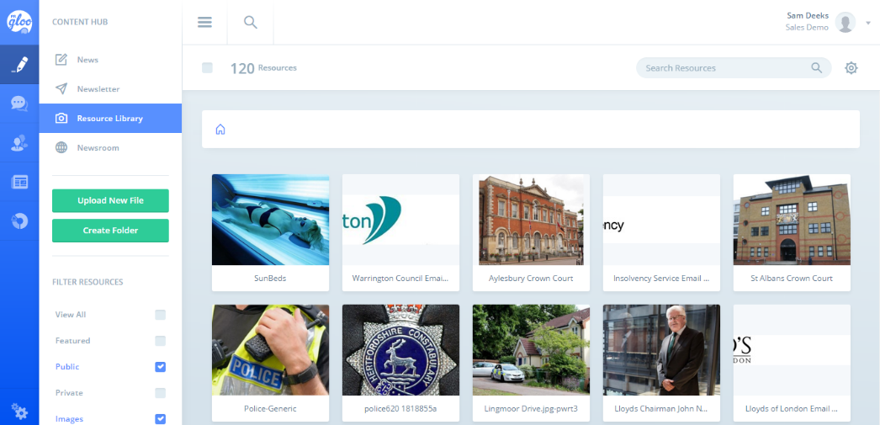Bulk upload images and documents from your computer by clicking ‘upload new file’ and selecting the items from your network. TIP make sure the images are named intuitively (EG Sunbed Awareness Campaign rather than IMG00422) as the system will take the file name and use this as the asset’s title.
* Create folders to house your assets by clicking Create Folder. You can create as many levels of sub folder as you want by simply navigating to the folder and hitting ‘create folder’ again.
* You also have a number of Bulk actions so if you search for and select a number of items you will then be able to:
  + Bulk move to another folder / sub folder
  + Bulk edit (their classifications tags and descriptions)
  + Delete
* From the list view you can also download, edit or delete files – simply hover over the asset to see these tools
* Editing a Resource is very simple. Click into the detail of the resource and you will see:
  + The name of the asset
  + The Description of the asset
  + Information such as when it was published and what it’s public URL is
  + Whether it is Public or Private (private documents can only be seen by those with a PRgloo login)
  + In the Information tab you will also be able to see details about the file and also what content items it is related to

# Coverage

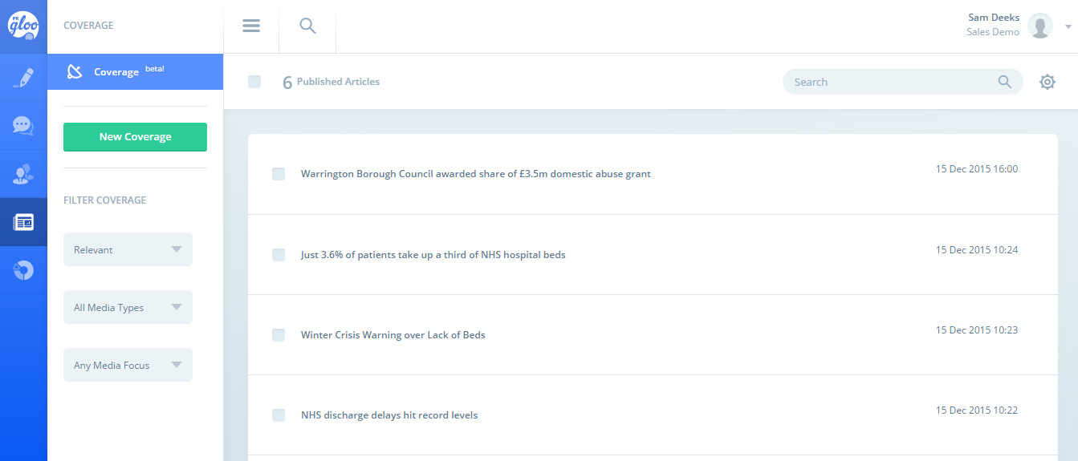The Coverage section allows our customers to manually log coverage items which can be associated to topics, influencers and organisations. To add coverage simply click ‘new coverage’ and fill in the following details:

* Headline of the article
* Outlet the article appeared in
* The date the article was published
* If it was related to a topic or topics
* What the link to the article is
* A summary of the article
* Who the author or authors were
* Whether this is an important bit of coverage (you can set this as featured)
* What the tone of the article was
* What the media type and focus of the publication is