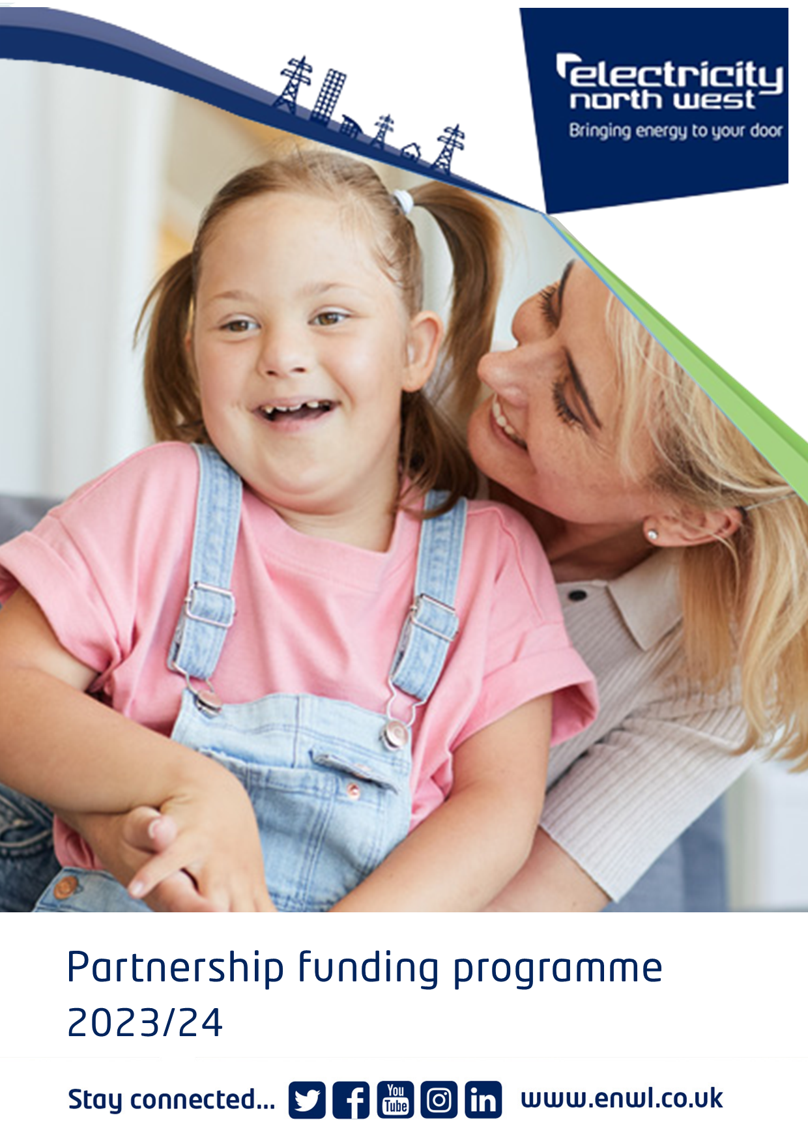

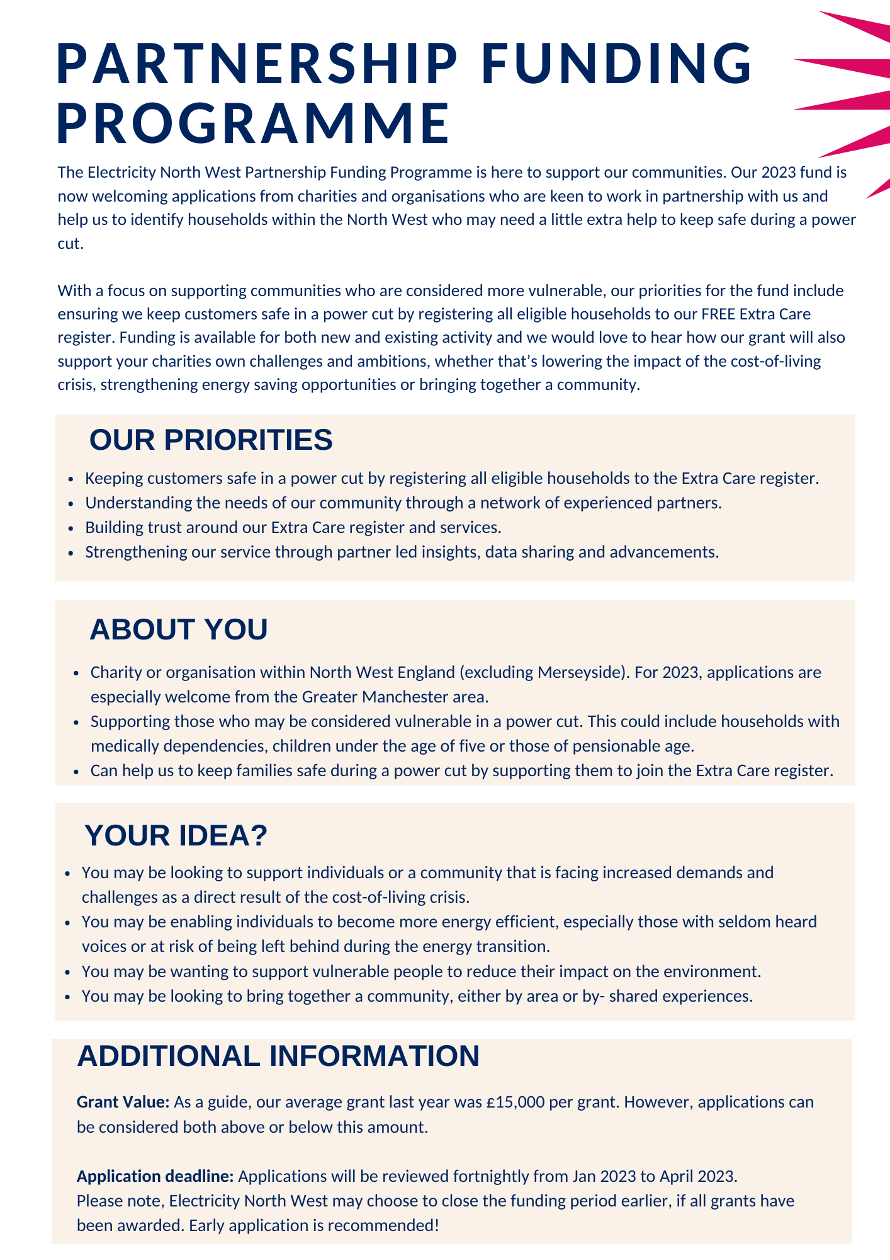
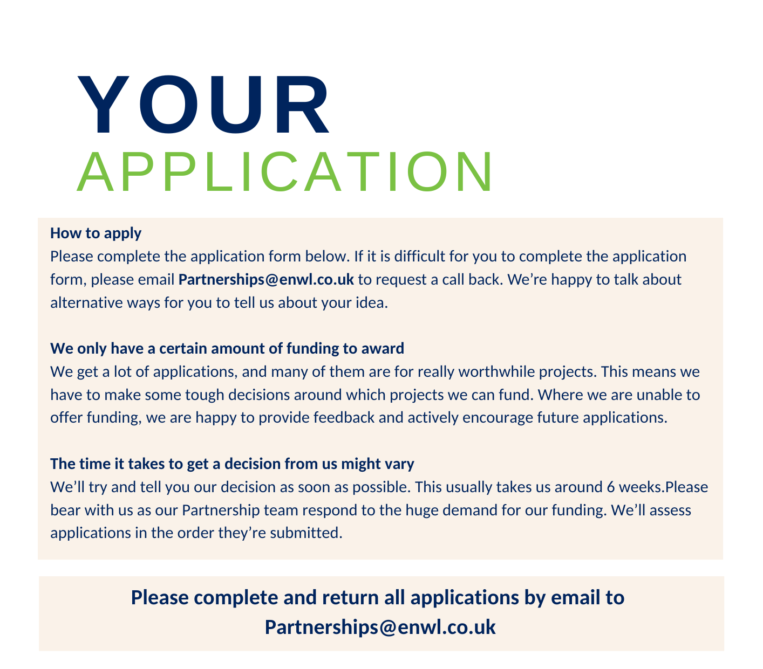
PROJECT INFORMATION
What is the name of your project?
Where will your project take place?
(If your project covers more than one area, please include all areas)
Where possible, please tell us the postcode (s) of where your project will take place?
How long will your project last for?
Tell us when you’d like to get the money if you’re awarded funding?
Please note successful bids will receive 50% of funding at the beginning of the project and the remaining 50% at the project midpoint subject to successful delivery
When will you spend the money by?

YOUR IDEA!
Tell us about your project. What would you like to do?
(Try to tell us in 250 words or less your idea)

How will your project benefit North West Electricity Users?
Please try to include:
- How many people will benefit?
- Who are the people that will benefit?
- What is their age range?

How much funding are you requesting?
Please provide a brief breakdown of costs
Will our grant fully fund your project?
If your project will be partly funded by other funders, please provide details of commitments secured.
How does your project meet our funding priorities?
(A reminder of our priorities can be found on page 1)
How does your project involve your community?
We need your help!
Our partners deliver a critical role in helping us to identify and register thousands of North West vulnerable service users who may benefit from our free Extra Care register.
There are over 300,000 eligible customers in our region who are not currently registered, tell us by answering the questions below how your organisation could help reduce this gap.
For more information on our Extra Care register visit: www.enwl.co.uk/extra-care/
Extra Care
Is your organisation willing to help register your service users on the free Extra Care Register?
If YES, how many households could you commit to signing up as a key part of this funding agreement?
Would your organisation be willing to promote our free Extra Care literature to your service users?
If YES tell us how you will promote & your anticipated reach
Would your organisation be happy to attend our regular stakeholder meetings to meet other partners and share best practice?
YES / NO
It’s unlikely we will ask for your help, but could your organisation provide support to vulnerable Electricity North West customers in the event of a significant power outage in your area?
If YES, please provide details.

MEASURING SUCCESS
What processes will you have in place for measuring the ongoing success of your project?

What processes will you have in place to capture accurate KPIs?
(Including your commitment to Extra Care Register sign ups?)
We would love to hear how our funding is making a difference!
Can your organisation commit to sharing at least one case study every 3 months? YES / NO
We will need high level monthly project reports against your agreed KPIs by the 2nd working day of each month.
Can you commit to this reporting? YES / NO

TELL US ABOUT YOUR ORGANISATION
What is the full legal name of your organisation?
Does your organisation use a different name in its day-to-day work?
When was your organisation set up?
What is your organisations legal status? (e.g. Charity, CIC etc)
If applicable, what is your charity registration number?
How many paid staff members do you have?
How many volunteers do you have?
Organisation address including postcode?

Senior Contact Details
Please provide details for your Senior Contact. This person will be legally responsible for the funding. Unfortunately, they can't be married to, in a civil partnership with, in a long-term relationship with, living with, or related to the main contact.
SENIOR CONTACT DETAILS
What is their role or job title?
What is the full name of the Senior Contact?
Address of Senior Contact?
(If different to organisation address)
Senior Contact email address?
Senior Contact phone number?
Main Contact Details
Please provide details of the Main Contact. Senior Contacts and Main Contact should not be the same individual.
MAIN CONTACT DETAILS
What is their role or job title?
What is the full name of the Main Contact?
Address of Main Contact?
(if different to organisation address)
Main Contact email address?
Main Contact office phone number?
Main Contact mobile phone number?

APPLICATION COMPLETITION
Application completed by (Full Name)
Date Application Submitted

