Concrete sleeper recycling
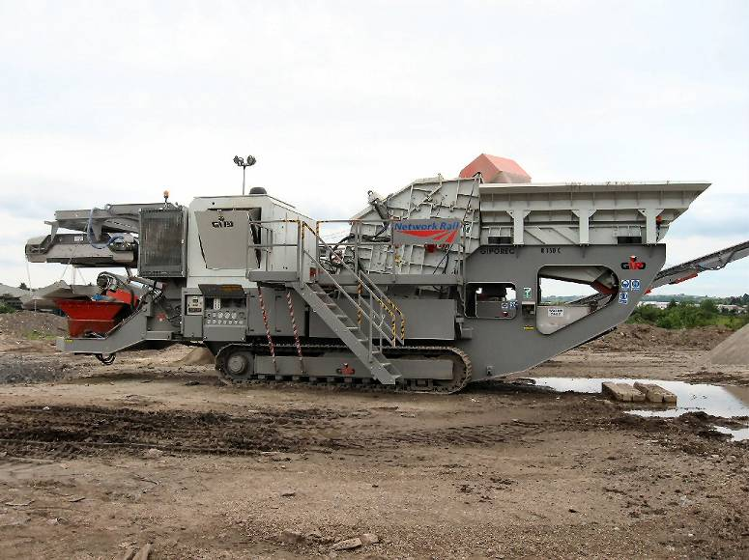
Old and broken concrete sleepers will be broken down by an advanced processor, creating aggregate that can be recycled in road building or construction across the region. Each year around 650,000 concrete sleepers are returned to material handling depots of these some 150,000 can be reused but 500,000 require disposal; often by means of being sent to land fill.

- The £650,000 concrete sleeper crusher is a bespoke piece of kit built specially for the job in hand.
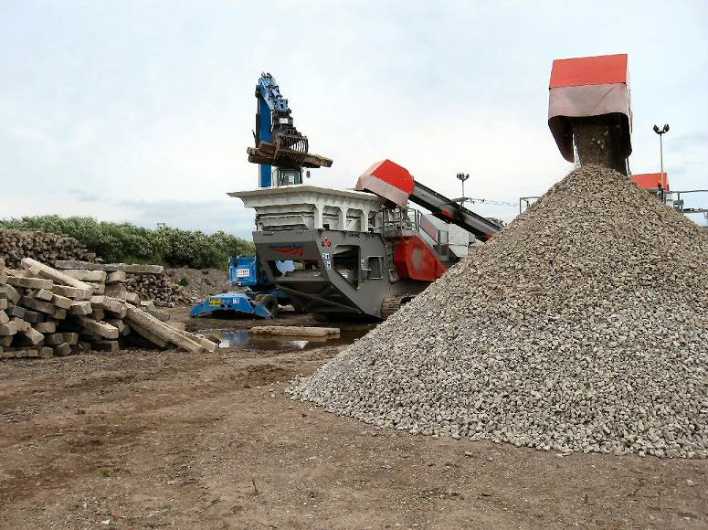

- It is capable of breaking down several sleepers per minute.

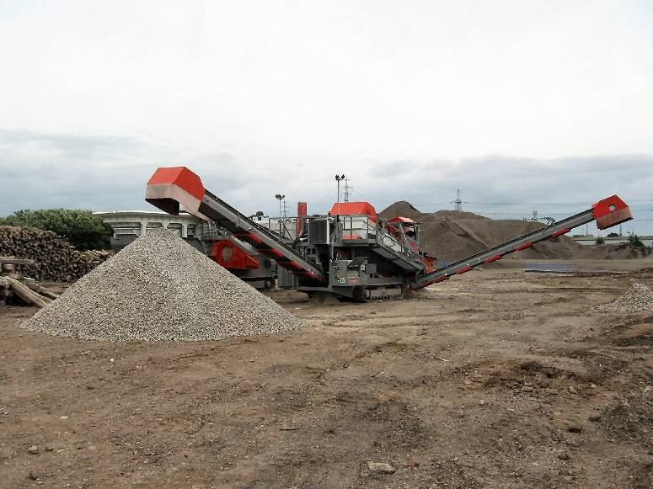
- Full sleepers are loaded in to a hopper that crushes the sleepers and separates out steel and aggregate.

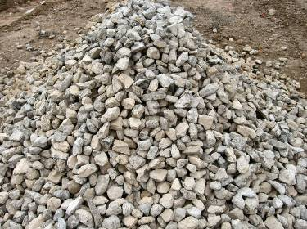
- A series of screens create stockpiles of different sized aggregate
for later re-use and/or sale.

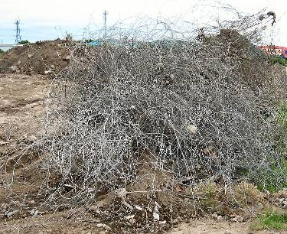
- The aggregate produced is good quality ‘like-new’ stone.

- The steel strand produced will also be able to be fully recycled.

