Land and Buildings Transaction Tax
– Residential rates and bands

Scottish Government
January 2015

The Scottish Government has today (Wednesday 21 January) announced new rates and bands for residential transactions taxable under Land and Buildings Transaction Tax (LBTT), which will replace Stamp Duty Land Tax (SDLT) in Scotland from 1 April 2015.
Purchase price | Rate
Up to £145,000 | 0%
£145,001 to £250,000 | 2.0%
£250,001 to £325,000 | 5.0%
£325,001 to £750,000 | 10.0%
£750,001 and over | 12.0%

These are marginal rates – only the proportion of the price above each tax threshold will be taxed at the next rate.
This means that the first £145,000 of every residential purchase is tax free. If the price of a property is less than that, the buyer pays nothing in tax. These new rates take an extra 5,000 transactions out of tax compared to our original residential LBTT rate proposals, announced in October, and an extra 10,000 transactions out of tax compared to current rates of UK SDLT.
This helps first time buyers and those who are less able to afford the tax.
Over 90% of transactions - those below £330,000 - will either pay less in tax on their new homes, or the same as they would under current rates of UK SDLT.
The average property price in Scotland is £170,000. People buying an average priced property are set to save £400 in tax from April.
The average residential property price in every local authority area in Scotland is below £330,000 so people buying the average priced house in every local authority area will pay less tax than they do under current rates of UK SDLT or will pay no tax at all.
The average price of a detached house in Scotland is £244,000 so people buying the average priced detached house in Scotland will pay less tax than they do under current rates of UK SDLT.
99.9% of all transactions will pay less LBTT or no LBTT, compared to the proposals which the Scottish Government announced in October 2014. Only purchases above £945,000 will pay more in tax than under the original proposals.

Comparison of tax charge under SDLT and LBTT
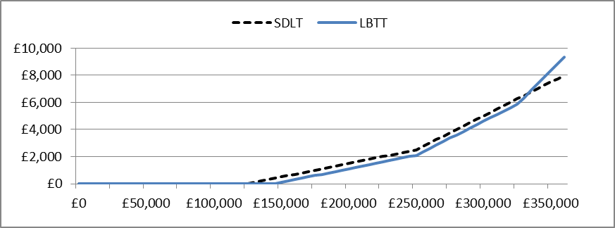
Examples
A first time buyer, buying a house worth £140,000 would now pay nothing under LBTT, saving £300 compared to current UK SDLT.
A couple buying a flat at £150,000 would now pay tax of £100 – saving £400 against current UK SDLT. This is also £1,400 lower than the UK tax which would have been due before the Chancellor made changes to SDLT in December 2014.
The tax charge on the average residential property price in Scotland (£170,000) will reduce from £900 to £500 – saving £400 compared to the current UK SDLT.
A family buying a home for £240,000 – the average detached property price in Scotland – will pay tax of £1,900 from April. They would have paid Stamp Duty of £2,300, giving them a saving of £400.
A family buying a home for £300,000 will pay LBTT of £4,600 from April, compared to the £5,000 they would pay under current UK SDLT.
A family buying a home for £1,000,000 will pay LBTT of £78,350 from April, compared to the £43,750 they would pay under current UK SDLT.
Notes
Figures on transaction prices are based on Registers of Scotland data for July to September 2014.
The tax rates and bands announced today are still to be approved by the Scottish Parliament. The Scottish Government will seek Parliament’s approval of formal rate-setting Orders which will be laid in early February.
LBTT calculators are available on the Revenue Scotland website – see www.revenue.scot.

