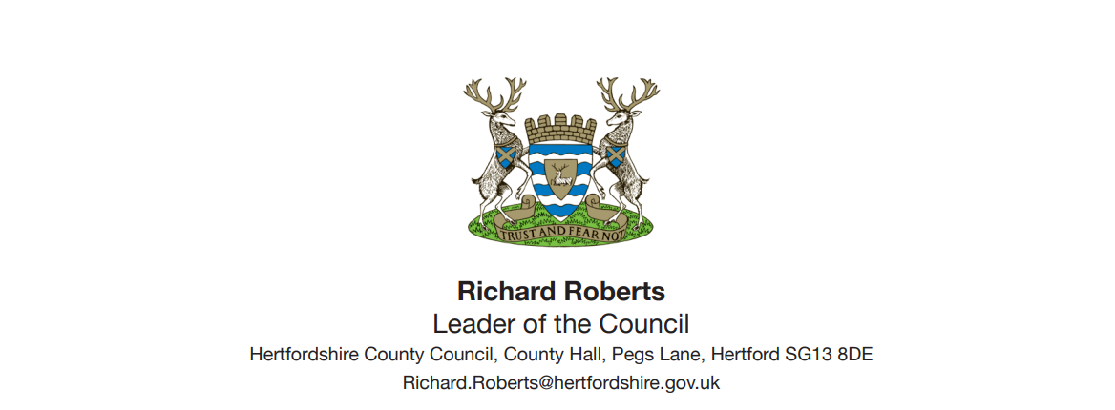

10th February 2023

Dear Mr Mayor,

When we responded to your consultation last year on the proposal to expand the ULEZ up to the Hertfordshire border, we were clear that while we support the aim of the ULEZ in improving air quality, we could not support the expansion as Transport for London had not properly assessed the impact on the towns and villages bordering London or put sufficient measures in place to mitigate the impact on our most vulnerable residents.

We know that London’s other neighbours share our concerns, and we are therefore surprised and disappointed that you have chosen to go ahead with this scheme, despite the blatant unfairness to residents outside London.

In the south of our county, many people must cross into London boroughs for work and leisure, but most importantly many residents from Hertfordshire and beyond use specialist medical services such as the cancer treatment hospital at Mount Vernon. At a time of considerable stress, often older patients, in particular our most vulnerable residents, will face daily charges to access treatment.

This is hugely regressive, hitting the poorest hardest, effectively targeting the least well off who are least likely to be able to replace their vehicle.

We therefore cannot support the ULEZ expansion, and we do not accept that any signage or cameras aimed at fining our drivers - potentially up to £180 if they forget to pay the £12.50 charge - should be based in Hertfordshire.

Our residents are facing sufficient hardship at the moment with cost of living pressures, without additional charges and fines for going about their daily lives.

We do support the continued rollout of EV charging across the county, the uptake of electric and hybrid vehicles as we draw near to the 2030 deadline for petrol and diesel cars and would welcome any support for a national scrappage scheme.

Cleaner air is a priority in Hertfordshire and with 2030 looming we welcome the Government’s long-standing commitment to phase out petrol and diesel engines after this date. In the meantime, we should not be penalising those going to work or hospital particularly at this difficult time.

Yours Sincerely,

Richard Roberts

Leader of Hertfordshire County Council