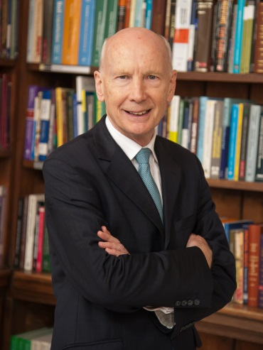

Lord Robert Mair CBE FREng FICE FRS
Emeritus Professor of Civil Engineering and Director of Research,University of Cambridge
Robert Mair is Head of the Centre on Smart Infrastructure and Construction (CSIC) at Cambridge, funded by EPSRC/Innovate(UK) and industry. CSIC’s principal aim is transforming the future of infrastructure through smarter information by developing innovative sensors and data analysis models. After working in industry for 27 years, in 1998 he was appointed Professor of Geotechnical Engineering at Cambridge and Head of Civil Engineering; he was Master of Jesus College from 2001-2011, and Sir Kirby Laing Professor of Civil Engineering from 2011-2017. His research group specialises in the geotechnics of tunnelling and underground construction. He delivered the Rankine Lecture in 2006.
He is one of the founding Directors of the Geotechnical Consulting Group, an international consulting company based in London, and has extensive experience of design and construction for a wide variety of civil engineering projects. He has been a member of Expert Review Panels on major international underground construction projects and was Co-Chair of the International Advisory Board for the Singapore Land Transport Authority, advising on underground transport tunnels and deep excavations in Singapore. In the UK he has been closely involved with the Jubilee Line Extension for London Underground, and with the Channel Tunnel Rail Link (now HS1), Crossrail and HS2 projects. He was responsible for the introduction of compensation grouting as a novel technique for controlling settlement of structures during tunnel construction, used on the Jubilee Line Extension Project for the protection of many historic buildings, including the Big Ben Clock Tower at the Palace of Westminster.
He was President of the Institution of Civil Engineers 2017-18. He is a Fellow of the Royal Academy of Engineering (its Senior Vice-President 2008-2011), a Fellow of the Royal Society and a Foreign Member of the US National Academy of Engineering. He was appointed an independent crossbencher in the House of Lords in 2015. He is Chairman of the Department of Transport’s Science Advisory Council and is a member of the House of Lords Select Committee on Science and Technology.

