Siemens Mobility – Chippenham case studies & history
People

Yasmin Rawle, Strategy and Business Development Graduate
I am a graduate working in the sales team at Siemens in Chippenham. My role involves strategy and business development, and I am currently in my second year of the graduate scheme. In my first year, I had the opportunity to rotate across different departments within the company, and now I have settled into my role.
My decision to pursue a career at Siemens was influenced by having family members in the industry. In fact, I started working at Siemens while I was still in university, taking night shifts in the factory to earn some extra money. After graduating, I wasn't sure what I wanted to do, but since I already had a positive experience at Siemens, I reached out to the person in charge of the graduate schemes to see if there was a suitable role for me.
In terms of my family's involvement with Siemens, my mother and sister both work in the factory. My mother has recently been promoted to a supervisor position, and my sister will be starting a degree apprenticeship soon. Even my grandparents had ties to Siemens in the past. My grandmother worked at the factory when it was still known as Westinghouse, and my grandfather used to make test sets for relays. It's quite interesting to have this family connection to the company.
Working alongside family members in the same office has its perks. Although we are in different departments and don't interact on a daily basis, it's nice to know they are there. My sister sometimes reaches out to me for help with Tableau, and it gives us an opportunity to share our skills and learn from each other. While I no longer live with my mom, I occasionally still join her for lunch breaks, which is a nice way to stay connected.
The culture at the Chippenham office is really great. Everyone is friendly, and there is a sense of a close-knit community. In the factory, I worked with a small team, and even after moving to a different department, I still maintain regular contact with them. Seeing familiar faces around the office gives it a homely feel, and it's comforting to know that you can approach people from different teams for a chat.
To anyone considering applying for a role at Chippenham, I would say that although it's a small town and the company may not be well-known to everyone, there are many positives to working here. The small size of the office allows you to build strong relationships with colleagues and feel part of a community. The support and familiarity can be really beneficial, especially for graduates and apprentices who often have a lot of social events with a strong community feel.
Siemens holds a special place for my family. It's not every day that you find multiple family members working in the same company. Siemens has also made a positive impact in the local community by participating in careers fairs and supporting educational institutions. I remember Siemens representatives visiting my school and college to provide practice job interview questions, which was very helpful for preparing for future interviews.
What really sets Siemens apart from other companies is the level of support and the willingness of management to accommodate employees' needs. Whenever I've needed to learn something new or had any issues, I have always felt supported by my managers.
Craig Samuels, Special Networks (IT)
My current role at Siemens is in IT. I've been working in this field since 1990, when I started as a commercial apprentice for Westinghouse Break and Signal Company (as our company was known back then). I went through a three-year apprenticeship where I gained experience in various areas of the business, including accounts, supply chain manufacturing, and even a short stint in IT.

I have a strong personal connection to Chippenham as I grew up in a village nearby. It was actually my grandfather who introduced me to Westinghouse. He worked for a company called Emerson Electrical and was familiar with Westinghouse as one of the major employers in the area. He believed it was a great company to work for and encouraged me to pursue the apprenticeship. Unfortunately, he passed away before I started, but his influence and guidance played a significant role in shaping my career path.
My mom was the first family member to join Siemens. She worked in manufacturing in the relay assembly department for a few years. Later, one of my aunties also joined the company. Although they have since moved on to other ventures, their time at Siemens was invaluable.
Currently, my daughter is working in IT for the application side of things. She joined about 18 months ago, and I'm proud to see her learning and growing in her career. I believe that Siemens offers plenty of opportunities for progression, just like it did for me. It's not just a job, but a place where she can build a successful and fulfilling career.
I also have a cousin who works in training. She joined Siemens about five years ago and has found her place within the company. It's great to see family members finding their own paths and contributing to the success of Siemens.
I feel a strong sense of loyalty and pride in working for Siemens. They have provided for me and my family, giving us stability and various opportunities. It's a company that values its employees and offers room for growth and development. Many employees, like myself, have dedicated decades of their lives to Siemens, and you can still find people who have been with the company for a long time.
I believe that Siemens' commitment to its employees and the community is evident in the way they continue to bring in new talent through graduate programs and apprenticeships. The company's diversity and the range of people it attracts are also expanding, which is fantastic to see.

Colin Morris, Lead Design Manager
I started my journey with Siemens through an apprenticeship in 1977 at Chippenham college. The apprenticeship involved a year of training at the workshop, where I learned skills like milling and electrical work, followed by a couple of years at the factory. One of the notable projects I worked on was the first interlocking at Leamington Spa in the mid-80s. However, I left Siemens for 22 years before returning in 2009.
I always had a keen interest in electronics, even during my school days. I was part of an electronics club and even built a rain sensor for my mom when I was just 15. Having a family background in the industry did influence my decision to pursue this path. My grandfather on my mother's side worked in a machine shop at our predecessor company, Westinghouse, for 45 years and my mother also worked at Westinghouse in relays for 32 years. She started in 1969 and still lives in Chippenham.
Being surrounded by family members in the same office feels quite normal to me. It's a part of our family history, and it's something we've grown up with. One memorable experience was working together with my brother on the Leamington Spa project, which was the first computer-based interlocking. We were involved in the research and development on-site during the installation.
I've had the opportunity to work with a training and development group across the whole of Siemens in the UK. I work in a small team, but it has allowed me to get to know a lot of people and contribute to the development of graduates and apprentices. It's a fun and rewarding experience to help develop people within the business.
I would say that working for Siemens is a great place to be. The career opportunities are excellent, and there is a strong focus on learning and development. A lot of the products we supply for railways are made in the factory below where I sit. So, joining us means being part of developing the next generation and exciting projects like the Elizabeth line.

Gail Satchell, Business partner & Head of Training RI
I joined Siemens Chippenham in 2015 as a training coordinator. Over the years, I have had the opportunity to take on various roles within the training department, ultimately leading to my current position as a Business Partner and Head of Training for RI. Siemens Mobility has provided me with numerous opportunities for growth and development, allowing me to expand my skills and expertise.
What’s made my experience at Siemens particularly special is the fact that my father was a former long-term employee of the company. While we had a rule of not discussing work outside of the office, I could turn to him for guidance and tap into his extensive knowledge of the company and the industry.
The workplace environment feels like an extended family, with everyone knowing each other and readily offering assistance. What I appreciate most is the open and collaborative nature of the company. Whether it's engaging in conversations in the kitchen or seeking advice from colleagues across different departments, there is a strong sense of camaraderie and a shared goal of helping one another succeed.
Siemens actively engages with the local community through its STEM initiative. Employees can volunteer their time to work with schools, promoting STEM education and inspiring young minds. Additionally, the company organizes apprentice insight evenings, offering guidance and support to schools and potential apprentices.

History

Our Chippenham history started when in 1856 John Saxby, a Brighton born engineer, was granted a patent for a signalling interlocking. The first interlocking of this kind was installed at the Bricklayers Arms junction, near the Old Kent Road in South London. John Saxby founded Saxby & Farmer Ltd, laying the foundations for our operations in Chippenham today.

Signalling and the Big Ben-legend: the start of Chippenham Works
In 1897 the factory at Chippenham was established by signalling contractors Evans O’Donnell. Shortly after Saxby & Farmer joined them on the site.​ The factory specialised in producing mechanical signalling, shafting, points and roller bearings. The latter rumoured to be in Big Ben! Meanwhile the Westinghouse Brake Company, set up in London, was working with McKenzie and Holland to deliver high technology signalling. As time went on, all these companies merged to form one organisation.

​From signal boxes to Centralised Traffic Control
In 1920 Westinghouse Brake & Saxby Signal Co Ltd was formed at Chippenham out of a number of signalling companies which had been working in a loose alliance before. From the 1920s onwards the concept of Centralised Traffic Control (CTC) was developed, establishing control centres capable of controlling a higher number of movements in a network, telling the system to send a train from place to place.

Westinghouse Brake & Signal Company
In 1935 the company was renamed and shortly afterwards sold all American stockholding, becoming 100% British and independent from the rest of the Westinghouse companies. During the coming years, railway innovations were at the core of the business, such as numerous mechanical, electrical and electronic signalling innovations, and diversification into control and monitoring of systems other than railways.

Our new Chippenham Site
The Chippenham site joined the Siemens family in 2013 and continues to develop and manufacture rail infrastructure for Britain and beyond, right here in Chippenham. With the £100 million investment in the state-of-the-art factory and R&D facility the company underscores its unwavering commitment to innovation, sustainability, excellence and products built in Britain with Britain built in. The new facility is poised to be a cornerstone for Siemens Mobility's future projects in rail technology, providing an efficient site to build the next generation of conventional and digital rail signaling and control systems for Britain.

Innovations

Pioneering technology for London’s railways
Since 1968, our signalling and control systems, designed in Chippenham, have ensured fast and frequent journeys for millions of passengers in London, first on the Victoria and later the Central and Elizabeth lines. Our intelligent digital technologies allow trains to run closer together, resulting in more frequent services and increased capacity. This enables one train to run every 100 seconds on the Victoria line, making it one of the most frequent services in the world. And for the Elizabeth line, our state-of the-art digital signalling systems enable main line trains to run every 2½ minutes through central London, which has helped transform around 600,000 journeys per day.

A century of relay expertise
Our Chippenham factory has specialised in creating electrically operated switches, known as relays, since they were first introduced to the rail network as a safety feature in the 1900s. Used for everything from train detection to power supply control, relays are an essential building block for the railway industry. With over a century of experience, our Chippenham team continues to transform railways worldwide by supplying more than two million relays across 95 countries and counting.

Technology leaders in railway traffic control
Chippenham was at the forefront of delivering the first centralised traffic control systems in the UK in the 1920s. The introduction of computer-based systems helped transform rail signalling by allowing for centralised control of large areas from regional operating centres. Today, intelligent systems developed in Chippenham analyse train movements and suggest timetable changes to transform rail travel by cutting delays and allowing more trains to run on the same amount of track.

Paving the way for a digital railway
Chippenham has been a leader in interlocking manufacturing since the 1890s, ensuring the safety of railways by controlling sections of track. Interlockings play a crucial role in ensuring that only one train occupies a particular track at any given time. Initially, Chippenham produced mechanical interlockings controlled by physical levers, but we have since transitioned to advanced computer-based systems. And now, we are collaborating with Network Rail and our partners to transform the East Coast Main Line into the UK's first digital intercity railway.

Appendix 1
Images
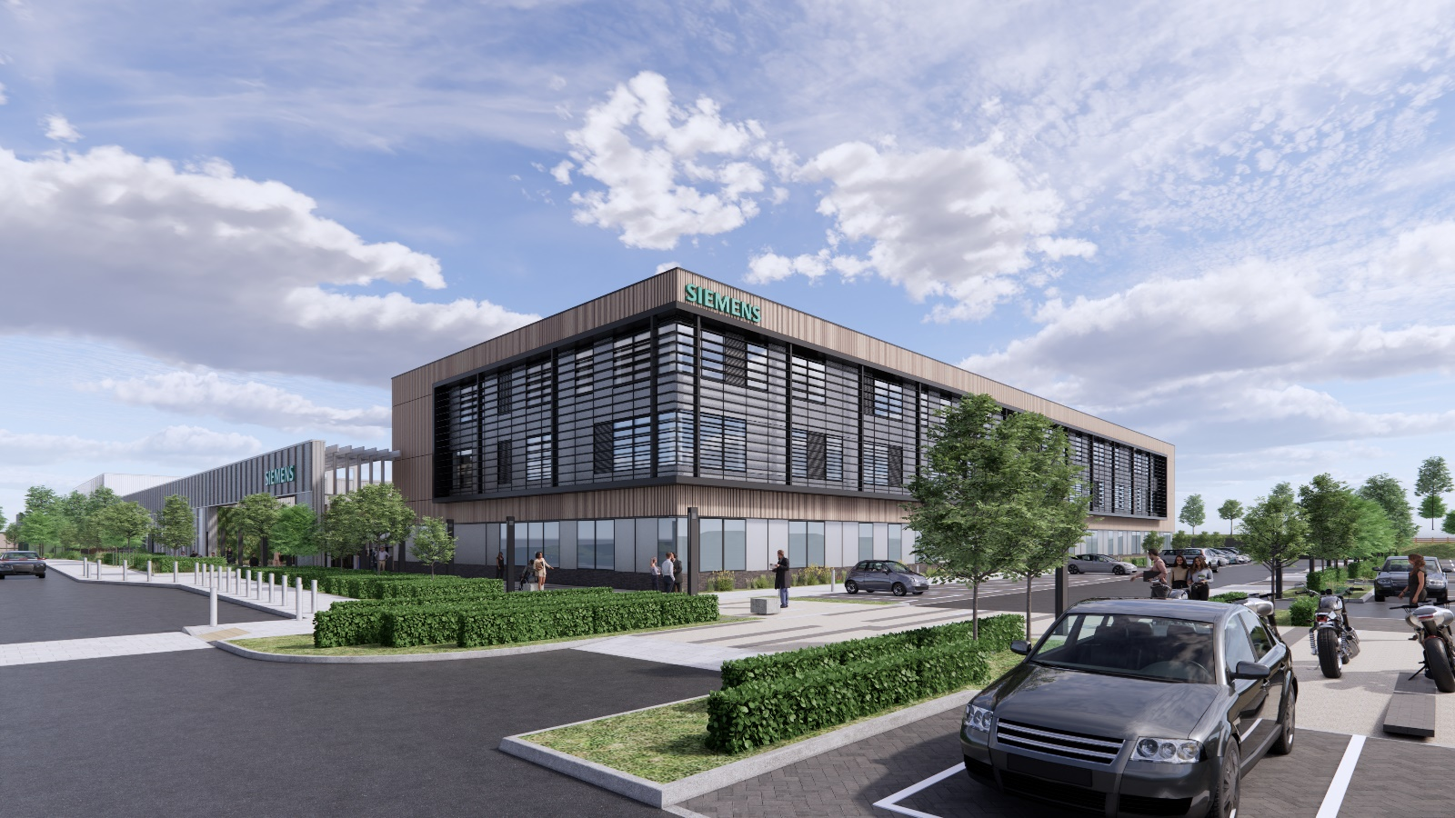
Front view of the site
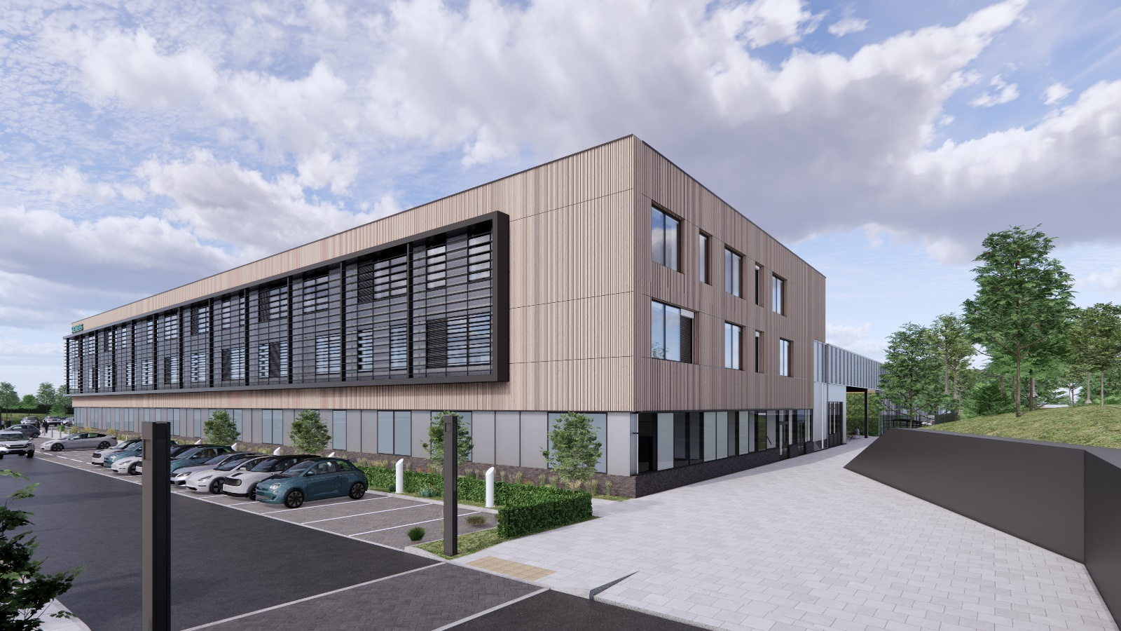
Terrace view

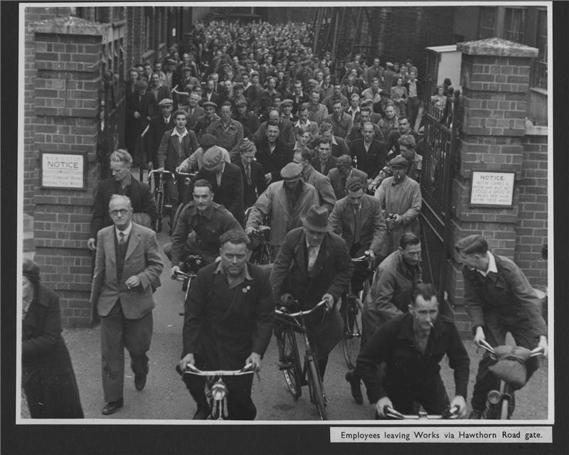
Employees leaving the Chippenham factory

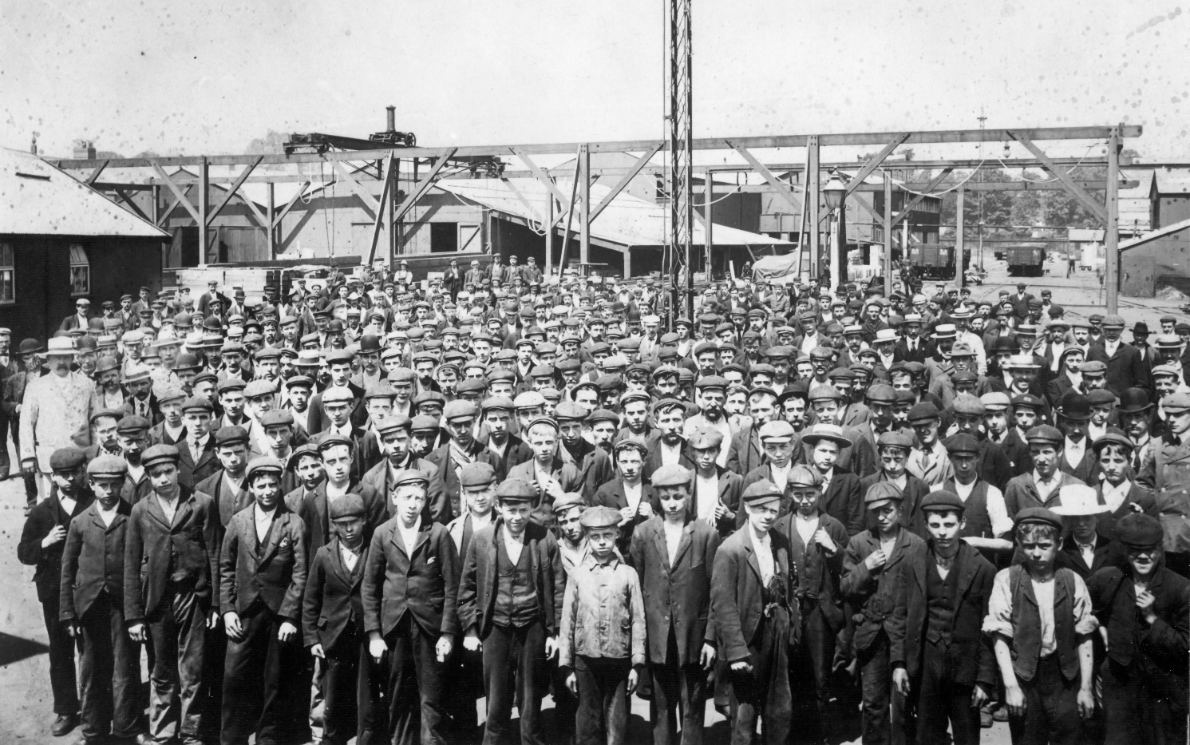
Chippenham employees
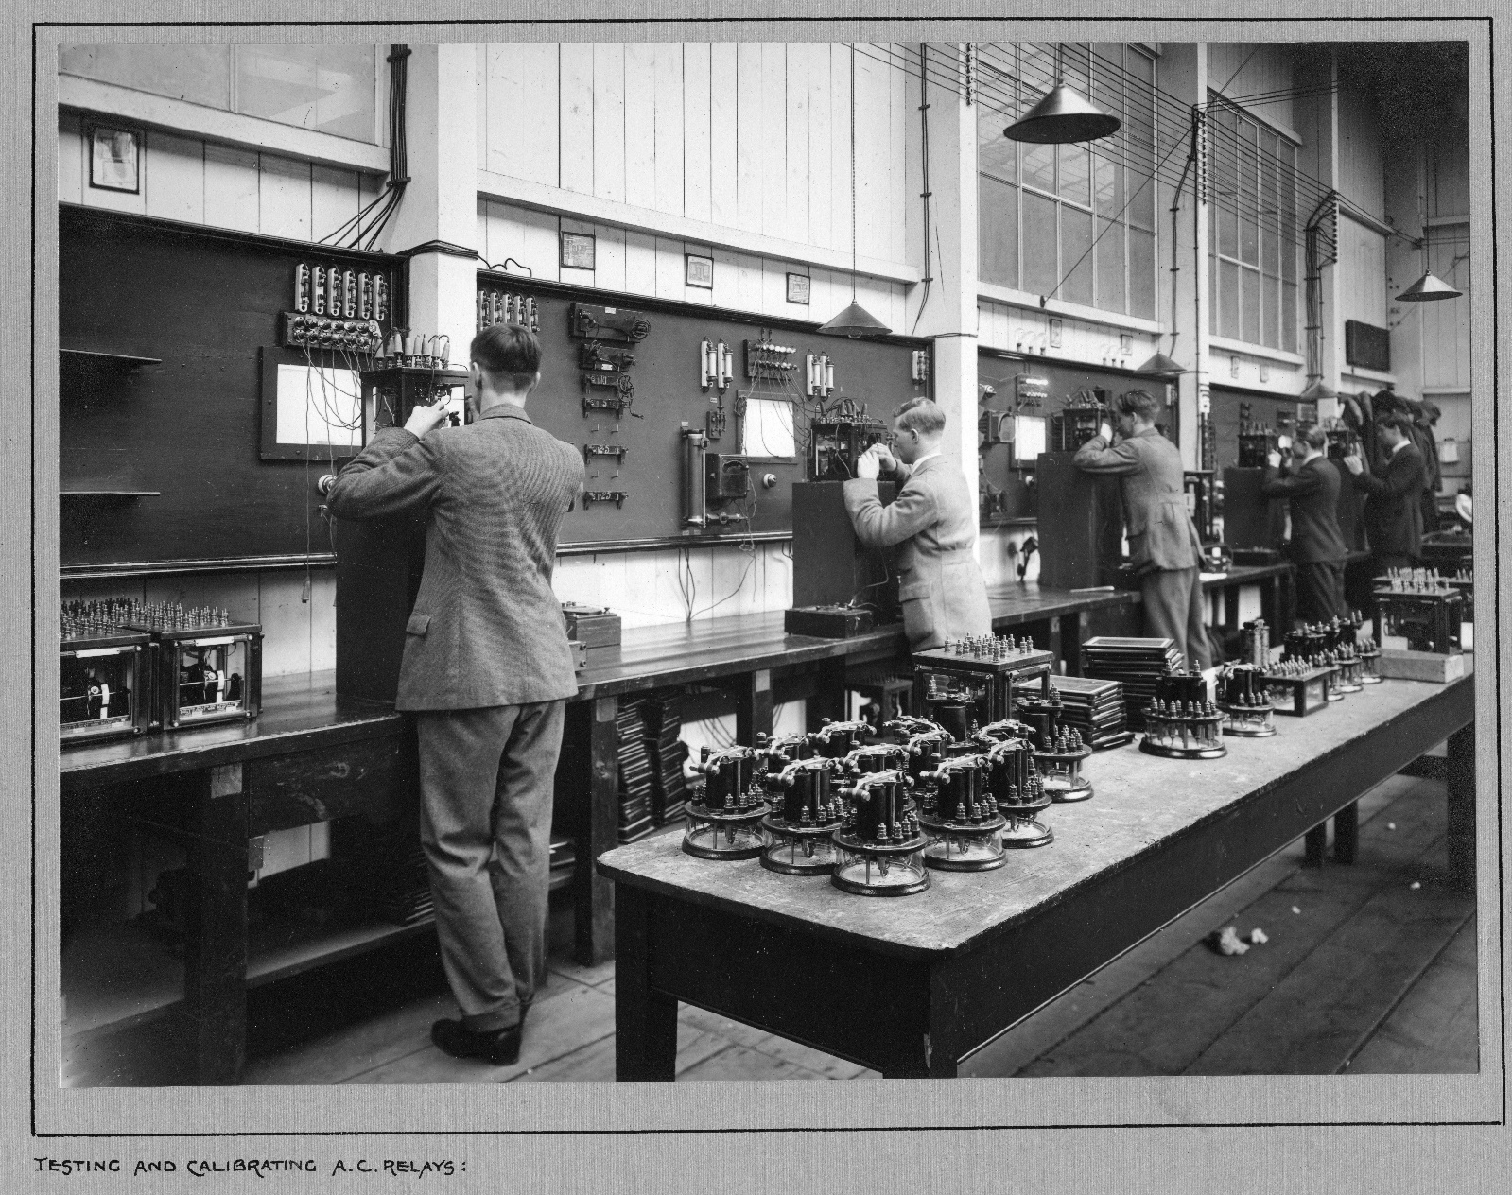
Relay assembley department

