A package of leadership and management development for those in senior leadership roles across health, social care and partner organisations

Information for potential participants and line managers in social care

2022/2023

Application process

This document provides a brief outline of Leading for the Future, which is due to commence in September 2022 and end in June 2023. There will be 90 places available in total across five groups, for those in senior leadership roles in health, social care and partner organisations. In social care it is particularly aimed at middle managers. The Scottish Social Services Council (SSSC) is working with NHS Education for Scotland (NES) to recruit participants from social care specifically.

Places available are limited and there is an application process to assist in identifying potential participants. If you want to be considered for a place on the programme, please complete the application form which accompanies this document, and which requires you to:

- outline your learning objectives for participation on the programme
- obtain a statement of support from your line manager
- submit the form by the date provided on your application form.

If you work in social care and require more information about the programme, please contact leadership@sssc.uk.com in the first instance.

Social care applications should be submitted to leadership@sssc.uk.com by 10am on Monday 9 May 2022. Shortlisting of social care applications will be completed by the SSSC. Applicants will be notified of the outcome of their application by 10 June 2022.

What is the programme all about?

Building leadership capacity and developing leaders’ capabilities across the system are central to ensuring that we can achieve both the Scottish Government’s National Workforce Strategy for Health and Social Care in Scotland as well as wider public services reform.

As part of the contribution to building capacity, Leading for the Future is an innovative package of leadership and management development which has been designed specifically for those in senior leadership positions in health (both clinical and non-clinical), social care and wider partner organisations. It is run in partnership across Health Boards, Local Authorities and Public Service organisations in Scotland.

There is increasing complexity across the health and social care system and all parts of the public services. This complexity impacts upon the kinds of challenges facing leaders across the system as well as on how they need to fulfil their roles. It is our belief that concepts such as ‘adaptive leadership’ have huge relevance and application in this context, as the following quote from Heifetz and Laurie illustrates:

“Rather than fulfilling the expectation that they will provide answers, leaders have to ask tough questions. Rather than protecting people from outside threats, leaders should allow them to feel the pinch of reality in order to stimulate them to adapt. Instead of orienting people to their current roles, leaders must disorient them so that new relationships can develop. Instead of quelling conflict, leaders have to draw the issues out. Instead of maintaining norms, leaders have to challenge ‘the way we do business’ and help others distinguish immutable values from historical practices that must go.”

By drawing on public management theory, our intention is to help leaders make sense of, as well as tackle, the kinds of complex challenges they find themselves increasingly facing.

The approach recognises the diversity of those in leadership roles across health and social care and wider public services. The richness of the learning will come from your interaction with your peers from across different organisations, different professions and diverse backgrounds.

In this sense, we recognise that how we lead and work as leaders is changing – and this needs to be reflected in how we learn together and develop ourselves as leaders.

Quoting John Benington and Jean Hartley from Warwick Business School:

“…instead of starting leadership development with theory and then trying to apply it back into practice, it may be more effective to start with the practical challenges facing an organisation or network and then search for leadership theories and concepts which help the practitioners to make better sense of the complexity of the specific whole system” ….

We describe Leading for the Future as a ‘package’ because it comprises several flexible learning and development elements. The emphasis is on enabling leaders to put theory into practice by applying it to their live leadership challenges. This is in line with latest thinking about how we should be developing and sustaining the development of leadership across the system.

What are the aims of the programme?

The broad aims of Leading for the Future are:
- To provide a challenging development experience for those in senior leadership positions, focused around their leadership and management skills and behaviours, to enable their delivery of service objectives.
- To support the professional and career development of those in senior leadership positions across health and social care and partner organisations.
- To enable participants to handle complexity, to engage with the public, and to work more effectively in partnership across the health and social care system and wider public services.
- To build leadership capacity and facilitate networks for shared learning and exchange of good practice across the health and social care system and wider public services in Scotland.

The intention is that Leading for the Future works alongside local systems and complements local development provision, as well as local performance management arrangements, for those in senior leadership positions. The added value for participants is that they will be experiencing learning at a regional and national level, within a multi-disciplinary and cross-organisational group.

What is involved in the programme?

The package of learning and development comprises three core elements over a ten-month period.
Online Resources

The programme is designed around a range of theories and models which are set out in the diagram below. The three 3 elements in blue below form the core models which underpin the programme and the remainder of the central picture are key supporting tools, models and theories. These are the elements which a facilitator team will develop confidence and competence for their groups in delivering.

Around the outside are the national elements which offer the feel of a national programme with a strong focus on local delivery.

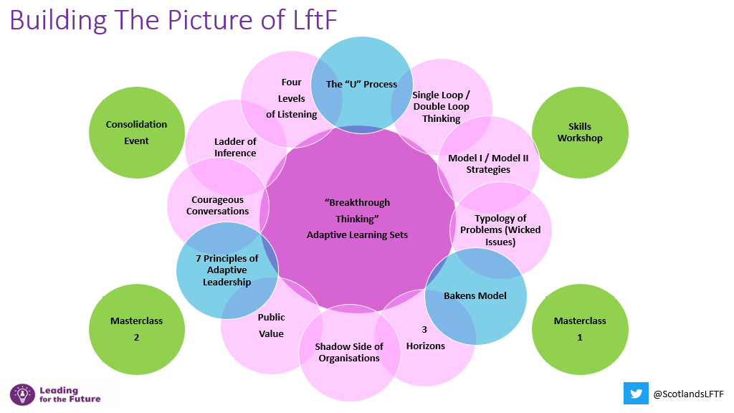

- Adaptive leadership modules and learning sets

This first element will enable participants to learn with others, to share work experiences, and to network with people from other professions and geographic areas.

The modules are a blend of theory input, group dialogue, skills practice, and adaptive learning. The learning format is highly experiential. Participants are introduced to concepts such as ‘adaptive leadership’ and then encouraged and supported, through adaptive learning sets, to work through their ‘live’ work-based issues. Previous participants have commented that the added value is that the cohorts comprised participants from across the participating organisations.

There will be five groups across Scotland, and each group will comprise members from across the participating organisations.

There will be five, one-day modules (in October and December 2022, and in February, March and April 2023) during which each group will work with their facilitators as a whole group and in their separate adaptive learning sets.

- Skills development workshop and masterclasses
The second element of the package comprises: one skills development workshop in November 2022 and two masterclasses in January and May 2023. These will provide participants with the opportunity to:
- Share learning with a more diverse group of peers from across the cohort
- Practice your leadership skills further
- Hear from and engage with leadership experts

The programme concludes with a Consolidation Event in June 2023.

- On-line resources
The third element of the package is the online resources which can be used both to support personal development as well as develop management/leadership skills. At the outset, participants will be introduced to these resources and to guidance on how best to use them throughout the programme and beyond. Participants will be able to identify individual areas of development and to work through these at their own pace.

As the resources are hosted on the Leadership and Management Zone on Turas, participants will need to have an account and password to access them. https://learn.nes.nhs.scot/946/leadership-and-management-zone/programmes/leading-for-the-future

If participants do not have access already, this link provides details on how to register.

The resources have been designed specifically for participants of Leading for the Future and include a programme induction pathway which will support you in your consideration of:
- Where am I now? The opportunity to access a range of self-assessment tools and approaches and set the scene for your development.
- Where do I need to be? The space in which to reflect on what you need to do, what you need to deliver in your role, or where you need to focus your development efforts and how to align this with your personal development plan.
- How do I get there? Providing information about the range of elements in Leading for the Future together with open access to a wide array of tools and information about management and leadership online.
- How am I doing? A learning log in which you can record your progress and make the linkages to your own personal development plan.

Please note that materials used during the programme modules will be available to download via the Leading for the Future pages on the Leadership and Management Zone. Social Care participants may also find some of the resources on the SSSC’s Step into Leadership website useful.

Participants will also find a range of other resources available via the Leadership and Management Zone which may be useful in developing your leadership and management practice. Accessing Leadership Links is highly recommended. Here you will be able to access information about events, webinar recordings, and other event-related resources.

Accessing ongoing 1:1 development (optional element)

Coaching / 360 Feedback / Myers Briggs Type Indicator (MBTI): Access to 1:1 coaching, 360 Feedback and MBTI may be available for some participants in some of the participating organisations. This is an optional (i.e. not compulsory) element of the programme which may serve to complement participants’ learning and development on and beyond the programme. Participants are encouraged to complete a 360º feedback tool prior to, or early in, the programme. Tools are available for social care participants via Step into Leadership.

Many of the participating organisations have developed their own internal register of trained coaches. Participants from these organisations will have the opportunity to discuss their ongoing personal development requirements with their organisation’s lead contact and consider whether 1:1 coaching is a viable option. Any costs associated with optional 1:1 development are the responsibility of the participant’s own organisation so must be agreed at local level.

What is the level of commitment?

Participants must attend all of the scheduled days for the modules, the skills development workshop, and the masterclasses in order to achieve a certificate of completion. The programme completes each year with a consolidation event and attendance at this is also mandatory. All dates associated with the programme will be communicated to participants when confirmed.

During the pre-programme induction participants will be expected to identify and agree development goals with their line manager. Support and guidance in shaping their learning experience to best effect will be available.

Feedback from past participants

The evaluation feedback from all cohorts indicates that what is particularly useful is:

- The blend of support and challenge;
- The mix of theory and practice; and,
- The chance to learn and network with peers from other organisations and professional groups.

In the words of six previous participants:

“I entered into the programme with a degree of scepticism that I might not learn anything new but, given the complex challenges associated with service change and my role, needed something. The programme for me provided an insight and methodology on how to approach complex or wicked problems.” Previous participant, NHS Board

I used to think that I was in a role where I needed to be able to fix stuff. The programme has fundamentally changed how I approach wicked problems and my role in working to resolve these. I now approach situations knowing that there may only be a ‘good enough’ solution. This has been liberating in many ways – but mostly improving my confidence to tackle some really complex situations that otherwise would have rumbled on.”
Ian Aitken, General Manager, Medicine, Emergency Care and Rehabilitation Unit, NHS Forth Valley (2011 cohort)

"Leading for the Future has had a dramatic impact on my ability to understand and cope with the demands of Clinical Leadership. I feel more confident in dealing with both tame and wicked issues. The support, networking and social aspects of the course have been invaluable and fun. I thoroughly endorse Leading for the Future to all in a leadership position; this is very high quality education, focused on your needs."
Dr Paul Davidson, Rural Practitioner Skye / Clinical Director North and West Highland

“It was helpful to stand outside current work commitments and challenges and reflect on how 'getting on the balcony' to gain a wide view of organisational processes and the external environment can support effective decision making.

Carolyn Fitzpatrick, Lead for Clinical Pharmacy and Prescribing, East Dunbartonshire CHP

“Leading for the Future has provided me with the confidence to address really complex work problems using adaptive leadership models that are academically sound and practically useful. I would strongly recommend it.
David Wylie, Podiatry Service Manager & Professional Lead, NHS Greater Glasgow & Clyde

“I found the course very refreshing. One of the best courses I have attended. I thought that knowing that there are ‘wicked’ problems was enlightening and that managers don’t have to have the answer to everything was a breath of fresh air. The adaptive learning sets were excellent. I found that they took a bit of getting used to because as a manager you are so used to keeping complex or “wicked” problems to yourself – so sharing them and hearing other people’s stories was excellent. My only criticism was that it was too short. Another couple of sessions may have bonded the adaptive learning groups more and possibly created longer term relationships.”
Service Manager, NHS Board

Heifetz, R.A. & Laurie, D.L. (1997), “The Work of Leadership”, Harvard Business Review, Jan-Feb, pp 124-134
Benington, J. & Hartley, J. (2009) “Whole systems go!” – Improving leadership across the whole public service system, National School of Government, Sunningdale Institute, p.9
Reference: The theoretical content of the programme is based on work of Ronald Heifetz, Keith Grint. Mark Moore, John Benington, Irwin Turbitt, Chris Argyris and Peter Senge, amongst others

