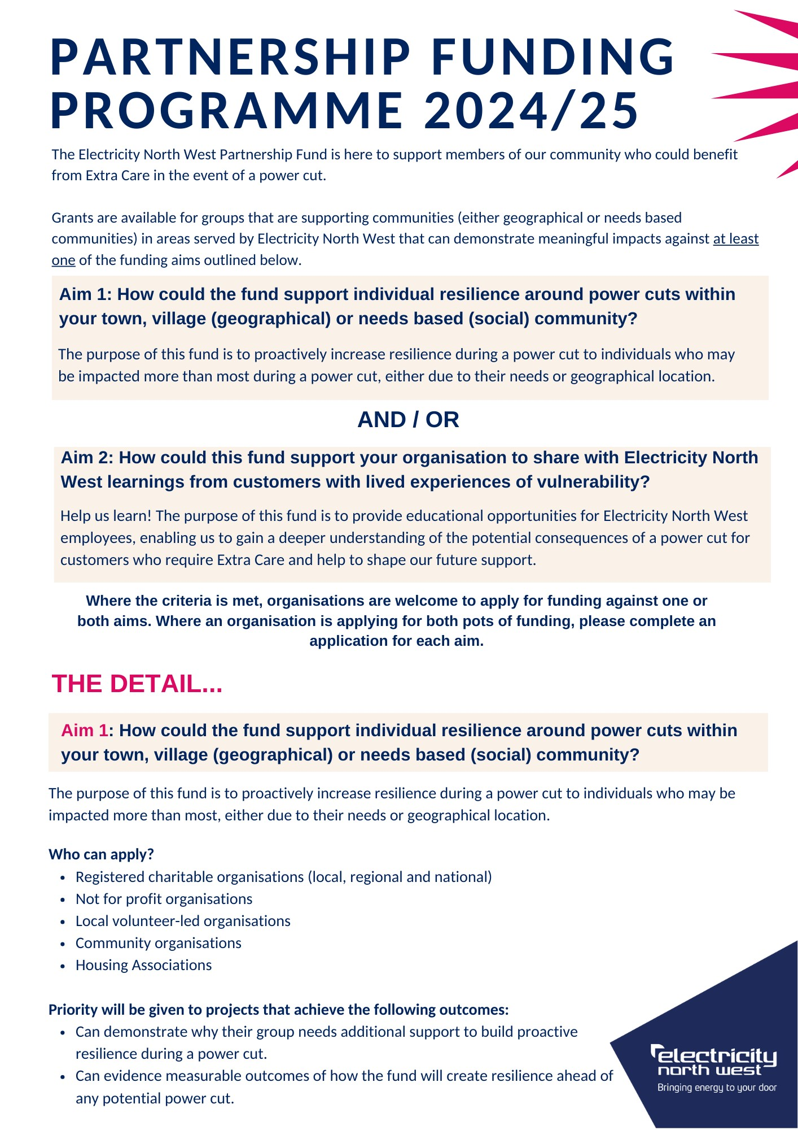

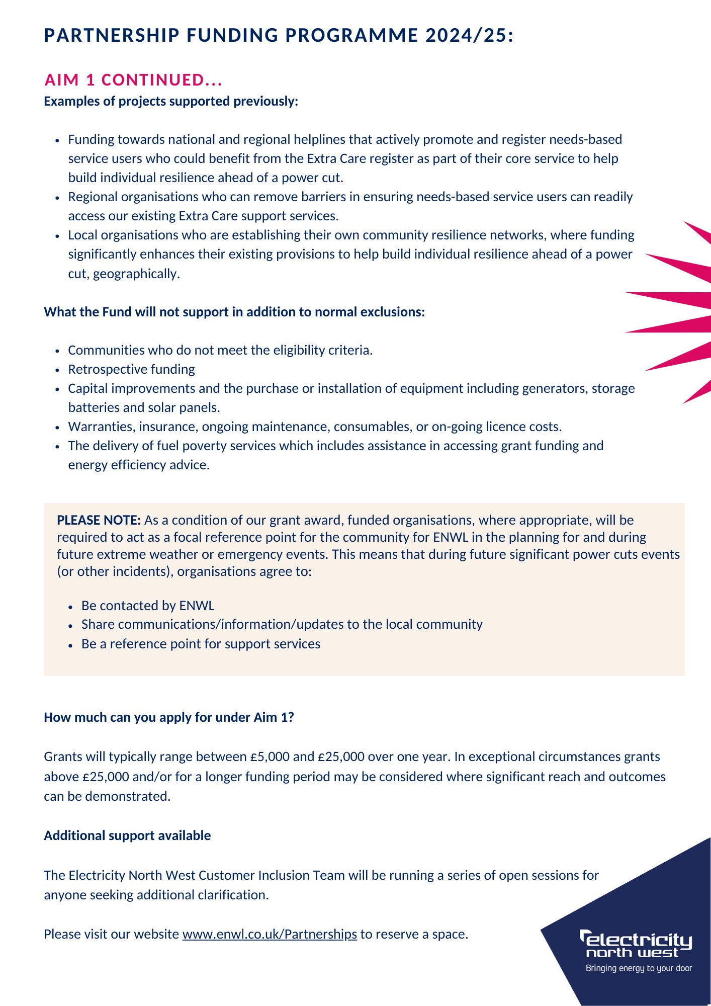
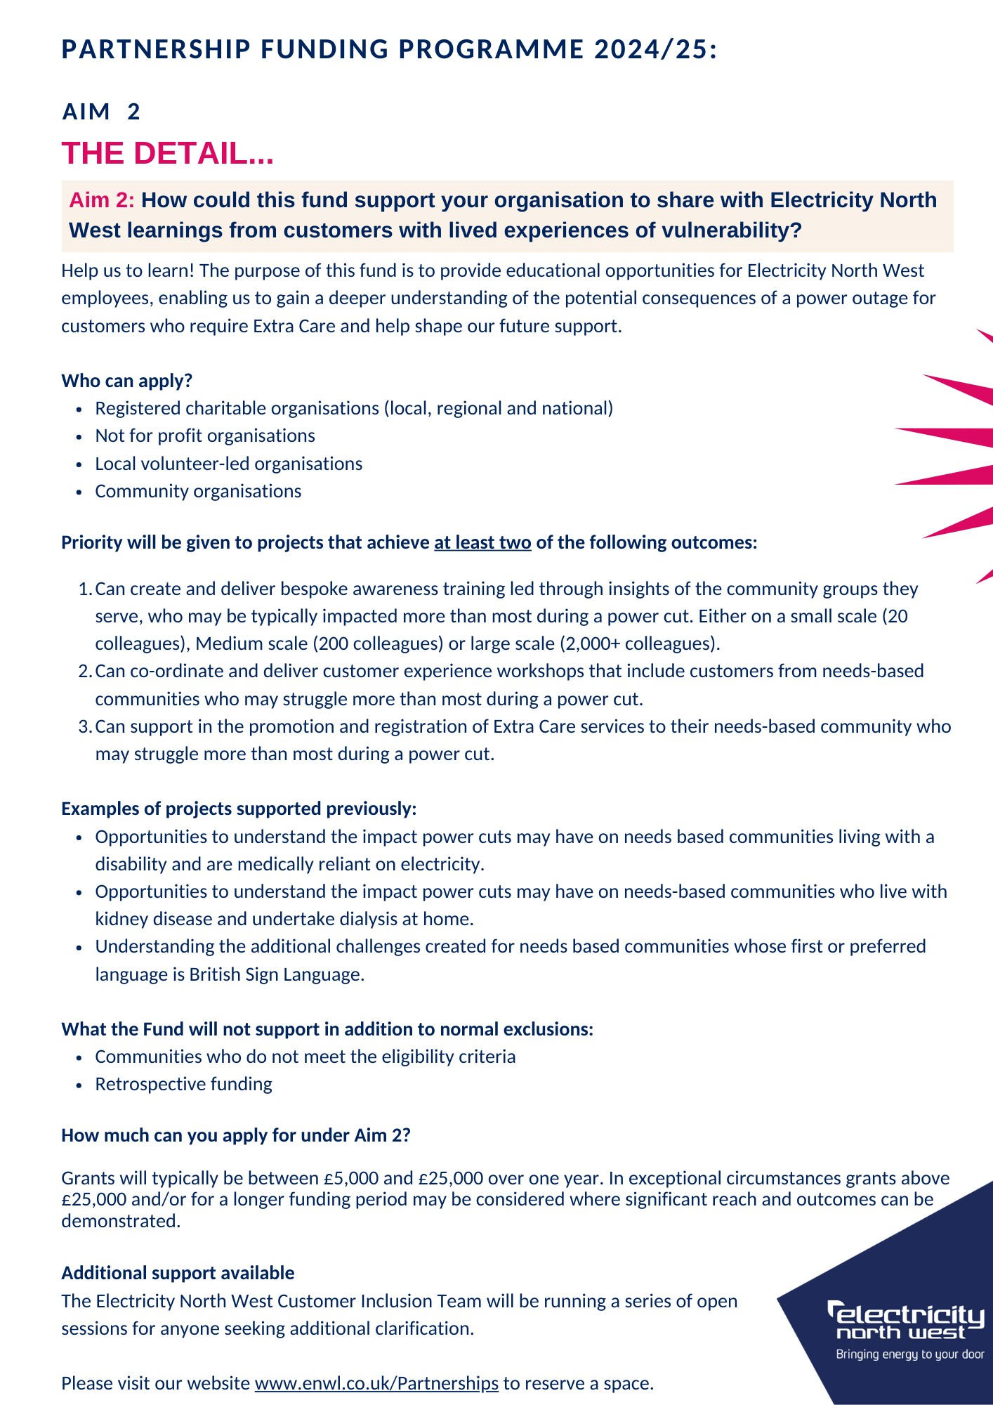

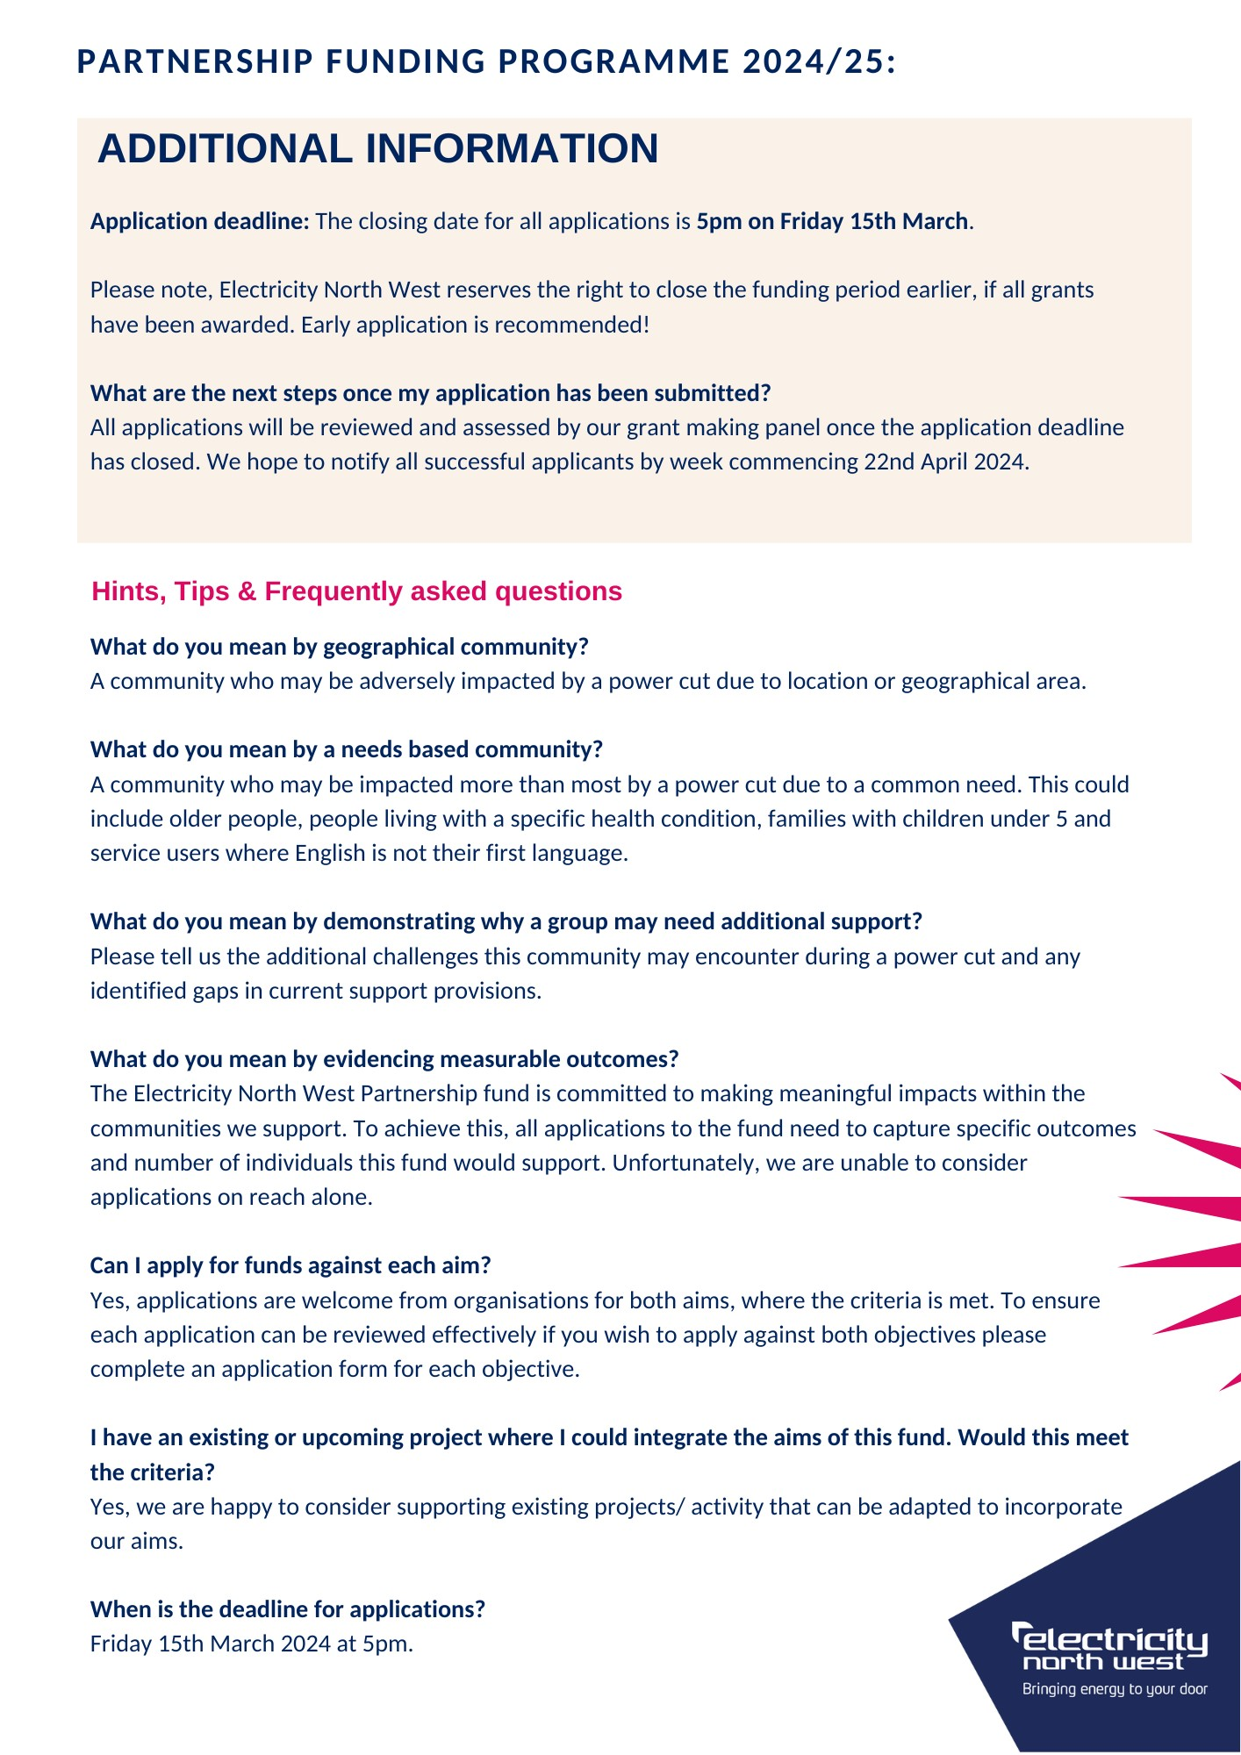

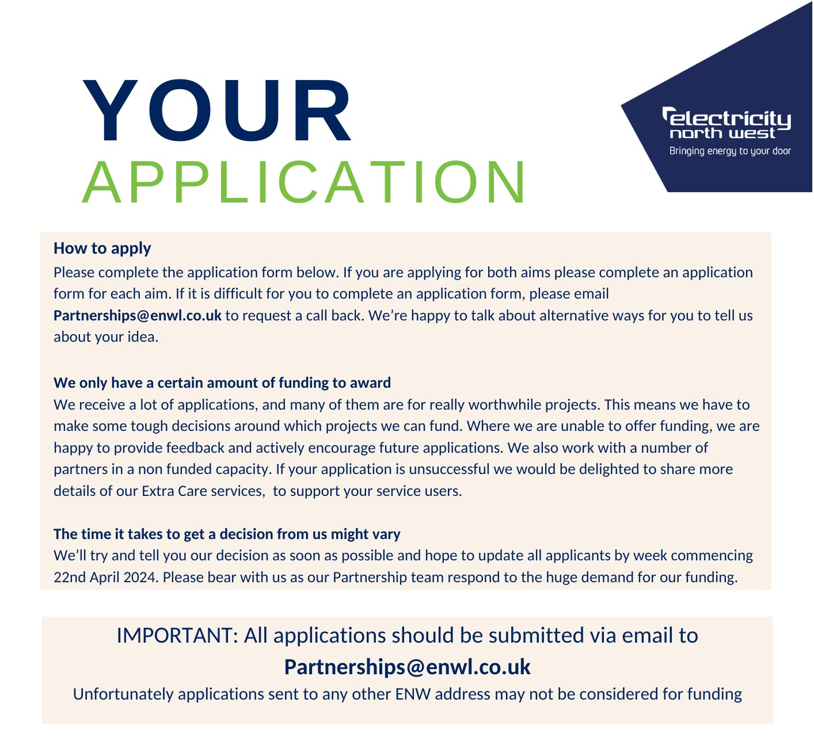
YOUR APPLICATION
Tell us which ‘AIM’ are you applying for funding | Aim 1: How could the fund support individual resilience around power cuts within your town, village (geographical) or needs based (social) community? | Aim 2: How could this fund support your organisation to share with Electricity North West learnings from customers with lived experiences of vulnerability?
 | Yes / No | Yes / No
 | (Remember, if you wish to apply for funding against both aims, please complete a separate application form for each)
Name of your organisation
Where will your project take place? (If your project covers more than one area, please include all areas)
Where possible, please tell us the postcode(s) of where your project will take place?

ABOUT YOU
Tell us about your organisation. Remember to include who you support, how you support them, your reach and area of expertise.
(As a guide, try to tell us in 150 words or less)

YOUR IDEA!
Tell us about your project. What would you like to do?
(Try to tell us in 250 words or less your idea)

How will your project benefit Electricity North West customers or colleagues?
Please try to include:
- How many people will benefit?
- Who are the people that will benefit?
- What is their age range?
How does your project meet the funding aim?
(A reminder our full description of funding aims can be found at the start of this document).
How long will your project last for? Our funding is available for up to 12 months however in exceptional circumstances longer funding periods may be considered.

We need your help!
Our partners deliver a critical role in helping us to identify and register thousands of North West customers who may benefit from our free Extra Care register. Being part of the Extra Care register helps to build individual resilience in the event of a power cut.
There are over 250,000 eligible customers in our region who are not currently registered, tell us by answering the questions below how your organisation could help reduce this gap.
For more information on our Extra Care register visit: www.enwl.co.uk/extra-care/
EXTRA CARE
Is your organisation willing to help register your service users on the free Extra Care Register?
If YES, approximately how many households could you commit to signing up as a key part of this funding agreement?
Electricity North West can also provide organisations with free Extra Care literature. Would your organisation be willing to promote our free Extra Care literature to your service users?
If YES tell us how you will promote & your anticipated reach
Our partners help to shape our Extra Care strategy to support our regulatory requirements. Would your organisation be happy to attend our regular stakeholder meetings to meet other partners and share best practice? (Up to 4 meetings per year)
YES / NO
It’s unlikely we will ask for your help, but could your organisation provide support to vulnerable Electricity North West customers in the event of a significant power cut in your area?
If YES, please provide details.

MEASURING SUCCESS
What processes will you have in place for measuring the ongoing success of your project?

What processes will you have in place to capture accurate KPIs?
(Including your commitment to Extra Care Register sign ups?)
We would love to hear how our funding is making a difference!
Can your organisation commit to sharing at least one case study every 3 months? YES / NO
We will need high level monthly project reports against your agreed KPIs by the 3rd working day of each month.
Can you commit to this reporting? YES / NO

FINANCES
Please provide a high-level summary of your organisations annual core running costs.
By providing this information it helps us to understand the broader social return on investment a grant could deliver.
How much funding are you requesting to deliver your project? Please provide a high level breakdown of costs.
Will our grant fully fund your project?
If your project will be partly funded by other funders, please provide details of commitments secured.
Please note successful bids will receive 50% of funding at the beginning of the project and the remaining 50% at the project midpoint, subject to successful delivery. Please type ‘AGREE’ to confirm your agreement.

TELL US ABOUT YOUR ORGANISATION
What is the full legal name of your organisation?
Does your organisation use a different name in its day-to-day work?
When was your organisation established?
What is your organisations legal status? (e.g. Charity, CIC etc)
If applicable, what is your charity registration number?
How many paid staff members do you have?
How many volunteers do you have?
Organisation address including postcode

Senior Contact Details
Please provide details for your Senior Contact. This person will be legally responsible for the funding. Unfortunately, they can't be married to, in a civil partnership with, in a long-term relationship with, living with, or related to the main contact.
SENIOR CONTACT DETAILS
What is their role or job title?
What is the full name of the Senior Contact?
Address of Senior Contact
(If different to organisation address)
Senior Contact email address
Senior Contact phone number
Main Contact Details
Please provide details of the Main Contact. Senior Contacts and Main Contact should not be the same individual.
MAIN CONTACT DETAILS
What is their role or job title?
What is the full name of the Main Contact?
Address of Main Contact
(if different to organisation address)
Main Contact email address
Main Contact office phone number
Main Contact mobile phone number

APPLICATION COMPLETITION
Application completed by (Full Name)
Date Application Submitted

