PRESS RELEASE
12 May 2018

Photos saved here

10 things you didn’t know about the Welsh railway

“It gets me from A to B” … sound familiar?

But in fact, Wales’ railway is far more interesting than you think — steeped in history and with facts and figures that will blow your mind.

For National Trains Day (12 May), Arriva Trains Wales has pulled together some of the best facts, destined to put your Welsh train knowledge on the right track.

1/. The first EVER steam railway journey took place in Wales
In 1804 Richard Trevithick, an engineer from Cornwall, created the first steam locomotive railway journey in the world. Hauling at 5mph, the Penydarren tram road engine ran across nine miles from Penydarren to the Merthyr-Cardiff Canal.
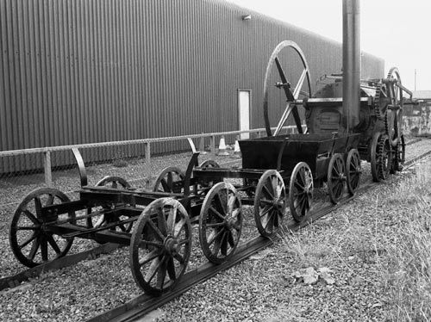
2/. The UK has the busiest railway in Europe
Over 3.5 million people travel in the UK daily. In Cardiff alone, 13,200 passengers arrive at the Welsh capital on a typical weekday during morning peak-times. On a rugby match day this number significantly rises and up to 40,000 people are expected to arrive by train in Cardiff.

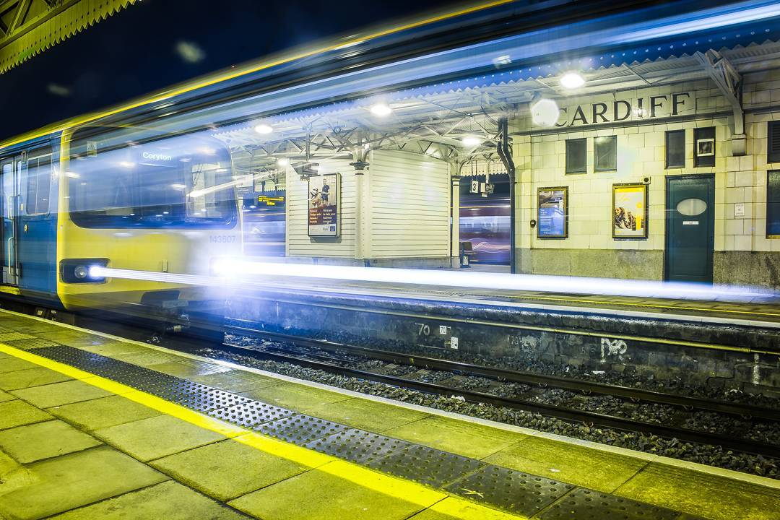

3/. The Severn Tunnel is the longest railway tunnel in the UK
Connecting Wales and England, the Severn Tunnel is the longest railway tunnel in the UK. Whilst it would take you over an hour to walk this 4.5-mile tunnel, trains manage to do it within 3 minutes and 30 seconds and it reaches 144 feet below sea level!
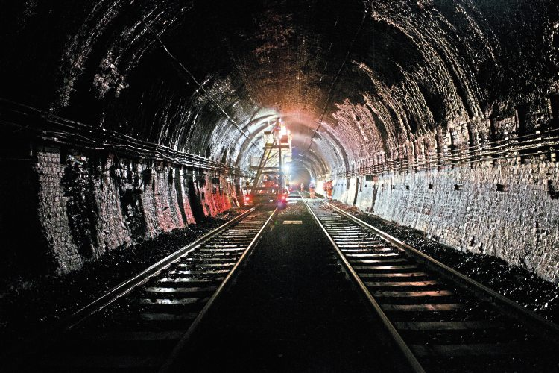

4/. Wales holds the record for the longest train announcement
Listing over 39 stations in English and Welsh, the Swansea-Crewe Arriva Trains Wales’ announcement lasts 2 minutes 45 seconds and blares 4 times a day — including tiny villages such as Llangynllo, Ffairfach and Cynghordy. This is believed to be the longest announcement in Britain, and possibly the world!

[include video — https://www.youtube.com/watch?v=iIKBikooTWU]

5/. The UK rail track stretches over 10,000 miles

With over 10,072 miles of railway track, British railways allow you to explore the UK to its fullest. This distance is the same as travelling from Wales to Australia!
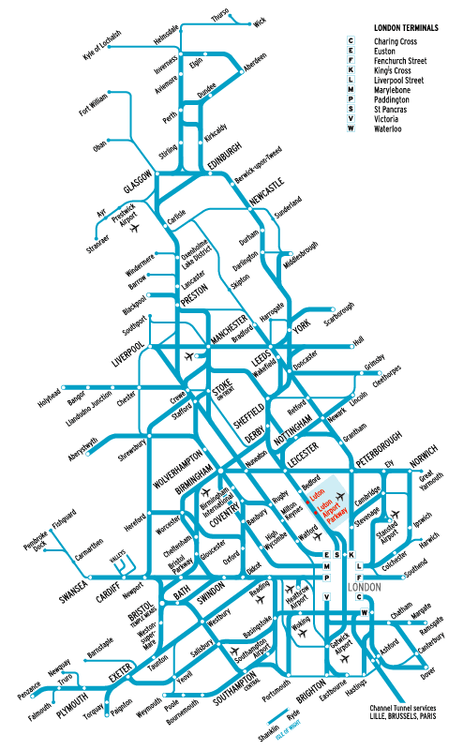
6/. Wales has some of the longest railways stretched across the seaside in the UK
The Cambrian Coast Line and North Wales line offer breath-taking coastal views that cannot be missed. From Shrewsbury to Pwllheli and Crewe to Holyhead, the two journeys have been welcomed as some of the most scenic rail journeys (Telegraph, 2017).
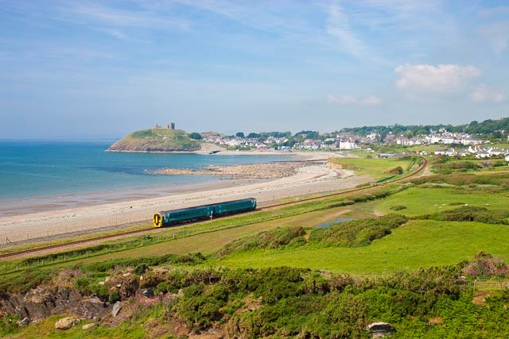

7/. The Heart of Wales line celebrates its 150th birthday this year
The four-hour journey from Swansea to Shrewsbury is recognised as one of the most beautiful lines in Britain with over 121 miles of architecture and history — crossing viaducts, Victorian spa towns and the striking Shropshire Hills. This year it is celebrating 150 years
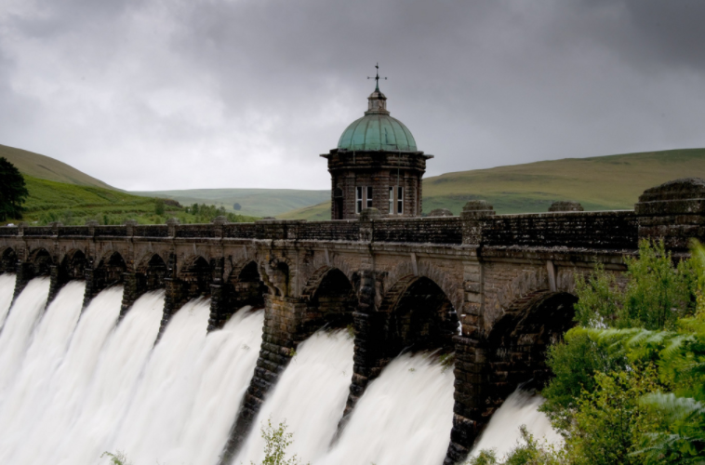
[Copyright: Simon Turton]
8/. Eight heritage railways are found in Wales
The Great Little Trains, which were originally created to move slate out of the mountains, have now become a popular family attraction. The old-time steam trains go through various scenic routes, including Wales’ National Parks Snowdonia (Snowdon Mountain) and the Brecon Beacons (Brecon Mountain Railway). The oldest Great Little Train is Ffestiniog Railway, which has also become the world’s oldest independent railway.
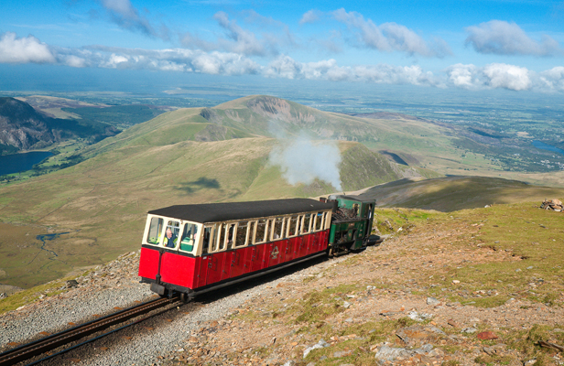
9/. Queen Street station is one of the busiest ‘points’ in the UK
The set of ‘points’ or junction by Queen Street station in Cardiff is one of the busiest in the UK railway network, taking passengers on multiple lines Northbound on the Valleys Lines and Southbound towards Cardiff Central and the Vale. It challenges the likes of London Paddington and Clapham Junction.
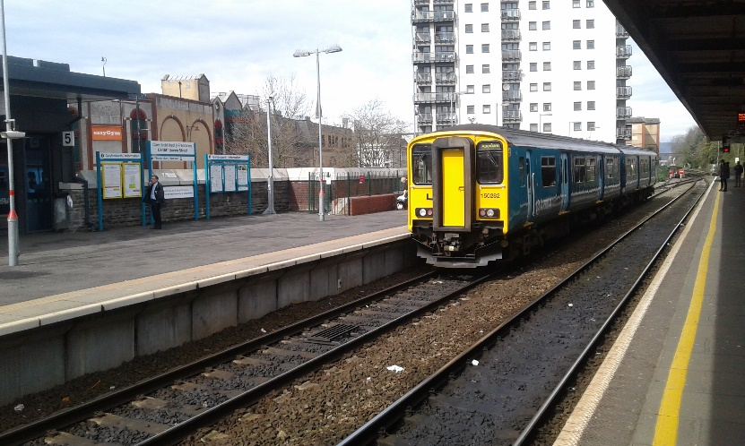
10/. The longest train station name is found in Wales
Llanfairpwllgwyngyllgogerychwyrndrobwll-llantysiliogogogoch, the train station on the island of Anglesey in Wales is the longest station name in the UK. It is also holds the Guinness World Record of the longest URL address. Many have struggled with the pronunciation, but actress Naomi Watts (The Impossible, King Kong) can do it perfectly, having lived there for a brief period.

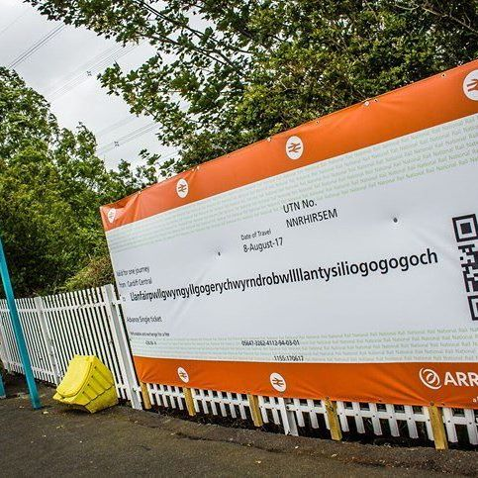

ENDS
Notes to Editor

About Arriva Trains Wales
- The Arriva Trains Wales network extends throughout Wales and the border counties of England, providing local and long-distance services to major destinations such as Swansea, Cardiff, Newport, Birmingham, Chester and Manchester.
- Arriva’s ‘Day to Go’ ticket allows for one day of unlimited, off peak train travel within the Cardiff and Penarth area, saving passengers money and offering greater flexibility in comparison to standard or day return tickets.
- Providing for just under 32 million passenger journeys per year, ATW plays a major social and economic role in connecting people and communities throughout its network with a fleet of 128 trains covering a route of over 1,000 miles. ATW operates 247 stations throughout England and Wales of which 55 are staffed.
- The Wales and Borders franchise started in December 2003 and runs for 15 years. In the past 10 years, Arriva Trains Wales has invested £31 million in the network to improve stations, staff facilities and training, service availability and ticket purchase opportunities.
- ATW is dedicated to providing excellent customer service throughout its network: National Rail Passenger Survey results report the overall customer satisfaction with Arriva Trains Wales is currently at 82% (Autumn 2015), while ATW is consistently one of the best national ‘right time’ performing rail operators in the UK.
- ATW is one of the largest private sector employers in Wales, employing around 2200 people, and has created more than 300 additional jobs in Wales and the border counties since 2003.
- ATW is committed to investing and developing in young talent: 21 apprentices and 13 graduate trainees have been recruited through its National Award-Winning Apprenticeship Scheme.
- ATW is constantly seeking to improve links with local communities and customers. In 2004, ATW set up the popular ‘Adopt a Station’ scheme, supports many large high profile events around Wales such as Velothon Wales and the Cardiff Half Marathon and is a community partner of Disability Sports Wales.
- ATW are industry leaders in utilising and developing new technology in order to better its customer service offering. In 2015 ATW introduced the UK’s first video assisted train ticket vending machine and the Mobile multi-flex ticket, the first smart-phone ticketing product of its kind in the UK rail industry.
- For more information on Arriva Trains Wales visit www.arrivatrainswales.co.uk

