**Press Release**

**Fidelity International study reveals active ETFs are most in-demand growth area for professional investors**

* 37% of investors surveyed anticipate an increase in their allocations to active ETFs over the next 18 months.
* This increases to 61% among intermediary distributors.
* Main reasons for choosing active ETFs are reducing cost, generating alpha and providing access to specialist areas.

**London:** Professional Investors are increasingly favouring active ETFs over other investment vehicles, according to new findings fromFidelity International’s (“Fidelity”) ***Professional Investor DNA*** ***Survey.***

The European ETF market continued its impressive growth in 2024, surpassing $2tn in asset under management for the first time1. Despite this, active ETFs remain relatively under-represented. According to Morningstar, active ETFs account for 8% of the overall US ETF market, while in Europe it stands at 3%2.

However, significant change is underway: the European active ETF market expanded sharply from $38bn to $64bn over the past year3, as more investors discover their benefits.

The surveyof over 120 institutional investors and intermediary distributors across Europe and Asia, in partnership with Crisil Coalition Greenwich, confirmed that nearly a quarter of professional investors **(24%)** are already utilising active ETFs.

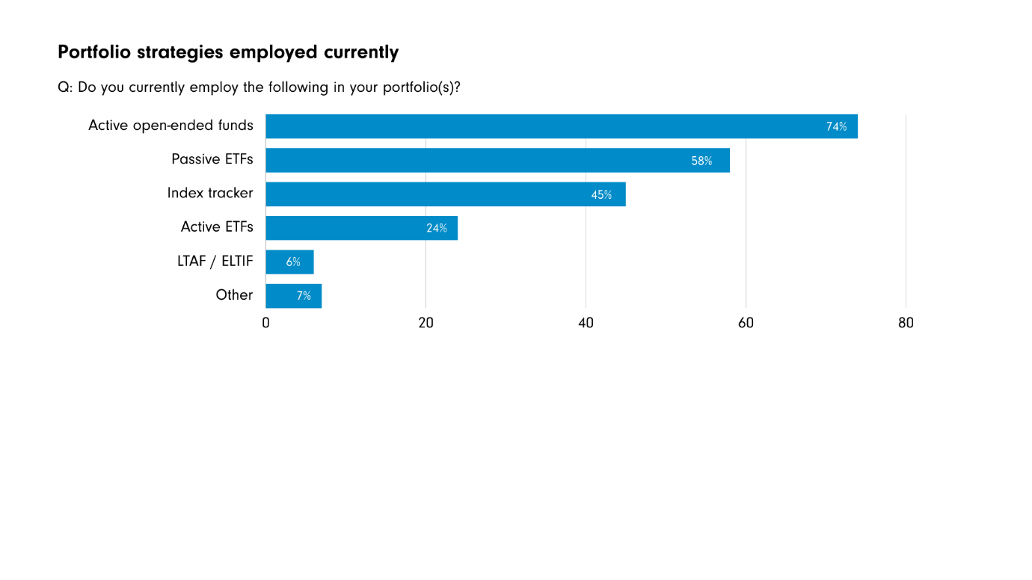

Demand for active ETFs is expected to increase more rapidly than any other type of investment vehicle over the next 18 months, with **37%** of investors surveyed anticipating an increase in their allocations. Intermediary investors show most interest, with **61%** anticipating an increase in usage in their portfolios over the next 18 months.

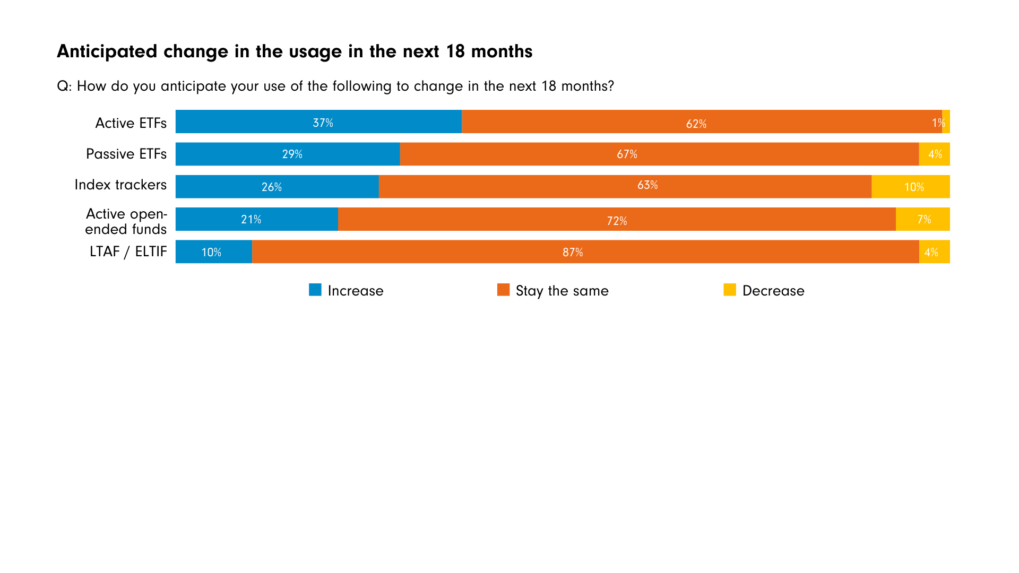

Top reasons for using active ETFs include to reduce costs, to generate alpha, and access to specialist areas.

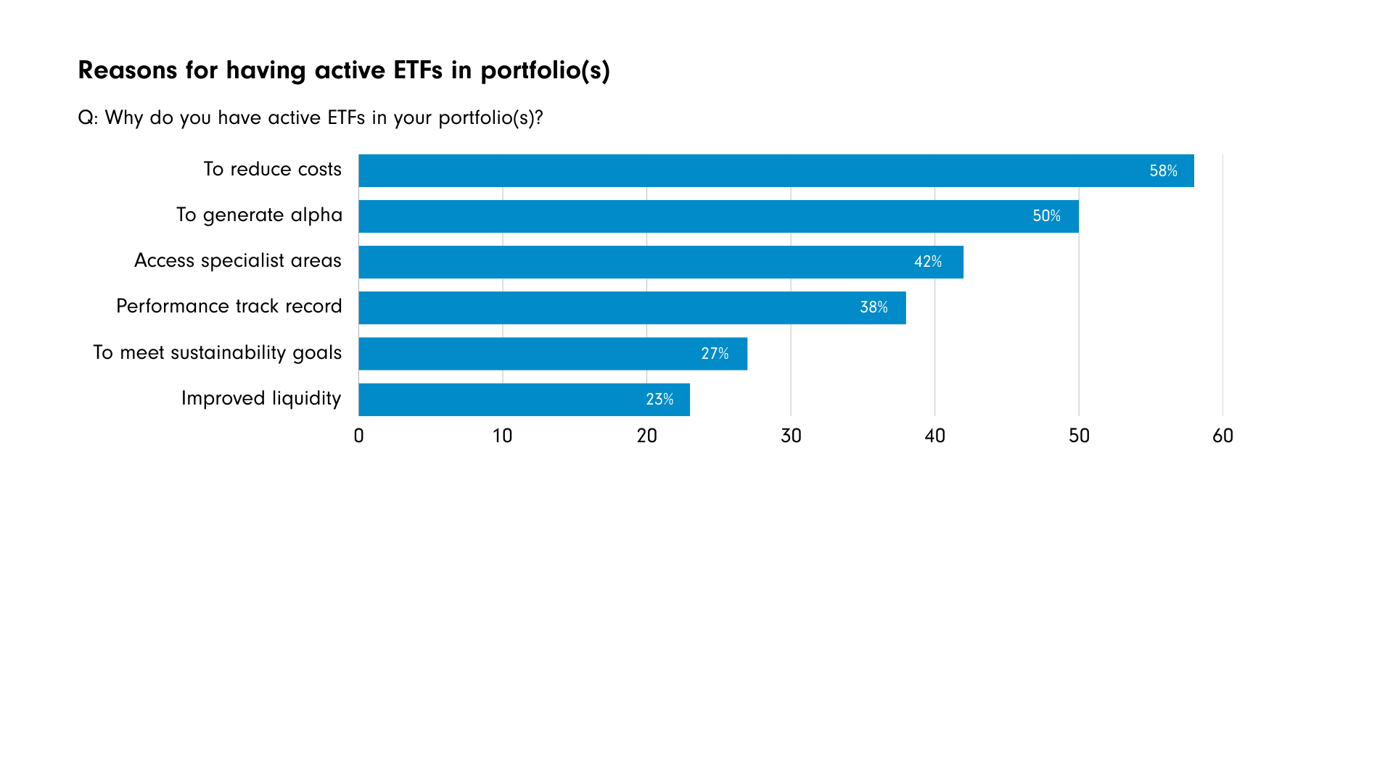

**Alastair Baillie Strong, Global Head of ETFs at Fidelity International** comments: “The anticipated growth in investor allocation to active ETFs identified in our survey reflects the evolving preferences of investors. There is growing investor awareness of the benefits of active ETFs; combining the advantages of traditional active funds: flexibility, potential for outperformance; and those of ETFs: lower costs, transparency and ease of access. PWC expects the global ETF market to grow to $20tn in assets under management by 2030, a 17% compound average growth rate4, and we anticipate that active ETFs’ will grow even faster, increasing their share as more investors discover their benefits.

“Our active ETF business is a key growth driver for Fidelity, and at the end of 2024, we were pleased to solidify our position as the second largest active ETF provider in Europe by assets under management ($6.0bn) and net new flows ($2.2bn)5.

“Looking ahead, we face a backdrop of ongoing complexities in the market which can be characterised by high valuations and various uncertainty factors. Given this backdrop, ETF selection is more important than ever. At Fidelity, our active ETF strategy is to support our clients as they seek to tackle the many idiosyncratic risks posed by today’s volatile global macroeconomic and geopolitical backdrops, leveraging our long-standing active research capabilities to deliver enhanced diversification and return benefits versus passive ETFs.”

**Important information:**

This material is for Investment Professionals only and should not be relied upon by private investors.

The value of investments and the income from them can go down as well as up so you/the client may get back less than you/they invest.

Investors should note that the views expressed may no longer be current and may have already been acted upon.

-Ends-

**Notes to editor**

Morningstar, 31/12/24

2 Morningstar, 31/12/24

3 Morningstar, 31/12/24

4 [ETFs 2026: The next big leap: PwC](https://www.pwc.com/gx/en/industries/financial-services/publications/etf-2026-the-next-big-leap.html)

5 Source: Fidelity International, ETFBook, data as of 31/12/2024

**About the study**

Fidelity International engaged Crisil Coalition Greenwich to conduct a study on future investment trends amongst 125 institutional investors and intermediary distributors in selected countries in Europe and Asia. The research was conducted in October and November 2024.

**About Fidelity International**

Fidelity International offers investment solutions and services and retirement expertise to more than 2.8 million customers globally. As a privately held, purpose-driven company with a 50-year heritage, we think generationally and invest for the long term. Operating in more than 25 locations and with $893.2 billion in total assets, our clients range from central banks, sovereign wealth funds, large corporates, financial institutions, insurers, and wealth managers, to private individuals.

Our Global Platform solutions business provides individuals, advisers and employers with access to world-class investment choices, third-party solutions, administration services and pension guidance. Together with our Investment Solutions & Services business, we invest $625.5 billion on behalf of our clients. By combining our asset management expertise with our solutions for workplace and personal investing, we work together to build better financial futures. Data as of 31 December 2024. Read more at fidelityinternational.com.

This information must not be reproduced or circulated without prior permission. This information does not constitute investment advice unless specifically agreed in a formal communication. Fidelity International refers to the group of companies which form the global investment management organisation that provides information on products and services in designated jurisdictions outside of North America. Unless otherwise stated all products and services are provided by Fidelity International, and all views expressed are those of Fidelity International. Fidelity, Fidelity International, the Fidelity International logo and F symbol are registered trademarks of FIL Limited.

Issued by FIL (Luxembourg) S.A., authorised and supervised by the CSSF (Commission de Surveillance du Secteur Financier).

Issued by Financial Administration Services Limited, authorised and regulated by the Financial Conduct Authority.

**CC25/14**