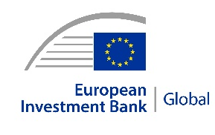 | 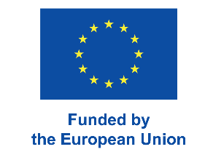 | 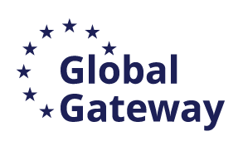 | 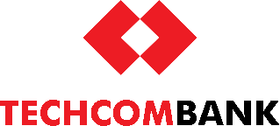
PRESS RELEASE
2026-109-EN
24 March 2026

EIB Global and Techcombank announce €200 million credit line for climate investments in Viet Nam
- The €200 million financing agreement between EIB Global and Techcombank was announced during the EU-Vietnam Global Gateway Business and Investment Forum in Hanoi.
- The financing will support green projects implemented by private businesses in Viet Nam, advancing the country’s Just Energy Transition Partnership (JETP).
- EIB Global will also work with Techcombank to strengthen climate risk management and support the bank’s sustainable finance activities.
EIB Global, the development arm of the European Investment Bank (EIB), and Vietnam Technological and Commercial Joint Stock Bank (Techcombank) have announced a €200 million financing agreement to accelerate climate action and environmental sustainability projects across Viet Nam.
The long-term financing facility aims to bridge the financing gap for green initiatives, particularly within the private sector. The agreement was unveiled during the EU-Vietnam Global Gateway Business and Investment Forum in Hanoi, in the presence of Prime Minister Pham Minh Chinh and European Commissioner for International Partnerships Jozef Síkela. The announcement was made by EIB Vice-President Nicola Beer and Vice Chairwoman of the Board at Techcombank Nguyễn Thu Lan.
With this funding, Techcombank will expand lending for projects in areas including renewable energy, energy efficiency and sustainable transport. The operation will contribute to several Sustainable Development Goals and support Viet Nam’s Just Energy Transition Partnership towards a green, carbon-neutral economy by 2050.
Alongside the financing, the EIB Advisory will work with Techcombank to strengthen its climate risk management framework, improve climate-related disclosures and support the implementation of the operation. This advisory support will be provided through the Greening Financial Systems (GFS) programme, financed by Germany and Luxembourg.
EIB Vice-President Nicola Beer, who oversees the Bank’s operations in Viet Nam, said: “Viet Nam has set ambitious goals for its energy transition and sustainable development. The European Investment Bank is supporting these efforts across sectors – from energy systems and sustainable transport to green finance with partners such as Techcombank, through which we support the private sector, including small and medium-sized enterprises. These investments will also deliver tangible benefits for people, including cleaner air, improved energy efficiency, better access to sustainable energy and new opportunities for jobs and economic growth. This cooperation reflects the European Union’s Global Gateway strategy and our shared commitment to supporting sustainable investment and the long-term development of Viet Nam.”
European Commissioner for International Partnerships Jozef Síkela said: “This agreement shows how our partnership with Viet Nam delivers on what matters most: sustaining economic growth while reducing pollution and expanding clean energy. Through this cooperation, we invest together with Vietnamese companies in renewable energy, improve energy efficiency and modernise transport. This is how Global Gateway turns partnership into practical results: jobs, stronger growth and a cleaner energy system for the future.”
Techcombank Vice Chairwoman of the Board Nguyen Thu Lan highlighted the following: “We value the opportunity to partner with the European Investment Bank following its rigorous appraisal process, which underscores Techcombank’s solid financial standing. The facility will strengthen our ability to expand climate-aligned lending, support our clients in their transition to lower-carbon business models, and accelerate investment in sustainable infrastructure. By integrating climate finance into our banking strategy, we reinforce our commitment to long-term, responsible growth that creates value for the economy, society and the environment.”

Background information

EIB Global
EIB Global is the EIB Group’s specialised arm devoted to increasing the impact of international win-win partnerships and development finance, and a key partner of Team Europe and the Global Gateway strategy. EIB Global brings the EIB Group closer to people, companies and institutions through its offices across the world.

EIB Global in Viet Nam
The European Investment Bank (EIB) has been active in Viet Nam since 1997, providing about €800 million to support sustainable infrastructure, renewable energy, climate action and urban transport. EIB financing has contributed to major projects such as Hanoi Metro Line 3 and climate finance initiatives through Vietnamese banks, and provides support for Viet Nam’s Just Energy Transition Partnership (JETP), including through the planned €500 million framework loan with the Ministry of Finance.
About Techcombank
Vietnam Technological and Commercial Joint Stock Bank (Techcombank) is one of the largest joint stock banks in Viet Nam and a leading bank in Asia, with a vision to “Change banking, Change lives.” The bank pursues a proven customer-centric strategy in providing a broad range of retail and corporate banking solutions and services to help financially empower its customers. Techcombank has around 18 million retail and corporate customers, which it serves through a market-leading digital banking platform and mobile app, and an extensive network of transaction service outlets at locations across Viet Nam. The bank’s ecosystem approach, co-created through partnerships in multiple key economic sectors, adds further scale and differentiation in one of the fastest growing markets in the world.
Techcombank is rated AA- by FiinRatings, Ba3 by Moody’s, BB by S&P and BB- by Fitch, among the highest rated joint stock commercial banks in Viet Nam.

Greening Financial Systems (GFS) programme

The GFS Programme, which is part of the EIB Advisory range of services, is funded by the Greening Financial Systems Fund (GFS Fund) mandate, financed by the German Federal Ministry of Environment, Climate Action, Nature Conservation and Nuclear Safety and the Luxembourgish Ministry of Environment, Climate and Biodiversity. The programme contributes to the NDC Partnership’s Readiness Support for Greening Central Banks initiative. It provides tailored support to help central banks, supervisors and financial institutions integrate climate risk management and sustainable finance practices into their operations. In 2024, the EIB and the State Bank of Vietnam (SBV) agreed to deepen their cooperation on sustainable finance through the GFS programme, paving the way for stronger green finance development in Viet Nam.
Press contacts

EIB:
Olga Sushytska, o.sushytska@eib.org
Website: www.eib.org/press – Press Office: press@eib.org

