EDINBURGH DECLARATION

For subnational governments, cities and local authorities on the post-2020 global biodiversity framework

31 August 2020

Preamble

We, subnational governments, cities and local authorities - as participants and contributors to the Edinburgh Process for Subnational and Local Governments on the development of the post-2020 global biodiversity framework, and supported by the Secretariat and some Parties to the Convention on Biological Diversity - are deeply concerned about the significant implications that the loss of biodiversity and climate change has on our livelihood and communities. The impacts on our environment, infrastructure, economy, health and wellbeing, and our enjoyment of nature are already visible. Indeed, the COVID-19 global pandemic has reminded us how important it is to live in harmony with nature. Healthy biodiversity and the ecosystem services that it provides are key for human well-being and to build the resilience of our cities and regions, both during and after the pandemic, and it should be central to our recovery.

We are concerned that, as outlined in the fifth edition of the Global Biodiversity Outlook, none of the 20 Aichi Biodiversity Targets have been fully met; that action by CBD Parties alone is insufficient to put us on a path to the 2050 vision of ‘living in harmony with nature’ or to achieving the UN Sustainable Development Goals (SDGs); and that convergence across multilateral environment agreements (MEA’s) is progressing at too slow a pace.

We acknowledge that the IPBES Global Assessment Report on Biodiversity and Ecosystem Services concludes that, despite insufficient action, it is not too late for the climate or for biodiversity, but that transformative action is needed at all levels.

We recognise the need for transformative change across terrestrial and marine ecosystems, and across urban development and all productive sectors to ensure enhanced food security, human health and sustainable livelihoods whilst avoiding, mitigating or minimising the negative impact on biodiversity. We also recognise the role that many indigenous peoples and local communities have in the management of their territories, though effective biodiversity mainstreaming across all sectors.

We note the need to develop effective policy, governance and financing solutions at all levels of government and to ensure vertical integration across national, subnational, city and local levels to affect transformative change. These should address both the direct and indirect drivers of biodiversity loss, and integrate all dimensions of sustainable development (environmental, economic, cultural and social).

We also note the vital role that indigenous peoples and local communities, women and youth, non-governmental organisations, and wider society, play in decision making and in taking action at subnational, city and local levels, and that there should be a fully collaborative approach to ensure active participation of these groups.

We highlight the key role of the private sector, including the financial sector, and encourage them to catalyse the transformative change needed through full, active and responsible engagement, in support of biodiversity conservation, ecosystem restoration and sustainable use.

We emphasise the key role that subnational governments, cities and local authorities already play in protecting and enhancing biodiversity and in delivering actions across planning, implementation, and monitoring.

We welcome the endorsement of the Plan of Action on Subnational Governments, Cities, and Other Local Authorities for Biodiversity (2011-2020) under Decision X/22 and recognise the productive role that this has played in the last decade mobilising subnational, city and local authorities actions towards implementing the goals of the Convention; and in fostering an increased recognition on the critical role of our constituency in the CBD.

We celebrate the commitments and statements already issued by subnational governments, cities and local authorities including recent declarations of intent, and in particular the results achieved through the outputs of the 5th and 6th Global Biodiversity Summit of Cities and Subnational Governments – the Quintana Roo Communique on Mainstreaming Local and Subnational Biodiversity (2016) and the Sharm El-Sheikh Communique for Local and Subnational Action for Nature and People (2018).

We acknowledge the need to build upon the existing Plan of Action under Decision X/22, and the advocacy agenda of subnational governments, cities and local authorities over the past decade, and collectively commit to raising our ambition and action in the coming decade.

Development of the post-2020 global biodiversity framework

We welcome the development of the post-2020 global biodiversity framework, in particular clear, action based, SMART (Specific, Measurable, Achievable, Relevant, Time-bound) targets and the inclusion of an integrated monitoring framework.

We thank the Co-Chairs of the Open-ended Working Group on the post-2020 global biodiversity framework for taking an inclusive and participatory approach in developing the framework; and welcome the ‘whole of government’ approach embodied in the framework, which captures the principle of governance across all levels of government, including at the level of subnational governments, cities and local authorities.

We continue to support the 2050 vision “living in harmony with nature” and stand ready with a raised ambition to make a contribution that will deliver a local to global impact, and meaningfully contribute to the long term goals.

We share the ambition of the 2030 Mission as was set out in the Zero Draft version of the post-2020 global biodiversity framework, ‘To take urgent action across society to put biodiversity on a path to recovery for the benefit of the planet and people.’ This ensures a clear pathway towards the 2050 Vision and corresponds with the ambition of subnational governments, cities and local authorities towards addressing the most pressing global challenges, including climate change, disaster risk reduction, health and poverty alleviation, as well as biodiversity.

Implementation of the post-2020 global biodiversity framework

We welcome the inclusion of subnational governments, cities and local authorities, as key enablers for the implementation of the post-2020 global biodiversity framework. However, we recognise that our role extends beyond the provision of enabling conditions.

Subnational governments, cities and local authorities play key roles in conserving, restoring and reducing threats to biodiversity, in meeting people’s needs through sustainable use and equitable benefit-sharing, in developing the tools and solutions needed for implementing biodiversity protection actions, and in monitoring and reporting.

We recognise that our actions in implementing and mainstreaming biodiversity ensure that support mechanisms and enabling conditions are in place at subnational, city and local levels - and that a vertically integrated and cross-cutting governance approach would enhance these efforts.

We highlight the significant role that subnational governments, cities and local authorities play in resource mobilisation for implementation and mainstreaming of biodiversity actions. We stress the need for immediate and increased efforts to mobilise financial resources at all levels of government and from the private sector.

We are uniquely and most effectively positioned to deliver the outreach, awareness, and uptake of the framework across the whole of society, facilitating engagement with key stakeholders to implement the framework at subnational, city and local levels. Nevertheless, we recognise that more can be done to build upon already existing policies and frameworks to ensure the full participation of the whole of society in delivering the post-2020 global biodiversity framework.

COMMITMENT FOR THE POST-2020 GLOBAL BIODIVERSITY FRAMEWORK

Subnational governments, cities and local authorities will continue to build upon our previous efforts, to deliver transformative actions by:
- Recognising the overall value of nature and integrating it into subnational, city and local planning, management and governance instruments;
- Implementing appropriate actions that deliver on the post-2020 global biodiversity framework goals and action targets;
- Aligning biodiversity strategies and actions, and our monitoring and reporting efforts with National Biodiversity Strategies and Action Plans (NBSAPs), within our subnational, city and local competencies;
- Increasing resource mobilisation for investment in biodiversity action at subnational, city and local levels, and providing incentives to ensure positive outcomes;
- Mainstreaming biodiversity across public, private and business sectors to achieve greater environmental, societal and economic resilience;
- Communicating, educating and raising public awareness with specific efforts to make knowledge available in several languages;
- Strengthening capacity building in order to implement nature-based solutions (NBS) and green and blue infrastructure, particularly through ecosystem based approaches and as a contribution to a green recovery from COVID-19;
- Providing opportunities for knowledge exchange across subnational, city and local levels, and between all sectors of society;
- Sharing best practices across subnational, city and local levels, to efficiently implement transformative actions;
- Delivering convergence with other intergovernmental agreements and processes, taking forward bold and innovative actions at the subnational, city and local level which result in mutually beneficial outcomes.

CALL FOR ACTION

We subnational governments, cities and local authorities therefore call upon Parties to the Convention on Biological Diversity to;

- Take strong and bold actions to bring about transformative change, as outlined in the IPBES global assessment report, in order to halt biodiversity loss.

- Recognise the vital role of subnational governments, cities and local authorities, in delivering the 2050 vision of the post-2020 global biodiversity framework, and the 2030 mission as set out in the Zero Draft document; and to explicitly place that recognition throughout the framework text, including the monitoring framework for the goals and targets.

- Support the adoption at COP15, of a new dedicated Decision for the greater inclusion of subnational governments, cities and local authorities within the post-2020 global biodiversity framework; that builds upon and renews the Plan of Action on Subnational Governments, Cities and Other Local Authorities for Biodiversity (2011-2020) as endorsed under Decision X/22; and that significantly raises ambition for subnational, city and local implementation of the post-2020 global biodiversity framework throughout the next decade.

- Establish a multi-stakeholder platform that ensures representation of subnational governments, cities and local authorities to support the implementation of the post-2020 global biodiversity framework.

We, subnational governments, cities and local authorities, stand ready to meet the challenge of delivering, alongside Parties, the post-2020 global biodiversity framework, to ensure investment, and play a stronger role in the implementation of the framework through a renewed and significantly stepped-up Plan of Action for subnational governments, cities and local authorities for the coming decade.

EDINBURGH PROCESS PARTNERS

__[insert signature]______  Ms Roseanna Cunningham, MSP  Cabinet Secretary for Environment,  Climate Change and Land Reform  On behalf of the Scottish Government   | Mr Ashok-Alexander Sridharan  Mayor of Bonn and ICLEI President  On behalf of ICLEI - Local Governments for Sustainability  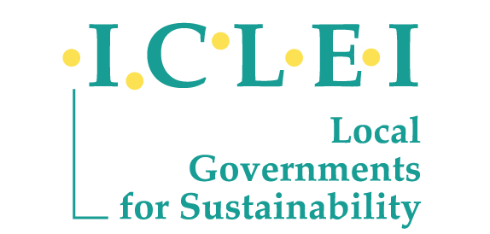
__[insert signature]______  -----[insert name]-------  ------[insert position]-------  On behalf of [ICLEI EU Secretariat] | __[insert signature]______  -----[insert name]-------  ------[insert position]-------  On behalf of [insert organisation]  
__[insert signature]______  -----[insert name]-------  ------[insert position]-------  On behalf of [insert organisation]  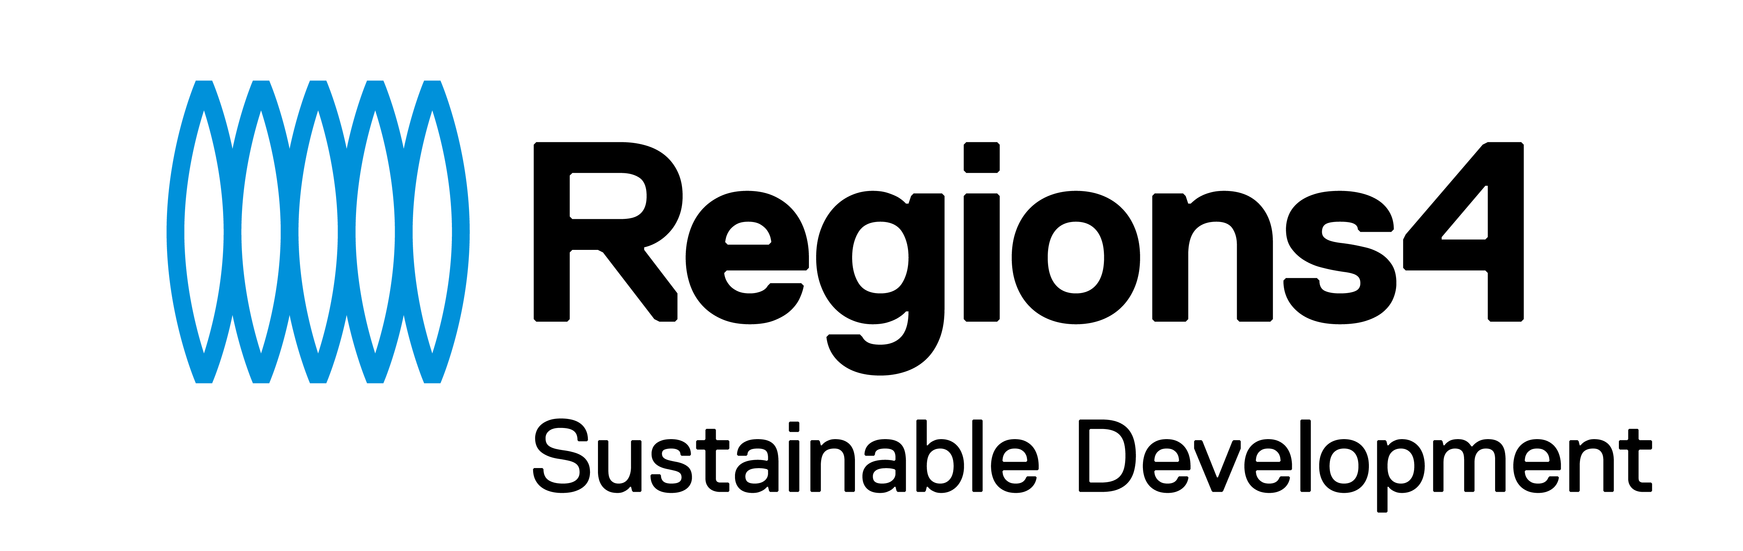 | __[insert signature]______  -----[insert name]-------  ------[insert position]-------  On behalf of [insert organisation]  
__[insert signature]______  -----[insert name]-------  ------[insert position]-------  On behalf of [insert organisation]  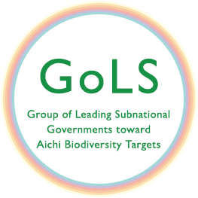 | __[insert signature]______  -----[insert name]-------  ------[insert position]-------  On behalf of [insert organisation]  

Supported by:

__[insert signature]______  -----[insert name]-------  ------insert position-------  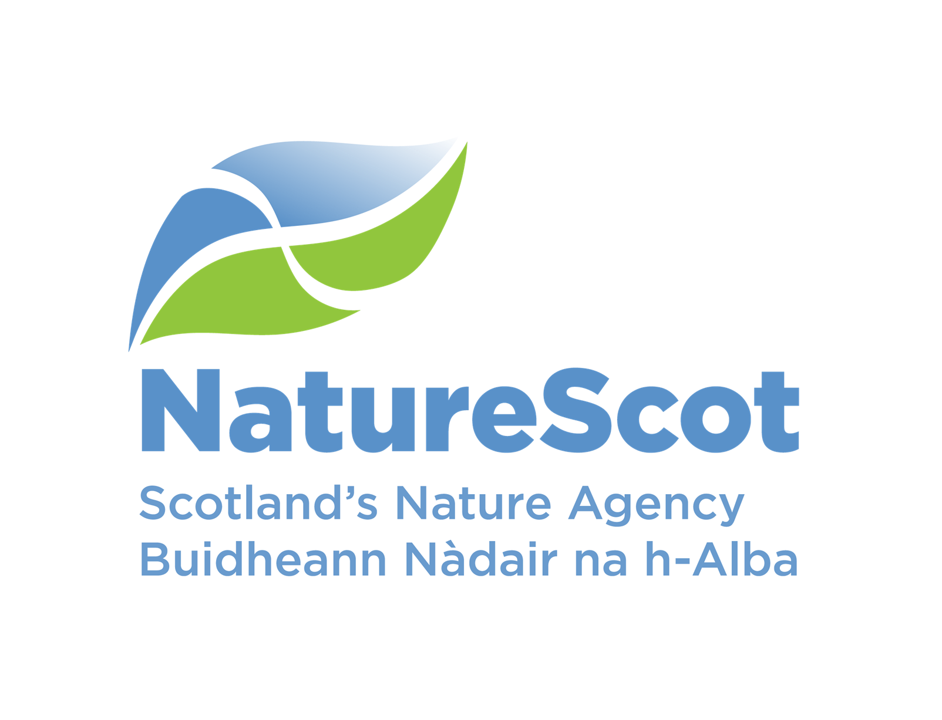 | __[insert signature]______  -----[insert name]-------  ------insert position-------  
Dated: 31 August 2020

[Intentional Blank Page]
SIGNATORIES

SUBNATIONAL, CITY AND LOCAL AUTHORITIES
Name | Position  Organisation | Date Signed
Jo Blogs | Head of Environment and Nature Division  Local Council | Xx/Month/2020

ADDITIONAL SUPPORTERS
Name | Position  Organisation | Date Signed
Nat Ure | Director, Scottish eNGO | Xx/Month/2020

Signing instructions
We very much welcome the participation of subnational governments, cities and local authorities from across the globe in signing up to this Edinburgh Declaration; thereby signalling their commitment to deliver transformative actions in order to achieve the aims and ambitions set out in the post-2020 global biodiversity framework.
In addition, recognising the role of, e.g. non-governmental and business organisations, in taking forward local level actions for nature, we welcome the additional support of such organisations for the principals set out in the Edinburgh Declaration.
It is Parties to the Convention who are responsible for delivering upon the global targets as set out in the post-2020 framework. In order to achieve truly transformational change for nature, all levels of government and society must work more effectively together over the next decade, therefore we greatly welcome the support of any State Party to the Convention who would wish to recognise – though the Edinburgh Declaration - the role of the subnational constituency within the post-2020 global biodiversity framework.
All potential signatories will be subject to a short vetting process to authenticate their representation, and to ensure allocation to the correct category:
i) Subnational, city, local authority signatory – e.g. Minister, governor, mayor, head of department, head of cities network, etc..
ii) State Party supporter – e.g. Minister, head of department, etc., within a supportive state government.
iii) Additional Supporter – e.g. non-governmental or business organisation.

Potential signatories should submit their application to;
enquiries-subnationalworkshop@gov.scot, with the subject line ED Signature.

In order to facilitate the vetting process, where possible please use an organisational/ official email address (i.e. not a personal email address). Please state:
- name,
- organisation,
- position within the organisation,
- Level of representation (e.g. subnational, regional, city, local authority)
- Country
- Signatory category applied to, i.e. (i) - (iii) above
Example:
Name | Frederica Gonzales
Official email address | F.Gonzales@madrid-council.es
Position within Organisation | Head of Environment and Nature Division of Council
Organisation | Council of Madrid
Level representation | City
Country | Spain
Signatory category | Subnational, city, local authority signatory

In the case of signing on behalf of a representative or official, applications should also include documented evidence of that delegated authority attached to the email submission, e.g. this could be a scanned copy of a headed letter, with signature of the representative or official.

Aburra Valley – Medellin Declaration of Metropolitan Areas to the post-2020 global biodiversity framework (2019)
Carta de São Paulo - BIO2020 – Brazilian Perspectives for the Post-2020 Global Biodiversity Framework (2020)

